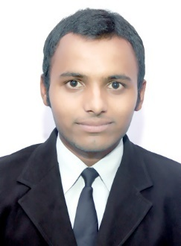 **SUMANT KUMAR**

Email id-sumanmu62@gmail.com

Contact-+91-9166802590

**CAREER OBJECTIVE:**

Seeking a job with an opportunity for professional challenges in the field of civil engineering.

**EDUCATION QUALIFICATION:**

|  |  |  |  |  |
| --- | --- | --- | --- | --- |
| Examination | Board/University | Institute | %ge/CGPA | Year of passing |
| Diploma (CIVIL) | Mewar University | Mewar University | 7.65 | 2016 |
| 10th | Bihar Board, Patna | JHS Inter College | 63.4% | 2013 |

**PERSONAL SKILLS:**

Comprehensive problem solving abilities, excellent verbal and written communication skills, ability to deal with people diplomatically, willingness to learn team facilitator hard worker.

**TECHNICAL SKILLS:**

* Short Term training in AMRAPALI TRAINING AND DEVELOPMENT. Here I have learnt about how to make a construction.

**INDUSTRIAL TRAINING:**

* Under gone training for 6 months at DEC INFRASTUCTURE PROJECTS (I) PVT,LTD. In construction of 89 no’s residential quarters at Surat, GUJARAT under Central Public Works Department (CPWD), And took active part in understanding and execution of plans during the training period at site.

**EXTRA CURRICULAR:**

* I have attend the national level seminar on the topic of **NEED AND SCOPE OF WASTE MANAGEMENT IN INDIA**.
* I participated in SEISMIC BUILDING, JUNKYARD WARS, and APTITUDE QUIZ.
* I played a key role in discipline comity of **ZEAL 2014-15** and also discipline member of ***Aagaaz 2K14*** various program like that seismic building

**PERSONAL PROFILE:**

Name : SUMANT KUMAR

Father’s Name : VISHNUDEV YADAV

Mother’s Name : PANPATI DEVI

Nationality : Indian

Date of Birth : 26/01/1998

Hobbies : Reading newspaper & playing cricket

Languages Known : English and Hindi, Bhojpuri

**DECLARAITION**: I here to declare that the information mentioned above is correct & true the best of my knowledge.

**Place-** BODHGAYA, BIHAR **SUMANT KUMAR**