**NOHID HASANMIYA WASTA**

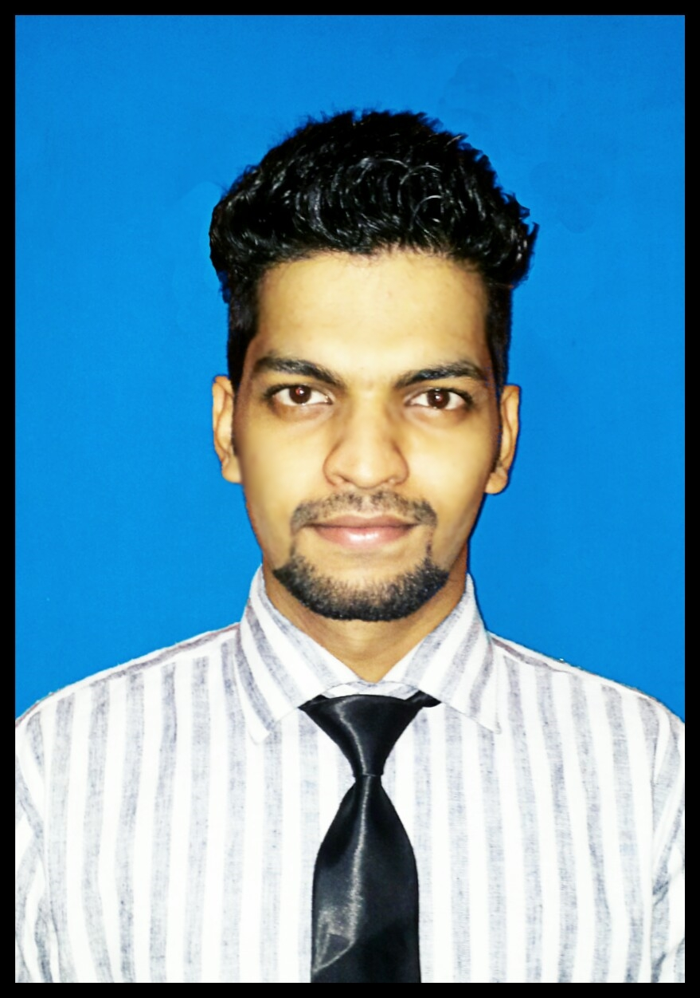

Banoo Estate, B wing Room no. 304,

Jeevan Baug, Opposite to

Mumbra Railways station,

Mumbra – Thane 400612 (INDIA)

**Email : nohidwasta@gmail.com**

**Mobile : +91 7303333290**

**DESIGNATION**

# CIVIL ENGINEER.

# PRECAST & STRUCTURAL STEEL DETAILER / MODULER (AutoCad / X-Steel Tekla Structures).

**WORK EXPERIENCE**

* Junior X-Steel Detailer (17th September 2012 to 8th March 2013) in

InSteel Engineers pvt ltd.

**PROJECT**

* Successfully completed project report on **“PRECAST TECHNOLOGY”** as a part of third year Civil Engineering.

**EDUCATIONAL QUALIFICATION**

**2016** **Diploma in Civil Engineering** from Maharashtra State Board of Technical Education (MSBTE)

**2011** **H.S.C.** from M.S.Naik Junior College of science, (Kolhapur Board)

**2009** **S.S.C .** from A.D.Naik High School, (Kolhapur Board)

**COMPUTER PROFICIENCY**

**Software Exposure : Completed Basic/Advanced Course in TEKLA STRUCTURES**

from Tekla India Pvt Ltd (Tekla Training centre, Mumbai)

**X-Steel (TEKLA STRUCTURES 18.0)**

**AutoCad**  : **Diploma in AutoCAD 2D, 3D**

**PERSONAL PARTICULARS**

Date of Birth : 24th August 1994

Marital Status : Unmarried

Nationality : Indian

Language : English, Hindi, Marathi & Urdu

Hobbies : Learning more about different packages.

Passport No. : J-8848372

Date of Issue : 25th July 2011

Date of Expiry : 24th July 2021

Place of Issue : Mumbai

I do hereby declare that the above information is true to the best of my knowledge.

**Nohid H Wasta.**