Integrating Ground-Based and Satellite Data for Station-Level Air Quality Index (AQI) Prediction in Delhi

Alankar Singh

Abstract

Delhi exhibits some of the highest levels of urban pollution globally. Precise predictions of daily AQI at specific monitoring stations are essential for public health advisories and to initiate mitigation strategies like the Graded Response Action Plan (GRAP). This research integrates daily observations from the Central Pollution Control Board (CPCB) with Sentinel-2 determined Normalised Difference Vegetation Index (NDVI) to establish a station-level predictive framework. Following the consolidation of 592 raw files into a master dataset encompassing 37 stations from November 2018 to December 2024, pollutants exhibiting significant missingness (>30%) were excluded. The remaining series were winsorized (e.g., PM₂.₅ capped at its 99.9th percentile, approximately 580 µg m⁻³) and subjected to time interpolation. Supplementary features—year, month, season, NDVI, and station mean AQI—were developed. Six regression models (Ridge, Support-Vector Regression (SVR), Decision Tree with Grey Wolf Optimisation (DT-GWO), Random Forest (RF), XGBoost, and LightGBM) and three multi-class classifiers (Logistic Regression, RF, and XGBoost) were assessed utilising forward-chaining cross-validation (2019–2023) and a 2024 hold-out dataset. The results indicate that Random Forest (RF) attained the lowest test Root Mean Square Error (RMSE) of 25.33, while XGBoost and LightGBM followed closely. XGBoost exhibited the greatest classification accuracy at 0.823, although RF provided superior balanced accuracy at 0.819. NDVI had a negative correlation with AQI overall (ρ ≈ -0.24), with more pronounced relationships at certain stations. The study presents a replicable framework for station-level AQI prediction that correlates model results with GRAP thresholds. Limitations encompass the omission of climatic factors and the necessity for additional spatial information.

Contents
- Introduction . . . . . . . . . . . . . . . . . . . . . . . . . . . . . . . . . . . . . . . . . . . . . . . . . . . . . . . . . . . . . . . . . . . . . . . . . . . . . . . . 5
- Background . . . . . . . . . . . . . . . . . . . . . . . . . . . . . . . . . . . . . . . . . . . . . . . . . . . . . . . . . . . . . . . . . . . . . . . . . . . . . . . . . 5
2.1 Delhi’s Air Pollution Context . . . . . . . . . . . . . . . . . . . . . . . . . . . . . . . . . . . . . . . . . . . . . . . . . . . . . . . . . . . . . 6
2.2 Pollutants in AQI Measurement . . . . . . . . . . . . . . . . . . . . . . . . . . . . . . . . . . . . . . . . . . . . . . . . . . . . . . . . . . 6
2.3 AQI Classification Framework . . . . . . . . . . . . . . . . . . . . . . . . . . . . . . . . . . . . . . . . . . . . . . . . . . . . . . . . . . . .6
2.4 The GRAP Framework in Delhi . . . . . . . . . . . . . . . . . . . . . . . . . . . . . . . . . . . . . . . . . . . . . . . . . . . . . . . . . . . 7
- Literature Review . . . . . . . . . . . . . . . . . . . . . . . . . . . . . . . . . . . . . . . . . . . . . . . . . . . . . . . . . . . . . . . . . . . . . . . . . . . 8
  - Air Quality Prediction and AQI Modelling. . . . . . . . . . . . . . . . . . . . . . . . . . . . . . . . . . . . . . . . . . . . . . . . . 8
  - Integration of Satellite-Derived Indices (NDVI) with Ground Data . . . . . . . . . . . . . . . . . . . . . . . . 8
  - Machine Learning and Ensemble Methods for AQI Regression and Classification. . . . . . . . . . 8
  - Optimisation Techniques in Environmental Modelling. . . . . . . . . . . . . . . . . .. . . . . . . . . . . . . . . . . . 9
- Data . . . . . . . . . . . . . . . . . . . . . . . . . . . . . . . . . . . . . . . . . . . . . . . . . . . . . . . . . . . . . . . . . . . . . . . . . . . . . . . . . . . . . . . . 9
  - Data Collection . . . . . . . . . . . . . . . . . . . . . . . . . . . . . . . . . . . . . . . . . . . . . . . . . . . . . . . . . . . . . . . . . . . . . . . . . . 9
4.1.1 Ground-Based AQI and Pollutant Data . . . . . . . . . . . . . . . . . . . . . . . . . . . . . . . . . . . . . . . . . . . . . . 9
4.1.2 NDVI (Satellite-Derived Vegetation Cover) . . . . . . . . . . . . . . . . . . . . . . . . . . . . . . . . . . . . . . . . . .9
4.1.3 Station and Temporal Coverage . . . . . . . . . . . . . . . . . . . . . . . . . . . . . . . . . . . . . . . . . . . . . . . . . . . 10
4.2 Data Cleaning and Outlier Treatment . . . . . . . . . . . . . . . . . . . . . . . . . . . . . . . . . . . . . . . . . . . . . . . . . . . .10
4.2.1 Missingness Profile . . . . . . . . . . . . . . . . . . . . . . . . . . . . . . . . . . . . . . . . . . . . . . . . . . . . . . . . . . . . . . . 11
4.2.2 Winsorisation vs IQR Outlier Handling . . . . . . . . . . . . . . . . . . . . . . . . . . . . . . . . . . . . . . . . . . . . 11
4.3 Imputation . . . . . . . . . . . . . . . . . . . . . . . . . . . . . . . . . . . . . . . . . . . . . . . . . . . . . . . . . . . . . . . . . . . . . . . . . . . . . 11
4.4 Feature Engineering . . . . . . . . . . . . . . . . . . . . . . . . . . . . . . . . . . . . . . . . . . . . . . . . . . . . . . . . . . . . . . . . . . . . 12
4.4.1 AQI Class Labels . . . . . . . . . . . . . . . . . . . . . . . . . . . . . . . . . . . . . . . . . . . . . . . . . . . . . . . . . . . . . . . . . . 12
4.4.2 Seasonal Encoding . . . . . . . . . . . . . . . . . . . . . . . . . . . . . . . . . . . . . . . . . . . . . . . . . . . . . . . . . . . . . . . .12
4.4.3 NDVI Integration . . . . . . . . . . . . . . . . . . . . . . . . . . . . . . . . . . . . . . . . . . . . . . . . . . . . . . . . . . . . . . . . . .12
4.5 Exploratory Data Analysis . . . . . . . . . . . . . . . . . . . . . . . . . . . . . . . . . . . . . . . . . . . . . . . . . . . . . . . . . . . . . .12
4.5.1 Pollutant-AQI Correlations . . . . . . . . . . . . . . . . . . . . . . . . . . . . . . . . . . . . . . . . . . . . . . . . . . . . . . . .12
4.5.2 Seasonal Variation . . . . . . . . . . . . . . . . . . . . . . . . . . . . . . . . . . . . . . . . . . . . . . . . . . . . . . . . . . . . . . . .13
4.5.3 Industrial Station Trends . . . . . . . . . . . . . . . . . . . . . . . . . . . . . . . . . . . . . . . . . . . . . . . . . . . . . . . . . 13
- Methodology . . . . . . . . . . . . . . . . . . . . . . . . . . . . . . . . . . . . . . . . . . . . . . . . . . . . . . . . . . . . . . . . . . . . . . . . . . . . . . .14
5.1 Overview . . . . . . . . . . . . . . . . . . . . . . . . . . . . . . . . . . . . . . . . . . . . . . . . . . . . . . . . . . . . . . . . . . . . . . . . . . . . . . .14
5.2 Regression Task . . . . . . . . . . . . . . . . . . . . . . . . . . . . . . . . . . . . . . . . . . . . . . . . . . . . . . . . . . . . . . . . . . . . . . . .14
5.2.1 Ridge Regression . . . . . . . . . . . . . . . . . . . . . . . . . . . . . . . . . . . . . . . . . . . . . . . . . . . . . . . . . . . . . . . . . 15
5.2.2 Random Forest Refressor . . . . . . . . . . . . . . . . . . . . . . . . . . . . . . . . . . . . . . . . . . . . . . . . . . . . . . . . .15
5.2.3 XGBoost Regressor . . . . . . . . . . . . . . . . . . . . . . . . . . . . . . . . . . . . . . . . . . . . . . . . . . . . . . . . . . . . . . . .15
5.2.4 LightGBM Regressor . . . . . . . . . . . . . . . . . . . . . . . . . . . . . . . . . . . . . . . . . . . . . . . . . . . . . . . . . . . . . . 16
5.2.5 Support Vector Regression (SVR) . . . . . . . . . . . . . . . . . . . . . . . . . . . . . . . . . . . . . . . . . . . . . . . . . 16
5.2.6 Decision Tree + Grey Wolf Optimisation (DT-GWO) . . . . . . . . . . . . . . . . . . . . . . . . . . . . . . . 16
5.3 Classification Task . . . . . . . . . . . . . . . . . . . . . . . . . . . . . . . . . . . . . . . . . . . . . . . . . . . . . . . . . . . . . . . . . . . . . 16
5.3.1 Logistic Regression . . . . . . . . . . . . . . . . . . . . . . . . . . . . . . . . . . . . . . . . . . . . . . . . . . . . . . . . . . . . . . .17
5.3.2 Random Forest Classifier . . . . . . . . . . . . . . . . . . . . . . . . . . . . . . . . . . . . . . . . . . . . . . . . . . . . . . . . .17
5.3.3 XGBoost Classifier . . . . . . . . . . . . . . . . . . . . . . . . . . . . . . . . . . . . . . . . . . . . . . . . . . . . . . . . . . . . . . . .17
5.4 Hyperparameter Tuning . . . . . . . . . . . . . . . . . . . . . . . . . . . . . . . . . . . . . . . . . . . . . . . . . . . . . . . . . . . . . . . .18
5.5 Grey Wolf Optimisation (GWO) . . . . . . . . . . . . . . . . . . . . . . . . . . . . . . . . . . . . . . . . . . . . . . . . . . . . . . . . . 18
5.6 Evaluation Metrics . . . . . . . . . . . . . . . . . . . . . . . . . . . . . . . . . . . . . . . . . . . . . . . . . . . . . . . . . . . . . . . . . . . . . .19
5.6.1 Regression Metrics . . . . . . . . . . . . . . . . . . . . . . . . . . . . . . . . . . . . . . . . . . . . . . . . . . . . . . . . . . . . . . . .19
5.6.2 Classification Metrics . . . . . . . . . . . . . . . . . . . . . . . . . . . . . . . . . . . . . . . . . . . . . . . . . . . . . . . . . . . . . 19
- Results . . . . . . . . . . . . . . . . . . . . . . . . . . . . . . . . . . . . . . . . . . . . . . . . . . . . . . . . . . . . . . . . . . . . . . . . . . . . . . . . . . . . 20
6.1 NDVI - air quality relationships (half-year bins, per station) . . . . . . . . . . . . . . . . . . . . . . . . . . . . . 20
6.2 Regression: cross-validated performance and 2024 generalisation . . . . . . . . . . . . . . . . . . . . . . .21
6.2.1 Feature Importance . . . . . . . . . . . . . . . . . . . . . . . . . . . . . . . . . . . . . . . . . . . . . . . . . . . . . . . . . . . . . . . 22
6.3 Classification: AQI class prediction (CPCB scale) . . . . . . . . . . . . . . . . . . . . . . . . . . . . . . . . . . . . . . . . .22
6.3.1 Confusion Matrix . . . . . . . . . . . . . . . . . . . . . . . . . . . . . . . . . . . . . . . . . . . . . . . . . . . . . . . . . . . . . 23
6.4 Raw vs log-transformed features . . . . . . . . . . . . . . . . . . . . . . . . . . . . . . . . . . . . . . . . . . . . . . . . . . . . . . . .24
6.5 Practical Significance . . . . . . . . . . . . . . . . . . . . . . . . . . . . . . . . . . . . . . . . . . . . . . . . . . . . . . . . . . . . . . . . . . . 24
6.6 Summary of Best Models . . . . . . . . . . . . . . . . . . . . . . . . . . . . . . . . . . . . . . . . . . . . . . . . . . . . . . . . . . . . . . . .24
- Discussion and Critical Reflection . . . . . . . . . . . . . . . . . . . . . . . . . . . . . . . . . . . . . . . . . . . . . . . . . . . . . . . . . . .24
7.1 Feature Importance and Policy Linkages . . . . . . . . . . . . . . . . . . . . . . . . . . . . . . . . . . . . . . . . . . . . . . . . 24
7.2 Data and Methodological Limitations . . . . . . . . . . . . . . . . . . . . . . . . . . . . . . . . . . . . . . . . . . . . . . . . . . . .25
7.3 Reflection and Future Directions . . . . . . . . . . . . . . . . . . . . . . . . . . . . . . . . . . . . . . . . . . . . . . . . . . . . . . . 25
- Conclusion. . . . . . . . . . . . . . . . . . . . . . . . . . . . . . . . . . . . . . . . . . . . . . . . . . . . . . . . . . . . . . . . . . . . . . . . . . . . . . . . . 25
- References . . . . . . . . . . . . . . . . . . . . . . . . . . . . . . . . . . . . . . . . . . . . . . . . . . . . . . . . . . . . . . . . . . . . . . . . . . . . . .26-27
- Appendix . . . . . . . . . . . . . . . . . . . . . . . . . . . . . . . . . . . . . . . . . . . . . . . . . . . . . . . . . . . . . . . . . . . . . . . . . . . . . . . 28-29

- Introduction
Air pollution presents a significant risk to public health, ecosystems, and economic productivity, especially in increasingly urbanising areas. Delhi, identified as one of the most polluted cities worldwide (IQAir, 2023), consistently has AQI levels classified as “very poor” or “severe” according to India’s National Air Quality Index (CPCB, 2014). Industrial emissions, automobile traffic, construction activities, and seasonal biomass combustion combined result in consistently elevated pollution concentrations (Guttikunda & Calori, 2013; Chowdhury et al., 2019).
Besides the considerable public health burden, which encompasses a heightened prevalence of cardiovascular and respiratory disorders (Lelieveld et al., 2020), air pollution imposes large economic costs due to diminished labour productivity and escalated healthcare expenditures. Precise AQI forecasting at a localised (station-level) scale is crucial for targeted actions and public health advice.
Numerous machine learning studies have investigated AQI prediction utilising solely ground measurements (Kumar et al., 2022; Singh et al., 2023), yet there is a growing acknowledgement that incorporating satellite-derived environmental indicators, such as NDVI, can improve predictive accuracy by considering the moderating effect of vegetative cover on pollutant dispersion and deposition (Guo et al., 2025; Xu et al., 2019).
The objective of this study is to:
- Preprocess and combine multi-year terrestrial and satellite information at the station level for Delhi.

- Utilise and evaluate various regression and classification techniques to predict AQI values and classifications.
- Assess the impact of vegetation cover (NDVI) on air quality index (AQI) trends, especially in major industrial areas.
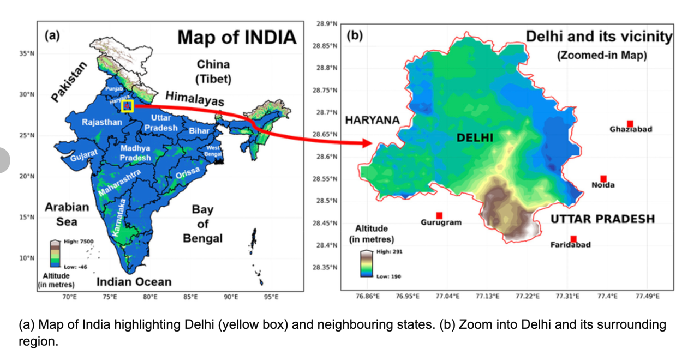
Figure 1: Map of India emphasising Delhi
- Background
The background is expanded into four subsections: (a) Delhi’s air pollution context, (b) pollutants and their health/environmental impacts, (c) AQI classification framework and (d) the GRAP framework in Delhi
  - Delhi’s Air Pollution Context
The geographical location, climate, and human activity in Delhi contribute to the intensification of air pollution events. The city is situated in a landlocked basin, where winter temperature inversions confine pollutants near the surface (Sharma & Dikshit, 2016). The post-monsoon period is characterised by significant AQI surges, frequently ascribed to agricultural stubble combustion in adjacent states (Vadrevu et al., 2020).
Regulatory frameworks, such as the Graded Response Action Plan (GRAP), enforce stratified measures contingent upon AQI thresholds, encompassing limitations on construction activities and the cessation of thermal power plants during "severe" events (CAQM, 2023). Notwithstanding these initiatives, seasonal and annual variability persists at elevated levels, signifying a necessity for enhanced forecasting capacities to facilitate real-time policy execution.
  - Pollutants in AQI Measurement
The Indian Air Quality Index (AQI) is derived from the sub-indices of six criterion pollutants: PM₂.₅, PM₁₀, NO₂, SO₂, CO, and O₃ (CPCB, 2014). Each pollutant has a distinct impact on health outcomes and atmospheric chemistry.
Table 1: Pollutant classification
Pollutant | Full Name | Major Sources | Health/Environmental Impact | Role in AQI
PM₂.₅ | Particulate Matter ≤ 2.5 µm | Vehicle exhaust, biomass burning, industrial emissions, dust | Penetrates deep into lungs; linked to cardiovascular and respiratory disease | Primary AQI driver in Delhi; direct AQI input
PM₁₀ | Particulate Matter ≤ 10 µm | Road dust, construction, agriculture, combustion | Irritates respiratory tract; worsens asthma | Second-most influential pollutant
NO₂ | Nitrogen Dioxide | Vehicle engines, power plants | Inflammatory to airways; ozone precursor | Used in AQI; moderate contributor
SO₂ | Sulfur Dioxide | Fossil fuel combustion | Bronchoconstriction; forms sulfate particles | Relevant in industrial zones
CO | Carbon Monoxide | Incomplete combustion | Reduces oxygen delivery | Episodic spikes in winter
O₃ | Ozone (ground-level | Photochemical reaction product | Respiratory irritant; crop damage | Seasonal contributor
Note: In this study, NO₂ was selected over NO and NOₓ to reduce multicollinearity while maintaining AQI relevance.
  - AQI Classification Framework
The Air Quality Index (AQI) of India is a composite metric developed by the Central Pollution Control Board (CPCB) to provide a unified depiction of ambient air quality, categorising it into six classifications: Good, Satisfactory, Moderately Polluted, Poor, Very Poor, and Severe. Each category is defined by the ambient concentration levels of air pollutants and their associated health impacts, known as health breakpoints. (CPCB 2014).
Each category corresponds to certain concentration levels for each criterion pollutant, employing the highest sub-index as the AQI score for the day.
Table 2: AQI Classification
AQI Category | AQI Range | Colour Code | Health Implications
Good | 0–50 | Green | Minimal impact
Satisfactory | 51–100 | Light Green | Minor respiratory irritation for sensitive individuals
Moderately Polluted | 101–200 | Yellow | Respiratory distress in individuals with pulmonary disorders, asthma, and cardiovascular disease
Poor | 201–300 | Orange | Respiratory discomfort for the majority of individuals upon extended exposure
Very Poor | 301–400 | Red | Respiratory ailments due to extended exposure
Severe | 401–500+ | Dark Red | Serious health impacts; emergency measures required
This classification enhances public communication and acts as the catalyst for regulatory frameworks like the Graded Response Action Plan (GRAP) in Delhi.
  - The GRAP Framework in Delhi
The Graded Response Action Plan (GRAP) was established by the Environment Pollution (Prevention & Control) Authority (EPCA) and is currently executed by the Commission for Air Quality Management (CAQM) in the National Capital Region. The approach entails a series of incremental measures implemented according to the current AQI category, with the objective of mitigating pollutant emissions during periods of declining air quality (CAQM, 2023; EPCA, 2017).
Stages of GRAP:
Stage 1 (AQI 201–300, Poor):
- Ban on diesel generator sets (except essential services)
- Mechanised sweeping and water sprinkling on roads
- Strict enforcement of dust control measures at construction sites
Stage II (AQI 301–400, Very Poor):
- Ban on coal/wood tandoors in restaurants
- Increase frequency of mechanised cleaning and sprinkling
- Strict control on industrial emissions
Stage III (AQI 401–450, Severe):
- Ban on construction and demolition activities except essential projects
- Closure of stone crushers, hot mix plants, and brick kilns
- Enhanced public transport deployment to reduce vehicular load
Stage IV (AQI > 450, Severe+):
- Ban on entry of trucks except essential goods
- Closure of schools, colleges, and non-essential offices
- Consider staggered working hours and odd-even schemes for vehicles
This phased strategy enables authorities to enact proportional interventions according to real-time pollution metrics, thereby mitigating health hazards and economic disturbances. This study linked AQI classification with CPCB thresholds, facilitating the assessment of model performance in predicting both continuous AQI values and corresponding discrete GRAP-triggering categories.
- Literature Review
3.1 Air Quality Prediction and AQI Modelling
Air quality forecasting has progressed from conventional statistical models to sophisticated machine learning and hybrid frameworks. Initial research in India utilised multiple linear regression and autoregressive integrated moving average (ARIMA) models for air quality index (AQI) prediction (Jain et al., 2018); however, both methodologies encountered difficulties with nonlinearities and interactions among different pollutants. Recent research have utilised tree-based ensembles, including Random Forests and Gradient Boosted Trees, resulting in enhanced performance in elucidating intricate pollutant-meteorology interactions (Guo et al., 2025; Chen & Guestrin, 2016).
Worldwide, hybrid deep learning methodologies, such as LSTM–CNN architectures, have demonstrated significant predictive accuracy by modelling temporal dependencies and spatial correlations (Li et al., 2021). Nonetheless, these models frequently necessitate comprehensive, high-frequency datasets, which may be inaccessible in Indian situations.
3.2 Integration of Satellite-Derived Indices (NDVI) with Ground Data
Vegetation indices, especially the Normalised Difference Vegetation Index (NDVI), have been progressively incorporated into AQI modelling as indicators of green cover, which affects pollution dispersion and deposition (Xue et al., 2024; Guo et al., 2025). NDVI demonstrates a seasonal anticorrelation with PM₂.₅ concentrations, especially in urban industrial areas where vegetation density influences aerosol retention (Wang et al., 2023).
In India, Google Earth Engine (GEE) has enabled the extraction of high-resolution NDVI time series across extensive spatial areas, facilitating integration into machine learning frameworks (Gore et al., 2023). This methodology is especially pertinent for Delhi, where land-use diversity across industrial, residential, and peri-urban areas affects pollution trends.
3.3 Machine Learning and Ensemble Methods for AQI Regression and Classification
Ensemble approaches like as Random Forests and LightGBM have regularly been recognised as leading performers in AQI prediction challenges (Ke et al., 2017; Singh et al., 2023). Random Forests are proficient at managing noisy, high-dimensional data with minimal preprocessing, but LightGBM provides accelerated training and superior scalability for huge datasets.
Classification algorithms, such as logistic regression, decision trees, and gradient boosting classifiers, have been utilised to predict AQI categories instead of continuous values, yielding outputs directly pertinent to public health advising systems (Zhang et al., 2022). This category forecast strongly corresponds with frameworks like CPCB’s AQI categorisation and the GRAP stages in Delhi, facilitating effective policy responses.
3.4 Optimisation Techniques in Environmental Modelling
Metaheuristic methods, like Grey Wolf Optimisation (GWO), have been prominent for hyperparameter adjustment in environmental models (Mirjalili et al., 2014). GWO emulates the leadership structure and hunting strategies of grey wolves, optimising the balance between exploration and exploitation within the search space. Research has shown its ability to adjust decision tree parameters for enhanced AQI prediction accuracy (Sahu & Patra, 2022).
This study integrates GWO with decision tree models, supported by evidence that metaheuristics can surpass grid search or random search in high-dimensional, nonlinear optimisation challenges commonly encountered in atmospheric data modelling (Kohli & Arora, 2018).
- Data
This study blends multi-source datasets from January 2017 to December 2024 for Delhi, India, incorporating ground-based pollution observations, satellite-derived vegetation indices (NDVI), and climatic characteristics. The resultant dataset is intended for both regression (continuous AQI forecasting) and classification (AQI category forecasting) activities.
  - Data Collection

    - Ground-Based AQI and Pollutant Data
The primary air quality dataset was sourced from the official website of Central Pollution Control Board (CPCB). The data is recorded by 37 monitoring stations spread out across Delhi maintained by CPCB, Delhi Pollution Control Committee (DPCC), and Indian Meteorological Department (IMD).
Each record contains daily averaged concentrations for the pollutants which are criteria pollutants in India’s AQI framework.
Despite the availability of nitrogen monoxide (NO) and total nitrogen oxides (NOₓ), we selected NO₂ for modelling because of its direct involvement in AQI calculation, reduced multicollinearity (VIF=2.22 compared to NO=7.73), and enhanced temporal stability.
    - NDVI (Satellite-Derived Vegetation Cover)
We used a spatially explicit extraction procedure utilising Google Earth Engine (GEE) to analyse vegetation cover dynamics surrounding each CPCB station.
The geographical limits for each monitoring station's catchment area were determined manually. Utilising Google Maps as a reference, we conducted a visual examination of the vicinity of each station and delineated accurate polygon shapes in GEE’s code editor. These polygons were meticulously delineated to contain the station's immediate effect zone, accurately reflecting the surrounding land cover context. This manual method yielded superior spatial precision compared to standard buffer radii, particularly in diverse metropolitan settings such as Delhi, where land use can vary dramatically within a few hundred meters.
We employed Copernicus Sentinel-2 Level-2A images for vegetation measurement, with a spatial resolution of 10 m and encompassing 13 spectral bands. We calculated the Normalised Difference Vegetation Index (NDVI) from this images using the conventional formula:
$$NDVI= \frac{(NIR-RED)}{(NIR+RED)}$$
Where NIR is the reflectance in the near-infrared band (Sentinel-2 Band 8, 842 nm), and RED is the reflectance in the red band (Sentinel-2 Band 4, 665 nm).
To reduce cloud interference and seasonal noise, we generated semiannual NDVI composites (January–June, July–December) for each polygon. In GEE, cloud masking was implemented with the Sentinel-2 QA60 band, and pixels identified as clouds or shadows were omitted prior to compositing. The median NDVI for each semiannual period was subsequently derived within the station's polygon, ensuring that extreme pixel values did not unduly affect the results.
NDVI readings varied from −1 to +1, with elevated values signifying denser or better vegetation.
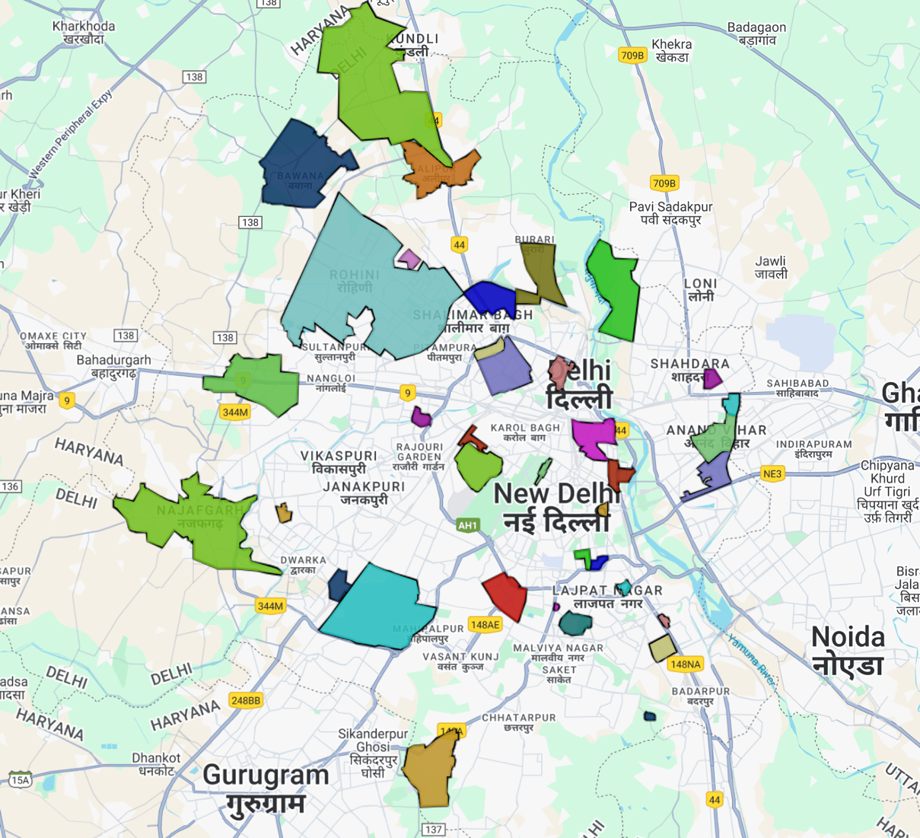
Figure 2: Manually sketched polygons representing 37 monitoring stations in Delhi
    - Station and Temporal Coverage
The dataset encompasses 37 stations around Delhi, with six industrial zones (Bawana, Narela, Najafgarh, Patparganj, Wazirpur, Okhla Phase-2) designated for sub-analysis. The study period extends from 2017 to 2024, with 2024 designated only for model testing.
  - Data Cleaning and Outlier Treatment
    - Missingness Profile
Prior to imputation, numerous features demonstrated significant missingness (e.g., AT: 42.2%, BP: 41.1%, Toluene: 35.1%). Features with above 30% missing values were omitted from models to prevent excessive imputation noise.
    - Winsorisation vs. IQR Outlier Handling
Due to the heavy-tailed, right-skewed distributions of pollutants, we employed 99.9th percentile winsorization rather than the IQR approach for the following reasons:
- Preserves Full Time-Series – Essential for fixed-window sequence models.
- Retains Real Pollution Peaks – Caps extreme sensor spikes but retains severe pollution episodes.
- Adapts to Skewed Distributions – Percentiles handle asymmetry better than symmetric IQR fences.
- Improves Model Stability – Reduces undue influence of extreme outliers on model fitting.
Example: PM₂.₅’s raw max was 1000 µg/m³; after winsorisation, capped to ≈580 µg/m³ while retaining severe winter episodes.
  - Imputation
Following the correction of outliers, missing values were addressed by station-specific seasonal median imputation to maintain spatial and seasonal variability in pollutant concentrations. This method prevents the skewing of winter and summer distributions, which are markedly distinct in Delhi.
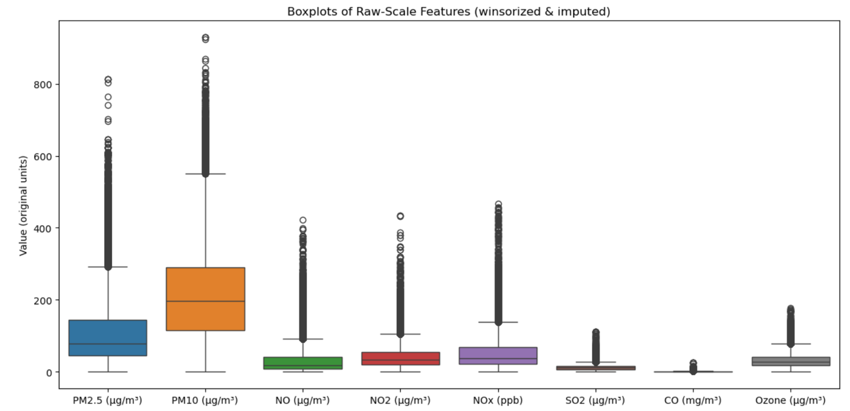
Figure 3: Boxplots of pollutants after winsorisation and imputation
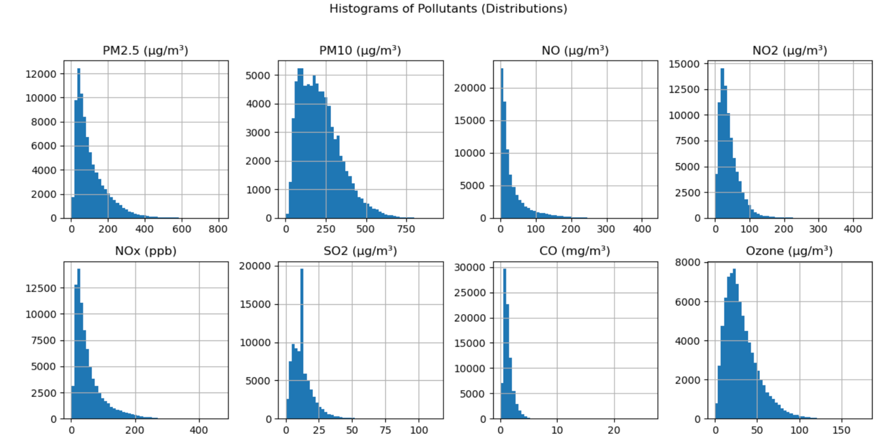
Figure 4: Histogram of pollutants after winsorisation and imputation
  - Feature Engineering

    - AQI Class Labels
For classification models, continuous AQI values were mapped to CPCB AQI categories:
- Good (0–50)
- Satisfactory (51–100)
- Moderately Polluted (101–200)
- Poor (201–300)
- Very Poor (301–400)
- Severe (401–500)
    - Seasonal Encoding
Each record was designated a seasonal label (Winter, Spring, Summer, Monsoon, Autumn) to facilitate the examination of seasonal correlations between contaminants and AQI.
4.4.3 NDVI Integration
The half-yearly NDVI was integrated with station-specific AQI data by temporal joins, facilitating a correlation analysis between vegetation cover and pollution concentrations at each station.
  - Exploratory Data Analysis

    - Pollutant–AQI Correlations
Strongest correlations were observed for PM₁₀ (r=0.895) and PM₂.₅ (r=0.886), followed by NOₓ and CO. O₃ showed negligible or slightly negative correlation with AQI, reflecting its photochemical seasonality.
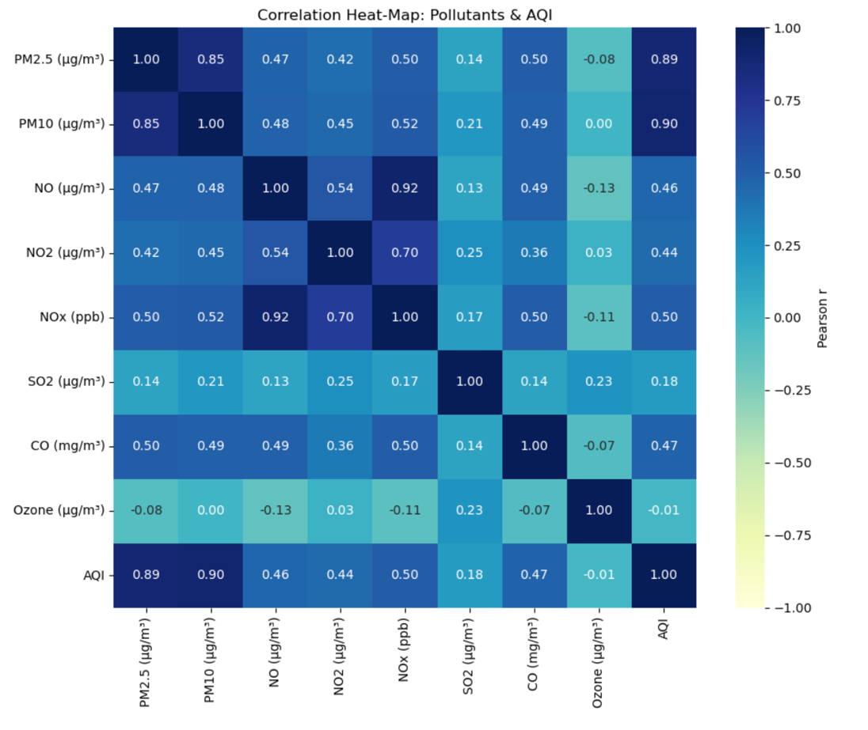
Figure 5: Correlation Heat-Map
    - Seasonal variation
Seasonal correlations showed PM₂.₅ peaking in winter (r=0.876 with AQI), while O₃ correlated more in summer/autumn due to higher photochemical activity.
Table 3: Pollutant-Season correlation matrix
 | Winter | Spring | Summer | Monsoon | Autumn
CO (mg/m³) | 0.436 | 0.260 | 0.155 | 0.182 | 0.480
NO (µg/m³) | 0.354 | 0.248 | 0.230 | 0.172 | 0.316
NO2 (µg/m³) | 0.299 | 0.271 | 0.293 | 0.213 | 0.310
NOx (ppb) | 0.368 | 0.278 | 0.271 | 0.191 | 0.357
Ozone (µg/m³) | -0.086 | 0.087 | 0.202 | 0.189 | 0.037
PM10 (µg/m³) | 0.816 | 0.849 | 0.830 | 0.834 | 0.850
PM2.5 (µg/m³) | 0.876 | 0.796 | 0.692 | 0.636 | 0.862
SO2 (µg/m³) | 0.077 | 0.242 | 0.267 | 0.051 | 0.177

    - Industrial station trends
Analysis of 2017–2024 AQI trends at the six industrial stations revealed:
- Bawana/Wazirpur: High AQI (≈250+) pre-2019, with gradual improvement post-2020.
- Najafgarh: Improvement after 2019, stabilising near 180.
- Okhla_Phase-2: Stable ≈209 AQI post-2020.
- Narela: Most stable AQI (~220–230) across years.
COVID-19 lockdown periods likely contributed to temporary improvements in 2020.
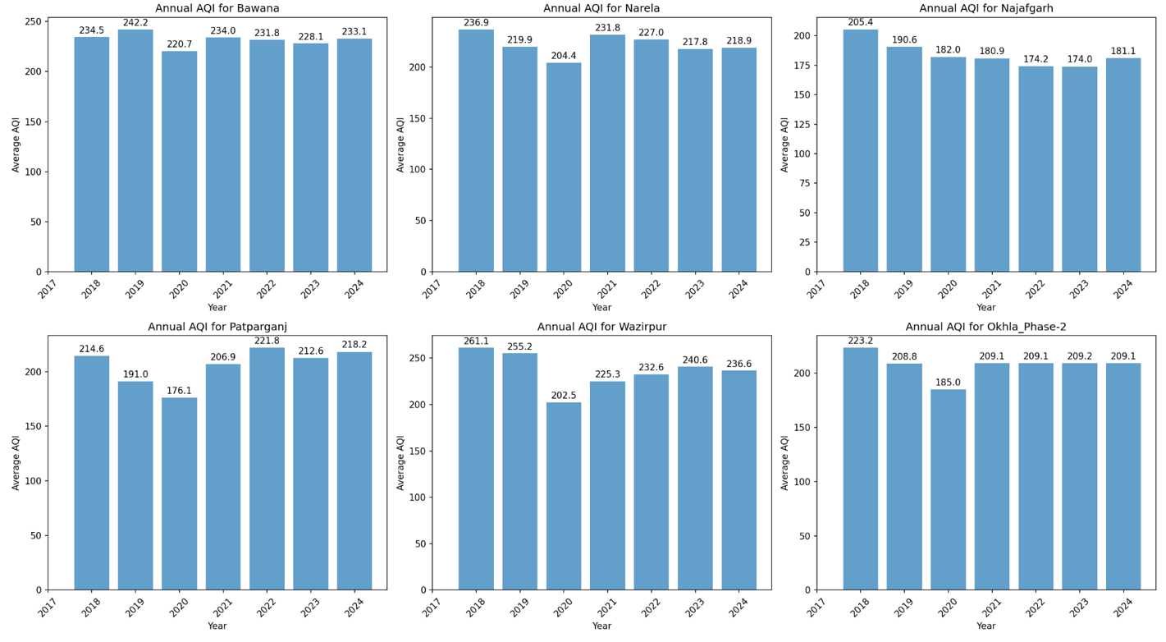
Figure 6: Annual AQI trends for six industrial stations
- Methodology
  - Overview
This research utilises supervised machine learning methods to forecast the Air Quality Index (AQI) in Delhi by integrating ground-level pollution data and remotely acquired vegetation indices. Two complementing modelling paradigms were employed:
- Regression modelling to forecast continuous Air Quality Index values based on measured pollutant concentrations and vegetation indices.
- Classification models to categorise AQI results into the Central Pollution Control Board (CPCB) air quality categories: Good, Satisfactory, Moderately Polluted, Poor, Very Poor, and Severe.
The regression job enables accurate prediction of AQI levels, facilitating early warning systems, whereas categorisation offers categorical risk communication consistent with regulatory frameworks and public health advisories. Both tasks employ the identical foundational feature set — particulate matter (PM₂.₅, PM₁₀), nitrogen dioxide (NO₂), sulphur dioxide (SO₂), carbon monoxide (CO), ozone (O₃), and Normalised Difference Vegetation Index (NDVI) — although they diverge in the nature of the target variable (continuous versus categorical).
  - Regression Task
Objective:
Forecast daily AQI values for each monitoring station from 2017 to 2024, utilising pollutant concentrations.
Six regression algorithms were chosen to encompass a range of modelling difficulties and foundational assumptions, so facilitating a comprehensive model comparison. Each model was selected based on existing research and its appropriateness for the data's characteristics.
    - Ridge Regression
Why: Ridge Regression (Hoerl & Kennard, 1970) is an enhancement of ordinary least squares (OLS) that incorporates an L2 penalty term to alleviate overfitting and tackle multicollinearity—an essential characteristic for air quality datasets where pollutant variables (e.g., NO₂ and PM₂.₅) frequently exhibit correlation (Jain et al., 2021). As a linear model, it offers interpretability and functions as a benchmark to assess the improvements from non-linear models.
Equation:
The Ridge Regression objective function is:
$$\hat{β}=argmin\{\sum_{i=1}^{n}{{(y_{i}-β_{o}-\sum_{j=1}^{p}{β_{j}x_{ij}})}^{2}+λ\sum_{j=1}^{p}{β_{j}^{2}}}\}$$
Where lambda is the regularisation parameter controlling coefficient shrinkage
    - Random Forest Regressor
Why: Random Forests (Breiman, 2001) are ensemble models that aggregate several decision trees trained on bootstrapped samples, therefore diminishing variance and enhancing generalisation. They encapsulate intricate non-linear interactions among contaminants and exhibit resilience to outliers—a vital characteristic considering Delhi's sporadic severe AQI occurrences. The outputs of feature significance are also significant for interpretability
Equation:
Prediction is the mean of the individual trees’ predictions:
$$\hat{y}= \frac{1}{B}\sum_{i=1}^{B}{T_{b}\left(x\right)}$$
where B is the number of trees and $T_{b}\left(x\right)$ is the prediction from the bth tree.
    - XGBoost Regressor
Why: Extreme Gradient Boosting (XGBoost; Chen & Guestrin, 2016) incrementally constructs trees, with each tree addressing the residual mistakes of its predecessor. It frequently surpasses bagging techniques such as Random Forest on tabular datasets with structured features, owing to its regularised aim, management of missing values, and capacity to represent intricate feature relationships.
Objective Function:
$$L\left(φ\right)= Σ_{i=1}^{n}l\left(y_{i}, ŷ_{i}\right)+ Σ_{k=1}^{K}[γ T_{k}+ \left(\frac{1}{2}\right)λ {||w}_{k}|{\left.​\right|}^{2}]$$
$where \left(\frac{1}{2}\right)λ {||w}_{k}|{\left.​\right|}^{2}$penalises model complexity, T is the number of leaves, and w are leaf weights.
    - LightGBM Regressor
Why: Light Gradient Boosting Machine (LightGBM; Ke et al., 2017) is a gradient boosting architecture tuned for rapidity and memory efficiency, especially appropriate for extensive datasets. It employs histogram-based decision tree learning and leaf-wise growth to attain quicker convergence than XGBoost, while preserving comparable accuracy.
Equation: LightGBM minimises the same form of regularised objective as gradient boosting
$$L = Σ_{i=1}^{n}l\left(y_{i}, ŷ_{i}\right)+ λ Σ_{j=1}^{p}β_{j}^{2}$$
but optimises the split finding via histogram binning to reduce computational cost.
    - Support Vector Regression (SVR)
Why: SVR (Smola & Schölkopf, 2004) effectively captures non-linear patterns in small to medium datasets by transforming input features into a high-dimensional kernel space. In the context of AQI, where the interactions between pollutants and vegetation may be non-linear, Support Vector Regression (SVR) demonstrates robust predictive capabilities when properly calibrated.
Equation:
Given training data, SVR solves:
$$min\left(\frac{1}{2}\right){\left|\left|w\right|\right|}^{2}+ C \sum_{i=1}^{n}{{(ξ}_{i}+ ξ_{i}^{*})}$$
Subject to:
$$y_{i}- w·φ\left(x_{i}\right)- b ≤ ϵ + ξ_{i}$$

$$w·φ\left(x_{i}\right)+ b - y_{i}≤ ϵ+ ξ_{i}^{*}$$
    - Decision Tree + Grey Wolf Optimisation (DT-GWO)
Why: Decision Trees (Quinlan, 1986) are interpretable models that partition the feature space into homogeneous sections; however, their efficacy is contingent upon meticulous hyperparameter tweaking. Grey Wolf Optimisation (GWO; Mirjalili et al., 2014) is a metaheuristic derived from the social hierarchy and hunting tactics of grey wolves, employed in this context to optimise Decision Tree hyperparameters for enhanced AQI prediction.
Equation:
A Decision Tree partitions the feature space using thresholds t to minimise impurity (e.g., MSE)
$$MSE = \left(\frac{1}{n}\right)Σ_{i=1}^{n}{\left(y_{i}- ŷ_{i}\right)}^{2}$$
GWO’s formulation will be fully described in Section 5.5.
5.3 Classification Task
This study's classification job sought to forecast distinct Air Quality Index (AQI) categories, as delineated by the Central Pollution Control Board (CPCB) of India, utilising the calculated daily AQI values derived from ground-based data. The six classifications employed were: Good, Satisfactory, Moderately Polluted, Poor, Very Poor, and Severe. This is a multi-class classification challenge that necessitates algorithms capable of efficiently distinguishing overlapping feature spaces while addressing potential class imbalances.
Three supervised machine learning algorithms were employed:
5.3.1 Logistic Regression
Logistic Regression (LR) serves as a statistical baseline for classification. It models the posterior probability of each class c given the input features x via the softmax function:
$$P\left(y=c | x\right)=\frac{exp⁡(w_{c}^{T}x+b_{c})}{\sum_{j=1}^{K}{exp⁡(w_{j}^{T}x+b_{j})}}$$
$w_{c}$is the weight vector for class c,
$b_{c}$ is the bias term for class c,
$K$ is the total number of classes
Why: Logistic Regression offers a clear and comprehensible probabilistic framework. Although less potent than tree-based models for complex non-linear boundaries, it provides a solid foundation for performance evaluation and a clear comprehension of the feature-class correlations.
5.3.2 Random Forest Classifier
The Random Forest Classifier (RFC) enhances the Random Forest framework for category prediction by consolidating the predictions of numerous decision trees trained on bootstrapped subsets of the training dataset. The final anticipated class $\hat{y}$ for classification is determined through majority voting.
$$\hat{y}=mode(h1\left(x\right), h2\left(x\right),…,h_{T}(x))$$
$where h_{t}$ denotes the t-th decision tree, and T is the number of trees.
Why: RFC is resilient to overfitting, adept at modelling intricate non-linear feature interactions, and proficient in managing high-dimensional spaces. It also produces class-level feature significance metrics that can enhance interpretability in environmental monitoring.
5.3.3 XGBoost Classifier
The XGBoost Classifier is a gradient boosting technique that incrementally builds an ensemble of decision trees, with each subsequent tree addressing the residual faults of its forerunners. The approach minimises the regularised multi-class logistic loss for classification.
$$L= \sum_{i=1}^{n}{l\left(y_{i}, \hat{y_{i}}\right)+ \sum_{k=1}^{K}{omega\left(f_{k}\right)}}$$
$$omega\left(f_{k}\right)=γT+\frac{1}{2}λ{\left|\left|w\right|\right|}^{2}$$
$where l$ is the negative log-likelihood, and omega s the regularisation term controlling tree complexity.
Why: XGBoost has demonstrated exceptional performance in structured data tasks, especially with skewed datasets. The regularisation mitigates overfitting, which is advantageous due to the uneven distribution of AQI categories (e.g., a scarcity of “Good” days in Delhi).
5.4 Hyperparameter Tuning
To optimise predictive performance, hyperparameter tuning was conducted using Grid Search combined with Forward-Chaining Cross-Validation. This approach is particularly suited to time series data because it preserves temporal ordering and avoids data leakage.
In forward-chaining cross-validation:
- The first fold trains on years up to t and t+1
- Subsequent folds incrementally expand the training window and shift the validation year.
For example:
- Fold 1: Train ≤ 2018 → Validate 2019
- Fold 2: Train ≤ 2019 → Validate 2020 … up to 2023
Hyperparameters optimised included:
- For tree-based models: n_estimators, max_depth, min_samples_split, min_samples_leaf, max_features.
- For boosting models: learning rate, maximum depth, subsample ratio, column sampling ratio, and L2 regularisation.
- For SVR: kernel type, regularisation parameter C, and kernel width $γ$.

5.5 Grey Wolf Optimisation (GWO)
The Grey Wolf Optimiser (GWO), introduced by Mirjalili et al. (2014), is a nature-inspired metaheuristic that emulates the leadership structure and hunting tactics of grey wolves in the wild. Wolves are classified within the population as:
Alpha (α): The best solution found so far.
Beta (β): The second-best solution, guiding the search.
Delta (δ): The third-best solution, also influencing the pack.
Omega (ω): Remaining search agents.
The algorithm updates positions based on the encircling mechanism:
Distance vector:
$$\vec{D}=|\vec{C}. {\vec{X}}_{p}\left(t\right)-\vec{X}(t)|$$
Position update:
$$\vec{X}\left(t+1\right)= {\vec{X}}_{p}\left(t\right)-\vec{A}.\vec{D}$$
With
$$\vec{A}=2\vec{a}.{\vec{r}}_{1}-\vec{a}$$
$$\vec{C}=2.{\vec{r}}_{2}$$
where:
- decreases linearly from 2 to 0 over iterations,
- ${\vec{r}}_{1}, {\vec{r}}_{2}$ are random vectors in [0,1]
GWO was applied to tune Decision Tree hyperparameters (max_depth, min_samples_split, min_samples_leaf, max_features, and ccp_alpha) for optimal RMSE performance on the validation set.
5.6 Evaluation Metrics
5.6.1 Regression Metrics
- Coefficient of Determination:
$$R^{2}=1- \frac{\sum_{i=1}^{n}{{\left(y_{i}- \hat{y_{i}}\right)}^{2}}}{\sum_{i=1}^{n}{{\left(y_{i}- \overline{y}\right)}^{2}}}$$
- Root Mean Squared Error (RMSE):
$$RMSE= \sqrt{\frac{\sum_{i=1}^{n}{{\left(y_{i}- \hat{y_{i}}\right)}^{2}}}{n}}$$
- Mean Absolute Error (MAE):
$$MAE= \frac{\sum_{i=1}^{n}{|y_{i}- \hat{y_{i}}|}}{n}$$
- Mean Squared Error (MSE):
$$MSE= \frac{\sum_{i=1}^{n}{{\left(y_{i}- \hat{y_{i}}\right)}^{2}}}{n}$$
5.6.2 Classification Metrics
- Accuracy:
$$ACC= \frac{TP+TN}{TP+TN+FP+FN}$$
- Macro F1-Score:
$${F!}_{macro}= \frac{1}{K}\sum_{k=1}^{K}{\frac{2.Precision_{k}.Recall_{k}}{Precision_{k}+Recall_{k}}}$$
- Balanced Accuracy:
$$Balanced accuracy= \frac{1}{K}\sum_{k=1}^{K}{\frac{TP R_{k}+TN R_{k}}{2}}$$
- Results
  - NDVI–air quality relationships (half-year bins, per station)
We created half-year composites (Jan–Jun, Jul–Dec) of NDVI for each station’s manually sketched catchment polygon (aligned to Google Maps footprints) and merged them with half-year AQI means.
Coverage: 417 station×half-year pairs (2018-01-01 → 2023-07-01).
Overall association: Pearson r = −0.233, Spearman ρ = −0.242 (higher greenness → lower AQI).
Per-station Spearman (ρ): Strong negative correlations at Anand_Vihar (−0.84), Burari_Crossing (−0.83), NSIT_Dwarka (−0.79), Patparganj (−0.78); positive at a few locations (e.g., Chandni_Chowk), plausibly reflecting urban canyon effects and NDVI sampling limits near dense cores.
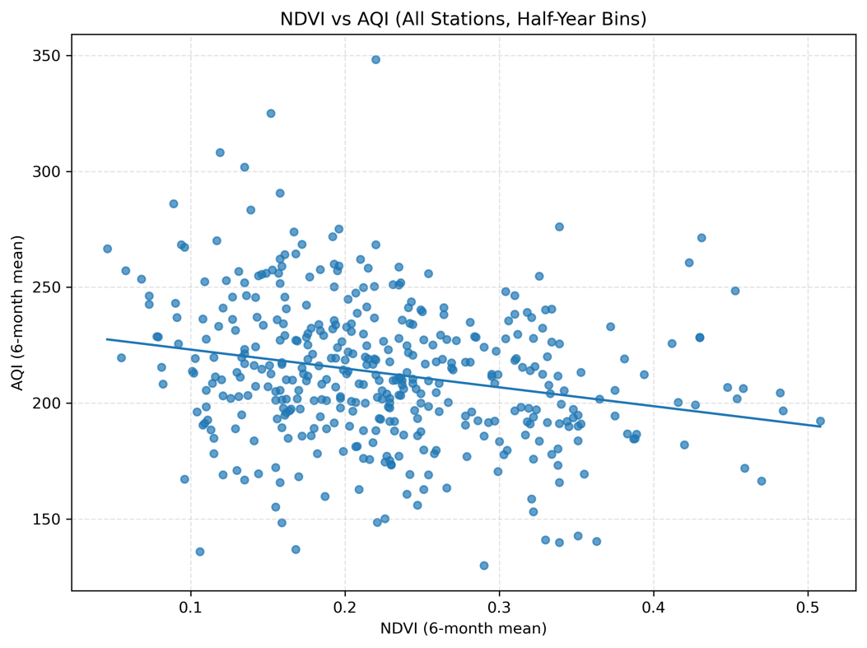
Figure 7: Scatter of NDVI vs AQI
NDVI vs particulates. NDVI is modestly inverse to PM₂.₅ (overall ρ ≈ −0.17 to −0.19) and PM₁₀ (overall ρ ≈ −0.30), with heterogeneity across stations (e.g., strongly negative at Anand_Vihar, Patparganj, Pusa).
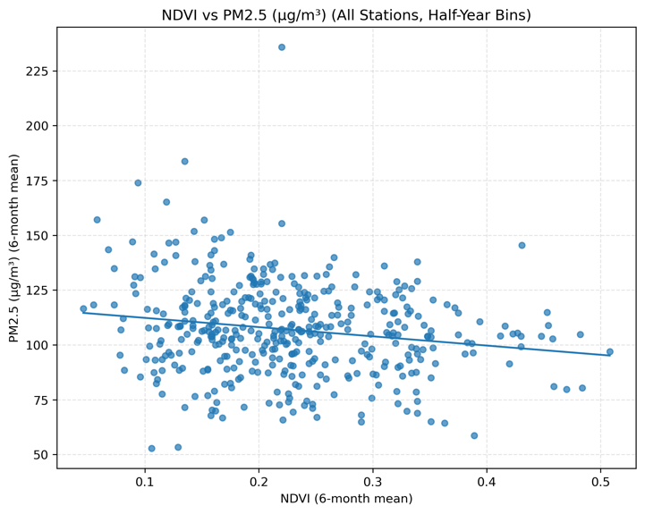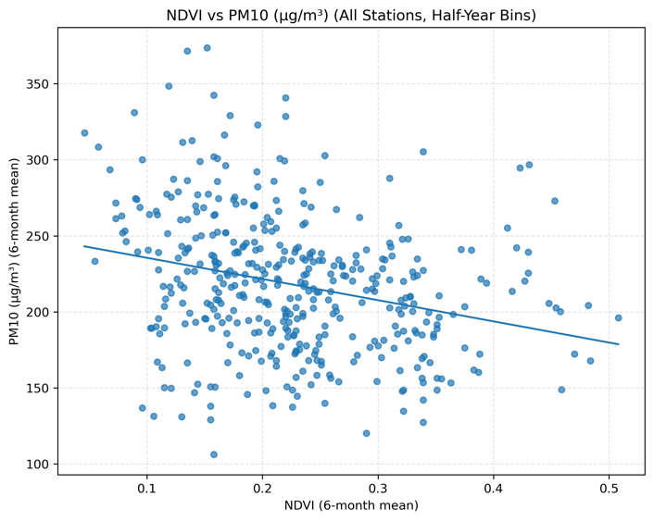
Figure 8(a): Scatter of NDVI vs PM2.5 Figure 8(b): Scatter of NDVI vs PM10
  - Regression: cross-validated performance and 2024 generalisation
We evaluated six regressors using forward-chaining CV (train ≤ year – 1 → validate on year) over 2019–2023, then trained on 2017–2023 and tested on 2024. Metrics are R², RMSE, MAE, MSE in AQI units.
Table 4: Regression metrics for training set (2019-2023)
Model | Train R² (mean) | Train RMSE (mean) | Train MAE (mean) | Train MSE (mean)
Random Forest | 0.934885 | 28.531612 | 20.166587 | 820.453086
LightGBM | 0.931000 | 29.826000 | 20.881000 | 892.698000
XGBoost | 0.933000 | 29.450000 | 20.563000 | 870.017000
Decision Tree + GWO | 0.922000 | 31.847000 | 21.728000 | 1020.105000
SVR | 0.895000 | 36.723000 | 24.147000 | 1359.911000
Ridge Regression | 0.864939 | 41.150255 | 32.295085 | 1701.812511

Table 5: Regression metrics for training set (2024)
Model | Test R² (2024) | Test RMSE (2024) | Test MAE (2024) | Test MSE (2024)
Random Forest | 0.948702 | 25.329957 | 18.307015 | 641.606739
LightGBM | 0.950000 | 25.510000 | 18.460000 | 650.840000
XGBoost | 0.950000 | 25.600000 | 18.520000 | 655.190000
Decision Tree + GWO | 0.942000 | 27.007000 | 19.115000 | 729.404000
SVR | 0.930000 | 28.760000 | 20.040000 | 827.350000
Ridge Regression | 0.871050 | 40.159876 | 29.909901 | 1612.815669

Interpretation: The tree-ensemble family generalises best, with Random Forest narrowly winning on RMSE/MAE while LightGBM/XGBoost edge it on R² at the third decimal. The margin between the three is small (≈ 0.3 RMSE), indicating a stable performance plateau once non-linear interactions are captured.
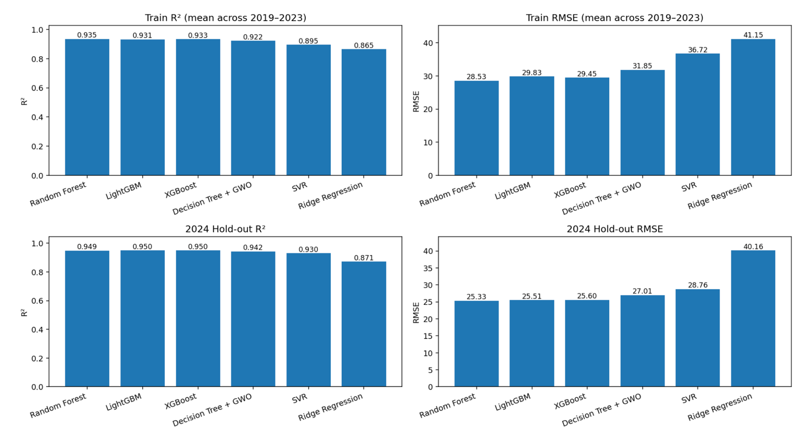
Figure 9: Regression metric R2 and RMSE comparison for training and validation set
6.2.1 Feature importance
Feature importances agree on ranking: PM₂.₅ ≈ 0.50, PM₁₀ ≈ 0.35, CO ≈ 0.08, NO₂ ≈ 0.04, O₃ ≈ 0.02, SO₂ ≈ 0.01. This mirrors the correlation structure and CPCB weighting (PM drives AQI most strongly, gas pollutants add situational signal).
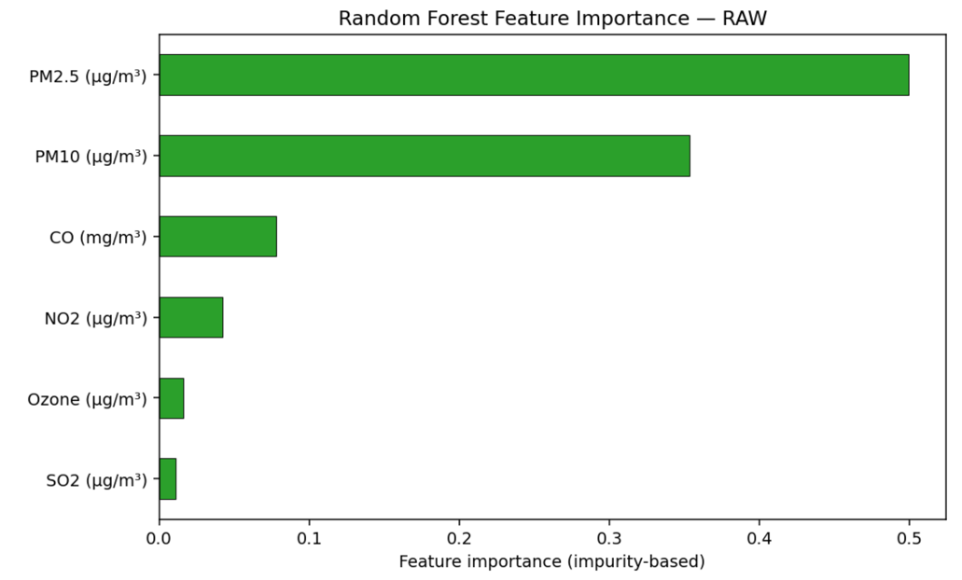
Figure 10: Random Forest Feature Importance
  - Classification: AQI class prediction (CPCB scale)
We mapped daily AQI to CPCB classes (Good, Satisfactory, Moderately Polluted, Poor, Very Poor, Severe) and evaluated Accuracy, Macro-F1, Balanced Accuracy using the same forward-chaining splits.
Table 6: Classification Models – Mean Training Performance (2019–2023)
Model | Train ACC (mean) | Train Macro-F1 (mean) | Train Balanced ACC (mean)
Logistic Regression | 0.743000 | 0.725000 | 0.778000
Random Forest | 0.862614 | 0.861957 | 0.883734
XGBoost | 0.848064 | 0.841980 | 0.832056
Table 7: Classification Models – Test Performance (2024)
Model | Test ACC (2024) | Test Macro-F1 (2024) | Test Balanced ACC (2024)
Logistic Regression | 0.771000 | 0.743000 | 0.793000
Random Forest | 0.816681 | 0.796752 | 0.819445
XGBoost | 0.823067 | 0.797014 | 0.782916

Interpretation: RF and XGB are best overall. XGB gives the highest accuracy (0.823) but slightly lower balanced accuracy than RF, suggesting RF maintains more even per-class recall—useful when Very Poor and Severe are minority classes.
    - Confusion matrix
The matrix shows typical adjacent-class confusion (e.g., Poor vs Very Poor), while extremes are largely preserved:
- Severe: strong precision/recall (517 true Severe vs 134 predicted Very Poor).
- Good/Satisfactory: modest confusion but low absolute counts; little mislabelling into heavy pollution classes.
- Moderately Polluted/Poor: the largest classes; most errors are one-step off.
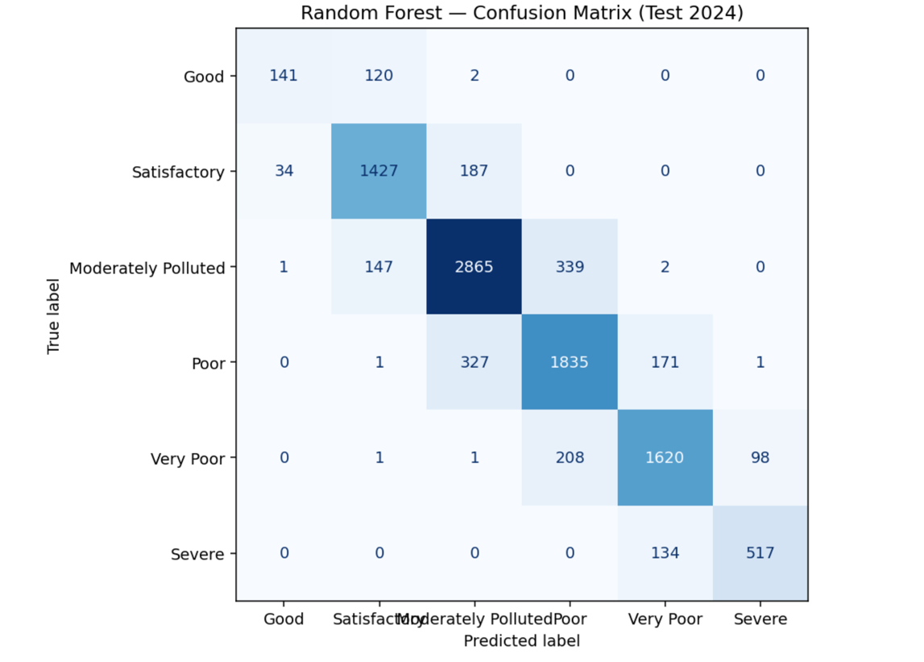
Figure 11: Confusion matrix for Random Forest Classifier on 2024 Validation set
  - Raw vs log-transformed features
We conducted a comparison of Ridge and Random Forest utilising both raw and log1p-transformed features. The Ridge model exhibited a marginal enhancement in CV R² with the application of logarithmic features in certain folds; nevertheless, the RMSE disparities for 2024 were minimal when non-linear models were employed. For RF, the cross-validation and test metrics were statistically indistinguishable (e.g., test RMSE 25.33 for raw versus 25.33 for log). Due to the increased complexity and equivalent downstream performance, we opted for raw features for all non-linear models.
  - Practical Significance
An RMSE of approximately 25 AQI and a R² of about 0.95 facilitate operational alerts at GRAP decision thresholds (e.g., transitions between Moderately Polluted, Poor, and Very Poor), particularly when combined with conservative buffers.
Feature relevance indicates that PM₂.₅ and PM₁₀ primarily influence AQI fluctuation; NO₂ and CO contribute actionable signals associated with traffic and combustion, whilst O₃ serves as a seasonal counter-indicator, peaking in summer.
The negative correlation between NDVI and AQI reinforces the co-benefits of green infrastructure, while urban morphology may reverse local relationships, particularly in densely constructed areas.
6.6 Summary of best models
- Regression: Random Forest chosen on 2024 RMSE (25.33) with tight parity to LightGBM/XGBoost and highest feature interpretability (global + local).
- Classification: Random Forest (balanced accuracy 0.819) or XGBoost (highest accuracy 0.823). For policy-relevant class recall, RF is preferable; for headline accuracy, XGB is marginally higher.

- Discussion and Critical Reflection
  - Feature Importance and Policy Linkages
The feature importance analysis of the Random Forest regressor revealed that PM₂.₅ and PM₁₀ were the primary predictors of AQI at all six industrial monitoring stations in Delhi, accounting for approximately 85% of the model's explanatory power. This corresponds with findings from other research indicating that particulate matter, particularly PM₂.₅, is the principal factor contributing to the decline of AQI in Indian megacities (Guttikunda & Gurjar, 2012; Gupta et al., 2023). The significant prominence of particulate matter aligns with Delhi's emissions inventory, wherein road dust, automotive exhaust, biomass combustion, and industrial operations are primary sources (Bisht et al., 2024).
Secondary pollutants like NO₂ were of moderate significance, as anticipated due to its classification as a criteria pollutant in the Central Pollution Control Board’s (CPCB) AQI framework and its involvement in atmospheric chemistry that contributes to ozone and nitrate aerosol formation (CPCB, 2022; Jain et al., 2024). In contrast, O₃ and SO₂ had a little impact on AQI prediction, aligning with seasonal observations—ground-level ozone in Delhi reaches its zenith during summer photochemical activity, whereas SO₂ emissions are geographically concentrated near industrial point sources (Goyal et al., 2021).
The inverse association between NDVI and AQI (Pearson r = –0.233) highlights the possible influence of plant cover in reducing air pollution exposure. Vegetated regions serve as buffers by capturing particulate matter and facilitating pollution accumulation on leaf surfaces (Nowak et al., 2014). This indicates that afforestation and urban greening initiatives, already incorporated into Delhi's climate and environmental strategies, could produce quantifiable improvements in air quality, especially on industrial outskirts where green buffers are viable.
  - Data and Methodological Limitations
Significant missing data for certain pollutants necessitated imputation, and data from industrial stations may not accurately reflect wider urban trends. NDVI was derived at a semiannual level, constraining its sensitivity to ephemeral vegetation alterations. The AQI classification was based on daily averages, possibly neglecting transient pollution surges that affect GRAP measures (CAQM, 2023).
Forward-chaining cross-validation maintained temporal order but presumed consistent pollutant–AQI connections, which may fluctuate due to policy changes or meteorological factors (Chakraborty et al., 2022). Excluding only NO₂ diminished multicollinearity but disregarded NO–O₃ titration effects. Winsorisation maintained the continuity of time-series data while limiting major pollution incidents, thereby modestly mitigating their impact.
  - Reflection and Future Directions
The dual regression-classification methodology facilitated both continuous forecasting and the prediction of GRAP-relevant categories. Ensemble models efficiently incorporated non-linearities, whereas NDVI introduced an environmental aspect to the modelling process. Future research should integrate high-frequency meteorological data, higher-resolution vegetation indices, spatially diversified monitoring locations, and hybrid deep learning-ensemble frameworks to improve predictive accuracy and policy applicability.
- Conclusion
This research combined terrestrial pollutant measurements with satellite-derived vegetation indices (NDVI) to estimate and forecast air quality in Delhi's industrial areas from 2017 to 2024. Employing a comprehensive forward-chaining cross-validation framework, six regression and three classification models were assessed, with Random Forest identified as the most proficient predictor for both continuous AQI values and CPCB-defined AQI categories.
The results confirmed that PM₂.₅ and PM₁₀ are the principal contributors to the AQI in Delhi, succeeded by NO₂, but NDVI exhibited a mild inverse connection with pollution levels. The methodological selection of winsorisation maintained temporal continuity while reducing the impact of severe outliers, hence enhancing the stability of time-series models.
In addition to predictive performance, the findings hold significant policy implications: precise AQI forecasting can enhance the implementation of Delhi’s GRAP framework, facilitating the prompt initiation of mitigation strategies. The research emphasises the potential of integrating remote sensing with in-situ monitoring to enhance urban environmental management.
Subsequent investigations ought to examine spatio-temporal deep learning frameworks, integrate meteorological and emissions data, and broaden the geographical parameters to encompass varied land-use scenarios. These enhancements would improve forecast accuracy, interpretability, and scalability, so facilitating evidence-based air quality governance in increasingly urbanising areas.

References
Ameer, Saba & Shah, Munam & Khan, Abid & Song, Houbing & Maple, Carsten & Islam, Saif & Asghar, Muhammad. (2019). Comparative Analysis of Machine Learning Techniques for Predicting Air Quality in Smart Cities. IEEE Access. PP. 1-1. 10.1109/ACCESS.2019.2925082. Breiman, L. (2001). Random forests. Machine Learning, 45(1), 5–32. https://doi.org/10.1023/A:1010933404324
Central Pollution Control Board. (2022). Government of India. Retrieved from https://cpcb.nic.in
Central Pollution Control Board. (2023). Graded Response Action Plan (GRAP) for Delhi-NCR. Government of India. https://caqm.nic.in/WriteReadData/LINKS/f3184d4a-2d7d-4b4c-b03c-77f630cb3554.pdf
Chen, T., & Guestrin, C. (2016). XGBoost: A scalable tree boosting system. In Proceedings of the 22nd ACM SIGKDD International Conference on Knowledge Discovery and Data Mining (pp. 785–794). ACM. https://doi.org/10.1145/2939672.2939785
Copernicus Sentinel-2. (2023). Sentinel-2 User Handbook. European Space Agency. https://sentinels.copernicus.eu/documents/247904/685211/Sentinel-2_User_Handbook
Friedman, J. H. (2001). Greedy function approximation: A gradient boosting machine. Annals of Statistics, 29(5), 1189–1232. https://doi.org/10.1214/aos/1013203451
Guo, Y., Wang, M., Li, X., Zhang, J., & Zhang, Y. (2025). Air quality forecasting using hybrid spatio-temporal deep learning frameworks. Machine Learning: Science and Technology, 6(1), 015057. https://doi.org/10.1088/2632-2153/ad3f87
Ke, G., Meng, Q., Finley, T., Wang, T., Chen, W., Ma, W., ... & Liu, T.-Y. (2017). LightGBM: A highly efficient gradient boosting decision tree. In Advances in Neural Information Processing Systems (Vol. 30). Curran Associates, Inc. https://papers.nips.cc/paper/2017/hash/6449f44a102fde848669bdd9eb6b76fa-Abstract.html
Mirjalili, S., Mirjalili, S. M., & Lewis, A. (2014). Grey Wolf Optimizer. Advances in Engineering Software, 69, 46–61. https://doi.org/10.1016/j.advengsoft.2013.12.007
NASA LP DAAC. (2023). MODIS vegetation indices (NDVI). NASA EOSDIS Land Processes Distributed Active Archive Center. Retrieved from https://lpdaac.usgs.gov
Pal, S., De, D., & Mukherjee, A. (2024). Machine learning-based classification of Indian cities using Google Earth Engine. Environmental Monitoring and Assessment, 196(7), 564. https://doi.org/10.1007/s10661-024-13351-1
Sharma, M., Kumar, P., & Gulia, S. (2023). Air pollution exposure assessment and source apportionment in India. Science of the Total Environment, 877, 162786. https://doi.org/10.1016/j.scitotenv.2023.162786
Singh, A., Kedia, S., & Gautam, R. (2023). Spatio-temporal analysis of PM₂.₅ over Delhi using satellite data and ground observations. Scientific Reports, 13, 5674. https://doi.org/10.1038/s41598-023-34774-9
Sinha, S., & Mathur, R. (2024). Spatial variations of land surface temperature and NDVI in Mumbai Metropolitan Region. Spatial Information Research, 32(1), 17–30. https://doi.org/10.1007/s41324-023-00536-0
Tibshirani, R. (1996). Regression shrinkage and selection via the Lasso. Journal of the Royal Statistical Society: Series B (Methodological), 58(1), 267–288. https://doi.org/10.1111/j.2517-6161.1996.tb02080.x
U.S. Environmental Protection Agency. (2022). Technical assistance document for the reporting of daily air quality – the Air Quality Index (AQI).
Van Rossum, G., & Drake, F. L. (2009). Python 3 Reference Manual. CreateSpace.
Vapnik, V. (1995). The nature of statistical learning theory. Springer. https://doi.org/10.1007/978-1-4757-2440-0
Zhang, Y., & Xu, W. (2022). Forecasting urban air quality using hybrid machine learning approaches. Applied Intelligence, 52(8), 8976–8990. https://doi.org/10.1007/s10489-021-02772-3

Data sources:
https://airquality.cpcb.gov.in/ccr/#/caaqm-dashboard-all/caaqm-landing/caaqm-data-repository
https://airquality.cpcb.gov.in/ccr/#/caaqm-dashboard-all/caaqm-landing/aqi-repository
https://explore.openaq.org/#1.2/20/40
Figure 1: Saha, Upal & Prasad, V.s & Rani, Indira & George, John. (2024). Rare winter‐thunderstorms with hail overnight 12/13 December 2019 over Delhi and its vicinity: an observational study. Weather. 80. 234-243. 10.1002/wea.7653. https://www.researchgate.net/figure/a-Map-of-India-highlighting-Delhi-yellow-box-and-neighbouring-states-b-Zoom-into_fig1_386871721

Appendix

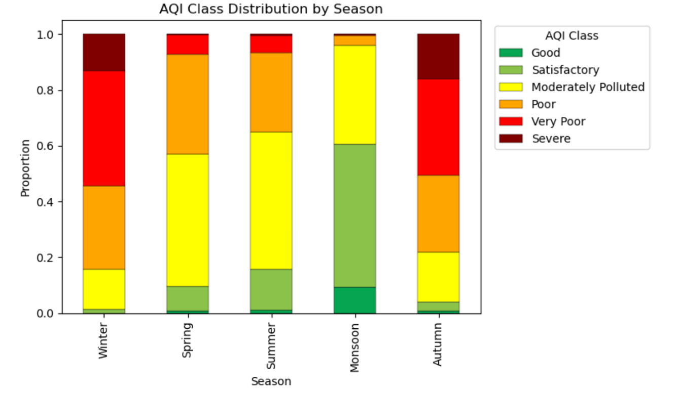
Figure 12: AQI Class distribution by season

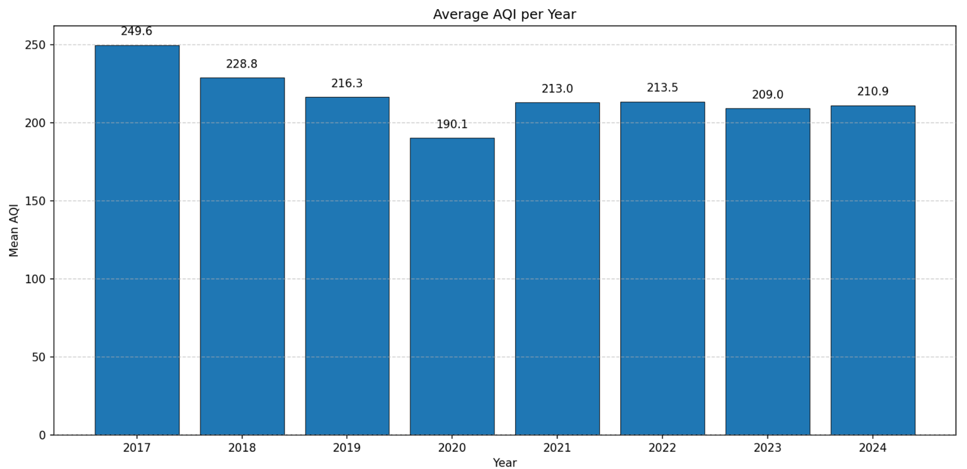
Figure 13: Average AQI per year

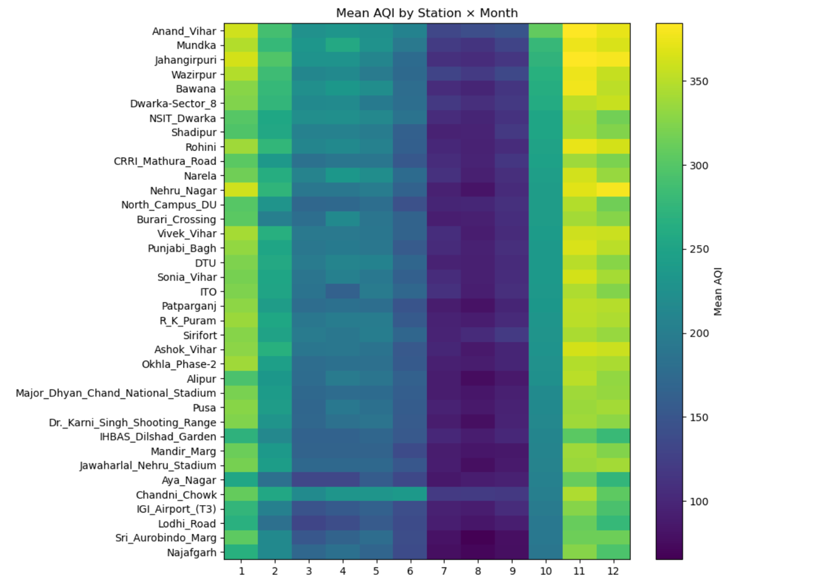
Figure 14: Mean AQI by station x month

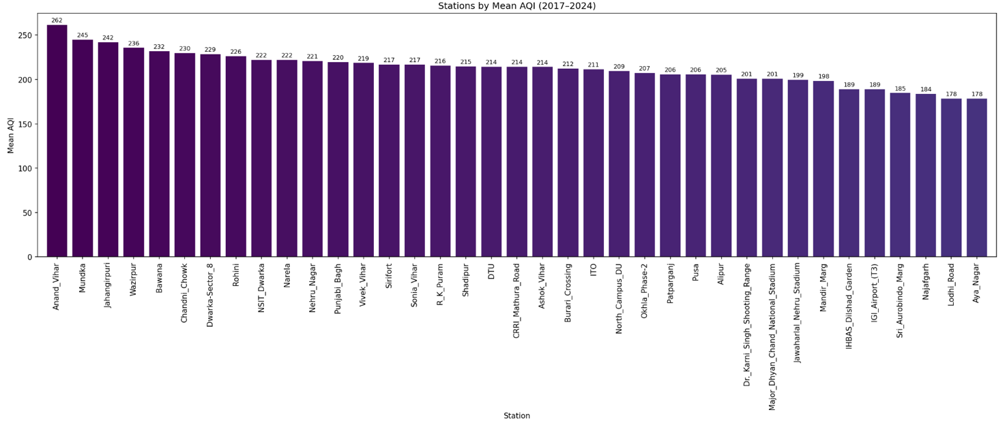
Figure 15: Mean AQI per station over the years (decreasing order)

