Data Analyst Nanodegree Program
Project 1: Explore Weather Trends

- Preparation:
- Data Gathering: The following SQL scripts are used to gather the weather data from SQL workspace for this project.
  - SELECT * FROM city_data WHERE city = 'Tokyo'; (city: Tokyo)
  - SELECT * FROM global_data; (global)
- Analysis: The weather data are imported to Microsoft Excel. Moving averages are calculated based on the data of the past 5 years. The value ($avg$) for a specific year ($y$) will be: $avg=\frac{\sum_{y-4}^{y}{temp(y)}}{5}$
- Plotting: The moving averages of local and global temperature are plotted in the same chart for ease of comparison, and two y-axes are used(left for “Tokyo”, right for “Global”).
- Line Chart:
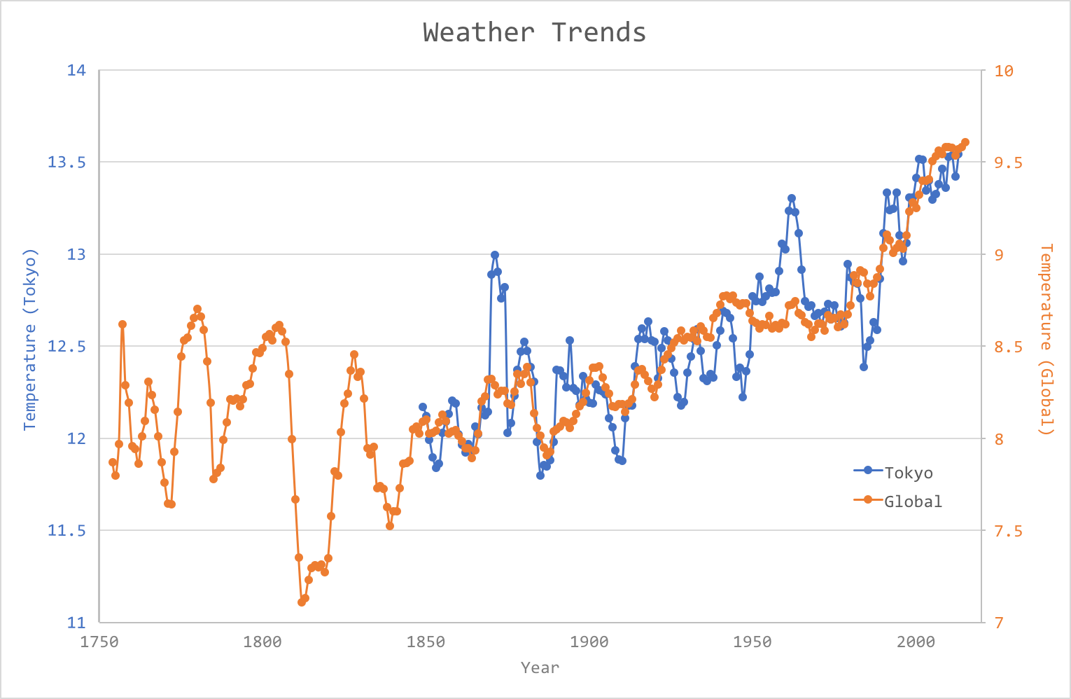

- Observations:
  - On average, the local temperature (Tokyo) is about 4℃ higher than global temperature.
  - The local temperature trends align with global trends. Temperature continues to rise between 1845 and 2013.
  - Local temperature has larger variation than global temperature.
  - The rising trend is only observed and apparent in the past hundred years.

