Claude Local Bridge Playground
Project Summary
Date: 2026-08-05 | Version: 1.0
Audience: Engineering Team, Architects, Stakeholders

Table of Contents
1. Executive Summary
2. Architecture Overview
2.1 Transport flow
2.2 Credential discovery (OAuth-only priority order)
2.3 Bridge endpoints
3. Processing Pipeline
4. Core Components
4.1 Agent loop
4.2 Tools, permissions, safety
4.3 Tool catalog (20 tools, 8 capability groups)
4.4 Durability quartet
4.5 Budget broker and child leasing
4.6 Orchestration stack
5. API Contracts / Message Schemas
5.1 Bridge request (Anthropic native Messages shape)
5.2 Runner stop-reason taxonomy (`kernel/contract.js`, 25 reasons)
5.3 Tool-result contract
5.4 Bridge auth
6. Infrastructure & Deployment
6.1 VS Code extension (the bridge)
6.2 Docker
6.3 CI/CD
6.4 Local checks
7. Extension Patterns
7.1 Add a new tool
7.2 Customize the prompt
7.3 Hooks, memory, skills
7.4 Orchestrate multiple workers
7.5 Presets and UX
8. Rules & Anti-Patterns
8.1 Do
8.2 Don't
9. Dependencies
10. Code Structure
11. Where the Experiment Record Lives

1. Executive Summary
Claude Local Bridge Playground is a two-layer personal research project: a VS Code extension ("Claude Local
Bridge") that exposes Claude Code OAuth credentials as a local Anthropic Messages API on http://localhost:11437,
and an experimental local coding-agent runner ("cc bridge runner") that uses that bridge as its model transport.
The runner implements a complete agent loop — prompt → model → tool_use → permission gate → local tool execution
→ tool_result → repeat — with conservative safety defaults, durable session artifacts, and a command-line UX. The
project ships with zero runtime dependencies (~24,500 lines of JavaScript across src/ and bin/), 117 test
files (~480 tests), a multi-stage Dockerfile, and a self-hosted GitHub Actions proof-of-concept workflow. It is
active at alankatanoisi/claude-local-bridge-playground on branch main; the canonical
claude-local-bridge repo is archived and reference-only.

2. Architecture Overview
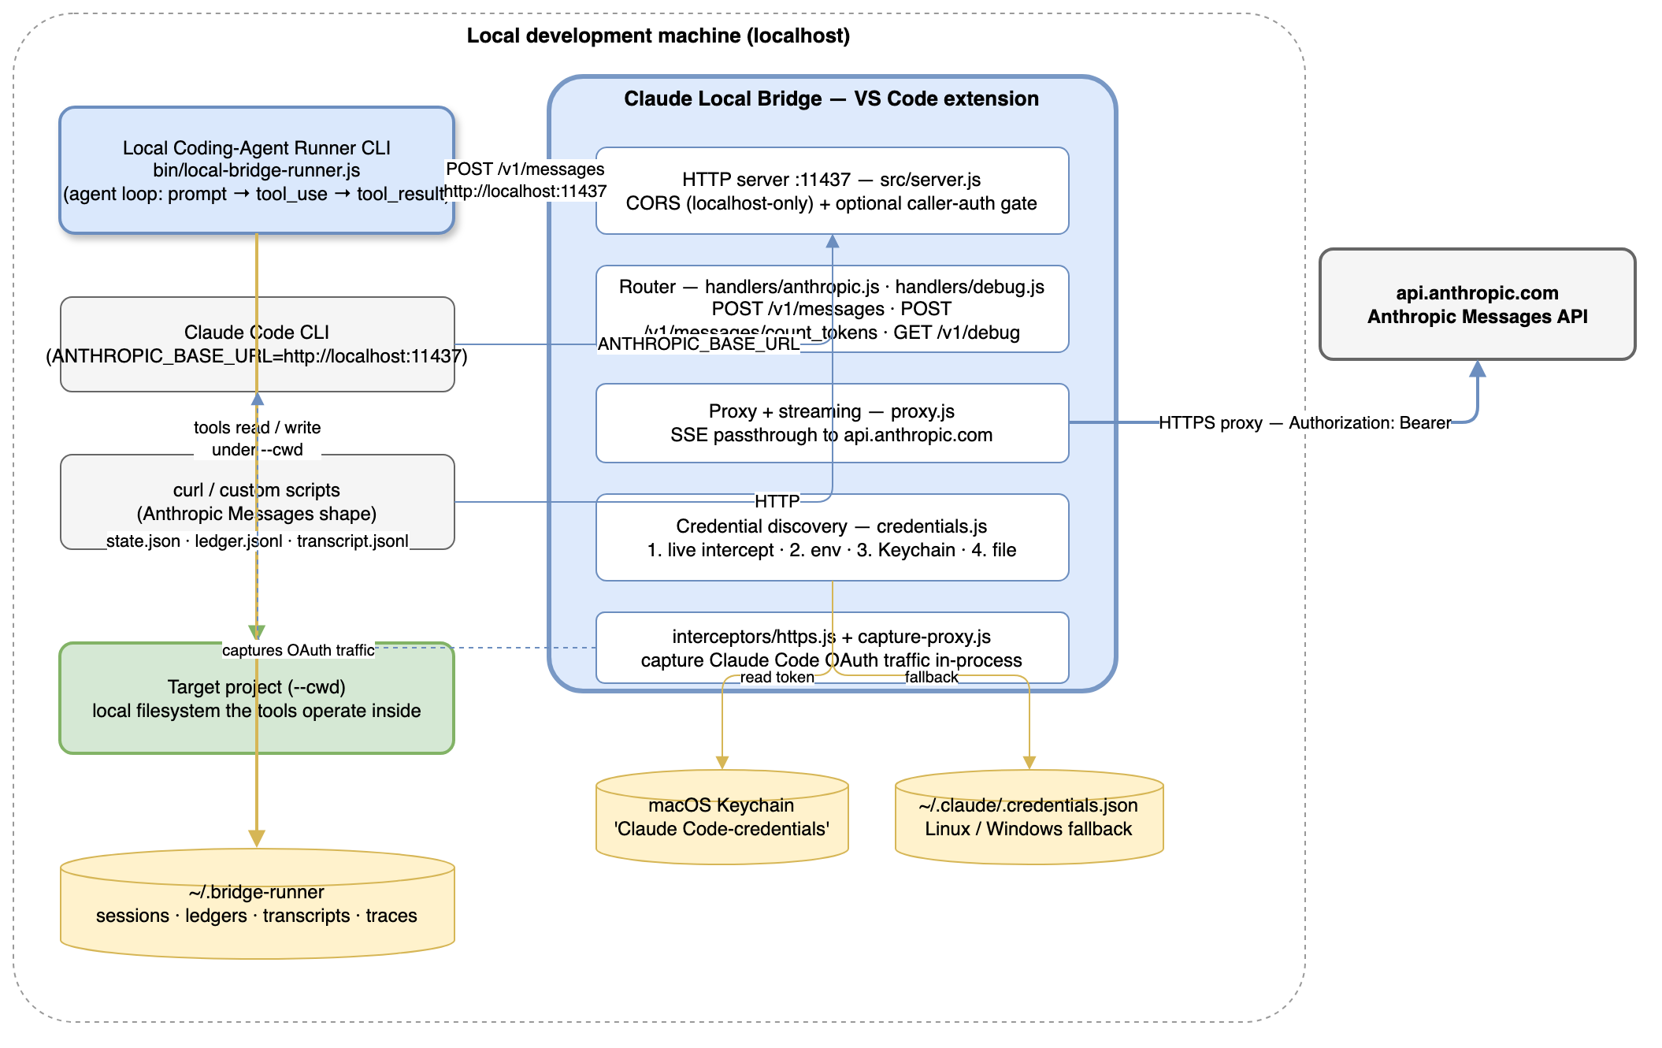
High-Level Architecture
The repository contains two products that must not be confused:
Layer | What it is | Where it lives
Bridge | VS Code extension exposing Claude Code OAuth credentials as a local Anthropic Messages endpoint | src/server.js, src/proxy.js, src/credentials.js, src/interceptors/**, src/handlers/**
Runner | Experimental local coding-agent loop on top of that endpoint (the active product surface) | src/runner/**, bin/local-bridge-runner.js

2.1 Transport flow
local runner / Claude CLI
└──> Claude Local Bridge (http://localhost:11437)
↓ credential discovery (OAuth only)
↓ Anthropic Messages request passthrough
└──> api.anthropic.com

Transport policy guardrails (invariants, not suggestions):
• Keep /v1/messages as the native Anthropic Messages surface. No OpenAI-compatible endpoints
(/v1/chat/completions, /v1/models) exist or may be added.
• Upstream auth is only Authorization: Bearer <Claude Code OAuth token>.
• The bridge ignores ANTHROPIC_API_KEY, the old claudeLocalBridge.apiKey setting, and intercepted
x-api-key credentials. A local placeholder like ANTHROPIC_API_KEY=local is for client-side env checks only
and is never forwarded upstream.
• Debug, trace, transcript, and log surfaces are redacted: OAuth tokens and fingerprints are sensitive local
account state.

2.2 Credential discovery (OAuth-only priority order)
# | Source | Notes
1 | Live intercepted Claude Code Bearer token | Captured from Claude Code traffic inside the VS Code process or the capture proxy
2 | CLAUDE_CODE_OAUTH_TOKEN env var | Long-lived OAuth token from claude setup-token
3 | macOS Keychain Claude Code-credentials | Automatically set by claude /login; used automatically on macOS
4 | ~/.claude/.credentials.json | Linux / Windows fallback; also macOS if the keychain is locked

2.3 Bridge endpoints
Endpoint | Format | Notes
POST /v1/messages | Anthropic native | Proxied verbatim to api.anthropic.com, SSE streamed back
POST /v1/messages/count_tokens | Anthropic | Mock response (returns 0) for Claude CLI preflight
GET /v1/debug | JSON | Locked diagnostic endpoint; requires the local debug token printed in the bridge Output log

3. Processing Pipeline
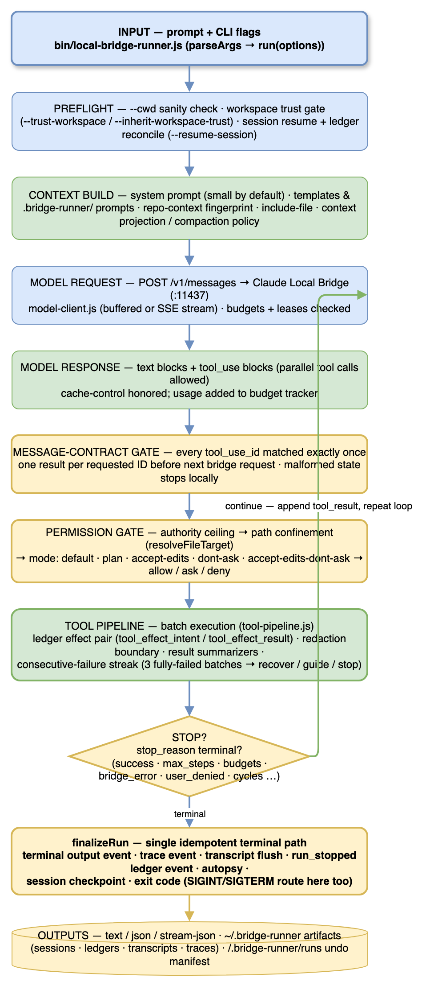
Processing Pipeline
The runner loop, end to end:
1. Input — bin/local-bridge-runner.js parses flags and calls run(options) in src/runner/run.js.
Retired --agent / --profile / --list-agents / --list-profiles options are rejected loudly.
2. Preflight — --cwd sanity check, workspace-trust gate (--trust-workspace / --inherit-workspace-trust),
and — for --resume-session — checkpoint loading plus ledger reconciliation (the checkpoint is reconciled
against the ledger before the run continues, closing the stale-checkpoint double-execution gap).
3. Context build — a small default system prompt, optionally extended by .bridge-runner/ prompts, prompt
templates (--prompt-template review|cleanup|explore|…), repo-context fingerprint, --include-file, and
context projection/compaction policy.
4. Model request — model-client.js POSTs to the bridge (buffered or SSE streaming), honoring cache-control
budgeting and token budgets/leases.
5. Model response — text blocks plus tool_use blocks. Parallel tool calls are allowed.
6. Message-contract gate — every tool_use_id must be matched by exactly one tool_result before the next
bridge request. Malformed state stops locally.
7. Permission gate — authority ceiling → path confinement (resolveFileTarget) → mode decision
(default · plan · accept-edits · dont-ask · accept-edits-dont-ask) → allow / ask / deny.
8. Tool pipeline — batch execution with a ledger effect pair (tool_effect_intent before,
tool_effect_result after, same effectId, even on throw/deny), redaction boundary, result summarizers, and a
consecutive-failure streak (3 fully failed batches → ask to recover/guide/stop; non-interactive runs stop safely).
9. Stop decision — 25 machine-readable stop reasons (see §5.2). If not terminal, append tool_result and
repeat from step 4.
10. finalizeRun — a single idempotent terminal path all exits funnel through: terminal output event, trace
event, transcript flush, run_stopped ledger event, autopsy, session persistence, exit code. SIGINT and
SIGTERM route through the same finalizer.
11. Outputs — text / JSON / stream-json on stdout; ~/.bridge-runner artifacts (sessions, ledgers,
transcripts, traces); <cwd>/.bridge-runner/runs/ recovery manifests for undo last-run.

4. Core Components
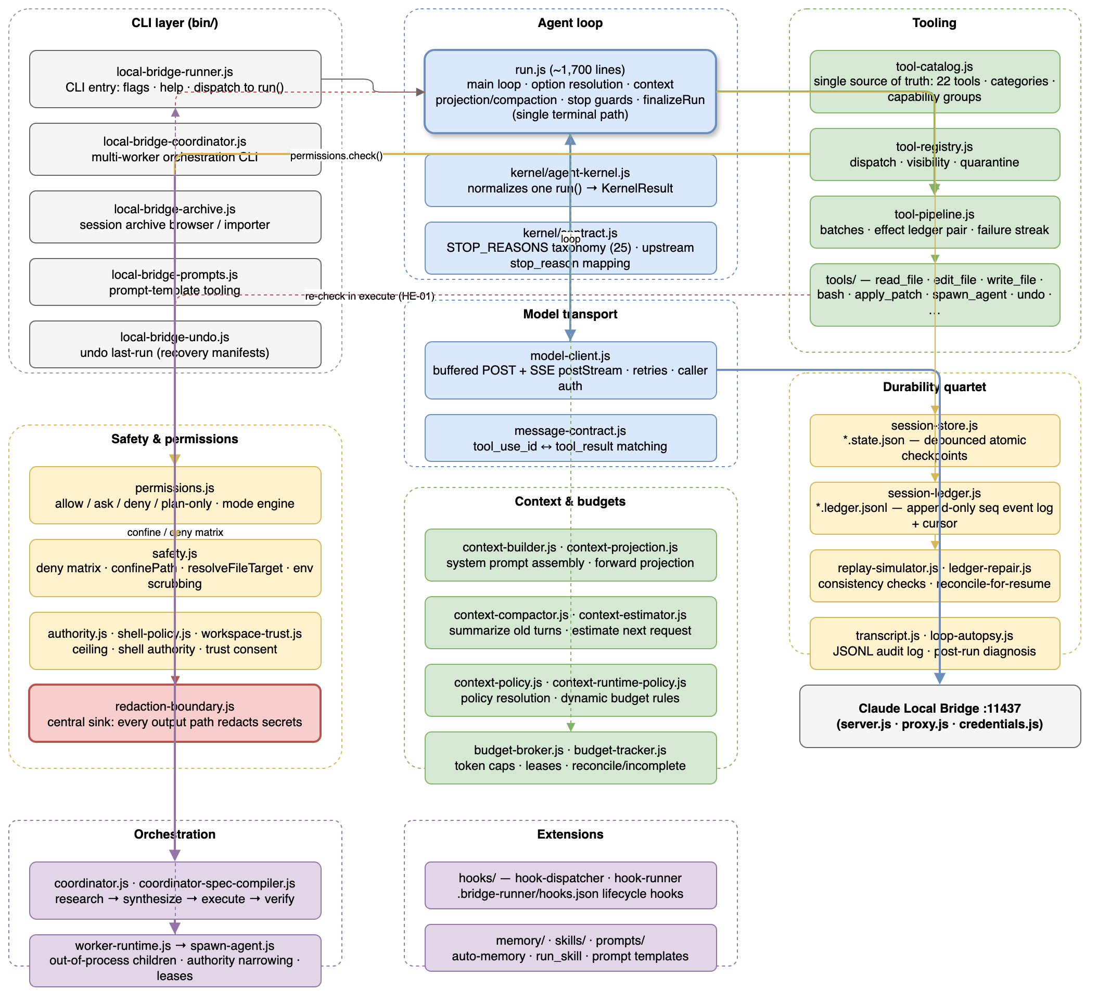
Component Relationships

4.1 Agent loop
Component | File | Responsibility
Run loop | src/runner/run.js (~1,700 lines) | Option resolution, context projection/compaction, tool pipeline, every stop reason, single finalizeRun terminal path
Kernel | src/runner/kernel/agent-kernel.js | Thin wrapper normalizing one run() invocation into a stable KernelResult contract; no orchestration logic
Contract | src/runner/kernel/contract.js | STOP_REASONS taxonomy + upstream stop_reason mapping
Model client | src/runner/model-client.js | Buffered post + SSE postStream clients, retries with Retry-After, caller-auth header injection
Message contract | src/runner/message-contract.js | tool_use_id ↔ tool_result matching validation

4.2 Tools, permissions, safety
The default surface is core read/session tools only. Write tools arrive via --capabilities edits, shell only
via --allow-shell, advanced patch mode stays hidden unless an exact --tools apply_patch allowlist exposes it.
Component | File | Responsibility
Tool catalog | src/runner/tool-catalog.js | Single source of truth: 20 tools, categories, capability groups; fails loudly on misregistration
Tool registry | src/runner/tool-registry.js | Dispatch, visibility, quarantine
Tool pipeline | src/runner/tool-pipeline.js | Batch execution, effect ledger pair, consecutive-failure streak
Permissions | src/runner/permissions.js | Allow/ask/deny/plan-only engine; authority ceiling + path checks + per-tool policy
Safety | src/runner/safety.js | The chokepoint: confinePath, two-tier deny matrix (directory segments like .ssh/.aws/.claude; sensitive basenames like .env, keys, tokens), resolveFileTarget (lexical + realpath + containment, so an innocently-named symlink to a denied target is caught), env scrubbing, secret redaction. File tools re-check in execute (HE-01 defense-in-depth)
Redaction boundary | src/runner/redaction-boundary.js | Every sink (tool results, transcripts, stream/JSON output, human logs, ledger payloads, session checkpoints) passes through one central redaction boundary

4.3 Tool catalog (20 tools, 8 capability groups)
Capability group | Tools | How to enable
core (always on) | list_files, read_file, search_text, glob, git_status, manage_tasks, ask_user_question | Default
edits | edit_file, write_file, apply_patch (hidden by default) | --capabilities edits
recovery | undo, undo_edit | --capabilities recovery
agents | spawn_agent (in-run read-only child delegation) | --capabilities agents
worktrees | enter_worktree, exit_worktree, list_worktrees | --capabilities worktrees
skills | run_skill | --capabilities skills
lsp | lsp_query | --capabilities lsp (or --enable-lsp)
shell | bash, manage_shell_jobs | --allow-shell only (never via --capabilities)

4.4 Durability quartet
Measured end-to-end by the A1 crash bake-off (docs/durability-crash-bakeoff-2026-07-31.md): all 74 kill trials
showed byte-perfect ledger survival and zero corrupt tails across the 141-ledger C3 corpus.
Piece | File pattern | Role | Crash behaviour (measured)
Session store | *.state.json | Debounced (75 ms) atomic-write checkpoint; what --resume-session loads | Whatever entered the debounce window before signal death is lost; flushed synchronously on process.exit and via the finalizer on SIGINT/SIGTERM
Session ledger | *.ledger.jsonl | Append-only, sequence-numbered event log written synchronously; cursor sidecar (*.cursor.json) for fast resume | Survived byte-perfect in all 74 A1 kill trials; zero corrupt tails across 141 ledgers
Replay simulator | read-only | Consistency check: sequence gaps, pending effect intents, orphaned tool uses | Correctly classified every induced crash
Ledger repair | planRepair / applyRepair | Proposes/mutates repairs; reconcileForResume auto-applies the safe subset on resume | Closes stale-checkpoint double-execution and dangling tool_use strands; report_gap stays manual-only

4.5 Budget broker and child leasing
• src/runner/budget-broker.js holds per-run input/output token caps and issues leases. Invariant (field-verified
2026-07-31): on every capped dimension, sum(active leases) + totalUsage ≤ cap; every child's usage is either
reconciled into totalUsage or recorded as incomplete[] — never silently lost or double-counted. Null caps make
leasing a no-op.
• src/runner/tools/spawn-agent.js delegates to one read-only child using the acquire → spawn → release/reconcile
pattern. The coordinator splits the unleased remainder across each concurrent batch so fan-out siblings cannot each
claim the whole ceiling.

4.6 Orchestration stack
bin/local-bridge-coordinator.js (CLI: objective, phases, ceilings, --research-plan)
└─ src/runner/coordinator.js research → synthesize → execute → verify
├─ research/verify: WorkerRuntime.spawnWorker — out-of-process child runners,
│ read-only tool set, leased budgets, results parsed from stdout JSON
├─ synthesize: coordinator-spec-compiler.compileSpec — local, no tokens
└─ execute: runKernel — in-process, full loop, edits allowed

• --research-plan takes a JSON array of { id, deps[], prompt, allowedTools?, maxSteps? } nodes; dependency-free
nodes run concurrently. Field-measured: 4-way fan-out gave a 4.13× wall-clock speedup at identical token cost
versus the dep-chained sequential baseline.
• src/runner/worker-runtime.js spawns each worker as a separate local-bridge-runner.js process, narrowing
authority against the parent ceiling (children may only narrow: flags AND-ed, tools intersected), passing lease +
inherit values via argv/env, and never passing --trust-workspace (only --inherit-workspace-trust).

5. API Contracts / Message Schemas

5.1 Bridge request (Anthropic native Messages shape)
The runner sends the native Anthropic Messages request body; the bridge proxies it verbatim:
Property | Type | Notes
model | string | Default claude-sonnet-5 (shared via the versioned model catalog, src/runner/model-catalog.js)
max_tokens | number | Runner default 2,000 output tokens per request
system | string | Small default system prompt, optionally extended
messages | array | user / assistant turns; assistant turns contain tool_use content blocks
tools | array | JSON-schema tool definitions from tool-catalog.js
stream | boolean | Runner may buffer full JSON or consume SSE
cache_control | object | Runner marks stable prefix with { type: 'ephemeral', ttl: '1h' } with a 1-breakpoint OAuth cache reserve

Response: content blocks (text | tool_use), stop_reason, usage. Upstream max_tokens and refusal
reasons are mapped to terminal taxonomy and never masquerade as success.

5.2 Runner stop-reason taxonomy (`kernel/contract.js`, 25 reasons)
Category | Reasons
Normal | success, max_steps, max_tool_calls_per_turn, model_max_tokens, model_refusal
Context/budget | context_budget_exceeded, initial_prompt_too_large, context_ceiling_unrecoverable, predictive_context_budget_exceeded, predictive_input_token_budget_exceeded, predictive_output_token_budget_exceeded, wall_clock_budget_exceeded, cost_budget_exceeded, input_token_budget_exceeded, output_token_budget_exceeded, retry_budget_exceeded
Errors | bridge_error, message_contract_error, cwd_invalid, resume_failed, tool_failure_escalation, cancelled, workspace_not_trusted, semantic_cycle_detected, user_denied

5.3 Tool-result contract
• Multi-tool responses are matched by tool_use_id, not completion order. Parallel results may finish out of
order, but the next user message must contain exactly one result for every requested ID.
• Tool-error recovery is deliberately more patient than the contract check: one fully failed multi-tool batch counts
as one failure; any successful sibling resets the streak; declining an approval is not counted as a broken tool.

5.4 Bridge auth
Mechanism | Header | Notes
Caller auth (optional) | Authorization: Bearer <caller-token> | claudeLocalBridge.requireCallerAuth + callerAuthToken; debug endpoints use a separate token
Debug endpoint | x-claude-local-bridge-debug-token | Printed in the bridge Output log; local diagnostic door code only
Upstream | Authorization: Bearer <Claude Code OAuth token> | Discovered per priority order in §2.2; never from an API key
CORS | — | Non-localhost Origin headers get HTTP 403

6. Infrastructure & Deployment
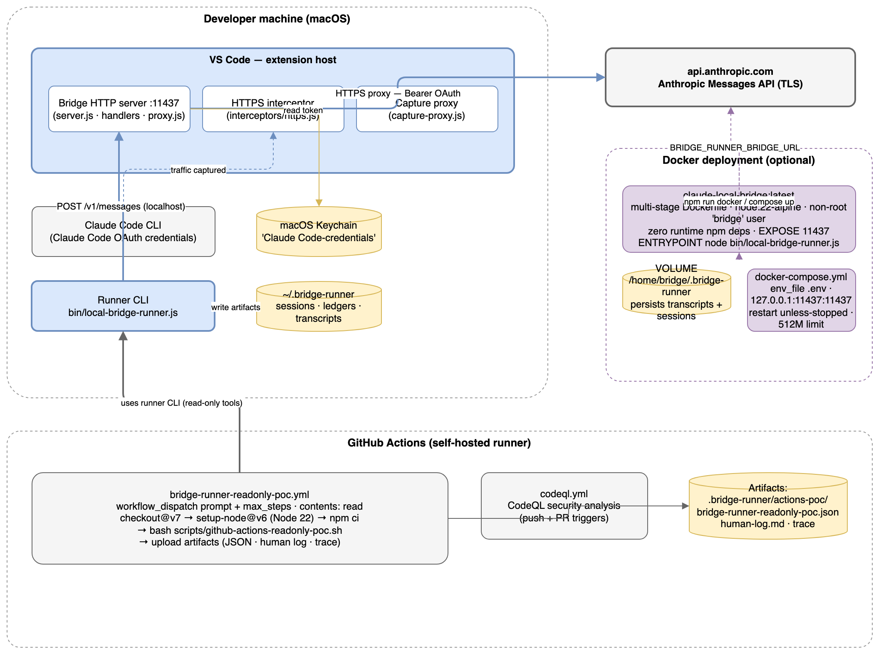
Deployment & Infrastructure

6.1 VS Code extension (the bridge)
• Activation: onStartupFinished; entry src/extension.js.
• Listens on 127.0.0.1 starting at port 11437 (walks up to 10 ports on EADDRINUSE).
• Settings (claudeLocalBridge.*): port (11437), anthropicBaseUrl
(https://api.anthropic.com), defaultModel (claude-sonnet-5), logRequests (false),
logTimeZone (local), traceLevel (off/summary/redacted/full),
requireCallerAuth (false), callerAuthToken ("").

6.2 Docker
• Multi-stage Dockerfile: node:22-alpine; deps stage installs devDeps only (optional tests); final image ships
no node_modules (zero runtime deps), runs as a non-root bridge user, EXPOSE 11437,
ENTRYPOINT ["node", "bin/local-bridge-runner.js"], VOLUME /home/bridge/.bridge-runner.
• docker-compose.yml: 127.0.0.1:11437:11437, named volume bridge-data for persistence, restart: unless-stopped,
512 MB memory limit, optional .env (BRIDGE_RUNNER_BRIDGE_URL, BRIDGE_CALLER_TOKEN).
• Secrets are passed at runtime via env; never baked into the image or committed.

6.3 CI/CD
Workflow | Triggers | Purpose
bridge-runner-readonly-poc.yml | workflow_dispatch (prompt + max_steps inputs) | Self-hosted runner: checkout → Node 22 → npm ci → bash scripts/github-actions-readonly-poc.sh → upload JSON / human-log / trace artifacts
codeql.yml | push / PR | CodeQL security analysis

6.4 Local checks
npm test # node --test, bridge + runner suites
npm run lint # ESLint 9 flat config
npm run check:docs # doc-defaults + runner-manifest consistency
npm run format:check # Prettier

Runner-only: node --require ./test/setup.js --test test/runner/*.test.js

7. Extension Patterns
The design philosophy is a small core with explicit opt-ins. Everything below is an extension point.

7.1 Add a new tool
1. Create src/runner/tools/<name>.js exporting { definition, execute, meta: { name, category, hidden?, quarantined? } }.
Categories: read-only | write | shell | recovery | orchestration | worktree.
2. Add the module to TOOL_MODULES in src/runner/tool-catalog.js.
3. Assign it to exactly one capability group in CAPABILITY_GROUPS (or extend the group list) — the self-check
fails loudly if you miss either step, so a half-registered tool breaks the build instead of silently widening
the default surface.
4. If the tool targets filesystem paths, declare meta.pathArgs if the argument name is not one of the canonical
keys (path, file_path, filepath, target_path) so the permission gate inspects it.
5. Test with a test/runner/<name>.test.js; the tool catalog's buildCatalog self-check is itself testable.

7.2 Customize the prompt
• --prompt-template review|cleanup|explore|… (or a Markdown path) prepends a template from
src/runner/prompts/; --prompt-arg k=v fills {{k}} placeholders.
• --append-system-prompt <s> / --append-system-prompt-file <p> extend the default prompt;
--system-prompt-file <p> replaces it.
• .bridge-runner/ project files (e.g. prompts/, hooks.json) customize per-project behavior.

7.3 Hooks, memory, skills
• Hooks: .bridge-runner/hooks.json lifecycle hooks, executed via src/runner/hooks/hook-dispatcher.js;
exec hooks additionally require "trusted": true in that file and --trusted-workspace.
• Memory: --auto-memory opts into runner auto-memory; --session-extract queues a run-summary memory proposal
after a successful trusted persisted session; --review-memory lists pending promotions.
• Skills: --capabilities skills exposes run_skill; skills run from .bridge-runner/-style skill folders.

7.4 Orchestrate multiple workers
Use bin/local-bridge-coordinator.js with --research-plan (JSON nodes with deps) to fan out read-only
research workers in parallel, synthesize locally, then execute edits in-process.

7.5 Presets and UX
docs/command-builder.html is the primary day-to-day runner UX (a lean HTML UI with hover/glossary explanations for
flags). When CLI flags or capability groups change, update it in the same turn.

8. Rules & Anti-Patterns

8.1 Do
• Keep the native surface: /v1/messages only; no OpenAI-compatible routes; no upstream API-key fallback.
• Keep safety defaults conservative: shell hidden unless --allow-shell; --dont-ask must never enable shell
by itself; write tools guarded by confirmation unless --accept-edits; .env, private keys, credential JSON,
token files, .ssh, .aws, .claude, and path escapes stay blocked.
• Keep the small core: default system prompt short and repo-agnostic; startup context minimal; tools as
capability groups; customization through .bridge-runner/ files, templates, hooks, and explicit flags.
• Route every exit through finalizeRun; funnel every sink through the redaction boundary; write artifacts
through the private-dir/0600 + redaction path.
• Treat the bridge as plumbing and the runner as the product surface; most new work lands in src/runner/**,
bin/**, test/runner/**, and docs/.

8.2 Don't
• Don't restore retired concepts: agent/capability profiles (--agent, --profile, --list-agents,
--list-profiles) are retired; keep shell and advanced patch mode hidden unless explicitly enabled.
• Don't add credentials fallbacks: no ANTHROPIC_API_KEY handling, no claudeLocalBridge.apiKey upstream
source, no replay of intercepted x-api-key credentials.
• Don't leak secrets: OAuth tokens and fingerprints must stay redacted in tool output, transcripts, traces,
JSON output, and human logs; --cwd is the target project, not necessarily the runner's folder.
• Don't silently widen the tool surface: adding a tool without a category/group assignment breaks the build by
design; shell cannot be enabled via --capabilities.
• Don't treat the transcript as a resume source: transcript resume is rejected at the CLI; only
--resume-session against the session store is valid.
• Don't open PRs against the canonical repo for playground experiments; this repo works directly on main.

9. Dependencies
Runtime dependencies: none. This is deliberate — the final Docker image ships without node_modules.
Package | Type | Version | Purpose
eslint | dev | ^9.0.0 | Linting (flat config eslint.config.cjs)
@eslint/js | dev | ^9.0.0 | ESLint shared config
globals | dev | ^15.0.0 | ESLint global definitions
jest | dev | ^30.4.2 | Keploy coverage reporting (npm run test:keploy)
prettier | dev | ^3.0.0 | Formatting (npm run format, format:check)

Runtime platform: Node.js 22 (per Dockerfile and CI), VS Code engine ^1.85.0 for the extension host.

10. Code Structure
claude-local-bridge-playground/
├── bin/ # CLI entry points
│ ├── local-bridge-runner.js # runner CLI (flags, help, dispatch to run())
│ ├── local-bridge-coordinator.js # multi-worker orchestration CLI
│ ├── local-bridge-archive.js # session archive browser / importer
│ ├── local-bridge-prompts.js # prompt-template tooling
│ └── local-bridge-undo.js # undo last-run (recovery manifests)
├── src/ # extension + runner source (zero runtime deps)
│ ├── extension.js # VS Code activation, commands, interceptor install
│ ├── server.js # bridge HTTP server (:11437), routing, CORS, auth gate
│ ├── proxy.js # Anthropic request forwarding / streaming
│ ├── credentials.js # OAuth discovery priority chain
│ ├── capture-proxy.js # auth capture proxy (Claude Code HTTPS_PROXY)
│ ├── caller-auth.js / local-auth.js / fingerprint.js / models.js / context.js / utils.js / bridge-trace.js / trace-utils.js
│ ├── handlers/ # anthropic.js (messages + count_tokens), debug.js
│ ├── interceptors/ # https.js (traffic capture)
│ └── runner/ # the agent loop (64 modules)
│ ├── run.js # main loop + finalizeRun (~1,700 lines)
│ ├── model-client.js # buffered + SSE bridge clients
│ ├── tool-catalog.js # 20 tools · categories · capability groups
│ ├── tool-registry.js / tool-pipeline.js / tool-envelope.js / tool-result-content.js / tool-result-summarizers.js / tool-prefetch.js / repeat-tool-detector.js / tool-visibility.js
│ ├── tools/ # read (list-files, read-file, search-text, glob, git-status) · write (edit-file, write-file, apply-patch) · shell (bash, manage-shell-jobs) · recovery (undo, undo-edit) · agents (spawn-agent) · worktrees · skills · lsp · tasks
│ ├── permissions.js / safety.js / authority.js / shell-policy.js / workspace-trust.js / redaction-boundary.js / permission-mode.js / private-fs.js
│ ├── context-builder.js / context-projection.js / context-compactor.js / context-estimator.js / context-policy.js / context-runtime-policy.js / context-budget.js
│ ├── session-store.js / session-ledger.js / replay-simulator.js / ledger-repair.js / session-health.js / session-anchor.js / transcript.js / loop-autopsy.js / archive/
│ ├── budget-broker.js / budget-tracker.js / model-capabilities.js / model-catalog.js / model-pricing.js
│ ├── coordinator.js / coordinator-spec-compiler.js / worker-runtime.js / subprocess-pool.js
│ ├── kernel/ # agent-kernel.js, contract.js (STOP_REASONS)
│ ├── hooks/ # hook-dispatcher.js, hook-runner.js
│ ├── memory/ · skills/ · prompts/ · lsp/ · recovery/ # extension subsystems
│ └── system-prompt.js / prompt-templates.js / bootstrap.js / confirmation.js / user-question.js / event-bus.js / golden-eval.js / replay-simulator.js / session-store.js / human-log.js / message-contract.js / streaming-write.js / media-read.js / test-watcher.js / workspace-fingerprint.js / worktree-utils.js / repo-map.js / instruction-delta.js / beginner-hints.js / background-shell.js / child-inherit.js / plan-proposals.js
├── test/ # 117 test files (~480 tests, node --test)
│ ├── runner/ # agent-loop, tool-pipeline, permissions, safety, ledger, coordinator, budgets, …
│ ├── bridge.test.js / caller-auth.test.js / anthropic.integration.test.js / …
│ └── __mocks__/ harbor/ golden/ bench/
├── evals/ # Python evaluation scaffolding (harbor/)
├── scripts/ # check-doc-defaults.js · check-runner-manifest.js · github-actions-readonly-poc.sh · create-runner-throwaway-lab.js
├── docs/ # dated experiment record + user docs (command-builder.html, runner-quickstart.html, ARCHITECTURE.md, threat-model.md, …)
├── .github/workflows/ # bridge-runner-readonly-poc.yml, codeql.yml
├── Dockerfile / docker-compose.yml # containerized runner deployment
├── package.json # extension metadata, scripts, VS Code settings schema
└── AGENTS.md / CLAUDE.md / CONTEXT.md # agent working agreements and repo context

11. Where the Experiment Record Lives
Dated docs under docs/ are the memory of this repo. Key entry points:
Topic | Document
Architecture (durable reference) | docs/ARCHITECTURE.md
62 verified runner claims | docs/runner-claims-validation-2026-07-31.md
Crash durability (A1) | docs/durability-crash-bakeoff-2026-07-31.md
Ledger forensics (C3) | docs/ledger-forensics-sweep-2026-07-31.md
Coordinator fan-out (A3) | docs/coordinator-fanout-field-test-2026-07-31.md
Threat model | docs/threat-model.md
Runtime concordance tracker | docs/runner-runtime-concordance-assessment-2026-07-17.html

> **Note on risk posture**: this is personal research and local tooling, not a product. Transport/auth behavior
> (OAuth capture, local proxy) is experimental exploration, not proof of Anthropic approval. Treat runs as
> personal research.

