A MICRO PROJECT REPORT
on
HYPERLOCALIZE
CONTEXT-AWARE IDENTITY-PRESERVING VIDEO LOCALIZATION
Submitted by
[STUDENT NAME] — [REGISTER NUMBER]
in partial fulfilment of the requirements for the award of the degree of
[BACHELOR OF ENGINEERING / BACHELOR OF TECHNOLOGY]
in
COMPUTER SCIENCE AND ENGINEERING
Under the guidance of
[GUIDE NAME], [DESIGNATION]
DEPARTMENT OF COMPUTER SCIENCE AND ENGINEERING
[COLLEGE NAME], [PLACE]
[UNIVERSITY NAME]
[MONTH, YEAR]

Abstract
Important public video information — health guidance, food and water safety, energy advisories, training material — often fails to reach the people who need it because it is produced in a language and cultural framing they do not share. Modern AI makes automatic dubbing look easy: a speech recogniser writes a transcript, a translation model or large language model produces the target text, and a speech synthesiser (sometimes a voice-cloning model) produces the new audio. Such a pipeline is fast, but it treats its own output as final. A dropped "not", a changed dosage number, a term the audience does not use, or an unconsented copy of a speaker's voice can reach the audience unnoticed, and the exported file carries no record of who checked what.
HyperLocalize is a context-aware, identity-preserving video localization system built as a controlled workflow rather than an autonomous pipeline. A Localization Manager creates a project with a target-audience profile and glossary. The source video is validated and analysed into timed scenes and segments. Each segment is localized with its context — the neighbouring lines, the speaker, the audience profile, the glossary, the available time slot and any reviewer instruction — and every draft records exactly which context inputs were used. A preview is rendered, and a human reviewer edits the text, overrides a check with a written reason, or regenerates a single scene. Rule-based checks on critical content (numbers, units, glossary terms, structure and speech overrun) block approval until the text is fixed or deliberately overridden. A speaker's identity is used only while that person's own versioned consent is valid; revocation stops running jobs, quarantines and deletes derived audio, invalidates affected approvals, and falls back to a stock voice. Approval freezes an immutable snapshot of exact versions with separation of duties, export refuses any placeholder (MOCK) artefact, and every governance action is written to an append-only, SHA-256 hash-chained audit log whose head is embedded in the exported evidence manifest.
The system is implemented as a Django modular monolith (nine apps) on PostgreSQL 17, with a hand-written database job queue, server-rendered pages using htmx, and all AI stages behind swappable provider interfaces. Candidate real providers are faster-whisper (English transcription on CPU), Gemini (context-aware translation), and MMS-TTS Tamil (stock voice on CPU); voice cloning remains a clearly labelled mock. The current demonstration scenario is English health information localized into Tamil.
Measured results: the full automated suite passed 210 tests with 2 optional real-model tests skipped (2026-10-22, 125 s); a separate black-box suite passed 11 of 11; and an end-to-end HTTP check passed 15 of 15 steps (2026-10-06). On a single 58-second public video, a real pipeline run produced real Tamil speech and subtitles: the intelligibility proxy (Whisper back-transcription character error rate) was 0.16, but only 2 of 14 lines fitted their time slot, which led to a length-budgeted prompt and a blocking overrun check. Translation quality, speaker similarity, speed and the benefit of context are not yet measured; a formal evaluation with consented speakers and a Tamil-literate rater is planned.
Keywords: video localization, dubbing, context-aware machine translation, human-in-the-loop review, consent management, hash-chained audit trail, evidence manifest, Tamil, Django.

Table of Contents
Right-click and choose “Update Field” to fill the page numbers.
Abstract
Table of Contents
List of Figures and Tables
List of Figures
List of Tables
Chapter 1: Introduction
1.1 Background of the Project
1.2 Problem Statement
1.3 Objectives
1.4 Scope of the Project
Chapter 2: Literature Survey
2.1 Review of Existing Research or Related Projects
2.1.1 Automatic speech recognition
2.1.2 Machine translation for Indian languages
2.1.3 Text-to-speech and voice cloning
2.1.4 Translation quality assessment
2.1.5 Provenance and audit
2.1.6 Commercial dubbing tools
2.2 Summary of Existing Approaches
2.3 Research Gap or Limitations of Existing Systems
Chapter 3: Methodology and System Design
3.1 Proposed Methodology
3.2 System Architecture or Block Diagram
3.3 UML Diagrams
3.4 Tools and Technologies Used
3.5 Module Description
Chapter 4: Implementation and Results
4.1 Implementation Details
4.1.1 Asynchronous job pipeline
4.1.2 Upload validation and video analysis
4.1.3 Context-aware localization
4.1.4 Critical-content checks
4.1.5 Rendering, timing fit and intelligibility proxy
4.1.6 Consent gate, revocation cascade and mid-job stop
4.1.7 Review, approval and export gates
4.1.8 Audit hash chain
4.1.9 Provider abstraction and labelled mocks
4.2 Screenshots of the Application
4.3 Sample Inputs and Outputs
4.3.1 Sample input
4.3.2 Sample output
4.3.3 Sample check behaviour (input → output pairs)
4.3.4 First real-clip trial: measured observations (n = 1)
4.4 Unit Testing and Results
4.4.1 Testing strategy
4.4.2 Test areas
4.4.3 Sample test cases
4.4.4 Measured test results
4.4.5 Not yet tested
Chapter 5: Conclusion and Future Enhancement
5.1 Summary of the Work
5.2 Conclusion
5.3 Future Enhancements
References

List of Figures and Tables

List of Figures
Figure | Title | Source to insert
1.1 | HyperLocalize workflow (Create → Upload/Analyse → Localize → Preview → Review → Regenerate → Approve → Export) | Redraw from the flow in §1.4
3.1 | System architecture / block diagram | Redraw from docs/uml/README.md §2 (component diagram)
3.2 | Use case diagram (UC1–UC9 and «include» Record Consent) | docs/uml/README.md §1
3.3 | Sequence diagram: main localization workflow | docs/uml/README.md §3
3.4 | Sequence diagram: consent revoked during a running voice job | docs/uml/README.md §4
3.5 | State diagram: Scene | docs/uml/README.md §5
3.6 | State diagram: Job | docs/uml/README.md §5
3.7 | State diagram: Consent version (append-only) | docs/uml/README.md §5
3.8 | Core entity-relationship diagram | docs/submission/source/er_core.mmd
3.9 | Class diagram (generated from the Django models) | docs/uml/class_diagram.md
4.1 | Localization Manager: project list | docs/screenshots/02-manager-project-list.png
4.2 | Localization Manager: project detail with the approval gate | docs/screenshots/03-manager-project-detail.png
4.3 | Reviewer: scene review with preview, checks and override fields | docs/screenshots/05-reviewer-scene-review.png
4.4 | Speaker / Identity Owner: consent page | docs/screenshots/06-identity-owner-consent.png
4.5 | Auditor: audit trail and hash-chain verification | docs/screenshots/07-auditor-audit-trail.png
4.6 | Administrator: policies, provider chains and free-quota warnings | docs/screenshots/08-admin-policies-and-quota.png
4.7 | Media Operator: job queue and states | docs/screenshots/04-operator-jobs.png
4.8 | Clip 01 timing: Tamil speech length ÷ slot length per line | Regenerate with docs/submission/source/chart.js, or plot the 14 ratios in §4.3

List of Tables
Table | Title
2.1 | Comparison of existing approaches and HyperLocalize
2.2 | Honest novelty classification of the project's features
3.1 | Actors and their responsibilities
3.2 | Tools and technologies used
3.3 | Modules (Django apps) and their responsibilities
3.4 | Consent checkpoints CP0–CP10
4.1 | Critical-content checks and their effects
4.2 | Provider chains and labelled mocks
4.3 | Test areas covered by the automated suite
4.4 | Sample unit and integration test cases
4.5 | Measured test results
4.6 | Evaluation metrics: TARGET versus MEASURED RESULT
4.7 | Problems found in the first real run and the design changes made

Chapter 1: Introduction

1.1 Background of the Project
Video has become one of the main ways public information is distributed. Health departments publish hand-washing and oral-rehydration videos, civic agencies publish water-safety and energy guidance, and organisations publish training material. Most of this material is produced in a small number of languages. For a viewer who does not understand the language, or for whom the examples, units and cultural references are unfamiliar, the information is effectively inaccessible even when the video itself is freely available.
Localization is broader than translation. It adapts content for a target audience: the language, the level of formality and reading level, cultural references, units of measure, and the timing of speech against the picture. When the content carries critical facts — a quantity, a duration, a warning, a negation — an error introduced during localization can change the meaning of the message. A dubbing pipeline that turns "do not give the child water" into a positive instruction is worse than no localization at all.
Recent speech and language models make automated dubbing technically easy. An automatic speech recognition (ASR) model produces a transcript; a machine translation (MT) model or a large language model (LLM) produces the target text; a text-to-speech (TTS) model, in some products a voice-cloning model, produces the new audio; and a media tool muxes it back onto the picture. This raises three practical problems that this project addresses directly:
- Trust. Machine output for critical information is a draft, not a fact. It needs checks a
reviewer can understand and a gate that cannot be bypassed by accident.
- Identity and consent. A real speaker's voice is personal data. Reproducing it requires that
person's informed, versioned consent, and revocation must actually stop the system.
- Accountability. Someone must be able to answer who reviewed, who approved, which model
produced which line, and which consent version applied at that moment.
HyperLocalize is positioned as an information-access layer. It can help critical video information in domains such as health, food, water and energy cross language and cultural barriers. It does not solve the underlying physical problems in those domains, and it is not a medical, nutritional or engineering tool.

1.2 Problem Statement
Existing automatic dubbing approaches treat localization as a one-shot pipeline whose output is assumed to be correct. In practice this creates four failures:
- Output is treated as final. Review, if it exists at all, is optional and unstructured. There is
no mechanism that prevents an unchecked machine translation from being exported.
- The errors that matter most are the ones least likely to be noticed. A reviewer reading a
translated script is unlikely to spot that "2 sachets" became "5 sachets", that a unit changed, or that a negation disappeared, especially in a language they read less fluently.
- Consent is, at best, an upload-time attestation. Revoking consent does not reliably stop work
already in progress, and there is no defined behaviour for previews, approvals and exports that already contain the person's voice.
- There is no verifiable record. The exported file does not say which models produced it, which
consent version was in force, or who approved it.
The problem addressed by this project is therefore: how do we build a video localization system in which AI output is only ever a draft, critical content is checked automatically, a human reviews and approves every scene before release, a speaker's identity is used only while their own consent is valid, and every governance action is recorded in a tamper-evident audit trail that travels with the exported package — on a zero-rupee budget and a single laptop?

1.3 Objectives
The objectives of the project are:
- Provide a complete project workflow: Create Localization Project → Upload and Analyse Source
Video → Context-Aware Localization → Generate Localized Preview → Human Review → Regenerate Scene/Output if Required → Approve → Export Localization Package.
- Localize each segment using its context — neighbouring segments, speaker, audience profile,
glossary, timing budget and reviewer instruction — and record which context inputs were used for every saved draft, so the decision is auditable rather than mysterious.
- Detect errors in critical content automatically (numbers, units, glossary terms, structure and
speech overrun), and block approval until a reviewer either fixes the text or overrides the check with a written, audited reason.
- Support scene-level regeneration, so a reviewer can redo one problematic scene without
disturbing the rest of an approved-in-progress project.
- Enforce consent in the backend before any use of a speaker's identity, and make revocation stop
new generation, cancel or kill running jobs, quarantine derived artefacts, and invalidate the approvals and exports that contained that identity.
- Gate approval and export: freeze an immutable snapshot on approval, apply separation of duties,
and refuse to export any placeholder (MOCK) output.
- Record every consent grant, revocation, approval, regeneration and export in an append-only,
SHA-256 hash-chained audit log, and include the chain head in an evidence manifest with every export.
- Keep AI stages behind provider interfaces, so models can be swapped, mocked and administered,
within a zero-rupee budget and without redesigning the workflow.

1.4 Scope of the Project
HyperLocalize is a general, controlled localization workflow — not a single-domain or single-language tool. Health is a demonstration domain, not the product boundary. For the first demonstrable build (the MVP), the scope was deliberately narrowed:
Item | MVP decision
Language pair | One pair and one target locale per project; the MVP pair is English → Tamil
Upload limits | Up to 5 minutes and 500 MB per video
Face processing / lip-sync | Not included (future scope only, and it would need its own consent design)
Identity in the MVP | A consented reference voice plus versioned consent records, with stock-voice or subtitles-only fallback (provisional)
Deployment | Demonstration on one laptop; Docker Compose files written but not yet run
Budget | ₹0: open-source software and free tiers only
Demo scenario | English health information (oral rehydration salts, hand-washing) → Tamil. A test case, not the product's domain

Figure 1.1 — HyperLocalize workflow. Draw the eight stages of objective 1 as a horizontal flow diagram with the governance layer (consent, review gate, audit) underneath.
In scope for this report: the full workflow above, the nine use cases, the consent and audit mechanisms, the provider abstraction, the automated test suite, and the measured results from one real public video plus one later end-to-end preview run.
Out of scope: lip-sync and face processing; multiple source languages per project; remote GPU execution (designed only); C2PA signing; and any claim of production readiness, regulatory compliance, or measured translation quality. These are stated as future work, not as delivered features.

Chapter 2: Literature Survey

2.1 Review of Existing Research or Related Projects

2.1.1 Automatic speech recognition
Whisper (Radford et al., 2022) is an encoder–decoder Transformer trained on roughly 680,000 hours of weakly supervised multilingual audio. It is robust to accents and background noise and emits timed segments, which makes it suitable as the first stage of a dubbing pipeline. faster-whisper (SYSTRAN) re-implements Whisper inference on CTranslate2, which makes CPU inference practical on a laptop. HyperLocalize uses faster-whisper small on CPU as its candidate English transcriber, and also reuses it to transcribe its own Tamil output back as an intelligibility proxy. The known weakness for this project is that Whisper is a recogniser, not a diarizer: without an additional model it cannot say who spoke when, so the current implementation labels every segment "Speaker 1".

2.1.2 Machine translation for Indian languages
IndicTrans2 (Gala et al., 2023) is an open multilingual translation model covering the 22 scheduled Indian languages, including Tamil. It translates essentially sentence by sentence. Large language models such as Gemini can translate while receiving additional context in the prompt — neighbouring sentences, a glossary, the audience profile, and a length constraint — and can state a rationale for an adaptation. The trade-offs are equally real: LLMs may omit content or hallucinate, their free tiers impose strict request quotas, and their output is non-deterministic. HyperLocalize therefore treats both as interchangeable candidates behind one provider interface, and records which adapter, model and prompt version produced each draft.

2.1.3 Text-to-speech and voice cloning
The Massively Multilingual Speech (MMS) project (Pratap et al., 2023) released TTS models for more than 1,100 languages, built on the VITS architecture (Kim et al., 2021). The Tamil model facebook/mms-tts-tam runs on CPU and is used here as the stock voice; its licence is CC-BY-NC-4.0, so it is suitable for a non-commercial academic demonstration only. Zero-shot voice-cloning models can imitate a speaker from a short reference clip, and Indian-language candidates such as IndicF5 exist, but cloning raises consent and misuse risks that are central to this project. In the current build, cloning sits behind the consent gate but is still a labelled mock.

2.1.4 Translation quality assessment
The Multidimensional Quality Metrics (MQM) framework (Lommel et al., 2014) scores translations by error category and severity and is the basis of the human evaluation planned for this project. chrF (Popović, 2015) is a character n-gram F-score that behaves better than word-level metrics for morphologically rich languages such as Tamil. Rule-based quality assurance for numbers, tags and terminology is a standard feature of professional computer-assisted translation (CAT) tools — which is exactly why the project treats such checks as support for a reviewer, not as proof of quality.

2.1.5 Provenance and audit
The C2PA specification defines signed provenance manifests for media. Hash chains, in which each record stores the hash of its predecessor, are a long-established way to make a log tamper-evident. HyperLocalize uses a hash-chained audit log and an evidence manifest; it does not implement C2PA signing, and it describes its audit as tamper-evident, never tamper-proof.

2.1.6 Commercial dubbing tools
Commercial AI dubbing products (for example ElevenLabs Dubbing, HeyGen and Rask) and platform features such as multi-language audio tracks already offer transcription → translation → voice cloning, transcript editing, segment regeneration and in some cases lip-sync. Some require attestation or verification of voice-cloning consent. These are capable products. HyperLocalize does not compete with them on raw dubbing quality; it competes on the control layer around the same commodity models. Product capabilities change frequently and should be re-verified before quoting.

2.2 Summary of Existing Approaches
Table 2.1 — Comparison of existing approaches and HyperLocalize
Approach | How it works | Strengths | Limitations for critical content
Manual localization studio | Human translator, voice artist and editor work from a script | Highest quality; human judgement throughout | Slow and expensive; not viable for large volumes of public information
Subtitles only | Human or machine transcript is translated and overlaid | Cheap; leaves the original voice intact; low consent risk | Requires literacy in the target script; no audio access for low-literacy audiences
ASR → MT → TTS dubbing pipeline | Fully automatic, one pass | Fast, cheap, scalable | Output treated as final; critical numbers and negations can drift; no review gate; no consent enforcement mid-job
Commercial AI dubbing products | Managed pipeline with an editing UI, sometimes voice cloning | Good voice quality, polished UX, some consent attestation | Closed and vendor-dependent; governance evidence is not usually portable; cost per minute
MT quality-estimation tooling | Automatic scores (BLEU, chrF, COMET) on translated text | Cheap signal for ranking | Scores do not identify which number or negation changed; not usable as an approval gate
HyperLocalize (this project) | Commodity models inside a governed workflow: context-aware drafts, rule-checked critical content, human review gate, consent gate, audit chain, evidence-carrying export | Errors that matter are made visible and block release; identity use is consented and revocable; every action is traceable | Slower than a pure pipeline because of review; quality of the underlying models is not yet measured; voice cloning still mocked

The comparison makes the project's position clear: it is not a better dubbing model, it is a control layer around dubbing models.

2.3 Research Gap or Limitations of Existing Systems
The gap this project targets is not a missing model. Each component — ASR, MT, TTS, QA checks, audit logging — exists and is mature. The gap is the combination and its enforcement:
- No unbypassable review gate in commodity pipelines. Open-source dubbing scripts produce a file
at the end; nothing structurally prevents an unchecked output from being released.
- Quality checks are not error-targeted. Automatic metrics score a whole sentence. They do not
answer the reviewer's real question: did a number, unit, negation or required term change?
- Consent is not enforced across stage boundaries. Attestation at upload does not stop a job that
is already running, nor does it define what happens to derived audio, previews and approvals.
- Evidence is not portable. Exported media rarely carries a verifiable record of the models used,
the consent version applied, and the human who approved it.
- Cost and vendor lock-in. Managed tools assume a budget and a connection. A zero-budget
academic build needs local, swappable models with an honest fallback path.
Where HyperLocalize is genuinely new, stated carefully. No individual feature is novel. The combination — critical-content checks that block approval + a human review gate that cannot be bypassed + backend-enforced, revocable consent + an evidence-carrying export — is a proposed novelty within the project's own honest classification (Table 2.2). It has not been validated against the literature or against existing products, and this report does not claim otherwise.
Table 2.2 — Honest novelty classification of the project's features
Feature | Classification | Reason
ASR → MT → TTS pipeline; voice cloning | Existing / Common | Commodity, and swappable by design
Transcript editing, per-segment regeneration, human review | Existing / Common | Expected in professional localization
Provider abstraction, labelled mocks, database job queue, modular monolith | Implementation choice | Good engineering, not novelty
LLM translation with audience profile, glossary, timing budget and stated rationale | Enhancement | Context-aware MT is an active research area
Rule-based hard checks used as an approval-blocking gate | Enhancement | Similar QA exists in CAT tools; using it as a release gate is the difference
AI meaning-reversal flags requiring acknowledgement | Enhancement | An aid to review, never verification
Versioned, backend-enforced consent with revocation cascade and fallback | Enhancement | A required safeguard, implemented carefully
Evidence-carrying export with audit chain head | Enhancement | Provenance manifests (C2PA) already exist
The combination above as one workflow | Proposed novelty | Needs a literature and product check before it can be called novel

Chapter 3: Methodology and System Design

3.1 Proposed Methodology
The project followed a design-first, evidence-first methodology in two phases.
Phase 0 — discovery and design. Requirements, actors and use cases were analysed, and every major decision was compared against two to four realistic alternatives on quality, performance, scalability, reliability, privacy, cost, implementation difficulty and how easily it could be defended in a viva. Each decision was recorded as an Architecture Decision Record (ADR); 22 ADRs exist, of which 17 are accepted and 5 (the AI provider and identity choices) are pending measurement.
Phase 1 — MVP build. The system was built in vertical slices: one thin path end to end (upload → analysis → localization → preview → review → approval → export) before widening. Three working rules shaped the build:
- AI is optional at every boundary. Every AI stage is a provider interface with an ordered chain;
a clearly labelled mock exists for tests and development, and mock output can never be exported.
- Governance is enforced in the backend. Role checks and the consent gate live in service
functions, not in templates, so a UI shortcut cannot bypass them.
- Claims are labelled. Every metric is a TARGET or a MEASURED RESULT; every mock is named as a
mock; limitations are reported rather than hidden.
The localization method itself. For each segment, the system builds a request that contains:
- the segment's source text and its time budget;
- two neighbouring segments on each side, for discourse context;
- the speaker (who is being localized);
- the audience profile (locale, formality, reading level, cultural notes, declared unit
conversions);
- the project glossary of required terms;
- any reviewer instruction (for a regeneration, for example "use simpler words").
The response is a subtitle text, a fully speakable speech text, an adaptation type (literal, adapted, or expanded) and a stated rationale. A length budget derived from the voice's measured speaking rate constrains the speech text so it can fit the slot. Each saved draft records the context inputs, the adapter, the model and the prompt version — so a reviewer can see why a phrase was adapted rather than translated literally. Visual context (keyframes, on-screen text) is not implemented; the method is therefore context-aware in the textual and audience sense only.
Development process. Requirements → ADR with alternatives → implementation in a slice → tests (negative cases first) → independent review for consent, audit and data-model changes → documentation update. Findings from review are recorded with their fixes; the code review of the consent and audit modules found 1 blocker and 6 major issues, all of which were fixed with regression tests.

3.2 System Architecture or Block Diagram
HyperLocalize is a modular monolith (ADR 0001): one Django codebase and one PostgreSQL database. This was chosen over microservices because the project has one developer, a laptop demonstration and a zero budget, and because database transactions and row locks provide exactly the strong guarantees that consent enforcement needs.
The architecture has four kinds of process:
- Web process. Serves server-rendered pages with htmx partial updates. It never blocks on long
work; it validates uploads, writes database rows and enqueues jobs.
- Worker processes. Claim jobs from a hand-written PostgreSQL queue
(run_worker --lane default|synthesis|all). Separate lanes stop slow speech synthesis from blocking analysis and localization.
- Inference subprocess. Heavy model inference runs in a separate, killable process, so a consent
revocation can terminate work in progress instead of waiting for it.
- PostgreSQL + media storage. The database holds all state, including the job queue and the audit
chain. Media lives outside the web root behind a storage interface.
AI stages sit behind provider interfaces with ordered fallback chains per stage; the Administrator can reorder the chains and set free-quota limits.
Figure 3.1 — System architecture / block diagram. Show the web process, the worker lanes, the inference subprocess, PostgreSQL, media storage, and the provider adapters (real candidates and labelled mocks). Source: docs/uml/README.md §2.
Request path for one project (as implemented):
Upload (ffprobe validation → Video row → audit VIDEO_UPLOADED → analyze_video job)
→ Worker: extract audio, transcribe (human SRT/VTT, else faster-whisper, else mock),
detect shot cuts, plan scenes and segments
→ localize job (context per segment → translation drafts → rule checks + AI flags)
→ render_scene job per scene (resolve voice mode from consent → synthesise → fit timing
→ mix → RenderedScene → scene IN_REVIEW)
→ Reviewer: edit / override with reason / acknowledge / regenerate one scene / accept
→ Manager: approve (gate → immutable snapshot → audit APPROVED)
→ Export (CP9 consent under lock → package + evidence manifest → audit EXPORT_CREATED)

3.3 UML Diagrams
The diagrams below were drawn from the implemented code, not from an intended design. Each names the module it describes. Insert the rendered figures at the points indicated.
Use case diagram (Figure 3.2). Six actors — Localization Manager, Reviewer/Linguist, Media Operator, Speaker/Identity Owner, Administrator, Auditor/Faculty Evaluator — and nine use cases. UC1 includes UC2, UC3, UC4 and Record Consent; UC5 includes UC3 and UC4. UC1–UC9 and the actors are confirmed project requirements (ADR 0013).
Sequence diagram, main workflow (Figure 3.3). Upload → validation → analyse job → transcript, speakers, segments and scenes → localize job → translation versions, hard checks and AI flags → per-scene render → reviewer actions → approval snapshot → export with CP9 under the owner lock and a manifest carrying the chain head.
Sequence diagram, revocation during a running job (Figure 3.4). The identity owner revokes project consent; the service locks the IdentityOwner row, inserts a REVOKED version, cancels queued jobs, flags the running job, quarantines that owner's artefacts in that project, invalidates only the affected approvals and exports, sets scenes to NEEDS_REGENERATION, queues a purge and stock-voice fallback renders, and writes the audit record. The worker's one-second poll sees the change and kills the inference subprocess. This flow is covered by a test that uses a real subprocess.
State diagrams. Three long-running objects have explicit state machines enforced in the service layer:
- Scene (Figure 3.5): PENDING → TRANSLATED → IN_REVIEW → ACCEPTED, with CHANGES_REQUESTED and
REGENERATING loops, and NEEDS_REGENERATION on revocation.
- Job (Figure 3.6): QUEUED → RUNNING → SUCCEEDED / FAILED, with CANCELLED on a cancel flag and a
return to QUEUED on transient error or a stale heartbeat.
- Consent version (Figure 3.7): append-only rows: ACTIVE → REVOKED or EXPIRED, where narrowing
inserts a new, narrower ACTIVE version rather than editing the old one.
Entity-relationship diagram (Figure 3.8). The core entities and their cardinalities: Project, AudienceProfile, GlossaryTerm, Video, Scene, Segment, SegmentTranslation (versioned), CheckResult, SynthesisedSegment, RenderedScene, Review, RegenerationRequest, Approval, IdentityOwner, Consent (versioned), VoiceProfile, Export, AuditRecord, Job, ProviderConfig, ProviderUsage.
Class diagram (Figure 3.9). Generated from the actual Django models by scripts/generate_uml.py (28 model classes across nine apps). Include it as a full-page figure; it is the ground truth for the data model and is referenced by ADR 0014 (amended by ADR 0020).
Design invariants worth stating in the viva: translations, consent versions and audit records are append-only; an Approval stores an immutable snapshot of exact version identifiers and is invalidated by any later change; and every AI artefact records its adapter, model, prompt version and is_mock flag.

3.4 Tools and Technologies Used
Table 3.2 — Tools and technologies used
Layer | Tool / technology | Version (as used) | Why it was chosen
Language | Python | 3.x | Readable, strong media and ML ecosystem, explainable in a viva
Web framework | Django (no Django REST Framework) | 6.1.1 | Server-rendered pages, built-in auth and admin, fewer moving parts
Database | PostgreSQL | 17 | Transactions, row locks, SKIP LOCKED, triggers for the audit table
DB driver | psycopg | 3.3.6 | Current PostgreSQL driver
Frontend | Django templates + htmx | — | No separate SPA build; partial page refreshes (jobs panel every 2 s)
Job queue | Hand-written PostgreSQL queue | — | Needs its own cancel flag and consent checkpoint CP2; avoids extra infrastructure
Media processing | ffmpeg / ffprobe (static-ffmpeg in development) | — | Validation, audio extraction, shot-cut detection, tempo, mixing, muxing
Transcription (candidate) | faster-whisper small / small-int8 on CPU | 1.2.1 | Accurate enough, runs without a GPU
Translation (candidate) | Google Gemini gemini-3.5-flash | free tier | Long context for neighbouring lines, glossary and length budget
Speech (candidate) | facebook/mms-tts-tam (MMS-TTS Tamil) on CPU | PyTorch 2.14.1 (CPU) | Real Tamil speech at zero cost; non-commercial licence
Voice cloning | Not implemented (mock only) | — | Needs ADR 0018 and a consented speaker first
Deployment | Docker Compose files + development script | — | Written but not yet run; development uses embedded PostgreSQL 17 binaries
Testing | Django test runner, pytest (black-box) | — | Unit, integration, web-layer and boundary-value tests
Diagrams | Mermaid (rendered with mermaid-cli 11.4.2) | — | Text-based diagrams kept in version control

Hardware used for development: Intel Core i5-13450HX (10 cores / 16 threads), 14 GiB RAM, Ubuntu 26.04.1 LTS, no GPU. This is the machine on which all measured results in Chapter 4 were produced.

3.5 Module Description
The system is divided into nine Django apps. Apps call each other only through services.py functions, and Django signals are not used, so every cross-module call is explicit and traceable.
Table 3.3 — Modules (Django apps) and their responsibilities
Module | Owns (data) | Key code | Responsibility
accounts | User, ProjectMembership, Policy | permissions.py | Identity of users, project-scoped roles, policy values, rate-limited login. Role checks used by every service live here
projects | Project, AudienceProfile, GlossaryTerm, Video, SpeakerTrack | services.upload_video, storage.LocalMediaStorage | Project creation and configuration, upload validation with ffprobe before storage, media storage behind an interface
localization | Scene, Segment, Localization, SegmentTranslation, CheckResult | services.localize_scene, checks.py | Scene planning, context-aware localization, append-only translation versions, critical-content checks
rendering | SynthesisedSegment, RenderedScene | services.render_scene | Resolve the voice mode per speaker from consent and policy, synthesise, fit timing, mix, render a scene preview
review | Review, RegenerationRequest, Approval | services.approve, request_changes | Human review, overrides with reasons, scene acceptance, scene-only regeneration, the approval gate and snapshot
identity | IdentityOwner, Consent, VoiceProfile, OfflineCopy | services.evaluate, demo.py | Consent versions, the single consent decider, the revocation cascade, demo reset and withdrawal
exports | Export | services.request_export, build_export | Package building (MP4, SRT, VTT, script, quality report, evidence manifest) and export validation
audit | AuditRecord, AuditChainHead | services.record, verify_chain | The single audit writer, the hash chain, and chain verification
pipeline | Job, ProviderConfig, ProviderUsage | jobs.py, handlers.py, inference.py, providers/ | Job queue and workers, provider chains, inference subprocess, usage ledger and quota warnings

Cross-cutting modules: media_tools.py (ffprobe/ffmpeg wrappers), pipeline/quota.py (free-quota warnings at 80% and 100%), and the management commands run_worker, seed_demo, check_providers, build_demo_seed, demo_reset, verify_audit_chain, download_models.
Table 3.4 — Consent checkpoints CP0–CP10 (ADR 0006)
Checkpoint | Where it is checked | Behaviour on failure
CP0 | Before source audio leaves the laptop (external ASR only) | Local ASR is used instead; audited
CP1 | Any API request that would use identity | Refused; CONSENT_DENIED recorded
CP2 | Job claim, in the same transaction | Job CANCELLED
CP3 | Before a reference clip is uploaded to a remote GPU | Cancelled; nothing uploaded
CP4 | Before synthesis of each segment | Stop; job CANCELLED
CP5 / CP7 | Saving synthesised audio / a rendered scene (row-locked) | Data discarded
CP6 | Before scene render and mix | Job CANCELLED
CP8 | Approval: every consent version in the snapshot is still latest and ACTIVE | Approval refused
CP9 | Before export build and when saving it (row-locked) | Export refused
CP10 | Serving previews and downloads | HTTP 410 Gone with an explanation

CP0 and CP3 are designed but have no code path yet, because no provider that sends audio off the machine is integrated. This is reported as a limitation, not hidden.

Chapter 4: Implementation and Results

4.1 Implementation Details

4.1.1 Asynchronous job pipeline
Jobs are rows in a Job table with states QUEUED, RUNNING, SUCCEEDED, FAILED and CANCELLED (DISPATCHED is reserved for a future remote runtime). A worker claims the next job with SELECT … FOR UPDATE SKIP LOCKED, and the consent check CP2 executes in the same transaction, so a job cannot be claimed on behalf of a speaker whose consent has just been revoked. Transient provider errors are retried with back-off (5 s, 30 s, 120 s); a stale heartbeat returns a job to the queue; a cancel_requested flag is checked at every checkpoint. Separate lanes (default, synthesis) keep slow speech synthesis from starving analysis and localization work.
The web process never waits for a model: it writes rows and enqueues jobs, and the pages poll for state with htmx. This is the implementation of the project rule "never block a web request on a long process".

4.1.2 Upload validation and video analysis
On upload the file is validated with ffprobe before it is stored: it must be a readable container with a video stream, supported codecs, duration ≤ 5 minutes and size ≤ 500 MB. Invalid files are rejected without entering media storage. The analysis job then extracts the audio, obtains the transcript (from a human-made SRT/VTT if supplied, otherwise from faster-whisper small on CPU, otherwise from a labelled mock in test/development), detects shot cuts with ffmpeg's scene-change score, and plans scenes.
Scene planning (localization.services.plan_scenes) places a boundary between two segments when ( a ) a shot cut falls in the gap, ( b ) the pause is at least 1.5 s, or ( c ) the scene would exceed 30 s. The boundary sits at the cut, or else in the middle of the pause; scenes are contiguous and cover the whole video. These thresholds are implementation choices and have not been tuned.

4.1.3 Context-aware localization
For every segment the request contains the source text, two neighbouring segments on each side, the speaker, the audience profile, the glossary, the timing budget and any reviewer instruction. The budget is computed from the target voice's measured speaking rate — 11 characters per second for MMS-TTS Tamil, derived from a measured median of 11.95 characters per second over 20 lines — so the model is told how much speech can actually fit. The model must preserve every number, unit, negation, warning and instruction, and must mark a line TOO_LONG if it cannot fit.
Quota-safe batching: the Gemini free tier allows roughly 20 requests per day per model (measured), so a localize job sends the whole clip in one request when it fits (at most 80 segments and 12,000 characters) and the meaning check is one further request. If a real provider fails (quota, outage, malformed output), the chain does not fall back to mock text: scenes stay PENDING, the page shows "Translation pending … Nothing was machine-translated by a MOCK", and a Retry button is offered. Gemini is permitted only for projects classified as scripted team content, or as published public content with a recorded source URL and licence (ADR 0021).

4.1.4 Critical-content checks
localization/checks.py implements a language-neutral framework: a source-language number reader plus a target language pack (Tamil). Numbers are read on both sides and compared as multisets; units come from a lexicon with forms per language; glossary forms are matched by prefix so inflected Tamil forms still match; structural checks catch empty, untranslated and mostly-Latin-script output; and a speech-overrun check runs after real synthesis.
Table 4.1 — Critical-content checks and their effects
Check | How it works | Result
Numbers | Digits, groupings, times and number words are read on both sides and compared as multisets; Tamil number words 0–100 are parsed (draft lexicon, pending a Tamil rater) | FAIL on mismatch; UNVERIFIABLE where words cannot be read safely
Units | Lexicon with forms per language; a declared unit conversion deliberately returns UNVERIFIABLE (fail-safe) | FAIL / UNVERIFIABLE / PASS
Glossary | Target forms matched by prefix, so inflected forms still match; a term with no target forms is never PASS | FAIL / UNVERIFIABLE
Structure | Empty, untranslated, mostly Latin script for a non-Latin target, or over the reading-time budget | FAIL
Speech overrun | After real synthesis, a line that still needs more time than its slot at 1.2× tempo (100 ms tolerance) | FAIL: "shorten the speech script"
AI meaning flag | MeaningCheckProvider flags possible meaning reversals, such as a dropped negation | Requires reviewer acknowledgement; never called verification

A FAIL or UNVERIFIABLE result blocks approval until the text is fixed or a reviewer overrides it with a written, audited reason. Known limitation, stated openly: the numbers check compares counts, not positions, so turning "2 tablets 3 times" into "3 tablets 2 times" still passes and must be caught by the reviewer.

4.1.5 Rendering, timing fit and intelligibility proxy
rendering.services.resolve_mode decides the voice on the server, per speaker:
- SUBTITLES_ONLY if policy forbids synthesis;
- otherwise CLONED_VOICE only if consent is valid, an active reference clip exists, policy allows
cloning and a cloning adapter is available;
- otherwise STOCK_VOICE.
The reason is shown to the reviewer, so the mode is explainable rather than implicit. The stock voice is MMS-TTS Tamil on CPU; it refuses unspeakable text (digits or Latin letters) instead of silently dropping content. If speech is longer than its slot the tempo is raised, at most to 1.2×. Every synthesised line is transcribed back with faster-whisper and its character error rate is stored as a clearly labelled intelligibility proxy — not a listening test, and pessimistic because it includes Whisper's own errors. The scene preview is an MP4 with the original picture, the original audio ducked under the new speech, and soft subtitles.

4.1.6 Consent gate, revocation cascade and mid-job stop
identity.services.evaluate is the only consent decider in the system. Identity use is allowed only if all of the following hold:
- the owner has not withdrawn;
- the latest project consent is ACTIVE, unexpired, and includes the requested use and language;
- it has a parent standing consent;
- the latest standing consent is ACTIVE, unexpired, and permits the project's purpose (a rehearsal
needs both STANDARD and DEMO_REHEARSAL);
- the project consent is still within the standing consent;
- the job is not flagged for cancellation.
Saving artefacts re-runs the gate under a row lock on the IdentityOwner, so a consent change cannot race a write.
On revocation, one transaction sets affected scenes to NEEDS_REGENERATION, cancels render jobs, quarantines that owner's artefacts in that project, marks reference clips DELETED, invalidates only the approvals and exports that contain that owner's identity, and queues a purge. After commit, stock-voice fallback renders are queued and must be reviewed again. A fixed lock order (IdentityOwner → Localization → Scene → Job → artefacts → Export → AuditChainHead) prevents deadlocks. While a synthesis subprocess runs, the worker polls the cancel flag and the consent gate about once a second and kills the subprocess on cancel; a test with a real subprocess passes inside an 8-second bound (the exact stop time was not recorded). Exports already downloaded cannot be recalled, and the system documentation states that plainly.

4.1.7 Review, approval and export gates
A reviewer's edit creates a new HUMAN version and re-runs the checks and the preview; regeneration targets one scene only — its script (with an instruction such as "use simpler words") or its preview. A scene can be accepted only when it has no open checks and a current preview.
Approval (review.services.approve) is refused unless all of these hold:
- every scene is accepted;
- no blocking checks remain on the latest versions;
- every preview is current;
- consent checkpoint CP8 passes;
- separation of duties: the approver did not edit any segment in this version.
Approval freezes an immutable snapshot of the exact version identifiers; any later change invalidates it. Export is refused if the approval is invalid, if any artefact in the snapshot is MOCK, if any artefact is quarantined, or if CP9 fails. The exported package contains the localized MP4, SRT and VTT subtitles tagged with the target language, script.json, quality_report.json and evidence_manifest.json (hashes, providers, rendering modes, consent versions, reviews, provenance, intelligibility proxy and the audit chain head).

4.1.8 Audit hash chain
Every governance action — consent grant, narrowing, revocation, approval, regeneration, export — is written by one function (audit.services.record). Each record stores the previous record's hash, and its own hash is SHA-256(prev_hash + canonical_json(record)). Appends are serialised by locking a single chain-head row. PostgreSQL triggers reject UPDATE, DELETE and TRUNCATE on the audit table. verify_audit_chain recomputes the entire chain, and every export manifest carries the current chain head. The design is tamper-evident, not tamper-proof: someone with full database rights could rebuild the whole chain, which is precisely why the head is also copied into each exported package.

4.1.9 Provider abstraction and labelled mocks
Each AI stage is an interface with an ordered chain of adapters that the Administrator can reorder. Mocks exist only in development and test modes, are named as mocks, carry an is_mock flag, show a MOCK badge in the interface, and can never be exported. A free-quota ledger warns the Administrator at 80% and 100% of limits they enter; nothing is blocked by a warning.
Table 4.2 — Provider chains and labelled mocks
Stage | Real / candidate adapter | Mock (development and tests only) | Status
Transcription | Human SRT/VTT; faster-whisper small on CPU | MockTranscriptionProvider: "[MOCK] Transcript segment N." every 4 s | Candidate run on real clips
Localization | Gemini gemini-3.5-flash (prompt with context and budget) | MockTranslationProvider: copies the source, applies glossary targets, prefixes "[MOCK]" | Candidate; quality not measured
Meaning check | Gemini batch check | MockMeaningCheckProvider: negation keyword rule (not AI) | Candidate
Stock voice | MMS-TTS Tamil on CPU | MockStockVoiceProvider: 440 Hz tone | Candidate, accepted in ADR 0021
Cloned voice | None yet (ADR 0018 pending) | MockClonedVoiceProvider: 660 Hz tone; imitates no one | Mock only

4.2 Screenshots of the Application
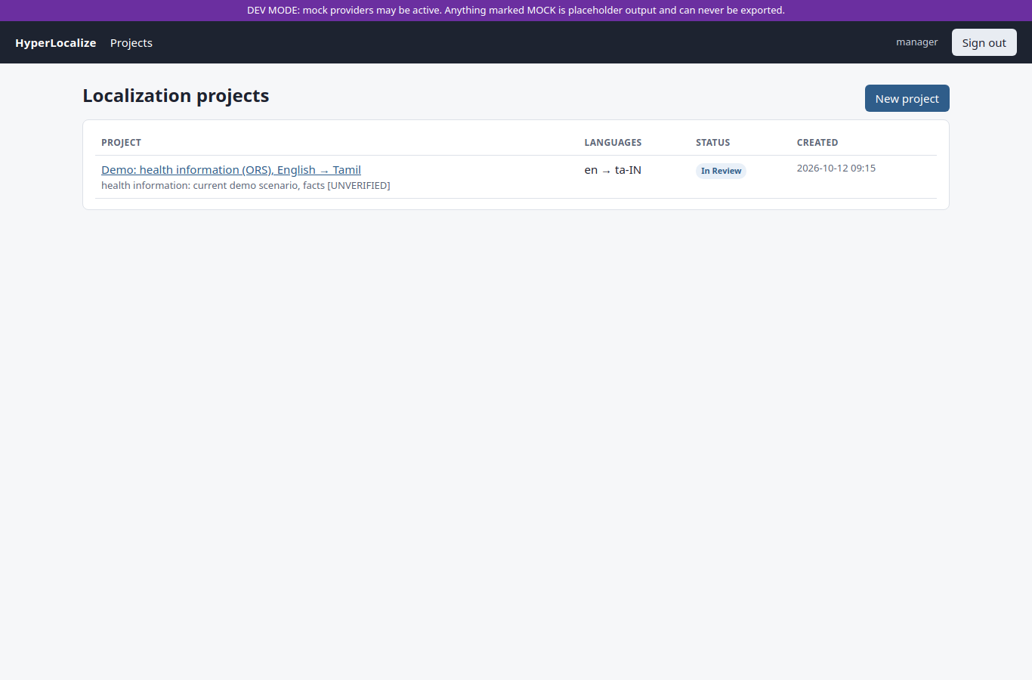
Figure 4.1 — Localization Manager: project list. Shows projects with their language pair, status and the "create project" action. The status column distinguishes draft, in-review, approved and exported.
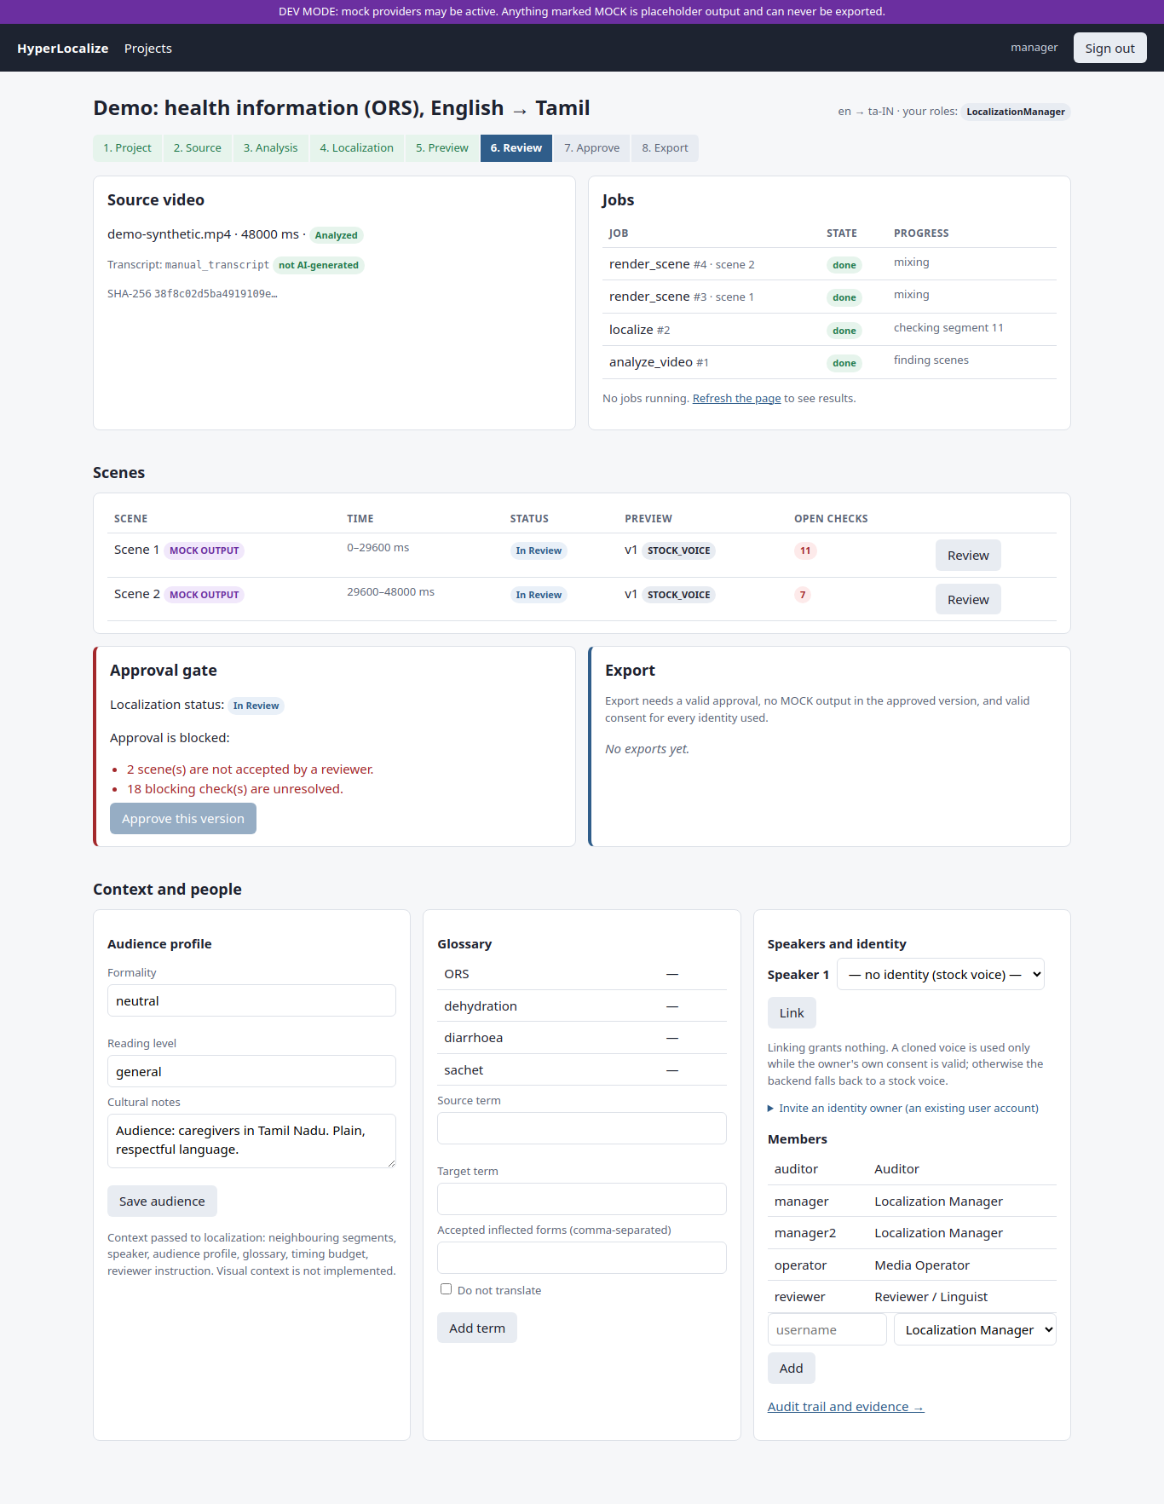
Figure 4.2 — Localization Manager: project detail with the approval gate. Shows the scene list, the check summary, the consent state and the disabled/enabled Approve action with the reason it is blocked. This is the visual form of the approval gate described in §4.1.7.
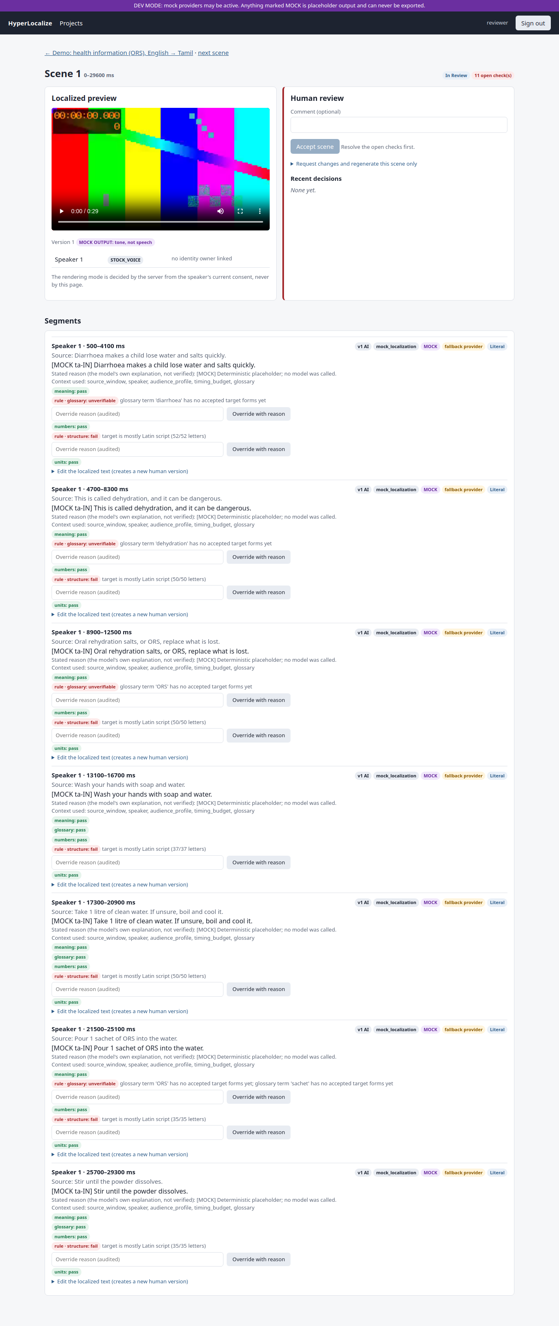
Figure 4.3 — Reviewer: scene review. Shows the preview player, the source and target text, the per-segment check results, the override reason field, the acknowledge controls for AI flags, and the accept/regenerate actions.
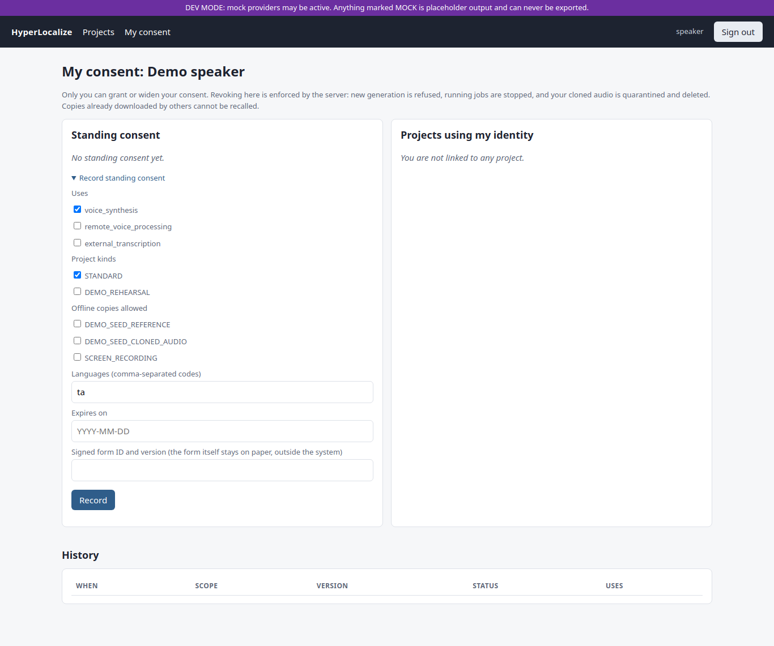
Figure 4.4 — Speaker / Identity Owner: consent page. Shows standing and project consent versions with uses, purposes, languages, processors and expiry, the revoke action, and the reference-clip status.
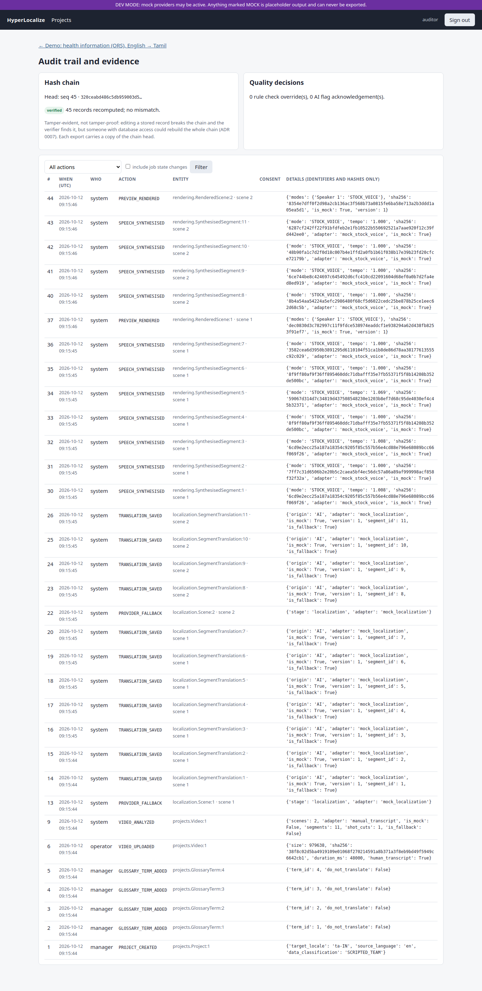
Figure 4.5 — Auditor: audit trail. Shows the filterable audit records (who, what, when, project, scene, consent version) and the on-demand chain verification result.
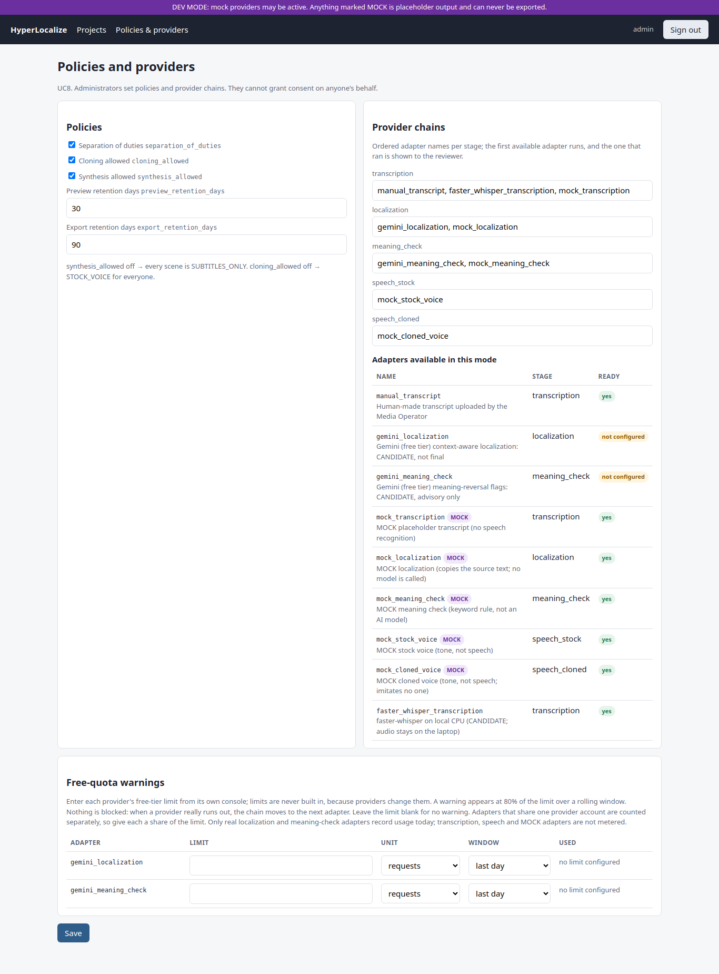
Figure 4.6 — Administrator: policies, provider chains and quota warnings. Shows provider ordering per stage, policy values, and the 80% / 100% free-quota warnings. Users and memberships are managed through the Django admin (the seeded admin is staff and superuser).

Figure 4.7 — Media Operator: job queue. Shows job states (QUEUED, RUNNING, SUCCEEDED, FAILED, CANCELLED), lanes, attempts and heartbeats.
Figure 4.8 — Clip 01 timing chart. Bar chart of Tamil speech length ÷ slot length for the 14 lines of the trial in §4.3; a bar at 1.0 fits, a bar above 1.0 overruns. Regenerate from docs/submission/source/chart.js.

4.3 Sample Inputs and Outputs

4.3.1 Sample input
The demonstration input is a public-domain / CC BY 3.0 English health-information video: test_datasets/01_handwashing_sf_health_dept_en — 58.4 seconds, 1280×960, from San Francisco Government Television, with its source URL, licence and attribution recorded in the project (required by ADR 0021 for published public content). The project target audience profile is Tamil, formal register, adult general audience, with a small glossary of required health terms. It is transcribed into 14 segments across 2 scenes.
A second, later run used the same clip and is the most recent verified end-to-end state (2026-10-29): faster-whisper small-int8 transcribed 14 segments in 2 scenes, Gemini gemini-3.5-flash localized 14 of 14 segments, and facebook/mms-tts-tam produced 14 real Tamil stock-voice clips.

4.3.2 Sample output
Scene previews (real, non-mock), measured with ffprobe on 2026-10-29:
Property | Scene 1 | Scene 2
Video codec | H.264 | H.264
Audio codec | AAC | AAC
Dimensions | 1280 × 960 (source dimensions preserved) | 1280 × 960
Actual duration | 28.120 s | 30.244 s
Expected duration | 28.120 s | 30.244 s
Subtitles | served as VTT | served as VTT

Both scenes are IN_REVIEW. No one accepted or approved them, and the system correctly prevents export at this point. The render path uses the source video stream and mixes the original audio at 25% under the target speech.
Export package contents (built when a human approves and exports):
File | Contents
localized.mp4 | Original picture, original audio ducked under target speech, soft subtitles, tracks tagged tam
subtitles.srt, subtitles.vtt | Target-language subtitles with source-aligned timings
script.json | Per-segment source and target text, origin (AI/HUMAN), adaptation type, rationale, context inputs
quality_report.json | Every check result, overrides, acknowledgements, intelligibility proxies
evidence_manifest.json | Hashes, providers and models, rendering modes, consent versions, reviews, provenance, audit chain head

Quality findings from the 2026-10-29 run (real output, unresolved): six checks remained open — three speech_overrun failures, two AI omission flags and one numbers_speech UNVERIFIABLE result. The audit chain verified successfully afterwards (726 records). These findings are the intended behaviour: the gate refused to let the project proceed to approval until a human resolves them.

4.3.3 Sample check behaviour (input → output pairs)
These are the actual behaviour of the check functions, and correspond to the test cases in §4.4:
Input | Condition | Output
Source "Give 2 sachets", target with 5 | Numbers differ | FAIL (blocks approval)
Source "2 tablets 3 times", target "3 tablets 2 times" | Counts equal, positions swapped | PASS — a known limitation; the reviewer must catch it
Correct translation with all numbers preserved | Numbers match as multisets | PASS
Target left empty, or an untranslated copy of the source | Structural check | FAIL
Correct translation for a language pair with no verification pack | Unsupported pair | UNVERIFIABLE (fail-safe, blocks approval)
Reading-time budget for a 1-second line (28 characters) | 28 characters / 29 characters | PASS / FAIL (boundary)
Latin-script share exactly 50% / 60% for a Tamil target | Boundary values | PASS / FAIL
Gemini returns HTTP 429 daily quota | Provider failure | Scenes stay PENDING, no MOCK text, Retry shown

4.3.4 First real-clip trial: measured observations (n = 1)
The first complete real run of the pipeline (2026-10-22, prior to the fixes in Table 4.7) produced these numbers. They are directional evidence from one 58-second clip, not a quality evaluation.
Observation | MEASURED RESULT
Lines translated by Gemini | 14 of 14, after two fallbacks on scene 2 (HTTP 429 per-minute, then HTTP 503)
Timing fit (±15% of slot) | 2 of 14 lines
Total speech vs available slots | 79.1 s of Tamil speech against 58.0 s of slots (tempo cap was 1.15× at the time)
Intelligibility proxy (Whisper back-transcription CER) | 0.16 over 850 characters (pessimistic; includes Whisper's own errors)
MMS-TTS Tamil speaking rate | median 11.95 characters/s over 20 lines (range 9.4–14.6)
Numbers and negation preserved | 1, 2, 3, 20 and 60% and "don't have soap" were kept; this reading is UNVERIFIED until a Tamil-literate rater checks it

Table 4.7 — Problems found in the first real run and the design changes made
Problem observed | Change made
One meaning-check call per line exhausted the free tier; on 429/503 the chain silently fell back to MOCK text | Batch the whole clip into one localization request and one meaning-check request (about 16 → 2 requests); never fall back to MOCK after a real provider fails; show "translation pending" with Retry
Only 2 of 14 lines fitted their slot | Length budget in the prompt (11 chars/s × time available); tempo cap raised to 1.2×; blocking speech-overrun check
Export tracks tagged und (undetermined) | Audio and subtitle tracks tagged with the target language (tam)
Tamil number words were unverifiable | Draft parser for Tamil number words 0–100; a wrong number word now FAILS

4.4 Unit Testing and Results

4.4.1 Testing strategy
Testing follows the project rule that every important component is tested, and that consent enforcement and state transitions have explicit tests written negative-first: every way the gate must refuse is tested before the way it allows. The suite runs on real PostgreSQL 17 and real ffmpeg, with MOCK AI providers and synthetic media; test mode is forced so that no test can reach the real Gemini API (a real leak of quota through an earlier test suite was found and fixed).
- Unit tests: number parsing, units, glossary matching, structural checks, scene planning,
provider chains, quota logic, audit hashing.
- Integration tests: full workflows through the service layer, identity workflows and revocation.
- Web-layer tests: pages per role, 403 for outsiders, wrong-role POSTs, previews only for members,
HTTP 410 after revocation, login rate limiting, retention sweeps.
- End-to-end test: scripts/e2e_check.py drives a live server and worker over HTTP.
- Black-box tests: equivalence partitioning and boundary value analysis on the check functions,
using only inputs and outputs.

4.4.2 Test areas
Table 4.3 — Test areas covered by the automated suite
Area | File | What is proven
Audit chain | audit/tests.py | Chain links and verifies; UPDATE, DELETE and TRUNCATE rejected by the database; tampering detected with the trigger disabled; no raw content stored
Consent gate | identity/tests.py | No consent, no standing consent, Administrator grants, wider-than-standing, wrong use or language, revoked, expired, old version after revocation, narrowing, final withdrawal, expiry sweep
Workflow | tests/test_workflow.py | Scenes at shot cuts; context inputs recorded; checks block acceptance; overrides need a reason and the reviewer role; scene-only regeneration; approval gate; separation of duties; MOCK never exportable; an edit after approval invalidates it
Identity in workflow | tests/test_identity_workflow.py | Cloned mode with consent; stock fallback without; revocation cascade quarantines, purges and falls back; scope isolation; a real mid-job kill of the inference subprocess
Review regressions | tests/test_review_fixes.py | Regressions for the independent code review (1 blocker, 6 major): two-owner mid-job stop, withdraw vs reset in both orders, and more
Demo reset | tests/test_demo_reset.py | Administrator only; rebuild only appends; refusals for purpose, drift and withdrawal; offline-copy permission
Web layer | tests/test_views.py | Per-role pages, 403s, CP10 410 after revocation, admin-only policies, login rate limit, retention sweeps
Providers and quota | pipeline/tests.py, tests/test_quota.py | Mocks absent in demo mode; chain fallback and ordering; data-use rule; Gemini parsing against a fake HTTP layer; 80% / 100% quota boundaries
Checks | localization/tests.py | Numbers (digits, words, Tamil digits, Indian grouping), units, conversions, glossary, structure, scene planning
Published-content rules | tests/test_published_public.py | Provenance required for published content; MOCK meaning check visible in the quality report; export refusal rules

4.4.3 Sample test cases
Table 4.4 — Sample unit and integration test cases (all part of the passing suite)
ID | Test case | Input / condition | Expected result | Result
TC01 | Upload validation | Corrupt or unsupported file | Rejected before storage | Pass
TC02 | Number mismatch | Source "Give 2 sachets", target with 5 | Numbers check FAIL; approval blocked | Pass
TC03 | Override needs a reason | Override without a reason, or by a non-reviewer | Refused | Pass
TC04 | Scene acceptance | Accept a scene with open checks | Refused | Pass
TC05 | Separation of duties | The manager who edited a segment approves | Refused; another manager must approve | Pass
TC06 | MOCK export | Approved snapshot contains MOCK output | Export refused | Pass
TC07 | Administrator grants consent | Admin tries to grant on behalf of a speaker | Refused | Pass
TC08 | Revocation mid-job | Revoke while a cloned-voice subprocess runs | Subprocess killed; job CANCELLED within the 8 s bound | Pass
TC09 | Preview after revocation | Request a revoked preview | HTTP 410 Gone | Pass
TC10 | Audit tampering | UPDATE/DELETE an audit row; edit with the trigger disabled | Rejected; verifier detects the change | Pass
TC11 | Provider quota failure | Gemini returns 429 daily quota | Scenes PENDING, no MOCK text, Retry shown | Pass
TC12 | Edit after approval | Reviewer edits a segment after approval | Approval INVALIDATED | Pass

The black-box suite additionally checks equivalence classes (valid translation; changed number; missing number; empty target; untranslated copy; unsupported language pair) and boundary values (28 vs 29 characters for a 1-second budget; 50% vs 60% Latin-script share; a single-character translation).

4.4.4 Measured test results
Table 4.5 — Measured test results
Suite | Date | MEASURED RESULT
Full application suite (manage.py test hyperlocalize) | 2026-10-22 | 210 passed, 2 skipped (optional real-model tests), 125 s
Focused suite after provider and language changes | 2026-10-29 | 75 passed, 1 optional skip
Black-box suite (pytest blackbox_testing/) | 2026-10-22 | 11 passed
End-to-end over HTTP (scripts/e2e_check.py) | 2026-10-06 | 15 / 15 steps passed: consent, cloned (MOCK) preview, review, approval, MOCK export refused, revocation (410, approval invalidated, fallback, clip deleted), subtitles-only export, auditor verifies the chain
Spike evaluation tooling (spike/) | 2026-10-05 | 75 passed, 1 skipped (synthetic inputs only)
UML render check | 2026-10-12 | All 10 Mermaid diagrams render

Honest note on the test numbers. The 210-test full run is the latest full-suite measurement; it predates the newest upload-first UI and dev mock-gating changes. Those later changes were checked with manage.py check, template compilation and a 75-test focused run, not with a full database-backed suite (the approval gate prevented creating a disposable test database). The report states this rather than implying a single continuous green run.
Table 4.6 — Evaluation metrics: TARGET versus MEASURED RESULT
Metric | Definition | TARGET | MEASURED RESULT
M1 Transcription accuracy | WER / critical-token errors on the test clip | Fixed in the spike plan | NOT MEASURED (no consented recording yet)
M2 Translation quality | MQM points per 100 words; pairwise preference; chrF | Fixed in the spike plan | NOT MEASURED (needs a Tamil-literate rater)
M3 Rule-check catch rate | Share of seeded errors caught | Fixed in the spike plan | NOT MEASURED (seeded set not written)
M4 Speech quality and similarity | Naturalness; pronunciation; speaker similarity | Fixed in the spike plan | NOT MEASURED; proxy only: CER 0.16 (clip 01, stock voice)
M5 Timing fit | Share of segments within ±15% of their slot | Assumed working threshold | Pre-spike clip 01: 2 / 14 lines
M6 Speed | Model load, per-segment time, peak RAM | Fixed in the spike plan | NOT MEASURED
Consent enforcement | Identity use refused in every denied state; revocation stops a running job | All denied states refused; stop within seconds | Every tested denied state refused; mid-job stop inside the 8 s test bound (exact time not recorded)
Review-gate integrity | No approval with open checks, unaccepted scenes, stale previews or invalid consent; no MOCK export | 0 bypasses | 0 bypasses in the tested cases
Audit integrity | Edits rejected; tampering detected | Detected | Rejected and detected in the tested cases
Context ablation | Context on vs off vs plain MT | Show whether context helps | NOT MEASURED

4.4.5 Not yet tested
- Any real AI model on real data at evaluation scale — only the single-clip trial and one
end-to-end preview run exist.
- The Docker images (Docker is not installed on the development laptop; the Compose files are written
but have never been run).
- Browser interaction beyond page loads (forms were not submitted by an automated browser test).
- Performance and load.

Chapter 5: Conclusion and Future Enhancement

5.1 Summary of the Work
The project set out to build a controlled video localization workflow rather than another automatic dubbing script, and that is what was delivered. All nine use cases are implemented on the MVP path and covered by automated tests:
Use case | State at the time of writing
UC1 Create and Generate a Localization Project | Implemented and tested
UC2 Upload and Analyze Source Video | Implemented and tested (ffprobe validation, limits, shot cuts, scenes; no speaker diarization)
UC3 Generate Context-Aware Localization Preview | Real English → Tamil preview verified; other pairs unverified; visual context not implemented
UC4 Generate Localized Preview | Real Tamil stock voice verified; cloned voice still a mock
UC5 Review and Regenerate a Scene | Implemented and tested
UC6 Approve and Export Localization Package | Implemented and tested (gate, snapshot, separation of duties, MOCK refused)
UC7 Revoke Consent and Stop Identity | Implemented and tested with mock voices (cascade, mid-job kill, purge, withdrawal, expiry)
UC8 Administer Users, Providers and Policies | Implemented and tested (policies, provider chains, quota warnings)
UC9 Inspect Quality, Audit and Evidence | Implemented and tested (filters, chain verification, overrides)

The system is a Django modular monolith of nine apps on PostgreSQL 17, with a database job queue, server-rendered pages with htmx, and every AI stage behind a provider interface. It has been exercised end to end on a real public video with real transcription, real translation, real Tamil speech synthesis and real MP4 scene previews. The governance mechanisms — consent gate with revocation cascade, review and approval gates, and the hash-chained audit trail — are the parts backed by the strongest evidence, because there are tests that specifically try to break them.

5.2 Conclusion
HyperLocalize demonstrates that video localization can be built as a controlled, accountable workflow around commodity AI models, and that doing so changes what the system makes visible. In the first real run, the workflow exposed problems a pure pipeline would have shipped silently: only 2 of 14 lines fitted their time slots, one meaning-check call per line exhausted the free tier, and the exported tracks were tagged with an undetermined language. Each finding was turned into an explicit design change and a test. In the later run, the real previews again stopped at Human Review with six open checks — three speech overruns, two omission flags and one unverifiable number — which is the intended behaviour of a system that refuses to release unchecked machine output.
The project therefore supports its governance claims more strongly than its quality claims. Consent enforcement, the review gate, export refusal for placeholder output and audit integrity are demonstrated by automated tests, including a real subprocess kill on revocation. Translation quality, speaker similarity, speed and the benefit of context have not been measured; the only real-data figures are directional results from one 58-second clip. These gaps are stated in the report rather than hidden, because a localization system for critical information is only as trustworthy as its willingness to admit what it has not verified.

5.3 Future Enhancements
- Run the planned evaluation. With consented Speakers A and B and two Tamil-literate raters,
measure WER, MQM, chrF, seeded-error catch rate, listening-test naturalness and speaker similarity, timing fit and speed, and record the results against the thresholds fixed in advance.
- Measure whether context actually helps. Run the context ablation: context on, context off, and
a plain machine-translation baseline (IndicTrans2, once model access is granted).
- Choose the voice-cloning provider from evidence (ADR 0018), or keep stock voice and
subtitles-only if cloning fails the thresholds.
- Re-measure timing fit after the length-budget and overrun changes, and add a Whisper baseline
on natural Tamil speech so the CER proxy can be interpreted.
- Close the open engineering findings: move the meaning-check network call out of the consent
lock, count every HTTP attempt (including retries and failures) in the quota ledger, compare number positions as well as counts, and add speaker diarization.
- Add visual context (keyframes and on-screen text OCR) and more language pairs, including
several target languages per project.
- Run and document the Docker Compose deployment, and extend the automated browser test to submit
forms rather than only load pages.
- Lip-sync and face processing remain future scope, and would require their own consent design
before any implementation.

References
[1] A. Radford, J. W. Kim, T. Xu, G. Brockman, C. McLeavey and I. Sutskever, "Robust Speech Recognition via Large-Scale Weak Supervision," arXiv:2212.04356, 2022.
[2] J. P. Gala et al., "IndicTrans2: Towards High-Quality and Accessible Machine Translation Models for all 22 Scheduled Indian Languages," Transactions on Machine Learning Research, 2023.
[3] V. Pratap et al., "Scaling Speech Technology to 1,000+ Languages," arXiv:2305.13516, 2023.
[4] J. Kim, J. Kong and J. Son, "Conditional Variational Autoencoder with Adversarial Learning for End-to-End Text-to-Speech," in Proc. ICML, 2021.
[5] A. Lommel, H. Uszkoreit and A. Burchardt, "Multidimensional Quality Metrics (MQM): A Framework for Declaring and Describing Translation Quality Metrics," Tradumàtica, no. 12, 2014.
[6] M. Popović, "chrF: character n-gram F-score for automatic MT evaluation," in Proc. Tenth Workshop on Statistical Machine Translation, 2015.
[7] Coalition for Content Provenance and Authenticity (C2PA), "C2PA Technical Specification," c2pa.org.
[8] M. Nygard, "Documenting Architecture Decisions," 2011 (the ADR format used in this project).
[9] Django Software Foundation, "Django documentation," docs.djangoproject.com.
[10] The PostgreSQL Global Development Group, "PostgreSQL 17 Documentation: SELECT … FOR UPDATE SKIP LOCKED; CREATE TRIGGER," postgresql.org/docs/17.
[11] SYSTRAN, "faster-whisper," github.com/SYSTRAN/faster-whisper.
[12] Meta AI, "facebook/mms-tts-tam" model card (CC-BY-NC-4.0), huggingface.co.
[13] Google, "Gemini API documentation and free-tier terms," ai.google.dev.
[14] htmx, "htmx documentation," htmx.org.
[15] FFmpeg project, "FFmpeg documentation (ffprobe, scene detection, atempo)," ffmpeg.org.
[16] Wikimedia Commons, source pages and licences of the twelve test videos, listed in test_datasets/README.md.

