Alankriti Dubey (50604200)
Nidhi Parab (50606993)
Final
Part 1
Dataset Overview
The dataset includes a
- Binary target and
- Numerical features (f1 - f7)
Number of samples: 766
Statistics:
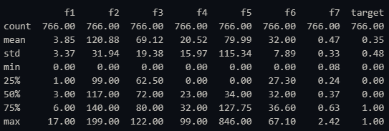
Number of missing samples: 0

Preprocessing:
The dataset contains no null values
The datatype object is changed to int using: pd.to_numeric
During this conversion NaN values are created
NaN is replaced using mode method

Graphs:
The first graph represents the frequency of f1 data
The histogram is right-skewed indicating that a large majority of the data is clustered near the lower range.

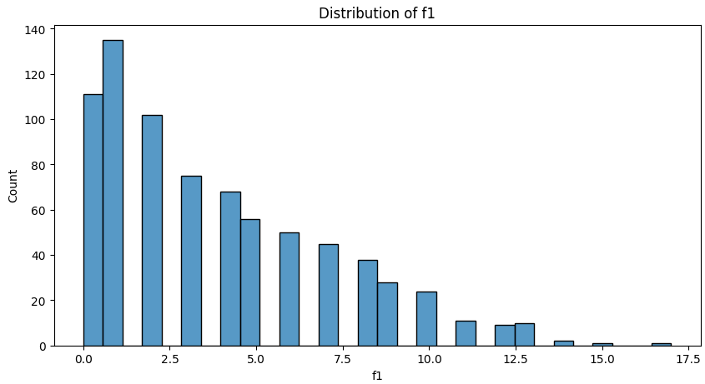

In the second graph, distribution of the variable f2 across two categories of a binary variable target (0 and 1) is displayed
For target 0:
Median: 125
A few outliers are higher than 175 but are not as severe as the lesser outliers.

For target 1:
Median: 150
There is just one outlier that can be seen below 75.

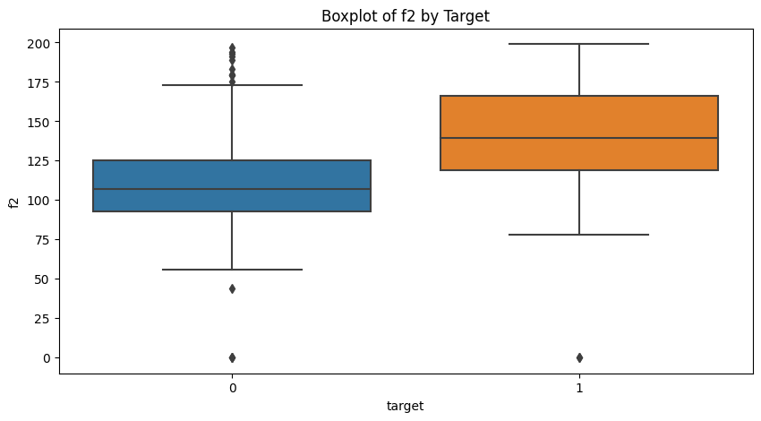

f2 and Target: The highest correlation with the target variable is 0.46.
The other variables (f3, f4, f5, and f7) have little to no linear connection with the target variable, as seen by their extremely weak correlations (all below 0.2).

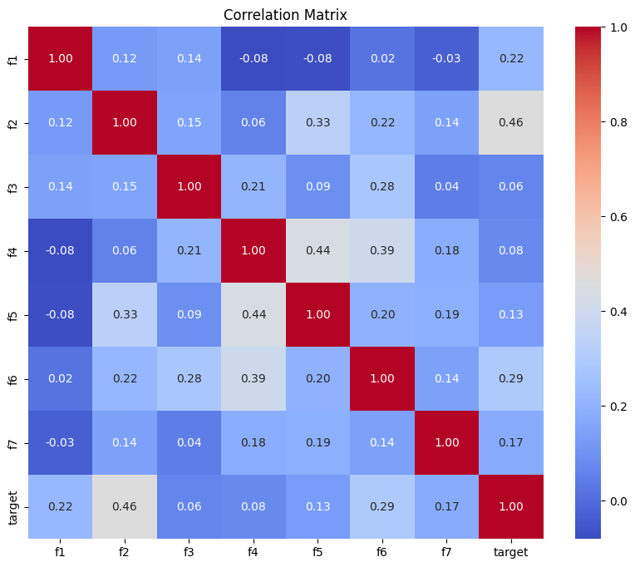

NN architecture
The model takes an input shape of [7, 1] and outputs predictions of the same shape [7, 1]
4,737 Parameters are trainable
The model is appropriate for small-scale classification problems because to its low computational and memory needs. It has a sigmoid activation for binary output predictions and uses dropout to avoid overfitting.
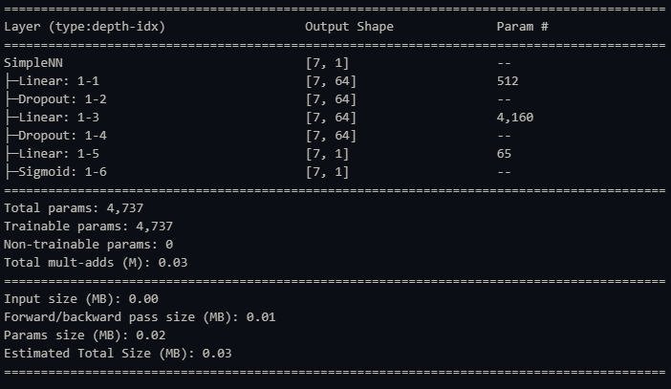

Analysis of the results

Performance metrics:
Accuracy: 0.7857142857142857
With a 78.57% accuracy rate, almost 79 out of 100 samples were properly identified by the model.

Precision: 0.7631578947368421
This metric is important when the cost of false positives is high, as it indicates the model's ability to avoid false alarms.

Recall: 0.5471698113207547
A comparatively poor recall suggests that a huge portion of real positive examples are being missed by the model.

F1 Score: 0.6373626373626373
The trade-off between recall and accuracy is reflected in the F1 score of 63.74%, suggesting that there is potential for improvement.

Loss Graph:

Training Loss:
The variations could indicate minor overfitting or model modifications, but as observed the loss generally keeps getting better until the training period is over.
Validation Loss:
Though it is still not as effective as the training set performance, the validation loss exhibits a smoother drop than the training loss, indicating that the model is becoming more capable of generalisation.
Test Loss:
Throughout, the test loss stays constant and is less than the training and validation losses.

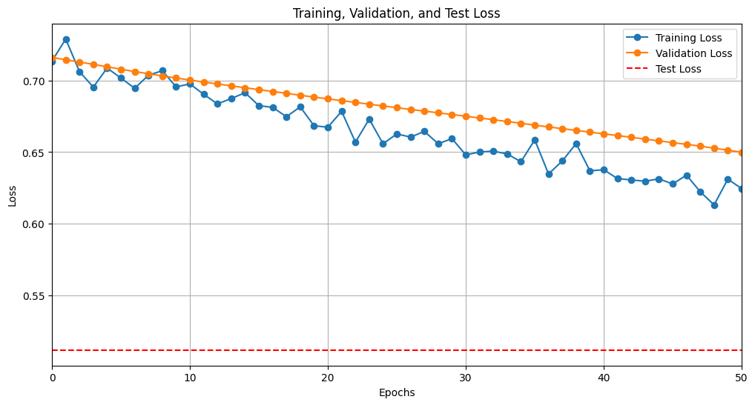
Accuracy graph
Training accuracy:
The training accuracy increases rapidly at the beginning and reaches around 75% by epoch 40 this indicates that the model is learning and fitting the training data well
Validation accuracy:
The decline in validation accuracy despite the increase in training accuracy is a sign of overfitting, where the model is becoming too specialized to the training data and is losing its ability to generalize to unseen data.
Test accuracy:
The test accuracy is fixed at around 77-78% throughout the training process.

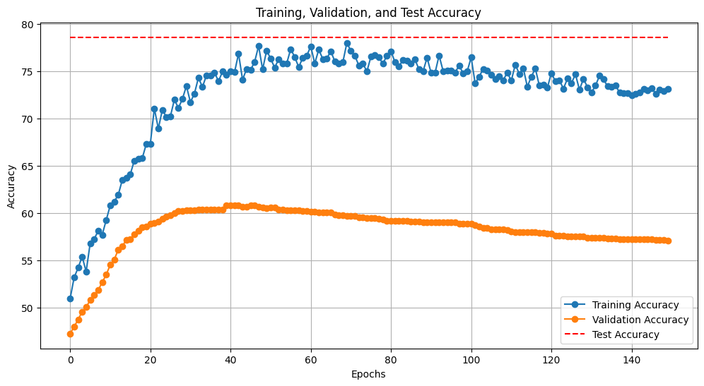
Confusion matrix
The model has a high precision, meaning most of the positive predictions are correct.
With an overall accuracy of 78.6%, the model performs decently, but there is room for improvement, especially in identifying more true positives and reducing false negatives.
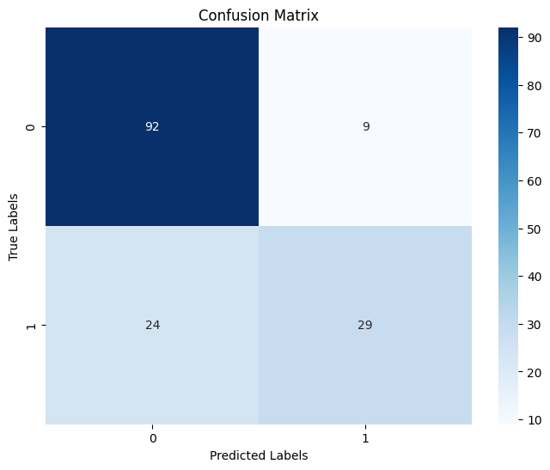
The sharp rise early on suggests that the model is able to achieve a relatively high true positive rate with a low false positive rate, which is a sign of good model performance.
Given the shape of this ROC curve, the AUC is likely moderate, suggesting the model performs reasonably well but has room for improvement.
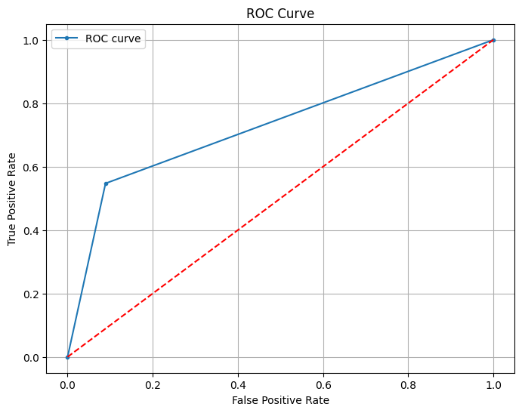
Part 2

Hyperparameter setups
Dropout Rate Tuning Results
Increasing the dropout rate from 0.1 to 0.5 improved test accuracy by approximately 9%.
This suggests that regularization via dropout helped the model generalize better by preventing overfitting, especially at 0.5 dropout as observed
A loss graph for dropout 5 is shown below. The loss generally keeps getting better until the training period is over.
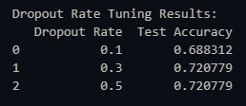
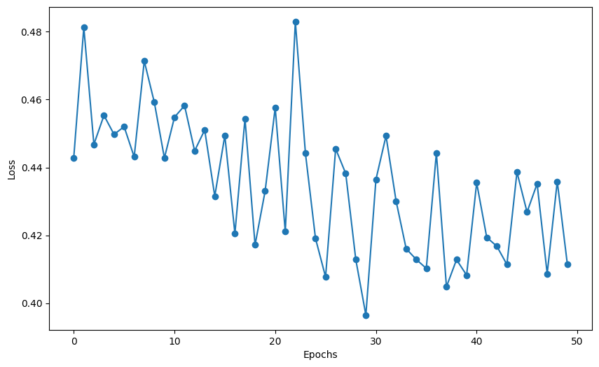
Learning Rate Tuning Results
Accuracy dropped to 74.68% as learning rates rose to 0.01 and 0.1, suggesting that the model could have overshot ideal weight modifications during training because of higher learning rates.
A loss graph for learning rate 0.01 is shown below. The loss generally keeps getting better until the training period is over.

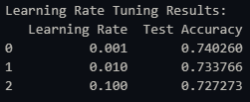
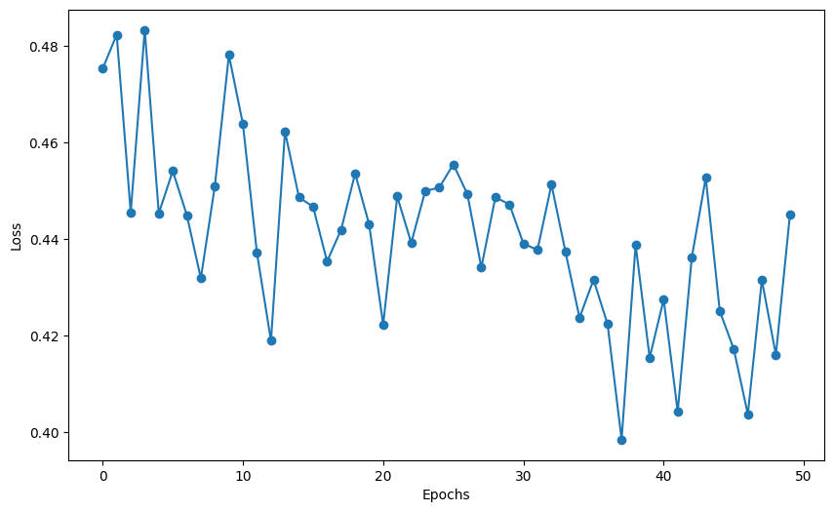
Number of Hidden Layers Tuning Results
Adding more layers does not necessarily improve the model's performance and could lead to overfitting
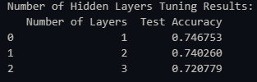
Methods used that help to improve the accuracy

K-Fold Cross-Validation:
Average Test Accuracy: 0.7511
Average Test Precision: 0.6310
Average Test Recall: 0.6667
Average Test F1 Score: 0.6476

By training and verifying the model on several subsets of the dataset, K-fold cross-validation made it possible to obtain a more accurate assessment of the model's performance. A little improvement over the original model was shown by the average test accuracy, which rose to 0.7511.

Learning Rate Scheduler
Test Accuracy: 0.7532
Test Precision: 0.6471
Test Recall: 0.6226
Test F1 Score: 0.6346

By modifying the learning rate in response to the model's performance during training, a learning rate scheduler was implemented, which improved the training process. In comparison to the basic model and the k-fold model, the test accuracy improved to 0.7532.

Early Stopping
Epoch: 24
Test Accuracy: 0.7597
Test Precision: 0.6600
Test Recall: 0.6226
Test F1 Score: 0.6408

By tracking validation loss, early stopping prevented overfitting by terminating training at epoch 24. The accuracy increased to 0.7597, demonstrating a significant improvement in model performance while preserving a balance between recall and precision.

Batch Normalization
Accuracy: 0.7662
Precision: 0.6977
Recall: 0.5660
F1 Score: 0.6250

By reducing the internal covariate shift, this method facilitated quicker convergence. Progress from 0.746753 (base model) to 0.7662 (with batch normalization).

Analysis:
Test accuracy:
The accuracies across all models are fairly similar, with slight variations. The Batch Normalized Model model has a better accuracy than all the models.

Training Time:
Compared to the other models, the Base Model requires the most training time. Although it is slower than the Base Model, the K-fold Model is still the second slowest. Training periods for the LR-Scheduled Model and Batch Normalised Model are gradually reduced. The Early Stopping Model performs the fastest and requires the least amount of training time.

Precision:
Batch Normalized Model has the highest precision among all models. Other models, including the Base Model, K-fold Model, LR-Scheduled Model, and Early Stopping Model, show slightly lower precision values but are still close to each other.

Recall:
The K-fold Model has the highest recall. The Base Model and Early Stopping Model have moderate recall values, closely following the K-fold Model. The Batch Normalized Model has the lowest recall, while the LR-Scheduled Model also performs similarly but slightly better than the Batch Normalized Model.

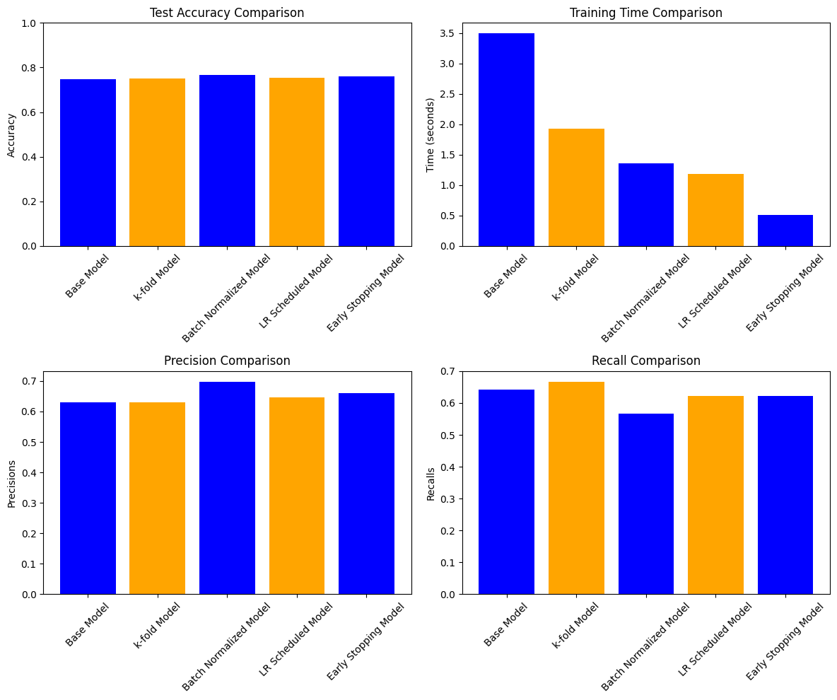
Best Model = Batch Normalized Model
After applying the test data on the model we get:
Accuracy: 0.7662337662337663
Precision: 0.6976744186046512
Recall: 0.5660377358490566
F1 Score: 0.625

Both training and validation accuracies being very low and constant suggest the model is underfitting, it is not learning well from the training data. The model may be too simple or not tuned properly, resulting in poor performance on training and validation, but better on the test set.
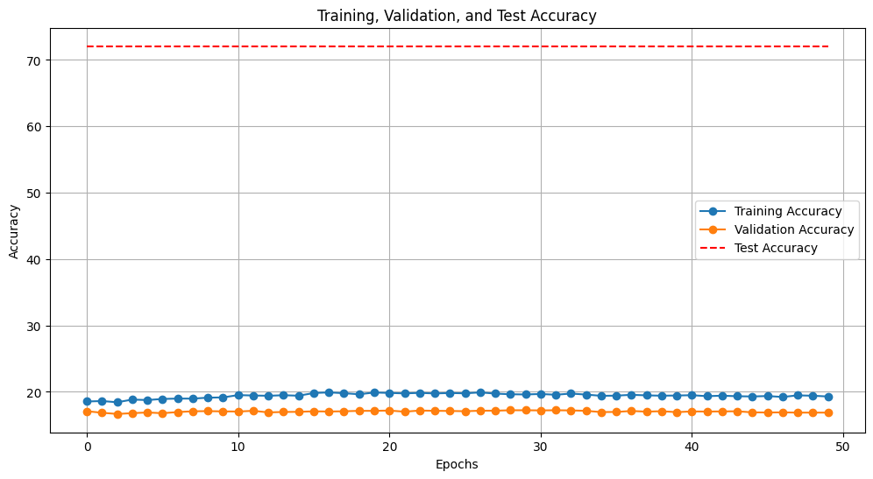

The Training and Validation Loss plots show a steady decline over epochs, which indicates that the model is indeed learning and improving. While the accuracy might be low, the consistent reduction in loss is a good sign that with some adjustments (like more epochs or better optimization), the model can improve further.
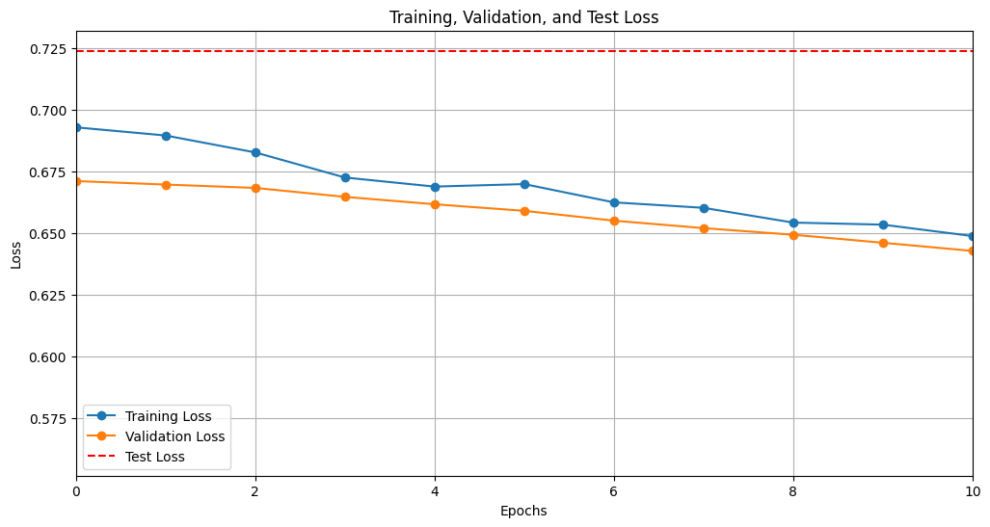
Confusion matrix and ROC Curve:
There are only a few misclassifications, and the model is correctly classifying most of the data. The model is slightly better at classifying the negative class than the positive class. ROC curve is above the random guessing line, which indicates that the model is performing better than random guessing. However, the AUC is not very high, which suggests that the model is not performing particularly well. The ROC curve is also quite steep, which means that the model is very sensitive to changes in the classification threshold.

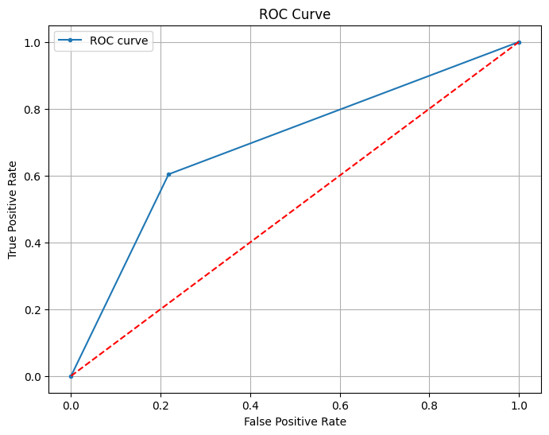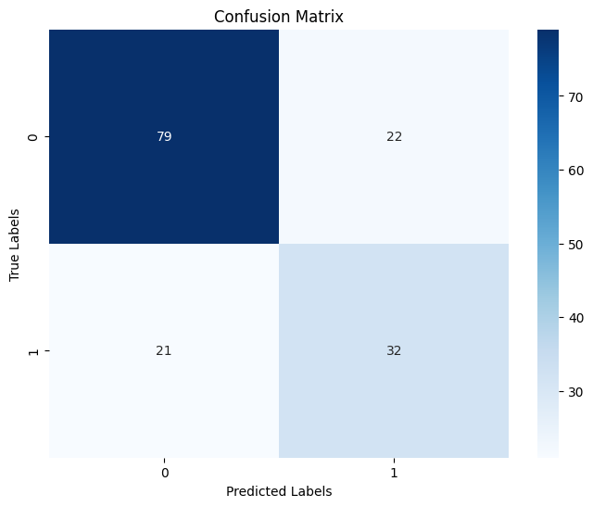

Part3
- Provide a brief overview of your dataset (e.g. type of data, number of samples, and features. Include key statistics.
The dataset consists of images categorized into 36 unique classes, with each category representing a different label. Each image is 28x28 pixels and may be grayscale (1 channel) or RGB (3 channels). In total, the dataset includes:
- Number of Samples: 100,800 images (2,800 samples per category).
- Image Resolution: Each image is 28x28 pixels.
- Features: Each image can have either 1 channel (grayscale) or 3 channels (RGB).
Key Statistics:
- Class Distribution: All the classes from 0-9 and ‘A’-‘K’ has 2800 samples whereas class ‘L’ has 1945 samples.
- Total number of pixels: 47624080.0000
- Mean of pixel intensities: -0.6537
- Standard deviation of pixel intensities: 0.6635

- Include at least 3 graphs, such as histograms, scatter plots, or correlation matrices. Briefly describe the insights gained from these visualizations.
  - Class Distribution Bar Plot
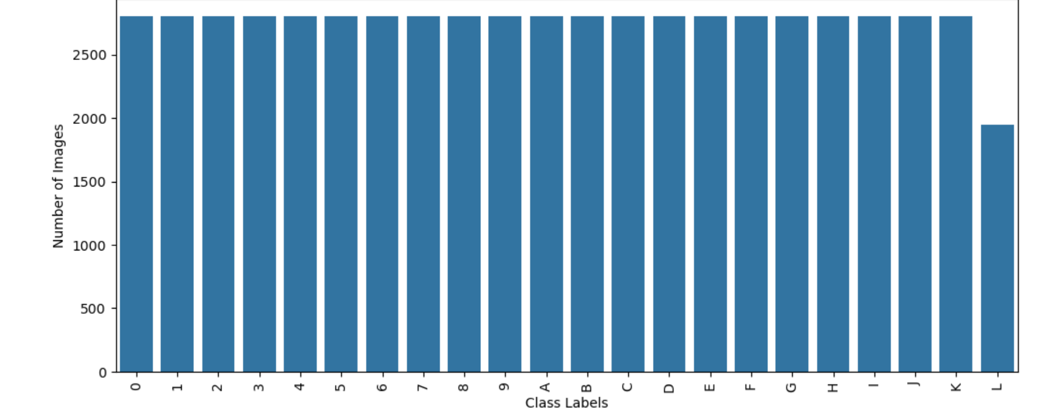
- Insights :
  - There are total of 22 classes.
  - These classes are named from 0-9 and ‘A’- ‘L’.
  - All the classes from 0-9 and ‘A’-‘K’ has 2800 samples whereas class ‘L’ has 1945 samples.

  - Pixel Intensity Histogram
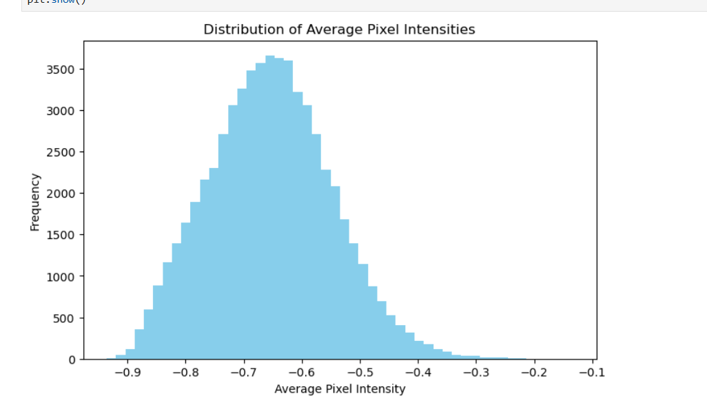

- Insights :
  - The pixel intensity distribution resembles a bell-shaped curve, indicating a roughly normal distribution. This is common in many datasets where pixel values are centered around a certain range of brightness values.
  - The distribution is fairly spread out, showing some images with pixel intensities extending further towards both lower and higher intensity ranges. This indicates a variety of contrast levels in the images.
  - There appears to be no extreme spikes or gaps in the histogram, implying that all images have relatively consistent average pixel intensity ranges, which is beneficial for stable model training.
  - Scatter Plot of Average Pixel Intensity vs. Pixel Variance
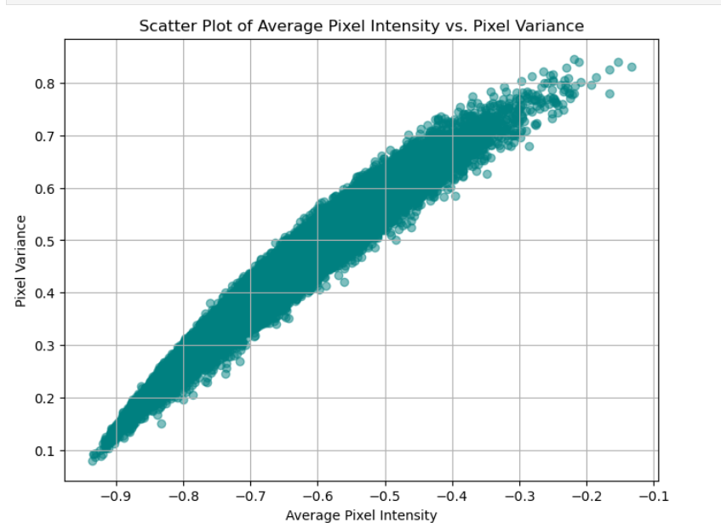
- Insights
  - Since no outliers are present, it reduced the risk of having significant model errors due to anomalous data.
  - Scatter plot shows straight line distribution showing linear relationship between average pixel intensity and pixel variance.

- Provide a summary of your final CNN model that returns the best results. Describe your CNN architecture choice.
Performance Overview:
- Accuracy: The model achieved a best accuracy of 95.58% using a tuned learning rate, which significantly contributed to optimizing the training performance.
CNN Architecture Description:
- Convolutional Layers:
  - Layer 1:
    - Type: Conv2d
    - Input Shape: 28x28
    - Output Shape: 32 channels of size 28x28
    - Parameters: 320
  - Layer 2:
    - Type: MaxPool2d
    - Operation: Reduces the spatial dimension to 14x14 for each channel using a pooling operation.
  - Layer 3:
    - Type: Conv2d
    - Output Shape: 64 channels of size 14x14
    - Parameters: 18,496
  - Layer 4:
    - Type: MaxPool2d
    - Operation: Reduces spatial dimensions further to 7x7.
  - Layer 5:
    - Type: Conv2d
    - Output Shape: 128 channels of size 7x7
    - Parameters: 73,856
  - Layer 6:
    - Type: MaxPool2d
    - Operation: Reduces spatial dimensions to 3x3.
- Fully Connected (Linear) Layers:
  - Layer 7:
    - Type: Linear
    - Input: 1152.
    - Output Shape: 512 neurons
    - Parameters: 590,336
  - Layer 8:
    - Type: Linear
    - Output Shape: 36 neurons (corresponding to the 36 output classes)
    - Parameters: 18,468
- Activation Functions: ReLU (Rectified Linear Unit
- Pooling: MaxPooling
- Parameter Summary:
  - Total Parameters: 701,476
  - Trainable Parameters: 701,476
  - Non-Trainable Parameters: 0
Architecture Choice Rationale:
- Convolutional Layers extract spatial features and capture patterns within the images, such as edges, textures, and shapes.
- MaxPooling reduces the dimensions progressively, minimizing computation while preserving essential features.
- Fully Connected Layers consolidate the spatial features extracted by convolutional layers into final classification decisions.
- The choice of using three convolutional layers allows for increasingly complex feature extraction while keeping the architecture relatively lightweight to prevent overfitting.
- Learning Rate Tuning: Adjusting the learning rate was crucial in optimizing model performance, achieving high accuracy efficiently by controlling how weights are updated during training.

- Provide performance metrics and graphs (Step 7 & 8). Include your detailed analysis of the results.
- Evaluation Time: 24.9368 seconds.
- Accuracy: 93.18%.
- This suggests that the model correctly predicted 93.18% of the instances in the test dataset.
- Precision: 93.50%.
- Precision indicates the percentage of relevant instances among all the instances that were predicted as positive by the model. This value shows that when the model predicts a positive class, it is correct 93.5% of the time. High precision helps ensure that there are fewer false positives.
- Recall: 93.18%.
- Recall tells us the percentage of actual positive instances that the model successfully predicted. With a recall of 93.18%, the model is doing well in correctly identifying the positive instances.
- F1 Score: 93.08%.
- The F1 score is the harmonic mean of precision and recall, providing a balance between them. An F1 score of 93.08% indicates a very good balance between precision and recall.
- Test Loss: 0.2178.
- The test loss measures how well the model's predictions align with the true labels. A low test loss (close to 0) is desirable, and this value indicates that the model is performing well without significant overfitting or underfitting.

Confusion Matrix Analysis
- The confusion matrix is a 22x22 matrix, which means that the model is dealing with a multi-class classification problem (22 classes).
- Diagonal elements represent correct predictions (True Positives), while off-diagonal elements represent misclassifications (False Positives and False Negatives).

Key observations from the confusion matrix:
- The diagonal elements are mostly high, meaning that the model is correctly classifying instances for most classes.
- Some off-diagonal elements indicate misclassifications, such as:
  - Class 13 has several misclassifications, with instances incorrectly classified as other classes (e.g., 32 instances classified as class 1).
  - Class 18 also shows some misclassifications (150 instances classified as class 0, etc.).
  - However, the overall distribution of misclassifications is relatively balanced, meaning that most errors are spread out across the classes and not concentrated in a few specific ones.

ROC Curve
The ROC curve illustrates the trade-off between the true positive rate (recall) and the false positive rate (1 - specificity) at various classification thresholds.
- True Positive Rate (TPR) and False Positive Rate (FPR) are plotted on the curve.
- The AUC (Area Under the Curve) is 0.2415, which is very low for a multi-class problem, suggesting that the ROC curve is not ideal. This might indicate that the classifier has difficulty distinguishing between classes at certain thresholds. However, AUC is typically more informative for binary classification problems, and the multi-class AUC might need to be computed differently (e.g., micro, macro, or weighted averaging).

Graphs :
- Losses for training, test and Validation
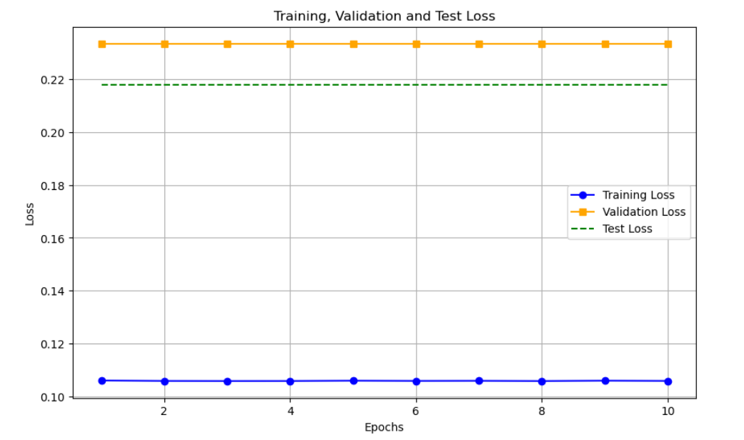\
- Training, test and validation accuracies

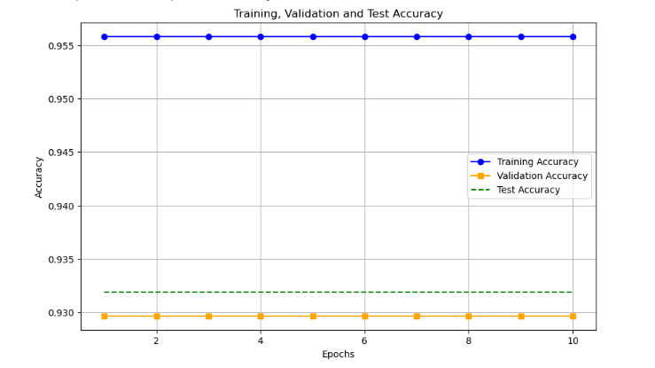

- Confusion Matrix Heatmap
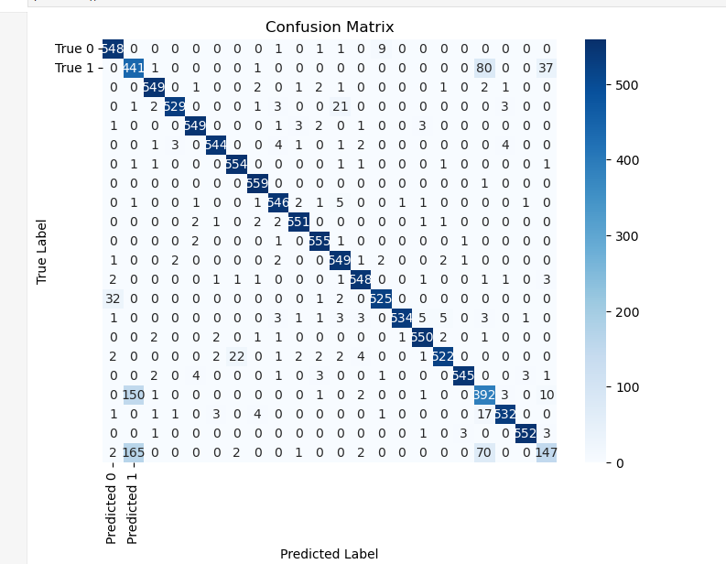
- ROC Curve
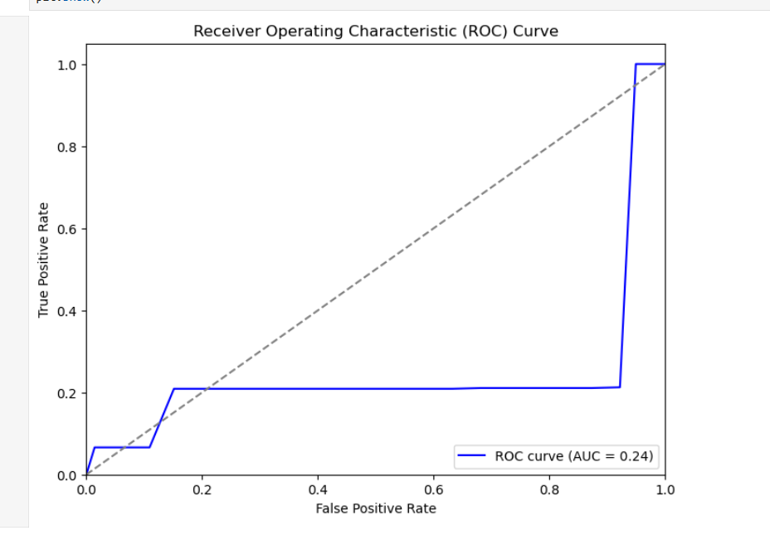
Part 4

Model Summary:
_________________________________________________________________
Layer (type) Output Shape Param #
=================================================================
conv2d (Conv2D) (None, 28, 28, 64) 640

conv2d_1 (Conv2D) (None, 28, 28, 64) 36928

max_pooling2d (MaxPooling2D (None, 14, 14, 64) 0
)

conv2d_2 (Conv2D) (None, 14, 14, 128) 73856

conv2d_3 (Conv2D) (None, 14, 14, 128) 147584

max_pooling2d_1 (MaxPooling (None, 7, 7, 128) 0
2D)

conv2d_4 (Conv2D) (None, 7, 7, 256) 295168

conv2d_5 (Conv2D) (None, 7, 7, 256) 590080

max_pooling2d_2 (MaxPooling (None, 3, 3, 256) 0
2D)

conv2d_6 (Conv2D) (None, 3, 3, 512) 1180160

conv2d_7 (Conv2D) (None, 3, 3, 512) 2359808

max_pooling2d_3 (MaxPooling (None, 1, 1, 512) 0
2D)

conv2d_8 (Conv2D) (None, 1, 1, 512) 2359808

conv2d_9 (Conv2D) (None, 1, 1, 512) 2359808

flatten (Flatten) (None, 512) 0

dense (Dense) (None, 4096) 2101248

dropout (Dropout) (None, 4096) 0

dense_1 (Dense) (None, 4096) 16781312

dropout_1 (Dropout) (None, 4096) 0

dense_2 (Dense) (None, 22) 90134
=================================================================
Trainable params: 28,376,534
Model Details:
Convolutional Layers: Ten convolutional layers (Conv2D) make up the initial network. The spatial dimensions of the feature maps are down-sampled by max-pooling layers, which come after two successive convolutional layers in each convolutional block. Beginning with 64 filters in the initial levels and rising to 512 in the deeper layers, the number of filters grows gradually.
Each of the four max-pooling layers shrinks the feature maps by a factor of two.
Dense Layers: Three dense layers are added after the model has been flattened following the convolutional blocks. Dropout layers are placed in between the first two completely linked layers, which each have 4096 units, to avoid overfitting.
Dropout: To prevent overfitting, dropout layers with a dropout rate (0.5) are put prior to the dense layers.
Output Layer: With 22 units, the last layer is dense and represents the number of classes.
28,376,534 trainable parameters in total.

CNN architecture P3 v/s P4:
Ten convolutional layers make up Part 4's architecture, which is far deeper than Part 3's three. The model can extract more intricate information from the data because of the deeper network.
In Part 4, the number of filters increases from 64 in the first levels to 512 in the deeper layers. Part 3, on the other hand, employs fewer filters (32, 64, and 128). The network can collect more feature representations because to Part 4's higher filter count.
Max-pooling is used in both architectures to down-sample feature maps. But as depth grows, Part 4's usage of more max-pooling layers results in a greater loss in spatial dimensions.
In contrast to Part 3, which only has one completely linked layer with 512 units, Part 4 contains two fully connected layers with 4096 units each. The model has greater potential to learn higher-level representations because to the bigger dense layers in Part 4.
In Part 4, dropout is used to reduce overfitting, which is not present in Part 3.

Performance metrics and graphs:
Epochs: 5
Training Time: 7137.94 seconds (approx. 1 hour 59 minutes)
Learning Rate: 1e-4

Training Performance
Training Loss: 0.3551
Training Accuracy: 87.81%

Validation Performance
Validation Loss: 0.2667
Validation Accuracy: 90.32%

Test Performance
Test Loss: 0.2667
Test Accuracy: 90.32%

Evaluation Metrics on Test Data
Precision: 0.90
Recall: 0.90
F1 Score: 0.90

Good generalisation from the training data to unseen data is indicated by the model's excellent validation and test accuracy. This implies that rather than overfitting, the network discovered significant patterns in the sample.

A balanced model performance is shown by the precision, recall, and F1 score of 0.90, which indicates that the model is equally adept at properly recognising positive cases and detecting the majority of actual positive occurrences. The F1 score provides more evidence that recall and accuracy are given equal weight.

For the majority of the test data, the model's predictions were rather near to the real labels, as seen by the comparatively low validation and testing loss value of 0.2667. This indicates that the model fits the underlying data distribution rather well.
Graphs:

Confusion Matrix:

The confusion matrix shows a high number of correct classifications along the diagonal, confirming that the model is performing well for most classes.
From the confusion matrix we can see that the ‘I’ and ‘L’ is very similar to ‘1’ and ‘D’ is similar to ‘0’. This similarity can be reduced by providing more dataset or additional layers in the network could potentially improve performance.

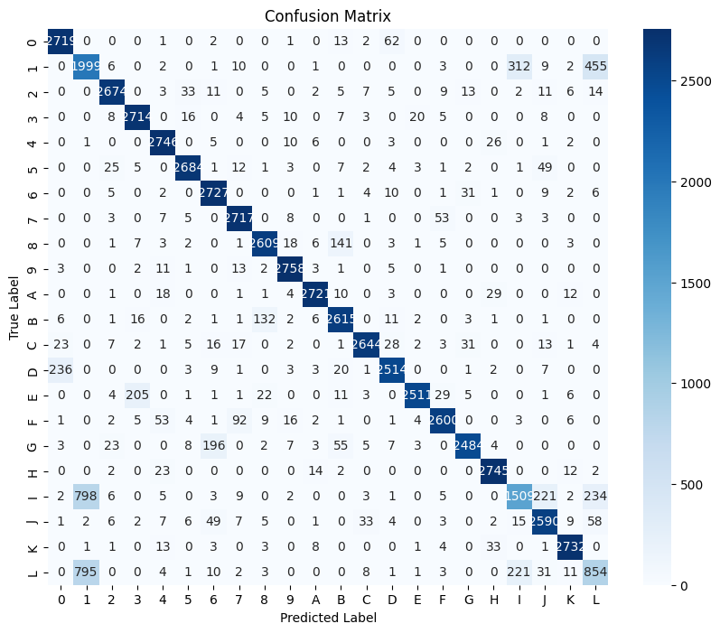
ROC Curve:

The overall robustness and efficacy of the model in multi-class classification are shown by the AUC values for each class being near 1.00.
It may be difficult for the model to discriminate precisely between the classes with AUCs that are marginally less than 1.00 due to overlapping characteristics or similarities. 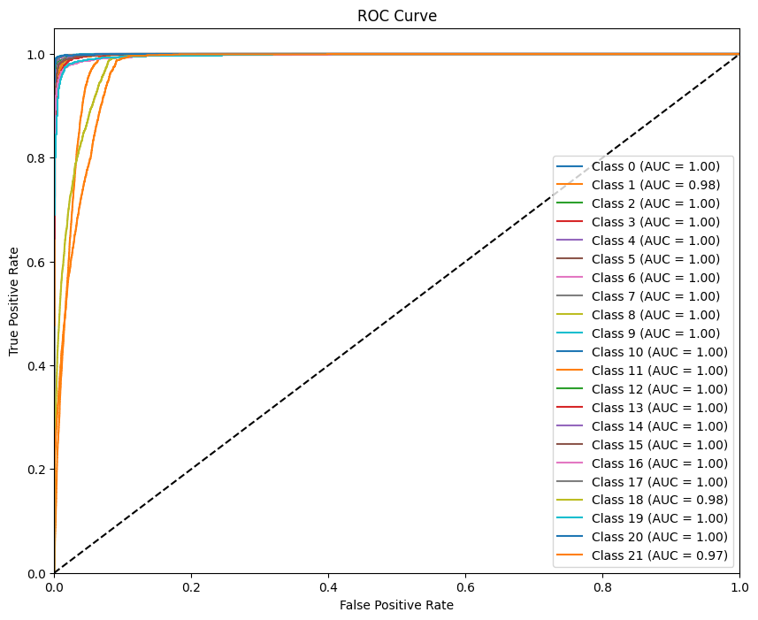
Accuracy and Loss Graph:

Starting at about 40% in the first epoch and approaching 90% by the fifth, training accuracy increases gradually over the course of epochs.

With a small lead in the early epochs, validation accuracy also rises gradually and nearly tracks training accuracy. Validation accuracy approaches test accuracy by the fourth and fifth epochs.

Plotting the test accuracy as a horizontal line at about 90% shows that the final model performs well and steadily on unknown data.

The training loss drops dramatically throughout the course of the epochs, from a peak of about 1.8 in the first to a low of less than 0.3 by the fifth.

The validation loss which also slowly declines, closely resembles the training loss pattern and reaches a low value by the end.

Test Loss shows little variation between test and validation performance, remaining low and flat.

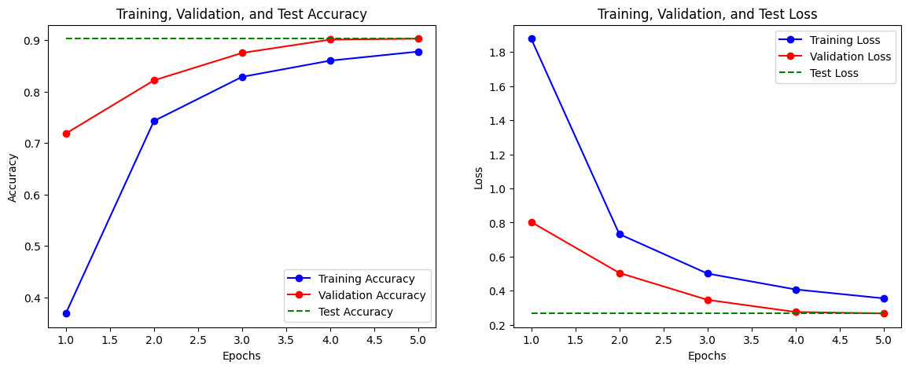

Comparison of Part 3 and Part 4 Results
Metric | Part 3 | Part 4 | Analysis
Accuracy | 93.18% | 90.32% | Part 3 is higher, indicating better classification.
Precision, Recall, F1 | 93.50%, 93.18%, 93.08% | 90%, 90%, 90% | Part 3 is higher across all metrics.
 |  |  | Lower in Part 3, suggesting better data fit.
  Test Loss
  0.2178
  0.2667
Confusion Matrix | Misclassifications in Classes 13, 18 | Misclassifications due to similar characters (e.g., 'I' and '1') | Misclassification types differ slightly.
AUC | 0.2415 (low) | Near 1.00 per class | Part 4 shows stronger class separability.
Contributions
Team Member | Assignment Part | Contribution (%)
Alankriti Dubey | Part 1- Defining the Neural Network  Part 2 – Early Stopping, Batch Normalization, and Learning Rate Scheduler.  Report – Part 1  Part 3 - Building a CNN  Report – Part 3 | 50
Nidhi Parab | Part 1 – Training the Neural Network  Part 2 – Hyperparameters tuning and K-Fold Cross Validation  Report – Part 2  Part 4: VGG-13 Implementation  Report – Part 4 | 50

