Alankriti Dubey (50604200)
Nidhi Parab (50606993)
Checkpoint
Part 1
Dataset Overview
The dataset includes a
- Binary target and
- Numerical features (f1 - f7)
Number of samples: 766
Statistics:
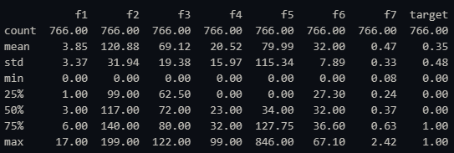
Number of missing samples: 0

Preprocessing:
The dataset contains no null values
The datatype object is changed to int using: pd.to_numeric
During this conversion NaN values are created
NaN is replaced using mode method

Graphs:
The first graph represents the frequency of f1 data
The histogram is right-skewed indicating that a large majority of the data is clustered near the lower range.

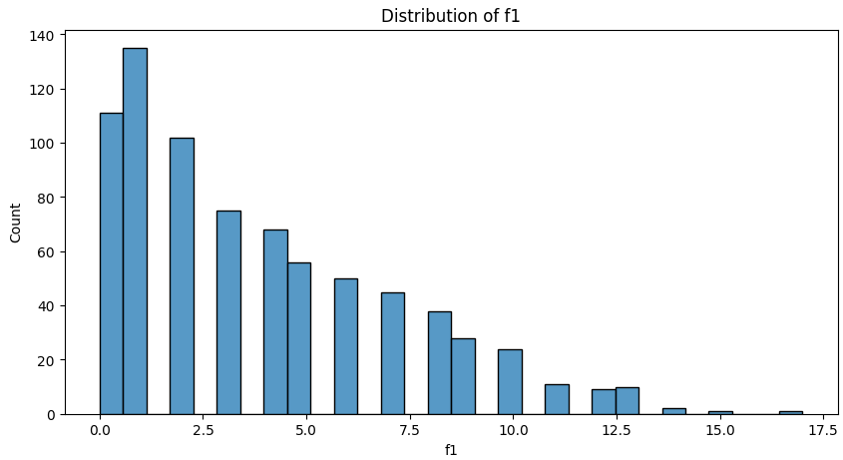

In the second graph, distribution of the variable f2 across two categories of a binary variable target (0 and 1) is displayed
For target 0:
Median: 125
A few outliers are higher than 175 but are not as severe as the lesser outliers.

For target 1:
Median: 150
There is just one outlier that can be seen below 75.

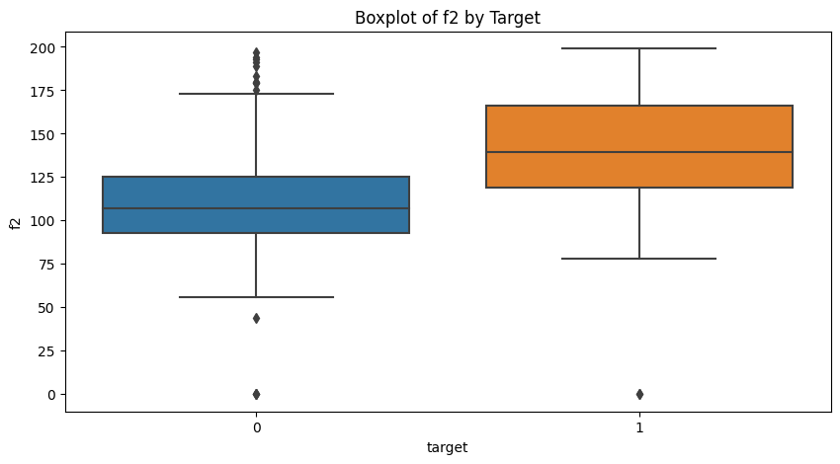

f2 and Target: The highest correlation with the target variable is 0.46.
The other variables (f3, f4, f5, and f7) have little to no linear connection with the target variable, as seen by their extremely weak correlations (all below 0.2).

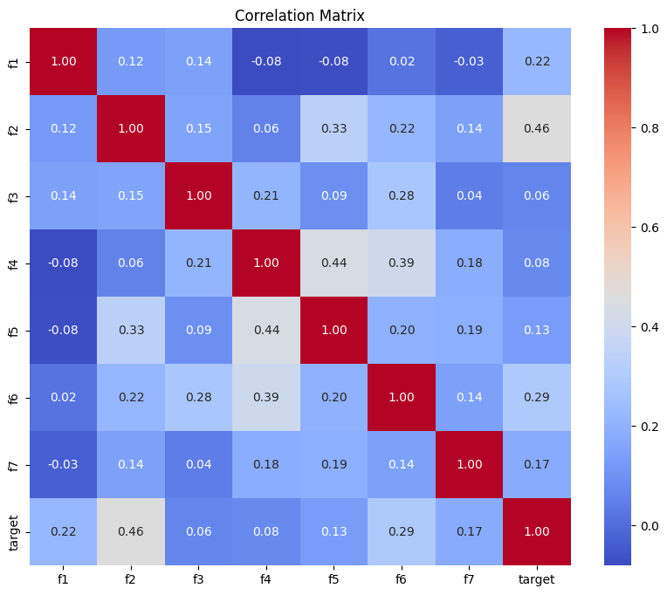

NN architecture
The model takes an input shape of [7, 1] and outputs predictions of the same shape [7, 1]
4,737 Parameters are trainable
The model is appropriate for small-scale classification problems because to its low computational and memory needs. It has a sigmoid activation for binary output predictions and uses dropout to avoid overfitting.
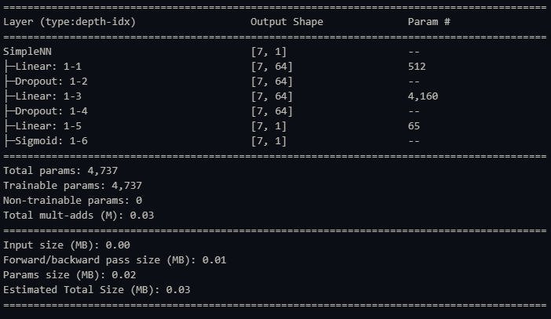

Analysis of the results

Performance metrics:
Accuracy: 0.7857142857142857
With a 78.57% accuracy rate, almost 79 out of 100 samples were properly identified by the model.

Precision: 0.7631578947368421
This metric is important when the cost of false positives is high, as it indicates the model's ability to avoid false alarms.

Recall: 0.5471698113207547
A comparatively poor recall suggests that a huge portion of real positive examples are being missed by the model.

F1 Score: 0.6373626373626373
The trade-off between recall and accuracy is reflected in the F1 score of 63.74%, suggesting that there is potential for improvement.

Loss Graph:
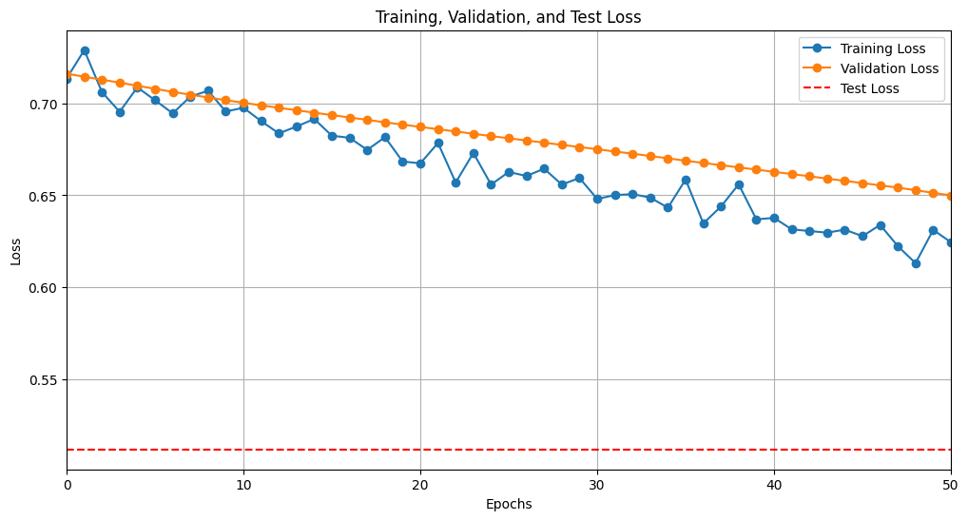
Accuracy graph
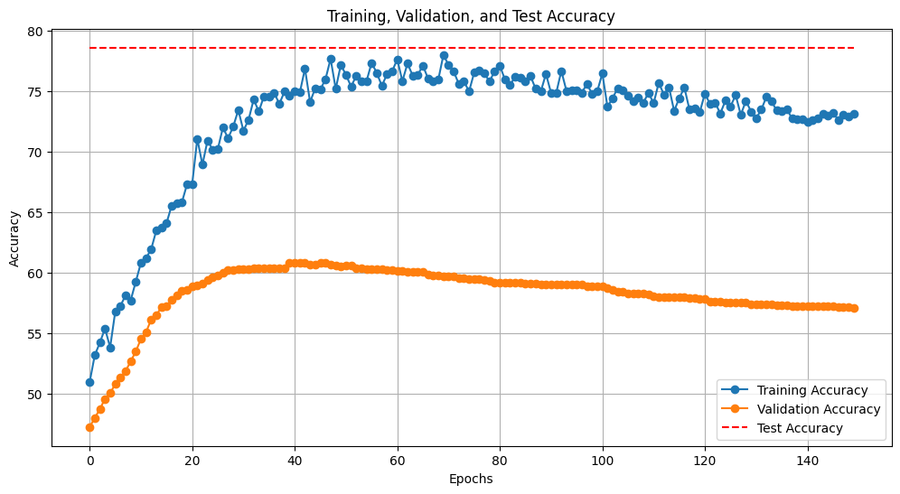
Confusion matrix
