*ABSTRACT*

This paper intends to delineate the details of the newly built platform DigiFarm which aids the farmers in making informed decision based on their soil pattern and weather condition.The central aim of DigiFarm is to help the farmers in predicting the crops most suited for their farm for maximum yield.The crop prediction system is designed in such a way that it is user friendly and it gives accurate results. The prediction model is theresult of testing the dataset with several algorithms and methodologies to determinewhich is best and has highest accuracy rate. The crops are the target label in the research work and different algorithms like Light Gradient Boosting Machine (LGBM)Classifier and Extra tree classifier have been used for training the machine learning model and it is constructed carefully using machine learning and artificial intelligence technologies. On testing the crop prediction system using both the training models the LGBM Classifier algorithm gives nearly hundred percent accuracy. Hence, LGBM Classifier is chosen to predict the crops in the website. For deploying this ML model, IBM cloud services has been used. DigiFarm would result in digitization of agriculture on a global scale. However, itwould prove extremely beneficial to farmers in India who find it difficult to access theinformation as their outreach is confined which results in using obsolete methods despite theadvancements.

*Keywords***-** Digital Farming,DigiFarm, Farmers, Machine Learning Model, Crop Prediction.

*Introduction*

Farmers, the soul of the Indian economy, are the ones who feed the huge population of India. Without them, no one would be getting food on their plate today. As the population keeps increasing every day, it gets more difficult to feed such a huge population with the required diet and supplements requirement. The authors [1] Sanoj Kumar Patel,Anil Sharma and Gopal Shankar Singh, in their paper ‘Traditional agricultural practices in India: an approach for environmental sustainability and food security’ discusses that it is estimated that the world population would be reaching 9.5 billion by the end of 2050. In order to feed such a huge population an extensive food production will be required [2]. In the literature [3] the authors talk about how 80% of the arable land is cultivated with single crops like rice, corn, wheat and soybean that degrade the quality of agriculture globally. Due to population explosion over-exploitation also keeps increasing of resources. The author P K Sofia [4] tells that traditional farming is considered to be 4000 years old.Traditional farming is economical and environment friendly to some extent. In the literature [5] [6] author tells that 70% of the population in Indiadepends on traditional farming methods for their livelihood.Almost 90% of the tribal population in India is dependent on traditional farming [7]. According to [8] Lincoln NK, traditional farmingproductivity is due to the usage of local resources and that they keep in mind the climatic conditions. Lincoln also stated in his paper that Ancient Hawaiians were popular for their traditional farming system in which they adapted to local climate by using natural resources. In the literature [9] ‘Agricultural biodiversity as a link between traditional food systems and contemporary development, social integrity and ecological health’ by Timothy Johns, Bronwen Powell, Patrick Maundu1 and Pablo B Eyzaguirreb, it is stated that traditional farming provides financial support to the farmers that secures the diet and nutrition of the global population. The author [10] Ram Bahadur Rana in his paper mentioned that various traditional rice varieties have high demand overseas as well as in domestic market. Although traditional farming is widely used yet it is not the best method of farming and there are numerous drawbacks for the same. The foremost problem is soil erosion. When the land gets eroded due to water, wind, ice or gravity there is an increase in soil erosion. Other factors that affect traditional farming are use of excessive pesticides which is harmful for the soil as well the crops. Likewise, water depletion, pollution, silt and eutrophication also play a significant role as a drawback for traditional farming. Climatechange has become one of the most pressing concerns in modern times. The worldhas indeed experienced some drastic changes in the recent past, from glaciers melting toerratic rainfall. A number of challenges have been created for agriculture as a result ofclimate change, and they will continue to grow. In addition to affecting crop growth rate,climate change also affects rainfall variability. They all play a role in raising globaltemperatures. Due to these factors also, traditional farming does not yield good results as expected. Due to the drawbacks of traditional farming farmers are in debt because of which many farmers commit suicide all the world every year [11]. In the literature [12] the author tells that between 1995 and 2006, 166304 farmers committed suicide in India and the number has kept on increasing since then. Increase in the usage of cash crops have also led to increase in suicide rate as these crops are costlier and majority of them are exported [13]. Various factors have led to farmers committing suicide every year and there is no one factor that contributes in this.

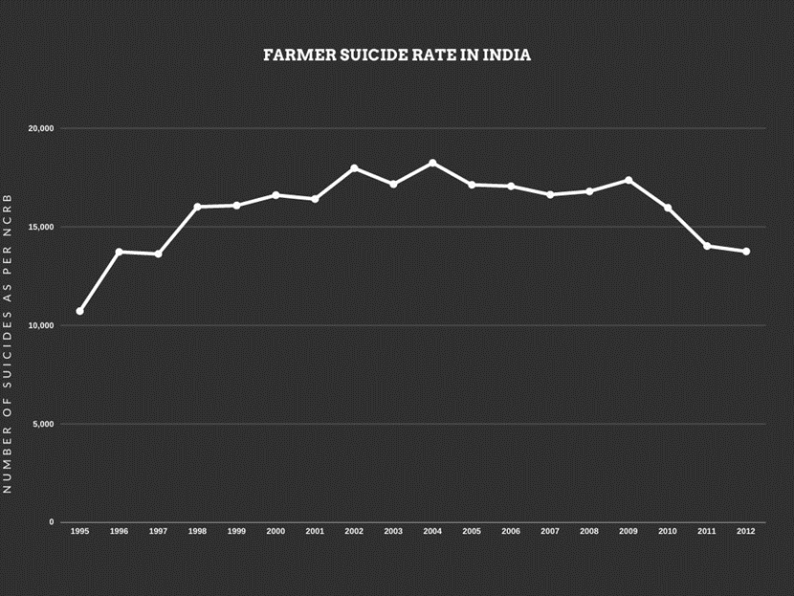

Figure 1: Farmer Suicide Rate in India as per NCRB

In order to help farmers with their problems DigiFarm is introduced with the sole purpose of helping farmers in various methods. In the literature [14] the authors talk about the latest advancements in digital farming such as field scouting and harvesting. They even tell various concepts such as sensors and robots that can be used extensively in digital farming. Their research is very beneficial for bringing a major change to the current farming trends and farmers could use them insightfully. However, they fail to predict the crops which the farmers could grow for better yield. DigiFarm is primarily aimed at farmers that can assist with their needs. The motive isto make the farmers aware of digital farming and make them aware about it and how is itbetter than traditional farming and using DigiFarm farmers can predict which crops they cansow on their land based on certain factors like their soil condition (pH of the soil, type of thesoil etc.,), weather conditions, state and district. The prediction is based on the machinelearning model which is trained with adequate amounts of statistical data so that theprediction is accurate and is ultimately helpful for the farmers to increase their income.In the literature survey [15], ‘Efficient Crop Yield Recommendation System Using Machine Learning for Digital Farming’ the authors talk about their work to help the farmers by deciding the dirt quality.They used the algorithm thatutilizes the arrangement calculation of Help Vector Machine to improve the crop prediction module.The algorithm detects the dirtand gives information about which crop would be best suited and it also tells which nutrients are not present abundantly for that specific crop.

The main aim of DigiFarm is to help the farmers in growing theirbusiness by growing theright crop at the right time and making them aware about Digital Farming. Due to the globalaccessibility of DigiFarm, even a farmer in some remote village can access it and make profitthereby. All their queries will be answered by the chatbot present in the website.The website DigiFarm which is designed carefully and accurately to predict the most suitablecrop that the farmer can produce in his region. The website is designed to equip the farmerswith digitized farming so that with the aid of thiswebsite, they can receive precise information about which crops would be most suitable fortheir land. They can also know about the weather in their area through the weather section present in DigiFarm. DigiFarm also provides the latest news related to agriculture in the news section.

This paper is organized as follows: Section 2 presents the Methodology used to develop thewebsite, collect the data and use different algorithms. Section 3 presents the result anddescription of the website. Section 4 summarizes the conclusion to our study derived fromthe website. Section 5 presents the future scope of the whole website and how it will benefitthe mass. Finally, Section 6 presents the references used in the paper.

**2. METHODOLOGY**

Data is a very important part of a Machine Learning Model. Hence, DigiFarm is a user-friendly website designed in such a way that anyone can use it to predict the best crop that can be grown on their soil. To predict the crop we have used Machine Learning (ML) and Artificial Intelligence (AI) technologies. The prediction model is the result of testing the dataset with several algorithms and methodologies to determine which are the best and has the highest accuracy rate.

Following are the steps that we have followed to create the crop prediction model:

1. Data collection
2. Data preparation and analysis
3. Choosing the algorithm for training the dataset
4. Testing the Machine Learning (ML) model and evaluation
5. Deploying
6. *Data collection*

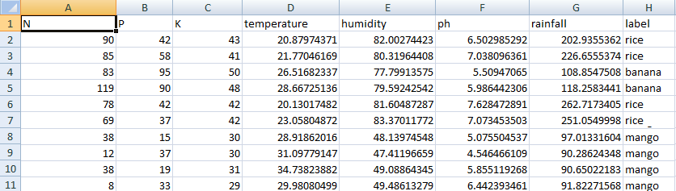 To train this prediction model we are using the dataset which we have procured from Kaggle Website (https://www.kaggle.com/siddharthss/crop-recommendation-dataset) which is shown in Figure 1. This dataset was build by augmenting datasets of rainfall, climate and fertilizer data available for India. Gathered over the period by ICFA, India.

*Figure 2: Dataset used to train Machine Learning Model*

1. *Data preparation and analysis*

The Dataset which is shown in Figure 1 has 2201 samples among which we have used 90% (i.e. 1980 samples) for the purpose of training. The remaining 10% (i.e. 221 samples) are used for testing purpose. The dataset contains 8 attributes (they are Nitrogen, Phosphorous, Potassium, Temperature and humidity of the region, pH of the soil, Rainfall in mm in that region and the crop).The dataset contains 22 distinct categories (i.e., Apple, Banana, Blackgram, Chickpea, Coffee, Cotton, Grapes, Jute, Kidneybeans, Lentil, Maize, Mango, Mothbeans, Mungbean, Muskmelon, Orange, Papaya, Pigeonpeas, Pomogranate, Watermelon, Rice, Coconut).

Before training our dataset we conducted following preliminary analysis of the dataset:

1. Finding out some statistical information about the data which is summarized in the Table 1

|  |  |  |  |  |  |  |  |
| --- | --- | --- | --- | --- | --- | --- | --- |
| *Statistical Parameters* | *N* | *P* | *K* | *Temperature* | *Humidity* | *ph* | *Rainfall* |
| *Count* | 2200.00 | 2200.00 | 2200.00 | 2200.00 | 2200.00 | 2200.00 | 2200.00 |
| *Mean* | 50.55 | 53.36 | 48.14 | 25.61 | 71.48 | 6.46 | 103.46 |
| *Standard Deviation* | 36.91 | 32.98 | 50.64 | 5.063 | 22.26 | 0.77 | 54.95 |
| *Minimum value* | 0.00 | 5.00 | 5.00 | 8.82 | 14.25 | 3.50 | 20.21 |
| *25%* | 21.00 | 28.00 | 20.00 | 22.76 | 60.26 | 5.97 | 64.55 |
| *50%* | 37.00 | 51.00 | 32.00 | 25.59 | 80.47 | 6.42 | 94.86 |
| *75%* | 84.25 | 68.00 | 49.00 | 28.56 | 89.94 | 6.92 | 124.26 |
| *Maximum Value* | 140.00 | 145.00 | 205.00 | 43.67 | 99.98 | 9.93 | 298.56 |

*Table 1: Basic statistical information about the dataset*

1. *We found out the correlation between different attributes which is summarized in the following Table 2.*

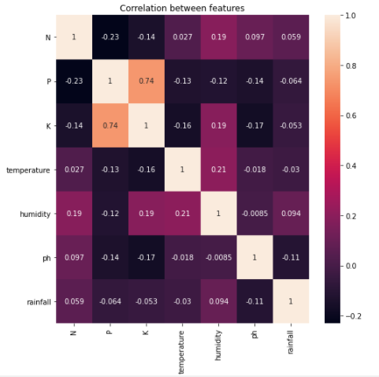

*Table 2: Correlation between features*

1. Since there were no missing cells or null values we then moved to the next step i.e., choosing the algorithm and training it.
2. *Choosing the algorithm for training the dataset*

In this research work, we have considered “crop name” as target label and used “Multiclass Classification”. We have used Gradient Boosting Classifier and Random forest algorithms for training the ML model.

*Algorithms*

*Gradient Boosting Classifier*

Gradient boosting is a Machine Learning technique for regression, classification and other tasks which was invented by Leo Breiman. It is a boosted ensemble of tree as opposed to a bagged ensemble they have very low interpretability because the second tree in the model no longer predicts the same target as the original model and the subsequent trees in the model seek to predict how far off the original predictions were from the truth by using the residuals from the prior trees. In this way each subsequent trees in the Gradient boosting model slowly reduces the overall error of the previous trees this enables Gradient boosting models to have very high predictive power but low interpretability. In addition Gradient boosting model are quite prone to overfitting the training data to combat there are several extra hyper parameters that are not needed in forests. They are learning rate which controls how you add subsequent trees together and also regularisation in the form of ridge and lasso hyper parameters

*Random Forest*

The Random decision forests or Random forests are an ensemble method (it groups multiple Decision tree predictors) used for regression, classification and other ML tasks which was developed by Leo Breiman. In this each tree makes their own prediction and they are aggregated into a final prediction either by votes for classification problems or as an average for regression problems. If all of the decision trees are the same then each tree will predict the same output this is where the random part of the random forests come into play. There are two aspects of randomness involved. First is what features in each decision tree a random subset of features is chosen. Second aspect of randomness is using only a sample of the training data each time a tree is fit. The idea is to have each row and feature utilized in at least one of the decision trees however not to use all the features in any single decision tree. This allows us to build trees that are not correlated while will add variation to our collection of models and reduce the risk of overfitting. Even with this approach overfitting is still a concern this can be solved by setting the max depth. Max depth is the number of questions asked before we reach the prediction. We limit the depth to reduce the risk of overfitting.

1. *Testing the Machine Learning (ML) model and evaluation*

Once training the dataset with LGBM Classifier and Extra tree classifier we test both the models with 10% samples of the dataset. On testing we found that the accuracy that we got from LBGM Classifier algorithm is 0.991 and that of Extra tree Classifier was 0.985. Since the accuracy of LGBM Classifier was high we chose that model to deploy and use it for predicting the crop.

1. *Deploying*

*For deploying this*  ML model we have used IBM cloud services. Since it is deployed in a cloud, we are using the ML Model for prediction through Application Program Interface (API).

**3. RESULT AND DISCUSSION**

In this section we shall see the outcome of our platform “DigiFarm” which is designed to carefully and accurately predict the most suitable crop that the farmer can produce in his region. DigiFarm is designed to equip the farmers with digitized farming so that they can make the most out of their crops. With the aid of this platform, they can receive precise information about which crops would be most suitable for their land. User can predict their crop based on two methods:

1. Making use of region's weather conditions, pH value of the soil, rainfall pattern and soil composition (i.e., nitrogen, phosphorus and potassium) as inputs
2. Making use of place/location and current season as inputs

*3.1 Software Compatibility*

Our platform DigiFarm is compatible with latest versions of browsers such as Google Chrome, Microsoft Edge, Mozilla Firefox etc. The Front-end of DigiFarm is designed using HTML 5, CSS 3 and JavaScript whereas for the Back-end we have used Django 3.2.5 (i.e., a Python back-end framework).

*3.2 Home Page*

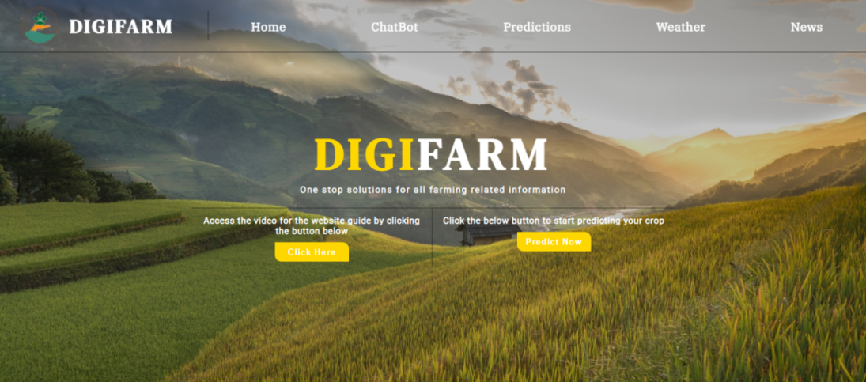

Figure 1: Home Page of the DigiFarm

DigiFarm along with its name is shown in the Figure 1. The logo displayed on the top left corner has two central elements: a hand and the water. The water is representative of rivers and oceans that forms the backbone of the irrigation system in Indian agriculture. The hand that is holding a plant represents the farmers who grow the crops. Since India is an agrarian economy, not only is the population dependent on the farmers for food, but the national economy is also dependent on the yield from the primary sector.

This page connects the user to all the different pages on the website. The Navigation bar on the homepage as shown in Figure 1 has different buttons for various purposes such as ChatBot, Prediction and News. Additionally, there are two icons: one to get the detailed tutorial on how to use the website for farmers and another for predicting the most suited crop(s).

Now, let us see what each section of the platform does in detail:

*3.3 Prediction Section*

This part of DigiFarm is the main part of the platform. The “Prediction” section as shown in the Figure 2 can be used to predict the most suitable crops by using two different methods.

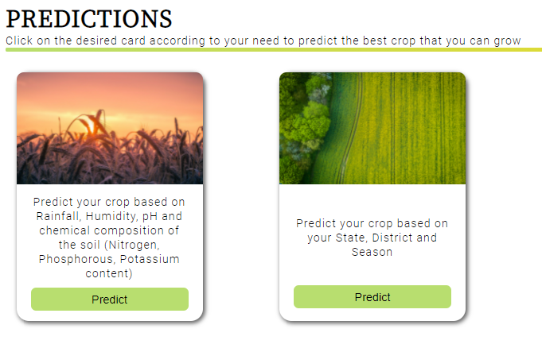

*Figure 2: Predictions Section (i.e. Different methods for predicting the crop)*

*3.3.1 Method 1*

Users can predict the crop by entering details such as rainfall, humidity, and temperature, and pH value along with the composition of the soil (i.e. nitrogen, phosphorus, and potassium content), the system will predict the crop which is most suitable for the given geographical conditions as shown in the Figure 3(a).

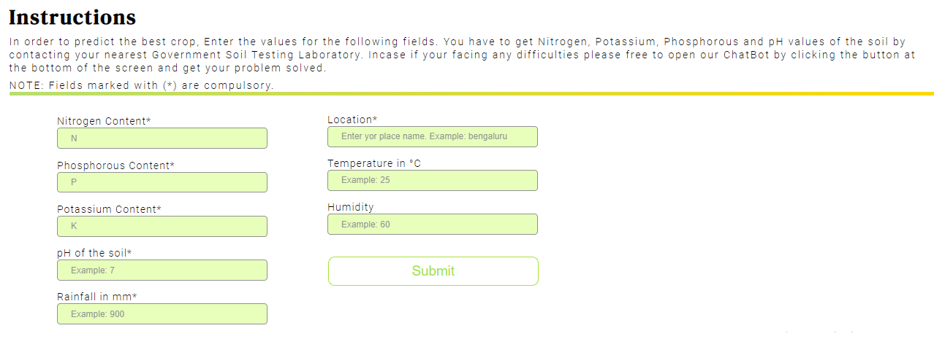*Figure 3(a): Prediction of crops using method 1*

Consider an instance, when the user enters the values of nitrogen content as 20, phosphorus content as 89, potassium content as 40, pH value as 6, rainfall as 700, location as Bengaluru (i.e. as shown in Figure 3(a)), the Machine Learning (ML) model will predict the crop based on the values entered and the result is displayed as Coconut as shown in the Figure 3(b).

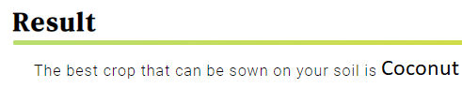

*Figure 3(b): The output based on method 1*

Similarly, we can get different crop names as output (as shown in the figures 3(c) to 3(f)) based on the different input combinations.

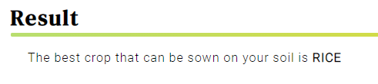

*Figure 3(c): For the input values N=89, P=58,*

*K=38, Temp=23°C, Humidity=83%, pH=6.3*

*And Rainfall=221mm.*

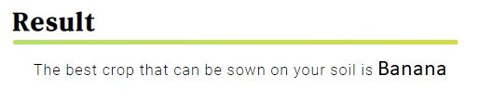

*Figure 3(d): For the input values N=86, P=76,*

*K=54, Temp=29°C, Humidity=80%, pH=5.9*

*And Rainfall=90mm.*

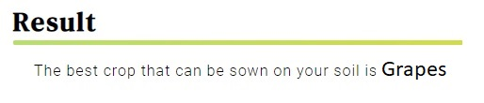

*Figure 3(e): For the input values N=36, P=125,*

*K=196, Temp=37°C, Humidity=80%, pH=6.1*

*And Rainfall=66mm.*

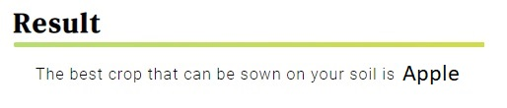

*Figure 3(f): For the input values N=34, P=140,*

*K=198, Temp=21°C, Humidity=93%, pH=5.75*

*And Rainfall=115mm.*

*3.2.1.1 Discussion on prediction of crop (method 1) dataset:*

The Dataset as shown in the Figure 4 below, has been used for training and testing our crop prediction model. In total, we have 2201 samples among which we have used 90% (i.e. 1980 samples) for the purpose of training. The remaining 10% (i.e. 221 samples) are used for testing purpose. The dataset contains 8 attributes (they are Nitrogen, Phosphorous, Potassium, Temperature and humidity of the region, pH of the soil, Rainfall in mm in that region and the crop).

 *Figure 4: Crop prediction dataset for method 1*

For training and deploying the ML model, the IBM Cloud Services is used which includes ML and AutoAI services. Since it is deployed in a cloud, we are using the ML Model through Application Program Interface (API).

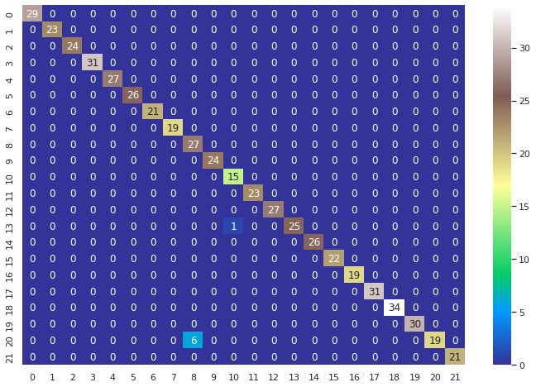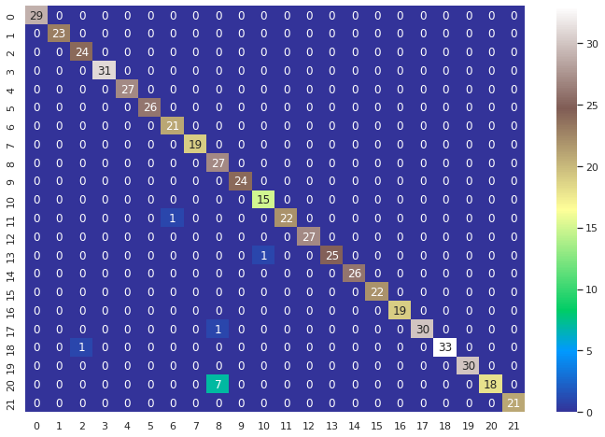In this research work, we have considered “crop name” as target label and used “Multiclass Classification”. The dataset contains 22 distinct categories (i.e., Apple, Banana, Blackgram, Chickpea, Coffee, Cotton, Grapes, Jute, Kidneybeans, Lentil, Maize, Mango, Mothbeans, Mungbean, Muskmelon, Orange, Papaya, Pigeonpeas, Pomogranate, Watermelon, Rice and Coconut). We have used Gradient Boost Classifier and Random Forest classifier algorithms for training. A confusion matrix is a table that is used to **describe the performance of a classification model** on a set of test data for which the true values are known. It represents the ways in which your classification model is confused when it make predictions. The confusion matrix that was generated on running the test data with Gradient Boost model and Random Forest model is as shown in the Figure x and y respectively where the numberings 0-21 refers to the crops as shown in the lookup table 4. For instance the Gradient Boosting Model is confused between crop 8 i.e. kidneybeans and crop 20 i.e. rice 7 times (in other words this model wrongly predicted the crop 8 as 20 7 times).

Figure x: Confusion Matrix for GB Model Figure y: Confusion Matrix for RF Model

|  |  |  |  |  |  |
| --- | --- | --- | --- | --- | --- |
| Number | Corresponding Crop | Number | Corresponding Crop | Number | Corresponding Crop |
| 0 | Apple | 8 | Kidneybeans | 16 | Papaya |
| 1 | Banana | 9 | Lentil | 17 | Pigeonpeas |
| 2 | Blackgram | 10 | Maize | 18 | Pomogranate |
| 3 | Chickpea | 11 | Mango | 19 | Watermelon |
| 4 | Coffee | 12 | Mothbeans | 20 | Rice |
| 5 | Cotton | 13 | Mungbean | 21 | Coconut |
| 6 | Grapes | 14 | Muskmelon |  |  |
| 7 | Jute | 15 | Orange |  |  |

Table 4: Crop lookup table

A **true positive** is an outcome where the model correctly predicts the positive class. Similarly, a **true negative** is an outcome where the model correctly predicts the negative class. A **false positive** is an outcome where the model incorrectly predicts the positive class. And a **false negative** is an outcome where the model incorrectly predicts the negative class. [3]

The Table 2 summarizes the true positive rate, true negative rate, false positive rate and false negative rate for Random Forest model and Gradient boosting model.

|  |  |  |
| --- | --- | --- |
|  | Random Forest Model | Gradient Boosting Model |
| True positive rate | 0.990 | 0.981 |
| True negative rate | 0.999 | 0.999 |
| False positive rate | 0.0004 | 0.0008 |
| False negative rate | 0.009 | 0.018 |

Table 2: What name can i give for this?

The way we evaluate ML models is generally through the parameters accuracy, precision, recall and F1 score.

Accuracy is the ratio of total number of correctly predicted data points to the total number of all the data points i.e.,

Accuracy = (True Positives + True Negatives) / ( True Positives + True Negatives + False Positives + False Negatives)

Precision is defined as the ratio of True Positives to the sum of True positives and false positives i.e.,

Precision = (True Positives) / ( True Positives + False Positives)

Recall is defined as the ratio of True Positives to the sum of True positives and false negatives i.e.,

Precision = (True Positives) / ( True Positives + False Negatives)

F1 score is a simple way to compare two classifiers and is defined as the harmonic mean of recall and precision.

F1 score = 2 / ((1/Precision)+1/Recall))

= (True Positives) / (True Positives + ((False Positives + False Negatives)/2))

Table 3 summarizes the values for these parameters that we got on testing Random Forest and Gradient Boosting models.

|  |  |  |
| --- | --- | --- |
| **Performance Measures** | **Random Forest Model** | **Gradient Boosting Model** |
| Accuracy | 0.989 | 0.982 |
| Recall | 0.990 | 0.981 |
| Precision | 0.990 | 0.981 |
| F1 Score | 0.990 | 0.981 |

Table 3: Performance measures (i.e. Accuracy, Recall, Precision, F1 Score) of predictive models

As we can see in the Table 3 Random Forest (RF) Model outperformed Gradient Boosting Model is all aspects so we chose RF model to deploy and use it for predicting the crop. This system of crop prediction results in accuracy and efficiency which is unprecedented. Farmers generally wish to continue growing the same crops on their land either to avoid risk or due to lack of awareness. However, this system would enable them to go beyond their regular pattern by providing them with accurate scientific and data based information.

*3.3.2 Method 2*

Another option for predicting the crops is by mentioning their state, district, and season as shown in Figure 5(a).

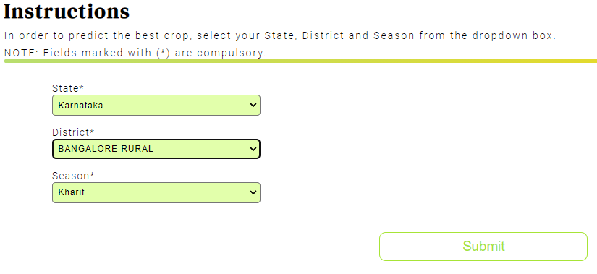

*Figure 5(a): Input fields for approach 2*

For example:- When we enter the state as Karnataka, district as Bengaluru Rural, season as kharif (ref Figure 5(a)), we get the crop prediction of ONION, DRY GINGER, RAGI, BAJRA, MAIZE, RICE, GRAM and many more as shown in Figure 5(b).

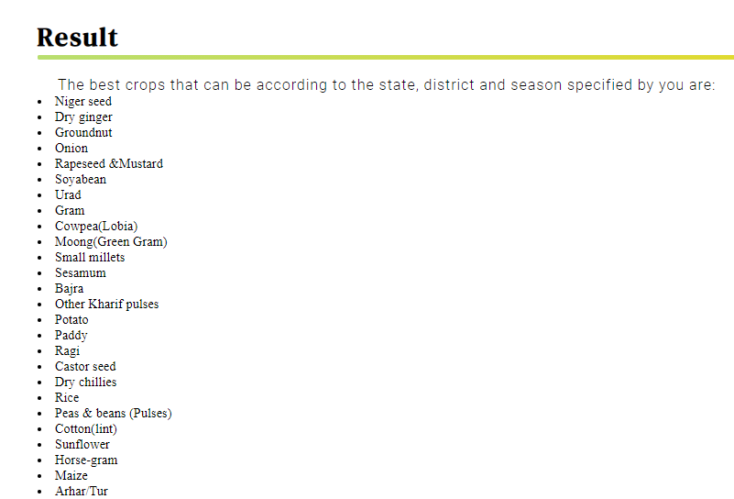

*Figure 5(b): Sample result from the second approach to Crop Prediction*

*3.3.2.1 Discussion on prediction of crop (method 2) dataset:*

For this 2nd method we have made use of a dataset which is different from the first one. This dataset contains the name of the crops which gave the best yield in each seasons (i.e. Autumn, Kharif, Rabi, Summer, Winter). This crop and season data is available for all the districts of India. This dataset has 4 columns (as shown in the Figure 6) namely the State Name, District Name, Cropping Season and crop names.

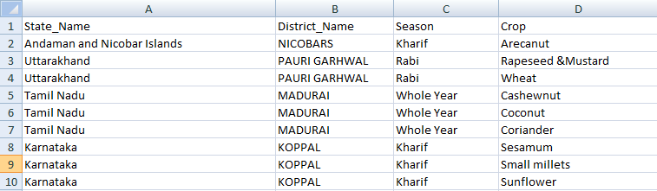For predicting the crops in this method we are not using any ML model instead we are searching the dataset and displaying the crop names according to the information (i.e. State name, District name and the preferred season) entered by the user.

*Figure 6: Crop prediction dataset for method 2*

*3.4 AgriBot*

In the current growing age of digitization, Artificial Intelligence (AI) powered chatbots are playing a leading role by exemplifying the function of a virtual assistant that could manage a conversation via speech or textual methods. It makes use of voice or textual queries to get answers, perform actions and recommendations according to user needs. They are adaptable to the user's individual language usages, searches, and preferences with continuing use. With the advent of AI, virtual assistants can be seen penetrating to the nook and corner of the world [1]. A conversational bot with a voice and/or chat interface can play a principal role in solving the user queries by giving instant service. This drastically reduces waiting time for the users (i.e. mainly farmers) to get their queries solved. The ChatBot as shown in Figure 4 is an AI based bot called the “AgriBot”. It is created using the IBM Watson Chatbot services (i.e. a part of IBM Cloud services).

The result of the AgriBotis the easy accessibility of DigiFarmplatform for the users. The AgriBot provides user three options (i.e. as shown in the Figure 7) which can be availed one at a time. This helps the user to get their queries solved.

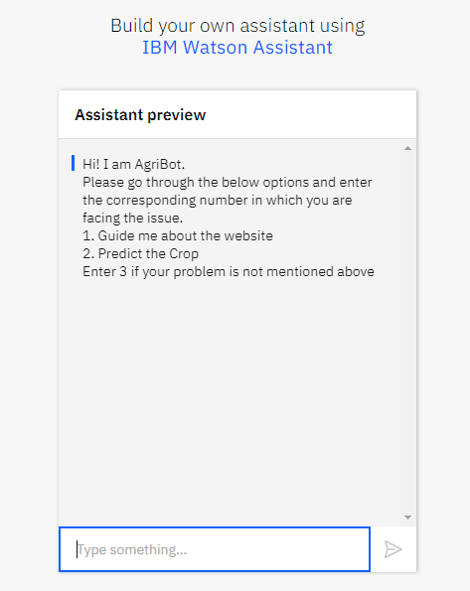

The different options available for users are:

1. To guide the users about the platform and how to make use of it.
2. Various methods to predict the crop
3. Directs users to a Google Form which they can fill for any further queries

The presence of a AgriBot on this platform simplifies the user experience which is the broader aim of the Digifarm.

*Figure 7: AgriBot*

*3.6 News Segment*

The news segment results in bringing together the latest information about agriculture from across the globe as shown in Figure 7. The idea behind this is to keep our users about the technological developments happening in the agricultural field from different parts of the world. This enables them to learn from these techniques and apply the suitable ones on their land. The result would be increased productivity, developing a nature of taking risks and also equip them with the most updated advancements which they may find suitable for their farm.

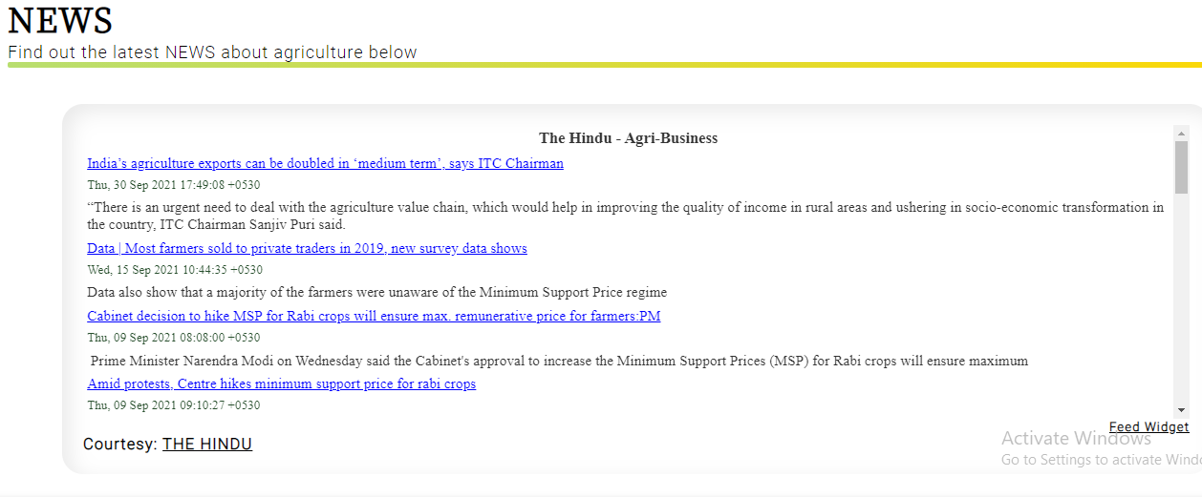In the news section of DigiFarm, we have used RSS (Really Simple Syndication) news feed from “The Hindu Agri-Business” news.

*Figure 7: News section*

The idea is to build a platform which solves all the queries of the farmers holistically and comprehensively. The main aim of DigiFarm is to help the farmers in increasing their production and yield per square by choosing the right crop for their field at the right time. Also, it enables them to sell their crop for maximum revenue. DigiFarm would result in digitization of agriculture on a global scale. However, it would prove extremely beneficial to farmers in India who find it difficult to access the information as their outreach is confined which results in using obsolete methods despite the advancements. DigiFarm, with the aid of technology will help them with the best possible information for their farm using a single platform.

1. References

[1] Patel, Sanoj Kumar, Anil Sharma, and Gopal Shankar Singh. "Traditional agricultural practices in India: an approach for environmental sustainability and food security." *Energy, Ecology and Environment* 5.4 (2020): 253-271.

[2] FAO (2016) The State of Food and Agriculture, Climate Change, Agriculture and Food Security. Food and Agriculture Organization of the United Nations Rome, 2016. [www.fao.org](http://www.fao.org)

[3] Adams MW, Ellingboe AH, Rossman EC (1971) Biological uniformity and disease epidemics. Bioscience 21(21):1067–1070

[4] Sofia, P. K., Rajendra Prasad, and V. K. Vijay. "Organic farming-tradition reinvented." (2006).

[5] Singh GS, Ram SC, Kuniyal JC (1997) Changing traditional land use patterns in the Great Himalayas: a case study of Lahaul Valley. J Environ Syst 25:195–211

[6] Jeeva SRDN, Laloo RC, Mishra BP (2006) Traditional agricultural practices in Meghalaya, North East India. Indian J Trad Knowl 5(1):7–18

[7] Pradhan, Aliza, et al. "Potential of conservation agriculture (CA) for climate change adaptation and food security under rainfed uplands of India: A transdisciplinary approach." *Agricultural Systems* 163 (2018): 27-35.

[8] Lincoln NK (2019) Learning from indigenous agriculture. Nat Sustain 2(3):167

[9]Johns, Timothy, Bronwen Powell, Patrick Maundu, and Pablo B. Eyzaguirre. "Agricultural biodiversity as a link between traditional food systems and contemporary development, social integrity and ecological health." *Journal of the Science of Food and Agriculture* 93, no. 14 (2013): 3433-3442.

[10] Rana, Ram Bahadur, Chris Garforth, BhuwonSthapit, and Devra Jarvis. "Influence of socio-economic and cultural factors in rice varietal diversity management on-farm in Nepal." *Agriculture and human values* 24, no. 4 (2007): 461-472.

[11] Gruyere G, Mehta-Bhatt P, Sengupta D. Bt cotton and farmer suicides in India: reviewing the evidence.

[12] Nagaraj K. Farmers’ suicides in India: magnitudes, trendsand spatial patterns.

[13] Kennedy, Jonathan, and Lawrence King. "The political economy of farmers’ suicides in India: indebted cash-crop farmers with marginal landholdings explain state-level variation in suicide rates." *Globalization and health* 10.1 (2014): 1-9.

[14] R Shamshiri, R., Weltzien, C., Hameed, I. A., J Yule, I., E Grift, T., Balasundram, S. K., ... & Chowdhary, G. (2018). Research and development in agricultural robotics: A perspective of digital farming.

[15] Suresh, G., Kumar, A. S., Lekashri, S., & Manikandan, R. (2021). Efficient crop yield recommendation system using machine learning for digital farming. *International Journal of Modern Agriculture*, *10*(1), 906-914.

[16] U. Bharti, D. Bajaj, H. Batra, S. Lalit, S. Lalit and A. Gangwani, "Medbot: Conversational Artificial Intelligence Powered Chatbot for Delivering Tele-Health after COVID-19," 2020 5th International Conference on Communication and Electronics Systems (ICCES), 2020, pp. 870-875, doi: 10.1109/ICCES48766.2020.9137944.

[17] <https://en.wikipedia.org/wiki/Out-of-bag_error#:~:text=Out%2Dof%2Dbag%20(OOB,utilizing%20bootstrap%20aggregating%20(bagging)>

[18] https://developers.google.com/machine-learning/crash-course/classification/true-false-positive-negative