**ALAN SAPUTRA LENGKOAN**

**Curriculum Vitae**

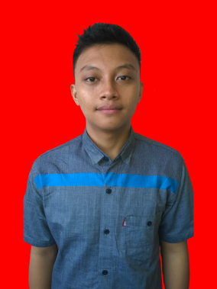

1. **CONTACT**
2. Email : [alanlengkoan15@gmail.com](mailto:alanlengkoan15@gmail.com)
3. Phone : +6285242907595 / +6285342679955
4. Website : <https://alanlengkoan15.000webhostapp.com/>
5. Account : 1. LinkedIn : [Alan Lengkoan](https://www.linkedin.com/in/alan-lengkoan-92952b133/)

2. Facebook : [Alan Lengkoan](https://web.facebook.com/alanlengkoan)

1. Address : Perumahan Taman Guna Asri Jl. Kelapa Hibrida

IV NO. 2, Desa Tamannyeleng Kec. Barombong

Kab. Gowa, Provinsi Sulawesi Selatan

1. **PERSONAL DETAILS**
2. Fullname : Alan Saputra Lengkoan
3. Piace of Birth : Polmas
4. Date of Birth : 26 Maret 1998
5. Gender : Male
6. Religion : Kristen Protestan
7. **EDUCATION**
8. Elementary School : SD Inpres 18 Kariango **(2004 - 2009)**
9. Junior High School : SMP Negeri 2 Anggrek **(2010 - 2012)**
10. Senior High School : SMA Negeri 5 Gorontalo Utara **(2013 - 2015)**

Majors : IPA

1. University : STMIK Handayani Makassar **(2015)**

Majors : Teknik Informatika

1. **HOBBY**
2. Olahraga
3. Mancing
4. Mendaki Gunung