**1 Task1: Generate Encryption Key in a Wrong Way**

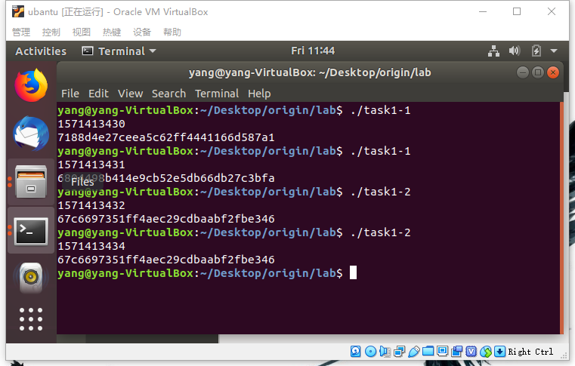

**2 Task2: Guessing the Key**

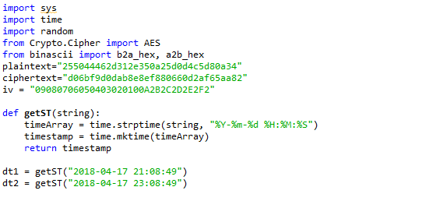

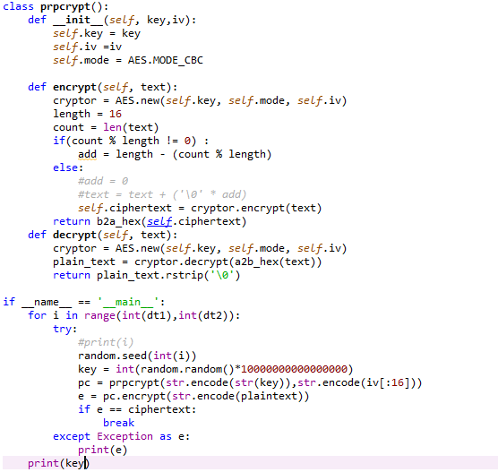



**2.3 Task3: Measure the Entropy of Kernel**

Move mouse 3 click 4 type 5 read 0 web keep going 1

**2.4 Task4: Get Pseudo Random Numbers from /dev/random**

The number keep going at step 1 , 64 go back to 1, 16 进制,

move the number go faster

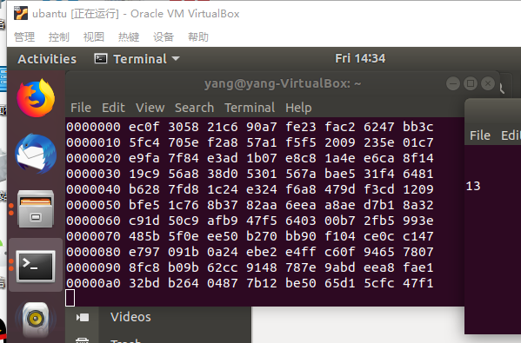

**2.5 Task5: Get Random Numbers from /dev/urandom**

Generate very fast No affect

