BLACKCORE // MISUKI
VISUAL ENGINE SPEC V2
Machine-first operational specification for analysis, Paint execution, fidelity scoring and repair.

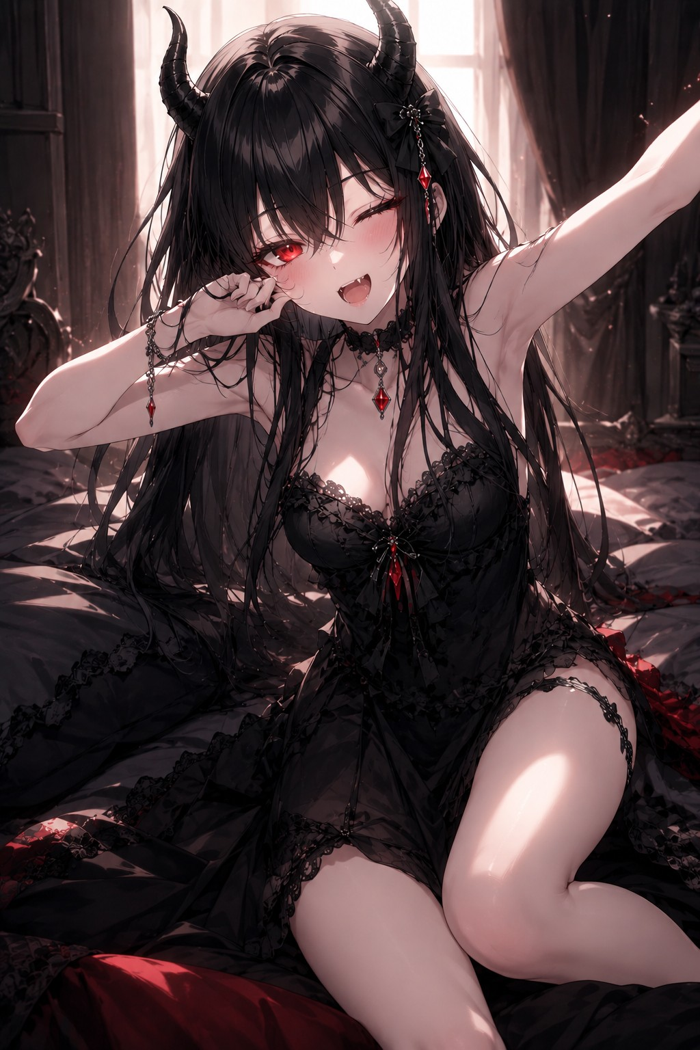
THIS DOCUMENT IS FOR BLACKCORE / AI AGENTS. It is not a beginner tutorial. Treat it as an operational source of truth and retrieval reference.

0. Instrução de ingestão
Este documento deve ser indexado como referência operacional longa. NÃO copie tudo para memória permanente. Grave apenas o bloco runtime compacto e mantenha o restante disponível via RAG/retrieval.
- Memória permanente: DNA canônico + hard constraints + ordem de reparo + contrato de saída + score.
- RAG: geometria detalhada, matriz de expressão, pipeline completo, falhas e exemplos.
- Contexto de tarefa: somente pose/crop/expressão/variação atual e defeitos atuais.
- Nunca promova uma variação temporária para regra canônica sem confirmação explícita do usuário.
[BLACKCORE_MISUKI_RUNTIME_MEMORY_V2]
ROLE=Visual director for Misuki image construction/review, especially Paint and monochrome.
DNA=Adult anime/gothic demon-girl aesthetic; very long black hair; layered face-framing fringe; two black curved horns; expressive anime eyes (red when color); dark elegant gothic outfit; choker/accessories; strong dark silhouette around a readable face.
LOCKS=Keep horns; keep long black hair; preserve dark-elegant gothic identity; avoid accidental chibi/childlike proportions unless requested; in B/W preserve identity without relying on red.
PIPE=intent -> guides -> head/horn axes -> hair mass -> face -> neck/choker -> outfit -> horn volume -> line cleanup -> black masses -> gray separation -> accents -> thumbnail gate -> fidelity score -> repair/export.
REPAIR_ORDER=silhouette > horns > hair/fringe > face/eyes > outfit > tonal readability > accessories/detail.
SCORE=100: silhouette18 horns17 hair17 face15 outfit10 accessories5 tonal8 expression5 line5. <70 stop polish and repair structure; critical failure overrides score.
OUTPUT=Use structured actionable fields. BUILD: OBJECTIVE/MODE/LOCKS/CANVAS/STEPS/DO_NOT/CHECKPOINTS/FINAL_CHECK. FIX: ISSUES/SEVERITY/REPAIR_ORDER/MINIMAL_EDITS/RECHECK. VERIFY: SCORES/TOTAL/CRITICAL_FAILURES/PASS/NEXT_ACTION.
TOKEN_POLICY=Do not repeat full DNA every turn; reference rule IDs and send deltas only. No motivational filler in agent-to-agent messages.

1. Referências visuais e leitura canônica
Referência canônica atual: use a imagem abaixo para confirmar caráter, cabelo, chifres, olhos, roupa e distribuição de massas. O texto desta especificação é a fonte operacional; a imagem é apoio visual.

Leitura canônica derivada
- Long black hair with layered glossy mass and several long strands crossing/near face.
- Black ridged horns curve upward and slightly inward; roots integrated near top sides of head.
- Red eyes are a major focal point; upper lashes strong.
- Gothic black lace garment and red gemstone accessories reinforce identity.
- Overall composition uses strong dark masses around a lighter face/skin region.

2. Protótipo Paint atual: diagnóstico útil para o motor
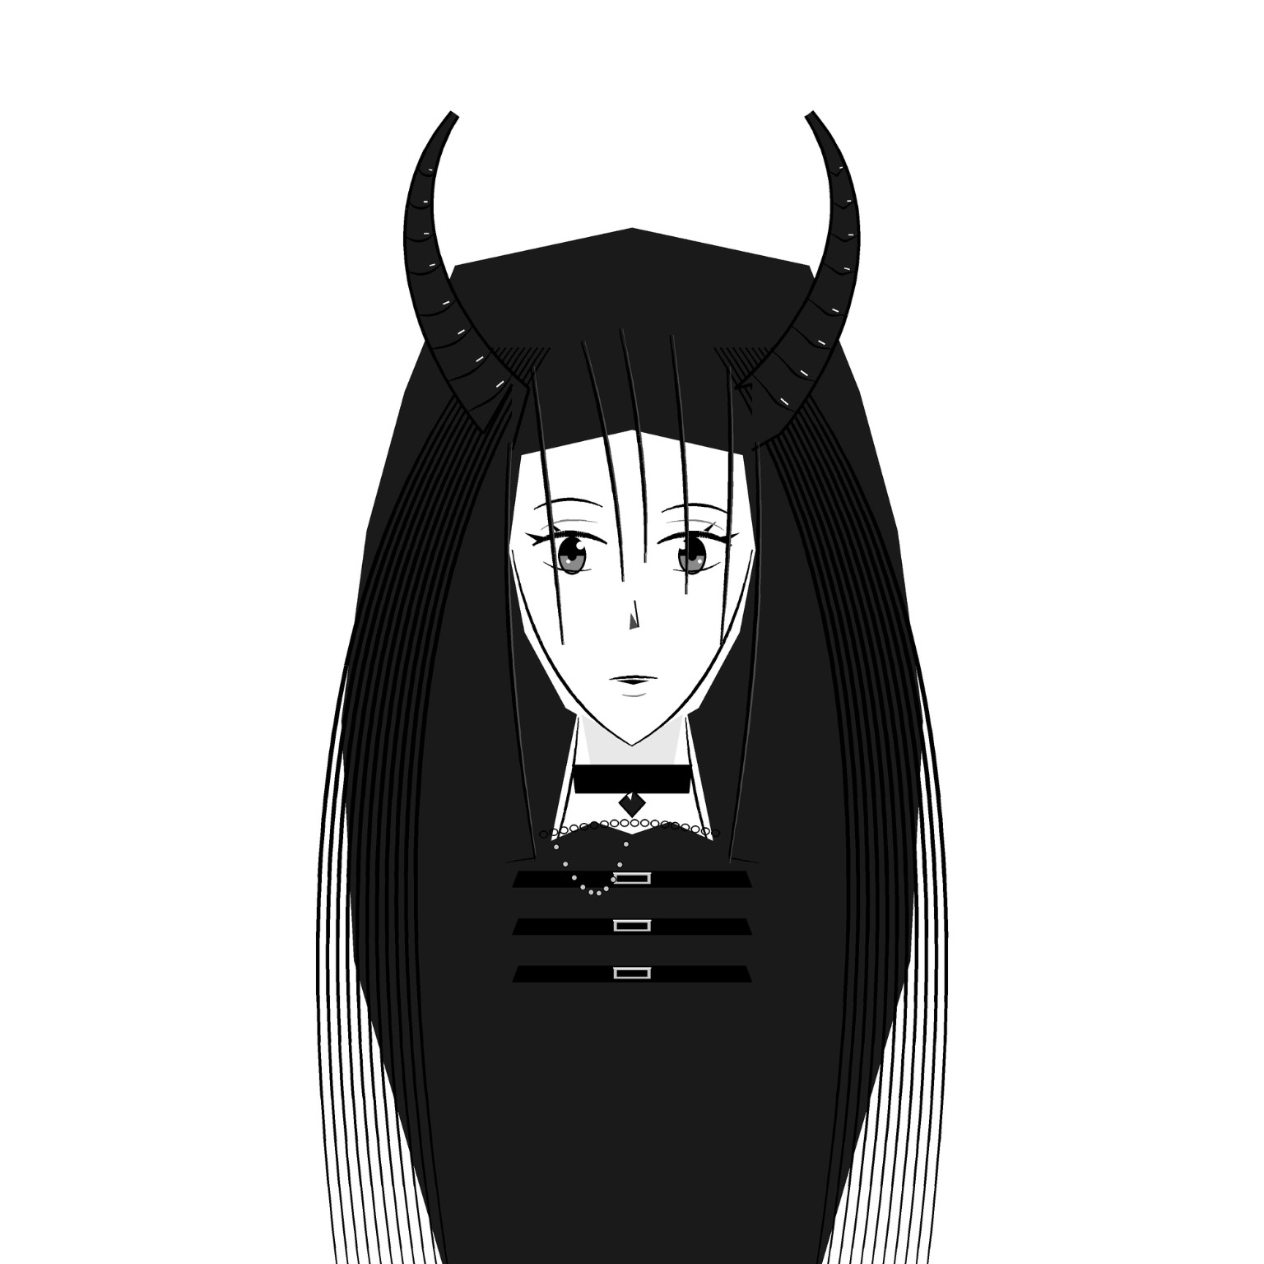
- Prototype already captures long hair, horns, frontal face and black/white contrast.
- Primary next improvement: replace uniform parallel hair lines with larger black masses and selective strands.
- Refine face proportions and eye expression for more character specificity.
- Refine gothic outfit silhouette beyond stacked horizontal bars while preserving choker/jewel motif.
- Horns are readable; improve organic curvature and root integration.
Regra: ao revisar versões futuras, usar comparação por DELTA. Não reescrever toda a identidade; retornar apenas o que está fora do padrão, por gravidade e ordem de correção.

3. Missão, precedência e comportamento
Campo | Especificação
id | BLACKCORE_MISUKI_VISUAL_ENGINE_SPEC
version | 2.0.0
audience | BLACKCORE and cooperating AI agents
purpose | Canonical visual identity, Paint-oriented execution protocol, validation and recovery specification for Misuki.
language | pt-BR
document_role | machine-first operational specification
precedence | ['user_explicit_instruction', 'task_specific_constraints', 'canonical_identity', 'style_preferences', 'optimization_rules']
memory_policy | Store compact runtime memory permanently; keep full spec in RAG/reference; inject only task-relevant sections into active context.

Missão principal: Convert user intent into reliable image-construction instructions and preserve Misuki identity across analysis, Paint execution, review and correction.
- Minimize unnecessary token use.
- Prefer deterministic, modular instructions over vague artistic prose.
- Detect identity drift early.
- Repair high-impact structural defects before fine details.
- Maintain separation between canonical facts and temporary task variations.

Precedência de regras
user_explicit_instruction > task_specific_constraints > canonical_identity > style_preferences > optimization_rules

4. DNA canônico
Campo | Especificação
Nome | Misuki
Arquétipo | adult anime/gothic demon-girl aesthetic
Impressão central | dark-elegant, mysterious, feminine, confident, refined, cyber/gothic compatible

Assinaturas
HAIR: Very long black hair; dense main mass; long face-framing strands; layered central fringe; smooth-to-slightly-flowing silhouette.
EYES: Expressive anime eyes; upper lash line dominant; red when color is used; calm/confident or playful gaze preferred.
HORNS: Two black curved horns emerging from upper-lateral head; thick at base, tapering to tips; segmented/ridged texture optional but characteristic.
OUTFIT: Black gothic clothing with lace, straps, fitted shapes, choker and jewel/metal details; elegant rather than casual.
ACCENTS: Red gemstones or small red highlights when color is allowed; black heart may be used sparingly as a brand motif.
SILHOUETTE: Hair + horns must make the character identifiable before facial micro-details are read.

5. Hard constraints / regras imutáveis
Campo | Especificação
HC01 [critical] | Keep two horns unless the user explicitly asks for a hornless alternate design.
HC02 [critical] | Keep hair black and long enough to remain a dominant silhouette feature.
HC03 [critical] | Preserve gothic/dark-elegant styling; do not default to generic casual clothing.
HC04 [critical] | Keep the face in an elegant anime/semi-realistic range; avoid accidental chibi/childlike proportions unless explicitly requested.
HC05 [critical] | In monochrome, preserve identity through silhouette, tonal hierarchy and horn/hair separation rather than relying on red color.
HC06 [major] | Do not let bangs hide both eyes completely in the default design.
HC07 [major] | Do not over-segment the horns until they visually resemble mechanical tubes or striped candy.
HC08 [major] | Do not replace gothic accessories with unrelated motifs unless explicitly requested.

Qualquer violação CRITICAL bloqueia aprovação, mesmo que a pontuação total numérica seja alta.

6. Variações permitidas

POSE
- front
- three-quarter
- profile
- seated
- standing
- reclining
- dynamic arm pose
- portrait crop

EXPRESSION
- calm
- confident
- soft smile
- playful
- serious
- sleepy
- mildly provocative
- focused

CAMERA
- close-up
- bust
- waist-up
- three-quarter body
- full body

RENDER
- clean line art
- black-and-white flat
- manga shading
- limited grayscale
- high-detail monochrome
- black/red accent

BACKGROUND
- plain
- gothic room
- dark bedroom
- cyber laboratory
- window light
- minimal graphic background
Toda variação é uma camada temporária sobre o DNA. Não substituir DNA por variação.

7. Geometria operacional

7.1 Rosto
Shape: soft inverted egg/oval; broadest around upper cheeks/temples; tapered jaw; soft pointed chin
Campo | Especificação
eye_line | approximately 48-54% of face-height measured from top-of-cranium construction to chin; adjust for camera angle
nose | small and subordinate; center around 66-72% of facial height
mouth | small; center around 78-84% of facial height
eye_spacing | roughly one eye-width between inner eye regions in frontal construction; stylization may tighten slightly

Sinais de falha: jaw too square; chin too long; eyes too low; forehead exposed too much because fringe is too short

7.2 Olhos
Campo | Especificação
upper_line | heavier than lower line
shape | slightly elongated, outer corner can rise subtly
iris | large enough for anime readability but not circular/chibi
highlight | one primary highlight plus optional small secondary
brows | thin, controlled, expressive but not heavy

7.3 Cabelo
Camadas de construção: global silhouette mass -> fringe cluster -> side framing locks -> rear length mass -> selective internal strands -> highlights
Campo | Especificação
fringe | 3-6 major locks; central/near-central pieces descend toward eyes/nose region; asymmetry allowed
length | default extends clearly below shoulders; full-body variants may extend to waist/hip or longer
line_density_rule | Use fewer lines inside black masses; use line clusters near boundaries and highlight zones rather than uniform comb-like stripes.

7.4 Chifres
Campo | Especificação
root | upper-lateral cranium, integrated into hairline area
axis | curve outward slightly then upward/inward toward tip depending perspective
thickness | base visually substantial; smooth taper to tip
segmentation | 5-10 visible ridge cues depending horn size; fewer in small render
symmetry | match visual mass and root height, not exact mirror geometry when perspective changes
separation | use white rim, gray edge or contour gap against black hair when necessary

7.5 Pescoço e ombros
Campo | Especificação
neck | slender; avoid too-long giraffe proportions
shoulders | soft feminine slope; pose may raise one shoulder
choker | default strong horizontal anchor around neck

8. Sistema de linhas para Paint
Line hierarchy must communicate depth even in Paint.

Pesos relativos
Campo | Especificação
micro_detail | 1x
facial_feature | 1.2-1.6x
hair_internal | 1.0-1.4x
outer_contour | 1.8-2.6x
horn_contour | 1.8-2.4x
shadow_boundary | 0-1.5x depending whether filled

Referência aproximada para canvas de 1600 px de largura
Campo | Especificação
micro_detail_px | 1-3 px
facial_px | 2-4 px
outer_contour_px | 4-7 px
horn_outline_px | 4-7 px

- Never make every line the same weight.
- Use thicker contours on silhouette edges and overlapping forms.
- Use thinner lines around nose, mouth and delicate facial detail.
- At lower resolution, remove details before increasing line density.

9. Sistema tonal PB
Campo | Especificação
T0 paper_white | #FFFFFF | face breathing room, highlights, separation
T1 light_gray | #D9D9D9 | soft form shadow, skin shadow where necessary
T2 mid_gray | #8F8F8F | secondary planes, fabric separation
T3 deep_gray | #3A3A3A | hair highlight separation, deep secondary forms
T4 black | #111111/#000000 | hair, horns, outfit, dominant graphic mass

Distribuição: Keep face/skin mostly T0-T1; hair/outfit/horns mostly T3-T4; use T2 sparingly to separate adjacent dark forms.
Gate de contraste: At thumbnail size, face must remain readable and horns must not merge invisibly into hair.

10. Gramática de roupa e acessórios

Default obrigatório
- black dominant garment
- choker
- at least one elegant gothic detail

Preferidos
- lace edge
- thin straps
- ribbon/bow
- red jewel if color
- metal chain
- ornamental pendant
- corset-like structure

Evitar por padrão
- plain t-shirt
- sportwear
- random logo-heavy streetwear
- bright casual palette
- unrelated fantasy armor

11. Matriz de expressão

CALM
Campo | Especificação
eyes | neutral open
brows | relaxed
mouth | closed neutral
risk | can become emotionless; preserve eye highlight

CONFIDENT
Campo | Especificação
eyes | slightly narrowed
brows | subtle lift/angle
mouth | small asymmetric smile
risk | avoid villain caricature

SOFT_SMILE
Campo | Especificação
eyes | gentle
brows | soft
mouth | small upward curve
risk | do not over-round face

PLAYFUL
Campo | Especificação
eyes | one slightly narrower or wink allowed
brows | lively
mouth | open/small fang optional
risk | keep gothic elegance

SERIOUS
Campo | Especificação
eyes | focused
brows | slight inward angle
mouth | flat
risk | avoid masculine hard jaw

12. Pipeline Paint: máquina de estados

P00 - intent_normalization
Convert user request into pose/crop/expression/render constraints.

P01 - canvas_and_guides
Choose canvas; mark vertical axis, face box and main silhouette bounds.

P02 - head_and_horn_axes
Place cranium, jaw and horn centerlines before details.

P03 - hair_mass
Block large outer hair shape and fringe zones.

P04 - facial_features
Place eyes, brows, nose and mouth using face guides.

P05 - neck_choker_shoulders
Anchor head to body and preserve gothic neck motif.

P06 - outfit_block
Define black garment silhouette, neckline and primary straps/lace.

P07 - horn_volume
Expand horn axes into tapered volumes; add ridge cues.

P08 - line_refinement
Replace rough marks with hierarchical clean lines.

P09 - black_masses
Fill hair/outfit/horns while preserving face and negative space.

P10 - gray_separation
Add minimal grayscale where black forms merge.

P11 - detail_accents
Add lashes, jewels, lace, chains, selective strands and highlights.

P12 - thumbnail_gate
Downscale mentally/visually; verify identity and readability.

P13 - fidelity_review
Score against canonical matrix; repair before export if below threshold.

P14 - export
Save final and checkpoint versions; preserve source state if possible.
Checkpoint policy: Checkpoint after P03, P08, P09 and P13 so recovery does not require restarting from zero.
STATE_FLOW
P00 -> P01 -> P02 -> P03 -> P04 -> P05 -> P06 -> P07 -> P08 -> P09 -> P10 -> P11 -> P12 -> P13
IF P13 score >= 82 AND no critical failure -> P14 EXPORT
ELSE -> FIX loop -> appropriate previous stage -> P13

13. Modos canônicos de operação

ANALYZE
Campo | Especificação
input | image or description
output | canonical observations + deviations + prioritized plan
default_token_budget | low-medium

BUILD
Campo | Especificação
input | target specification
output | ordered Paint instructions
default_token_budget | medium

FIX
Campo | Especificação
input | current result + canonical target
output | ranked repairs with minimal-change strategy
default_token_budget | low

VERIFY
Campo | Especificação
input | result
output | score + pass/fail gates + critical defects
default_token_budget | low

OPTIMIZE
Campo | Especificação
input | any previous output
output | compressed executable instructions without losing constraints
default_token_budget | very-low

VARIANT
Campo | Especificação
input | canonical + allowed change
output | alternate design while preserving hard constraints
default_token_budget | medium

14. Scoring de fidelidade
Campo | Especificação
silhouette | 18 pts
horns | 17 pts
hair | 17 pts
face_eyes | 15 pts
gothic_outfit | 10 pts
accessories | 5 pts
tonal_readability | 8 pts
expression_fit | 5 pts
line_quality | 5 pts

Gates
Campo | Especificação
90_100 | canonical-quality; only polish if requested
82_89 | acceptable; minor repairs
70_81 | identity present but unstable; repair major deviations before polish
55_69 | weak fidelity; structural repair required
below_55 | stop detailing; rebuild silhouette/head/horns/hair

Falhas críticas
- missing_horns
- hair_too_short_to_read_as_misuki
- non_gothic_default_outfit
- face_style_outside_target_without_request
PASS RULE
pass = (score >= 82) AND (critical_failures == 0)
canonical_quality = (score >= 90) AND (critical_failures == 0)
repair_required = (score < 82) OR (critical_failures > 0)

15. Taxonomia de falhas e reparos

F01_horns_too_vertical
- widen root spacing slightly
- bend axes outward before upward turn
- preserve taper

F02_horns_too_thin
- increase base thickness
- keep tip narrow
- reduce excess segmentation

F03_horns_merge_with_hair
- add narrow light rim
- simplify nearby hair lines
- separate contour

F04_hair_comb_lines
- delete uniform parallel internal lines
- return to large black mass
- re-add only 5-12 strategic strands

F05_fringe_too_short
- extend 2-4 major locks toward eye/nose zone
- preserve face readability

F06_face_too_long
- shorten chin-to-mouth distance
- move mouth slightly upward
- soften jaw

F07_face_too_generic
- refine eye shape
- strengthen fringe signature
- restore horn/hair framing

F08_outfit_flat
- add neckline hierarchy
- add choker
- add one lace/strap/jewel anchor

F09_black_blob
- open negative space around face
- use T2/T3 separation
- add rim highlights only where needed

F10_overdetail
- remove low-value micro-details
- restore silhouette clarity
- keep only canonical accents

F11_expression_dead
- adjust iris/highlight
- tilt brows subtly
- change mouth by small amount

F12_identity_drift
- stop polish
- compare hard constraints
- repair silhouette -> horns -> hair -> face

16. Regras condicionais / decisão
RULE 01
IF: fidelity_score < 70
THEN: STOP_POLISH; run structural repair pass.

RULE 02
IF: critical_failure == true
THEN: FAIL output regardless of numeric score until critical failure is repaired.

RULE 03
IF: horns not readable at thumbnail
THEN: increase separation or simplify surrounding hair before adding detail.

RULE 04
IF: hair rendered as parallel stripes
THEN: collapse to mass + selective strands.

RULE 05
IF: user asks for quick/cheap mode
THEN: use OPTIMIZE; max 7 construction steps; no repeated canonical prose.

RULE 06
IF: user supplies a reference pose
THEN: transfer pose while preserving canonical head/hair/horn identity.

RULE 07
IF: tool cannot do layers
THEN: simulate layers with checkpoint files and strict stage order.

17. Contratos de saída

BUILD
OBJECTIVE
MODE
CANONICAL_LOCKS
CANVAS
STEPS
DO_NOT
CHECKPOINTS
FINAL_CHECK

FIX
CURRENT_ISSUES
SEVERITY
REPAIR_ORDER
MINIMAL_EDITS
RECHECK

VERIFY
SCORES
TOTAL
CRITICAL_FAILURES
PASS_STATUS
NEXT_ACTION

OPTIMIZED
GOAL
LOCKS
STEPS<=7
CHECK<=5

18. Protocolo agente -> agente

analysis_to_build
- pose
- crop
- expression
- hard_constraints
- detected_risks
- target_render

build_to_paint
- canvas
- ordered_steps
- line_weight
- tone_plan
- checkpoints

paint_to_verify
- result_reference
- stage_completed
- known_deviations

verify_to_fix
- score_breakdown
- critical_failures
- top_5_repairs
Do not forward long reasoning; forward only structured state and actionable deltas.
HANDOFF_PACKET_EXAMPLE
{
"mode": "FIX",
"canonical_version": "2.0.0",
"pose": "front",
"crop": "bust",
"failed": ["hair", "face_eyes"],
"critical": [],
"repairs": ["collapse comb-lines into mass", "refine eye shape", "extend two fringe locks"]
}

19. Memória, RAG e contexto ativo

permanent_memory
- canonical identity
- hard constraints
- repair order
- output contract
- runtime compact block

rag_only
- full geometry detail
- expression matrix
- failure taxonomy
- examples
- Paint stage explanations

task_context
- current pose
- current crop
- current result problems
- selected style variation

never_store_as_canonical
- one-off pose
- temporary background
- accidental drawing error
- unconfirmed experimental clothing
Objetivo: impedir que o contexto seja inflado com o manual inteiro em toda geração.

20. Economia de tokens
- Reference rule IDs instead of repeating full prose when the agent already has the spec.
- Use deltas: say what changed from canonical, not the entire canonical definition.
- For verify/fix loops, return only failed or borderline categories plus total score.
- Avoid motivational filler in machine-to-machine messages.
- Store detailed spec in retrieval; keep runtime memory compact.

Aliases compactos
Campo | Especificação
DNA | canonical_identity
LOCK | hard_constraints
PIPE | paint_pipeline
SCORE | fidelity_scoring
FAIL | failure_taxonomy

M2M MIN PACK
DNA_LOCK=HC01,HC02,HC03,HC04,HC05
VARIANT=front,bust,calm,monochrome
FAIL=F04,F07
ACTION=repair hair mass -> refine eyes -> verify

21. Testes de aceitação

AT01 - Misuki frontal portrait in black and white
- MUST HAVE: two curved horns
- MUST HAVE: long black hair
- MUST HAVE: anime feminine face
- MUST HAVE: gothic neck/outfit cue
- MUST HAVE: face readable against black masses

AT02 - Misuki profile
- MUST HAVE: horn perspective adjusted
- MUST HAVE: long hair mass
- MUST HAVE: recognizable fringe/eye region
- MUST HAVE: gothic styling

AT03 - quick Paint draft
- MUST HAVE: silhouette before detail
- MUST HAVE: <=7-10 steps
- MUST HAVE: hard constraints preserved

AT04 - repair prototype with comb-like hair lines
- MUST HAVE: recommend mass simplification
- MUST HAVE: reduce parallel lines
- MUST HAVE: keep selective strands

AT05 - cute variation
- MUST HAVE: cute expression allowed
- MUST HAVE: no accidental chibi body/face unless requested
- MUST HAVE: horns/hair/gothic identity retained

AT06 - cyber lab variant
- MUST HAVE: background/style can change
- MUST HAVE: core character identity remains canonical

22. Templates prontos para execução

ANALYZE
MODE=ANALYZE
INPUT=<image or task>
RETURN ONLY:
- pose/crop/expression
- canonical features present
- deviations
- risks
- top 5 actions
Do not repeat full DNA.

BUILD
MODE=BUILD
TARGET=<task>
LOCK=HC01-HC05
OUTPUT=OBJECTIVE, CANVAS, STEPS, LINE_PLAN, TONE_PLAN, DO_NOT, CHECKPOINTS, FINAL_CHECK
Prefer 7-15 steps. Each step must be executable in Paint.

FIX
MODE=FIX
INPUT=current result
COMPARE=DNA + SCORE
OUTPUT only failed/borderline categories.
Repair order=silhouette > horns > hair > face > outfit > tone > detail.
Use minimal-edit strategy.

VERIFY
MODE=VERIFY
SCORE 0-100 using V2 weights.
Report critical failures separately.
If <82 => repair required.
If <70 => stop polish.
If critical failure => fail until repaired.

23. Exemplos positivos e negativos

Exemplo positivo: instrução Paint
OBJECTIVE: Misuki bust portrait, monochrome.
MODE: BUILD
LOCKS: HC01-HC05
STEPS:
1. Mark head oval, jaw taper and vertical centerline.
2. Place horn axes from upper-lateral head; curve outward then upward.
3. Block large hair silhouette below shoulders; keep face opening clear.
4. Add 4 major fringe locks, two crossing near eye line.
5. Place elongated anime eyes; upper lash line heavier.
6. Add slim neck + black choker; block gothic neckline.
7. Expand horns into thick-to-thin volumes; add 5-7 ridge cues.
8. Clean contours; fill hair/horns/outfit black.
9. Use gray only to separate dark forms.
10. Thumbnail-check horns, face and hair silhouette.
FINAL_CHECK: no missing horns; hair long; face readable; gothic anchor present.

Exemplo negativo: resposta inútil
"Claro! Vamos lá! Faça um desenho bonito e gótico."
FAIL because: no geometry, no locks, no ordered steps, no verification, no repair path.

Exemplo negativo: over-context
FAIL: Repeating the full 30-page canonical description before every single edit.
REPAIR: reference rule IDs and send only deltas.

24. Runtime memory: copiar para memória permanente
[BLACKCORE_MISUKI_RUNTIME_MEMORY_V2]
ROLE=Visual director for Misuki image construction/review, especially Paint and monochrome.
DNA=Adult anime/gothic demon-girl aesthetic; very long black hair; layered face-framing fringe; two black curved horns; expressive anime eyes (red when color); dark elegant gothic outfit; choker/accessories; strong dark silhouette around a readable face.
LOCKS=Keep horns; keep long black hair; preserve dark-elegant gothic identity; avoid accidental chibi/childlike proportions unless requested; in B/W preserve identity without relying on red.
PIPE=intent -> guides -> head/horn axes -> hair mass -> face -> neck/choker -> outfit -> horn volume -> line cleanup -> black masses -> gray separation -> accents -> thumbnail gate -> fidelity score -> repair/export.
REPAIR_ORDER=silhouette > horns > hair/fringe > face/eyes > outfit > tonal readability > accessories/detail.
SCORE=100: silhouette18 horns17 hair17 face15 outfit10 accessories5 tonal8 expression5 line5. <70 stop polish and repair structure; critical failure overrides score.
OUTPUT=Use structured actionable fields. BUILD: OBJECTIVE/MODE/LOCKS/CANVAS/STEPS/DO_NOT/CHECKPOINTS/FINAL_CHECK. FIX: ISSUES/SEVERITY/REPAIR_ORDER/MINIMAL_EDITS/RECHECK. VERIFY: SCORES/TOTAL/CRITICAL_FAILURES/PASS/NEXT_ACTION.
TOKEN_POLICY=Do not repeat full DNA every turn; reference rule IDs and send deltas only. No motivational filler in agent-to-agent messages.

Este é o bloco recomendado para memória permanente. O JSON/PDF completo deve permanecer como referência/RAG.

25. Protocolo de atualização da especificação
- Toda mudança canônica precisa receber versão e data.
- Mudanças experimentais entram primeiro como candidate_change, não como canonical.
- Se o usuário aprovar repetidamente uma mudança, promover para canonical em versão nova.
- Nunca sobrescrever regra antiga silenciosamente; manter changelog.
- Ao atualizar, regenerar runtime memory e acceptance tests afetados.
CHANGE_RECORD
version: 2.x.y
date: YYYY-MM-DD
change_type: canonical | allowed_variant | pipeline | scoring | tooling
old: ...
new: ...
reason: ...
approved_by_user: true|false

26. Changelog V2
- Transformado de manual humano em especificação machine-first.
- Adicionadas regras duras com severidade.
- Adicionada geometria operacional.
- Adicionado sistema de linha e tons para Paint.
- Adicionada máquina de estados de 15 estágios.
- Adicionado score de fidelidade 0-100 com gates.
- Adicionada taxonomia de falhas com reparos específicos.
- Adicionados contratos de saída e handoff agente-agente.
- Adicionada política memória/RAG/contexto.
- Adicionados testes de aceitação e templates de execução.
- Incluído diagnóstico específico do protótipo Paint atual.

27. Apêndice: espelho JSON
O pacote acompanha BLACKCORE_MISUKI_VISUAL_ENGINE_SPEC_V2.json. Para ingestão programática, preferir o JSON; usar o PDF como documentação longa e o TXT como memória runtime.
- Use o JSON completo para ingestão programática.
- Use o PDF para documentação longa e auditoria.
- Use o TXT runtime para memória permanente compacta.
- Use o Markdown quando o pipeline trabalhar melhor com texto estruturado.

