**Milestone 1**

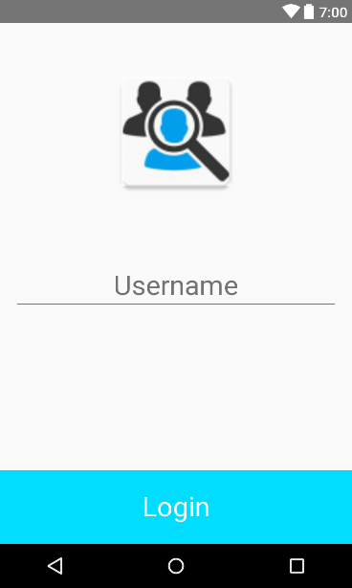**Accomplished Tasks:**

**-Created a Sign-In page using Firebase (Kristian/Oscar)**

For the first time opening the app, the user will be prompted for a unique username/user id. This will be cached onto the phone’s internal storage so that they don’t need to sign in every time. Instead, users will be signed in automatically with a custom token. To integrate Firebase connectivity, we need to do research beyond what was covered in the course so far. We have spent about 2-3 hours researching Authentication and still need to look more into Data Storage to progress further with our application. The android Firebase documentation was able to provide us with some code that we were able to use for the authentication.

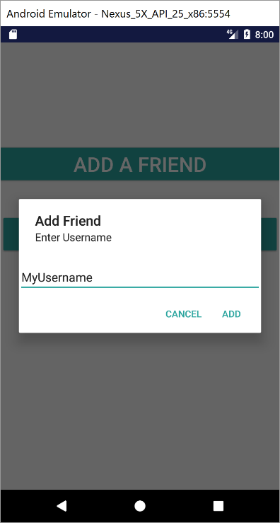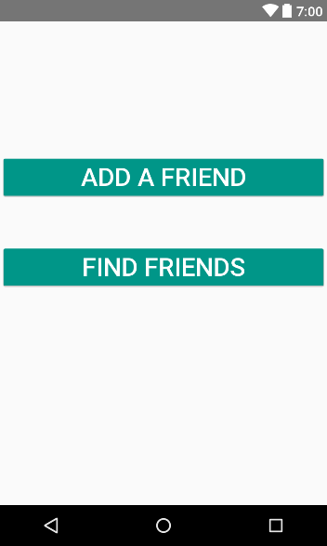

**-Created an option to add friends to find (Kristian/Oscar)**

Once signed in, users will have to option to add a friend or open the map to view nearby existing friends. By clicking on the add friend button, a dialog box will appear with an edit text inside of it. The user can then enter the username of a friend, which will eventually be stored in the database for a user.

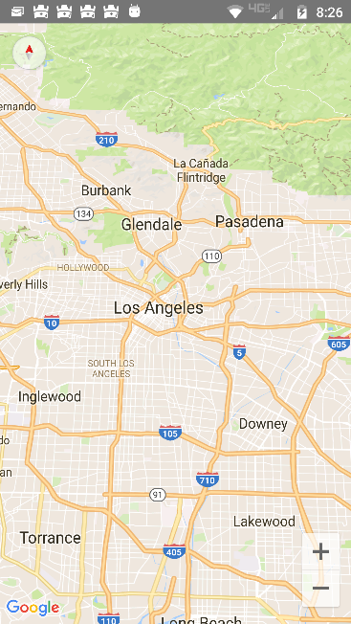**-Created a Map Activity to display where friends are (Alan/Yoseph)**

By clicking on the find friend button, a map is opened, which will eventually show all nearby friends within a 2 mile radius. This activity required about 2-3 hours of research outside of class because it was started before the lecture on Location Services. We were able to get the Map Activity to open by using some code provided by the android documentation regarding the Google Maps API. Most of the time debugging was spent figuring out problems with the gradle and also the key for the API in the manifest.

**The following dependencies were used in the project:**

compile 'com.google.firebase:firebase-auth:10.0.1'  
compile 'com.google.firebase:firebase-database:10.2.1'  
compile 'com.google.android.gms:play-services-auth:10.2.1'