ITE3711 Programming Concepts and Applications
Project

Objective: Write a window application using VB2017 to determine the module grade for our students and the module average according to the given requirements.

Submission Deadline: TBC

Grouping of students: 1 or 2 students per project.

Submission:
- Soft copy: your VB system for submission
- Zip the folder of your VS2017 project
- Save as the file name as ITE3711_StudentNo1_StudentNo2.zip
(e.g.: ITE3711_200000112_200000113.zip)
- Upload the zip file to Moodle
**Only 1 student in the group is required to submit the zip file to Moodle

- Hard copy: printing your program code for submission
  - Create a new Microsoft Word document
  - Create the document with the following:
- Margin: 2 cm top, bottom, left, right
- Page layout: Landscape Orientation
- Font size: 12 point
- Line Spacing: Single
  - Copy and paste your all program codes from the Visual Studio editor
  - Include your class, your name and your student ID
  - Save the file name as ITE3711_StudentNo1_StudentNo2.docx
  - Print out the hard copy and submit to the subject lecturer during the demonstration

Demonstration: each group will present the project during class to your subject lecturer to show the layout and walk through all the functions.

Instructions:
- Use standard notation in naming your VB controls.
- All programs should be properly documented/commented and structured.
- Use blank lines to separate group of statements.
- Use inline comments to describe statement/group of statements.
- Use appropriate data type in solving the problems.
- Design a nicer user interface, such as easier to read/use or more user friendly, instead of copying the attached sample form.
Calculation of Marks and Grade:
Marks and grade are calculated according to the following rules:
- CA Marks = Test * 50% + Project * 30 % + Quizzes * 20%.
- Module Mark = CA Mark * 40% + Exam Mark * 60%
- Module Grade is determined as follows:
CA Marks | Exam Marks | Module Marks | Grade
< 40 | --- | --- | F
--- | < 40 | --- | F
>=40 | >=40 | >=75 and <=100 | A
>=40 | >=40 | < 75 and >=65 | B
>=40 | >=40 | < 65 and >=40 | C
- Remark (Decision for Restudy/Resit) of a module is determined as follows:
Module Grade | Module Marks | Remark(Decision for Restudy/Resit)
F | >=30 | Resit Exam
F | <30 | Restudy
A, B or C | --- | Pass
Note: The symbol "---" in the above tables stands for "Not Considered".

Detailed Program Requirements:
- Use VS2012 to create a window application that contains all the fields/controls shown below: 5%
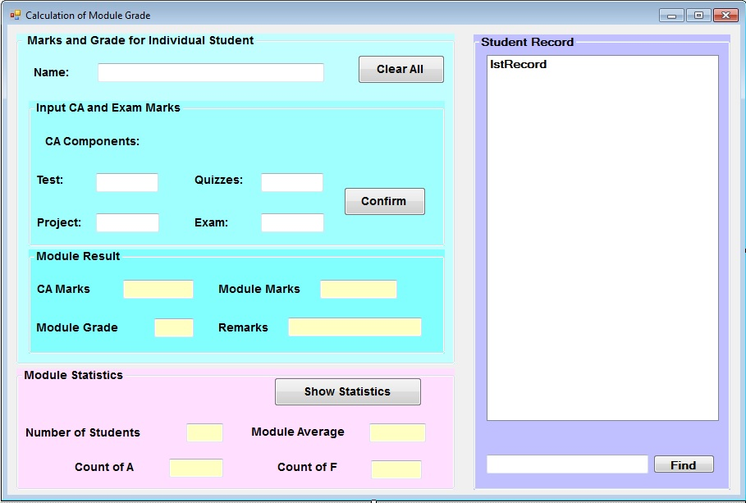
- When your program is started, it shows the percentage of each of the CA components and module components.
5%
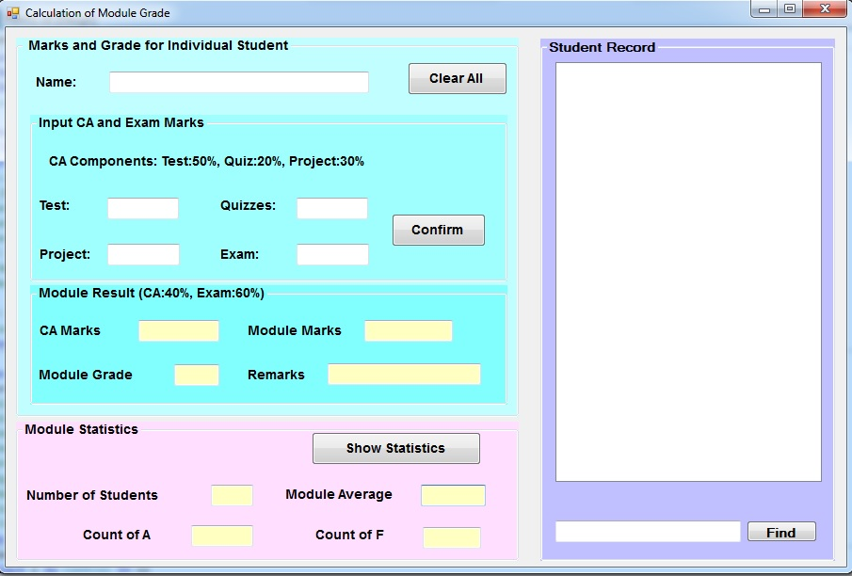
The percentage of each of the CA components and module result components must be declared as a constant in your program. The percentage shown in the form is changed automatically as the constant changes.
(e.g. the statement Const TEST_PERCENTAGE As Double = 0.5 declares that test is 50%)
- Button "[Confirm]": 40%
Before the user clicks the Confirm button, he/she must input the student name and the marks for the test, project, quizzes and exam. Your program will then do the following:
  - Validate all the input data: make sure that the student name is entered; all marks are in between 0 and 100. If the user enters any invalid data, your program shows an error message and stops processing for the current set of input data.
  - Compute and display the CA marks and module marks
  - Determine and display the module grade and the remark
  - Accumulate number of students, total marks, count of A/F grade student
  - display the student name into student record
You may consider to write a procedure/function to compute/determine each of the following:
- CA marks, Module grade and Remark.

- Button "[Clear All]": 5%
Clear all textboxes in the group-box "Marks and Grade for Individual Student"
- Button "[Show Statistics]": 10%
Compute the module average of all students; update all fields in the group-box "Module Statistics".
Be reminded that the module average is 0 when number of students = 0.
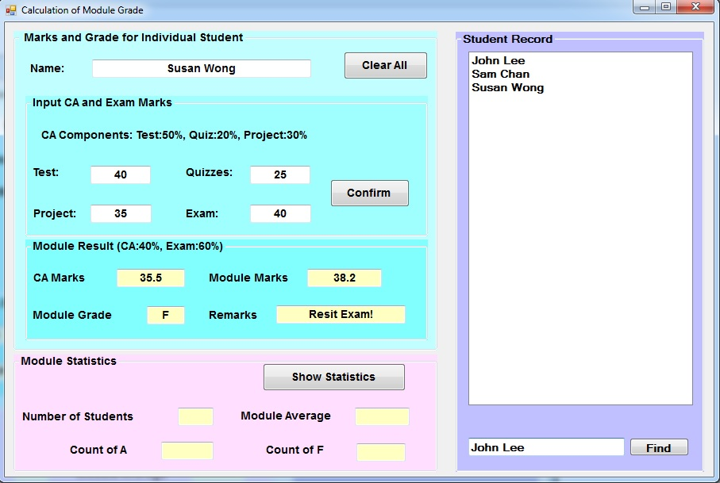
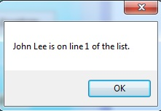
- When the user input the student name and then click the button “Find”, your program can search the student record by the student name. If the student name is found in the student record, the message box will be shown as follow: [Note: Write a “For…Next” loop to search the student record.] (5%)
Hint: Using “CStr” to convent the items of the object when checking the student name, you may refer to textbook P.275.

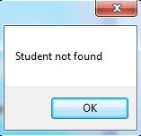
If the student name cannot be found in the student record, the message will be shown as follow: [Note: Write a “For…Next” loop to search the student record.] (5%)
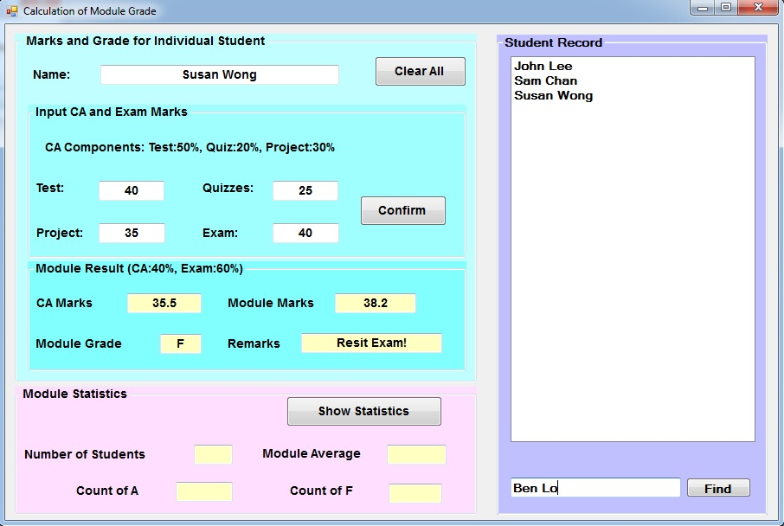
- Program style 15%
- Naming of variables, proper use of class-level variable
- Proper use of program structures (e.g. procedure, function, if-else vs. else-if ... etc.)
- Indentation of the program
- Easy to read
- Project enhancement 10%
- Extra/New function is implemented in the project successfully such as database connection

Penalty for Plagiarism (抄襲)
Submit your own work. Plagiarism will be treated seriously.

All assignments that have been found involved wholly or partly in plagiarism (no matter these assignments are from the original authors or from the plagiarists) will score ZERO mark. Furthermore, disciplinary action will be followed.
~ Late Submission: 0 Mark ~
~ End ~

