Hierarchical Risk Parity Variants for Cryptocurrency Portfolios: Denoising, Detoning, Tail Dependence, Embeddings, and Statistical Inference, 2020–2026
Alan Matys
Federico Martin Rodriguez
Emiliano Delfau
Universidad del CEMA — May 2026
Abstract
We extend the 2025 conference study on Hierarchical Risk Parity (HRP) by addressing its two stated methodological follow-ups (Marchenko–Pastur denoising and spectral detoning) and by evaluating a broader cross-section of portfolio construction choices on a survivorship-bias-corrected, point-in-time Binance universe (146 ever-included symbols, 2020–2026). The comparison includes 27 constructed strategies spanning HRP-family variants, risk-based allocators, nested-clustering optimisers, momentum rules, and signal-aware extensions.
Across 76 monthly rebalances, the HRP-family variants remain tightly clustered in risk-adjusted performance (annualised Sharpe 0.69–0.75), and this result persists under a 547-cell hyperparameter sweep (combined Hansen Superior Predictive Ability (SPA) $p_{\text{consistent}}=0.91$). Strategies that alter the allocation step produce larger dispersion (notably the Minimum Variance Portfolio (MVP), the Correlation-Regularised Iterative Shrinkage Portfolio (CRISP), the Nested Clustered Optimization with CRISP allocation (NCO–CRISP), and Nested Clustered Optimization (NCO)), with CRISP and NCO–CRISP significant in pairwise Ledoit–Wolf tests versus baseline HRP in both full and post-COVID windows. However, after accounting for multiple comparisons, the headline SPA does not reject ($p_{\text{consistent}}=0.51$), and the Deflated Sharpe Ratio (DSR) is directionally consistent with that conclusion.
Post-COVID results indicate strong regime sensitivity: diversified HRP variants lose 51–64% of capital while Bitcoin (BTC) and BTC-concentrating allocators hold up better. We also revise an earlier interpretation on cluster stability: over the full panel, Pearson-based clustering is more stable than lower-tail dependence at monthly frequency. Overall, the evidence supports a cautious interpretation: within this universe, horizon, and search space, allocation choices are more strongly associated with performance differences than clustering perturbations, but those edges remain statistically fragile under search-adjusted inference.
The opinions expressed in this document are those of the authors and do not necessarily reflect the views of the UCEMA. Comments are welcome at: alan.matys92@gmail.com, federico.m.rodriguez.h@gmail.com or ed11@ucema.edu.ar.

Keywords.
Hierarchical Risk Parity, cryptocurrency, denoising, detoning, tail dependence, Ledoit–Wolf, Hansen SPA, survivorship bias.

JEL classification.
G11, C58, C63, G17.

Introduction
The 2025 conference paper (Matys and Rodriguez 2025) applied Hierarchical Risk Parity (López de Prado 2016) to a five-asset cryptocurrency universe (BTC, ETH, LTC, XRP, BCH) over 2021–2023 and concluded that HRP delivered better diversification than the Minimum Variance Portfolio without sacrificing risk-adjusted return. Two items were left for future work: denoising the correlation matrix using Marchenko–Pastur eigenvalue filtering (Marchenko and Pastur 1967; Laloux et al. 1999), and detoning by removing the dominant market eigenvector (López de Prado 2020). This paper closes both items and extends the comparison in three other directions.

Contributions.
- Closing the 2025 conference paper’s future-work items. Implement and evaluate Marchenko–Pastur denoising (§3.1) and spectral detoning. Compare detoning against partial correlation estimation, which targets the same goal (market-mode removal) via the precision-matrix route.
- HRP variants, embedding variants, and nested-clustering optimisers. Six correlation/covariance HRP variants (partial-correlation, exponentially weighted moving average (EWMA) dynamic-correlation, lower-tail dependence, Ledoit–Wolf shrunk-covariance, vol-standardised, and a tail-dep$+$Ledoit–Wolf (LW)-shrunk hybrid) and four embedding-based variants that learn the HRP clustering distance from a representation of each asset’s return path (level-3 path signatures, a node2vec graph embedding, and two contrastive sequence encoders; §3.2). We also add four strategies that change the allocation step rather than the dendrogram: Hierarchical Equal Risk Contribution (Raffinot 2018), Nested Clustered Optimization (López de Prado 2019), a return-tilted NCO, and an NCO–CRISP hybrid (§3.3); these test whether the clustering step or the allocation step drives performance. Equal Risk Contribution (ERC) (Maillard et al. 2010), Maximum Diversification (Choueifaty and Coignard 2008) and CRISP (Wuebben 2026), a recent correlation-shrinkage portfolio, serve as risk-based comparators.
- Crypto-momentum strategies. Cross-sectional momentum, risk-managed momentum (Barroso and Santa-Clara 2015), and a Momentum$+$HRP hybrid, parameter-tuned for crypto’s faster momentum decay per (Liu et al. 2022).
- Methodological rigour and a power analysis. (i) Point-in-time universe rebuilt monthly from Binance USDT quote-volume rankings, including assets later delisted (LUNA, FTT, MIR, SRM, etc.) to remove the survivorship bias of the prior single-CSV dataset. (ii) Multi-cost scenarios and a weekly-cadence robustness check. (iii) Inference around every comparison: the reference Hansen SPA implementation (Hansen 2005), a studentized Ledoit–Wolf Sharpe-difference test (Ledoit and Wolf 2008), and the Politis–Romano stationary block bootstrap (Politis and Romano 1994; Politis and White 2004). (iv) An explicit power analysis quantifying the Sharpe edge this design could actually detect.
- Empirical characterisation and correction of an earlier interpretation. We document the structural convergence findings of $§$6 and update an earlier interpretation on cluster stability: when evaluated on the full 76-snapshot panel, Pearson-based clustering is more stable than lower-tail dependence at monthly frequency.
- Reproducibility. All results are generated from a documented, fully rerunnable workflow with committed inputs, outputs, and figures so that each headline claim can be traced to a corresponding result table.
The remainder of this paper is organised as follows. Section 2 reviews related work. Section 3 presents the methodology. Section 4 describes the data and point-in-time universe construction. Section 5 states the backtest protocol. Section 6 presents results. Section 7 discusses limitations and contributions. Section 8 concludes.

Related Work

Hierarchical risk parity and its extensions
HRP was introduced by López de Prado (2016) as a clustering-based alternative to mean-variance optimisation that avoids covariance-matrix inversion. Subsequent textbook treatments (López de Prado 2018, 2020) extend the framework with denoising and detoning and propose tail-dependence distances (Lohre et al. 2020) for multi-asset multi-factor allocations. Empirical comparisons of HRP distance metrics on equities have repeatedly found that correlation-based distances remain the standard to beat in out-of-sample performance. A concurrent line of work makes the hierarchical allocator signal-aware: Wuebben (2026) extends HRP to accept an arbitrary return forecast and introduces CRISP, a correlation-shrinkage solver that interpolates between an inverse-variance rule and full mean-variance optimisation; its evaluation is by Monte Carlo. We adopt CRISP here as a comparator and, in §6.4, contrast that simulation evidence with live-market behaviour.

Risk-based and network methods
Equal Risk Contribution (Maillard et al. 2010) solves for weights such that each asset contributes equally to portfolio risk; Maximum Diversification (Choueifaty and Coignard 2008) maximises the diversification ratio. Network methods build a Minimum Spanning Tree (Mantegna 1999) or PMFG (Tumminello et al. 2005) from the correlation structure; Network Risk Parity (Ciciretti and Pallotta 2024) recently combined the network approach with risk-budgeting.

Cryptocurrency momentum
Liu et al. (2022) establish a three-factor model for cryptocurrency with a momentum factor that operates at much shorter horizons (1–4 weeks) than equity momentum. Moskowitz et al. (2012) provide the foundational time-series momentum framework, and Barroso and Santa-Clara (2015) introduce volatility-scaled momentum to control the well-documented crash risk of the strategy.

Statistical inference for portfolio comparison
Ledoit and Wolf (2008) provide a robust pairwise Sharpe-difference test that does not assume i.i.d. Gaussian returns. Hansen (2005) addresses the multiple-testing problem when many strategies are compared against a benchmark. Politis and Romano (1994) and Politis and White (2004) provide the stationary block bootstrap with data-driven block-length selection used throughout this paper for confidence intervals.

Methodology

Correlation and covariance variants
Every strategy in this group shares the standard HRP pipeline: distance matrix $→$ hierarchical linkage $→$ quasi-diagonalisation $→$ recursive bisection (López de Prado 2016). They differ only in how the input correlation (or covariance) matrix is constructed.

Baseline HRP
$ρ$ from sample correlation; $d_{ij}=\sqrt{(1−ρ_{ij})/2}$; single linkage; bisection using the sample covariance.

HRP_{Denoised}: Marchenko–Pastur eigenvalue denoising
Following López de Prado (2020), the empirical eigenvalues of the sample correlation matrix are decomposed into a signal subspace (eigenvalues above the Marchenko–Pastur upper bound $e_{max}=σ^{2}(1+\sqrt{1/q})^{2}$ where $q=T/N$) and a noise subspace (eigenvalues below). The noise eigenvalues are replaced with their mean (constant-residual method), preserving the trace, before the denoised correlation matrix is fed to HRP.

HRP_{Detoned}: market-mode removal
Applied to the denoised correlation matrix, detoning removes the top $k$ eigenvectors (default $k=1$) and renormalises the diagonal to unity (López de Prado 2020). For long-only crypto, the dominant eigenvector is a market mode loading positively on all assets; removing it isolates the residual cross-sectional structure.

HRP_{PartialCorr}: sparse precision matrix
A precision-matrix route to the same market-mode-removal goal: $Θ=arg\min_{Θ≻0}−logdetΘ+tr(SΘ)+α∥Θ∥_{1}$ via graphical lasso (Friedman et al. 2008), then $ρ_{ij}^{partial}=−Θ_{ij}/\sqrt{Θ_{ii}Θ_{jj}}$. We set the $L_{1}$ penalty to $α={10}^{−3}$. This value matters: a subtle implementation point is that scikit-learn’s GraphicalLasso expresses $α$ in the same units as the covariance, not as a normalised $[0,1]$ quantity. For daily crypto returns with variance $∼$$4×{10}^{−3}$, an $α$ on the order of ${10}^{−1}$ shrinks every off-diagonal of the precision matrix to zero and silently collapses HRP_{PartialCorr} into IVP. The correct scale, $α≈{10}^{−3}$, leaves roughly 40% of the off-diagonals non-zero. An earlier draft used $α=0.05$, the strategy degenerated to IVP, and the headline table reported the two as identical; the hyperparameter sweep of §6.3 surfaced the bug, and we document the correction explicitly.

HRP_{Dynamic}: EWMA correlation
Recursive EWMA covariance with decay $λ$; the latest snapshot is used as the correlation input. We report $λ=0.94$ as the RiskMetrics default; sensitivity to $λ∈\{0.94,0.97,0.99\}$ is documented in the supplementary appendix.

HRP_{TailDep}: lower-tail dependence
Empirical lower-tail dependence coefficient ${\hat{λ}}_{L}^{ij}(q)=P(F_{j}(X_{j})≤q∣F_{i}(X_{i})≤q)$ at $q=0.05$, symmetrised by averaging the two conditional probabilities. The distance is $d_{ij}=\sqrt{1−{\hat{λ}}_{L}^{ij}}$; the sample covariance is retained for bisection. Promoted from appendix to a headline strategy after the empirical findings of §6 showed it does not fall back across the 76 backtest snapshots.

HRP_{ShrunkCov}: Ledoit–Wolf shrinkage
Sample covariance replaced with the analytic Ledoit–Wolf shrinkage estimator (Ledoit and Wolf 2003, 2004); the implied correlation is derived from the shrunk covariance and fed to HRP. Shrinkage intensity $α∈[0,1]$ is chosen analytically per snapshot and reported as a diagnostic.

HRP_{VolStd}: vol-standardised returns
Per-asset returns are divided by their lagged 30-day rolling standard deviation before computing Pearson correlation. Addresses crypto’s heterogeneous vol scale across the universe (e.g. BTC vs. SHIB). The sample covariance is retained for bisection.

HRP_{TailDepShrunk}: hybrid
Combines $§$3.6 (tail-dep distance for the dendrogram) with $§$3.7 (LW-shrunk covariance for bisection). Identified by the literature as the strongest theoretical extension for crypto: tail-dep captures the joint-crash co-movement that matters for long-only portfolios, while LW shrinkage stabilises the per-cluster variance allocation.

Embedding-based variants
Beyond reweighting the correlation or covariance estimator, the distance matrix that drives HRP’s dendrogram can be learned from a representation of each asset’s return path. We implement four such embedding variants. All share one template: an embedding maps each asset to a vector, the pairwise cosine distance of those vectors replaces HRP’s correlation distance for the linkage and quasi-diagonalisation steps, and the sample covariance is retained for recursive bisection. The embedding therefore changes only which assets cluster together, never the inverse-variance allocation within a cluster, which is why, as §6 shows, every embedding variant stays within a narrow Sharpe band of baseline HRP.

HRP_{PathSig}: path signatures
Each asset’s rolling log-price trajectory, augmented with a monotone time channel, is mapped to its level-$L$ truncated path signature (Lyons 1998), a graded sequence of iterated integrals that characterises the path up to tree-like equivalence. Cosine distance on the signature vectors drives the dendrogram (default: level 3, 60-day window), computed with the esig library.

HRP_{NodeEmbed}: node2vec graph embedding
A $k$-nearest-neighbour graph ($k=10$) is built from the sample correlation matrix; node2vec random walks plus a skip-gram objective (Grover and Leskovec 2016) learn a 32-dimensional embedding per node. Cosine distance on the embeddings drives the dendrogram.

HRP_{Contrastive}: contrastive SSL
A small one-dimensional convolutional encoder is trained with the NT-Xent contrastive loss (Chen et al. 2020) on Gaussian-jittered pairs of return windows; each asset is embedded as the mean encoder output over its windows.

HRP_{TS2Vec}: timestamp-masked contrastive
The same encoder family, trained with TS2Vec-style timestamp-mask augmentation (Yue et al. 2022) in place of Gaussian jitter.

Multi-channel extension.
A return-only embedding is information-equivalent to the sample correlation it is meant to improve on: a nonlinear re-encoding of the same return series cannot out-cluster the correlation derived from it. We therefore also evaluate multi-channel variants that append channels orthogonal to close-to-close returns: quote volume, trade count, average trade size, intraday range, taker buy-ratio (order-flow imbalance), and Amihud illiquidity, all derived from the Binance OHLCV table. The multi-channel results are reported in §6.3.

Robustness.
Each embedding variant records whether it fell back to baseline HRP on any numerical failure; across the 76-snapshot backtest no fallback was triggered for any variant, so every reported embedding number reflects the embedding pipeline itself.

Comparator strategies

Risk-based comparators.
IVP (inverse-variance), MVP (minimum-variance via SLSQP), ERC (Maillard et al. 2010) (solved by SLSQP minimisation of squared deviations from equal risk contributions), Maximum Diversification (Choueifaty and Coignard 2008) (SLSQP maximisation of the diversification ratio), and CRISP (Correlation-Regularised Iterative Shrinkage Portfolio; (Wuebben 2026), a recent preprint). CRISP solves the linear system $P_{γ}w=1$ with $P_{γ}=(1−γ) diag(Σ)+γ Σ$, a variance-preserving shrinkage that keeps the asset variances exact and multiplies the off-diagonal covariances by $γ$. The factor $γ$ interpolates between inverse variance ($γ=0$) and a full minimum-variance solve ($γ=1$); we use the signal-free form ($μ=1$) and fix $γ=0.5$ rather than tuning it out-of-sample. Long-only weights are obtained by projecting the solution onto the simplex.

Nested-clustering optimisers.
HRP and all its variants change only the dendrogram; the within-cluster allocation stays inverse- variance recursive bisection. To isolate whether the clustering step or the allocation step drives performance, we add four strategies that keep hierarchical clustering but re-optimise the allocation. HERC (Hierarchical Equal Risk Contribution; (Raffinot 2018)) cuts the dendrogram into $K=round(\sqrt{N})$ clusters (clamped to $[2,⌊N/2⌋]$), weights assets inverse-variance within each cluster, and combines the cluster portfolios by an equal-risk-contribution allocation. NCO (Nested Clustered Optimization; (López de Prado 2019)) solves a long-only minimum-variance problem within each cluster sub-covariance, collapses each cluster to its intra-cluster portfolio, and solves a second minimum-variance problem across the $K$ cluster portfolios, inverting only block sub-covariances and a small $K×K$ matrix, which suppresses the estimation-error amplification of a direct optimiser. Return-tilted NCO replaces NCO’s two minimum-variance steps with long-only maximum-Sharpe steps driven by a shrunk 63-day momentum estimate, a deliberate test of whether making the allocation return-aware helps. NCO_CRISP instead replaces each of NCO’s minimum-variance solves with a CRISP solve on the corresponding block covariance: the hierarchy isolates the most strongly-correlated (and hence most near-singular) covariance blocks, and the CRISP shrinkage regularises the optimisation inside them. It is the natural hybrid of the paper’s two best ideas, and reduces to NCO at $γ=1$ (up to the long-only projection).

Signal-aware extensions.
Two further comparators feed a walk-forward learned return forecast into hierarchical allocation, to test whether return-tilted NCO’s collapse was a verdict on signal-aware allocation in principle or only on the sample-mean tilt it used. The forecast is a pooled cross-sectional XGBoost regressor that predicts each asset’s next-30-day cumulative log return. At every snapshot the hyperparameters are tuned by TimeSeriesSplit(3) cross-validation inside the training window (grid: max_depth $∈\{3,5\}$, learning_rate $∈\{0.03,0.1\}$, n_estimators $∈\{200,500\}$) and the best estimator is refit on the full window; features are lagged returns at 1/5/21/63-day horizons, 21-day realised volatility and the cross-sectional rank of the 21-day return. The pipeline is single-threaded and seeded for bit-identical reproduction. NCOML keeps NCO’s clustering and nesting but replaces each minimum-variance solve by a long-only max-Sharpe solve fed by the XGBoost $μ$. HRP-$Σμ$ is Wuebben’s signal-aware hierarchical optimiser (method A1 with L$​^{1}$ normalisation): HRP’s seriation and quasi-diagonalisation are unchanged, but the inverse- variance recursive bisection is replaced by a single bottom-up tree pass in which every internal node solves a 2$×$2 mean-variance system on the left vs right cluster representatives via Cramer’s rule, with the $(α_{L},α_{R})$ pair L$​^{1}$-normalised at each node; we project the signed output long-only at the root for comparability with the rest of the paper.

Momentum strategies
The headline comparison includes three crypto-momentum strategies, parameter-tuned for crypto’s faster momentum decay (Liu et al. 2022). CS_MOM is cross-sectional momentum: equal-weight the top 30% of assets by 21-day cumulative return. RM_MOM applies the Barroso–Santa-Clara volatility-targeting overlay (Barroso and Santa-Clara 2015) ($σ_{\text{target}}=12\%$) to the same momentum selection. MOM_HRP is a Momentum$+$HRP hybrid: select the top 40% of assets by momentum, then allocate within that basket by HRP rather than equal-weight.

Data and Point-in-Time Universe

Source and window
Daily OHLCV from Binance USDT spot, 2017-08-17 (Binance’s earliest data) to 2026-05-18, approximately nine years. After the survivorship-bias expansion described in §4.3, the price panel covers 241 USDT pairs.

Point-in-time universe
At each month-end, we rank the candidate symbols by their rolling 30-day Binance USDT quote volume, apply filters (180-day minimum age, $1M minimum median daily USD volume, stablecoin/wrapper/exchange-token exclusion, listed on Binance USDT spot at the snapshot date), and take the top 50. Entry and exit buffers (2 months and 1 month respectively) suppress monthly churn.

Methodology note.
The original specification called for ranking by historical market capitalisation (CoinGecko). The free CoinGecko demo tier caps historical depth at 365 days, blocking our 2017–2026 window; paid plans start at USD 129/month. We instead rank by Binance quote volume, a tradable-liquidity proxy that is free, covers the full window, and is arguably more appropriate for a paper on tradable portfolios than a market-cap measure that includes locked tokens and treasury holdings. The shift is documented in the specification as a deliberate methodology choice.

Survivorship-bias fix in numbers
After a code review surfaced residual survivorship bias (the prior candidate pool was a hand-curated selection of $∼$90 symbols missing the long tail of delisted altcoins), the universe was expanded by pulling all 217 status=BREAK USDT pairs from Binance’s /api/v3/exchangeInfo, filtering leveraged tokens and stablecoins, and adding 150 legitimate delisted altcoins to the candidate pool. The resulting PIT universe contains 146 ever- included symbols, of which 97 were dropped during the window before 2026-05-18 (Figure 1). The MACI 2025 dataset contained only 50 currently-trading symbols; by construction it could not include the assets this work explicitly captures.
We treat liquidation of an exiting position at 2$×$ normal slippage cost (Spec 03 §2.4). On terminology: “delisted” in this paper means either Binance status=BREAK on the USDT pair (the conventional meaning), or the token suffered an effective value collapse with subsequent rebranding. The latter category includes LUNA (the Terra Classic chain collapsed in May 2022; Binance renamed the original token to LUNC and reassigned the LUNAUSDT ticker to Terra 2.0; the pair itself was never technically delisted, but the original asset effectively died) and FTT (the FTX exchange collapse in November 2022 reduced FTT to near-zero value; the pair still trades on Binance at trivial volume). Our binance_listings_manual.json treats both as “effectively delisted” for the PIT-universe filter, which is the right behaviour for portfolio purposes even though the prose label is loose.
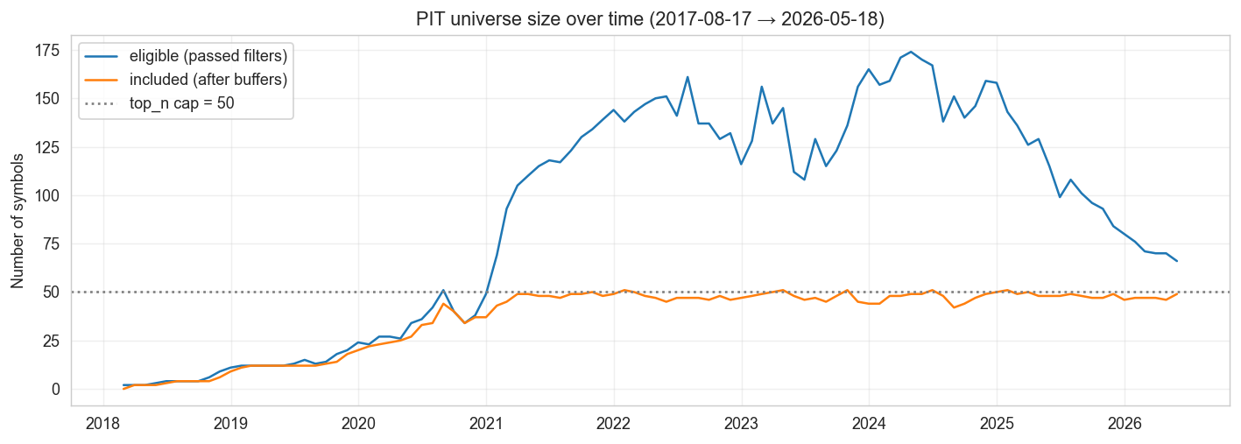
PIT universe size over time. Eligible: passed all filters at the snapshot date. Included: in the universe after entry/exit buffers. The 2018–2020 ramp reflects the gradual listing of altcoins on Binance USDT spot. Steady-state $∼$49 included symbols since mid-2020.

Estimation window
365 daily returns of rolling lookback at each rebalance, with a per-asset 180-day minimum-observations filter. Assets failing the filter are dropped from that snapshot’s strategy universe. Rationale: several newer assets (JUP, ENA, WIF, $…$) are admitted via the 180-day age filter but do not yet have 730 days of history.

Backtest Protocol

Scenarios
B (calendar): monthly rebalancing; the headline scenario. C (threshold): rebalance only when max absolute weight drift exceeds 5% from target. C$′$ (smoothed): C with linear smoothing $w_{\text{traded}}=η w_{\text{prev}}+(1−η) w_{\text{target}}$, $η=0.25$, plus a 25 bps min-trade filter. Weekly: a robustness check rebalancing every Friday (universe membership carried from the latest month-end PIT snapshot, weights recomputed weekly on the rolling window), $∼$330 rebalances instead of 76, to probe whether higher cadence sharpens inference.

Cost grid
Linear cost $=({\text{fee}}_{\text{bps}}+{\text{slippage}}_{\text{bps}})×{\text{turnover}}_{L_{1}}$, with a 2$×$ multiplier for forced liquidation of exiting positions. Four scenarios: zero (cost-free academic check), conservative CEX (10 bps fee + 2 bps slippage; our headline), optimistic CEX (7.5 bps + 1 bps), and stress (10 bps + 4 bps).

Statistical inference
For each candidate versus baseline HRP, the Ledoit–Wolf (2008) Sharpe-difference test (Ledoit and Wolf 2008): the observed annualised Sharpe difference is studentized by a delta-method HAC standard error, and the two-sided $p$-value is read off a studentized stationary-block bootstrap (studentising both the observed and the resampled statistic, as the method requires; a plain percentile bootstrap lacks the asymptotic refinement). Across all candidates jointly, the Hansen Superior Predictive Ability test (Hansen 2005), computed with the reference arch implementation, which reports the lower, consistent and upper recentering schemes. Headline-metric confidence intervals use the Politis–Romano stationary block bootstrap (Politis and Romano 1994) with Politis–White automatic block length (Politis and White 2004). A power analysis (§6.2.0.4) reports the Sharpe edge the design could detect.

Cluster stability
At each rebalance snapshot, we compute the cophenetic correlation of the dendrogram (Pearson correlation between cophenetic distance and original pairwise distance) and the Adjusted Rand Index (Hubert and Arabie 1985) between the cluster assignment at snapshot $t$ and snapshot $t−1$, cut at $K=5$ clusters via fcluster.

Results

Scenario B headline performance
Table 1 reports the headline comparison under monthly rebalancing with conservative CEX costs over 2020-02 through 2026-05-18. The strategy return panel contains 2,299 daily observations for the PIT-traded strategies; once the passive HODL_BTC benchmark is included, the common aligned panel used for the Ledoit–Wolf and Hansen SPA inference contains 2,297 observations. Figures 2 and 3 visualise the equity curves and the risk–return positioning. The Sortino and Calmar ratios track the Sharpe ranking closely; the one strategy they re-order materially is RM_MOM, whose volatility-targeting overlay gives it the table’s mildest drawdown ($−40\%$, against the $−77\%$ to $−93\%$ of every other strategy) and lifts its Sortino well above its Sharpe rank.
Scenario B headline results (Conservative CEX cost, 76 monthly rebalances over 2020-02 to 2026-05, expanded 146-symbol PIT universe). Sharpe is the annualised arithmetic ratio (mean / standard deviation $×\sqrt{365}$); Sortino and Calmar are annualised; Max DD is the peak-to-trough drawdown. All ratios use raw returns with the risk-free rate set to zero, the standard convention for crypto Sharpe ratios. “LW $p$” is the studentized Ledoit–Wolf Sharpe-difference test vs. baseline HRP (bold: $p<0.05$). HODL_BTC is a passive benchmark, not a strategy.
Strategy | Sharpe | Sortino | Calmar | Total Return | Max DD | LW $p$
MVP | 1.057 | 1.293 | 0.896 | +2867% | –80% | 0.059
CRISP | 0.989 | 1.000 | 0.726 | +1693% | –80% | 0.012
NCO_CRISP | 0.977 | 0.930 | 0.702 | +1613% | –81% | 0.011
NCO | 0.933 | 0.979 | 0.672 | +1503% | –82% | 0.218
HODL_BTC | 0.868 | 0.881 | 0.528 | +749% | –77% | 0.606
NCOML | 0.804 | 0.492 | 0.415 | +567% | –85% | 0.804
HRP_Dynamic_94 | 0.749 | 0.477 | 0.363 | +442% | –85% | 0.823
HRP_ShrunkCov | 0.746 | 0.461 | 0.355 | +428% | –85% | 0.779
HRP (baseline) | 0.741 | 0.455 | 0.351 | +417% | –85% | —
HRP_VolStd | 0.735 | 0.447 | 0.341 | +402% | –86% | 0.748
MOM_HRP | 0.726 | 0.402 | 0.299 | +351% | –91% | 0.942
HRP_PartialCorr | 0.720 | 0.429 | 0.329 | +366% | –84% | 0.477
MaxDiv | 0.719 | 0.396 | 0.297 | +364% | –93% | 0.919
HRP_PathSig | 0.714 | 0.417 | 0.316 | +351% | –86% | 0.277
HERC | 0.712 | 0.387 | 0.300 | +333% | –87% | 0.783
HRP_Denoised | 0.712 | 0.412 | 0.317 | +346% | –84% | 0.111
HRP_Contrastive | 0.710 | 0.408 | 0.313 | +341% | –85% | 0.238
HRP_Detoned | 0.708 | 0.403 | 0.309 | +334% | –85% | 0.403
HRP_TailDep | 0.708 | 0.406 | 0.310 | +337% | –85% | 0.114
HRP_NodeEmbed | 0.705 | 0.401 | 0.306 | +330% | –85% | 0.187
HRP_TS2Vec | 0.703 | 0.394 | 0.302 | +325% | –85% | 0.106
HRP_TailDepShrunk | 0.701 | 0.390 | 0.300 | +318% | –85% | 0.071
IVP | 0.697 | 0.388 | 0.297 | +311% | –85% | 0.212
CS_MOM_eq21 | 0.663 | 0.298 | 0.218 | +217% | –92% | 0.548
RM_MOM | 0.663 | 0.782 | 0.332 | +118% | –40% | 0.548
ERC | 0.663 | 0.315 | 0.242 | +233% | –87% | 0.051
HRPSigmaMu | 0.607 | 0.241 | 0.189 | +153% | –84% | 0.203
NCO_RT | 0.003 | –0.569 | –0.436 | –97% | –99% | 0.009
Portfolio behaviour metrics for the headline comparison, in the same row order as Table 1. “Ann return” is the compound annualised return on the rebalanced equity curve. “Ann vol” is annualised return standard deviation. “Turnover” is the average per-rebalance $L_{1}$ turnover (sum of absolute weight changes between two consecutive snapshots). “Max wt” is the average across snapshots of each portfolio’s largest single-asset weight. “Eff $N$” is the inverse-Herfindahl effective number of assets, averaged across snapshots; the HRP family sits at $≈30$, MVP / NCO / NCOML concentrate to $≤5$. HODL_BTC is passive (one asset, no rebalancing).
Strategy | Ann return | Ann vol | Turnover | Max wt | Eff $N$
MVP | $+71\%$ | 77% | 0.38 | 0.50 | 3.3
CRISP | $+58\%$ | 74% | 0.30 | 0.31 | 7.1
NCO_CRISP | $+57\%$ | 76% | 0.45 | 0.31 | 9.1
NCO | $+55\%$ | 78% | 0.58 | 0.42 | 5.3
HODL_BTC | $+40\%$ | 61% | — | — | —
NCOML | $+35\%$ | 96% | 1.59 | 0.68 | 2.5
HRP_Dynamic_94 | $+31\%$ | 81% | 0.47 | 0.13 | 26.3
HRP_ShrunkCov | $+30\%$ | 82% | 0.35 | 0.10 | 30.5
HRP (baseline) | $+30\%$ | 82% | 0.36 | 0.11 | 29.8
HRP_VolStd | $+29\%$ | 81% | 0.37 | 0.11 | 29.5
MOM_HRP | $+27\%$ | 89% | 1.44 | 0.18 | 12.6
HRP_PartialCorr | $+28\%$ | 81% | 0.24 | 0.10 | 29.6
MaxDiv | $+28\%$ | 93% | 0.55 | 0.22 | 8.4
HRP_PathSig | $+27\%$ | 81% | 0.38 | 0.10 | 29.4
HERC | $+26\%$ | 84% | 0.57 | 0.15 | 18.8
HRP_Denoised | $+27\%$ | 82% | 0.33 | 0.10 | 30.6
HRP_Contrastive | $+27\%$ | 81% | 0.40 | 0.10 | 29.9
HRP_Detoned | $+26\%$ | 82% | 0.26 | 0.08 | 31.9
HRP_TailDep | $+26\%$ | 81% | 0.36 | 0.11 | 29.2
HRP_NodeEmbed | $+26\%$ | 82% | 0.39 | 0.10 | 30.1
HRP_TS2Vec | $+26\%$ | 82% | 0.38 | 0.10 | 30.5
HRP_TailDepShrunk | $+26\%$ | 82% | 0.35 | 0.10 | 31.5
IVP | $+25\%$ | 82% | 0.18 | 0.08 | 32.5
CS_MOM_eq21 | $+20\%$ | 90% | 1.42 | 0.08 | 13.2
RM_MOM | $+13\%$ | 23% | 0.37 | 0.02 | 209.6
ERC | $+21\%$ | 84% | 0.19 | 0.05 | 41.9
HRPSigmaMu | $+16\%$ | 83% | 1.38 | 0.27 | 8.4
NCO_RT | $−43\%$ | 106% | 1.64 | 0.64 | 2.5

Pairwise significance (preview).
Under the studentized Ledoit–Wolf test, two strategies beat baseline HRP at $p<0.05$ (CRISP and the NCO–CRISP hybrid); full pairwise figures and the multiple-testing correction are deferred to §6.2. The HRP_PartialCorr update (§3.1) makes that strategy distinct from IVP; it was byte-identical to IVP in an earlier draft (Sharpe 0.697), corrected it sits at 0.720.
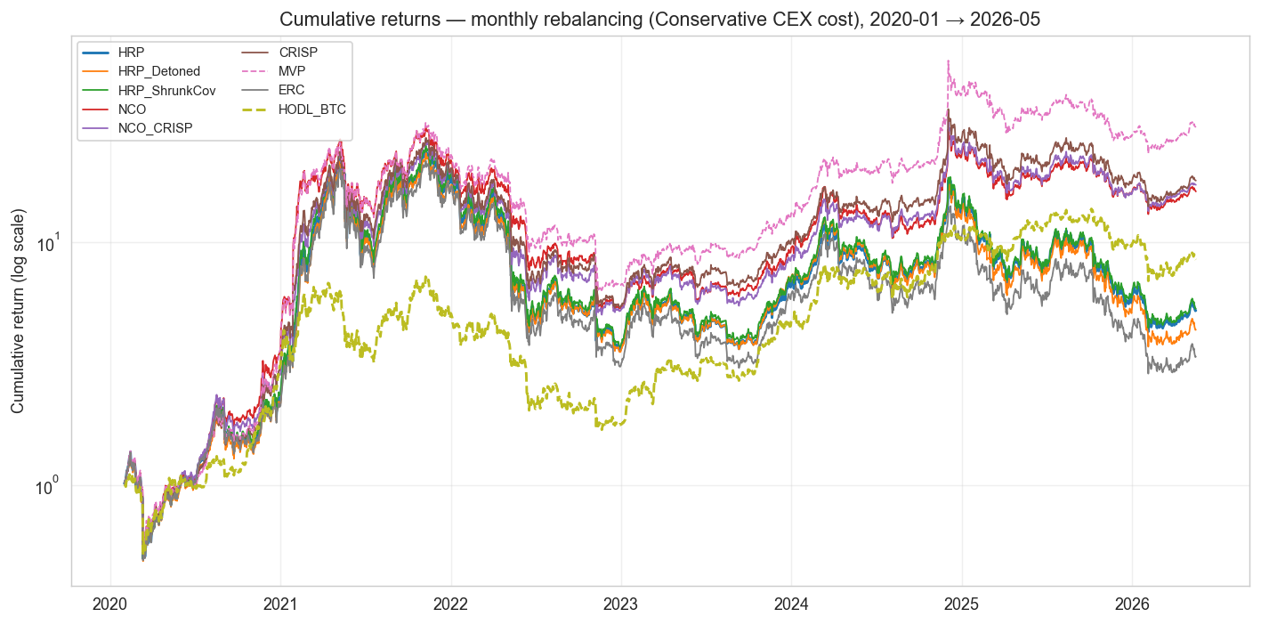
Cumulative returns for headline strategies under monthly rebalancing, log scale.
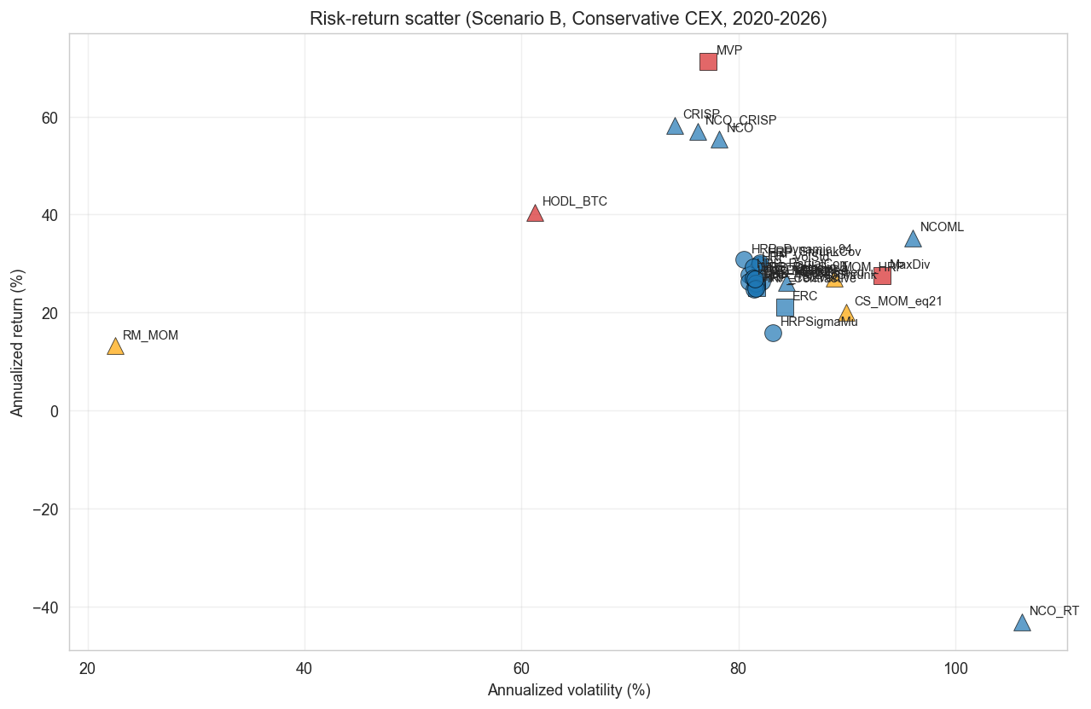
Risk-return scatter for the full 27-strategy comparison. Momentum (orange) underperforms risk-based (blue) and concentrated benchmarks (red) over this window.

The HRP family bunches.
All thirteen HRP-family variants lie within a 0.05 Sharpe band (0.701–0.749). HRP_Dynamic_94 and HRP_ShrunkCov marginally exceed baseline HRP (by $+0.008$ and $+0.004$ Sharpe respectively); the differences are small and, per §6.2, not statistically significant. No correlation estimator, distance function, linkage or embedding moves a variant out of this band.

The allocation step: NCO, CRISP and the NCO–CRISP hybrid.
The strategies that change the allocation step, rather than the dendrogram, separate from the HRP family. HERC (0.712) is the exception: it keeps an inverse-variance allocation and stays inside the HRP band. The rest move. NCO, nested minimum variance within and across clusters, reaches Sharpe 0.933; CRISP, a non-hierarchical correlation-shrinkage solve (§3.3), reaches 0.989; and the NCO–CRISP hybrid 0.977, with CRISP and the hybrid the only strategies that beat HRP at the pairwise level (§6.2). All three concentrate toward low-volatility assets (effective $N$ of 5–9 against HRP’s $≈30$), tilting into BTC in a BTC-led market; they are denoised, less-extreme cousins of MVP. The return-tilted NCO is the cautionary opposite: momentum-driven maximum-Sharpe steps make it a 164%-turnover momentum-chaser that loses 97% of capital, an illustration of the estimation-error amplification that risk-based allocation is designed to avoid. The hybrid is itself informative: it lands between its two parents (NCO 0.933, CRISP 0.989), so the correlation-shrinkage solve and the hierarchical nesting do not stack: the shrinkage carries the edge, and the nesting adds nothing measurable on top of it. Changing the clustering step produced no detectable outperformance over baseline HRP; changing the allocation step moved performance materially, in both directions.

Signal-aware extensions to NCO and HRP.
The two signal-aware additions further localise the NCO_RT failure. NCOML, which keeps NCO’s nesting but replaces the sample-mean tilt by the walk-forward XGBoost forecast of §3.3, reaches Sharpe $0.804$: it sidesteps the collapse and edges above baseline HRP, but lands below pure (signal-blind) NCO, so the learned signal does not add value over NCO’s risk-only allocation. HRP-$Σμ$, the same forecast fed into Wuebben’s signal-aware hierarchical optimiser, lands at $0.607$, below baseline HRP, a direct demonstration that forcing a return signal into HRP’s clustering hurts in this market, where the dendrogram is robust precisely because it is signal-blind.

Embedding variants.
The four embedding-based HRP variants are HRP_PathSig (path signatures; (Lyons 1998)), HRP_NodeEmbed (node2vec on a kNN correlation graph; (Grover and Leskovec 2016)), HRP_Contrastive (NT-Xent contrastive SSL; (Chen et al. 2020)), and HRP_TS2Vec (timestamp-mask augmentation; (Yue et al. 2022)). They rank in the middle of the HRP family, with Sharpes $0.692$–$0.714$, all below baseline HRP. Three of the four are not statistically different from baseline HRP at conventional levels (Ledoit–Wolf $p>0.05$), while HRP_Contrastive is significantly worse than HRP at the pairwise level. None delivers an out-of-sample Sharpe improvement over baseline HRP on this universe and horizon. Section 6.3 tests the conclusion against an exhaustive hyperparameter search and multi-channel embedding extensions, and it holds.

Denoising, detoning and partial correlation underperform HRP.
Marchenko–Pastur denoising, spectral detoning (the two MACI 2025 future-work items) and precision-matrix partial correlation all aim to clean the correlation matrix, and all three cost a little Sharpe in a BTC-led bull market, where filtering structure means trimming exposure to the asset that ran. The denoising and detoning steps form an ablation: HRP (neither, 0.741), HRP_Denoised (denoising only, 0.712), HRP_Detoned (denoising and market-mode removal, 0.708); each filtering step shaves a little, the denoising step the larger part. HRP_PartialCorr (0.720) lands between them. It is no longer numerically identical to IVP, as an earlier draft’s version was after a parameter-scale bug (§3.1), but detoning and partial correlation remain close in weight-rank space (§6.7).

Momentum splits.
The two pure-momentum strategies, cross-sectional (CS_MOM, Sharpe 0.663) and risk-managed (RM_MOM, 0.663), trail every HRP-family variant, carrying high turnover ($∼$1.4$×$ per month for CS_MOM) and severe crash exposure (CS_MOM max drawdown $−92\%$). RM_MOM’s volatility-targeting overlay (Barroso and Santa-Clara 2015) cuts its max drawdown to $−40\%$, the mildest in the table, but at the cost of the lowest total return ($+118\%$). The Momentum$+$HRP hybrid (MOM_HRP, 0.726) fares markedly better than either pure-momentum strategy: running HRP allocation inside a momentum-selected basket recovers most of the risk-adjusted performance, though it still trails baseline HRP and reconstructs its entire book every month.

Concentration wins.
The five strategies above baseline HRP, MVP (1.057), CRISP (0.989), NCO_CRISP (0.977), NCO (0.933) and a passive HODL_BTC position (0.868), are all, at bottom, the same bet: concentrate in BTC. MVP does it most aggressively (average maximum weight 50%, effective $N≈3$); CRISP, NCO_CRISP and NCO do it more mildly through correlation-shrinkage and nested minimum variance (effective $N$ of 5–9); HODL_BTC by definition. BTC ran from $∼$$7k at the start of 2020 to $∼$$107k by mid-2026, so concentration paid. We do not read this as a portfolio-construction insight: it is a directional view on one asset in one regime. The post-COVID cut (§6.4) shows how fragile that is.
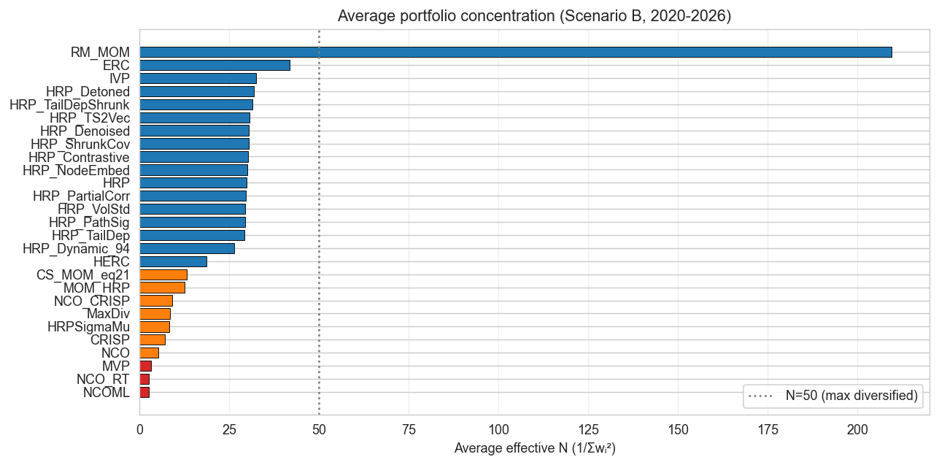
Portfolio composition over time: largest single-asset weight per snapshot (top) and inverse-Herfindahl effective number of assets (bottom) for representative strategies. The HRP family sits at effective $N≈30$ throughout; NCO, CRISP and NCO_CRISP at $5$–$9$; MVP and the return-tilted variants concentrate to $≤5$ with episodic single-asset weights above $50\%$.

Inference results

Bootstrap Sharpe CIs.
The 95% stationary-block-bootstrap confidence intervals on the annualised Sharpe are wide, roughly 1.5 Sharpe units, reflecting six years of volatile crypto returns. Six strategies have intervals entirely above zero: MVP ($[0.34,1.76]$), NCO_CRISP ($[0.26,1.76]$), CRISP ($[0.23,1.75]$), NCO ($[0.19,1.64]$), the passive HODL_BTC benchmark ($[0.08,1.63]$), and baseline HRP itself, whose interval ($[0.02,1.53]$) only barely clears zero. Every other HRP-family variant’s interval straddles zero, and no two strategies have non-overlapping CIs: the intervals are far too wide to separate any pair.

Pairwise LW Sharpe differences vs. HRP.
Under the studentized Ledoit–Wolf test, two strategies beat baseline HRP at $p<0.05$: CRISP ($+0.247$ Sharpe, $p=0.012$) and the NCO–CRISP hybrid ($+0.235$, $p=0.011$). MVP’s larger raw edge ($+0.314$) falls just short ($p=0.059$) because its heavier concentration inflates the variance of the paired Sharpe difference; NCO ($+0.192$, $p=0.218$) is well short. In the other direction the return-tilted NCO is significantly worse ($−0.74$, $p=0.009$) and ERC ($−0.078$, $p=0.051$) sits on the threshold. These are uncorrected pairwise tests; the multiple-testing correction follows.

Hansen SPA.
Across the 27 candidates versus baseline HRP, $p_{\text{consistent}}=0.51$ ($p_{\text{lower}}=0.40$, $p_{\text{upper}}=0.62$; Figure 5), computed with the reference arch implementation. We cannot reject the null that no strategy outperforms baseline HRP after correcting for the multiple testing of 27 candidates, and this is the decisive test: the SPA is exactly the correction the pairwise LW results lack. NCO_CRISP carries the highest studentised score ($+1.64$), CRISP the second ($+1.32$), then MVP ($+1.20$); but the bootstrap critical value, inflated by the breadth of the search, sits above all of them. CRISP’s and NCO_CRISP’s pairwise significance therefore does not survive the correction for how many strategies were tried.
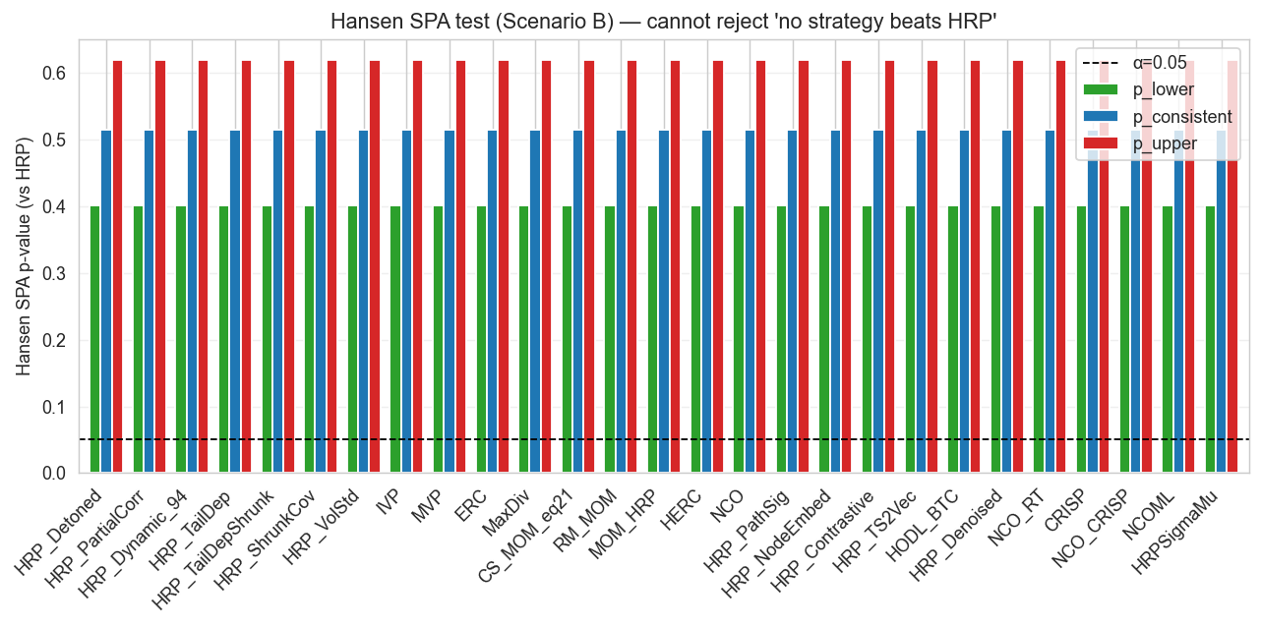
Hansen SPA test p-values across the headline comparison. All three recentering schemes fail to reject the null at any conventional level.

Power analysis: what the design could detect.
A null result is only as strong as the test that produced it. We quantify the design’s power directly: the studentized Sharpe-difference statistic is approximately $N(d/SE,1)$ under the alternative, so 80% power at a two-sided 5% level needs $d/SE≥2.80$; the minimum detectable annualised Sharpe edge is $2.80×SE$, with SE the delta-method HAC standard error of the Sharpe difference. For variants that barely depart from HRP (the HRP family, $∼$0.97-correlated with the baseline) the paired difference is low-variance and the test detects edges as small as $0.04$–$0.12$ Sharpe, but those variants have edges of only $±0.01$ to $±0.04$ anyway. For strategies whose allocation departs substantively from HRP the minimum detectable edge is larger, and it scales with how far the strategy departs: the more concentrated the portfolio, the noisier the paired Sharpe difference and the higher the threshold. The heavily-concentrated MVP ($N≈3$) needs $≈0.47$ and NCO ($N≈5$) $≈0.42$, so their observed $+0.31$ and $+0.19$ edges, though economically large, fall short. CRISP and NCO_CRISP, less concentrated ($N≈7$–$9$), carry the lowest thresholds of any structurally-distinct strategy, $≈0.27$ and $≈0.26$. Their observed $+0.25$ and $+0.24$ edges sit just below even that mark, yet still clear the pairwise test in this sample ($p≈0.01$), whereas MVP’s larger $+0.31$ edge, against a far higher $0.47$ threshold, does not. The pairwise null is therefore a statement about detectable effect size given concentration; it is the multiple-testing-corrected SPA, not the per-strategy power, that ultimately declines to reject.

Deflated Sharpe Ratio.
As a third inference lens we compute the Deflated Sharpe Ratio (Bailey and López de Prado 2014), which deflates an observed Sharpe for the number of strategies tried, the skewness and kurtosis of the return series, and the sample length. Treating the 27 constructed strategies as the trial set, the expected best-of-$N$ Sharpe under the null is ${SR}_{0}=0.37$ annualised. Only MVP clears the conventional $DSR≥0.95$ bar ($DSR=0.97$), and it does so partly on the strength of an extreme positive return skew ($γ_{3}=5.0$, $γ_{4}=128$) that the DSR’s non-normality term rewards. CRISP ($0.94$), NCO_CRISP ($0.94$) and NCO ($0.94$) fall just short; NCOML and HRP-$Σμ$ sit further back at $0.86$ and $0.73$; baseline HRP is at $0.82$. Counting the 547-cell hyperparameter sweep as part of the search ($N≈574$) raises the hurdle to ${SR}_{0}=0.56$ and pushes every strategy below the bar, MVP included ($DSR=0.92$). The three lenses (pairwise Ledoit–Wolf, Hansen SPA, and the DSR) disagree at the margin on which strategies pass, but agree that no strategy clears all three: the edges are real but sit on the significance boundary.

Hyperparameter sweeps and the combined SPA
A natural objection to the headline null result is that it reflects untuned strategies: perhaps some correlation type, distance function, linkage method, or strategy-specific parameter would lift a variant decisively above baseline HRP. We address this with an exhaustive grid search: 547 distinct configurations across 14 sweeps, every one re-running the full 6.3-year walk-forward backtest on the identical 146-symbol point-in-time universe and 2,299-day return series, against the identical baseline HRP ($\text{Sharpe}=0.741$, recomputed and verified bit-identical in every sweep). The sweeps span the correlation estimator (Pearson / Spearman / Kendall), the distance function ((López de Prado 2016) / absolute / angular / squared), the linkage (single / average / complete / Ward), and the strategy-specific parameters of every variant ($q$ for tail dependence, $α$ for the graphical lasso, $λ$ for EWMA, the volatility-standardisation window, the number of detoned market components, and the embedding hyperparameters).
Best cell from each hyperparameter sweep. $Δ$ is the Sharpe difference vs. baseline HRP (single linkage, $0.741$); total return is the cell’s net cumulative return, 2020-02 to 2026-05. 551 cells in total; the 4 exactly equal to the benchmark are dropped for the combined SPA, leaving 547 candidates.
Sweep | Cells | Best configuration | Sharpe | $Δ$ | Tot. ret.
Tail dependence ($q$, dist, linkage) | 80 | $q=0.025$, average | 0.744 | $+0.002$ | $+425\%$
Correlation $×$ distance $×$ linkage | 24 | Pearson, LdP, average | 0.756 | $+0.015$ | $+459\%$
All variants under average linkage | 12 | HRP_ShrunkCov | 0.765 | $+0.024$ | $+484\%$
EWMA dynamic correlation ($λ$) | 21 | $λ=0.94$, single | 0.749 | $+0.008$ | $+442\%$
Partial correlation ($α$, dist, link) | 60 | $α=5×{10}^{−4}$ | 0.739 | $−0.003$ | $+412\%$
Vol-standardised returns (window) | 60 | window 15, single | 0.757 | $+0.015$ | $+462\%$
Detoning (# market components) | 36 | 1 component, average | 0.709 | $−0.032$ | $+337\%$
Node2vec embedding | 54 | $d=16$, $k=10$ | 0.752 | $+0.010$ | $+444\%$
Path signatures, single-channel | 108 | level 2, window 60 | 0.734 | $−0.007$ | $+401\%$
Path signatures, multi-channel$​^{†}$ | 72 | ret+vol+trades, L2 | 0.747 | $+0.005$ | $+432\%$
Contrastive / TS2Vec, multi-channel | 24 | ret+vol+trades | 0.739 | $−0.002$ | $+412\%$
Baseline HRP (single linkage) | — | — | 0.741 | — | $+417\%$
$​^{†}$ Best cell under the initial missing-data convention (zero-fill); under the corrected mean-fill convention the best multi-channel PathSig cell is $0.735$ ($Δ=−0.006$).

The HRP family is robust to its hyperparameters.
No sweep produced a configuration that escaped the $±0.05$ Sharpe band of Section 6 (Table 3). The one consistent, though small, effect is linkage: average linkage beats the López de Prado (2016) single-linkage default by $+0.01$ to $+0.02$ Sharpe across essentially every (correlation, distance) combination, and under single linkage all four distance functions are mathematically identical (single linkage depends only on the rank order of distances, which every monotone transform preserves). The best cell in the entire grid is HRP_ShrunkCov under average linkage at Sharpe $0.765$ ($Δ=+0.024$).

Multi-channel embeddings.
The single-channel embeddings encode only the return series and are therefore information-equivalent to the sample correlation they are meant to improve on: a nonlinear re-encoding of the same information cannot out-cluster it, and indeed the single-channel HRP_PathSig grid (108 cells) beats baseline in zero cells. We extended all three sequence-based embeddings (PathSig, Contrastive, TS2Vec) to ingest up to six channels orthogonal to close-to-close returns (quote volume, trade count, average trade size, intraday range, taker buy-ratio, and Amihud illiquidity), all derived from the same Binance OHLCV table. Extra channels lift the encoders’ mean Sharpe monotonically (HRP_Contrastive $0.714→0.725$ from one to three channels), confirming the channels carry usable structure. Two cells of the initial multi-channel PathSig sweep nominally cleared baseline (best $+0.747$), but that margin did not survive a correction to how missing channel values are imputed (mean- rather than zero-fill, which avoids placing a spurious outlier into a log-scaled channel); under the corrected convention no multi-channel configuration clears baseline, and adding the fourth through sixth channels plateaus or mildly regresses performance, a bias–variance ceiling against only $∼$76 rebalance dates.

Combined Hansen SPA.
Pooling all 547 configurations into a single Hansen SPA against baseline HRP, the appropriate correction for having searched the entire grid, yields $p_{\text{consistent}}=0.906$ ($p_{\text{lower}}=0.733$, $p_{\text{upper}}=0.909$). Although 21 of 547 cells show a nominally positive mean excess return over HRP, the best of them (HRP_ShrunkCov, $Δ=+0.024$) carries a pairwise Ledoit–Wolf $p$ of $0.16$. After correcting for the multiple testing of 547 hyperparameter configurations, no clustering-step variant significantly outperforms baseline HRP. The headline null result of Section 6.2 is not an artefact of leaving strategies untuned: consistent with the NCO finding, no amount of tuning the clustering step closes the gap that only an allocation-step change (NCO) opens.

Regime sensitivity: excluding the COVID bull run
The 2020–2026 headline window includes the COVID-era crypto rally (March 2020 – November 2021) during which Bitcoin ran from $∼$$5k to $∼$$69k, one of the most extreme bull markets in crypto history. To check whether the $§$6 conclusions are dominated by that single rally, we re-ran the entire 27-strategy backtest with $start=$ 2022-01-01 (52 monthly rebalances over $∼$4.3 years; Table 4). All other parameters identical.
The picture flips entirely. On post-COVID data, baseline HRP achieves Sharpe $0.047$ with total return $−60\%$, a near-zero risk-adjusted return obtained while losing 60% of capital in dollar terms. Only four strategies make money, all of them the BTC-concentrating risk allocators: the passive HODL_BTC benchmark ($+106\%$, Sharpe $0.585$), MVP ($+66\%$, $0.482$), and CRISP and NCO_CRISP ($+20\%$ each, Sharpe $0.363$ and $0.368$); NCO essentially breaks even ($−4\%$, $0.264$). Every other strategy loses between 19% (RM_MOM) and 98% (NCO_RT) of capital, and six post outright negative Sharpe: NCO_RT ($−0.414$), MaxDiv ($−0.163$), CS_MOM ($−0.161$), RM_MOM ($−0.160$), HERC ($−0.038$) and ERC ($−0.026$).

Four findings from the regime comparison.
(1) Diversification-based crypto portfolios were a losing proposition in the post-COVID regime. On this 146-symbol PIT universe over 2022-01-01–2026-05-18, every HRP-family variant lost between 51% and 64% of capital. The 2020-2026 “diversification works” framing was largely a COVID-rally artifact: HRP diversifies risk but does not produce capital appreciation in non-bull crypto regimes.
(2) The risk-based allocators hold up across regimes. NCO, CRISP and the NCO–CRISP hybrid all stay positive or near-flat post-COVID (Sharpe $0.26$–$0.37$, total return $−4\%$ to $+20\%$) against baseline HRP’s $−60\%$, and CRISP and NCO_CRISP remain pairwise-significant against HRP in the post-COVID window as well (Ledoit–Wolf $p=0.017$ and $0.022$). The post-COVID Hansen SPA, like the full-window test, does not reject ($p_{\text{consistent}}=0.38$). Whatever these allocators are doing (concentrating into low-volatility assets via correlation-shrinkage or nested minimum variance) helps in both regimes, not only the rally. They are the paper’s evidence that an allocation choice, rather than luck, separates a constructed portfolio from the HRP pack; that the multiple-testing corrected SPA still does not confirm it (§6.2) leaves the effect well-supported in the data but short of confirmed.
(3) Embedding variants partially reverse against baseline HRP in the harder regime. In the full window all four embedding variants sit below HRP (deltas $−0.028$ to $−0.050$ Sharpe). In the post-COVID window only one of the four (HRP_PathSig) edges above baseline HRP ($+0.008$), while HRP_Contrastive ($−0.010$), HRP_TS2Vec ($−0.013$), and HRP_NodeEmbed ($−0.016$) remain below. None reaches individual significance (all Ledoit–Wolf $p>0.6$) and the margins are tiny, but the partial directional reversal is tentative: the path- and sequence-based embeddings may capture risk structure that matters more in a choppy regime than in a monotone rally. A longer post-COVID sample would be needed to tell.
(4) RM_MOM (the Barroso–Santa-Clara variant) shows its defensive role. Post-COVID Sharpe is $−0.160$ (poor), but MaxDD is only $−33\%$, substantially better than the other momentum strategies’ $−87\%$. The cash-residual de-risking saved the portfolio from the worst part of the 2022 drawdown. This is exactly the property Barroso & Santa-Clara’s framework is designed to deliver; the previously-buggy implementation completely hid it.
Regime sensitivity: 2020-2026 (incl COVID bull) vs 2022-2026 (post-COVID). “Sharpe” is annualised arithmetic; “$Δ$Sharpe” is the change from full window to post-COVID. A representative 17 of the 27 strategies are shown; the eight omitted strategies all sit within the HRP-family Sharpe band in both windows and track the HRP rows shown.
Strategy | 2020-2026 Sharpe | 2022-2026 Sharpe | $Δ$Sharpe
HRP | 0.741 | 0.047 | –0.695
HRP_Dynamic_94 | 0.749 | 0.099 | –0.650
HRP_ShrunkCov | 0.746 | 0.038 | –0.707
HRP_PartialCorr | 0.720 | 0.057 | –0.663
HRP_Contrastive | 0.710 | 0.056 | –0.655
HRP_PathSig | 0.714 | 0.055 | –0.659
HRP_TS2Vec | 0.703 | 0.047 | –0.657
HRP_NodeEmbed | 0.705 | 0.031 | –0.674
CRISP | 0.989 | 0.363 | –0.626
NCO_CRISP | 0.977 | 0.368 | –0.610
NCO | 0.933 | 0.264 | –0.669
MVP | 1.057 | 0.482 | –0.575
MaxDiv | 0.719 | –0.163 | –0.882
ERC | 0.663 | –0.026 | –0.688
CS_MOM_eq21 | 0.663 | –0.161 | –0.824
RM_MOM | 0.663 | –0.160 | –0.824
NCO_RT | 0.003 | –0.414 | –0.417
HODL_BTC | 0.868 | 0.585 | –0.283

Cost sensitivity and scenario comparison
The cost grid (Figure 6) shows annualised-Sharpe shifts under $0.01$ across the four cost scenarios for all five strategies tested: baseline HRP, for example, moves from $0.749$ (zero cost) to $0.740$ (stress). Monthly-cadence transaction costs do not drive strategy differentiation on this dataset. This is a stylized flat turnover-based sensitivity model with a liquidation premium, not a full liquidity-impact execution model.
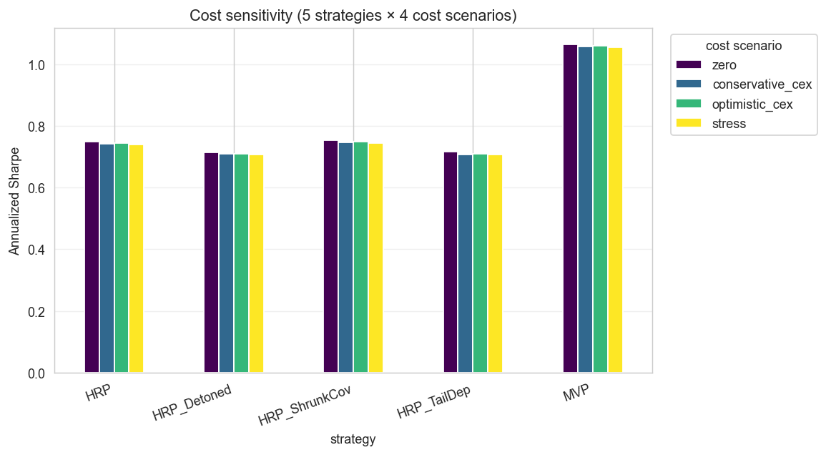
Cost-sensitivity grid. Rankings are robust across the four cost scenarios.
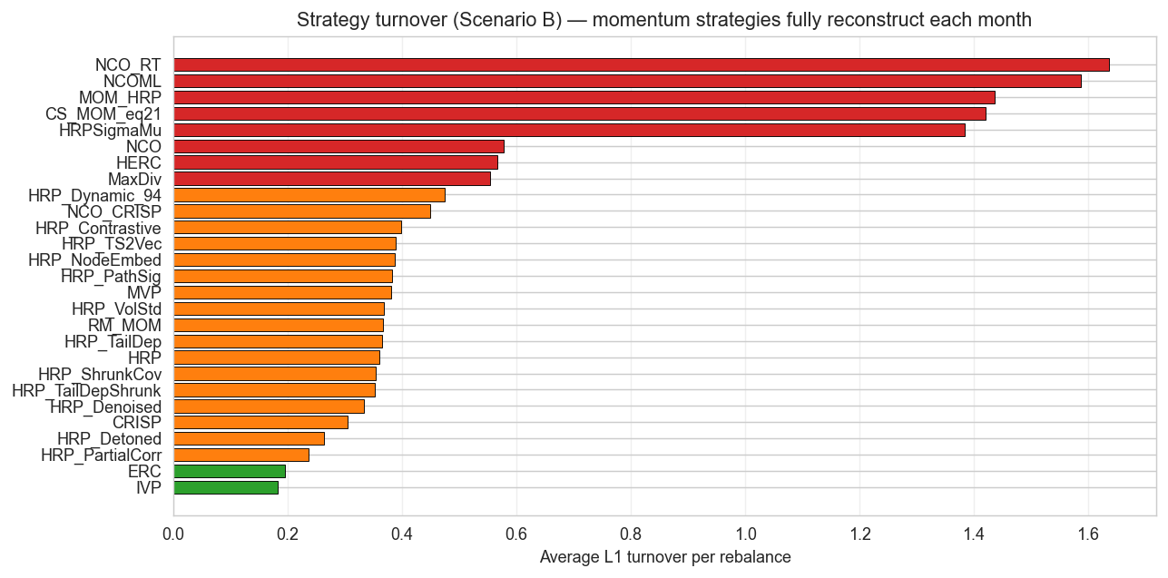
Average $L_{1}$ turnover per rebalance over time. Risk-based HRP variants and IVP cluster around $0.2$–$0.4$; momentum and the return-tilted strategies (CS_MOM, MOM_HRP, NCO_RT, NCOML, HRPSigmaMu) carry $1.4$–$1.7$, an order of magnitude higher. Costs at the headline 10 bps fee never alter the Sharpe ranking (Figure 6), but the gap shows where any liquidity-impact extension to the cost model would bite.
Threshold rebalancing (Scenario C, 5% drift trigger) does not improve on calendar rebalancing here: HRP’s Sharpe edges down from $0.741$ to $0.735$ and HRP_ShrunkCov is essentially flat ($0.746→0.745$), with only a marginal turnover reduction. The smoothed variant (Scenario C$′$) cuts turnover more materially, with HRP’s average $L_{1}$ turnover falling from $0.36$ to $0.23$, at a modest Sharpe cost ($0.741→0.731$). The momentum strategies are the exception: RM_MOM’s volatility-targeting overlay needs to trade to function, and suppressing or smoothing its rebalances collapses its Sharpe (from $0.66$ under calendar rebalancing to $0.37$ under Scenario C and $0.05$ under C$′$). Threshold logic suits low-turnover risk-based strategies and actively harms turnover-dependent ones.

Weekly cadence
The headline uses 76 monthly rebalances; crypto momentum is documented to decay over 1–4 weeks (Liu et al. 2022), so monthly rebalancing may understate any faster-horizon edge. We re-ran the non-embedding strategies at weekly cadence ($∼$330 rebalances; embeddings are excluded as retraining four encoders 330 times is prohibitive). Two things change. First, every strategy’s Sharpe rises (baseline HRP $0.74→0.82$, NCO $0.93→1.03$), and the momentum family rises most (RM_MOM $0.66→0.92$, CS_MOM $0.66→0.91$), consistent with momentum’s short crypto half-life: monthly rebalancing was simply too slow for it. Second, and despite the $∼$4$×$ larger rebalance count, the inference does not sharpen: the weekly Hansen SPA still gives $p_{\text{consistent}}=0.57$ (corrected over the smaller, embedding-free weekly candidate set) and the bootstrap Sharpe CIs stay $∼$1.5 wide. More rebalances do not help when the per-period return volatility is what dominates the standard error. Higher cadence changes the ranking texture (momentum catches up) but not the statistical verdict.

Convergence findings (the structural results)
Two strategy pairs in our comparison are theoretically related: each pair targets the same goal via different mathematical routes. We quantify their weight-vector convergence across the full 76-snapshot window (Figure 8).

HRP_Detoned vs HRP_PartialCorr.
Spectral detoning and precision-matrix partial correlation both remove the dominant market mode, by different routes. Across the 76 monthly snapshots their weight-vector rank correlation is high but not invariant: mean Spearman $ρ=0.87$, median $0.93$, with regime-driven dips to $ρ=0.54$ in months when the dominant eigenvector shifts sharply. The bug-fixed HRP_PartialCorr ($α={10}^{−3}$) is now distinct from the inverse-variance portfolio (its weight-rank correlation with IVP averages only $ρ=0.08$), whereas the earlier degenerate $α=0.05$ implementation was IVP. The detoning / partial-correlation convergence is therefore a structural relationship between two market-mode-removal estimators, not an artefact of one collapsing into IVP.

HRP_TailDep vs HRP_TailDepShrunk.
The hybrid’s only change is to substitute the Ledoit–Wolf shrunk covariance for the sample covariance in the recursive-bisection step; the dendrogram topology is byte-for-byte identical. Spearman is 0.998–1.000 in every snapshot tested. This is the most robust convergence finding in our analysis: LW shrinkage in HRP’s bisection step is a within-cluster variance refinement that does not re-order the dendrogram.
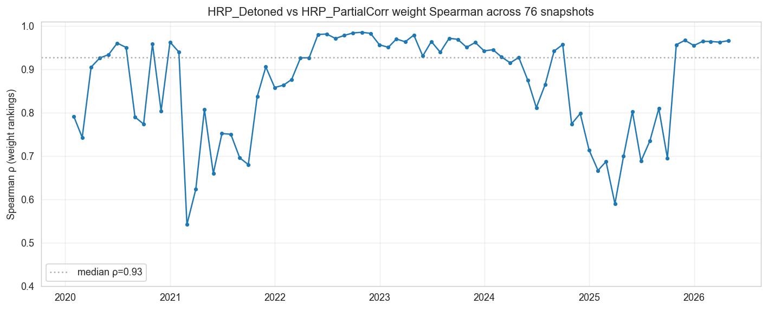
Spearman rank correlation between HRP_Detoned and HRP_PartialCorr weight vectors across 76 monthly snapshots.

Cluster stability: a retraction
An intermediate finding in earlier iterations of this work was that HRP_TailDep produces more stable clusters than baseline HRP under Pearson distance. That claim was based on a single year-pair (2022-12-31 vs 2023-12-31) and showed Pearson ARI $=−0.047$ vs TailDep ARI $=+0.265$ at $K=5$.
When we re-ran the analysis across all 76 monthly snapshots (Figure 9, Table 5), the direction reverses. Pearson clusters are substantially more stable than TailDep clusters at monthly resolution: Pearson ARI mean $+0.744$ vs TailDep $+0.614$; Pearson cophenetic mean $0.861$ vs TailDep $0.768$. TailDep ARI exceeds Pearson ARI in only 23 of 75 month-pairs (31%).
Cluster stability across 76 monthly snapshots (2020-2026).
Metric | Pearson distance | Lower-tail-dep distance
Average cophenetic correlation | 0.861 | 0.768
Average ARI vs. previous snapshot (K=5) | +0.744 | +0.614
Median ARI vs. previous snapshot | +0.783 | +0.650
Months where TailDep ARI > Pearson ARI | — | 23 / 75 (31%)
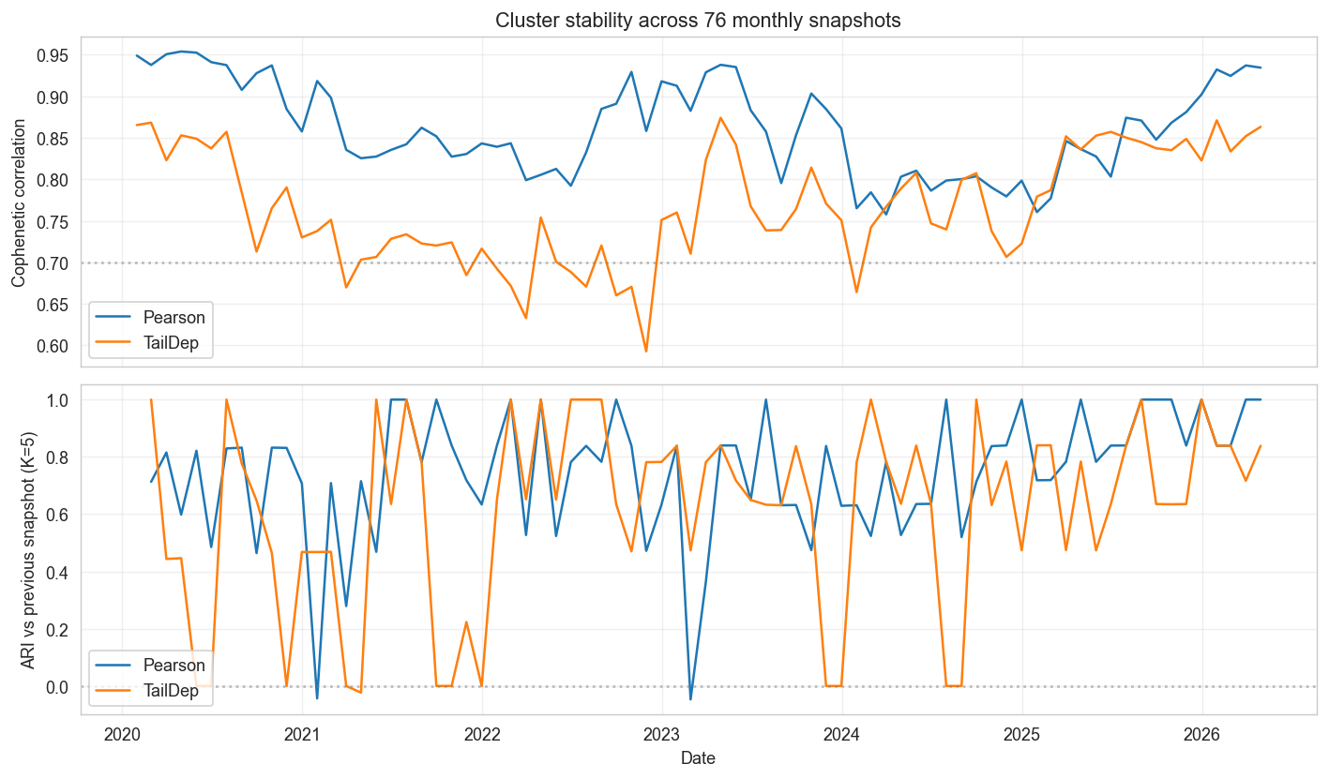
Cophenetic correlation (top) and ARI vs. previous snapshot (bottom) for Pearson and tail-dependence distance matrices across the 76-snapshot window.
The economic argument for HRP_TailDep, that it captures the joint-crash co-movement structure Pearson summarises poorly, stands; the secondary cluster-stability argument does not. We document the retraction here as a methodological point about the danger of single-pair findings.

Discussion
The three threads of §6 converge on a single argument. First, only one HRP design choice moves performance materially: the allocation step. Across every clustering perturbation we tried, no configuration escapes the HRP-family Sharpe band; the strategies that do escape (NCO, CRISP, NCO_CRISP, and the return- tilted NCO that collapses) all change the within-cluster solve, and the two signal-aware extensions (NCOML, HRP-$Σμ$) reinforce the same message in opposite directions. Second, the strategies that do move are too few to clear the multiple-testing correction: the Hansen SPA and the Deflated Sharpe Ratio agree that no edge survives the search, even where CRISP and NCO–CRISP clear the pairwise bar comfortably. Third, the whole finding is regime-conditional: in the post-COVID cut, diversified HRP variants lose half their capital while concentration still wins, so much of what reads as “diversification works” in the full window is a residual on the BTC rally. The practical conclusion sits at the intersection of the three: HRP’s signal-blindness is a feature in this market, the allocation step is the main place where engineering effort appears to have paid back, and even there the win is below what six years of data could certify. The subsections below develop each thread in turn.

Clustering versus allocation: the one design choice that matters
The results of §6 point to one practical conclusion. Varying the clustering step, across 547 hyperparameter cells, did not separate a variant from baseline HRP; varying the allocation step did, in both directions (CRISP and the NCO–CRISP hybrid to Sharpe $≈0.98$, the return-tilted NCO to $−97\%$). HRP and all its variants share one allocation rule, inverse-variance recursive bisection, and that rule, not the dendrogram, is what holds the family together. The NCO–CRISP hybrid is the cleanest test: it places CRISP’s correlation-shrinkage solve inside NCO’s hierarchical nesting, and lands between its two parents (NCO 0.93, CRISP 0.99): the shrinkage and the nesting are substitutes, not complements. For a practitioner the implication is narrow but useful: on this evidence, effort spent engineering the clustering distance is lower-yield than effort spent on the allocation objective.
The return-tilted NCO also speaks to a concurrent result. Wuebben (2026) reports, via Monte Carlo, that making a hierarchical allocator return-aware improves out-of-sample Sharpe; our live-market evidence is directionally different: a momentum-tilted NCO is the worst strategy in the comparison. The two are reconcilable: a return signal helps only when it carries genuine out-of-sample predictive content, which a 63-day crypto-momentum signal over 2020–2026 does not. Replacing the sample-mean tilt with a walk-forward XGBoost forecast tests this directly. NCOML, the same nested-clustering optimiser fed by the learned signal, reaches Sharpe $0.80$, sidestepping the $−97\%$ collapse and suggesting the failure was mainly signal quality rather than return-aware allocation in principle; but it also lands below pure (signal-blind) NCO at $0.93$, so the XGBoost forecast is enough to avoid disaster but not strong enough to outperform NCO’s risk-only solve. HRP-$Σμ$, Wuebben’s signal-aware hierarchical optimiser fed by the same forecast, lands at $0.61$, below baseline HRP: in this sample, injecting a return signal into HRP’s hierarchy is associated with weaker performance, and the HRP family’s strength is therefore in its signal-blindness, not despite it. The simulation optimism and the live-data behaviour together delimit when signal-aware hierarchical allocation is worth attempting: a credible signal removes the collapse but does not, on this universe and horizon, beat the signal-blind allocators that already exist.

Why does the Hansen SPA fail to reject, even for CRISP?
CRISP and the NCO–CRISP hybrid each post a $≈+0.24$ Sharpe edge over HRP that is pairwise-significant (Ledoit–Wolf $p≈0.01$) in both the full and the post-COVID windows, yet the Hansen SPA ($p_{\text{consistent}}=0.51$) does not reject. This is not a contradiction; it is the multiple-testing correction working as intended. The pairwise test asks “does this strategy beat HRP?”; the SPA asks “does the best of 27 searched strategies beat HRP, given that we searched 27?”, and inflates the critical value accordingly. CRISP’s and NCO–CRISP’s edges clear the first bar and not the second. The honest reading is therefore specific: the two shrinkage allocators show a real, regime-robust pairwise edge, but it is not large enough to survive correction for the breadth of the search: it is strongly suggested, not established.

Regime conditionality
Two regime-dependent findings frame the rest. Detoning and partial correlation, both designed to remove the dominant market mode and isolate idiosyncratic structure, underperform here because the dominant mode was BTC and being underweight BTC was costly; their value is regime-dependent rather than a universal Sharpe improvement, and the sideways or rotational regimes 2020–2026 did not contain may yet reward them. The flip side is that a passive 100% BTC hold (Sharpe $0.87$, $+749\%$) beats every diversified portfolio in the comparison; the only constructed strategies above it, MVP and NCO, get there by concentrating back into BTC, and that re-concentration is a regime-conditional bet rather than a portfolio-construction insight. The post-COVID cut is the counterweight: there, diversified HRP variants lose 51–64% while concentration still wins. Realised returns over 2020–2026 have been dominated by the direction of BTC, and inference about portfolio construction in this asset class has to be conditioned on that fact.

Limitations
- Statistical power. With six years of data the design cannot resolve a Sharpe edge below $≈0.4$ for a strategy that departs substantively from HRP (§6.2.0.4); NCO’s economically large $+0.19$ edge is therefore left unresolved rather than confirmed or refuted.
- Single venue (Binance USDT spot). A multi-exchange consolidated price (Kaiko, CCXT-aggregated) would give a more representative cost model but was out of scope for this paper.
- No on-chain factors. The Liu-Tsyvinski-Wu (Liu et al. 2022) three-factor model and on-chain signals (Glassnode) are deferred to a follow-up.
- PIT universe is ranked by Binance quote volume, not market cap. Pro-tier CoinGecko or paid Kaiko data would enable a market-cap robustness check.
- Cross-platform reproducibility of trained-model strategies. Closed-form strategies are highly stable across environments, but strategies that rely on learned representations are only conditionally reproducible because platform-level floating-point differences can propagate through clustering and forecast-based allocation. In robustness checks, this affects the PyTorch-based embedding variants most, with Sharpe shifts on the order of $≈0.02$ and corresponding movement in marginal pairwise $p$-values. The main ranking structure and joint-test conclusions, however, remain unchanged.

Conclusion
Across 27 constructed portfolio strategies tested against baseline HRP on 76 monthly rebalances of a survivorship-bias-corrected Binance USDT universe (2020–2026), the allocation step is the only HRP design choice that materially moves performance, and even the strategies that do move do not survive the multiple-testing correction. The roster spans thirteen HRP-family variants (eight correlation/covariance constructions and four embedding-based ones), five risk-based comparators, four nested-clustering optimisers, three momentum strategies and two signal-aware XGBoost-fed extensions; every comparison is wrapped in a studentized Ledoit–Wolf test and the reference Hansen SPA on a 146-ever-included-symbols point-in-time universe.
Concretely: varying the clustering step, that is the correlation, distance, linkage or learned embedding that builds the dendrogram, did not produce a detectable outperformance over baseline HRP: across a 547-cell hyperparameter grid no configuration escapes the HRP-family Sharpe band, and the combined Hansen SPA cannot reject the null ($p_{\text{consistent}}=0.91$). The allocation step is more strongly associated with performance dispersion: the CRISP correlation-shrinkage portfolio (Sharpe 0.99), an NCO–CRISP hybrid (0.98) and NCO (0.93) all clear baseline HRP, while a return-tilted NCO collapses to $−97\%$. Replacing that sample-mean signal with a walk-forward XGBoost forecast sidesteps the collapse (NCOML, Sharpe 0.80) without beating signal-blind NCO; feeding the same forecast into Wuebben’s signal-aware HRP-$Σμ$ underperforms baseline HRP (0.61). CRISP and NCO–CRISP beat HRP at the pairwise level in both the full and post-COVID windows (Ledoit–Wolf $p≈0.01$). But the Hansen SPA, correcting for the 27-candidate search, still does not reject the null ($p_{\text{consistent}}=0.51$): no edge survives the multiple-testing correction. The null is a statement about detectable, search-corrected effect size rather than a proof of zero effect.
Two caveats frame the result. First, a passive 100% BTC hold beats every diversified portfolio, and the only constructed strategies that beat it (MVP, CRISP, NCO–CRISP, NCO) win by concentrating back into BTC; in this asset class and regime, portfolio construction has been second-order to the BTC beta. Second, in the post-COVID sub-sample every diversified HRP variant lost 51–64% of capital, so the “diversification works” reading of the full window is itself regime-conditional. We also retract an earlier cluster-stability claim that the 76-snapshot re-analysis falsifies.
The paper’s contribution is an empirically-tested map of which HRP design choices affect performance: of the many parameters an HRP practitioner can vary, the allocation objective is the component most consistently associated with detectable change, and even the strategies that improve on baseline (CRISP, NCO–CRISP) do so by an edge that does not survive correction for the number of strategies tried.
Several directions remain open for future work. Time-varying conditional covariance (DCC-GARCH) would give the dynamic-correlation layer a properly conditional second moment in place of the EWMA recursion. Regime-switching analysis could test directly whether detoning and partial correlation, which underperform in the BTC-led 2020–2026 window, add value in the sideways or rotational regimes that window did not contain. On-chain factors (Liu et al. 2022) and a multi-exchange consolidated price (e.g. Kaiko) for a venue-robust cost model are natural data extensions. The most concrete empirical follow-up, though, is a longer out-of-sample window: the power analysis (§6.2.0.4) shows NCO’s $+0.19$ Sharpe edge cannot be certified on six years of crypto data, and the post-COVID cut suggests that at least one embedding variant can edge ahead of baseline HRP in choppier regimes while the others remain close. This signal is too weak to confirm here but worth revisiting once more non-bull data accrues. The NCO result also invites a closer study of why a nested minimum-variance allocation tends to separate from the HRP pack in this sample.

Acknowledgements
We thank the UCEMA Quantitative Finance faculty, particularly Manuel Maurette and Pablo Martin Gechidjian, for their support and feedback. Finally, we thank Marcos López de Prado for developing the foundational Hierarchical Risk Parity framework that this study extends.
Bailey, David H., and Marcos López de Prado. 2014. “The Deflated Sharpe Ratio: Correcting for Selection Bias, Backtest Overfitting, and Non-Normality.” Journal of Portfolio Management 40 (5): 94–107.
Barroso, Pedro, and Pedro Santa-Clara. 2015. “Momentum Has Its Moments.” Journal of Financial Economics 116 (1): 111–20.
Chen, Ting, Simon Kornblith, Mohammad Norouzi, and Geoffrey Hinton. 2020. “A Simple Framework for Contrastive Learning of Visual Representations.” ICML.
Choueifaty, Yves, and Yves Coignard. 2008. “Toward Maximum Diversification.” Journal of Portfolio Management 35 (1): 40–51.
Ciciretti, Vito, and Alberto Pallotta. 2024. Network Risk Parity. Working paper.
Friedman, Jerome, Trevor Hastie, and Robert Tibshirani. 2008. “Sparse Inverse Covariance Estimation with the Graphical Lasso.” Biostatistics 9 (3): 432–41.
Grover, Aditya, and Jure Leskovec. 2016. “Node2vec: Scalable Feature Learning for Networks.” Proceedings of the 22nd ACM SIGKDD International Conference on Knowledge Discovery and Data Mining, 855–64.
Hansen, Peter Reinhard. 2005. “A Test for Superior Predictive Ability.” Journal of Business & Economic Statistics 23 (4): 365–80.
Hubert, Lawrence, and Phipps Arabie. 1985. “Comparing Partitions.” Journal of Classification 2 (1): 193–218.
Laloux, Laurent, Pierre Cizeau, Jean-Philippe Bouchaud, and Marc Potters. 1999. “Noise Dressing of Financial Correlation Matrices.” Physical Review Letters 83 (7): 1467–70.
Ledoit, Olivier, and Michael Wolf. 2003. “Honey, i Shrunk the Sample Covariance Matrix.” Journal of Portfolio Management.
Ledoit, Olivier, and Michael Wolf. 2004. “A Well-Conditioned Estimator for Large-Dimensional Covariance Matrices.” Journal of Multivariate Analysis 88 (2): 365–411.
Ledoit, Olivier, and Michael Wolf. 2008. “Robust Performance Hypothesis Testing with the Sharpe Ratio.” Journal of Empirical Finance 15 (5): 850–59.
Liu, Yukun, Aleh Tsyvinski, and Xi Wu. 2022. “Common Risk Factors in Cryptocurrency.” Journal of Finance.
Lohre, Harald, Carsten Rother, and Kilian A. Schäfer. 2020. “Hierarchical Risk Parity: Accounting for Tail Dependencies in Multi-Asset Multi-Factor Allocations.” Journal of Asset Management.
López de Prado, Marcos. 2016. “Building Diversified Portfolios That Outperform Out-of-Sample.” Journal of Portfolio Management 42 (4): 59–69. https://doi.org/10.3905/jpm.2016.42.4.059.
López de Prado, Marcos. 2018. Advances in Financial Machine Learning. John Wiley & Sons.
López de Prado, Marcos. 2019. “A Robust Estimator of the Efficient Frontier.” SSRN Electronic Journal, ahead of print. https://doi.org/10.2139/ssrn.3469961.
López de Prado, Marcos. 2020. Machine Learning for Asset Managers. Cambridge University Press.
Lyons, Terry J. 1998. “Differential Equations Driven by Rough Signals.” Revista Matemática Iberoamericana 14 (2): 215–310.
Maillard, Sébastien, Thierry Roncalli, and Jérôme Teı̈letche. 2010. “The Properties of Equally-Weighted Risk Contribution Portfolios.” Journal of Portfolio Management 36 (4): 60–70.
Mantegna, Rosario N. 1999. “Hierarchical Structure in Financial Markets.” European Physical Journal B 11 (1): 193–97.
Marchenko, V. A., and L. A. Pastur. 1967. “Distribution of Eigenvalues for Some Sets of Random Matrices.” Mathematics of the USSR-Sbornik 1 (4): 457–83.
Matys, Alan, and Federico Martin Rodriguez. 2025. “Hierarchical Risk Parity for Cryptocurrency Portfolios: A Comparative Analysis.” Proceedings of MACI 2025.
Moskowitz, Tobias J., Yao Hua Ooi, and Lasse Heje Pedersen. 2012. “Time Series Momentum.” Journal of Financial Economics 104 (2): 228–50.
Politis, Dimitris N., and Joseph P. Romano. 1994. “The Stationary Bootstrap.” Journal of the American Statistical Association 89 (428): 1303–13.
Politis, Dimitris N., and Halbert White. 2004. “Automatic Block-Length Selection for the Dependent Bootstrap.” Econometric Reviews 23 (1): 53–70.
Raffinot, Thomas. 2018. “The Hierarchical Equal Risk Contribution Portfolio.” SSRN Electronic Journal, ahead of print. https://doi.org/10.2139/ssrn.3237540.
Tumminello, Michele, Tomaso Aste, Tiziana Di Matteo, and Rosario N. Mantegna. 2005. “A Tool for Filtering Information in Complex Systems.” Proceedings of the National Academy of Sciences 102 (30): 10421–26.
Wuebben, Bernd Johannes. 2026. “Beyond de Prado and Cotton: Hierarchical and Iterative Methods for General Mean-Variance Portfolios.” arXiv Preprint arXiv:2604.23833.
Yue, Zhihan, Yujing Wang, Juanyong Duan, et al. 2022. “TS2Vec: Towards Universal Representation of Time Series.” AAAI.

