Written by Alan McIlwaine 300653905

# App test plan with scenarios:

# Scenario 1: Game Start

**Steps:**

1. Start the game.
2. Verify that the initial UI displays the correct game information (level, time left, keys left, treasure left.)

**Expected Results:**

The game starts at level 0, and the game displays the level and all its components. The countdown timer starts at 60 seconds, nothing is displayed in the inventory.

**Evidence:**

# Scenario 2: Game Exit

**Steps:**

1. Start the game.
2. Move the character through the game and pick up an item.
3. Press CTRL-X and exit the game.
4. Restart the game.

**Expected Results:**

The game starts at level 0. No progress is saved.

**Evidence:**

# Scenario 3: Save Game

**Steps:**

1. Start the game.
2. Move the character through the game and pick up an item.
3. Press CTRL-S to save and exit the game.
4. Restart the game.

**Expected Results:**

The game state is saved, and upon restarting, the game resumes from where it was saved.

**Evidence:**

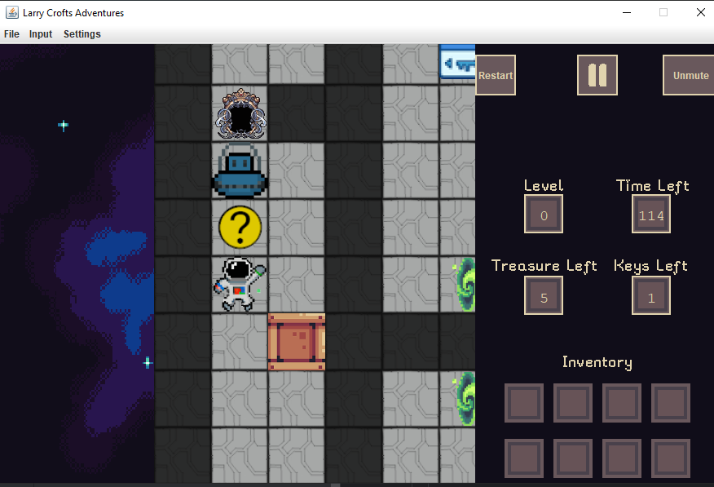

Figure Before save and exit

Figure After save and exit

FAIL: Time left doesn’t reset on save.

# Scenario 4: Restart Game

**Steps:**

1. Start the game.
2. Press CTRL-R and select a saved game.

**Expected Results:**

The saved game loads and resumes correctly.

**Evidence:**

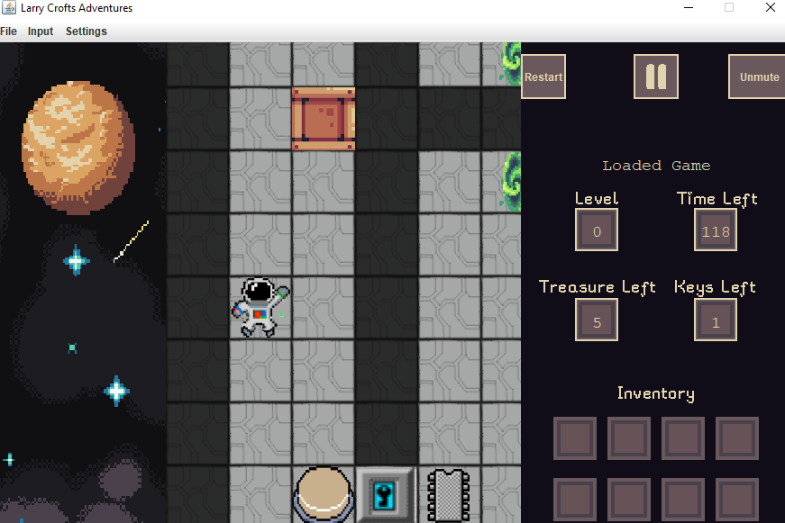

Figure Restarted and then loaded this save

# Scenario 5: Start a new game at level 0

**Steps:**

1. While in-game press CTRL-0.

**Expected Results:**

The game restarts at level 0, resetting all collected items, time and game state.

**Evidence:**

# Scenario 6: Start a new game at level 1

**Steps:**

1. While in-game press CTRL-1.

**Expected Results:**

The game restarts at level 1, resetting all collected items, time and game state.

**Evidence:**

# Scenario 7: Start a new game at level 2

**Steps:**

1. While in-game press CTRL-2.

**Expected Results:**

The game restarts at level 2, resetting all collected items, time and game state.

**Evidence:**

# Scenario 8: Pause game

**Steps:**

1. While in-game press SPACE

**Expected Results:**

The game pauses, and a dialog box appears saying, “Game is paused.”

**Evidence:**

# Scenario 9: Move the character within the maze

**Steps:**

1. Start the game.
2. Use the WASD keys to move character around.

**Expected Result:**

Character moves in the corresponding direction in the game.

**Evidence:**

# Scenario 10: Countdown timer reaches zero

**Steps:**

1. Start the game.
2. Wait until the timer has reached zero.

**Expected Result:**

The game terminates for a few seconds before resetting the current level.

**Evidence:**

# Scenario 11: Exit using Menu Button

**Steps:**

1. Start the game.
2. Click the Exit button

**Expected Result:**

The game exits and closes the application.

**Evidence:**

Cannot take screenshot as the game is closed now.