I have 3 aliases *(and 4 alias-aliases for quick usage)* that I normally throw in my ~/.gitconfig file:

[alias]

lg = !"git lg1"

lg1 = !"git lg1-specific --all"

lg2 = !"git lg2-specific --all"

lg3 = !"git lg3-specific --all"

lg1-specific = log --graph --abbrev-commit --decorate --format=format:'%C(bold blue)%h%C(reset) - %C(bold green)(%ar)%C(reset) %C(white)%s%C(reset) %C(dim white)- %an%C(reset)%C(auto)%d%C(reset)'

lg2-specific = log --graph --abbrev-commit --decorate --format=format:'%C(bold blue)%h%C(reset) - %C(bold cyan)%aD%C(reset) %C(bold green)(%ar)%C(reset)%C(auto)%d%C(reset)%n'' %C(white)%s%C(reset) %C(dim white)- %an%C(reset)'

lg3-specific = log --graph --abbrev-commit --decorate --format=format:'%C(bold blue)%h%C(reset) - %C(bold cyan)%aD%C(reset) %C(bold green)(%ar)%C(reset) %C(bold cyan)(committed: %cD)%C(reset) %C(auto)%d%C(reset)%n'' %C(white)%s%C(reset)%n'' %C(dim white)- %an <%ae> %C(reset) %C(dim white)(committer: %cn <%ce>)%C(reset)'

git lg/git lg1 looks like this:

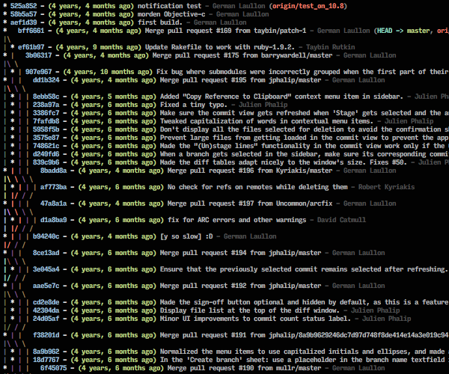

git lg2 looks like this:

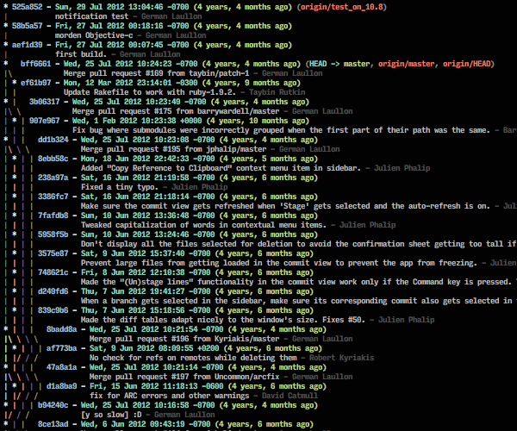

and git lg3 looks like this:

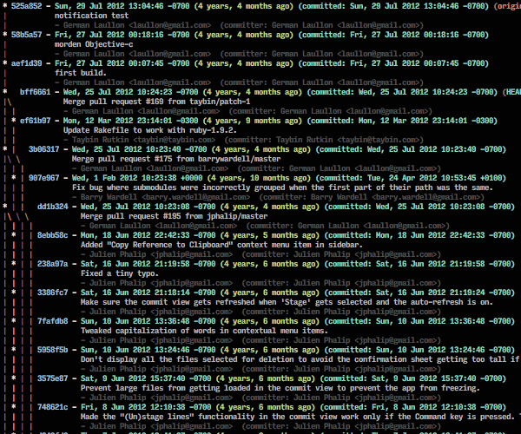

*Note: Answer copied from and improved upon the answer at [stackoverflow.com/questions/1057564/pretty-git-branch-graphs](https://stackoverflow.com/questions/1057564/pretty-git-branch-graphs/9074343" \l "9074343) since it's far more appropriate here than it was there.  Left the copy on the other question for historical reasons— it's closed now, and the answer's referenced by a bunch of other answers.*