# **Appendix B: Configuring Dragino LoRaWAN Gateways**

Dragino makes a few different LoRaWAN gateways, including the indoor LIG16, the outdoor DLOS8, and the indoor, cellular-capable LG308. This Appendix gives some notes on how to configure these gateways. Full documentation for each gateway is on the Dragino website and should be consulted for detailed information.

When you power up the gateway, it broadcasts a new WiFi network that you can connect to with a PC (just like connecting to a WiFi network at a coffee shop). The network name always starts with “dragino”, for example “dragino-1eb408”. The WiFi password for connecting to this network is “dragino+dragino”.

Next, you need to use a web browser to access the configuration web pages located on the gateway. You access those pages by typing in the following IP address into the address bar of your browser: 10.130.1.1. The first time you try to access this address, a dialog will pop up requesting you to log in. For this log in, the username is “root” and the password is “dragino”. You are then presented with the following system diagram:

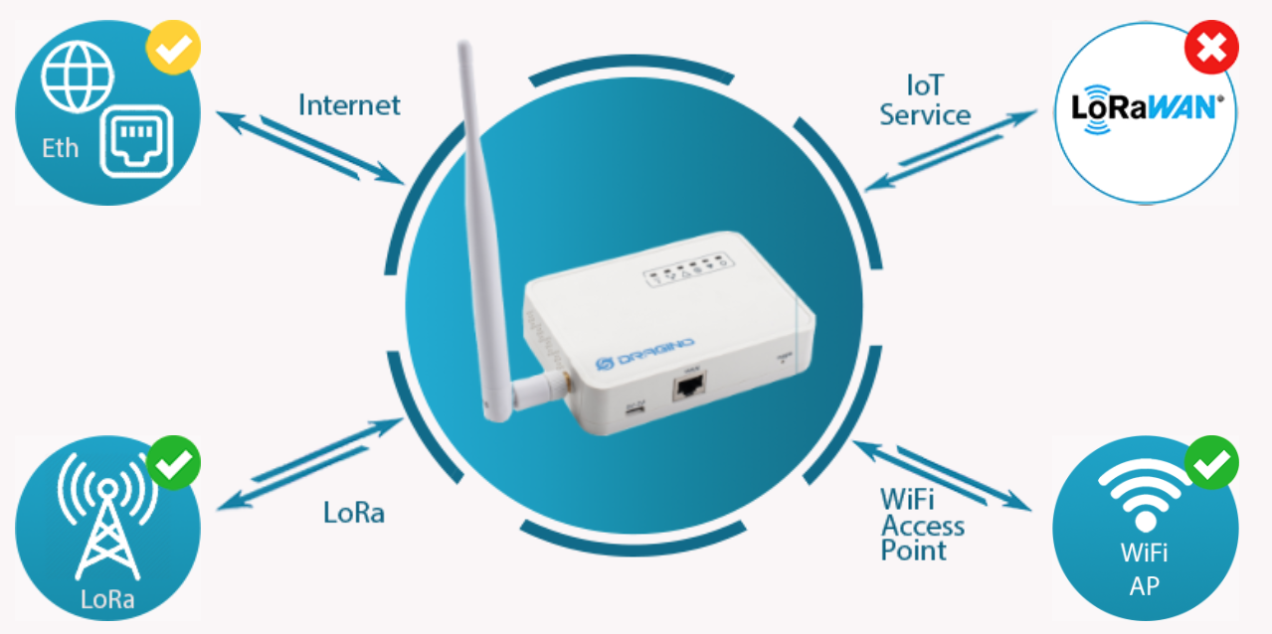

which generally displays which parts of the gateway are working. Access to different configuration pages can be done by clicking on parts of the diagram or by using the menus at the top of the page.

It is often a good idea to upgrade the firmware of the gateway when you first receive it. Check the User Manual for details. First, you need to download the latest firmware from the Dragino website. Then, click the “Firmware Upgrade” option from the System menu at the top of the Home Dragino web page you accessed above. Finally, you “Upload Firmware File” from your PC to the Gateway and “Proceed with Flash”. You will be forced to reconnect to the gateway WiFi network and access the configuration page again.

Here are the key settings that need to be changed to configure the gateway for US operation on the Things Network:

1. From the “LoRa” menu, click the “LoRa” item. Change the Radio Settings section to look like the following:  
   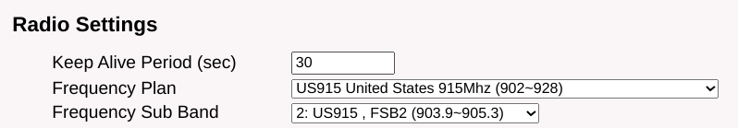  
   Click the “Save&Apply” button at the bottom of the page.
2. From the “LoRaWAN” menu, click the “LoRaWAN” item. Copy and save the Gateway ID from the General Settings section, as you will need this later when you register this gateway on the Things Network. Do not change the ID.  
     
   Then set the “Primary LoRaWAN Server” as follows:  
   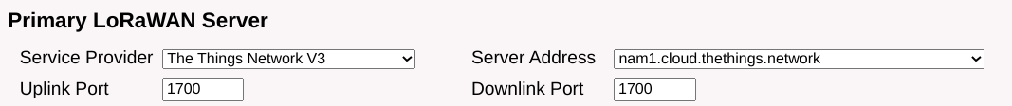  
   Click the “Save&Apply” button at the bottom of the page.
3. If you are going to connect the gateway to the Internet via a wired Ethernet connection, there is no more configuration required on the gateway. If you want to use WiFi to connect the gateway to the Internet, then you need to access the “Network” menu and click “WiFi”. On the WiFi page, you must fill out the settings in the “WiFi WAN Client Settings” section of the page, making sure to “Enable WiFi WAN Client” and to properly fill out the name of the WiFi network (SSID) and the Passphrase. Also, keep the “Enable WiFi Access Point” checkbox enabled so that you can access the gateway in the future for configuration (i.e. make no changes in that section).   
   Note one issue we have discovered with filling out and enabling the “WiFi WAN Client Settings” section: if that WiFi connection is not available, an Ethernet connection will also not work. If you use WiFi for testing the gateway but ultimately intend to use an Ethernet connection, make sure you disable the WiFi WAN Client.
4. You then need to register the gateway on the Things Network through the [Things Console](https://console.cloud.thethings.network/https://console.cloud.thethings.network/). The important settings there are the “Gateway EUI”, which is the “Gateway ID” that we copied in a prior step (it is called the Gateway ID on the Dragino configuration page, but it is labeled Gateway EUI on theThings Console). Also, the frequency plan must be set correctly:  
   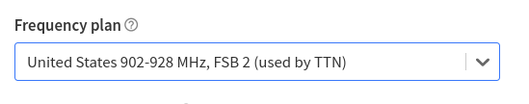
5. Unplug and then re-power the gateway. If you reconnect to the gateway’s WiFi network and visit the home page at 10.130.1.1, you should see green checkmarks:  
   