# Section 1: *Intro to BMON*

# Acknowledgements

This material is based upon work supported by the U.S. Department of Energy's (DOE) Office of Energy Efficiency and Renewable Energy (EERE) under the Advanced Building Construction with Energy Efficient Technologies & Practices (ABC) award, award number DE-EE0009088.

This manual was created under a contract with Analysis North over the Alaska state fiscal years 2021 and 2022. Many thanks to Information Insishts and Ben Loeffler (Loeffler Engineering) for editing this manual.

# Introduction

The Building Monitoring (BMON) System, often referred to as simply BMON, is a free, open-source software platform designed by Alaska Housing Finance Corporation (AHFC) and built by Alaska energy experts to track and analyze energy use and operations in buildings of all sizes. Analysis North has been the primary software developer of the BMON application through a contract funded by the DOE State Energy Program.

While the software is available to the public at no cost, a BMON user’s data collection and storage costs must be weighed against potential energy cost savings such that an acceptable payback on monitoring can be achieved. The BMON software and data collection system has many uses and some technical aspects but the basic functions can be used by anyone. One of the biggest advantages of BMON over other systems is that it can receive input from multiple data sources, including automation systems, on-site sensors, local weather stations, utility companies, and other databases.

This tool allows users to see overall building energy usage at any scale and time period alongside specific equipment data. By comparing multiple data sources, patterns emerge that can identify the causes of high energy consumption and unexpected costs. Benefits can also include improved operations due to advanced warning of equipment failures and/or runtime data. This is particularly useful for facilities where the manager may not be on site. The goal of this manual is to explain how BMON can be used to identify high energy consumption and safely reduce wasted energy through operational modifications. BMON can be used to support existing energy efficiency goals and to create awareness of energy use for general energy and cost savings.

Examples of BMON uses:

* Measuring heating fuel use of a building to properly size a replacement boiler.
* Tracking lighting against the occupied schedule to make sure lighting is not used unnecessarily during unoccupied times.
* Monitoring indoor temperatures compared to the occupied schedule to properly time warm-up sequence.

Here are examples of a couple different BMON information sites:

Alaska Housing Finance Corporation: <https://bms.ahfc.us/>

Alaska Native Tribal Health Consortium: <https://anthc.bmon.org/reports/>

[Basic Architecture of the BMON System]

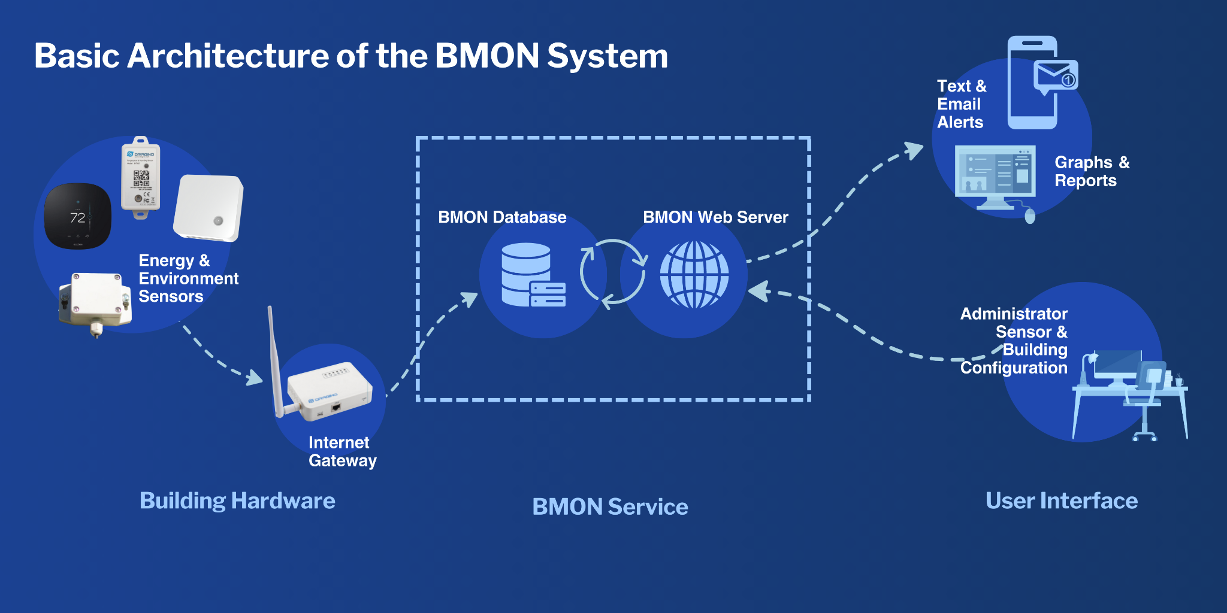

[**Video: Intro to BMON**](https://vimeo.com/672543509)

## Purpose of this Manual

This manual is a guide to setting up and using the [Building Monitoring](https://bms.ahfc.us/reports/?select_org=0&select_group=0&select_bldg=2&select_chart=0&select_sensor=680) (BMON) [System](https://bms.ahfc.us/reports/?select_org=0&select_group=0&select_bldg=2&select_chart=0&select_sensor=680). **The manual is not a comprehensive guide to building monitoring and BMON; instead, it focuses on a basic but valuable monitoring system that allows the user to identify energy savings potential, better maintain and operate a facility, and avoid catastrophic failures, such as frozen pipes. The information in this manual is intended for those seeking to use BMON for energy management, indoor air-quality management, occupant comfort, and identification of equipment malfunction to prevent catastrophic failures.** This manual contains the information necessary to set up and use the BMON system, plus some tips based on past experience. More in-depth information can be found in the [BMON software documentation](https://bmon-documentation.readthedocs.io/en/latest/user-introduction.html).

**This manual covers:**

* **The types of sensors used with BMON, what they measure, and how those measurements can be useful to a facilities manager, energy manager, or a building owner.**
* **The process of configuring a new building and dashboard in BMON, installing the sensors and internet-connected hardware, setting up alerts, and using the data for simple but powerful analysis.**

## Value of BMON

BMON was originally created to help building owners and managers save energy through efficiency and conservation measures informed by data. BMON organizes information that can be used to make low-cost changes to operational schedules, set-points, and general strategies to reduce energy waste and wear and tear on components. The changes made through monitoring and analysis can potentially reduce the financial burden of high energy costs and equipment repair or replacement. Although saving energy is still the main purpose of BMON, some other uses of the system include:

* Identifying equipment malfunctions to prevent catastrophic failures such as freeze-ups, loss of building pressure, equipment overheating, etc. Equipment may operate erratically or intermittently prior to a failure so monitoring critical equipment can provide early warning of a problem.
* Monitoring building occupancy to make the best use of space and maximize safety for occupants. Measuring actual occupancy can provide valuable insights into the usage of a building that can promote safety and productivity practices.
* Providing an operations log as a reference and a record of maintenance activities.
* If HVAC equipment is going to be replaced, measuring the actual loads required by a building or space to help determine the proper size of the new equipment. This is especially true if retrofits occurred in the building, making it more efficient, or if the usage of the building has changed since it was built. Measuring the space heating and/or water heating needs is valuable because the equipment being replaced may not have been properly sized in the first place and substantial savings may be realized by right-sizing equipment.