📘 1. Module Title Section
Title: Module 3: Secrets and Sensitive Data Management
Subtitle: Protecting Credentials in Terraform, State Files, and CI/CD Workflows
This module provides an in-depth, real-world exploration of how sensitive data should be handled in Terraform-based infrastructure automation. It focuses on enterprise-grade practices using secret managers, CI/CD pipelines, and secure runtime injection patterns to eliminate the risks of credential exposure.

🎯 2. Learning Objectives
By the end of this module, you will understand:
- Why Terraform state and plan outputs can leak secrets
- Enterprise patterns for integrating AWS Secrets Manager and HashiCorp Vault
- Secure CI/CD secret injection using Jenkins credentials
- How to design Terraform code that never stores secrets permanently
- Practical credential rotation workflows
- How to audit and monitor secret usage in pipelines

🤔 3. Why Do We Need This?
🧩 Scenario: Production Data Breach Due to Terraform State Leak
A company stored DB credentials in Terraform variables. Their remote state was kept in an S3 bucket without encryption and broad IAM permissions. An engineer downloaded the state file locally and the credentials were exposed.
❌ What Went Wrong?
- Password was passed via Terraform variable
- Variable stored in Terraform state
- State backend lacked encryption
- No centralized secret manager
✅ Proper Secure Design
- Password stored in AWS Secrets Manager
- Terraform fetches secret dynamically
- State backend encrypted with KMS
- Jenkins injects temporary credentials during runtime

🧠 4. Concept Deep Dive
🔹 How Terraform Leaks Secrets
Terraform stores values in:
- State file
- Plan output
- Console logs
- Resource metadata
Example Risk
resource "aws_db_instance" "db" {
username = "admin"
password = var.db_password
}
Even if marked sensitive:
variable "db_password" {
sensitive = true
}
The value still exists in state unless handled carefully.

🔹 Scenario 1: Secure RDS Deployment Using AWS Secrets Manager
Architecture Flow
Developer → Jenkins Pipeline → Terraform → AWS Secrets Manager → RDS
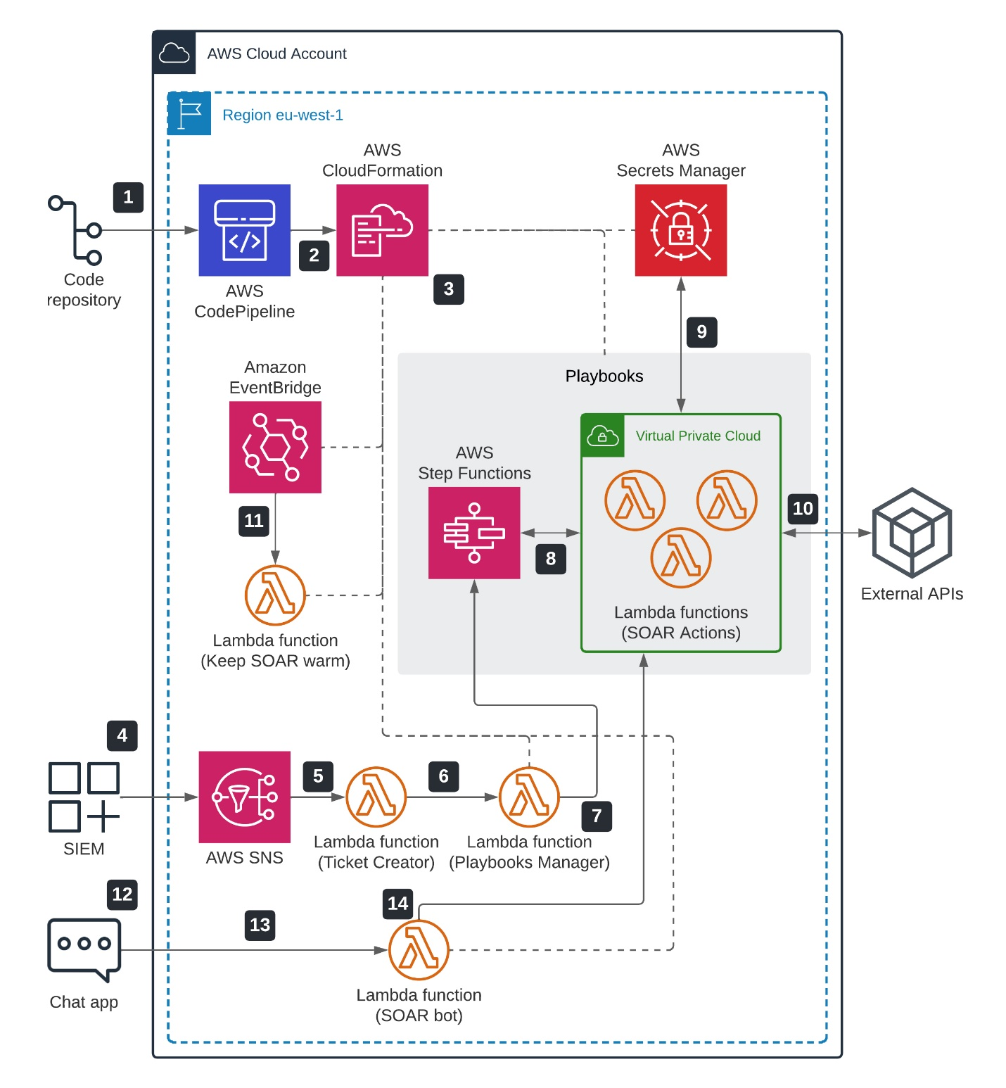
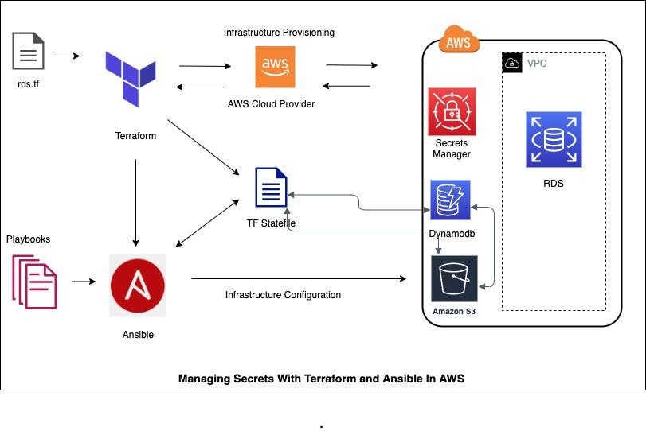
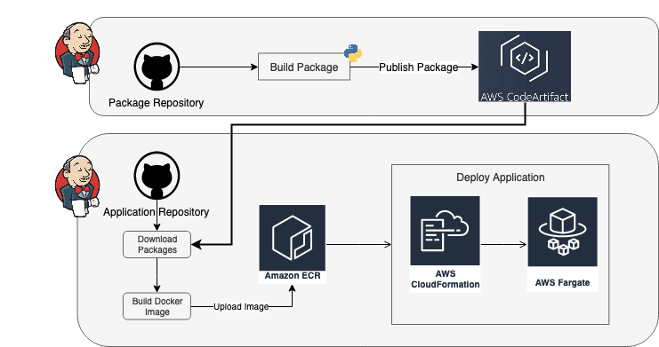
Step 1 – Store Secret
Secret stored as:
prod/rds/master-password
Step 2 – Terraform Data Source
data "aws_secretsmanager_secret_version" "rds" {
secret_id = "prod/rds/master-password"
}
Step 3 – Use Secret Without Exposure
resource "aws_db_instance" "prod" {
identifier = "prod-db"
engine = "mysql"
username = "admin"
password = data.aws_secretsmanager_secret_version.rds.secret_string
}
Why This Is Secure
- Password not in Git
- Password not in .tfvars
- Rotatable centrally

🔹 Scenario 2: Dynamic Database Credentials Using HashiCorp Vault
Vault can generate temporary DB credentials.
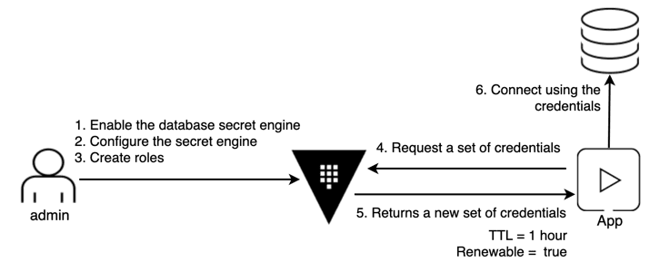
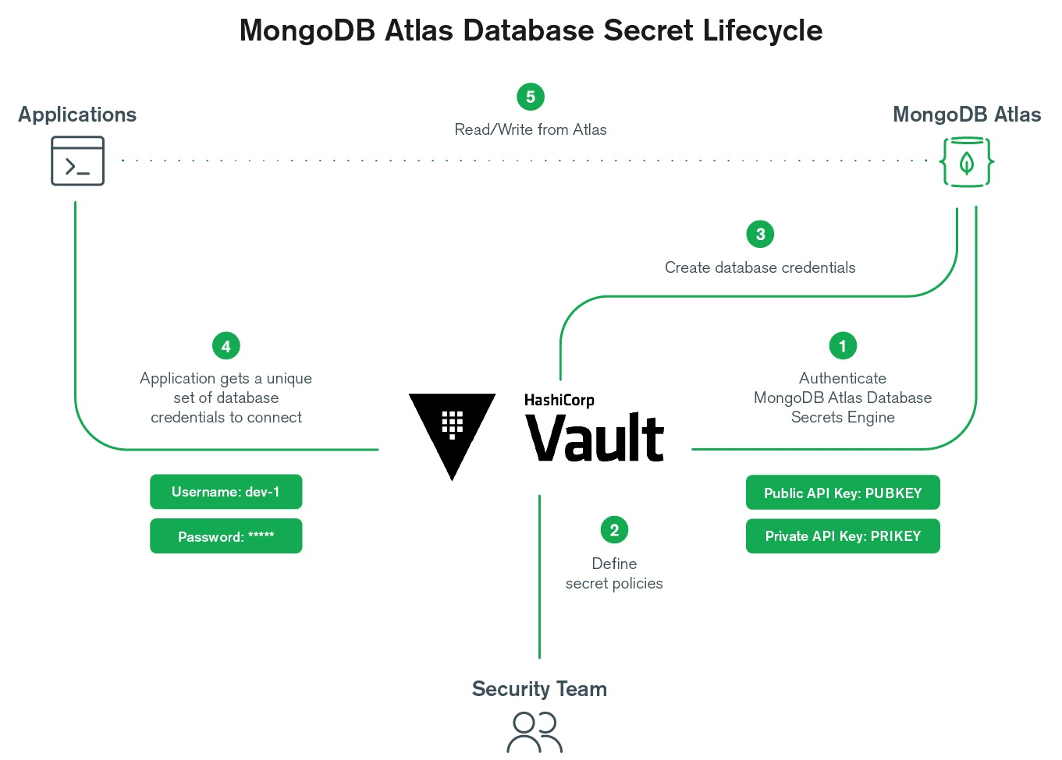

data "vault_database_creds" "db" {
name = "readonly-role"
}
locals {
db_user = data.vault_database_creds.db.username
db_pass = data.vault_database_creds.db.password
}
Security Advantage
- Credentials expire automatically
- No long-lived passwords
- Reduced blast radius

🔹 Scenario 3: Injecting Secrets via Jenkins Pipeline
Instead of Terraform pulling secrets, Jenkins injects them securely.
pipeline {
environment {
AWS_REGION = "us-east-1"
}
stages {
stage('Terraform Apply') {
steps {
withCredentials([string(credentialsId: 'prod-db-pass', variable: 'DB_PASS')]) {
sh '''
terraform init
terraform apply -var="db_password=$DB_PASS" -auto-approve
'''
}
}
}
}
}
Why This Works
- Secret never stored in repo
- Jenkins masks output
- Credential stored securely in Jenkins vault

🛠 5. Practical Enterprise Example
Secure EC2 App Deployment with API Key
data "aws_secretsmanager_secret_version" "api" {
secret_id = "prod/app/api-key"
}

resource "aws_instance" "app" {
ami = "ami-12345678"
instance_type = "t3.micro"

user_data = templatefile("${path.module}/app.sh", {
api_key = data.aws_secretsmanager_secret_version.api.secret_string
})

tags = {
Name = "secure-app"
}
}

🔄 6. Step-by-Step Breakdown
- Terraform queries Secrets Manager
- AWS IAM role attached to Jenkins agent allows access
- Secret injected into user data at runtime
- Instance boots with secret
- Secret never appears in Git or Terraform variables

🧩 7. Combining with Other Terraform Concepts
Feature | Use with Secrets
for_each | Multiple secrets per environment
locals | Structure secret-based configs
dynamic blocks | Inject secret-driven configs
Remote backend | Encrypt state with KMS

⚠️ 8. Common Mistakes / Gotchas
- Forgetting to encrypt S3 backend
- Printing secrets in shell scripts
- Using output blocks with sensitive data
- Storing secrets in GitHub Actions logs
- Not using IAM least privilege

📌 9. Key Takeaways
- Secret managers centralize and secure credentials
- Terraform should reference secrets, not store them
- CI/CD pipelines must inject secrets securely
- Vault enables dynamic, short-lived credentials
- State encryption and IAM policies are mandatory

🧪 10. Knowledge Check (MCQs)
1. What is the biggest risk of passing secrets via Terraform variables?
A. Slower execution
B. Stored in state file
C. Hard to rotate
D. Not supported in AWS
2. What is the advantage of Vault dynamic secrets?
A. Easier Git commits
B. Auto-expiring credentials
C. Faster deployment
D. No IAM needed
3. Why use Jenkins credentials binding?
A. To expose secrets to logs
B. To permanently store secrets in pipelines
C. To securely inject masked secrets at runtime
D. To bypass secret managers

✅ 11. Answers Section
- B – Terraform stores variable values in state
- B – Vault generates temporary credentials
- C – Jenkins masks and injects secrets securely

📖 12. Dictionary of Terms
Secret Rotation – Automatic replacement of credentials
Dynamic Secret – Temporary credential generated on demand
State Encryption – Protecting Terraform state using KMS
Credential Binding – Secure injection of secrets into CI/CD

🔗 13. Documentation Links
- Terraform Sensitive Variables
- AWS Secrets Manager Provider
- HashiCorp Vault Provider
- Jenkins Credentials Binding Plugin

End of Advanced Module 3

