Error & Uncertainty

Lizzie Wheeldon

Western science relies on quantitative measurements to convey information and provide evidence to support different hypotheses. Due to inherent imperfections in the tools we use and the nature of the processes being analysed, we are always limited in the exactness of our measured value. This short course deals with how to express how confident we are that the data we report are correct.

# Learning Objectives

# Define and understand the difference between accuracy and precision

# Determine values and uncertainties with an appropriate number of significant figures

# Identify methods to improve systematic and random errors

# Calculate means and standard deviations

# Understand the relationship between standard deviation and normal distribution

# Suggested Resources

* *Introduction to Error Analysis,* Jack Merrin, 2017: A short, easy-to-digest summary
* *Introduction to Error Analysis*, John R Taylor, 1997: A very detailed, comprehensive resource
* *Maths for Chemists*, Graham Doggett & Martin Cockett, 2012: Reminder of basic math skills
* *Principles and Practice of Analytical Chemistry,* F. W. Fifield & D. Kealey, 2000 (5th ed) or *Statistics and Chemometrics for Analytical Chemistry*, J. Miller, 2011 (online from York library): Information on uncertainty in analytical data & measurements

# Support

Contact me with any questions: [lizzie.wheeldon@york.ac.uk](mailto:lizzie.wheeldon@york.ac.uk)

Visit my office: C/B/136

Maths Skills Centre: <https://www.york.ac.uk/students/studying/skills/maths-skills-centre/>

# Where you will see use these concepts & methods

* Y1 Skills exam in January exam period
* Practical lab courses
* Scientific reports including mini-projects and MChem reports
* Any career that deals with numbers!

# Definitions

## Accuracy: is the data *right*?

“the degree to which the result of a measurement, calculation, or specification conforms to the correct value or a standard” (Oxford Languages dictionary)

Errors = deviations from “right” value

* Error ≠ mistake
* Percent error defined as: $\frac{"True" -Meas}{"True"} ×100$

## Precision: how *consistent* are the values?

“refinement in a measurement, calculation, or specification, especially as represented by the number of digits given” (Oxford Languages dictionary)

Uncertainties = range of values we believe includes the “right” value

*Note: Often in research we do not know what the “right” value is so it is not easy to determine errors, however precision is unrelated to the correctness of the measurement.*

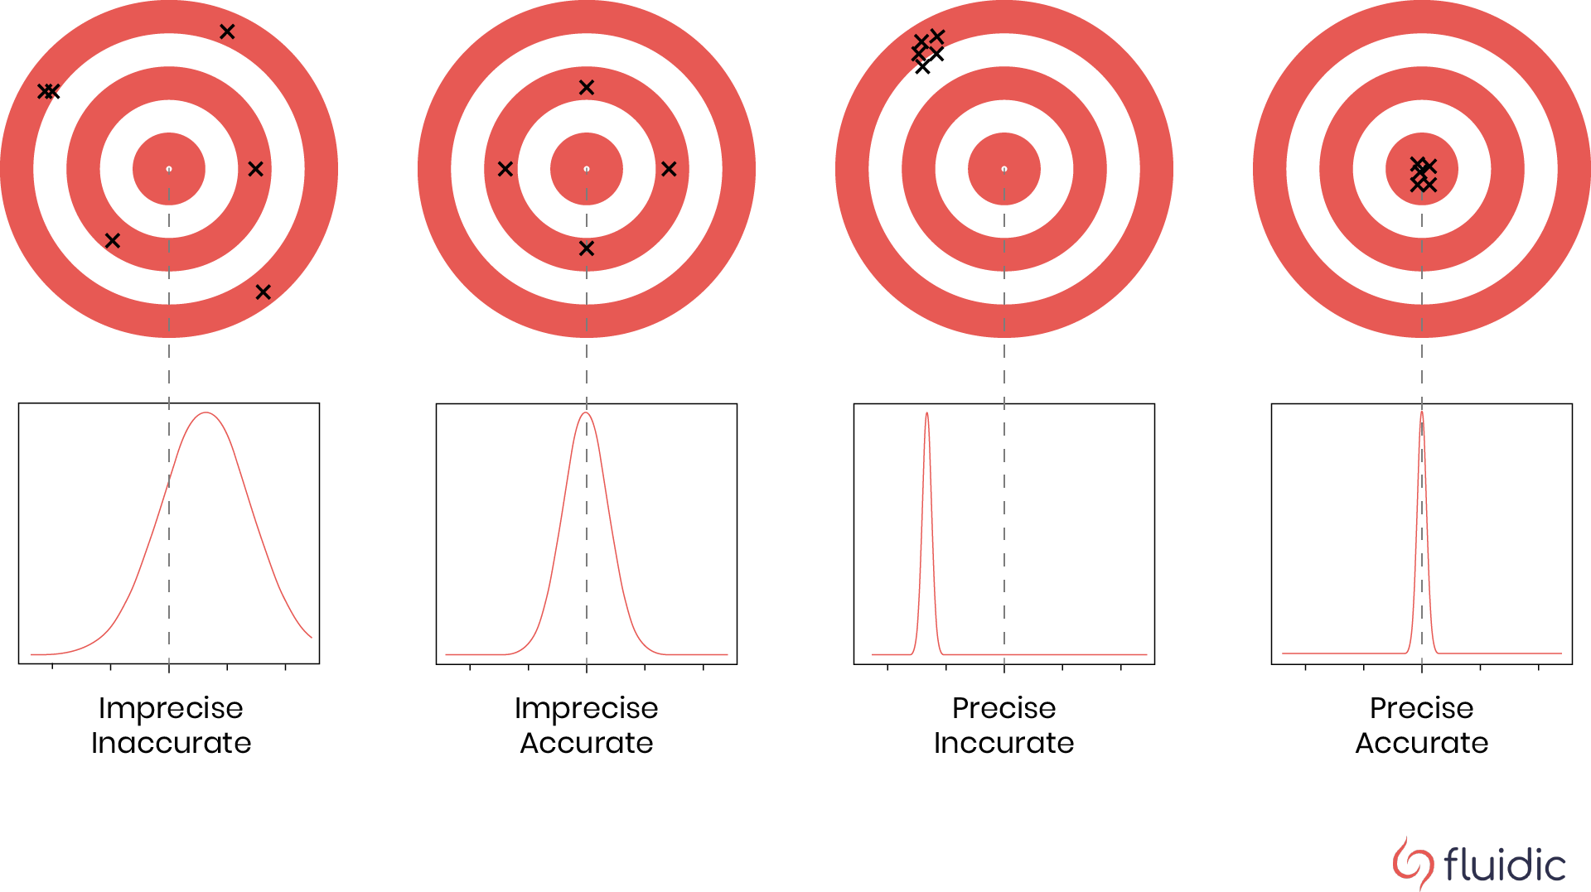

Figure 1: Visualization of accuracy and precision using bullseye target (top) and mapping these concepts onto a probability distribution plot (bottom). Note that accuracy refers to how close the points are to the centre of the bullseye (or distribution), whereas precision refers to how close the points are to each other (narrowness of distribution).

## Types of errors

* systematic errors or biases: consistent errors that can reduce the accuracy of our results
* random errors: inconsistencies in repeat measurements reflected in uncertainties on given value – affect the precision of measurements

Significant figures (significant digits): digits in a number that are necessary and meaningful

* How we write numbers provides an *implied uncertainty* (range of possible values)

Significant figures are important because they *imply* a level of precision.

* **10** *(1 s.f.)*indicates you know that the value is between 5 and 15
* **10.** *(2 s.f.)* indicates you know that the value is between 9.5 and 10.5
* **10.0** *(3 s.f.)* indicates you know that the value is between 9.95 and 10.05

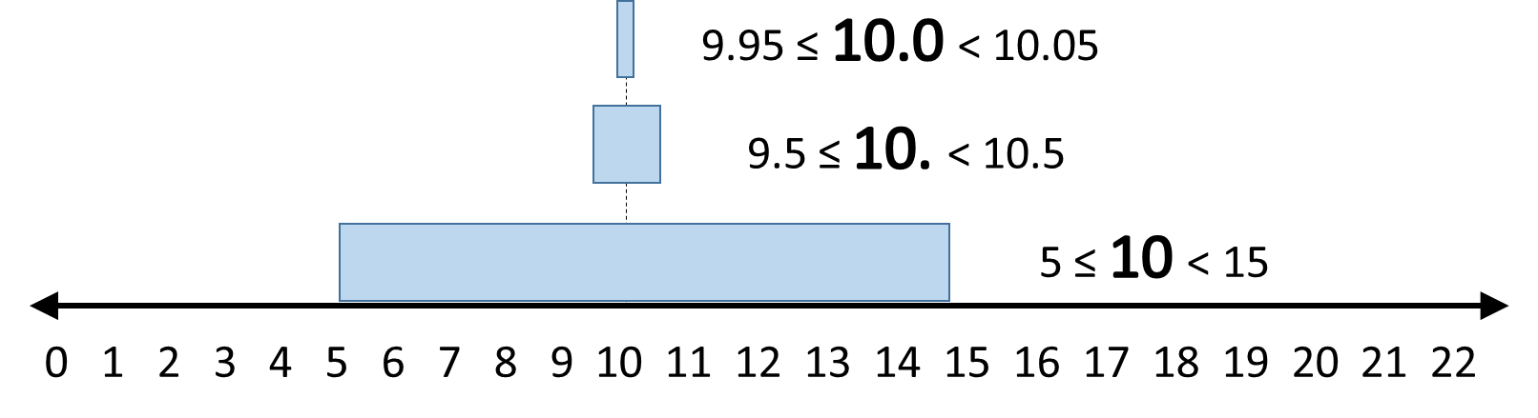

Figure 2: Number line indicating implied precision of ten reported to 1, 2, and 3 significant figures. Note the presence (or absence) of the decimal point changes the implied precision in this case as it indicates which zeroes (if any) are considered significant.

Guidelines for determining whether digit is significant:

* All non-zero numbers are significant

3.14159 → 6 significant figures

* Zeroes in between non-zero numbers are significant

6.02 → 3 significant figures

* Leading zeroes are not significant

0.00100425 → 6 significant figures

* Trailing zeroes are only significant if there is a decimal point

10.0 → 3 significant figures 152300 → 4 significant figures

## Significant figures & maths

Adding and subtracting: When adding or subtracting values, *round the answer to the fewest number of significant figures after the decimal point* (or to the place in the number with the last significant figure)

Example: 25°C + 273.15 = 298 K (rounded to “ones” place)

2.456 g – 0.01654 g = 2.439 g (rounded to “thousandths” place)

Multiplying and dividing: When multiplying or dividing values, *round answer to the fewest total number of significant figures*.

Example: 1.6605x10-24 g x 6.022x1023 mol-1 = 1.000 g/mol (4 s.f.)

# Explicit Uncertainty

In most cases, you will want to indicate an uncertainty explicitly:

Value ± uncertainty [units]: $x±δx$

Example: 0.90 ± 0.02 mm

* Uncertainty generally reported to 1 significant figure
* Value must be reported to same significant figure after decimal
* We will only deal with symmetric uncertainty (same above/below value)

Scientific notation: include uncertainty with value before exponential term

Example: (9.0 ± 0.2) x 10-1 mm

Fractional uncertainty: usually given as percentage ($\frac{δx}{x} ×100$)

Example: 0.90 mm ± 2%

## Determining uncertainty in laboratory

For a single measurement, uncertainty determined by the method of measurement

|  |  |  |
| --- | --- | --- |
| Many types of equipment will explicitly state uncertainty | 500 mL volumetric flask has label on outside indicating an uncertainty of +/-0.50 mL | Figure 3 This volumetric flask indicates that you can measure out 500.0 ± 0.5 mL of a liquid (if used correctly). |
| If measuring something visually, assume of last increment indicated | Image of analog thermometer with indicator liquid extending up to approximately 17 degrees celsius (63 degrees Fahrenheit). The Celsius scale has increments every 1 degree while the equivalent Fahrenheit has increments every 2 degrees. | Figure 4: The increments on this analogue thermometer are 1°C (or 2°F). It appears by eye to indicate a temperature of 17°C (63°F), this means you would report the measurement as 17 ± 0.5°C (63 ± 1°F). |
| If using a digital instrument that does not explicitly state uncertainty, assume  of last increment indicated.[1] | Image of digital calipers that read a measurement of 0.90 mm | Figure 5: The digital calliper indicates a length of 0.90 mm. This implies that you know the value is 0.90 ± 0.005 mm. |

# Calibrations

Our measurements may be affected by systematic errors or biases. **These are consistent errors that can reduce the accuracy of our results**. Calibrations are procedures used to “check” our instruments and determine whether we need to quantitatively adjust measured values to mitigate effects from biases. We can perform a few different types of calibrations:

* Zero calibrations: make sure instrument measures “zero” when no sample is present (e.g. zeroing a digital balance with nothing on the scale)
* Standard measurement: ensure that measured value matches known value of sample (e.g. concentration of gas in a mixture from certified source)
* Full range calibration: measure multiple standards and fit a model (e.g. concentrations of gas in range of mixtures from certified source)
  + This can also apply to calibrating a conversion (e.g. UV absorbance at λmax at different solute concentrations)
  + Generally this will be a linear relationship (y = mx + c)
  + Want to include values at regular intervals across a range that covers all expected values (i.e. no extrapolation)

Calibrations should be performed regularly and as close to the experiment as possible. It is important to note that **performing calibrations regularly will improve accuracy in measurements but will not improve precision**. In most cases, precision will actually worsen because you will be combining uncertainty from sample measurements with uncertainty from calibration.

# **Reporting uncertainty**

## Determining uncertainty from repeat measurements

Often we will take repeat measurements in order to mitigate the effects of random error (inevitable small variations in how we measure values). Instead of reporting all values, it is useful to use statistics to report a *most probable* value and uncertainty margin that reflects the *range of probable values*

Assume we have collected *N* measurements. We will denote individual measurements as *.*

The mean(average) is the most probable value, calculated as $\overline{x}= \frac{\sum_{i=1}^{N}{x_{i}}}{N}$

The standard deviation represents spread of values around the mean: $σ_{x}=\sqrt{\frac{\sum_{i=1}^{N}{{\left|x-x̅\right|}^{2}}}{N-1}}$

Alternatively, you may see variance used: $σ_{x}^{2}=\frac{\sum_{i=1}^{N}{{\left|x-x̅\right|}^{2}}}{N-1}$

Standard error of mean takes into account the number of data (*N*): $σ_{x̅}=\frac{σ_{x}}{\sqrt{N}}$

Values are often reported as mean ± standard error $(x̅±σ_{\overline{x}})$**.**

This means that the more measurements we collect, the more precise our result will be. Even though measurements may be different, we can identify what value is *most probable*. Random error (also called statistical error or noise) is related to $\frac{1}{\sqrt{N}}$ and can be mitigated by taking multiple, *independent* measurements of the same thing.

# Histograms & PDFs

Histograms can help visualize the *most likely* value to measure, as well as the range of possible values. Histograms are used to display the number of occurrences of values in a data set, often as a bar chart. To create a histogram, we have to sort data into discrete bins (for example, in the figure below, all of the measured values between 2.10 and 2.19 seconds would contribute to the first bar).

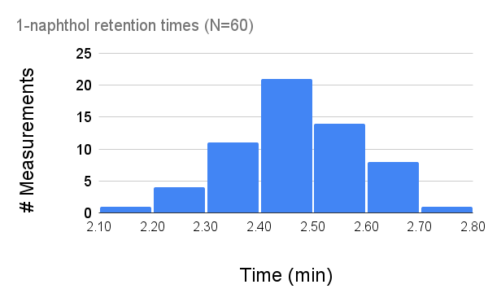

Figure 6: Histogram of retention times (fake data) where measurements have been binned in units of 10 seconds (e.g. 2.10 – 2.19 s; 2.20 – 2.29 s; etc.)

Probability density function: If we take this to the extreme of increasingly narrow bins, we can produce a continuous *probability distribution function*. For large sets of independent measurements, increase the number of data collected does NOT change mean and standard deviation.

## Normal distribution

We will assume the *probability density function* of our measurements obey a *normal distribution* due to *random noise*. This assumption implies that measured values are not dependent on rate of sampling or time when they were collected, and are completely independent (e.g.  does not influence ).

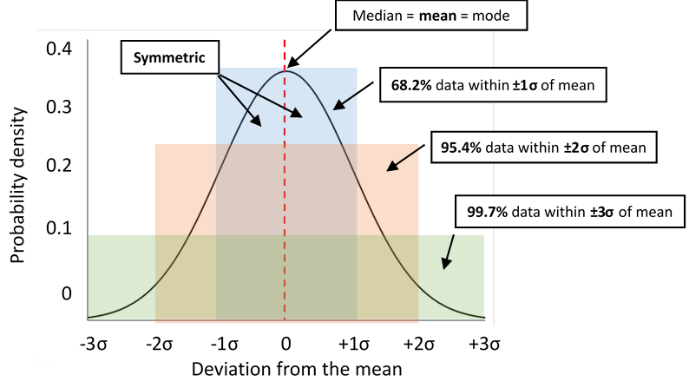

Figure 7: The normal distribution gives the probability of measuring values defined by how far away they are from the mean value.

Key features of a normal distribution

* Shape of distribution only dependent on standard deviation ()
* Mean () = median = mode
* Symmetric about mean
* **68.2% probability** 
* **95.4% probability** 
* **99.7% probability** 

Remember, standard deviation is the range of possible values (not the uncertainty on our answer).

1. You may see in other places, people assume in last digit shown but for this course we will use the ±0.5 uncertainty due to imprecision in rounding.