# Waves and Oscillations

Waves are a type of periodic motion or oscillation that occur throughout the physical sciences. In Chemistry waves and oscillations are particularly important in **Quantum Mechanics** and **Spectroscopy**.

## Definition of a wave

Consider a wave travelling through space along the x axis.

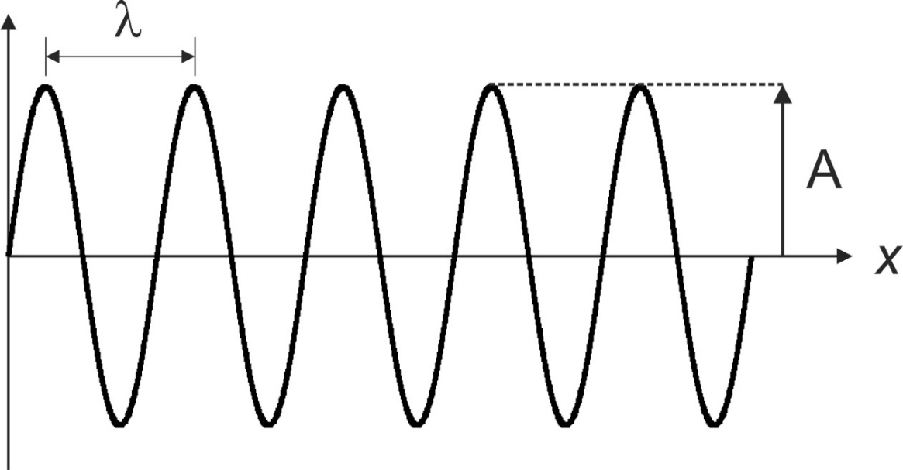

How do we describe the features of this wave?

| Variable | Name | Definition | Base units |
| --- | --- | --- | --- |
| *λ* (lambda) | Wavelength | Distance between two wave crests | m |
| *A* | Amplitude | Height of a wave crest |  |
| *ν* (nu) | Frequency | The number of wave crests that pass a single point per unit time | Hz (s-1) |
|  | Wavenumber | The number of wavelengths per unit distance | m-1 |
| *c* | Speed | Speed of the wave travelling through space | m s-1 |

How are **wavelength**, **frequency** and **velocity** related?

How are **wavelength** and **wavenumber** related?

What is the relationship between **wavenumber** and **frequency**?

Consider a wave travelling through time.

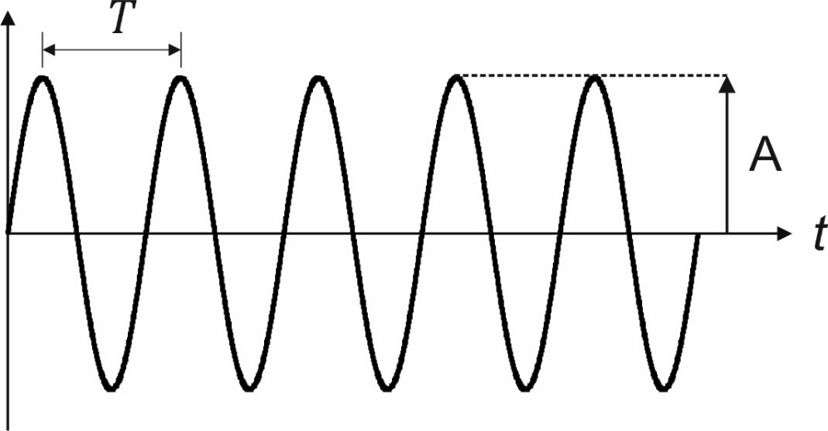

| Variable | Name | Definition | Units |
| --- | --- | --- | --- |
| *T* | Period | Time between two crests of the wave (time to complete a single oscillation) | s |
| *A* | Amplitude | Height of a wave crest |  |
| *ν* (nu) | Frequency | The number of complete waves (full oscillations) within a second | Hz (s-1) |

How are **period** and **frequency** related?

## Wave Equation

Consider the sine function. This function defines a wave where the position along the wave is defined by an angle: .

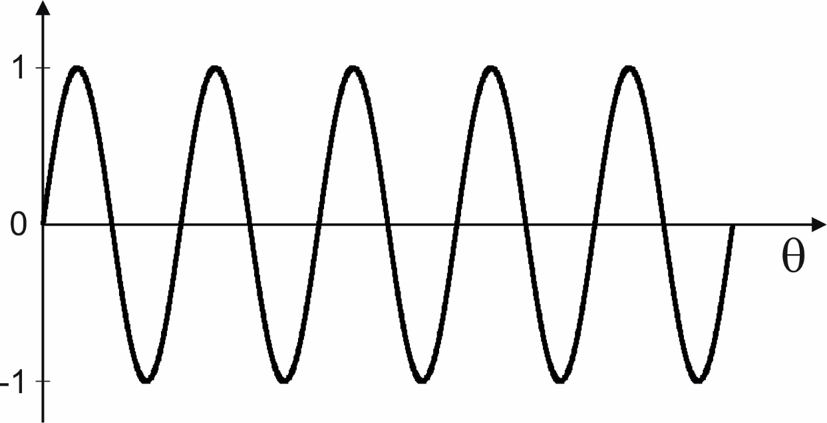

## Phase ()

The **phase** defines the point in the cycle. It is the name given to the angle, , in the sine function of the wave equation. It can be defined by units of **radians** or **degrees**. In mathematics **radians** is usually the unit used.

Remember:

Regions of **positive** amplitude can be said to have **positive** **phase**.

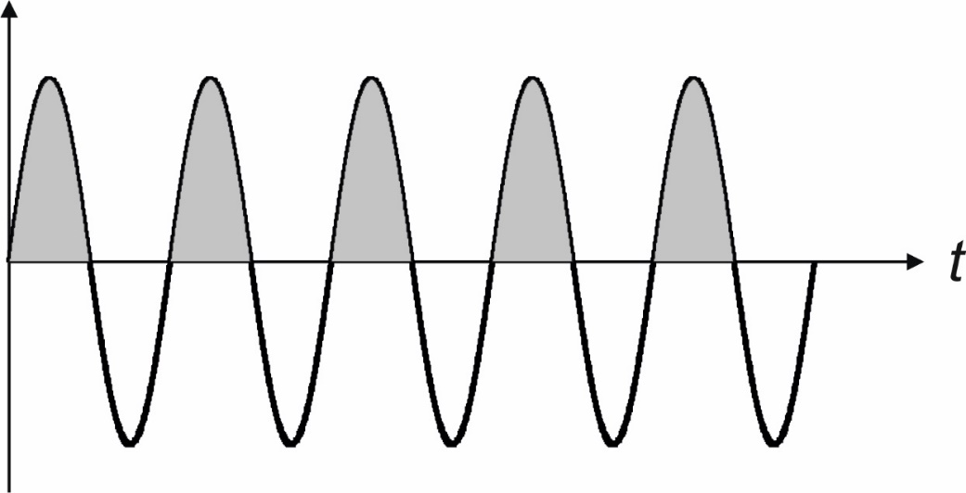

Regions of **negative** amplitude can be said to have **negative** **phase**.

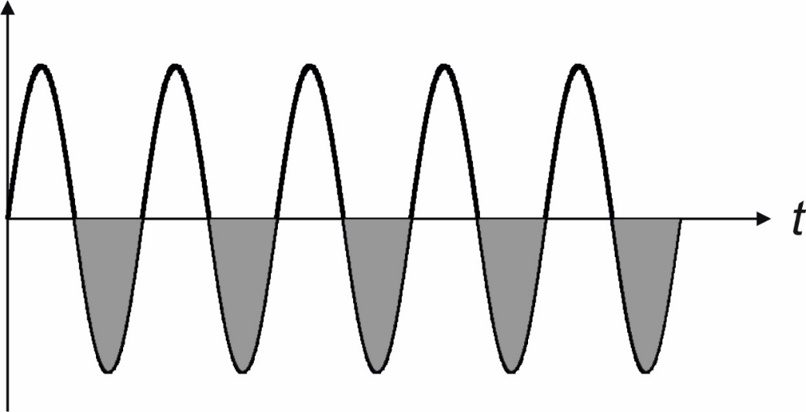

For a wave oscillating with **time** we define the phase, as the product of the **frequency** and **time**.

The **angular frequency**, ω, is the frequency in units of **radians s-1**. It is related to the **frequency**, ν, in **Hz (s-1)** by 2π.

For a wave travelling through **space** we define phase, as the product of the **wavenumber** and **position** (x).

*K* has units of **radians m-1** and is related to the **wavenumber** in **m-1** by 2π.

For a wave travelling through time and space we need to include both factors.

## Principle of superposition

One of the key special features of waves is how they interact with each other. Waves can pass through each other and come out the same as they went in. However, in the interaction region where the waves overlap we see interesting and important effects.

Mathematically, the interaction of two waves and in the region where they overlap can be written as a sum.

### How the two waves interact will depend on their relative frequency, wavelength and phase.

### Constructive interference

If the peaks and troughs of two waves line up, then the waves add up. This is **constructive interference**. This requires the two waves to have the same **frequency** and the same **phase** (). Positive and negative regions line up leading to a net increase in amplitude.

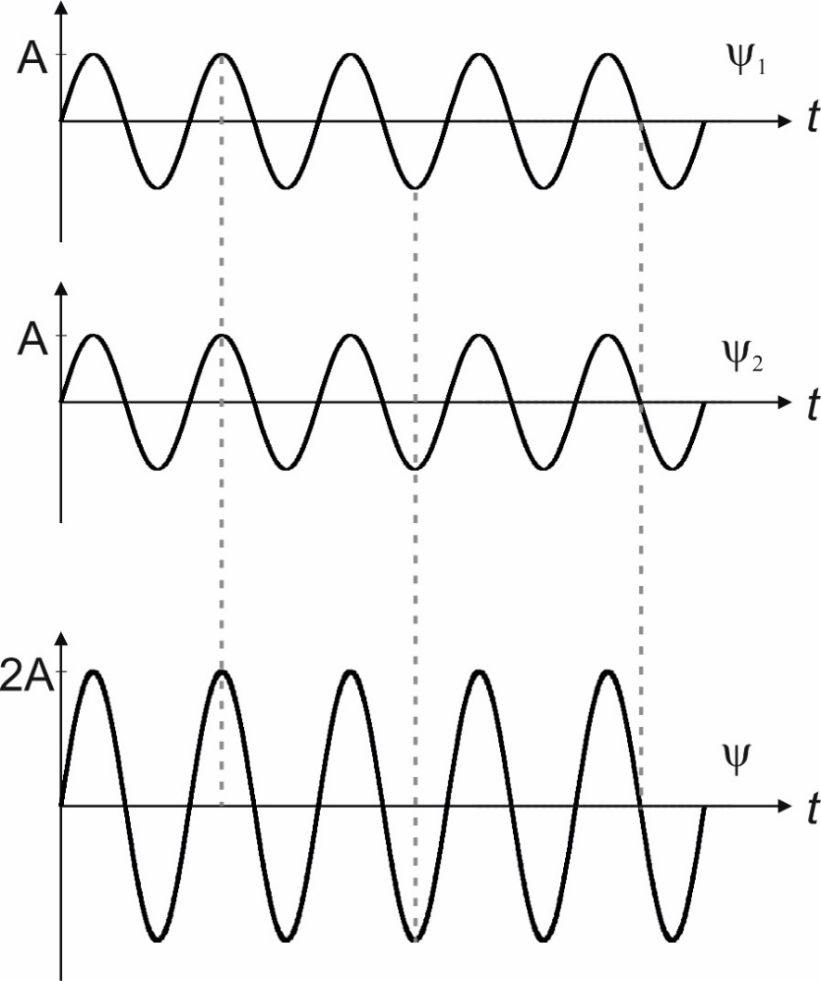

### Destructive interference

If the peaks and troughs of two waves do not line up (i.e. if the waves have different phases) then the waves will not perfectly add up and will at least partially cancel out. This is **destructive interference**. If positive regions of one wave match perfectly with negative regions of the other wave there is complete cancellation. This means that the difference in their phases is . We call this having **opposite phase**.

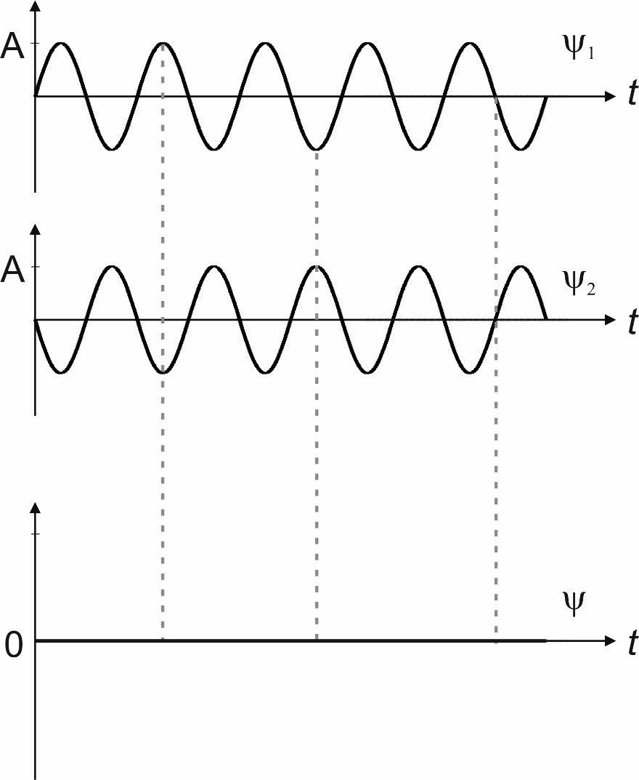

In most cases the waves will not have completely opposite phases () and so will not completely add up or completely cancel out. There will either be partial addition or partial cancellation.

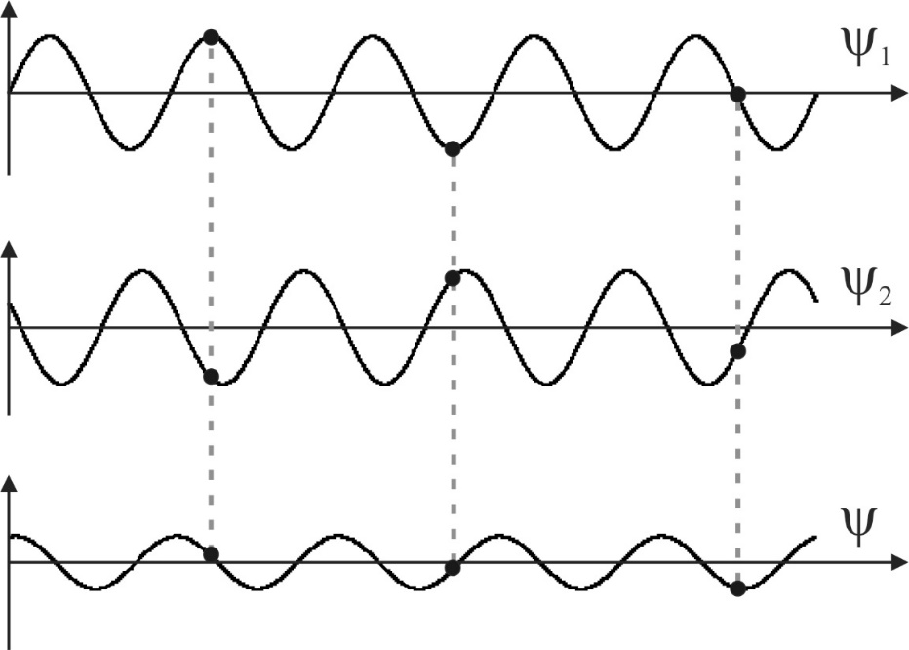

The sum, ψ, has the same frequency as ψ1 and ψ2 but a different **phase** and **amplitude**.

## Beat patterns

What happens when waves of different frequencies interact?

Consider two waves, and , with **different** frequencies, and and wavelengths and . These waves combine to form a **beat pattern**.

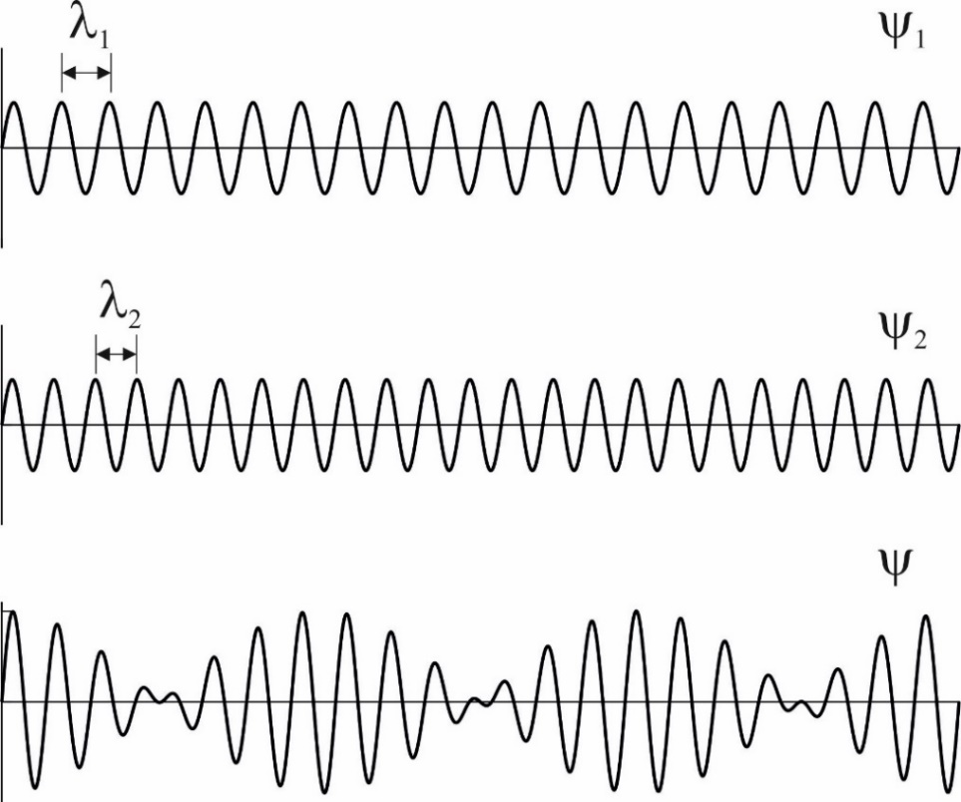

# Standing waves

A standing wave is a wave that oscillates in time but is fixed in space. It can be visualised as a vibrating string where the ends are fixed. Another classic example of a standing wave is a **particle in a box**.

The standing wave arises from **constructive interference** of waves travelling backwards and forwards along the string.

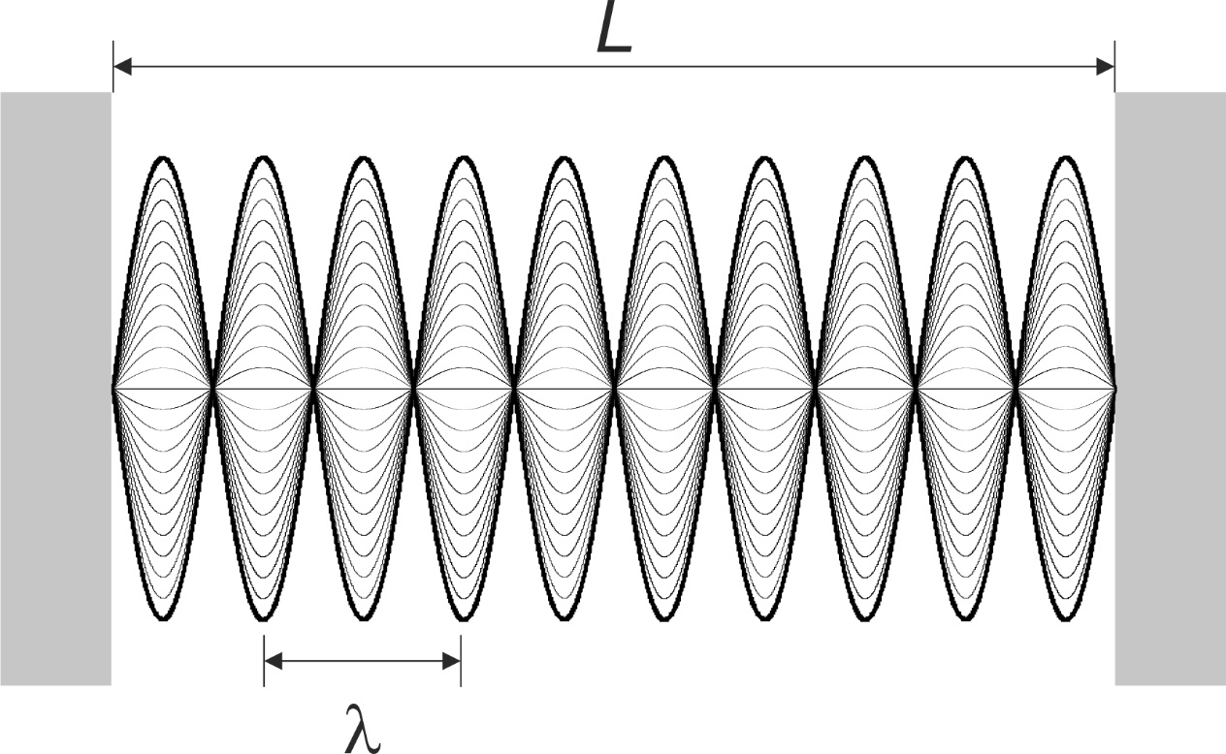

In order for **constructive interference** to occur, the wave must go through **zero** at both **ends** of the string.

Therefore, the **length** of the string (*L*) must be an **integer multiple** of **half the wavelength**.

Therefore, the **wavelength** has to fulfil the following

How does this relate to **frequency**?

How many **nodes** are there in the standing wave?

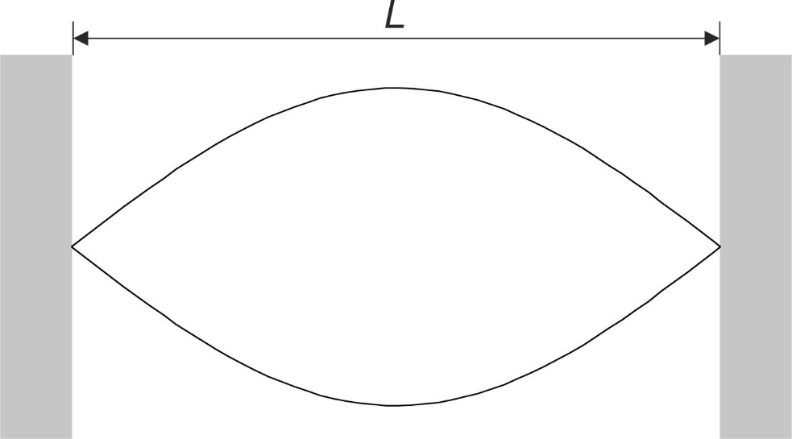

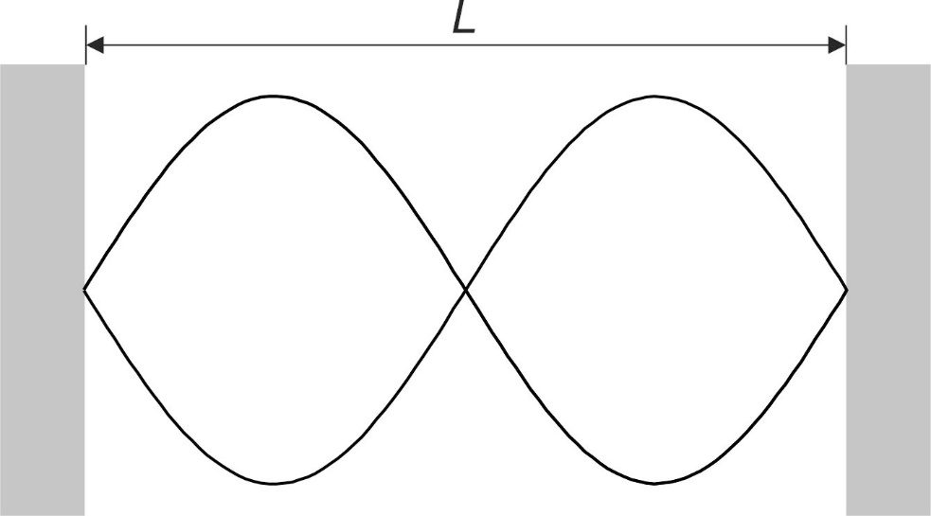

# Practical Application: Radial Distribution Functions

The form of atomic and molecular **orbitals** are a consequence of the principles of standing waves and interference. The wavelike properties of electrons mean that **constructive interference** leads to orbitals with very specific, **quantised** frequencies.

The atomic orbitals can be visualised in 1D using the **radial distribution function.** These are essentially standing waves, with a number of nodes that is related to the quantum number, *n*.

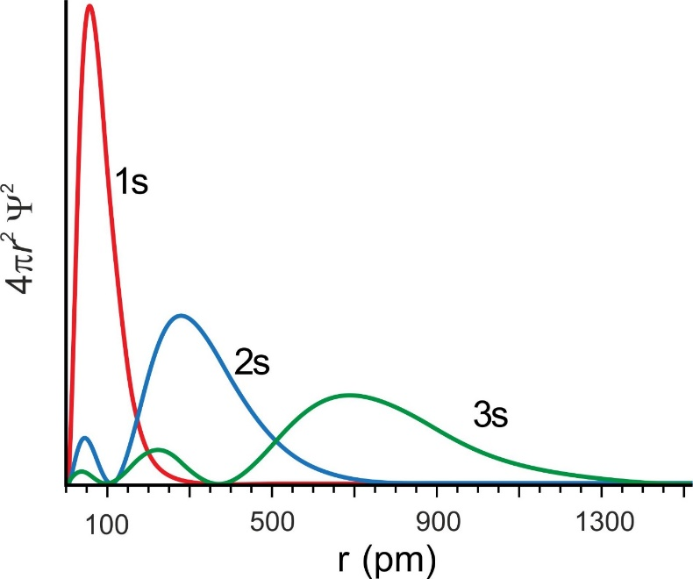

# Electromagnetic (EM) Radiation

One of the applications of waves in Chemistry is in the idea of the **wave-particle duality** of light. Visible light is just one type of **electromagnetic (EM) radiation**. Wave-particle duality tells us that EM radiation behaves both like a wave and like a particle.

## Electromagnetic spectrum

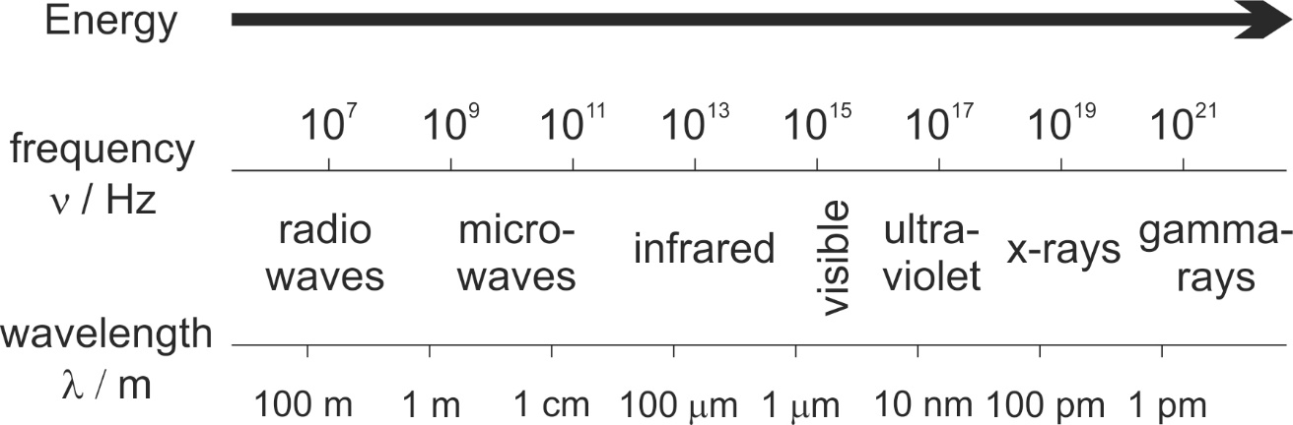

Electromagnetic radiation travels as the speed of light, *c* = 2.998 x 108 m s-1. This constant relates the **frequency** and **wavelength** of EM radiation.

The energy associated with EM radiation is defined by **Planck’s constant**, which defines the amount of energy (J) per unit frequency.

Energy is directly proportional to **frequency** (and **wavenumber**) and indirectly proportional to **wavelength**.

For angular frequency, ω, the relationship uses the **reduced Planck’s constant** (“h-bar”)

# Practical Application: Spectroscopy



**cm-1**

**kHz - GHz**

**nm**

**NMR Spectroscopy**

**IR Spectroscopy**

**UV-*vis* Spectroscopy**