Grid Electricity: Net-Load Forecasting and Flexibility Planning for High-Renewable Grids
Day-ahead net-load forecasting, operating regimes and calibrated uncertainty for six US balancing authorities, 2019–2024
SIADS 696 — Milestone II Final Report · Master of Applied Data Science, University of Michigan School of Information
Authors: Alan Mossinger · Eric Londo · Eran Abeysekera Mentor: Erik Lang October 2026
Repository: alanmossinger/Electricity-Grid-Net-Load-Forecasting-and-Fexiblity-Planning-for-High-Renewable-Grids
Contents
Executive summary 1
1. Problem, questions and goals 2
2. Data and exploratory analysis 3
3. Methodology 6
4. Unsupervised learning: what kind of day is it? 8
5. Supervised learning: forecasting net load 10
6. Interpretation and error analysis 12
7. Uncertainty, robustness and reliability 15
8. Causal inference: does more solar cause steeper ramps? 17
9. Discussion, limitations and conclusions 17
References 19

Executive summary
Grid operators schedule power plants a day ahead, but they dispatch against net load: demand minus wind minus solar, the part of consumption the controllable fleet must still supply. Across the six balancing authorities studied here, wind and solar rose from 16.6% to 26.2% of generation between 2019 and 2024, while the only public day-ahead forecast, published by the U.S. Energy Information Administration (EIA), is a forecast of demand alone. This report asks three questions: (Q1) can net load be forecast a day ahead from public data alone, better than the best public alternative; (Q2) can its uncertainty be stated honestly, region by region; (Q3) what recurring daily shapes does net load fall into, and do they help?
On a sealed holdout of 47,299 hours from 7 February 2024, a tuned histogram gradient-boosting model reaches a day-ahead mean absolute error (MAE) of 2,139.7 MW on the hours every benchmark can reach: 49.8% better than the seasonal-naive forecast, 30.1% better than a composite built on the EIA's own day-ahead demand forecast, and 13.9% better than a deliberately strengthened composite. It wins in five of six regions under blocked paired tests, with New York a statistical tie. A conformal 90% band conditioned on region covers 88.7% of holdout hours, every region within five points of nominal. Clustering the shape of the daily curve yields three operating regimes (conventional, duck, winter-shaped) that reproduce under resampling with an adjusted Rand index of 0.996.
Three findings went against the project and are reported as such: the regime labels improve the point forecast by only 17.4 MW; 77% of duck days are California's; and the calibrated median sits at 0.538 rather than 0.500 because the holdout year drifted from the calibration year. The largest error, a 57,477 MW miss in MISO, is a data failure that can be flagged from the inputs alone. A reserve rule built on the regime-conditional band moves shortfall on duck-day evening ramps from 5.8% to 4.1% of hours for 3.7% more capacity; no monetary value is claimed. Figure 1 summarises the project on one page.
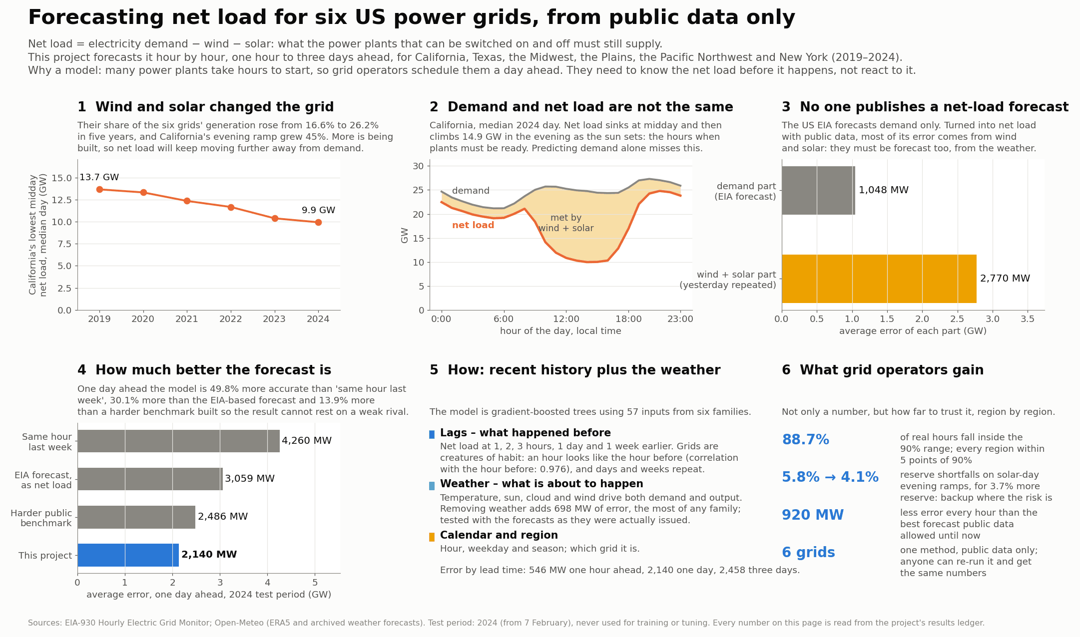
Figure 1. The project on one page. Panels 1–3 state the problem: wind and solar grew from 16.6% to 26.2% of the six grids' generation, California's lowest midday net load fell from 13.7 GW (2019) to 9.9 GW (2024), and the EIA forecast covers only demand, so its wind-and-solar leg carries 2,770 MW of error against 1,048 MW for demand. Panels 4–6 state the answer: 2,140 MW day-ahead error against 4,260, 3,059 and 2,486 MW for the three benchmarks; the model's inputs; and a 90% band covering 88.7% of real hours. Source: reports/figures/report/project_overview_in_report.png.

1. Problem, questions and goals
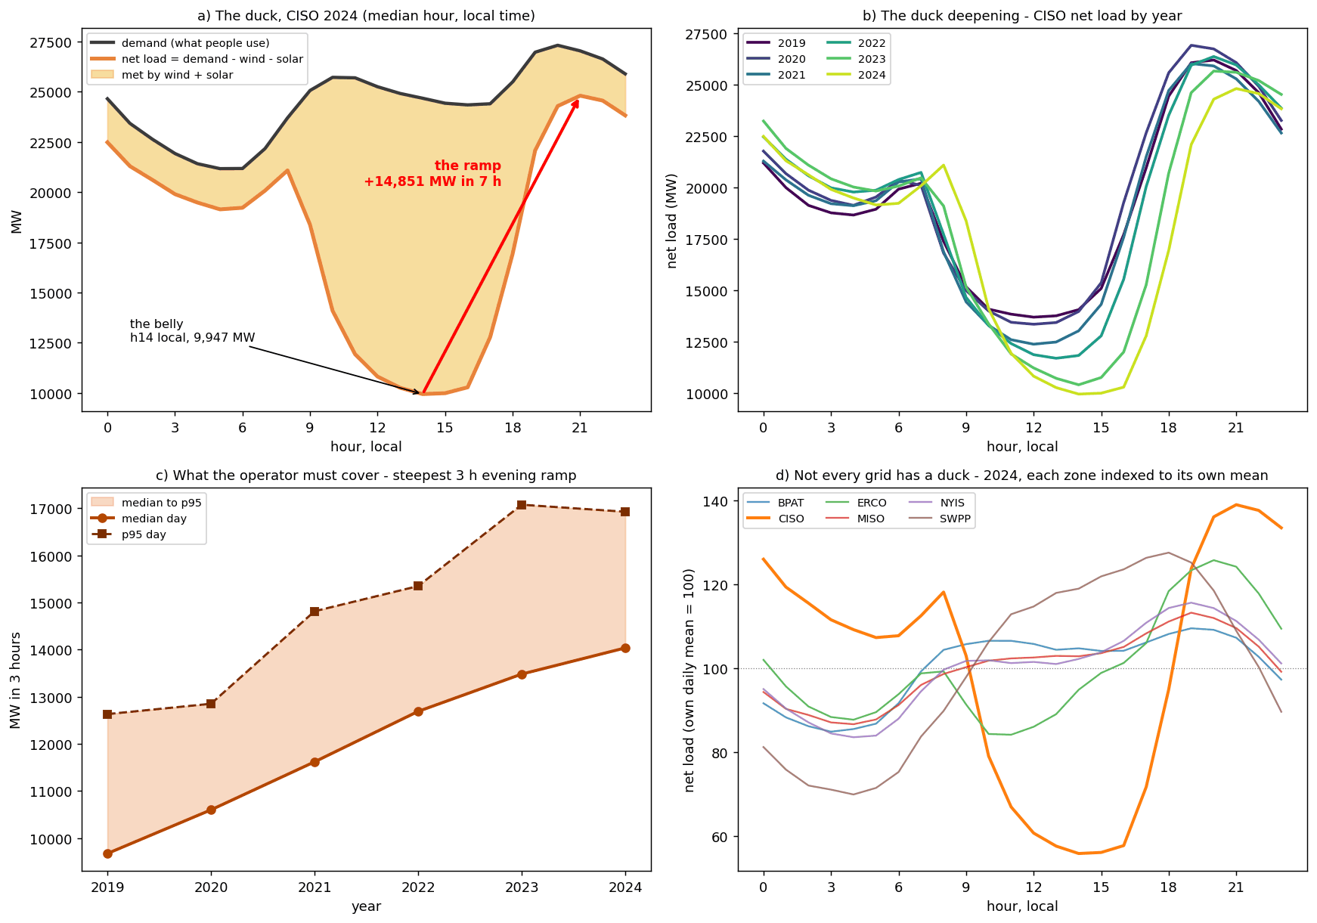
Figure 2. The duck curve is a measurement. (a) California's median 2024 day in local time: demand (black), net load (orange) and the wedge wind and solar served. (b) The same profile for each year 2019–2024: the belly deepens and moves later. (c) Each day's steepest three-hour evening ramp, median and 95th-percentile day per year. (d) Every region's 2024 median profile divided by its own daily mean: only California has a deep midday belly. Source: notebook 00 §0.6 (00_duck_curve.png).
Every hour a grid operator must match generation to consumption exactly. Without wind or solar the day-ahead problem is essentially solved: demand follows the clock, the calendar and the temperature. Wind and solar are generation the operator does not schedule, so the plants it does control must meet only net load, and that remainder sets how many plants to commit the evening before and how much reserve to hold. In California (Figure 2), demand on the median 2024 day moves by only 6,140 MW while net load swings 14,851 MW, from a belly of 9,947 MW at 14:00 to 24,798 MW at 21:00, and the steepest three-hour evening ramp on a median day rose 45% from 2019 to 2024. Commitment is decided on a forecast, which is why this project forecasts at 1, 24, 48 and 72 hours, and reserve is sized from the forecast error. No model can flatten the duck curve; a better forecast can make standing ready for it cheaper.
Question | Goal | Target
Q1. Can net load be forecast a day ahead from public data, better than the best public alternative? | G1 beat seasonal naive; G2 beat the EIA composite; G2′ beat the strengthened composite (added later) | skill ≥ 25%; skill > 0; skill > 0
Q2. How wrong is the forecast, hour by hour and region by region? | G3 calibrated 90% intervals | coverage within ±5 points; median at 0.50 ± 0.01 (added later)
Q3. What recurring daily shapes does net load fall into, and do they matter downstream? | G4 stable operating regimes | ARI stability ≥ 0.6 under resampling
Application | G5 reserve-cost surface | reported in the notebooks only; no monetary claim here
Table 1. The three research questions and the goals set against them. Skill is 1 − MAE_{model}/MAE_{benchmark}, so a skill of 0.5 means half the benchmark's error. Source: notebook 04 §4.3, §4.8, §4.9b; notebook 06 §6.2; notebook 08 §8.10.
What the forecast has to beat. Every result is scored on the same held-out hours against three benchmarks, each harder than the last: seasonal naive, the same hour one week earlier (4,259.8 MW off); the EIA composite, the EIA's day-ahead demand forecast minus the previous day's wind and solar (3,059.2 MW); and a strengthened composite v2 whose wind leg is replaced by a weather regression (2,485.9 MW). The EIA's own forecast is good on its own target (1,048.5 MW on demand); it is the renewables leg, 2,769.7 MW of error, that it lacks.
GEFCom2014 set the reference for probabilistic load forecasting on the pinball loss [11]; this project forecasts net load for six balancing authorities and calibrates its quantiles per region with conformal prediction [3, 4]. Kaur et al. [12] found that forecasting net load directly beat forecasting load and solar separately; Denholm et al. [14] analyse the duck chart as California's problem, and Section 2 finds it in one grid of six; Ruggles et al. [15] impute EIA-930 gaps where this project abstains; Hong et al. [16] show weather-station choice moves accuracy, the basis for the first upgrade in Section 9.
Goals were fixed before any model ran and two were later made stricter (Table 1). Five predictions were also registered in notebook 01, before the supervised notebook existed: P1 MAE rises with the horizon and the largest step is h=1 → h=24; P2 the weekly lag overtakes the daily lag in importance as the horizon lengthens; P3 MAE is worst in the evening ramp hours (17:00–21:00 local); P4 scaled error is highest in the Plains and lowest in New York; P5 the weather family's share of importance rises with the horizon. Three held and two failed (Section 5.4).

2. Data and exploratory analysis

2.1 Sources, regions and cleaning
Three public sources were combined. EIA-930 [1] reports, per balancing authority and hour, metered demand, the operator-submitted day-ahead demand forecast and generation by fuel: lagged demand is an input, the forecast is the benchmark, and demand minus wind minus solar defines the target. ERA5 reanalysis from Open-Meteo [2] supplies fifteen hourly weather variables at one population-weighted point per region, and Open-Meteo's archived forecasts supply six of them as they were forecast one to three days ahead over the holdout year (Section 7.5). The raw panel is 315,648 rows (6 zones × 52,608 hours).
Six balancing authorities were chosen for contrast (Table 2): they differ by a factor of ten in size, nine in renewable share, and in the shape of the day itself; only California has an afternoon solar belly, while the others trough overnight. Pre-registered cleaning nulled twelve impossible values and interpolated short gaps, and dropped four 24-hour demand outages (one in MISO from 2024-07-01 06:00) plus 67 further rows, 163 rows in all (0.052%), leaving 315,485. The split is chronological: the holdout begins on 2024-02-07, so it holds no January, and it is 2.16 °C warmer than the development block; Section 5.2 addresses the missing winter with rolling-origin refits.
Region | Operator and footprint | Mean net load (holdout) | Wind + solar share 2019–24 | Belly (local hour, share of daily mean) | Why it is in the panel
CISO | California ISO | 17,973 MW | 31% | 14:00, 56% | the canonical duck
ERCO | ERCOT, Texas | 34,646 MW | 29% | 11:00, 84% | high wind, fast-rising solar
MISO | Midcontinent ISO, central US | 60,151 MW | 14% | 04:00, 87% | the largest system
SWPP | Southwest Power Pool, Great Plains | 20,014 MW | 35% | 04:00, 70% | the wind corridor
BPAT | Bonneville, Pacific Northwest | 5,765 MW | 8% | 03:00, 85% | hydro-dominated
NYIS | New York ISO | 16,407 MW | 4% | 04:00, 83% | low renewables, the control
Table 2. The six regions. Wind-and-solar shares in 2024 alone are CISO 33.9%, ERCO 35.1%, MISO 18.1%, SWPP 38.9%, BPAT 8.9%, NYIS 4.7%. Source: notebook 08 §8.16; notebook 01 Pass 7.

2.2 Four findings that shaped the models
The fleet is changing, unevenly (Figure 3a–b). Comparing the first and last twelve months, coal fell from 25.7% to 16.5% of the six grids' generation and wind plus solar rose from 16.6% to 26.2%. But wind and solar went from 21.6% to 35.1% in Texas and 29.0% to 38.9% in the Plains, while New York (3.4% to 4.7%) and Bonneville (6.6% to 8.9%) barely moved, which is why every result is reported per region.
Where the lag sets come from (Figure 3c). The partial autocorrelation of net load has the same shape in every zone: lag 1 dominates (mean |PACF| 0.976), a daily block sits at 23–26 hours (lag 24 mean 0.355), and after that almost nothing, including lag 168 (0.097). Lag sets were therefore chosen by one rule at every horizon: the three freshest observable hours, the next whole-day anchor, and lag 168, giving (24, 25, 26, 48, 168) at h=24. Augmented Dickey–Fuller and KPSS tests point to calendar features, not differencing.
Weather: a U-shape that correlation cannot see (Figure 4). Net load against temperature is a U in every zone, so the per-zone Pearson correlations disagree (Bonneville −0.23, Texas +0.45) and pooled they cancel to −0.020; apparent_temp has the highest mutual information of any meteorological column after surface pressure (0.247) while its correlation is 0.003. Hub-height wind beats the 10 m reading in five of six zones, and the curve flattens near the rated speed, which is the turbine power curve appearing in the data. Only Bonneville gets worse, because its weather point is Portland and its turbines are in the Columbia Gorge: the cost of one weather point per region, measured.
Two cautions. Surface pressure's mutual information of 0.386 is a zone identifier (elevation), not a weather signal, and snow_depth is the same effect with a season attached; neither is quoted as a mechanism. And ERA5 is a reanalysis, so every result before Section 7.5 hands the model perfect weather foresight; the archived forecasts measure the gap (temperature off by 1.349, 1.952 and 2.091 °C at one, two and three days).
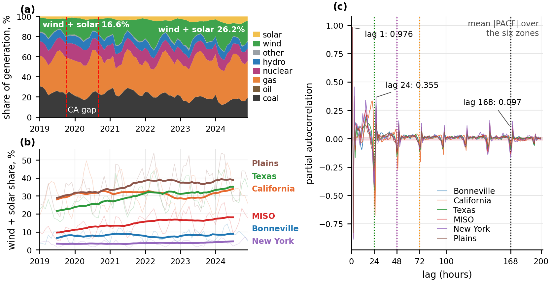
Figure 3. (a) The generation mix of the six grids, 2019–2024, as shares of generation; (b) wind and solar as a share of each region's own generation: steep in Texas, the Plains and MISO and nearly flat in New York and Bonneville. (c) Partial autocorrelation of hourly net load to lag 200, the six regions overlaid, with dotted lines at lags 24, 48, 72 and 168: the signal collapses after the daily block, including at the weekly lag. Source: notebook 01 Pass 7 and Pass 5 (01_fuel_mix_over_time.png; 01_pacf.png).
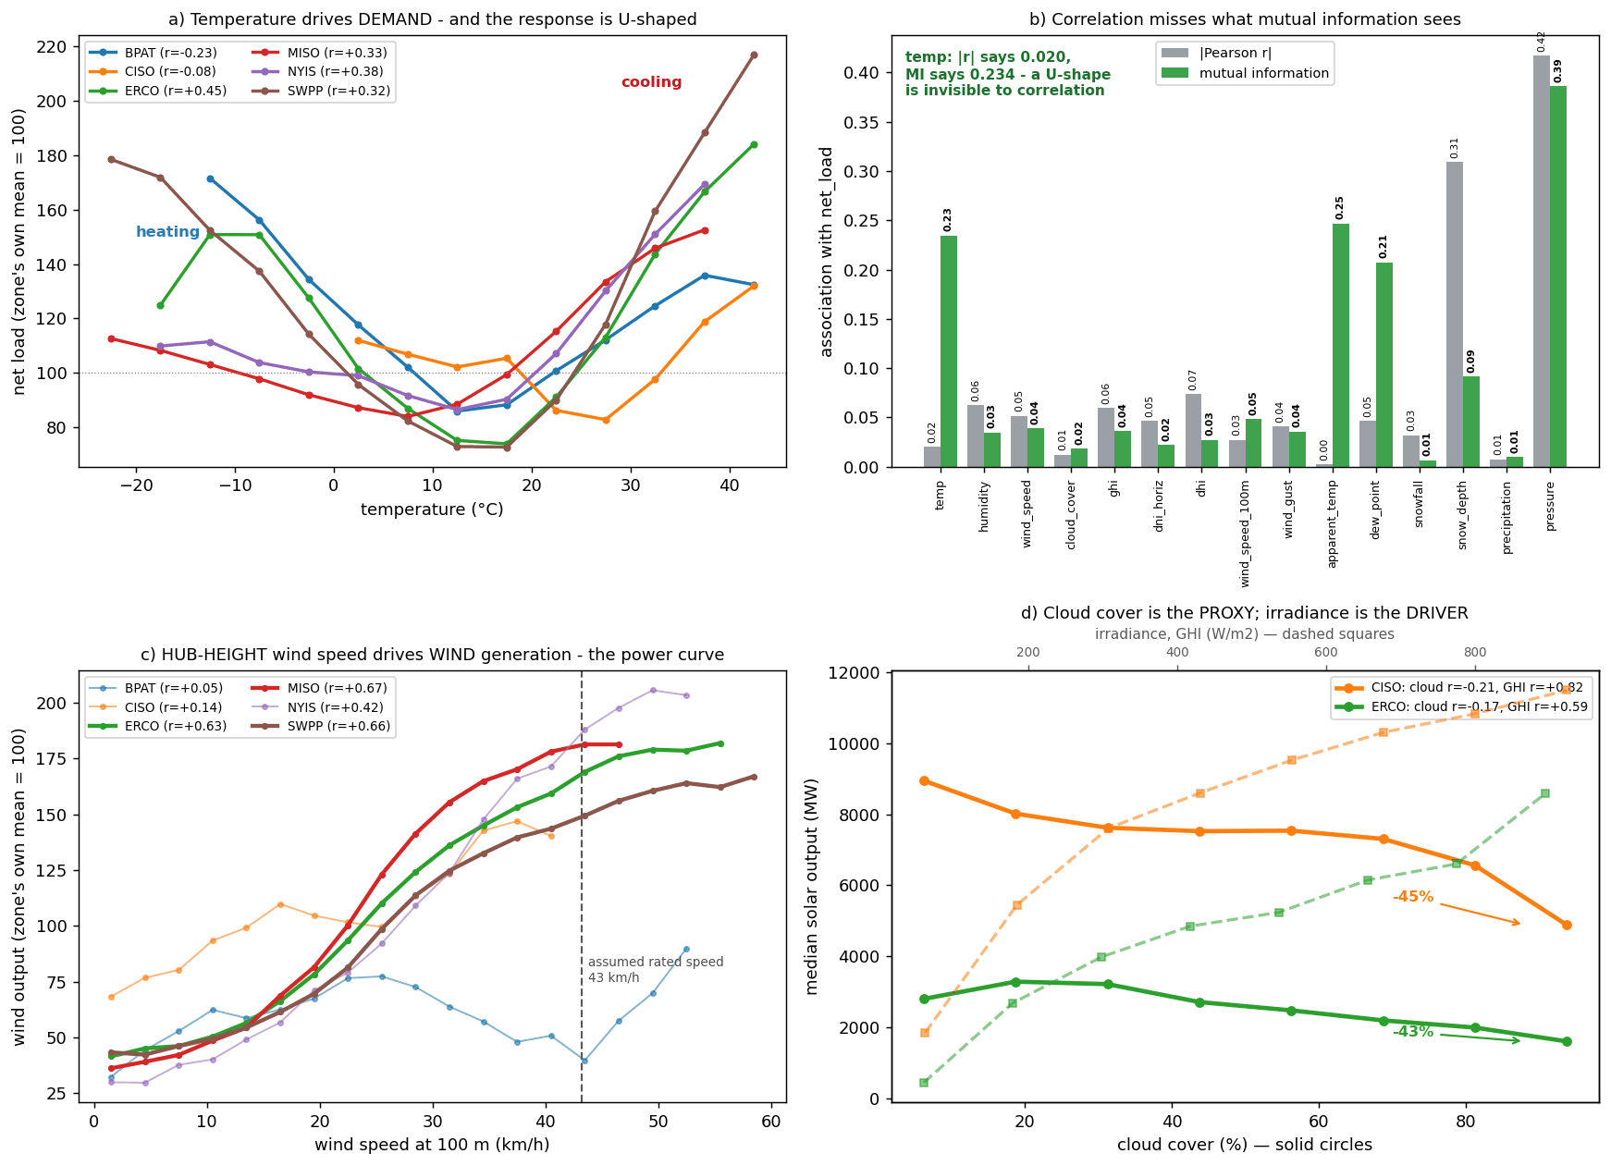
Figure 4. What the fifteen ERA5 columns carry. (a) Net load binned by temperature, each zone indexed to its own mean: a U everywhere. (b) |Pearson r| of each weather column with the target beside its mutual information: apparent_temp is near the bottom on correlation and near the top on information. (c) Wind output against hub-height wind speed: the power curve. (d) Median solar output against cloud cover and irradiance. What to observe: the physics is in the data, but only a non-linear, non-monotone learner can use it. Source: notebook 01 Pass 8 (01_era5_weather.png).

3. Methodology

3.1 One pipeline, two arms, one protocol
The supervised and unsupervised arms share everything up to and including the feature pipeline (Figure 5) and diverge only at notebooks 04 and 05; they are reunited in notebook 07, where a surrogate tree explains the clusters with the forecaster's inputs, and in the uncertainty arm, which conditions its reserve rule on the regimes. The comparison is fair because the protocol is shared: the same 315,485-row panel, the same five expanding chronological folds with a 191-hour gap at h=24 (168 hours for the longest rolling window plus the horizon minus one), and the same sealed holdout of 47,299 rows. A random split of hourly rows would place a training hour next to a validation hour that is 0.976 correlated with it and report an error no operator could reproduce. A pooled model with zone identity as a feature was chosen over six per-zone models because the lags carry each zone's level and the small zones have too little variation to tune separately; deep sequence models were rejected for a tabular problem of 57 features where tree ensembles are the established frontier and interpretability is required.
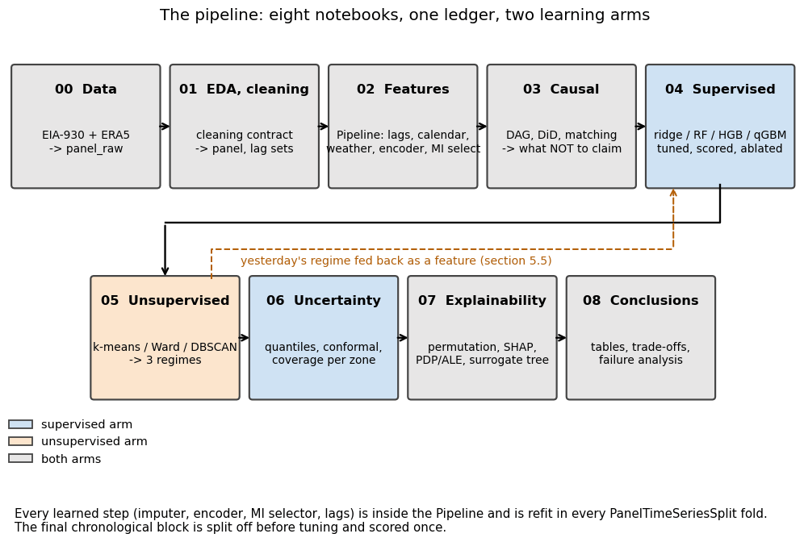
Figure 5. The pipeline end to end: what each notebook reads and writes and which arm it serves. The dashed arrow is the only loop, notebook 05's regime label fed back into notebook 04's feature set, and only a past day's label is admitted. What to observe: anything that learns a parameter sits inside a scikit-learn Pipeline refit inside every chronological fold, the structural guarantee behind the leakage claims below. Source: notebook 08 §8.2 (08_pipeline_overview.png).

3.2 Leakage: two defects found by audit, measured, then removed
The project's rule is that a defect found by an audit, measured and fixed is stronger evidence of rigour than a defect that was never there, and two were found (Figure 6). First, the nine same-hour fuel-generation columns reconstruct the target: their sum correlates with net load at r = 0.9997 in Texas and 0.9940 in the Plains, and the identity net load ≡ demand × (1 − renewable share) holds to 0.000000 MW. A model given these columns is doing arithmetic, not forecasting, and nobody knows tomorrow's gas output at a 24-hour origin, so same-hour demand, net generation, total interchange and all nine fuel columns are excluded; their lagged copies are admissible. A unit test now fails if any unvetted column becomes a feature. Second, a trailing mean computed as rolling(24).mean() includes the current row, which is correct at h=1 but at longer horizons reaches into hours the operator has not lived through. Measured: admissible and leaked arms are identical at h=1 (538.8 MW each), but the leaked model scores 1,874.8 against the admissible 2,173.2 MW at h=24 (optimism 298.4 MW, 13.7%) and 1,890.1 against 2,615.1 MW at h=72 (725.1 MW, 27.7%). The leaked model degrades by only 15.3 MW from h=24 to h=72 against the admissible 442.0 MW; it erased the horizon signal, and a check at h=1 alone would have found nothing.
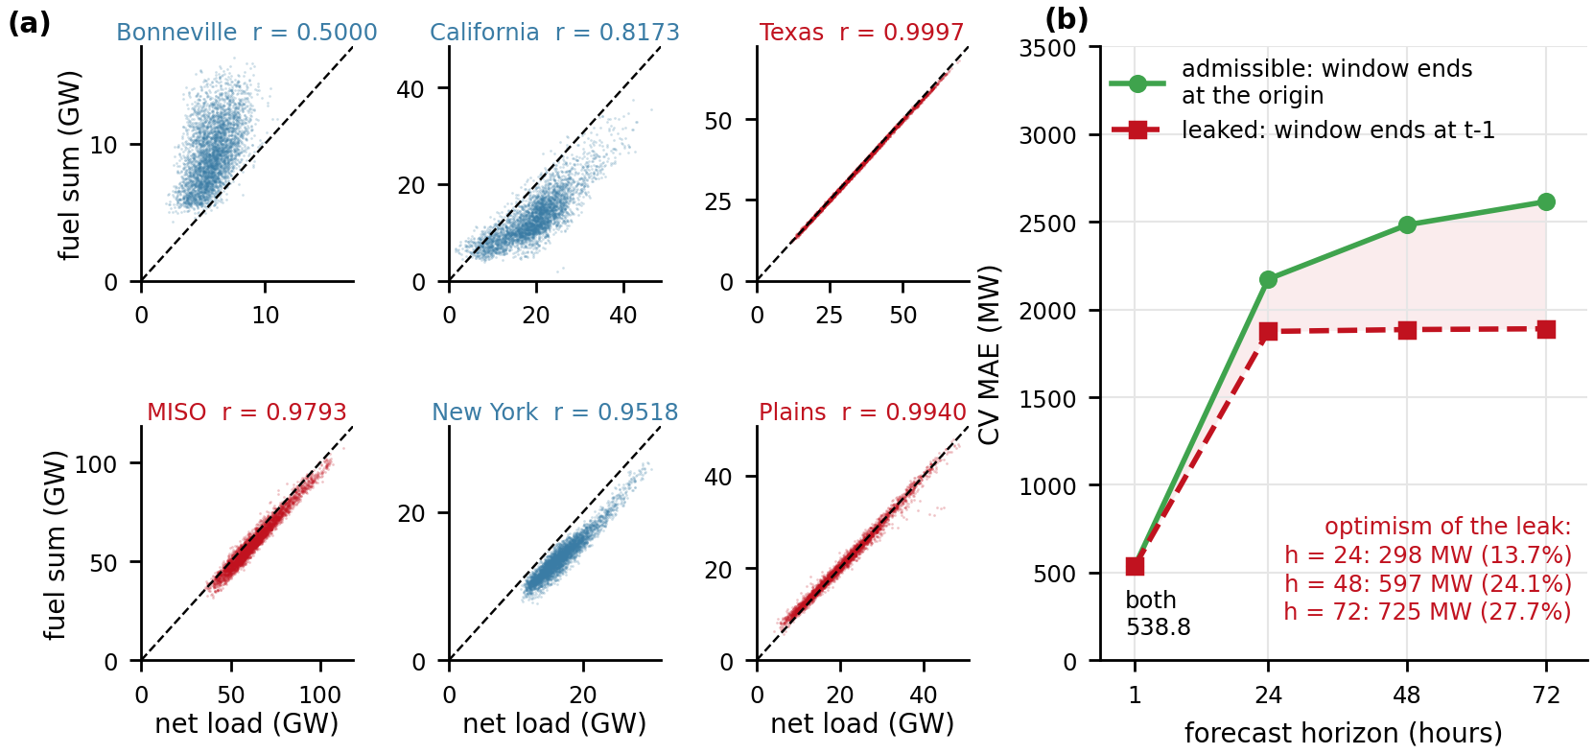
Figure 6. Two leaks, measured before removal. (a) the sum of the nine same-hour fuel columns against net load per region, with the 45° identity line; Texas (r = 0.9997), the Plains and MISO lie on it, and New York (r = 0.9518) sits just below it. (b) cross-validated MAE by horizon with rolling windows ending at the forecast origin (admissible) against windows ending the hour before the target (leaked): the arms coincide at h=1 and the leaked model's error barely moves with the horizon because it is reading part of the answer. Source: notebook 02 §2.15; notebook 04 §4.2 (02_leakage_fuel_columns.png; 04_leak_cost.png).

3.3 Features, and why the selector keeps all of them
Six feature families are computed inside the pipeline: target lags at the horizon's lag set; rolling statistics (24- and 168-hour trailing mean and standard deviation ending at the origin); calendar (hour, weekday, month, weekend, a year-end holiday proxy, with sine and cosine encodings); weather (fifteen ERA5 columns plus heating and cooling degree terms and a per-zone clear-sky index); exogenous lags (lagged demand and fuel columns); and zone (one-hot identity plus the lags expressed as ratios to the zone's trailing 168-hour level). Missing values are imputed by the training-fold median.
Selection is where the audit changed the project's mind. The pipeline's selector ranks candidates by mutual information, yet the tuned model keeps every column (select__k = all): the forward-selection curve has no knee, and the 39 lowest-ranked features are jointly worth 61.95 MW. Mutual information scores features marginally, while the model uses them conditionally (hour_sin is ranked 60th by MI and 2nd by SHAP; the two rankings correlate at only +0.31), so a practitioner who trusted the marginal ranking would have deleted useful accuracy. Collinearity is severe (45 of 69 features have VIF above 10); it does not touch a tree ensemble, but it is why the linear rung's coefficients are not interpreted.

3.4 Baselines, ladder, tuning and metrics
Four benchmarks bound the results: seasonal naive, persistence (1,211.9 MW, fair at h=1 only), the EIA composite v1 and composite v2. The supervised ladder climbs from ordinary least squares, to ridge, to a random forest, to histogram gradient boosting [18] (the champion), to a quantile gradient-boosting model that produces the seven quantiles Section 7 needs, each rung justified by a failure of the one below. Tuning searched the whole pipeline, including the selector's k, with 40 randomised draws and a 9-cell refining grid; every hyperparameter was then swept against a fold-to-fold noise floor of 50.7 MW. The headline metric is MAE in megawatts, the unit reserve is procured in; RMSE was set aside because the error distribution is heavy-tailed, and MAPE because minimising it pulls forecasts low. Model differences are tested with Diebold–Mariano [7] and Wilcoxon signed-rank tests on 1,974 zone-day blocks with Benjamini–Hochberg correction [10], because hourly residuals are autocorrelated at 0.95. Intervals are scored by coverage, width and the Winkler score [6]; clusters by adjusted Rand index (ARI) [20] stability under 80% resampling; the classifier by PR-AUC against its base rate.

3.5 Unsupervised and uncertainty methods
The unsupervised question is about shape, so each zone-day was expressed as 24 local-hour values normalised within the day to [0, 1] (13,069 zone-days × 24); local hours matter because the six systems' solar noons differ by up to three hours in UTC. The matrix was reduced by PCA, and k-means, Ward's clustering and DBSCAN were tuned on 3, 5 and 8 components, 39 grid cells in all. The partition was chosen by ARI stability, validated against weather the clustering never saw, and tested as a feature in the forecaster.
Prediction intervals come from a quantile gradient-boosting model at seven levels (0.05 to 0.95) on the champion's feature set, repaired and calibrated in three measured steps: monotone rearrangement [19] to remove quantile crossing; a chronological split of the development block at 2023-01-30 into a fit block and a calibration block; and nine interval constructions compared on the holdout, from split conformal and conformalised quantile regression (CQR) [3] to Mondrian versions conditioned on zone [4]. The shipped arm is CQR additive, Mondrian by zone.

4. Unsupervised learning: what kind of day is it?

4.1 Choosing the partition
Figure 7 reports all 39 grid cells. K-means is stable at every k (never below 0.90) and Ward much less so (below the 0.6 goal for most cells); DBSCAN finds structure but pays in noise, because a manifold without density gaps is the wrong problem for it. Silhouette, Davies–Bouldin and Calinski–Harabasz agree, so all four metrics pick k=3. The chosen configuration, k-means with k=3 on 5 principal components keeping 94.8% of the shape variance, scores ARI 0.996 and silhouette 0.429. Clustering raw megawatts instead agrees with this partition at ARI −0.034, no better than chance, and gives a cluster that is 92% MISO, so the partition is about shape.

4.2 The three regimes, and the validation that half failed
The centroids (Figure 7d) are three different shapes, not three depths of one shape. Cluster 2 (n = 2,791, 21.4%) is the duck: minimum at local hour 13, evening ramp 0.841, the steepest. Cluster 1 (n = 7,782, 59.5%) is the conventional day: minimum at hour 4, ramp 0.364. Cluster 0 (n = 2,496, 19.1%) is winter-shaped: a morning peak, an afternoon decline, minimum at hour 23, ramp 0.173. The names were derived from the centroids and then required to pass a weather check.
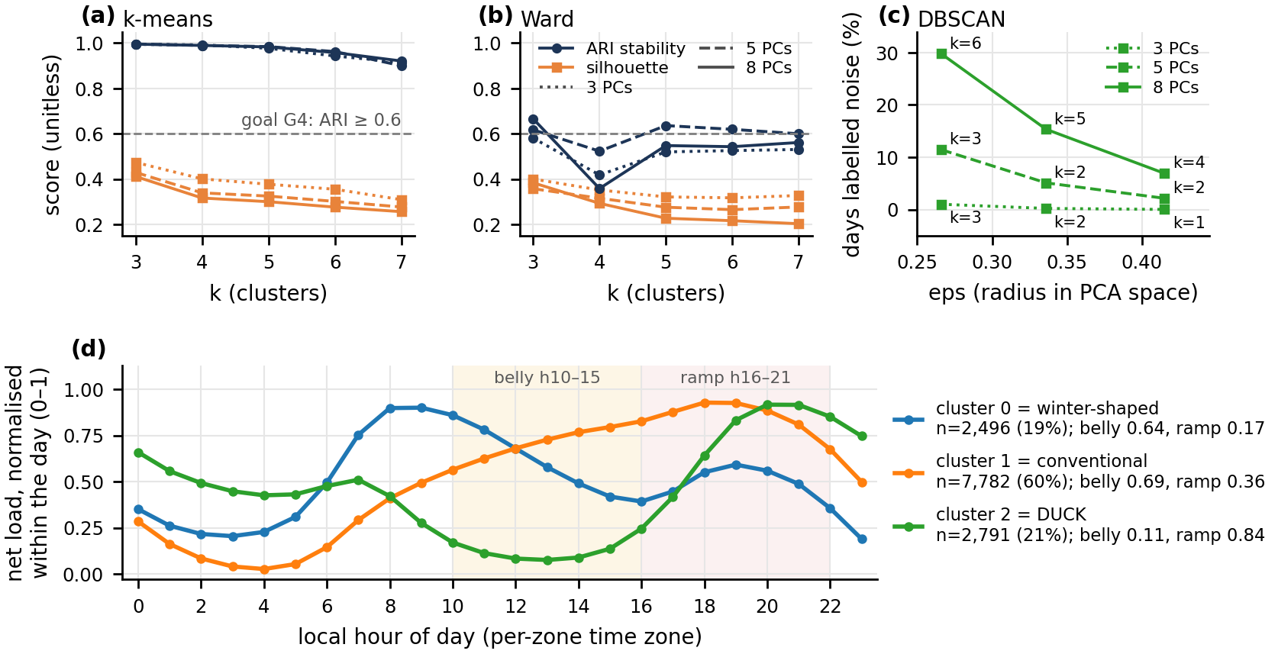
Figure 7. (a) k-means and (b) Ward across k = 3…7 on 3, 5 and 8 components, ARI stability and silhouette; (c) DBSCAN across its three eps candidates with its noise fraction. K-means is above 0.99 at k=3 and never below 0.90, Ward is below the 0.6 gate in 11 of 15 cells, and every metric picks k=3. (d) Each regime's mean within-day-normalised net load by local hour: cluster 2 bottoms at solar noon and ramps 0.841 into the evening. Source: notebook 08 §8.5; notebook 05 §5.4 (08_unsupervised_summary.png; 05_centroids.png).
Not one weather column enters the clustering, so weather separating across regimes would be external corroboration. But are the regimes zones in disguise (Figure 8a)? Substantially, yes. 77% of all duck days (2,148 of 2,791) are California's, and 98% of California's days are duck days. Within zone, the winter-shaped regime is colder than its own zone's mean in all five zones with at least thirty such days (by 3.7 to 11.1 °C), which a shape clustering was never told, while the duck's brightness holds in only two of six zones. The temperature signature is physical; the irradiance signature is mostly geography.

4.3 Do the regimes help the forecast, and can they be explained?
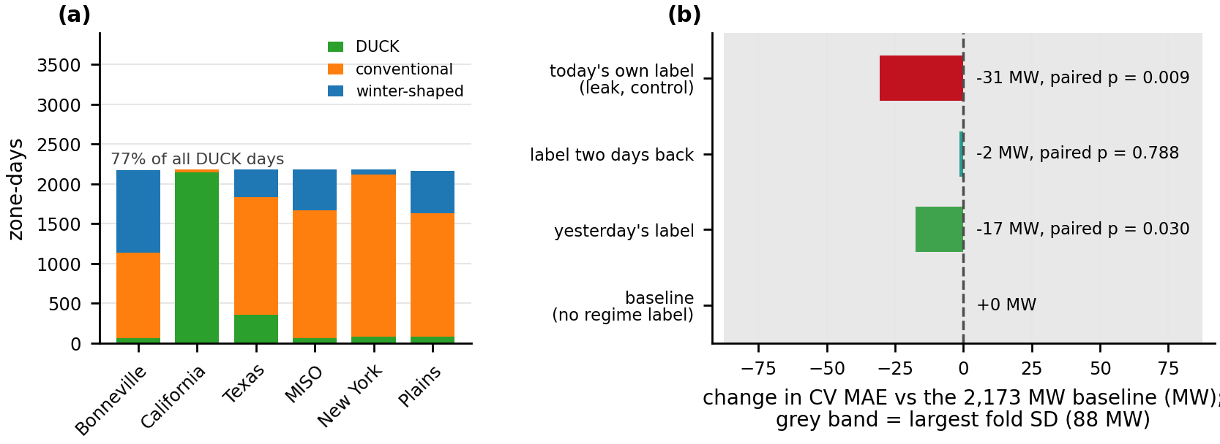
Figure 8. (a) Zone × regime crosstab: the duck regime is almost entirely California. (b) Change in cross-validated MAE when yesterday's label, the label two days back, or today's own label (a leak, as control) is added to the champion, with paired p-values; the grey band is the largest fold-to-fold SD. What to observe: the gain is ordered as it should be (leak > yesterday > two days back) and is 17.4 MW for the admissible framing. Source: notebook 05 §5.4c and §5.5 (05_regime_vs_zone.png; 05_downstream_utility.png).
Adding yesterday's regime label to the champion's pipeline under identical folds (Figure 8b) lowers cross-validated MAE from 2,173.2 to 2,155.8 MW, −17.4 MW (paired p = 0.030); the label two days back gives nothing measurable, and today's own label, a deliberate leak kept as a control, −30.6 MW. The ordering is right and the gain is small, under 1%: the lags already carry most of what a shape label could add. A depth-3 surrogate tree predicting the regime from weather and calendar reaches balanced accuracy 0.627 against chance 0.333, splitting first on temperature. The honest answer to Q3 is that the regimes are stable and physically meaningful in their temperature signature, and useful mainly as a conditioning variable for uncertainty (Section 7.6) rather than as a point-forecast feature.

5. Supervised learning: forecasting net load

5.1 The model ladder and the search
Ordinary least squares was fitted first, and its diagnostics forbid reading its coefficients: the pooled R² of 0.9710 collapses to 0.8282 within zone, Durbin–Watson is 0.099 within zone with residual autocorrelation 0.950, and 18 coefficients change sign across time blocks. Ridge buys coefficient stability but no accuracy. Two facts carry forward: residuals are autocorrelated, so every test must be blocked, and the problem is non-linear.
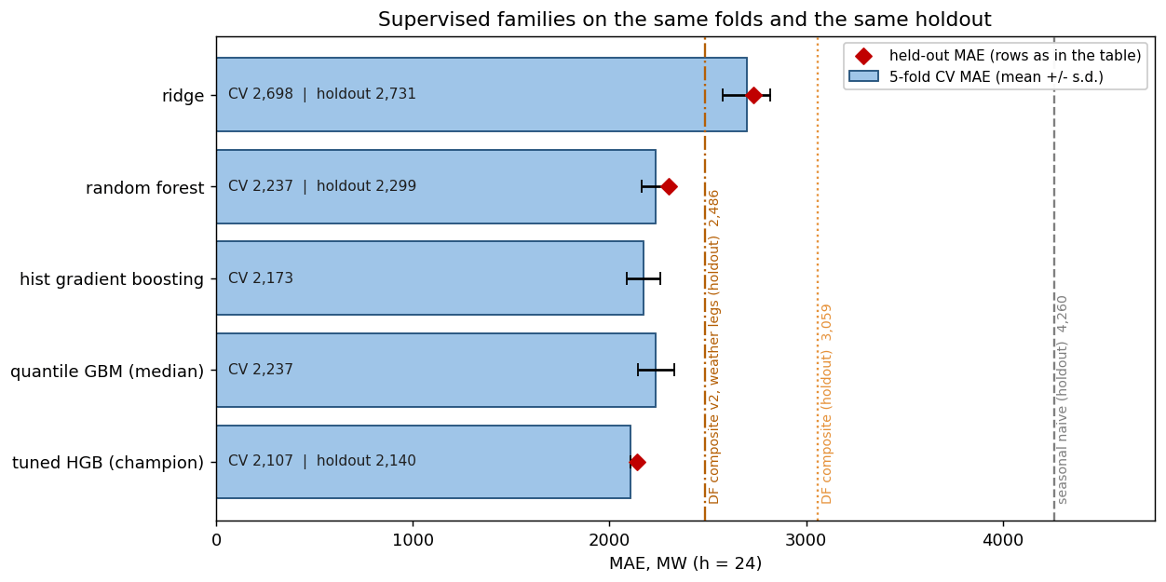
Figure 9. Supervised results: bars are five-fold cross-validated MAE with the fold SD as the error bar, diamonds are the sealed holdout, vertical lines are the three baselines scored on the holdout only. What to observe: the gap between the linear family and the trees is the size of the non-linearity in the problem; the two ensembles are within a fold SD of each other on CV, which is why paired holdout tests were run. Source: notebook 08 §8.4 (08_supervised_summary.png).
Figure 9 is the supervised result in one picture. Under identical pipeline, folds and gap, cross-validated MAE at h=24 falls from ridge 2,697.9 ± 120.4 MW to random forest 2,237.1 ± 73.7 and histogram gradient boosting 2,173.2 ± 85.5: the large step is linear to non-linear, not forest to booster, and the forest takes 17 times the booster's fit time for the worse score. Tuning takes boosting to 2,107.3 MW. Feature choices matter far more than settings: the selector's k spans 823.3 MW of error, while l2_regularization spans 5.2 MW, inside the noise floor. The learning curve has flattened (the last step of added history is worth 4 MW), so more of the same history will not help much; better inputs will. The h=24 champion uses 57 features.

5.2 The held-out result by horizon
The champion's cross-validated 2,107.3 MW becomes 2,159.6 MW on the sealed holdout, an optimism of +2.5% that says the tuning did not eat the holdout. On the 46,123 common rows the model scores 2,139.7 MW: skill 49.8% against seasonal naive (G1 met, target 25%), 30.1% against the EIA composite (G2 met) and 13.9% against composite v2 (G2′ met). Issued once a day at 10:00 D−1, as the EIA's forecast is, it keeps margins of 24.9% and 7.6% over the two composites. Table 3 and Figure 10 give all four horizons: 84% of the degradation from h=1 to h=72 happens in the first step, because once the recent lags are gone what remains is diurnal and weekly structure. Because the holdout holds no January, the champion was also refit at four rolling origins and scored on the following quarter: the winter quarter is hardest in megawatts (2,400.8 MW) but not in skill (51.7% against naive).
Horizon | Champion MAE, all rows | Champion MAE, common rows | Skill vs seasonal naive | Skill vs composite v2 | Fair comparison?
h = 1 | 547.1 MW | 546.0 MW | 87.2% | 78.0% | no: benchmark is day-ahead; vs persistence (1,211.9 MW) skill is 54.9%
h = 24 | 2,159.6 MW | 2,139.7 MW | 49.8% | 13.9% | yes: information sets match
h = 48 | 2,389.7 MW | 2,370.8 MW | 44.3% | 6.3% | lower bound: composite keeps its day-ahead demand leg
h = 72 | 2,470.8 MW | 2,457.7 MW | 42.3% | 3.7% | lower bound
Table 3. Held-out error at four horizons, each with its own re-tuned champion and lag set. Steps between horizons are +1,612.5, +230.1 and +81.1 MW, so P1 holds. Composite v2 is rebuilt at a horizon-matched persistence lag (2,485.9 / 2,530.1 / 2,550.8 MW at 24/48/72 h). Source: notebook 04 §4.9, §4.9b; notebook 08 §8.4c.
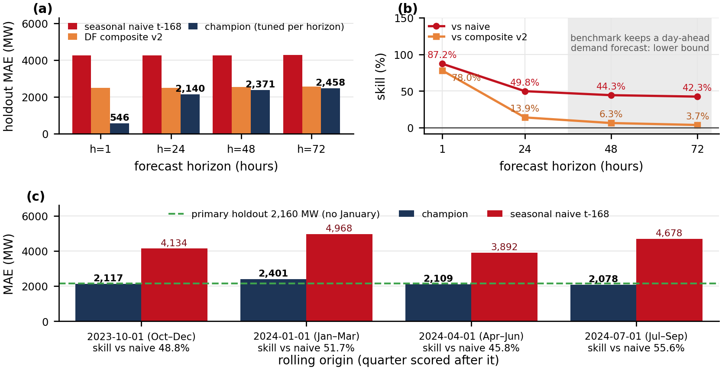
Figure 10. (a) Held-out MAE of the champion at each horizon beside composite v2 (rebuilt per horizon) and seasonal naive on the same rows, and (b) skill against each: skill against the composite narrows from 13.9% to 3.7% beyond a day. (c) The champion refit at four rolling origins and scored on the following quarter, so that a January is evaluated somewhere. Source: notebook 04 §4.9b and §4.15b (04_skill_by_horizon.png; 04_rolling_origins.png).

5.3 Is the ranking real, and does it hold per region?
Paired tests on 1,974 zone-day blocks confirm the ranking: the champion beats ridge by 583.2 MW, the random forest by 138.0 MW (block-bootstrap 95% interval [95.4, 179.3]) and the EIA composite by 923.1 MW, and all ten pairwise tests survive Benjamini–Hochberg at α = 0.05. Against composite v2 the margin is 346 MW [290, 402]. With 46,000 scored hours significance is nearly automatic; the number to argue from is the interval, 95 to 179 MW over the forest.
Table 4 and Figure 11 judge the goals region by region. G1 and G2 are met everywhere. Against the strengthened composite the champion wins in five regions; in New York the composite's 641.1 MW beats the model's 709.7, but the paired interval for that gap, [−60.7, +164.5] MW, contains zero. This is the section's central finding: the model's advantage appears to come from forecasting the renewable term. California, where solar is half of midday demand, gains a third of its error (1,454.4 against 2,121.5 MW); New York, where net load is demand, gains nothing. The Plains carry the highest scaled error (14.6% of mean load), yet the model beats every benchmark there, so the difficulty sits in the wind corridor itself.
Region | Champion MAE (common rows) | Skill vs naive (G1 ≥ 25%) | Skill vs EIA composite (G2 > 0) | Skill vs composite v2 (G2′ > 0) | MAE as share of mean net load
CISO | 1,454.4 MW | 47% | +30% | +31% (v2: 2,121.5 MW) | 8.1%
ERCO | 3,777.0 MW | 49% | +27% | +12% (v2: 4,289.9 MW) | 10.9%
MISO | 3,379.5 MW | 55% | +36% | +15% (v2: 3,980.7 MW) | 5.8%
SWPP | 2,938.5 MW | 44% | +32% | +9% (v2: 3,236.7 MW) | 14.6%
BPAT | 586.3 MW | 36% | +19% | +11% (v2: 656.6 MW) | 10.2%
NYIS | 709.7 MW | 58% | +7% | −11% (v2: 641.1 MW; paired gap [−60.7, +164.5]) | 4.3%
Table 4. The champion against every benchmark per region on the rows every benchmark can reach. The last column divides the MAE over all of the region's holdout rows by its mean net load. Source: notebook 04 §4.8; notebook 08 §8.4b (continued), §8.16.
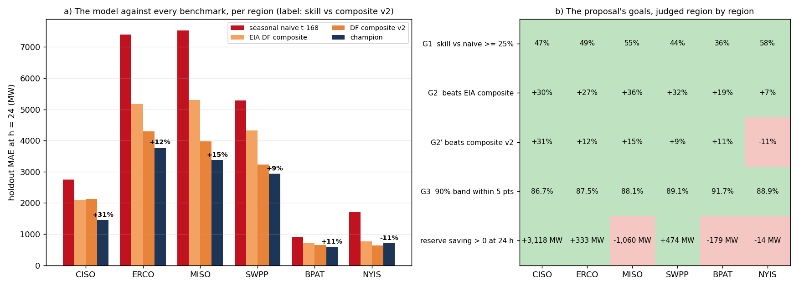
Figure 11. (a) Day-ahead holdout MAE per region for seasonal naive, the EIA composite, composite v2 and the champion, labelled with the champion's skill over composite v2. (b) The goals of Table 1 judged region by region, green met and red missed; the bottom row is the h=24 reserve saving of notebook 08 §8.6b. What to observe: the margin over the strengthened composite is largest where solar is largest and vanishes where net load is demand. Source: notebook 08 §8.16 (region_results.png).

5.4 The five registered predictions
P1 holds: MAE is monotone in the horizon and the first step (+1,612.5 MW) is seven times the next. P2 fails, in reverse: in permutation importance the weekly lag leads the daily anchor at h=24 (258.2 against 251.5 MW), not at h=72 (275.7 against 289.9). P3 fails, informatively: evening hours are worse than the rest of the day, but the single worst hour is 16:00, the hour before the predicted window (Section 6.2). P4 holds: scaled error is highest in the Plains (14.6%) and lowest in New York (4.3%). P5 holds: the weather family's share of importance rises with the horizon (Section 6.1). The two that failed are the stronger evidence that the predictions were made in advance.

6. Interpretation and error analysis

6.1 What the model leans on, and how it uses its inputs
Permutation importance shuffles one column on the holdout and measures the added error. Against a baseline of 2,159.6 MW, shuffling net_load_lag24 costs 8,983.2 MW and demand_lag24 3,597.6; then a cliff to zone_is_MISO 798.3. For a non-specialist, this is a persistence model with corrections: the best predictor of net load tomorrow at 18:00 is net load today at 18:00, and weather and calendar refine it. Ablation answers a different question: removing a family and refitting costs +698.1 MW for weather but only +66.0 MW for the target lags, because refitting leaves near-substitutes standing (demand correlates at about 0.96 with net load). Permutation measures what this fitted model leans on; ablation measures what the model could not do without, and weather is the family nothing else can reconstruct. The weather family's share of permutation importance rises from 0.9% at h=1 to 10.3% at h=72 as the lag family's falls from 93.9 to 39.9%, the direct test of P5.
SHAP attributions [8] agree closely with permutation (Spearman +0.95): net_load_lag24 averages 8,857.8 MW, demand_lag24 4,791.5 and wind_speed_100m 1,004.2, and the beeswarm (Figure 12b) shows direction as well as size: high yesterday-net-load pushes the forecast up, high hub-height wind pushes it down. Partial-dependence and accumulated-local-effects [9] curves for temperature recover the U, with net load rising in both directions from about 16 °C.
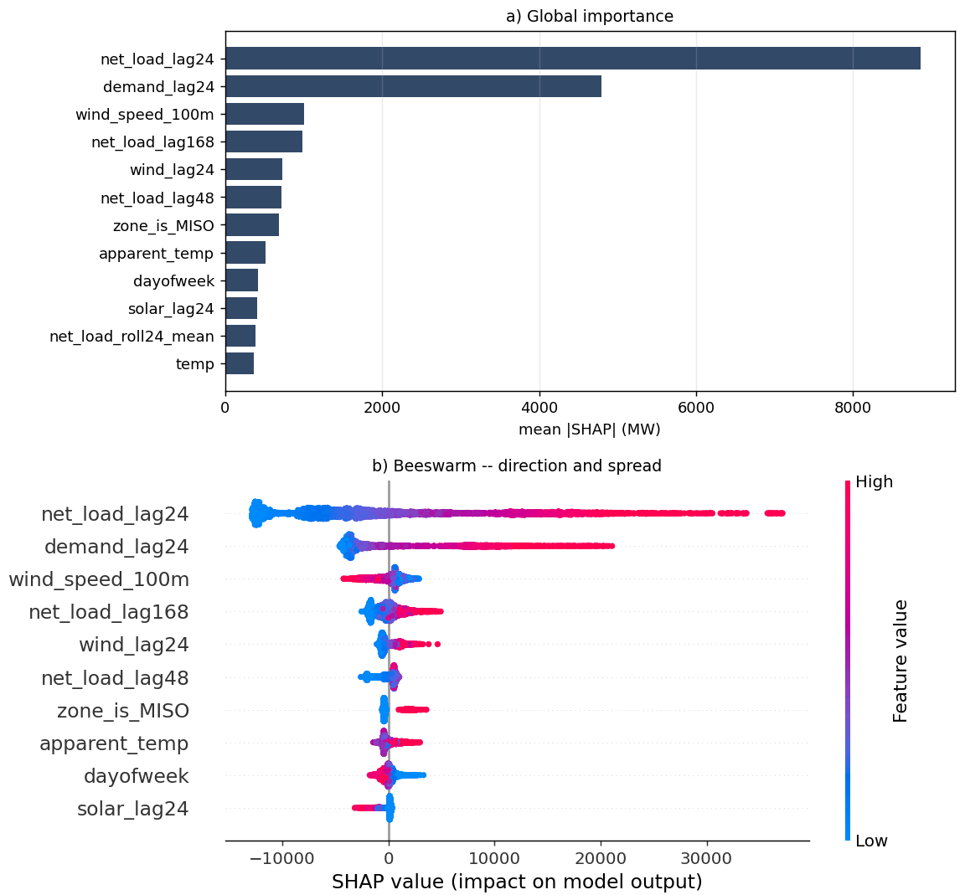
Figure 12. How the model uses its inputs: SHAP on 3,000 held-out hours, (a) mean |SHAP| by feature and (b) the beeswarm, each dot one hour, colour the feature's value. What to observe: the two most important inputs are yesterday's net load and demand. Source: notebook 07 §7.4 (07_shap.png panels a–b).

6.2 Where the forecast fails, in three classes
Failure analysis was done as the course asks: specific examples, categorised, with a fix for each (Figure 13). Large errors concentrate in the afternoon: the worst decile (|error| ≥ 5,441 MW) over-represents 14:00–17:00, peaking at 16:00 (1.24×), when solar is falling in the solar regions and afternoon heat is near its peak. Which region fails most depends on whether size is removed: an absolute cut ranks Texas first, a scaled cut the Plains.
Operational: the imputed-lag failure. The worst hour in the project is MISO on 2024-07-03 at 01:00 UTC, a miss of 57,477 MW (Figure 13). Cleaning had found a 24-hour gap in MISO's demand from 2024-07-01 06:00, so the lags on 2024-07-03 looked up history inside that hole and received imputed values; the SHAP waterfall shows the two fabricated inputs contributing −7,443.5 MW. The class is identifiable from the inputs alone: 233 holdout rows (0.49%) are missing at least one lag, with MAE 7,561.9 MW against 2,132.8 MW on clean rows. Abstaining on them keeps 99.51% of hours and lowers MAE to 2,132.8 MW, the cheapest improvement in the project. Systematic: the afternoon ramp. Afternoon MAE exceeds overnight MAE by 458–481 MW per hour, depending on how the two windows are drawn; a solar-ramp feature family that recovered a third of it would be worth about 40–51 MW, the same order as the whole tuning search. Edge case: the wind corridor. The Plains' 14.6% scaled error is shared by every benchmark and traces to one weather point for turbines that span several states.
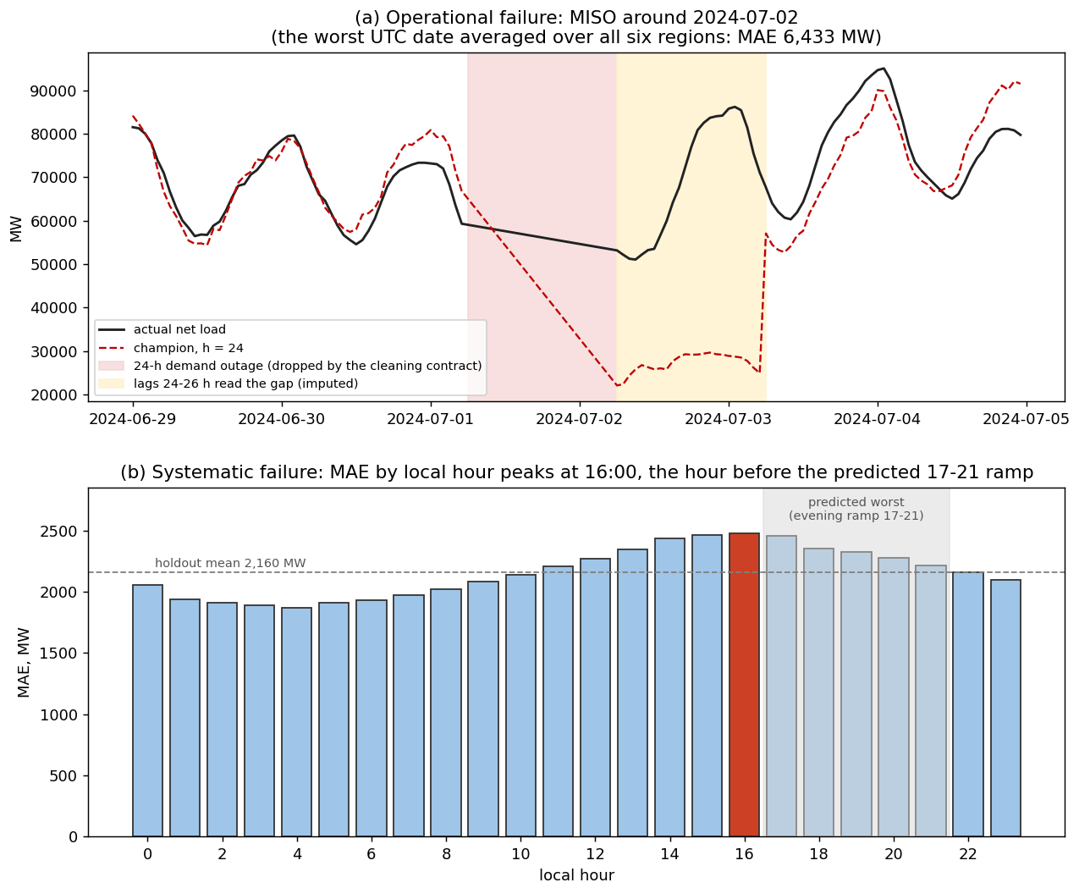
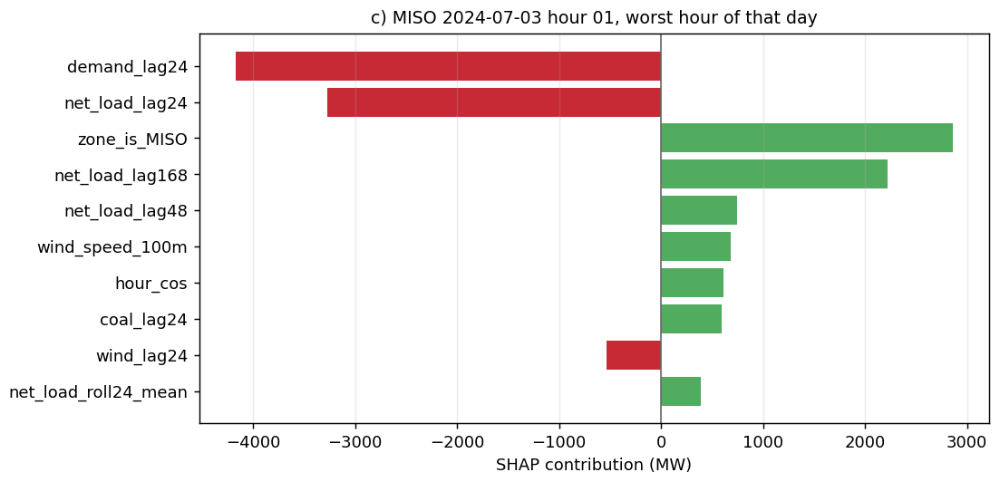
Figure 13. Three failures, three classes. Top: (a) a held-out week in MISO in which the forecast tracks the actual until the lags begin reading from the reporting outage, then misses by up to 57,477 MW; (b) held-out MAE by local hour, rising through the afternoon to a peak at 16:00. Bottom: the SHAP waterfall for the worst hour, in which the two imputed lag inputs contribute −7,443.5 MW. Source: notebook 08 §8.4h; notebook 07 §7.4 (08_failure_cases.png panels a–b; 07_shap.png panel c).

6.3 A companion classifier: curtailment-risk hours
A classification arm flags hours at risk of curtailment, defined by a proxy: renewable share above its zone's 85th percentile and net load below its zone's 15th percentile, a base rate of 15.85%. The classifier reaches PR-AUC 0.772, a 4.9× lift over the base rate (ROC-AUC 0.936); accuracy of 0.905 is the trap, since a model that never predicts curtailment scores 0.841. F1 is 0.674 at a threshold of 0.258 found on the holdout, and therefore optimistic. No feature restates the same-hour label; only lagged copies of its inputs reach the model.

7. Uncertainty, robustness and reliability

7.1 Which interval sizes reserve
Two intervals are routinely confused. The 90% confidence interval for the mean holdout error of the median forecast is [−375.1, −191.8] MW on 1,974 zone-day blocks; the 90% prediction interval for the next hour's error is [−5,893.5, +5,000.2] MW, 59 times wider. The first is epistemic and shrinks with data; the second is aleatoric, would not shrink with ten more years of history, and is what reserve is held against. Sizing reserve from the confidence interval would say no reserve is needed at all, because its upper edge is negative.

7.2 Three defects, three named fixes, and what each is worth
The raw quantile model's quantiles crossed on 10.034% of rows, which monotone rearrangement removed; its nominal 90% band under-covered at 80.4%; and its median was biased: 54.1% of outcomes fell below it. Figure 14 scores nine constructions. Every calibrated arm lands inside the ±5-point tolerance at 88.4–88.9% coverage, so the choice is made on width and Winkler score: split conformal is widest and worst (10,594.5 MW, Winkler 15,750.6), and the shipped Mondrian CQR additive scores 8,709.5 MW / 11,545.4. Methods scored on the same hours move together, so every comparison is paired. The G3 scorecard at h=24: coverage met (88.7%), crossings met (10.0% → 0), median missed (0.538 against 0.500 ± 0.010), because California's bias changed sign between the calibration block and the holdout, which is drift.

7.3 Conditioning on region: the result that matters more than the calibration
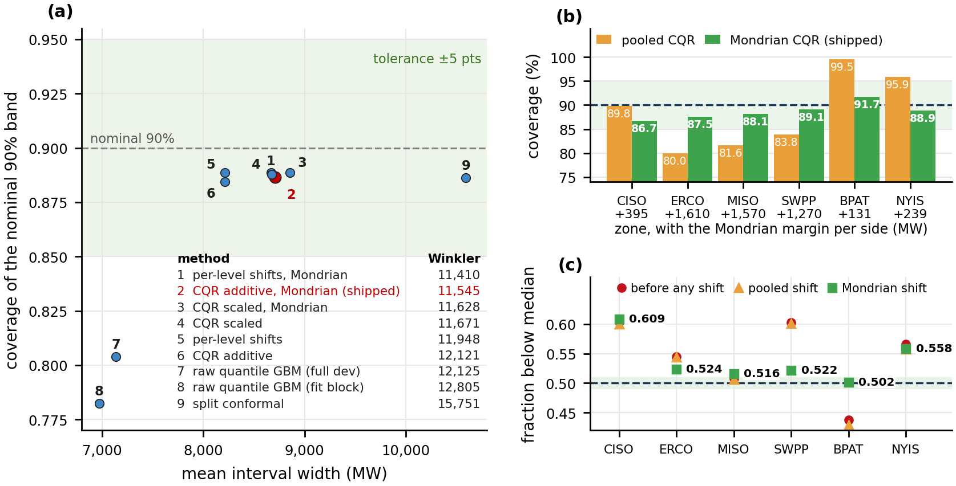
Figure 14. (a) Coverage against mean width for every interval construction, with the nominal 90% dashed and the ±5-point tolerance shaded: the raw band under-covers, every calibrated band reaches the tolerance. (b) 90% coverage per zone, pooled against Mondrian; (c) the fraction of outcomes below the median per zone before and after the shifts, against the 0.500 ± 0.010 band. What to observe: conditioning on zone collapses the coverage spread from 19.6 to 5.0 points, but California's median moves away from 0.5. Source: notebook 08 §8.6; notebook 06 §6.2c (08_coverage_vs_width.png; 06_mondrian_by_zone.png).
Marginal coverage is easy; conditional coverage is the work. The pooled band's 88.4% was an average right for no zone (Figure 14b): 99.5% in Bonneville but 80.0% in Texas, a 19.6-point spread. Conditioning the conformal margin on zone collapses it to 5.0 points, every zone inside the gate. The per-zone margins run from +130.6 MW for Bonneville to +1,610.4 MW for Texas against the single pooled +619.1, and Winkler improved from 12,121 to 11,545 because the width went where the misses were. The median is the most informative failure: Mondrian fixed the zones whose bias was cross-sectional (Bonneville exact at 0.502) and made California worse, 0.604 → 0.609, because California's bias is temporal: the shift fitted on the calibration block said its median was too low, while the holdout says it is too high. That sign reversal is the solar-fleet growth of Figure 3 showing up in the interval. The named fix, a rolling calibration window per zone [5], was not run.

7.4 By horizon and by regime
A band fitted, calibrated and scored at every horizon on that horizon's own champion reaches Mondrian coverage 85.9% at h=1, 88.8% at h=24, 89.4% at h=48 and 89.7% at h=72, so the conformal correction transfers across lead time. h=1 is not helped (California 80.8%): the band is narrow there, so the California drift is a larger relative miss, and exchangeability between calibration and prediction blocks is the assumption a year of solar build-out breaks first. By regime the shipped band covers 90.8% of winter-shaped days, 90.0% of conventional days, 85.6% of duck days and 84.7% of duck-day evening hours (16:00–21:00): the regime the project exists for is the one the band protects least, which Section 7.6 acts on.

7.5 With the weather as it was actually forecast
Every result above hands the model perfect weather foresight. Re-scoring the holdout on the weather forecast as issued at each lead, swapping only same-hour weather columns, shows essentially no penalty at h=24 (−10.1 MW, where the issued forecast scored slightly better than reanalysis), +1.9 MW at h=48 and +37.0 MW (+1.50%) at h=72; Gaussian noise at published forecast-error magnitudes changes almost nothing either. What widens the band is losing the recent lags, not weather error.

7.6 What the distribution is for: reserve placed where the risk is
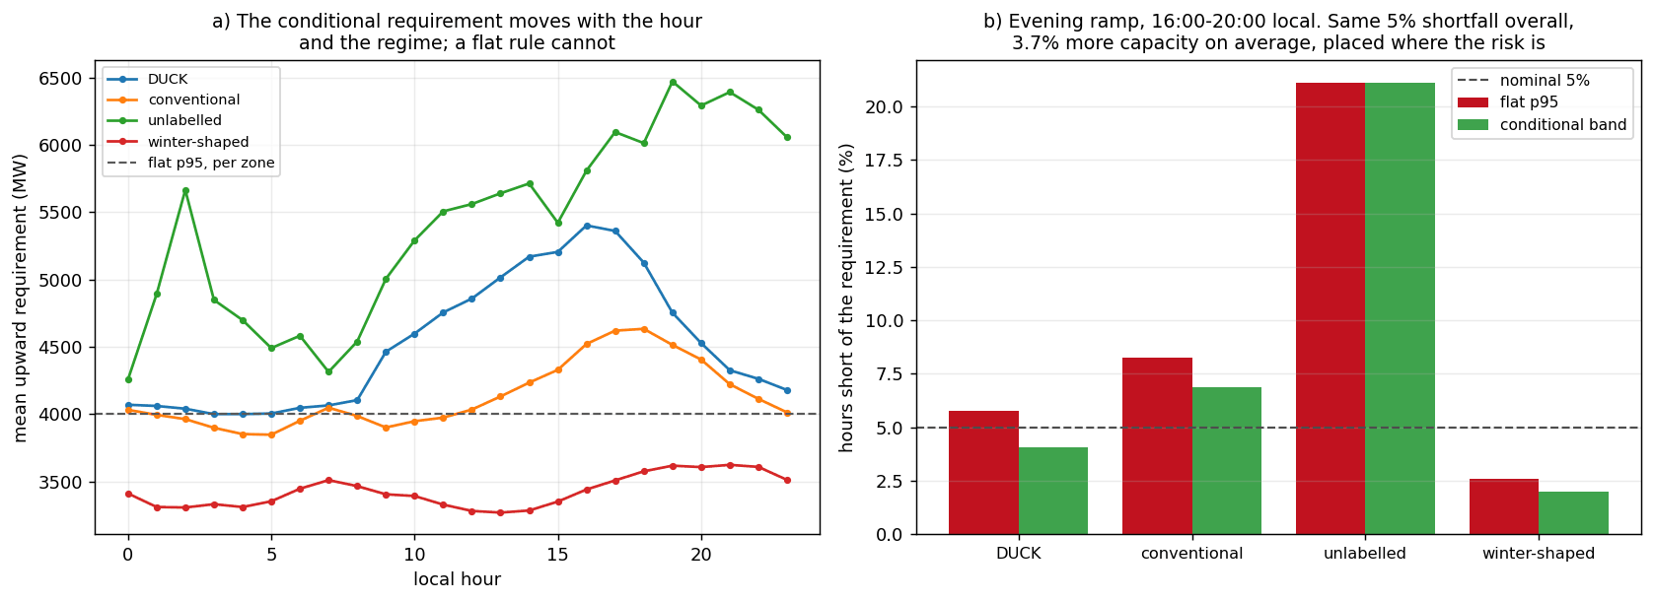
Figure 15. The conditional band against a flat quantile at equal risk. (a) Mean upward reserve requirement by local hour, one line per regime, against the flat per-zone 95th percentile (dashed). (b) Share of evening-ramp hours (16:00–20:00) each rule leaves short, by regime, against the nominal 5%. What to observe: the conditional rule holds 880 MW (3.7%) more capacity and cuts the duck-evening shortfall from 5.8% to 4.1%. Source: notebook 08 §8.6c (08_conditional_reserve.png).
The calibrated conditional band can be turned into a reserve rule and compared, at equal average risk, with the flat per-zone 95th-percentile rule an operator would use by default (Figure 15). Across the six zones the conditional band asks for 880 MW (3.7%) more. Both rules are set on the same holdout hours they are scored on, so this compares where reserve is placed at equal risk, not how either rule would do in a new year. What it buys is capacity in the right hours: across the evening ramp (16:00–20:00 local) the flat rule is short 8.3% of the time on conventional days and 5.8% on duck days against its nominal 5%, the conditional band 6.9% and 4.1%, at the price of more misses overnight on duck days. Conditioning does not make reserve cheaper; it makes it better placed, and the regime label that barely helped the point forecast is what makes the placement possible. No monetary value is claimed: across reserve-price scenarios and scoring conventions the annual value spans −31.6 to +40.6 million dollars, its sign depending on the convention.

8. Causal inference: does more solar cause steeper ramps?
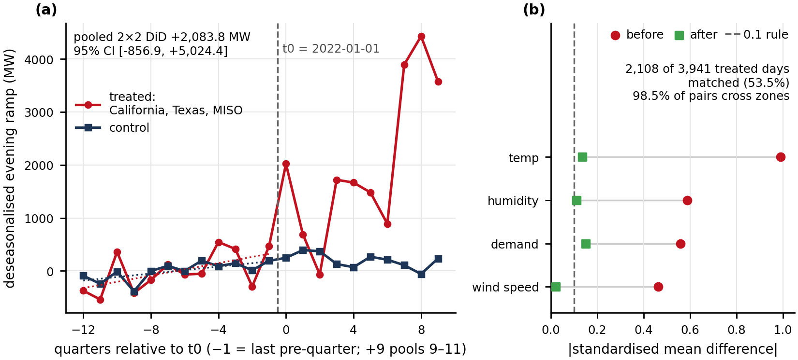
Figure 16. Two causal designs, no claim. (a) Difference-in-differences event study, quarterly treated-minus-control evening ramp before and after 2022-01-01. (b) Covariate balance before and after propensity matching; three of four covariates remain marginally above the 0.1 convention and 98.5% of pairs cross zones. What to observe: the designs point the same way and cannot identify the size. Source: notebook 03 §3.4–3.5 (03_did.png panel a; 03_matching.png panel a).
The question is natural and three designs asked it; the answer is that the data cannot settle it. A directed acyclic graph with demand growth, zone characteristics, weather and solar share gives 56 back-door paths from solar share to the evening ramp, 48 of them opened by conditioning on same-hour demand, a collider; the admissible observed set is {demand, humidity, temperature, wind speed}. The naive pooled slope is +582.1 MW of evening ramp per percentage point of solar share. Difference-in-differences (Figure 16a), treating California, Texas and MISO against Bonneville, New York and the Plains at a 2022-01-01 cut-off, passes its pre-trend screen and estimates +2,083.8 MW with a 95% interval of [−856.9, +5,024.4] that contains zero, because the design learns from six groups. Propensity matching of high-solar to low-solar days (Figure 16b) gives +7,180.3 MW with a Rosenbaum Γ [17] of 18.40, but 98.5% of matched pairs are cross-zone, so the obvious hidden confounder is which zone a day belongs to. The designs agree on direction, disagree by a factor of three on size and none identifies it, so the report records a claim withheld rather than a claim made.

9. Discussion, limitations and conclusions

9.1 Conclusions
Q1: yes, and the advantage is in the renewable term. Net load can be forecast a day ahead from public data better than the EIA's own forecast lifted to net load and better than a harder composite built so that the result could not rest on a weak rival; the margin is largest where solar is largest, absent in New York, and it is a day-ahead margin. Q2: a band that holds per region, with a named failure. Conditioning the conformal band on zone is what makes it reliable for every grid; the remaining misses come from the test year drifting away from the calibration year in a way conditioning on zone cannot see. Lead time, not weather error, widens the band. Q3: a stable partition whose usefulness is specific. The regimes reproduce and their temperature signature is physical, but the duck is California and the label barely helps the point forecast; the regimes earn their place in the uncertainty arm, where they turn a marginal band into a better-placed reserve rule.
How the two arms form one investigation. They share the panel, the pipeline, the folds and the gap, so the regime label was tested inside the forecaster's own cross-validation; the failure analysis finds the error peaking at 16:00, where falling solar and peak heat coincide; and the uncertainty arm uses the regime as the conditioning variable of its reserve rule. The supervised arm produces the forecast, the unsupervised arm says what kind of day it is forecasting, and the interval connects both to a decision.
What surprised, and what went wrong. Mutual information would have deleted useful features; the lag family the model leans on most is nearly replaceable on refit while weather is not; and three defects were found by audit (the fuel columns, the rolling windows, the local-versus-UTC join of the regime labels), each measured before it was fixed. The method is as much the result as the numbers: goals and predictions registered before modelling, a holdout sealed before tuning, every comparison paired and blocked, and every number traced to a ledger.
Ethics and deployment. An under-forecast of the evening ramp is paid for by consumers through scarcity prices or load shedding, so the recommended operational object is the conditional band, not the point forecast, and abstaining on imputed inputs is an ethical choice as well as a technical one. New York gains nothing over the strengthened composite, so replacing its operator's own forecast there would not be an improvement, which per-region reporting makes visible.

9.2 Limitations and future work
Limitation | What it affects | What would address it
One weather point per balancing authority | Bonneville's hub-height wind correlation fell when the reading moved up; the Plains' 14.6% scaled error is shared by every benchmark | Three to four metro points per region, load-weighted; the decision log's first upgrade
ERA5 reanalysis as the weather input | Every result except Section 7.5 assumes perfect weather foresight; measured penalty 1.50% at h=72, ≈0 at h=24, for six of fifteen variables | Archived forecasts for all fifteen variables; a forecast-weather training arm
Holdout holds no January and is 2.16 °C warmer than the development block; Winter Storm Uri (Feb 2021) is in training only | Winter is evaluated only by rolling-origin refits (2,400.8 MW); no claim about extreme-weather skill is possible | A second test year with a January and an extreme episode
Calibration block and holdout differ (drift) | Median 0.538; California's bias changed sign; h=1 coverage 85.9% | Rolling or adaptive calibration per zone [5]; not run
New York's public data show no solar | Net load ≈ demand there; the strengthened composite built on the ISO's forecast is not beaten (paired gap includes zero) | Behind-the-meter PV estimates [13]
Pooled model, pooled importance | Pressure and snow depth cannot be read as mechanisms; 5-PC clustering choice is on a thin margin (0.9958 vs 0.9951) | Within-zone importance; report the 8-PC partition as a robustness check
Classifier threshold chosen on the holdout; coverage by hour of day not computed | The 0.674 operating point is optimistic; the trough escapes in notebook 06's fan chart are a visual reading | Threshold from development folds; per-hour coverage tables
Reserve prices are contingency products; no energy prices | Any dollar figure is an upper bound of uncertain sign; none is quoted | Market-specific flexible-ramp prices; a cost-asymmetry estimate
Table 5. Limitations, their consequences and the named remedy. Source: docs/decision_log.md; notebooks 01, 04, 05, 06, 08.
Table 5 lists the limitations that bound the results. Three further sources of uncertainty were not quantified: measurement error in EIA-930 itself, data latency and forecast revision cycles in deployment, and deep sequence models, rejected by argument rather than measured.
Future work follows the failure analysis in priority order: several weather points per region with a load-weighted mean, the one change that addresses the hardest region, the worst-covered zone and the published finding on station selection at once; a solar-ramp feature family from forecast irradiance, aimed at the 16:00 peak; a rolling calibration window per zone for the median and h=1 coverage failures; and a second test year with a January and, ideally, an extreme episode. None of these needs a different model: what would help is better inputs and a calibration that moves with the grid.

References
- U.S. Energy Information Administration. Hourly Electric Grid Monitor (EIA-930), EIA Open Data API v2. https://www.eia.gov/opendata/
- Open-Meteo. Historical Weather API (ERA5 reanalysis, ECMWF) and Previous Runs API. https://open-meteo.com/
- Romano, Y., Patterson, E. and Candès, E. (2019). Conformalized quantile regression. NeurIPS 32.
- Vovk, V. (2012). Conditional validity of inductive conformal predictors. ACML, PMLR 25.
- Gibbs, I. and Candès, E. (2021). Adaptive conformal inference under distribution shift. NeurIPS 34.
- Winkler, R. L. (1972). A decision-theoretic approach to interval estimation. JASA 67(337), 187–191.
- Diebold, F. X. and Mariano, R. S. (1995). Comparing predictive accuracy. J. Business & Economic Statistics 13(3), 253–263.
- Lundberg, S. M. and Lee, S.-I. (2017). A unified approach to interpreting model predictions. NeurIPS 30.
- Apley, D. W. and Zhu, J. (2020). Visualizing the effects of predictor variables in black box supervised learning models. JRSS-B 82(4), 1059–1086.
- Benjamini, Y. and Hochberg, Y. (1995). Controlling the false discovery rate. JRSS-B 57(1), 289–300.
- Hong, T., Pinson, P., Fan, S., Zareipour, H., Troccoli, A. and Hyndman, R. J. (2016). Probabilistic energy forecasting: GEFCom2014 and beyond. Int. J. Forecasting 32(3), 896–913.
- Kaur, A., Nonnenmacher, L. and Coimbra, C. F. M. (2016). Net load forecasting for high renewable energy penetration grids. Energy 114, 1073–1084.
- Wang, Y., Zhang, N., Chen, Q., Kirschen, D. S., Li, P. and Xia, Q. (2018). Data-driven probabilistic net load forecasting with high penetration of behind-the-meter PV. IEEE Trans. Power Systems 33(3), 3255–3264.
- Denholm, P., O'Connell, M., Brinkman, G. and Jorgenson, J. (2015). Overgeneration from Solar Energy in California: A Field Guide to the Duck Chart. NREL/TP-6A20-65023.
- Ruggles, T. H., Farnham, D. J., Tong, D. and Caldeira, K. (2020). Developing reliable hourly electricity demand data through screening and imputation. Scientific Data 7, 155.
- Hong, T., Wang, P. and White, L. (2015). Weather station selection for electric load forecasting. Int. J. Forecasting 31(2), 286–295.
- Rosenbaum, P. R. (2002). Observational Studies, 2nd ed. Springer.
- Ke, G. et al. (2017). LightGBM: a highly efficient gradient boosting decision tree. NeurIPS 30.
- Chernozhukov, V., Fernández-Val, I. and Galichon, A. (2010). Quantile and probability curves without crossing. Econometrica 78(3), 1093–1125.
- Hubert, L. and Arabie, P. (1985). Comparing partitions. J. Classification 2, 193–218.

Statement of work. Alan Mossinger, Eric Londo, Eran Abeysekera wrote the code and ran the analysis together: Eran focused on data acquisition and cleaning, the feature pipeline and its leakage audits, the causal analysis, while Eric focused on the supervised modeling, tuning and evaluation, and Alan focused on unsupervised modelling, uncertainty calibration and explainability. The team wrote the report and prepared the GitHub structure simultaneously and collectively.

