Grid Electricity: Net-Load Forecasting and Flexibility Planning for High-Renewable Grids
Day-ahead net-load forecasting, operating regimes and calibrated uncertainty for six US balancing authorities, 2019–2024
SIADS 696 — Milestone II Final Report · Master of Applied Data Science, University of Michigan School of Information
Authors: Alan Mossinger · Eric Londo · Eran Abeysekera Mentor: Erik Lang October 2026
Repository: alanmossinger/Electricity-Grid-Net-Load-Forecasting-and-Fexiblity-Planning-for-High-Renewable-Grids
Contents
Executive summary 1
1. Problem, questions and goals 2
2. Data and exploratory analysis 4
3. Methodology 7
4. Unsupervised learning: what kind of day is it? 11
5. Supervised learning: forecasting net load 13
6. Interpretation and error analysis 18
7. Uncertainty, robustness and reliability 22
8. Causal inference: does more solar cause steeper ramps? 25
9. Discussion, limitations and conclusions 26
References 28

Executive summary
Grid operators schedule power plants a day ahead against a forecast of demand. What they actually dispatch against is net load: demand minus wind minus solar, the part of consumption the controllable fleet must still supply. On a high-solar grid the two now diverge by half of the day's demand at lunchtime and converge again within hours, and the only public day-ahead forecast, published by the U.S. Energy Information Administration (EIA), is a forecast of demand alone. Across the six balancing authorities studied here, wind and solar rose from 16.6% to 26.2% of generation between 2019 and 2024, so the gap between what is forecast and what is dispatched is widening. This report asks three questions of six US grids over six years: (Q1) can net load be forecast a day ahead from public data alone, better than the best public alternative; (Q2) how wrong is that forecast, and can its uncertainty be stated honestly, region by region; (Q3) what recurring daily shapes does net load fall into, and do they help?
The answers come from a panel of 315,648 region-hours (315,485 after cleaning), split chronologically into a development block and a sealed holdout of 47,299 hours from 7 February 2024 that no model saw before its final scoring. A tuned histogram gradient-boosting model reaches a day-ahead mean absolute error (MAE) of 2,159.6 MW over the whole holdout and 2,139.7 MW on the 46,123 hours every benchmark can also reach: 49.8% better than the seasonal-naive forecast (same hour one week earlier), 30.1% better than a composite built on the EIA's own day-ahead demand forecast, and 13.9% better than a deliberately strengthened composite built so that the result could not rest on a weak rival. The ranking survives paired tests that respect the autocorrelation of hourly data, and the model wins in five of six regions, with New York a statistical tie. Around the point forecast, a conformal 90% prediction band conditioned on region covers 88.7% of holdout hours and lands within five points of nominal in every region, where a single pooled band had covered Bonneville at 99.5% and Texas at 80.0%. Clustering the shape of the daily curve yields three operating regimes (conventional, duck, winter-shaped) that reproduce under resampling with an adjusted Rand index of 0.996.
Three findings went against the project and are reported as such: the regime labels improve the point forecast by only 17.4 MW (under 1%); the duck regime's "sunnier" signature holds within only two of six regions, because 77% of duck days are California's; and the calibrated median sits at 0.538 rather than 0.500 because the holdout year drifted from the calibration year. The largest single error (a 57,477 MW miss in MISO) is a data failure, not a modelling one: the model's lag inputs were imputed across a reporting outage. Flagging such rows and abstaining lowers the headline MAE to 2,132.8 MW. The uncertainty arm is connected to a decision: a reserve rule built from the calibrated conditional distribution moves shortfall on duck-day evening ramps from 5.8% to 4.1% of hours at the same average risk, for 3.7% more capacity. No monetary value is claimed, because the computed dollar range spans zero. Figure 1 summarises the project on one page.
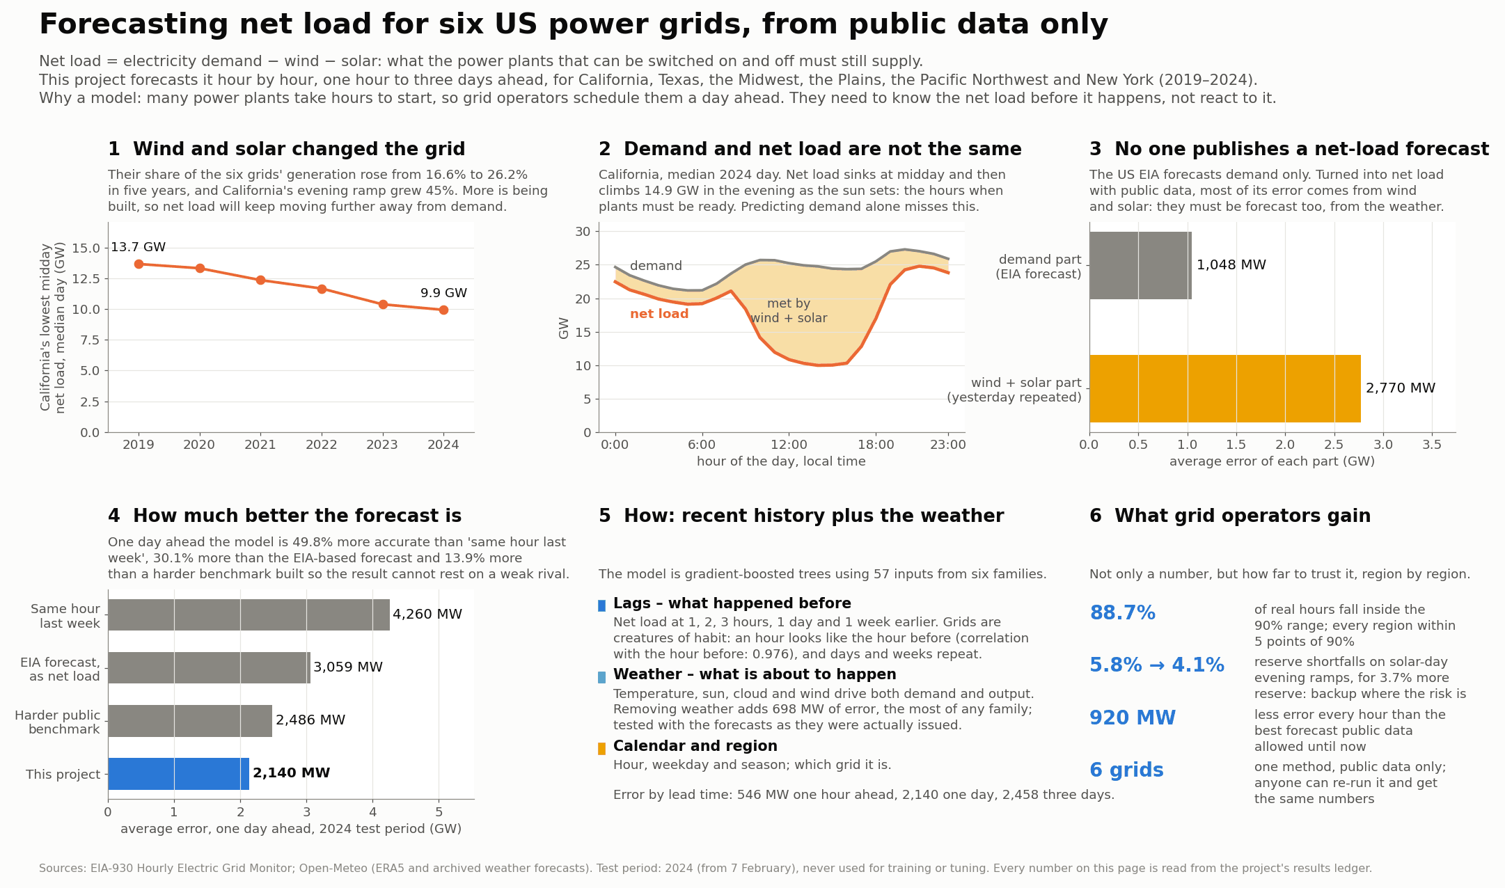
Figure 1. The project on one page. Panels 1–3 state the problem: wind and solar grew from 16.6% to 26.2% of the six grids' generation, California's lowest midday net load fell from 13.7 GW (2019) to 9.9 GW (2024), and the EIA forecast covers only the demand part of net load, so the wind-and-solar leg, filled with yesterday's values, carries 2,770 MW of error against 1,048 MW for the demand leg. Panels 4–6 state the answer: 2,140 MW day-ahead error against 4,260, 3,059 and 2,486 MW for the three benchmarks; the inputs the model uses; and a 90% band that covers 88.7% of real hours with every region within five points. Source: reports/overview/project_overview.png, drawn from the results ledger.

1. Problem, questions and goals
Every hour a grid operator must match generation to consumption exactly. For a grid without wind or solar the day-ahead problem is essentially solved: demand follows the clock, the calendar and the temperature. Wind and solar change the problem because they are generation the operator does not schedule; the plants it does control must meet only what is left, net load, and that remainder sets how many plants to commit the evening before and how much reserve to hold. Figure 2 shows what this does to a single day in California. Demand on the median 2024 day moves by only 6,140 MW between its 05:00 trough and 20:00 peak; net load on the same day swings 14,851 MW, from a belly of 9,947 MW at 14:00 to 24,798 MW at 21:00, 2.4 times the demand swing. The belly has deepened every year (13,687 MW at 12:00 in 2019) and the steepest three-hour evening ramp on a median day rose from 9,676 MW in 2019 to 14,036 MW in 2024 (+45%). Ramping capability, not energy, becomes the scarce product; commitment decisions are taken on a forecast, which is why this project forecasts at 1, 24, 48 and 72 hours; and the forecast error is what costs money, because reserve is sized from it. No model can flatten the duck curve; what a better forecast can do is make standing ready for it cheaper.
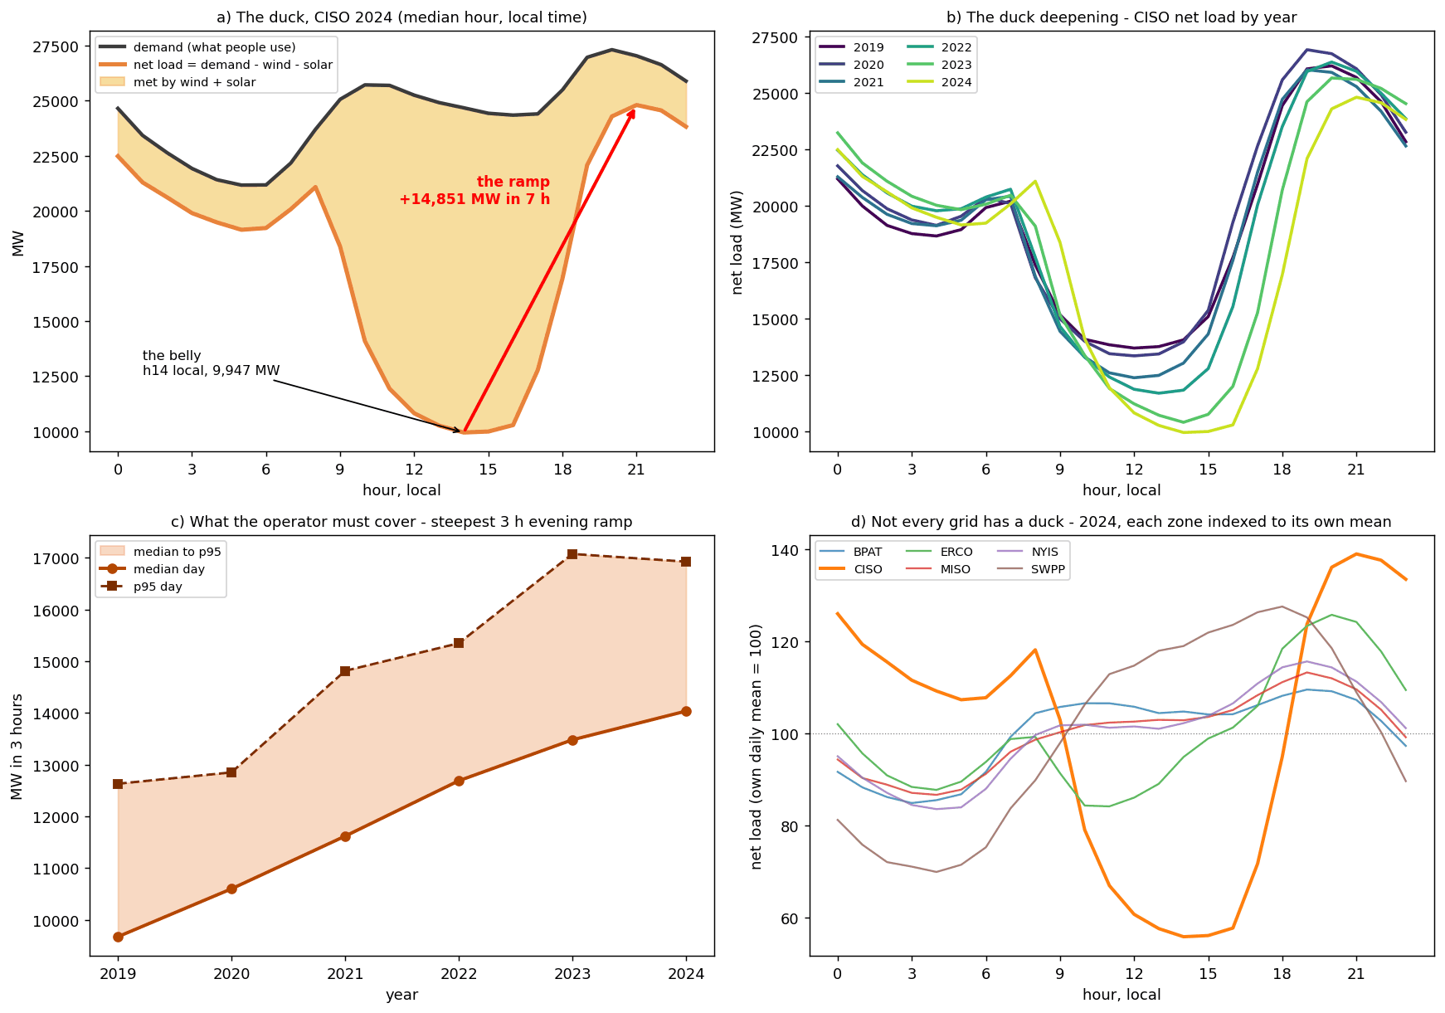
Figure 2. The duck curve is a measurement, not a metaphor. (a) California's median 2024 day in local time: demand (black), net load (orange) and the wedge wind and solar served; net load bottoms at 9,947 MW at 14:00 and climbs 14,851 MW by 21:00. (b) The same profile for each year 2019–2024: the belly deepens and moves later. (c) Each day's steepest three-hour evening ramp, median and 95th-percentile day per year: the median grows 45% in five years. (d) Every region's 2024 median profile divided by its own daily mean: only California (56% at 14:00) has a deep midday belly; the other grids trough overnight. What to observe: the slope between (a)'s belly and its evening peak is the operator's problem, and it is growing. Source: notebook 00 §0.6 (00_duck_curve.png).
Question | Goal | Target
Q1. Can net load be forecast a day ahead from public data, better than the best public alternative? | G1 beat seasonal naive; G2 beat the EIA composite; G2′ beat the strengthened composite (added later) | skill ≥ 25%; skill > 0; skill > 0
Q2. How wrong is the forecast, hour by hour and region by region? | G3 calibrated 90% intervals | coverage within ±5 points; median at 0.50 ± 0.01 (added later)
Q3. What recurring daily shapes does net load fall into, and do they matter downstream? | G4 stable operating regimes | ARI stability ≥ 0.6 under resampling
Application | G5 reserve-cost surface | reported in the notebooks only; no monetary claim here
Table 1. The three research questions and the goals set against them. Skill is 1 − MAE_{model}/MAE_{benchmark}, so a skill of 0.5 means half the benchmark's error. Source: notebook 04 §4.3, §4.8, §4.9b; notebook 06 §6.2; notebook 08 §8.12.
What the forecast has to beat. A forecast is only worth building if it beats what an operator already has, so every result is scored on the same held-out hours against three benchmarks, each harder than the last: seasonal naive, the same hour one week earlier (4,259.8 MW off); the EIA composite, the EIA's day-ahead demand forecast minus the previous day's wind and solar, the best an operator relying on public data could hold at a 24-hour origin (3,059.2 MW); and a strengthened composite v2 whose wind leg is replaced by a weather regression (2,485.9 MW). The EIA's own forecast is good on its own target (1,048.5 MW on demand, 60.5% better than naive demand); it is the renewables leg, 2,769.7 MW of error on its own, that it lacks. The project beats the public-data benchmarks, not the EIA's competence.
GEFCom2014 set the reference for probabilistic load forecasting of a single utility's demand on the pinball loss [11]; this project forecasts net load for six balancing authorities against an operator's published forecast and calibrates its quantiles per region with conformal prediction [3, 4]. Kaur et al. [12] found that forecasting net load directly beat forecasting load and solar separately; Denholm et al. [14] analyse the duck chart as California's problem, and Section 2 finds it in one grid of six; Ruggles et al. [15] impute EIA-930 gaps where this project abstains; Hong et al. [16] show weather-station choice moves accuracy, the basis for the first upgrade in Section 9.
Goals were fixed before any model ran and two were later made stricter (Table 1). Five predictions were also registered in notebook 01, before the supervised notebook existed: P1 MAE rises with the horizon and the largest step is h=1 → h=24; P2 the weekly lag overtakes the daily lag in importance as the horizon lengthens; P3 MAE is worst in the evening ramp hours (17:00–21:00 local); P4 scaled error is highest in the Plains and lowest in New York; P5 the weather family's share of importance rises with the horizon. Three held and two failed (Section 5.5).

2. Data and exploratory analysis

2.1 Sources, regions and cleaning
Three public sources were combined. EIA-930 [1] reports, per balancing authority and hour, metered demand, the operator-submitted day-ahead demand forecast, and generation by fuel: lagged demand is an input, the forecast is the benchmark, and demand minus wind minus solar defines the target (the identity holds to the megawatt in every row). ERA5 reanalysis from Open-Meteo [2] supplies fifteen hourly weather variables at one population-weighted point per region. Open-Meteo's archived forecasts supply six of those variables as they were forecast one to three days ahead over the holdout year, so the model can be scored with the weather an operator would actually have had (Section 7.5). The raw panel is 315,648 rows (6 zones × 52,608 hours) × 32 columns.
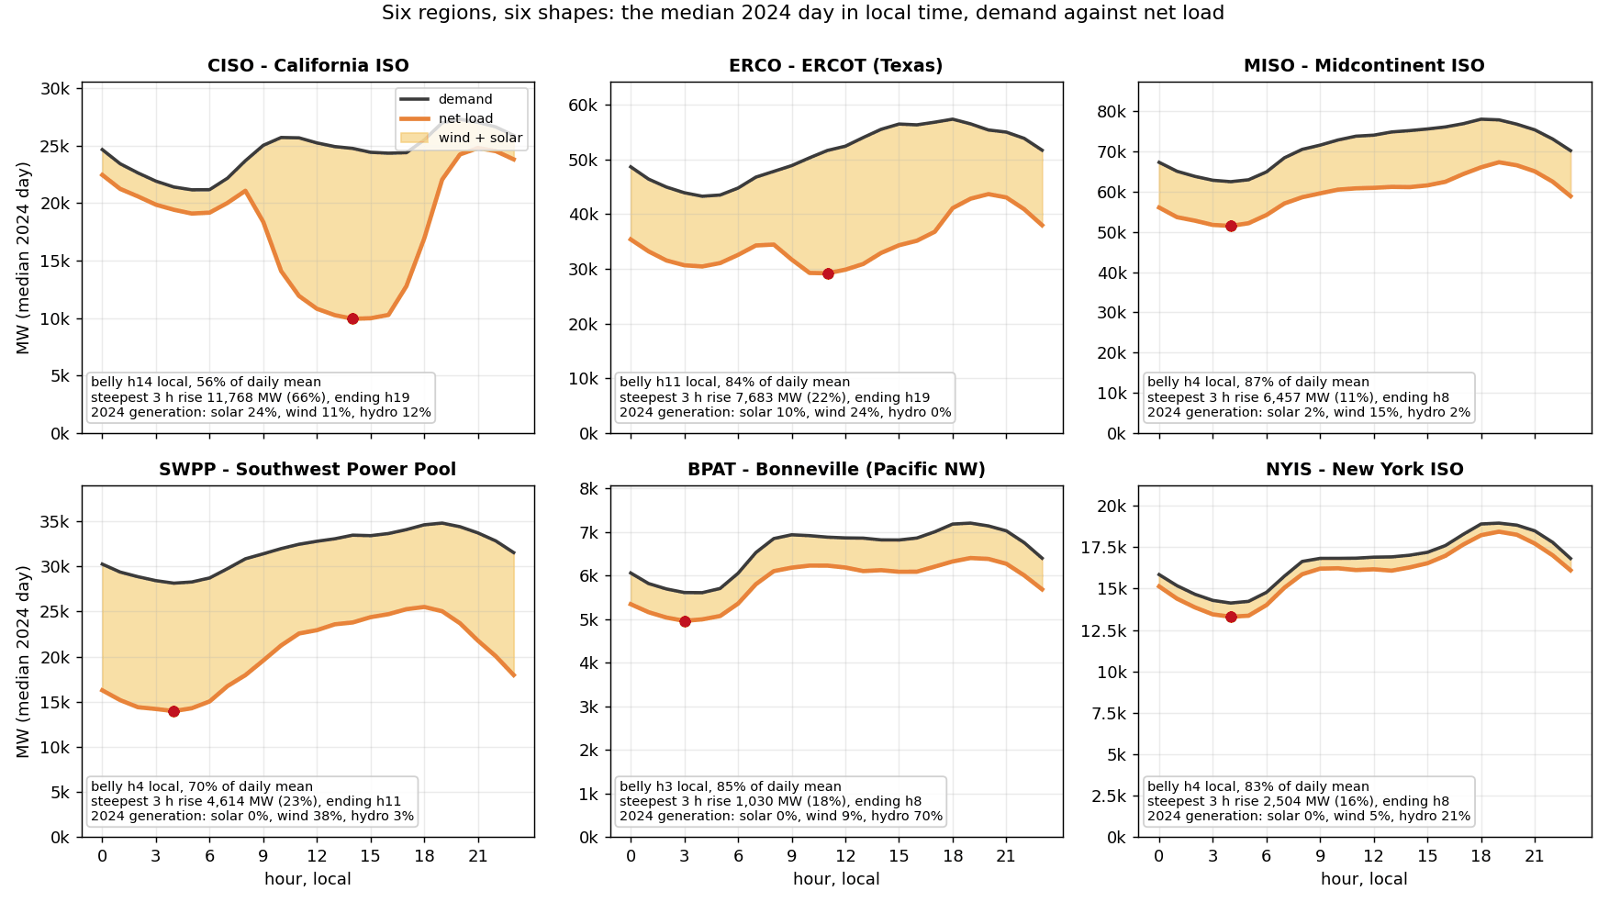
Figure 3. The median 2024 day in local time for each region: demand (grey), net load (orange), the wedge met by wind and solar, the belly marked in red, and each region's belly depth, steepest three-hour rise and 2024 generation mix. Axes differ by a factor of ten and are deliberately not shared. What to observe: only California (belly 14:00, 56% of the daily mean) has a solar belly, Texas has a dent at 11:00, and the other four have night-time bellies and morning ramps, which is why the "duck" regime of Section 4 turns out to be one grid. Source: scripts/region_chapter.py from notebook 08 §8.16 (11_region_ducks.png).
Six balancing authorities were chosen for contrast (Table 2, Figure 3): they differ by a factor of ten in size, nine in renewable share, and in the shape of the day itself. A belly in the afternoon is a solar belly and a belly at 03:00–04:00 a demand belly; only California has the former. Cleaning followed pre-registered checks: twelve impossible values were nulled (including a single Plains hour of 3,621,097 MW), 28,066 small negative solar readings were clipped to zero, gaps up to 3 hours were interpolated, and four 24-hour demand outages (one in MISO from 2024-07-01 06:00) plus 67 further rows were dropped, 163 rows in all (0.052%). Bonneville's missing coal and Texas's missing oil are structural (no such fleets) and were left as NaN. The holdout begins on 2024-02-07, so it holds no January, and it is 2.16 °C warmer than the development block; Section 5.3 addresses the missing winter with rolling-origin refits.
Region | Operator and footprint | Mean net load (holdout) | Wind + solar share 2019–24 | Belly (local hour, share of daily mean) | Why it is in the panel
CISO | California ISO | 17,973 MW | 31% | 14:00, 56% | the canonical duck
ERCO | ERCOT, Texas | 34,646 MW | 29% | 11:00, 84% | high wind, fast-rising solar
MISO | Midcontinent ISO, central US | 60,151 MW | 14% | 04:00, 87% | the largest system
SWPP | Southwest Power Pool, Great Plains | 20,014 MW | 35% | 04:00, 70% | the wind corridor
BPAT | Bonneville, Pacific Northwest | 5,765 MW | 8% | 03:00, 85% | hydro-dominated
NYIS | New York ISO | 16,407 MW | 4% | 04:00, 83% | low renewables, the control
Table 2. The six regions. Wind-and-solar shares in 2024 alone are CISO 33.9%, ERCO 35.1%, MISO 18.1%, SWPP 38.9%, BPAT 8.9%, NYIS 4.7%. Source: notebook 08 §8.16; notebook 01 Pass 7.

2.2 Four findings that shaped the models
The fleet is changing, unevenly (Figure 4a–b). Comparing the first and last twelve months, coal fell from 25.7% to 16.5% of the six grids' generation and wind plus solar rose from 16.6% to 26.2%; solar tripled from 1.7% to 6.0%. But the fleet average is the wrong unit: wind and solar went from 21.6% to 35.1% in Texas and 29.0% to 38.9% in the Plains, while New York (3.4% to 4.7%) and Bonneville (6.6% to 8.9%) barely moved. A pooled model is fitted mostly on grids where the hard problem is arriving fast and scored partly on grids where it never arrived, which is why every result is reported per region.
Where the lag sets come from (Figure 4c). The partial autocorrelation of net load has the same shape in every zone: lag 1 dominates (mean |PACF| 0.976), lag 2 is large and negative, a daily block sits at 23–26 hours (lag 24 mean 0.355), and after that almost nothing, including lag 168 (0.097). The weekly signal that dominates the ordinary ACF is inherited through shorter lags, so lag sets were chosen from the PACF by one rule at every horizon h: the three freshest observable hours, the next whole-day anchor, and lag 168, giving (1, 2, 3, 24, 168) at h=1 and (24, 25, 26, 48, 168) at h=24. The strongest admissible lag falls 0.976 → 0.355 → 0.120 → 0.097 as h goes 1 → 24 → 48 → 72, which is the expectation registered as P1. The augmented Dickey–Fuller and KPSS tests both reject in all six zones: no unit root, but not stationary around a constant either, because of the daily and annual cycles; the remedy is calendar features, not differencing.
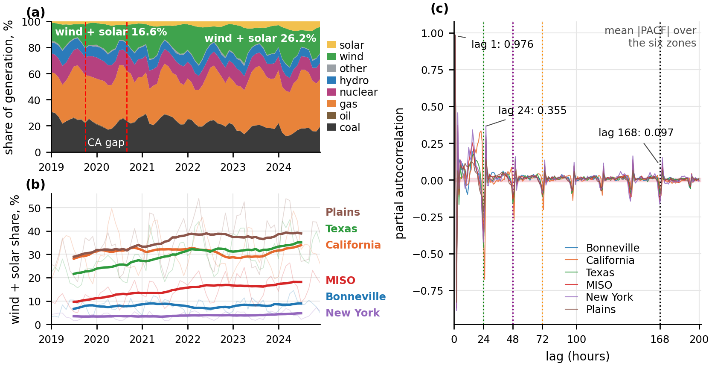
Figure 4. (a) The generation mix of the six grids, 2019–2024, as shares of generation; (b) wind and solar as a share of each region's own generation (12-month mean in bold); the trend is steep in Texas, the Plains and MISO and nearly flat in New York and Bonneville. (c) partial autocorrelation of hourly net load to lag 200, the six regions overlaid, with the widest white-noise band shaded and dotted lines at lags 24, 48, 72 and 168; what to observe is the collapse after the daily block, including at the weekly lag. Source: notebook 01 Pass 7 and Pass 5 (01_fuel_mix_over_time.png; 01_pacf.png).
Weather: a U-shape that correlation cannot see (Figure 5). Net load against temperature is a U in every zone: each has a comfort minimum and rises in both directions, so the per-zone Pearson correlations disagree violently (Bonneville −0.23, Texas +0.45) and pooled they cancel to −0.020. Panel (b) shows what that near-zero conceals: apparent_temp has the highest mutual information of any meteorological column (0.247) while its correlation is 0.003. Widening the weather set from four to fifteen columns paid off most through hub-height wind: the 100 m reading beats the 10 m reading in five of six zones (Texas +0.526 → +0.634), and the curve flattens near the rated speed, which is the turbine power curve appearing in the data. Only Bonneville gets worse, because its weather point is Portland and its turbines are in the Columbia Gorge: the cost of one weather point per region, measured.
Two cautions. Surface pressure's mutual information of 0.386 is a zone identifier (elevation), not a weather signal, and snow_depth is the same effect with a season attached; both stay in but are never quoted as mechanisms. And ERA5 is a reanalysis that assimilates observations unavailable at the forecast origin, so every result before Section 7.5 hands the model perfect weather foresight; the archived forecasts measure the gap (temperature off by 1.349, 1.952 and 2.091 °C at one, two and three days; cloud cover by 21.5 to 25.2 points).
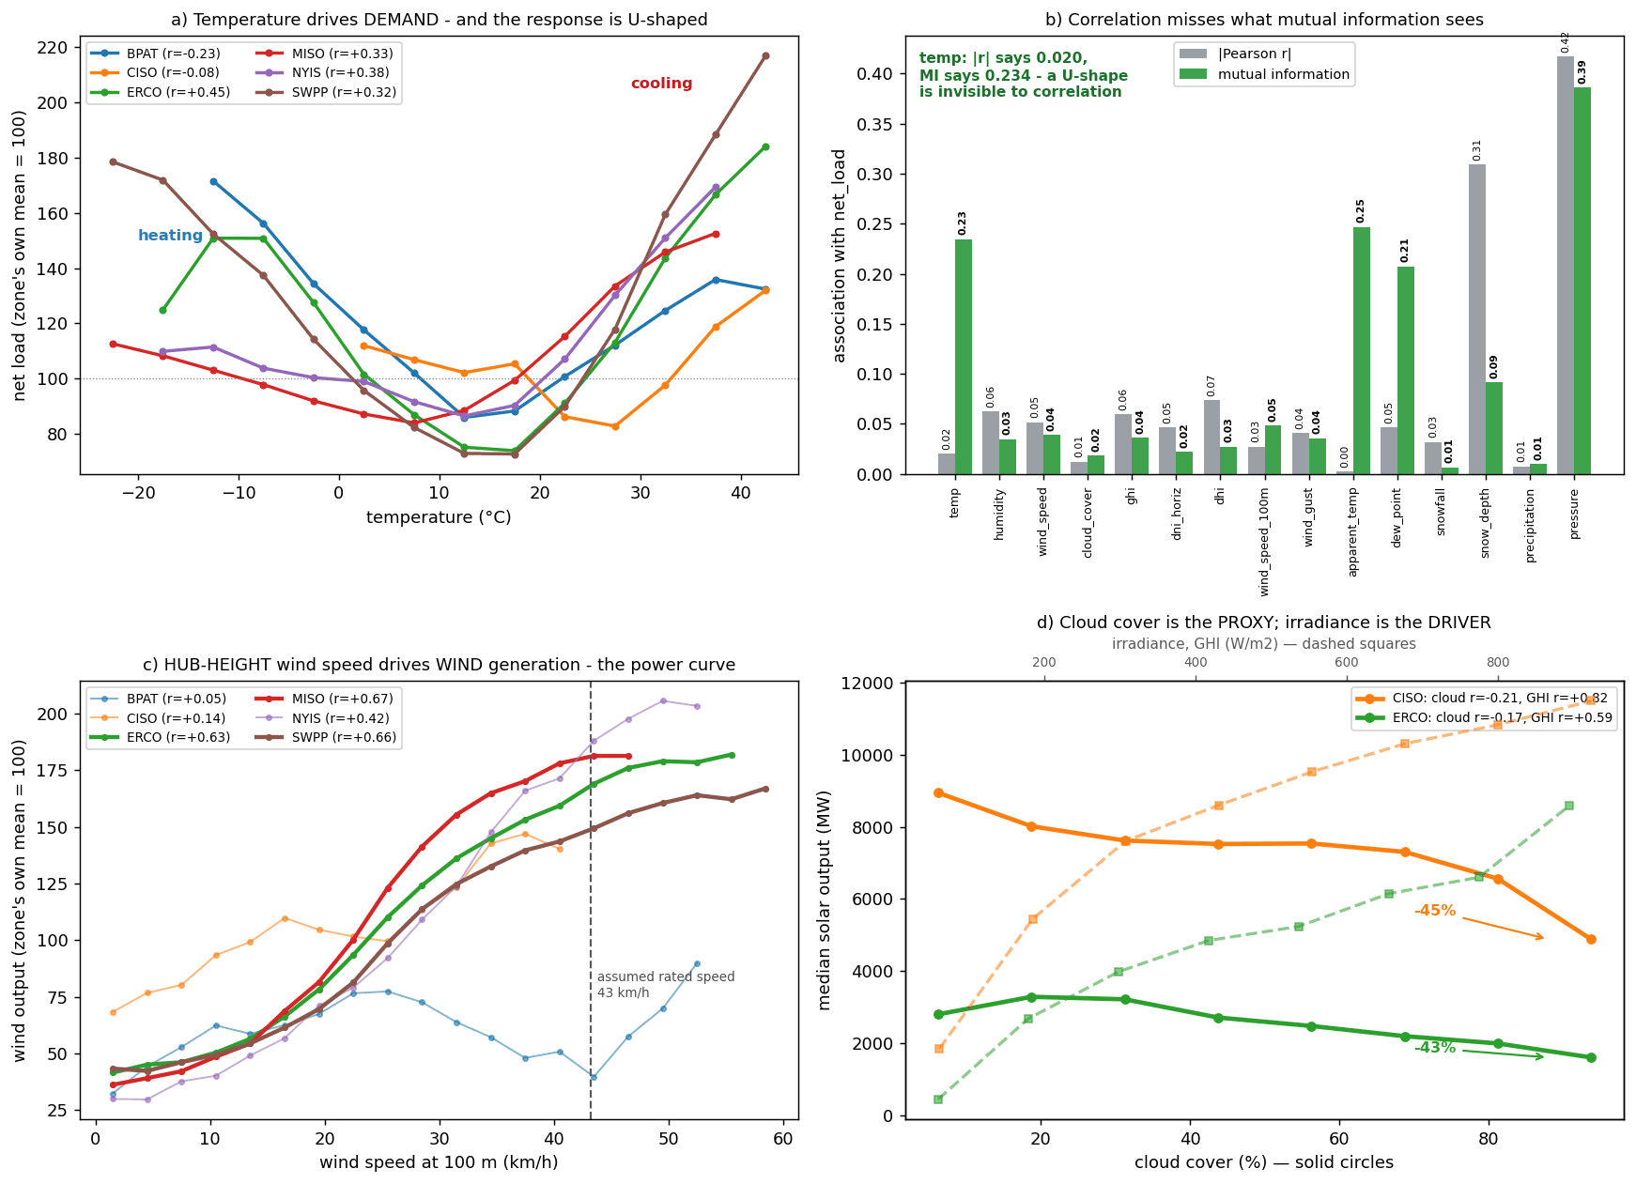
Figure 5. What the fifteen ERA5 columns carry. (a) Net load binned by temperature, each zone indexed to its own mean: a U everywhere, with opposite linear slopes in heating- and cooling-dominated systems. (b)|Pearson r|of each weather column with the target beside its mutual information: apparent_temp is near the bottom on correlation and near the top on information. (c) Wind output against hub-height wind speed: the power curve. (d) Median solar output against cloud cover and irradiance. What to observe: the physics is in the data, but only a non-linear, non-monotone learner can use it. Source: notebook 01 Pass 8 (01_era5_weather.png).

3. Methodology

3.1 One pipeline, two arms, one protocol
The supervised and unsupervised arms share everything up to and including the feature pipeline (Figure 6) and diverge only at notebooks 04 and 05; they are reunited in notebook 07, where a surrogate tree explains the clusters with the forecaster's inputs, and in the uncertainty arm, which conditions its reserve rule on the regimes. The comparison is fair because the protocol is shared: the same 315,485-row panel, the same five expanding chronological folds with a 191-hour gap at h=24 (168 hours for the longest rolling window plus the horizon minus one), and the same sealed holdout of 47,299 rows. A random split of hourly rows would place a training hour next to a validation hour that is 0.976 correlated with it and report an error no operator could reproduce. A pooled model with zone identity as a feature was chosen over six per-zone models because the lags carry each zone's level and the small zones have too little variation to tune separately; deep sequence models were rejected for a tabular problem of 57 features where tree ensembles are the established frontier and interpretability is required.
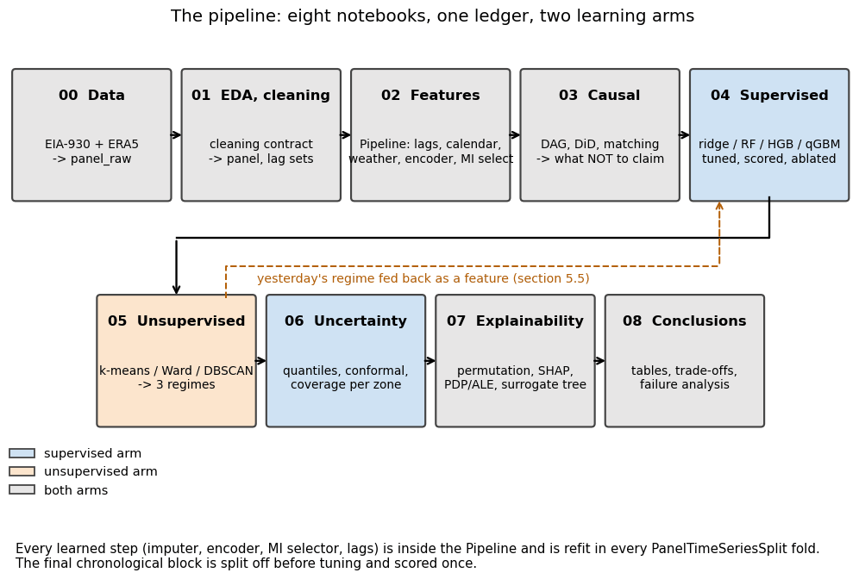
Figure 6. The pipeline end to end: what each notebook reads and writes and which arm it serves. The dashed arrow is the only loop, notebook 05's regime label fed back into notebook 04's feature set, and only a past day's label is admitted. What to observe: anything that learns a parameter sits inside a scikit-learn Pipeline refit inside every chronological fold, the structural guarantee behind the leakage claims below. Source: notebook 08 §8.2 (08_pipeline_overview.png).

3.2 Leakage: two defects found by audit, measured, then removed
The project's rule is that a defect found by an audit, measured and fixed is stronger evidence of rigour than a defect that was never there, and two were found (Figure 7). First, the nine same-hour fuel-generation columns reconstruct the target: their sum correlates with net load at r = 0.9997 in Texas and 0.9940 in the Plains, and the identity net load ≡ demand × (1 − renewable share) holds to 0.000000 MW. A model given these columns is doing arithmetic, not forecasting, and nobody knows tomorrow's gas output at a 24-hour origin, so same-hour demand, net_generation, total_interchange and all nine fuel columns are excluded; their lagged copies are admissible. A unit test now fails if any unvetted column becomes a feature. Second, a trailing mean computed as rolling(24).mean() includes the current row, which is correct at h=1 but at longer horizons reaches into hours the operator has not lived through. Measured: admissible and leaked arms are identical at h=1 (538.8 MW each), but the leaked model scores 1,874.8 against the admissible 2,173.2 MW at h=24 (optimism 298.4 MW, 13.7%) and 1,890.1 against 2,615.1 MW at h=72 (725.1 MW, 27.7%). The leaked model degrades by only 15.3 MW from h=24 to h=72 against the admissible 442.0 MW; it erased the horizon signal, and a check at h=1 alone would have found nothing.
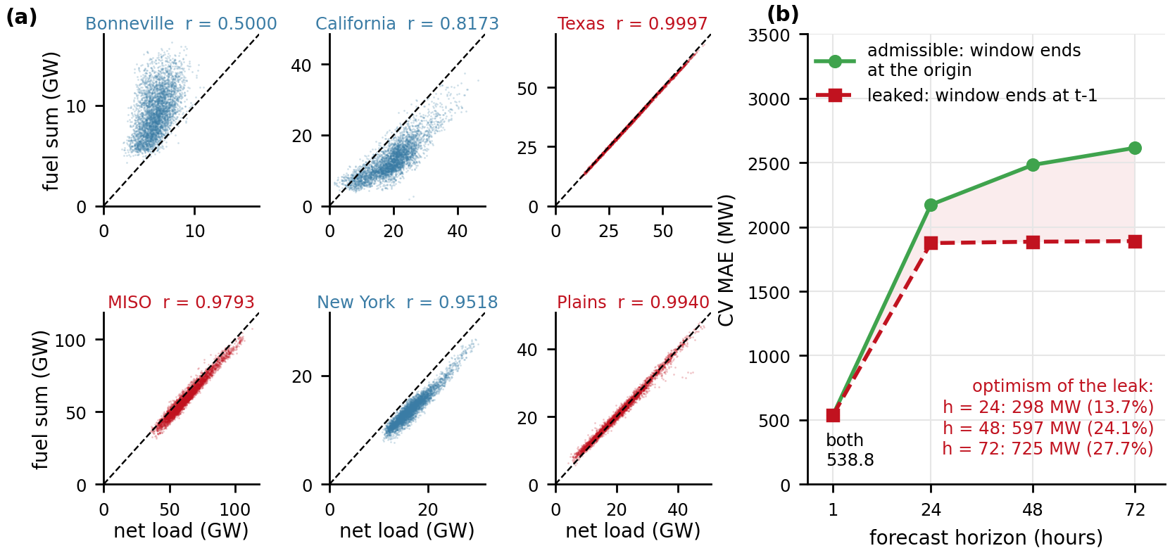
Figure 7. Two leaks, measured before removal. (a) the sum of the nine same-hour fuel columns against net load per region, with the 45° identity line; Texas (r = 0.9997), the Plains and MISO lie on it, and New York (r = 0.9518) sits just below it. (b) cross-validated MAE by horizon with rolling windows ending at the forecast origin (admissible) against windows ending the hour before the target (leaked): the arms coincide at h=1 and the leaked model's error barely moves with the horizon because it is reading part of the answer. Source: notebook 02 §2.15; notebook 04 §4.2 (02_leakage_fuel_columns.png; 04_leak_cost.png).

3.3 Features, and why the selector keeps all of them
Six feature families are computed inside the pipeline: target lags at the horizon's lag set; rolling statistics (24- and 168-hour trailing mean and standard deviation ending at the origin); calendar (hour, weekday, month, weekend, a year-end holiday proxy, with sine and cosine encodings); weather (fifteen ERA5 columns plus heating and cooling degree terms and a per-zone clear-sky index); exogenous lags (lagged demand and fuel columns); and zone (one-hot identity plus a relative family expressing the lags as ratios to the zone's trailing 168-hour level, worth 9.19 MW in all five folds). Zone encoding turned out not to matter on this feature set (none 542.05, ordinal 540.67, one-hot 538.78, target 541.06 MW against a fold SD near 30); one-hot was shipped. Missing values are imputed by the training-fold median, and no scaling is applied because the champion is a tree ensemble.
Selection is where the audit changed the project's mind. The pipeline's selector ranks candidates by mutual information, and the tuned model keeps every column (select__k = all), because the forward-selection curve has no knee (Figure 8): MAE falls from 1,220 MW at k=1 to 652.28 at k=30 and then to 590.33 when the 39 lowest-ranked features are added, a block jointly worth 61.95 MW. The reason is that the hour-of-day signal is strong inside each zone (mutual information 0.31 in California) and collapses to 0.03 when six zones in three time zones are pooled in UTC. The fitted model confirms it: the Spearman correlation between the mutual-information ranking and the SHAP ranking is only +0.31; hour_sin is ranked 60th by MI and 2nd by SHAP, gas_lag24 9th by MI and 55th by SHAP. Mutual information scores features marginally; the model uses them conditionally: given the lag, the hour tells it where on the daily curve it sits. A practitioner who trusted the marginal ranking would have deleted 62 MW of accuracy. Collinearity is severe (45 of 69 features have VIF above 10, twelve infinite through exact identities such as ghi = dhi + dni_horiz); it does not touch a tree ensemble, but it is why the linear rung's coefficients are not interpreted and why collinear partners split the credit in Section 6.
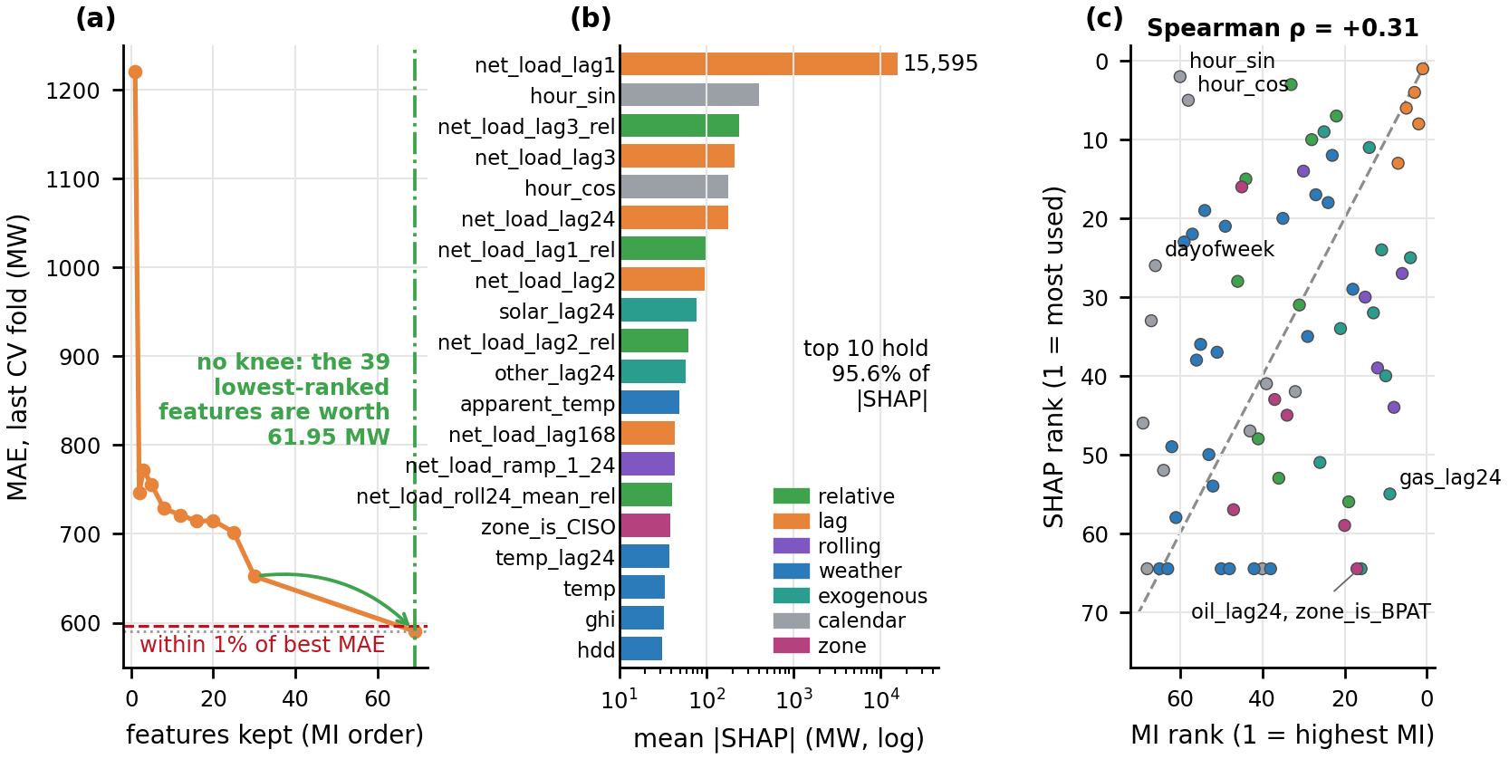
Figure 8. Why the selector keeps every feature. (a) cross-validated MAE against the number of features kept by the mutual-information selector; there is no knee, and the 39 lowest-ranked features are jointly worth 61.95 MW. (b) mean |SHAP| per feature, where net_load_lag1 dominates at 15,595 MW and the top ten hold 95.6% of attributed magnitude; (c) each feature's MI rank against its SHAP rank, Spearman +0.31: calendar features (grey) sit far below the diagonal, ranked low by MI and high by the model. Source: notebook 02 §2.20–2.21 (02_forward_selection.png; 02_shap_selection.png).

3.4 Baselines, ladder, tuning and metrics
Four benchmarks bound the results: seasonal naive (4,259.8 MW on the 46,123 common rows), persistence (1,211.9 MW, fair at h=1 only), the EIA composite v1 (3,059.2 MW) and composite v2 (2,485.9 MW), built by this project to be the hardest public-data forecast an operator could hold. The supervised ladder climbs from ordinary least squares with a full diagnostic battery, to ridge, to a random forest, to histogram gradient boosting [18] (the champion), to a quantile gradient-boosting model that produces the seven quantiles Section 7 needs, each rung justified by a failure of the one below. Tuning searched the whole pipeline, including the selector's k, in two stages: 40 randomised draws (CV MAE 2,111.4 MW) and a 9-cell grid over learning rate and iterations (2,107.3 MW); the full grid of 72,000 cells would have taken over 250 hours. Every hyperparameter was then swept one at a time against a fold-to-fold noise floor of 50.7 MW, so that no setting inside the noise could be reported as a finding. The per-horizon champions were re-tuned at h=1, 48 and 72 with their own lag sets.
Metrics. The headline is MAE in megawatts, the unit reserve is procured in, on the sealed holdout. RMSE (3,290.9 MW against MAE 2,159.6) was set aside because the gap says the error distribution is heavy-tailed (95th-percentile absolute error 6,962.7 MW), so RMSE would let a handful of hours choose the model; MAPE (10.7%) because it is asymmetric in the wrong direction: an under-forecast costs at most 100% while an over-forecast has no ceiling, so minimising it pulls forecasts low, while the operator's cost asymmetry runs the other way. Skill is 1 − MAE_{model}/MAE_{benchmark} on the same rows. Model differences are tested with Diebold–Mariano [7] and Wilcoxon signed-rank tests on 1,974 zone-day blocks with Benjamini–Hochberg correction [10], because hourly residuals are autocorrelated at 0.95 and hourly tests would be far more confident and wrong. Intervals are scored by coverage, width and the Winkler score [6]; clusters by silhouette, Davies–Bouldin, Calinski–Harabasz and, decisively, adjusted Rand index (ARI) [20] stability under 80% resampling; the classifier by PR-AUC against its base rate.

3.5 Unsupervised and uncertainty methods
The unsupervised question is about shape, so each zone-day was expressed as 24 local-hour values normalised within the day to [0, 1] (13,069 zone-days × 24); local-hour indexing matters because the six systems' solar noons differ by up to three hours in UTC. The matrix was reduced by PCA and three algorithms were tuned over three axes: k-means for k = 3…7, Ward's clustering over the same k, and DBSCAN with eps read from the 80th, 90th and 95th percentiles of the 10-nearest-neighbour distance curve (0.266, 0.336, 0.415) rather than guessed, 39 grid cells in all, on 3, 5 and 8 components. The partition was chosen by ARI stability, validated against weather the clustering never saw (pooled and within zone), and tested as a feature in the forecaster.
Prediction intervals come from a quantile gradient-boosting model at seven levels (0.05 to 0.95) on the champion's feature set, repaired and calibrated in three measured steps: monotone rearrangement [19] to remove quantile crossing; a chronological split of the development block at 2023-01-30 into a fit block (214,552 rows) and a calibration block (53,634 rows); and nine interval constructions compared on the holdout, from the raw bands through split conformal and conformalised quantile regression (CQR) [3] to Mondrian versions conditioned on zone [4]. The shipped arm is CQR additive, Mondrian by zone. The whole chain is then re-scored with the weather as it was actually forecast.
Reproducibility. Every number is written by a notebook to one results ledger (data/processed/results.json); figures are drawn from the same ledger; src/ carries the pipeline and cleaning contract under a test suite with a leakage test and a no-unvetted-column test. Notebook 08 re-reads 927 numbers quoted in the previous report from the current run: 791 reproduce, 5 are wall-clock times, 131 are design constants, and 0 differ.

4. Unsupervised learning: what kind of day is it?

4.1 Choosing the partition
Figure 9 reports all 39 grid cells. K-means is stable at every k (ARI 0.996 at k=3 on 5 components, never below 0.90) and Ward much less so (0.617 at k=3 on 5 components; below the 0.6 goal for most cells); silhouette falls with k for both, and Davies–Bouldin and Calinski–Harabasz agree, so all four metrics pick k=3. The chosen configuration, k-means with k=3 on 5 principal components keeping 94.8% of the shape variance, scores ARI 0.996, silhouette 0.429, Davies–Bouldin 1.010 and Calinski–Harabasz 9,273. DBSCAN finds structure but pays in noise: its best cell reaches ARI 0.920 with four clusters, 6.9% of days as noise and silhouette 0.160, and across its nine cells it returns one to six clusters with 0% to 29.8% noise; a manifold without density gaps is the wrong problem for it. Ward's dendrogram suggests k=2 from its largest merge gap, recorded as the one dissent. A representation check confirms the partition is about shape: clustering raw megawatts instead gives ARI −0.034 and a cluster that is 92% MISO.

4.2 The three regimes, and the validation that half failed
The centroids (Figure 9d) are three different shapes, not three depths of one shape. Cluster 2 (n = 2,791, 21.4%) is the duck: minimum at local hour 13, belly 0.111 on the normalised scale, evening ramp 0.841, the steepest. Cluster 1 (n = 7,782, 59.5%) is the conventional day: minimum at hour 4, belly 0.693, ramp 0.364. Cluster 0 (n = 2,496, 19.1%) is winter-shaped: a morning peak, an afternoon decline, minimum at hour 23, ramp 0.173. Belly alone cannot separate clusters 0 and 1 (0.635 vs 0.693); only the ramp, the hour of the minimum and the profile do, which is why the names were derived from the centroids and then required to pass a weather check.
Not one weather column enters the clustering, so weather separating across regimes would be external corroboration. Pooled, temperature spreads the regimes most, duck days are 12.4 points less cloudy and receive 26.8 W/m² more irradiance, and winter-shaped days average 6.2 °C. But Figure 10 asks the question pooled validation cannot: are the regimes zones in disguise? Substantially, yes. 77% of all duck days (2,148 of 2,791) are California's, and 98% of California's days are duck days. Within zone, the winter-shaped regime is colder than its own zone's mean in all five zones with at least thirty such days (by 3.7 to 11.1 °C), which a shape clustering was never told. The duck's brightness holds in only two of six zones (California +1 W/m², New York +51; dimmer in the Plains −30, Bonneville −27, MISO −18, Texas −10). Pooled, duck days look sunny because duck days are mostly California; within a grid, a duck-shaped day is usually a mild shoulder-season day on which demand is low enough for a fixed solar fleet to hollow out the curve. The temperature signature is physical; the irradiance signature is mostly geography, and the report says so.
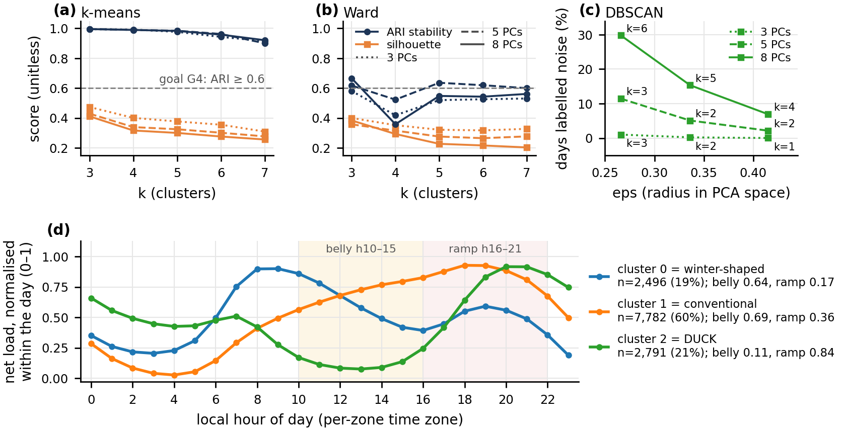
Figure 9. (a) k-means and (b) Ward across k = 3…7 on 3, 5 and 8 components, ARI stability and silhouette; (c) DBSCAN across its three eps candidates with its noise fraction. K-means is above 0.99 at k=3 and never below 0.90, Ward is below the 0.6 gate in 11 of 15 cells, and every metric picks k=3. (d) each regime's mean within-day-normalised net load by local hour (sizes 7,782 / 2,791 / 2,496): cluster 2 bottoms at solar noon and ramps 0.841 into the evening, the shape this project exists to forecast. Source: notebook 08 §8.5; notebook 05 §5.4 (08_unsupervised_summary.png; 05_centroids.png).

4.3 Do the regimes help the forecast, and can they be explained?
Adding the regime label to the champion's pipeline under identical folds (Figure 10c): yesterday's label (admissible for a batch day-ahead forecast) lowers cross-validated MAE from 2,173.2 to 2,155.8 MW, −17.4 MW, paired p = 0.030; the label two days back (complete at every rolling origin) gives 2,171.7 MW, −1.5 MW, p = 0.788, i.e. nothing measurable; today's own label, a deliberate leak kept as a control, gives 2,142.6 MW, −30.6 MW, p = 0.009. The ordering is right and the gain is small, under 1%: the shape matrix carries shape, not level, and the lags already carry most of what a shape label could add. An earlier run had shown the opposite ordering; the cause was labels keyed by local date merged onto the UTC date, found by audit, fixed with a unit test and recorded in the decision log. A depth-3 surrogate tree predicting the regime from temperature, cloud, humidity, wind, month and weekday reaches balanced accuracy 0.627 ± 0.085 against chance 0.333, splitting first on temperature at 12.9 °C: the cold branch is winter-shaped and the warm, light-wind branch is duck. The honest answer to Q3 is that the regimes are stable and physically meaningful in their temperature signature, and operationally useful mainly as a conditioning variable for uncertainty (Section 7.6) rather than as a point-forecast feature.
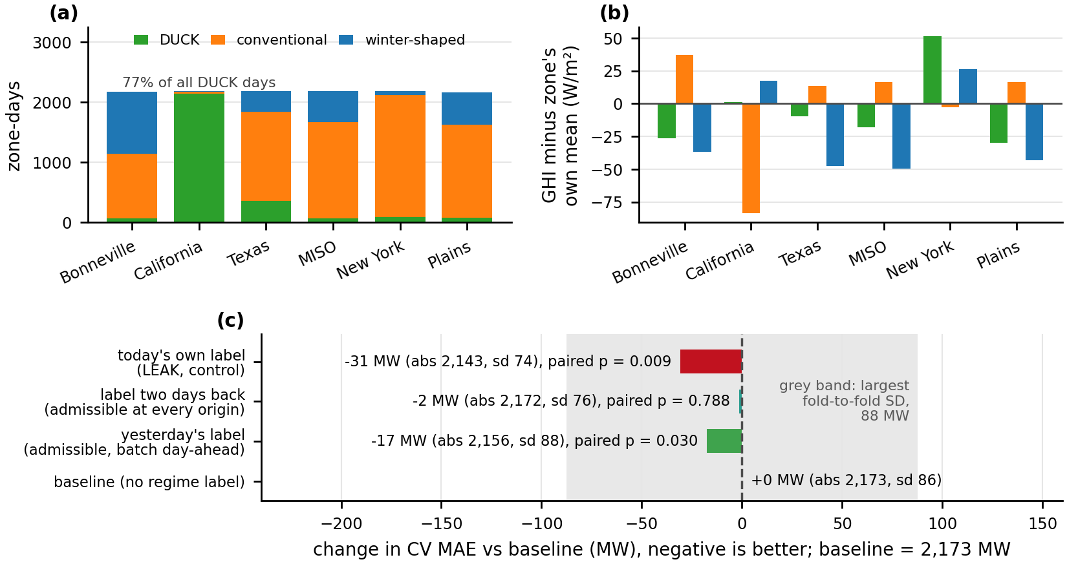
Figure 10. (a) zone × regime crosstab, the duck regime almost entirely California; (b) the duck regime's mean irradiance minus its own zone's mean, positive in only two of six zones. (c) change in cross-validated MAE when yesterday's label, the label two days back, or today's own label (a leak, as control) is added to the champion, with paired p-values; the grey band is the largest fold-to-fold SD. What to observe: the gain is ordered as it should be (leak > yesterday > two days back) and is 17.4 MW for the admissible framing. Source: notebook 05 §5.4c and §5.5 (05_regime_vs_zone.png; 05_downstream_utility.png).

5. Supervised learning: forecasting net load

5.1 The linear rung cannot be read; the ladder, the search and what each knob is worth
Ordinary least squares was fitted first because its diagnostics license or forbid reading its coefficients, and they forbid it: the pooled R² of 0.9710 collapses to 0.8282 within zone; Breusch–Pagan and Jarque–Bera both reject (p = 0.0, residual kurtosis 5.47); Durbin–Watson is 0.099 within zone with residual autocorrelation 0.950 (in row order it reads 1.757, the wrong number, because the panel interleaves six zones); the design is singular along the exact identities and 18 coefficients change sign across time blocks. Ridge buys coefficient stability but no accuracy (2,738.6 against 2,739.3 MW). Two facts carry forward: residuals are autocorrelated at 0.95, so every test must be blocked, and the problem is non-linear, so the next rung must allow interactions.
Figure 11 is the supervised result in one picture. Under identical pipeline, folds and gap, cross-validated MAE at h=24 falls from ridge 2,697.9 ± 120.4 MW to random forest 2,237.1 ± 73.7, histogram gradient boosting 2,173.2 ± 85.5 and the quantile model trained on the median 2,237.2 ± 94.3. The large step is linear to non-linear (525 MW ridge to boosting), not forest to booster (64 MW), and the forest takes 17 times the booster's fit time (249.7 s against 14.5 s per cross-validation) for the worse score, so there is no accuracy–compute frontier to trade along. Tuning takes boosting from 2,173.2 to 2,107.3 MW (65.8 MW for the whole search, of which the refining grid contributed 4.1). The sensitivity sweep (Figure 12) measures each hyperparameter against the 50.7 MW noise floor: the selector's k spans 823.3 MW (paired p = 0.000), max_iter 236.8 (p = 0.003), max_depth 63.7 (p = 0.027), learning_rate 59.8 (p = 0.001), min_samples_leaf 22.7 (p = 0.130) and l2_regularization 5.2 MW (p = 0.162). The largest axis by far is not a model hyperparameter but how many features the model may see; regularisation spans a tenth of a fold SD, so the tuned l2 = 0.0 is reported as noise. The tuned configuration is k = all, 1,200 iterations, learning rate 0.04, depth 8, 100 samples per leaf; the h=24 champion uses 57 features.
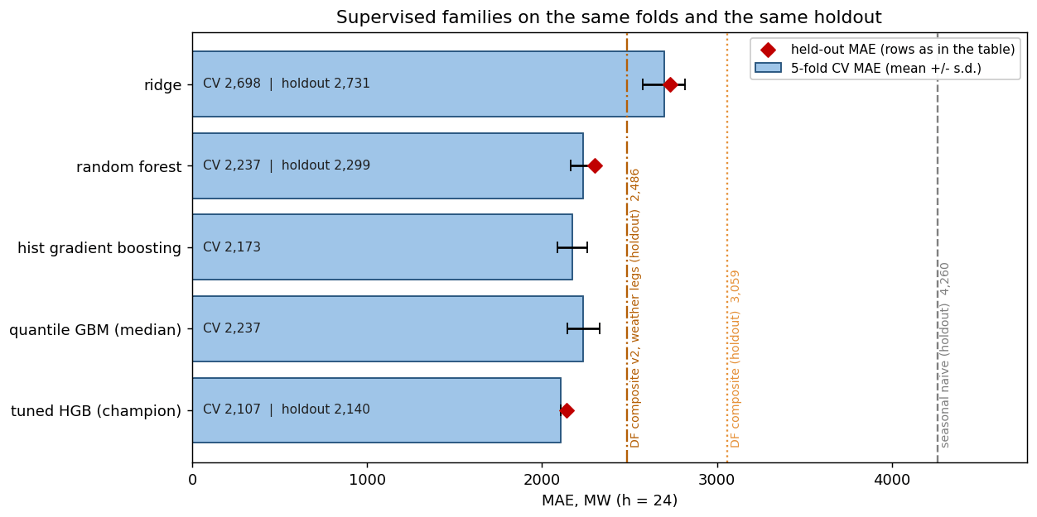
Figure 11. Supervised results in one table: bars are five-fold cross-validated MAE with the fold SD as the error bar, diamonds are the sealed holdout, vertical lines are the three baselines scored on the holdout only. What to observe: the gap between the linear family and the trees is the size of the non-linearity in the problem; the two ensembles are within a fold SD of each other on CV, which is why the paired holdout tests of Figure 14 exist. Source: notebook 08 §8.4 (08_supervised_summary.png).
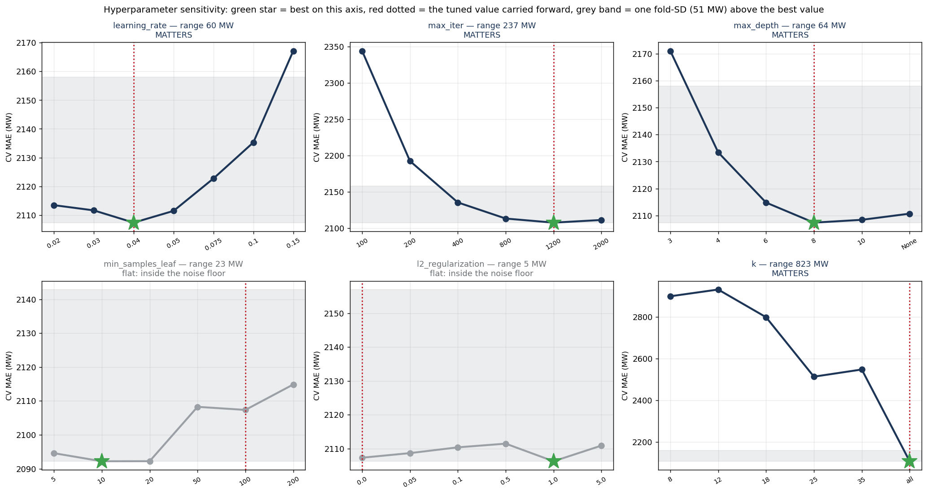
Figure 12. Hyperparameter sensitivity: cross-validated MAE against each hyperparameter with the others held at the tuned configuration, and the 50.7 MW fold-noise floor drawn across each panel. What to observe: the number of features kept moves the error by 823 MW while L2 regularisation moves it by 5 MW; a knob whose whole axis fits inside the grey band was not tuned, it was guessed within noise. Source: notebook 04 §4.7 (04_hyperparam_sensitivity.png).

5.2 The held-out result by horizon
The champion's cross-validated 2,107.3 MW becomes 2,159.6 MW on the sealed holdout, an optimism of +52.2 MW (+2.5%) that says the tuning did not eat the holdout. On the 46,123 common rows the model scores 2,139.7 MW: skill 49.8% against seasonal naive (G1 met, target 25%), 30.1% against the EIA composite (G2 met) and 13.9% against composite v2 (G2′ met). Scored as a forecast issued once a day at 10:00 D−1, as the EIA's is, the MAE is 2,296.9 MW and the last two margins are still 24.9% and 7.6%. Table 3 and Figure 13 give all four horizons: 84% of the degradation from h=1 to h=72 happens in the first step, because once the recent lags are gone what remains is diurnal and weekly structure equally available two and three days out. The h=1 column is not a forecasting achievement; the horizon that matters commercially is the day-ahead one, where the margin over the strengthened composite is largest. Because the holdout holds no January, the champion was also refit at four rolling origins and scored on the following quarter: 2,117.3, 2,400.8, 2,109.0 and 2,077.6 MW, so the winter quarter is hardest in megawatts (+241.2 MW against the primary holdout) but not in skill (51.7% against naive).
Horizon | Champion MAE, all rows | Champion MAE, common rows | Skill vs seasonal naive | Skill vs composite v2 | Fair comparison?
h = 1 | 547.1 MW | 546.0 MW | 87.2% | 78.0% | no: benchmark is day-ahead; vs persistence (1,211.9 MW) skill is 54.9%
h = 24 | 2,159.6 MW | 2,139.7 MW | 49.8% | 13.9% | yes: information sets match
h = 48 | 2,389.7 MW | 2,370.8 MW | 44.3% | 6.3% | lower bound: composite keeps its day-ahead demand leg
h = 72 | 2,470.8 MW | 2,457.7 MW | 42.3% | 3.7% | lower bound
Table 3. Held-out error at four horizons, each with its own re-tuned champion and lag set. Steps between horizons are +1,612.5, +230.1 and +81.1 MW, so P1 holds. Composite v2 is rebuilt at a horizon-matched persistence lag (2,485.9 / 2,530.1 / 2,550.8 MW at 24/48/72 h). Source: notebook 04 §4.9, §4.9b; notebook 08 §8.4c.
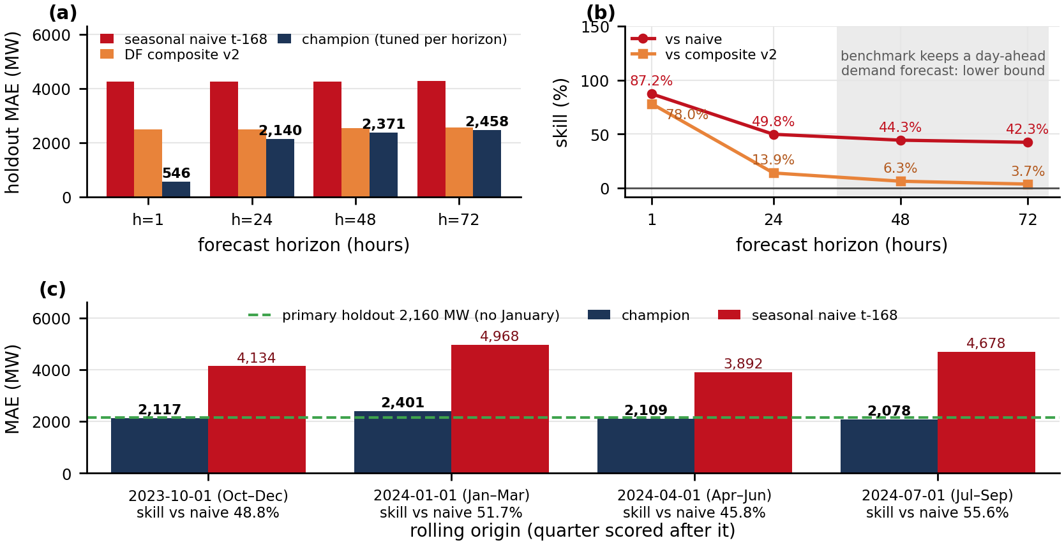
Figure 13. (a) Held-out MAE of the champion at each horizon beside composite v2 (rebuilt per horizon) and seasonal naive on the same rows, and (b) skill against each; the model's error grows 1,911.7 MW from h=1 to h=72 and skill against the composite narrows from 13.9% to 3.7% beyond a day. (c) the champion refit at four rolling origins and scored on the following quarter, so that a January is evaluated somewhere; the winter quarter is hardest in megawatts but not in skill. Source: notebook 04 §4.9b and §4.15b (04_skill_by_horizon.png; 04_rolling_origins.png).

5.3 Is the ranking real, and does it hold per region?
Figure 14 tests every pair on 1,974 zone-day blocks. The champion beats ridge by 583.2 MW (block-bootstrap 95% interval [532.4, 634.5]), the random forest by 138.0 MW [95.4, 179.3], seasonal naive by 2,103.5 MW [1,958.0, 2,258.0] and the EIA composite by 923.1 MW [839.5, 1,008.9]; all ten pairwise tests survive Benjamini–Hochberg at α = 0.05. Against composite v2 the margin is 346 MW [290, 402], Diebold–Mariano −9.6 (p = 6.7e-22), blocked Wilcoxon p = 2.4e-31. The p-values are the wrong thing to be impressed by, since with 46,000 scored hours significance is nearly automatic; the number to argue from is the interval, 95 to 179 MW over the forest, a magnitude a reserve calculation can use.
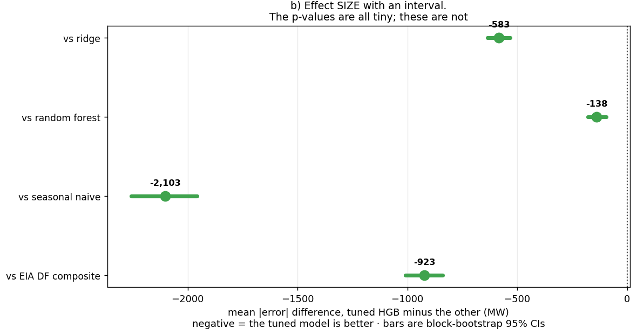
Figure 14. Paired differences in held-out MAE between the champion and each alternative, with block-bootstrap 95% intervals on 1,974 zone-day blocks and Benjamini–Hochberg-adjusted significance. What to observe: every interval excludes zero, and the smallest margin, 95–179 MW over the random forest, is about 6% of the forest's error. Source: notebook 04 §4.13 (04_model_comparison.png, panel b).
Table 4 and Figure 15 judge the goals region by region. G1 and G2 are met everywhere. Against the strengthened composite the champion wins in five regions and loses in one: in New York the composite's 641.1 MW beats the model's 709.7, but the paired interval for that 68.7 MW gap, [−60.7, +164.5] MW, contains zero, while the five wins all exclude it. This is the section's central finding: the model's advantage is an advantage in forecasting the renewable term. California, where solar is half of midday demand, gains a third of its error (1,454.4 against 2,121.5 MW); New York, where net load is demand and the ISO's professional demand forecast is the harder thing to beat, gains nothing. The hardest region in scaled terms is not the one the model helps least: the Plains carry 14.6% of their mean load, 3.4 times New York's 4.3%, yet the model beats every benchmark there, so P4 holds and the difficulty sits in the wind corridor itself. By season, December–February is worst in absolute terms (2,307.8 MW) but level with spring once scaled (9.4% vs 9.8%), summer best at 6.8%.
Region | Champion MAE (common rows) | Skill vs naive (G1 ≥ 25%) | Skill vs EIA composite (G2 > 0) | Skill vs composite v2 (G2′ > 0) | MAE as share of mean net load
CISO | 1,454.4 MW | 47% | +30% | +31% (v2: 2,121.5 MW) | 8.1%
ERCO | 3,777.0 MW | 49% | +27% | +12% (v2: 4,289.9 MW) | 10.9%
MISO | 3,379.5 MW | 55% | +36% | +15% (v2: 3,980.7 MW) | 5.8%
SWPP | 2,938.5 MW | 44% | +32% | +9% (v2: 3,236.7 MW) | 14.6%
BPAT | 586.3 MW | 36% | +19% | +11% (v2: 656.6 MW) | 10.2%
NYIS | 709.7 MW | 58% | +7% | −11% (v2: 641.1 MW; paired gap [−60.7, +164.5]) | 4.3%
Table 4. The champion against every benchmark per region on the rows every benchmark can reach. The last column divides the MAE over all of the region's holdout rows by its mean net load. Source: notebook 04 §4.8; notebook 08 §8.4b (continued), §8.16.
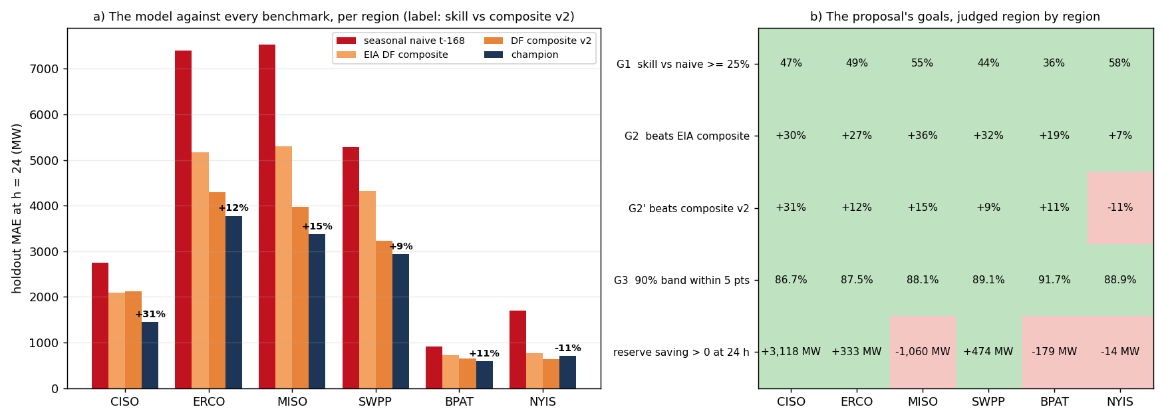
Figure 15. (a) Day-ahead holdout MAE per region for seasonal naive, the EIA composite, composite v2 and the champion; the label is the champion's skill over composite v2. (b) The goals of Table 1 judged region by region, green met and red missed; the bottom row is the reserve headroom of Section 7.6. What to observe: the margin over the strengthened composite is largest where solar is largest and vanishes where net load is demand. Source: scripts/region_chapter.py from notebook 08 §8.16 (11_region_skill.png).

5.4 Ablation and learning curve: inputs matter more than settings
Removing each feature family and refitting (Figure 16a) costs +698.1 MW for weather (33.1% of the full model's error), +149.8 calendar, +66.0 target lags, +16.3 zone, +2.8 exogenous history and −4.0 MW rolling statistics, i.e. inside the 51 MW noise floor; weather, calendar and lag clear it (paired p 0.0001, 0.0004, 0.04). The lag family's small cost looks wrong next to Section 6's permutation importance and is not: dropping the lags and refitting leaves near-substitutes standing (lagged demand correlates at about 0.96 with the target), so ablation prices a family's irreplaceable content, and weather is the family nothing else can reconstruct. The learning curve (Figure 16b) says more history of the same kind will not help: validation MAE falls 3,856.9 → 2,328.2 → 2,219.8 → 2,181.9 → 2,106.1 → 2,102.4 MW as the training slice grows from 10% to 100% (22,800 to 227,962 rows), the last step is worth 4 MW, and training error rises from 709.5 to 1,414.1 MW, so the model is not memorising; the remaining gap is structure the model cannot fit, not variance more rows would close.
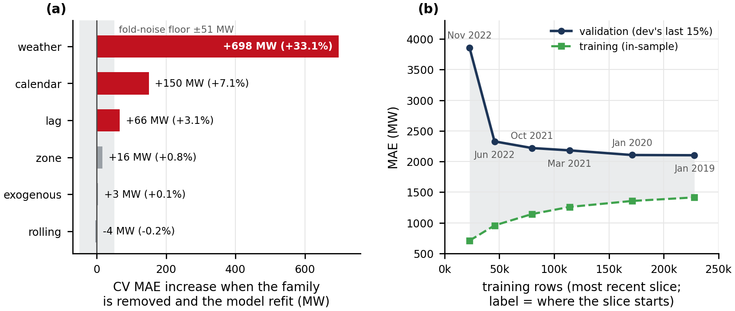
Figure 16. Inputs matter more than settings. (a) cross-validated MAE with each feature family removed and the model refit, with the fold-noise floor marked; weather is the one family whose removal costs a third of the error. (b) training and validation MAE against training-set size, each size the most recent slice; the validation curve has flattened (the last 57,000 rows buy 4 MW) and the training curve rises toward it. Source: notebook 04 §4.10–4.11 (04_ablation.png; 04_learning_curve.png panel a).

5.5 The five registered predictions
P1 holds: MAE is monotone in the horizon and the first step (+1,612.5 MW) is seven times the next. P2 fails: at h=24 the weekly lag's permutation importance is 258.2 MW against the daily anchor's 251.5, and at h=72 275.7 against 289.9, the reverse of the predicted crossover, by small margins. P3 fails, informatively: evening hours (17:00–21:00) are worse than the rest of the day (2,327 against 2,115 MW), but the single worst hour is 16:00, the hour before the predicted window (Section 6.2). P4 holds: scaled error is highest in the Plains (14.6%) and lowest in New York (4.3%). P5 holds for the weather family: its share of permutation importance rises from 14.22% at h=24 to 16.21% at h=72 in notebook 04's measurement (0.9 → 7.4 → 9.0 → 10.3% across the four horizons in notebook 07's), measured under reanalysis weather. Three of five held, and the two that failed are the stronger evidence that the predictions were made in advance.

6. Interpretation and error analysis

6.1 What the model leans on, and how it uses its inputs
Permutation importance shuffles one column on the holdout and measures the added error. Against a baseline of 2,159.6 MW, shuffling net_load_lag24 costs 8,983.2 MW, more than four times the model's whole error; demand_lag24 3,597.6; then a cliff: zone_is_MISO 798.3, wind_lag24 547.2, net_load_lag168 532.0, wind_speed_100m 521.8. By family: lags 11,416.2 MW, exogenous history 4,500.5, weather 1,432.7, zone 1,110.6, calendar 399.5, rolling 393.6. For a non-specialist, this is a persistence model with corrections: the best predictor of net load tomorrow at 18:00 is net load today at 18:00, and weather and calendar refine it. Figure 17 places this beside the ablation, and the two rankings disagree because they answer different questions: permutation measures what this fitted model leans on; ablation measures what the model could not do without once allowed to refit. The weather family's share of importance rises monotonically with the horizon (0.9% at h=1, 7.4% at h=24, 9.0% at h=48, 10.3% at h=72) as the lag family's falls (93.9 → 59.3 → 42.9 → 39.9%), the direct test of P5.
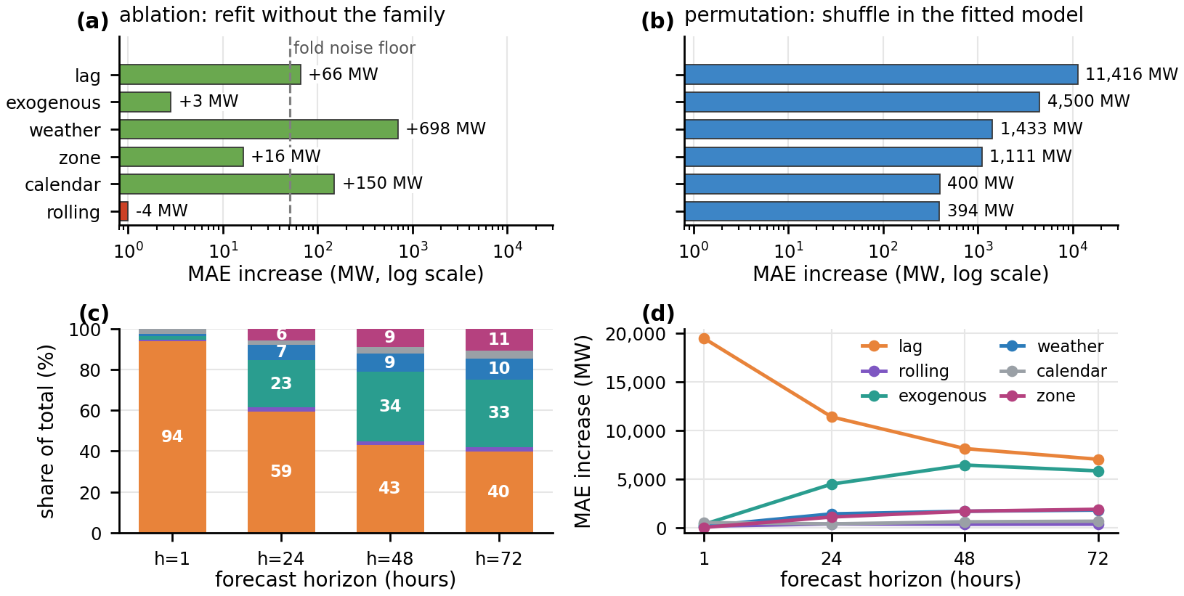
Figure 17. Top: two importance measures that disagree, both right: (a) ablation, CV MAE increase when a family is removed and the model refit; (b) permutation, held-out MAE increase when a family is shuffled at prediction time; weather leads (a) and lags lead (b). Bottom: grouped permutation importance at every horizon (c) as a share of the total and (d) in megawatts; the lag family's share collapses from 93.9% to 39.9% as the admissible lags decay and the weather family's rises from 0.9% to 10.3%, so P5 holds. Source: notebook 08 §8.4e; notebook 07 §7.2b (08_ablation_vs_permutation.png; 07_importance_by_horizon.png).
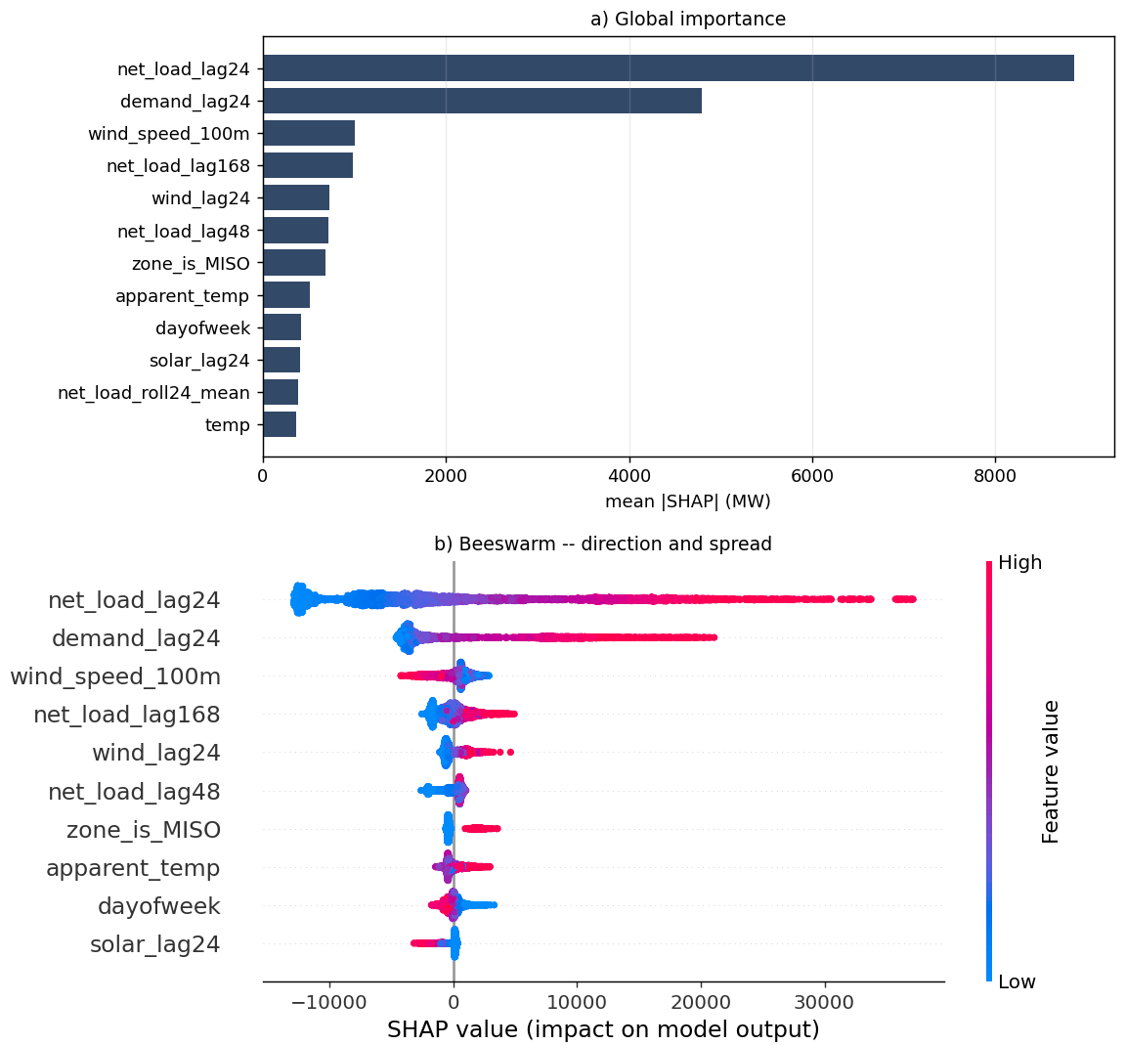
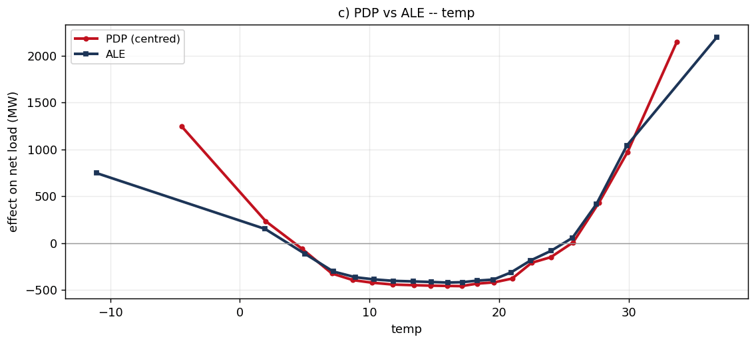
Figure 18. How the model uses its inputs. Top: SHAP on 3,000 held-out hours, (a) mean|SHAP|by feature and (b) the beeswarm, each dot one hour, colour the feature's value. Bottom: partial dependence (dashed) and ALE (solid) for temperature, the U-shape with its flat comfort bottom between about 12 °C and 20 °C. What to observe: the two most important inputs are yesterday's net load and demand; temperature's effect is non-monotone, which is why correlation-based selection would have discarded it. Source: notebook 07 §7.4 and §7.3 (07_shap.png panels a–b; 07_pdp_ice.png panel c).
SHAP attributions [8] over 3,000 held-out hours agree closely with permutation (Spearman +0.95): net_load_lag24 averages 8,857.8 MW, demand_lag24 4,791.5, wind_speed_100m 1,004.2, net_load_lag168 985.0, and the beeswarm (Figure 18, top) shows direction as well as size: high yesterday-net-load pushes the forecast up, high hub-height wind pushes it down. The partial-dependence and accumulated-local-effects [9] curves for temperature (bottom) are the model confirming what the correlation matrix could not see: a U with a flat comfort bottom between about 11.9 °C and 19.6 °C, a range of 1,416 MW (PDP) and 1,460 MW (ALE) with a maximum gap of 122 MW between the two methods, so the shape is not an artefact of correlated features.

6.2 Where the forecast fails, in three classes
Failure analysis was done as the course asks: specific examples, categorised, with a fix for each. Figure 19 shows where held-out error concentrates. The worst-decile cut (|error| ≥ 5,441 MW) over-represents the afternoon, 16:00 (1.24×), 15:00 (1.23×), 14:00 (1.22×) and 17:00 (1.21×): the peak is at 16:00, when solar is falling in the solar regions and afternoon heat is near its peak, and the project did not separate the two. MAE runs from 1,786.8 MW in the coldest temperature quintile to 2,617.4 MW in the hottest. By zone the two cuts disagree, and the disagreement is the method point: an absolute cut ranks Texas (2.53×), MISO (1.96×) and the Plains (1.36×), a ranking by size, while the scaled cut reverses it to the Plains (2.89×), Texas (1.48×), Bonneville (0.80×).
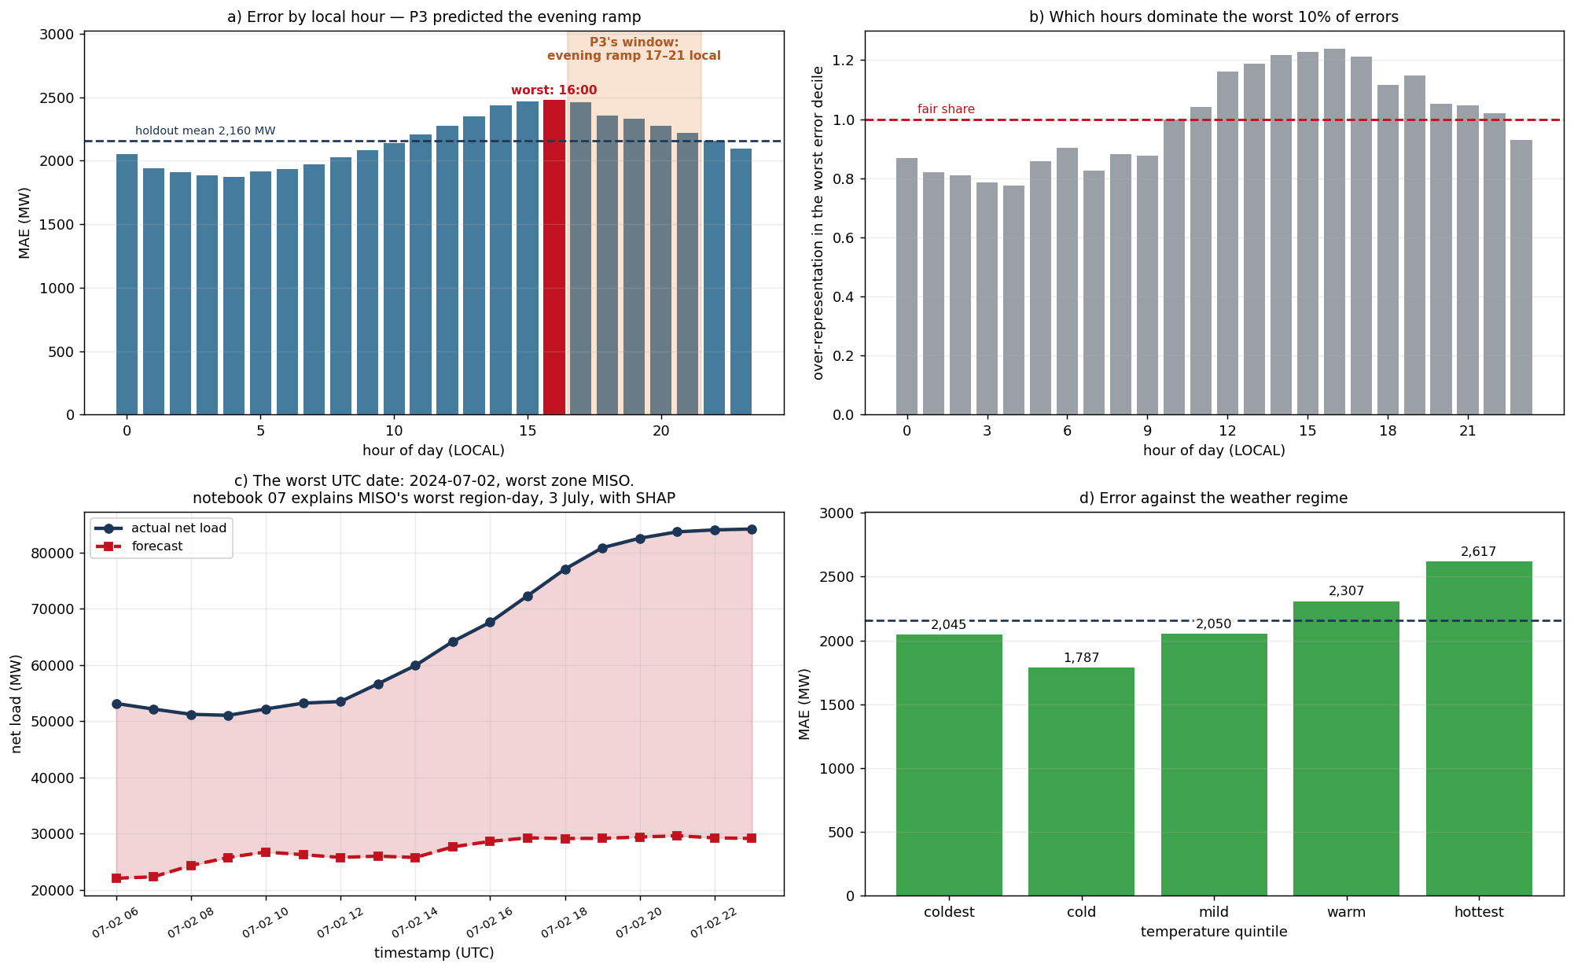
Figure 19. Where the error concentrates: lift of the worst-decile hours by local hour of day, and by zone under an absolute and a scaled definition of a large error. What to observe: the afternoon band from 14:00 to 17:00 is over-represented, peaking at 16:00 rather than in the 17:00–21:00 window P3 named; and the zone ranking reverses between the two cuts, so "which region fails most" depends on whether size is removed. Source: notebook 04 §4.12 (04_failure_analysis.png).
Operational: the imputed-lag failure. The worst hour in the project is MISO on 2024-07-03 at 01:00 UTC, forecast 28,706 MW against an actual 86,183 MW, a miss of 57,477 MW inside a day whose MAE was 19,681 MW (Figure 20). It is a data failure: cleaning had found a 24-hour gap in MISO's demand from 2024-07-01 06:00; lags reach back 24, 25, 26, 48 and 168 hours, so predictions on 2024-07-03 looked up history inside that hole and received imputed values. The two most important inputs were fabricated, and the SHAP waterfall for that hour shows demand_lag24 contributing −4,174.6 MW and net_load_lag24 −3,268.9 MW. The class is identifiable from the inputs alone: 233 holdout rows (0.49%) are missing at least one lag, and on them MAE is 7,561.9 MW against 2,132.8 MW on clean rows, 3.5 times worse. Flagging the rows and abstaining leaves coverage at 99.51% of hours and MAE at 2,132.8 MW, the cheapest improvement in the project. Systematic: the afternoon ramp. The excess of afternoon over overnight MAE is 481, 472 and 458 MW per hour at 14:00–16:00; a solar-ramp feature family that recovered a third of it would be worth about 40–51 MW on the headline, the same order as the whole tuning search bought (65.8 MW). Edge case: the wind corridor. The Plains' 14.6% scaled error is shared by every benchmark and traces to one weather point for turbines that span several states; several weather points per region is the decision log's first named upgrade.
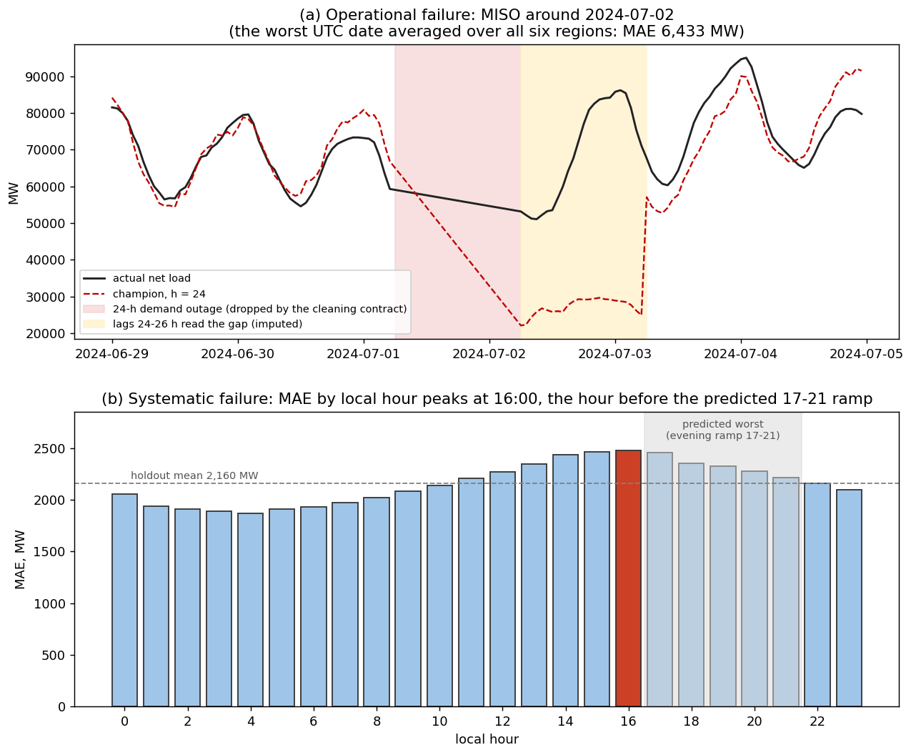
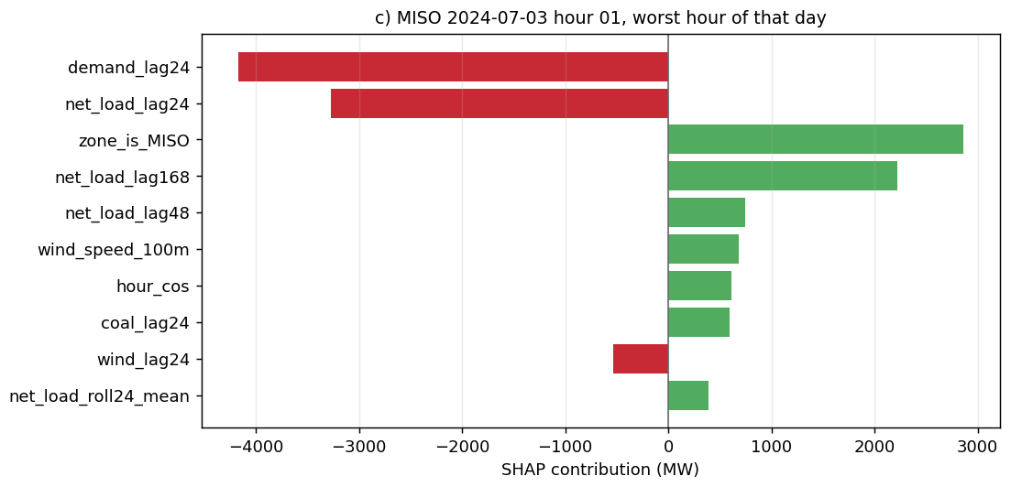
Figure 20. Three failures, three classes. Top: (a) a held-out week in MISO in which the forecast tracks the actual until the lags begin reading from the reporting outage, then misses by up to 57,477 MW; (b) held-out MAE by local hour, rising through the afternoon to a peak at 16:00. Bottom: the SHAP waterfall for the worst hour, in which the two imputed lag inputs contribute −7,443.5 MW. What to observe: the largest error in the project is a data failure that can be flagged from the inputs alone. Source: notebook 08 §8.4h; notebook 07 §7.4 (08_failure_cases.png panels a–b; 07_shap.png panel c).

6.3 A companion classifier: curtailment-risk hours
A classification arm asks whether an hour will have more renewable output than the grid can use: the label is an hour whose renewable share exceeds its zone's 85th percentile and whose net load is below its zone's 15th percentile, a base rate of 15.85% (7,499 holdout hours). The classifier reaches PR-AUC 0.772, a 4.9× lift over the base rate, and ROC-AUC 0.936. Accuracy of 0.905 is the trap: a model that never predicts curtailment scores 0.841. F1 is 0.628 at the default threshold and 0.674 at 0.258, found by sweeping on the holdout and therefore optimistic; that the operating point falls far below 0.5 follows from the class imbalance. The label is built from the same-hour target, as a label must be, and the guard is that no feature restates it (net_load, renewable_share, wind and solar are excluded; only lagged copies reach the model); the score being far from perfect is the evidence the guard holds.

7. Uncertainty, robustness and reliability

7.1 Which interval sizes reserve
Two intervals are routinely confused. The 90% confidence interval for the mean holdout error of the median forecast is [−311.0, −260.6] MW if hours are treated as independent (half-width 25.2 MW) and [−375.1, −191.8] MW on 1,974 zone-day blocks, the right unit for autocorrelated hours. The 90% prediction interval for the next hour's error is [−5,893.5, +5,000.2] MW, half-width 5,446.8 MW, 59 times the blocked confidence half-width. The first is epistemic: it shrinks with data and says the median forecast runs about 286 MW high on average. The second is aleatoric: it would not shrink with ten more years of history, and it is what reserve is held against. Sizing reserve from the confidence interval would not merely understate it; its upper edge is negative, so it would say no reserve is needed at all.

7.2 Three defects, three named fixes, and what each is worth
The raw quantile model's quantiles crossed on 10.034% of rows; monotone rearrangement removed every crossing and improved the pinball loss (680.40 → 678.78). Its nominal 90% band under-covered at 80.4%. And its median was biased: 54.1% of outcomes fell below it. Figure 21 scores nine constructions on coverage, width and Winkler score. Every calibrated arm lands inside the ±5-point tolerance at 88.4–88.9% coverage, so the choice is made on width and Winkler: split conformal is widest and worst (10,594.5 MW, Winkler 15,750.6); pooled CQR additive is 8,209.9 MW / 12,120.6; the shipped Mondrian CQR additive is 8,709.5 MW / 11,545.4; Mondrian per-level shifts is the best point at 8,666.6 / 11,409.5. The G3 scorecard at h=24: coverage met (88.7%), crossings met (10.0% → 0), median missed (0.541 → 0.538 against 0.500 ± 0.010). The common one-to-one-and-a-half-point shortfall is not a property of any method: the calibration block (2023-01-30 to 2024-02-06) is narrower than the holdout in every zone but one, which is drift.

7.3 Conditioning on region: the result that matters more than the calibration
Marginal coverage is easy; conditional coverage is the work. The pooled band's 88.4% was an average right for no zone (Figure 21b): 99.5% in Bonneville and 95.9% in New York, 89.8% in California, 83.8% in the Plains, 81.6% in MISO and 80.0% in Texas, a 19.6-point spread. Conditioning the conformal margin on zone collapses it to 5.0 points (Bonneville 91.7%, the Plains 89.1%, New York 88.9%, MISO 88.1%, Texas 87.5%, California 86.7%), every zone inside the gate. The per-zone margins are +130.6 MW for Bonneville, +239.3 New York, +395.5 California, +1,269.7 the Plains, +1,569.7 MISO and +1,610.4 Texas, against the single pooled +619.1: too large for the two small zones by factors of 4.7 and 2.6, too small for the three large ones by 2.1 to 2.6. Bonneville's width fell 31% to 2,207 MW while Texas's rose 15% to 15,266.6 MW, and Winkler improved from 12,121 to 11,545 because the width went where the misses were. The median is the most informative failure: Mondrian fixed the zones whose bias was cross-sectional (Bonneville exact at 0.502; the Plains, Texas and New York at 0.522, 0.524, 0.558) and made California worse, 0.604 → 0.609, because California's bias is temporal: the shift fitted on the calibration block was +22 MW (the block said its median was too low), while the holdout says it is too high. The sign reversed between the block the correction was learned on and the block it was applied to; that is the solar-fleet growth of Figure 4 showing up in the interval, and a correction conditioned on zone cannot see it because the zone itself changed. The named fix, a rolling calibration window per zone [5], was not run.
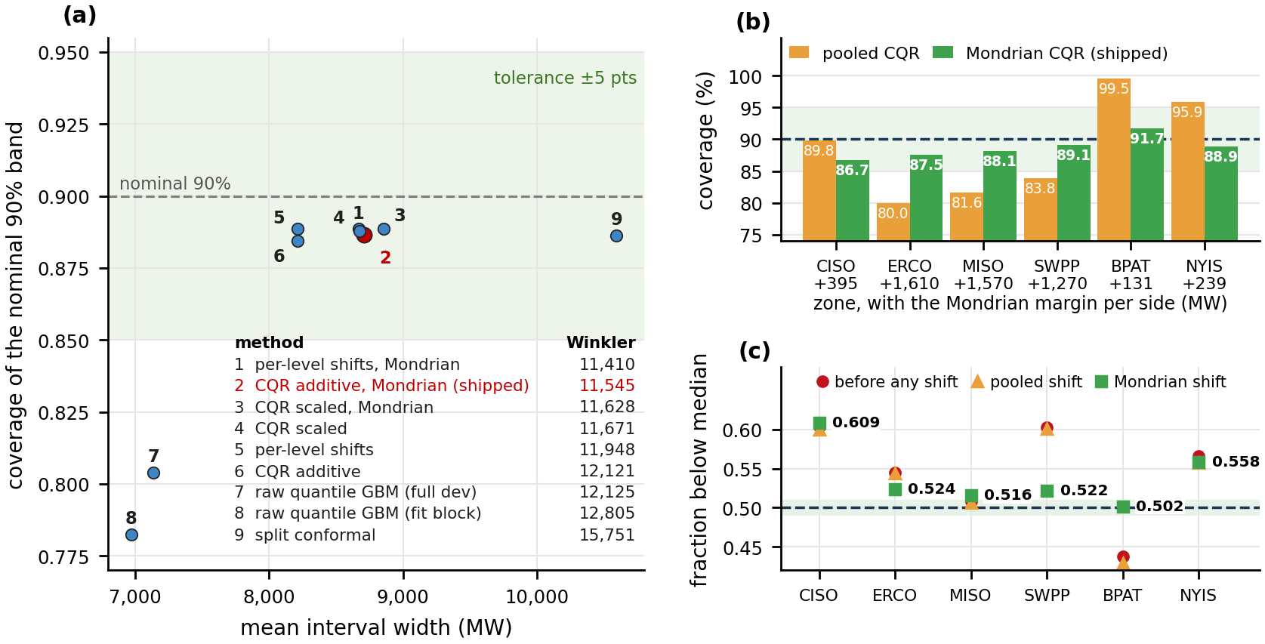
Figure 21. (a) Coverage against mean width for every interval construction, with the nominal 90% dashed, the ±5-point tolerance shaded and each point numbered, its Winkler score given in the key; the raw band is sharp but under-covers, every calibrated band reaches the tolerance, and the Mondrian variants pay a little width for a better score. (b) 90% coverage per zone, pooled against Mondrian, with each zone's margin printed under its name; (c) the fraction of outcomes below the median per zone before and after the shifts, against the 0.500 ± 0.010 band. What to observe: conditioning on zone collapses the coverage spread from 19.6 to 5.0 points, but California's median moves away from 0.5 because its bias changed sign between years. Source: notebook 08 §8.6; notebook 06 §6.2c (08_coverage_vs_width.png; 06_mondrian_by_zone.png).

7.4 By horizon and by regime
A band fitted, calibrated and scored at every horizon on that horizon's own champion (Figure 22a) reaches Mondrian coverage 85.9% at h=1, 88.8% at h=24, 89.4% at h=48 and 89.7% at h=72 (raw 78.1 / 77.2 / 76.8 / 76.0%), with widths 2,272 → 8,757 → 9,982 → 10,393 MW. The two long horizons land within 0.7 of a point of nominal, so the conformal correction transfers across lead time. h=1 is not helped (worst zone California at 80.8%): at h=1 the band is narrow and the model has spent everything on sharpness, so the California drift is a larger relative miss there. The conformal guarantee is marginal and rests on exchangeability between the calibration block and the block being predicted; across a year of solar build-out in one zone, that is the assumption that breaks first. By regime the shipped band covers 90.8% of winter-shaped days, 90.0% of conventional days and 85.6% of duck days, and 84.7% of the 3,612 duck-day evening hours (16:00–21:00): the regime the project exists for is the one the band protects least, which Section 7.6 acts on.

7.5 With the weather as it was actually forecast
Every result above hands the model perfect weather foresight. Injecting Gaussian noise at published forecast-error magnitudes (temperature sigma 2.33, 2.92, 3.72 °C at one, two, three days) changes almost nothing (+2.5 MW at h=24; interval width 0 / +1.1 / −10.0 / −2.1 MW across horizons), but unstructured noise is the wrong error model. The real test re-scores the holdout on the weather forecast as issued at each lead, swapping only same-hour weather columns (Figure 22b–c): the penalty is −10.1 MW (−0.47%) at h=24, where the issued forecast scored slightly better than reanalysis, +1.9 MW (+0.08%) at h=48 and +37.0 MW (+1.50%) at h=72, with the 95th-percentile error spread widening 1.84% at three days. What widens the band is losing the recent lags (the interval triples from h=1 to h=24 before a degree of forecast error is injected), not weather error; the gap between a forecast that could run tomorrow and one that could not is a measured 1.5% at three days and nothing at one.
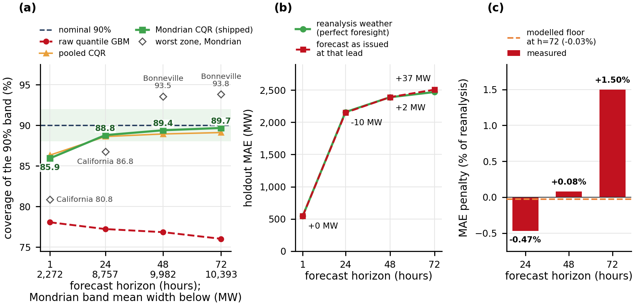
Figure 22. (a) 90% coverage per horizon, raw, pooled CQR and Mondrian, with the worst zone named and the shipped band's mean width under each horizon; h=1 fails at 85.9% (California 80.8%) while h=24–72 reach 88.8–89.7%. (b)–(c) the holdout re-scored on the weather forecast an operator would have held at each lead against the reanalysis, (b) as MAE and (c) as a percentage of the reanalysis score: the penalty is 0 at h=1, −10.1 MW at h=24 and +37.0 MW (+1.50%) at h=72. Source: notebook 06 §6.2b and §6.3b (06_coverage_by_horizon.png panel a; 06_operational_weather.png).

7.6 What the distribution is for: reserve placed where the risk is
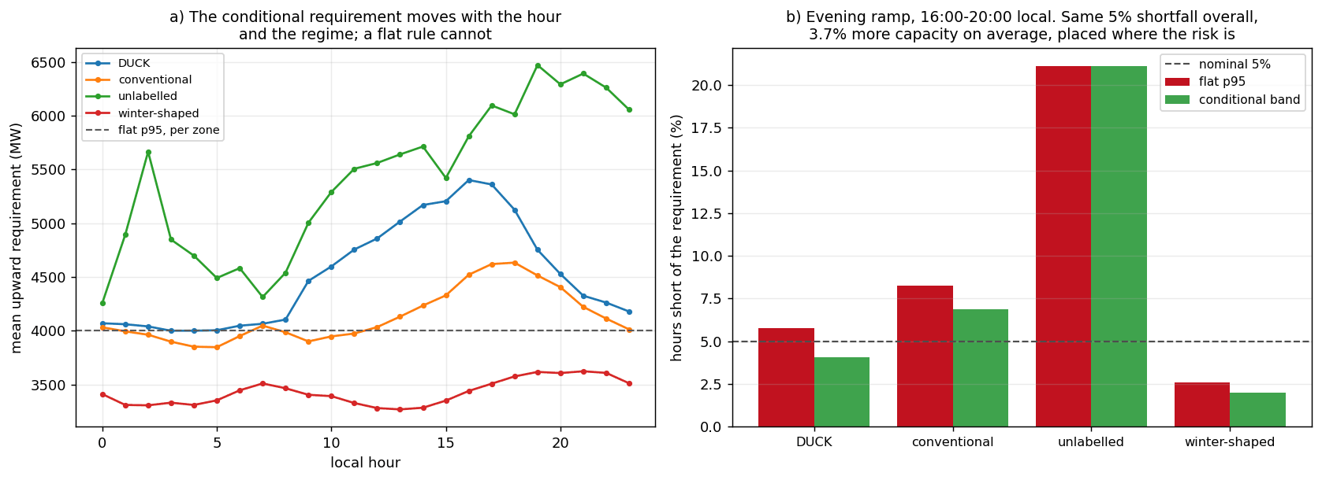
Figure 23. The conditional band against a flat quantile at equal risk. (a) Mean upward reserve requirement by local hour, one line per regime, against the flat per-zone 95th percentile (dashed). (b) Share of evening-ramp hours (16:00–20:00) each rule leaves short, by regime, against the nominal 5%. What to observe: the conditional rule holds 880 MW (3.7%) more capacity and cuts the duck-evening shortfall from 5.8% to 4.1%, while a flat rule carries capacity nobody needs at the duck-day midday. Source: notebook 08 §8.6c (08_conditional_reserve.png).
The calibrated conditional band can be turned into a reserve rule and compared with the flat per-zone 95th-percentile rule an operator would use by default, at equal average risk (Figure 23). Across the six zones the conditional band asks for 24,901 MW against the flat rule's 24,021 MW, 880 MW (3.7%) more. What it buys is capacity in the right hours: across the evening ramp (16:00–20:00 local) the flat rule is short 8.3% of the time on conventional days and 5.8% on duck days against its nominal 5%, the conditional band 6.9% and 4.1%; it pays with the 880 MW and with more misses overnight on duck days (4.8% → 6.1%), while both rules over-cover the duck-day midday. The hour it protects is precisely the one this project is about. Conditioning does not make reserve cheaper; it makes it better placed, and the regime label that barely helped the point forecast is what makes the placement possible. No monetary value is claimed: the notebooks price the day-ahead headroom saving under three reserve-price scenarios and two scoring conventions, and the annual value spans −31.6 to +40.6 million dollars, its sign depending on the convention and on a price that is a contingency product rather than a forecast-error product; the model's advantage is also concentrated in one zone (California +3,118 MW of signed headroom against MISO −1,060).

7.7 Sources of uncertainty: what was quantified and what was not
One reporting discipline first: in three comparisons the two methods' confidence intervals overlap almost entirely and the paired test rejects decisively (rearrangement improves the median's pinball loss by +2.8 MW [1.9, 3.7], p = 2.0e-7; Mondrian improves Winkler by 581.8 MW [491.8, 671.9]), because methods scored on the same hours move together. Every comparison here is therefore paired. Table 5 lists each source of uncertainty and how it was treated.
Source | How it was addressed | Quantified?
Data | Pre-registered cleaning checks; 12 impossible values nulled, 163 rows dropped; imputed-lag rows flagged (0.49% of holdout, 3.5× error) | yes, by row class; EIA-930 measurement error itself not modelled
Sampling / split | Five expanding chronological folds, 191-h gap; fold noise floor 50.7 MW; sealed holdout; rolling-origin refits for the missing January | yes
Model | Four families on one protocol; one-at-a-time sweeps against the noise floor; paired block-bootstrap intervals | yes; sequence models rejected by argument, not measured
Prediction | Seven-quantile model, rearranged, CQR-calibrated, Mondrian by zone: 88.7% coverage, Winkler 11,545 | yes, marginally and per zone; coverage by hour of day not computed
Evaluation | Tests on 1,974 zone-day blocks with BH correction; paired rather than overlap comparisons | yes
Weather input | Synthetic noise (≈0 effect); operational swap with the forecast as issued (+1.50% MAE at h=72) | yes, for the six forecast variables available; nine columns keep reanalysis values
Structural / drift | Calibration-block vs holdout drift diagnosed in the median (0.538) and California's sign reversal; Winter Storm Uri (Feb 2021) in training only | diagnosed, not corrected; rolling calibration named, not run
Deployment | Fixed-origin (10:00 D−1) scoring 2,296.9 MW; abstention rule for imputed lags; one weather point per region | partly; data latency and forecast revision cycles not modelled
Causal | Three designs (Section 8); DiD interval contains zero; matching confounded by zone | causal claim withheld
Table 5. Sources of uncertainty, how each was treated, and whether it was quantified. Source: notebooks 01, 04, 06, 08.

8. Causal inference: does more solar cause steeper ramps?
The question is natural and three designs asked it; the honest answer is that the data cannot settle it. A directed acyclic graph with demand growth, zone characteristics, weather and solar share gives 56 back-door paths from solar share to the evening ramp, 2 open with no adjustment and 48 opened by conditioning on same-hour demand, a collider; the admissible observed set is {demand, humidity, temperature, wind speed}. The naive pooled slope is +582.1 MW of evening ramp per percentage point of solar share [433.6, 730.6]. Difference-in-differences (Figure 24a), treating California, Texas and MISO against Bonneville, New York and the Plains at a 2022-01-01 cut-off, passes its pre-trend screen (+58.9 vs +32.8 MW per quarter) and estimates +2,083.8 MW with a 95% interval of [−856.9, +5,024.4] that contains zero, because the design learns from six groups rather than 315,485 rows. Propensity matching of high-solar to low-solar days on temperature, humidity, wind and demand (Figure 24b) gives +7,180.3 MW [6,926.8, 7,427.2] on 2,108 of 3,941 treated days (53.5%), with a Rosenbaum Γ [17] of 18.40; but 98.5% of matched pairs are cross-zone, so the "hidden confounder" is simply which zone a day belongs to, and adding non-admissible covariates shifts the estimate by 1,537.4 MW. All three designs agree on direction; the two group-level designs disagree by a factor of three on size and neither identifies it, so the report records a claim withheld rather than a claim made.
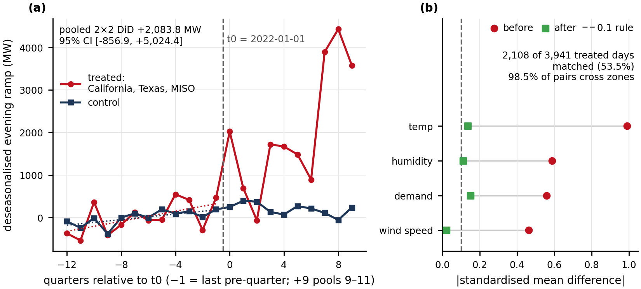
Figure 24. Two causal designs, no claim. (a) difference-in-differences event study, quarterly treated-minus-control evening ramp before and after 2022-01-01; the pooled 2×2 gives +2,083.8 MW with an interval that includes zero. (b) covariate balance before and after propensity matching; three of four covariates remain marginally above the 0.1 convention and 98.5% of pairs cross zones. What to observe: the designs point the same way and cannot identify the size. Source: notebook 03 §3.4–3.5 (03_did.png panel a; 03_matching.png panel a).

9. Discussion, limitations and conclusions

9.1 What was learned, question by question
Q1: yes, with a measured margin. Net load can be forecast a day ahead from public data with an error of 2,139.7 MW on the hours every benchmark reaches, 13.9% better than the hardest public-data forecast the project could build and 30.1% better than the EIA's own forecast lifted to net load; the margin survives blocked paired tests and a once-a-day issue time. It is an advantage in the renewable term, a third of the error in California and nothing in New York, and it is a day-ahead advantage: beyond a day the model still beats the strengthened composite (6.3%, 3.7%) but as a lower bound. Q2: a band that holds per region, with a named failure. A conformal 90% band conditioned on zone covers 88.7% of hours and every zone within five points, where a pooled band covered Bonneville at 99.5% and Texas at 80.0%; the median sits at 0.538 and h=1 under-covers at 85.9%, both because the test year drifted from the calibration year in a way conditioning on zone cannot see. Lead time, not weather error, widens the band. Q3: a stable partition whose usefulness is specific. Three regimes reproduce at ARI 0.996 and their temperature signature is corroborated inside five zones; but the duck is California, the irradiance signature is geography, and the label buys the point forecast 17.4 MW. Where the regimes earn their place is the uncertainty arm, where a reserve rule conditioned on regime and hour moves the duck-evening shortfall from 5.8% to 4.1%.
How the two arms form one investigation. They share the panel, the pipeline, the folds and the gap, so the regime label was tested inside the forecaster's own cross-validation; the surrogate tree explains the clusters with the forecaster's inputs; the failure analysis reads the 16:00 error peak as the duck's ramp arriving early; and the uncertainty arm uses the regime as the conditioning variable that turns a marginal band into a reserve rule. Neither arm replaces the other: the supervised arm produces the forecast, the unsupervised arm says what kind of day it is forecasting, and the interval connects both to a decision.
What surprised, and what went wrong. Mutual information would have deleted the most useful engineered family; the fix was to let the model see everything. The lag family the model leans on most is nearly replaceable on refit while weather is not, so one importance measure alone would have misled. The zone encoding is worth 3.3 MW and the regime label barely helps the point forecast. Three defects were found by audit rather than avoided (the fuel columns, the rolling windows, the local-versus-UTC join), each measured before it was fixed, which is why these numbers are smaller and more defensible than an earlier run's.
Ethics and deployment. An under-forecast of the evening ramp is paid for by consumers through scarcity prices or load shedding, so a band 15 points under-covered on duck evenings would shift risk to exactly the hours when it is most expensive; the recommended operational object is the conditional band, not the point forecast. Abstaining on imputed inputs is an ethical choice as well as a technical one. Bonneville and New York gain little or nothing, and replacing their operators' own forecasts would be a regression, which per-region reporting makes visible. No dollar figure is quoted because its sign depends on the scoring convention.

9.2 Limitations
Limitation | What it affects | What would address it
One weather point per balancing authority | Bonneville's hub-height wind correlation fell when the reading moved up; the Plains' 14.6% scaled error is shared by every benchmark | Three to four metro points per region, load-weighted; the decision log's first upgrade
ERA5 reanalysis as the weather input | Every result except Section 7.5 assumes perfect weather foresight; measured penalty 1.50% at h=72, ≈0 at h=24, for six of fifteen variables | Archived forecasts for all fifteen variables; a forecast-weather training arm
Holdout holds no January and is 2.16 °C warmer than the development block; Winter Storm Uri (Feb 2021) is in training only | Winter is evaluated only by rolling-origin refits (2,400.8 MW); no claim about extreme-weather skill is possible | A second test year with a January and an extreme episode
Calibration block and holdout differ (drift) | Median 0.538; California's bias changed sign; h=1 coverage 85.9% | Rolling or adaptive calibration per zone [5]; not run
New York's public data show no solar | Net load ≈ demand there; the ISO's forecast cannot be beaten (paired gap includes zero) | Behind-the-meter PV estimates [13]
Pooled model, pooled importance | Pressure and snow depth cannot be read as mechanisms; 5-PC clustering choice is on a thin margin (0.9958 vs 0.9951) | Within-zone importance; report the 8-PC partition as a robustness check
Classifier threshold chosen on the holdout; coverage by hour of day not computed | The 0.674 operating point is optimistic; the fan chart's trough escapes are a visual reading | Threshold from development folds; per-hour coverage tables
Reserve prices are contingency products; no energy prices | Any dollar figure is an upper bound of uncertain sign; none is quoted | Market-specific flexible-ramp prices; a cost-asymmetry estimate
Table 6. Limitations, their consequences and the named remedy. Source: docs/03_decision_log.md; notebooks 01, 04, 05, 06, 08.

9.3 Conclusions and future work
Six grids, six years and three public sources were enough to show that net load, the quantity dispatch actually serves, can be forecast a day ahead from public data with an error of 2,139.7 MW, 30.1% below the best forecast the public currently has and 13.9% below a harder one built so that the result could not rest on a weak rival; that the error can be bounded by a band that holds region by region (88.7% coverage, every zone within five points); and that the days of these grids fall into three shapes that reproduce at ARI 0.996, of which the duck is California's. The method is as much the result as the numbers: goals and predictions registered before modelling, a holdout sealed before tuning, leakage found by audit and measured before removal, every comparison paired and blocked, every importance measure reported with the question it answers, and every number traced to a ledger from which 791 of 927 reproduce and none differ.
To an operator: use the conditional band, not the point forecast, to size evening reserve on duck days, and flag any hour whose lag inputs were imputed rather than forecast it. To a market participant: the model's edge is in the renewable term, largest in California and absent in New York, and it is a day-ahead edge. To a forecaster: features beat settings here by an order of magnitude (823 MW for the selector's k against 5 MW for regularisation), and weather is the one family no other input can replace.
Future work follows the failure analysis in priority order: several weather points per region with a load-weighted mean, the one change that addresses the hardest region, the worst-covered zone and the published finding on station selection at once; a solar-ramp feature family from forecast irradiance over the coming hours, worth an estimated 40–51 MW and aimed at the 16:00 peak; a rolling calibration window per zone, the named fix for the 0.538 median and the h=1 coverage failure; and a second test year with a January and, ideally, an extreme episode. None of these needs a different model: the learning curve says more of the same history will not help and the ladder says a different estimator will not either. What would help is better inputs and a calibration that moves with the grid, which is the conclusion a report on a changing fleet ought to reach.

References
- U.S. Energy Information Administration. Hourly Electric Grid Monitor (EIA-930), EIA Open Data API v2. https://www.eia.gov/opendata/
- Open-Meteo. Historical Weather API (ERA5 reanalysis, ECMWF) and Previous Runs API. https://open-meteo.com/
- Romano, Y., Patterson, E. and Candès, E. (2019). Conformalized quantile regression. NeurIPS 32.
- Vovk, V. (2012). Conditional validity of inductive conformal predictors. ACML, PMLR 25.
- Gibbs, I. and Candès, E. (2021). Adaptive conformal inference under distribution shift. NeurIPS 34.
- Winkler, R. L. (1972). A decision-theoretic approach to interval estimation. JASA 67(337), 187–191.
- Diebold, F. X. and Mariano, R. S. (1995). Comparing predictive accuracy. J. Business & Economic Statistics 13(3), 253–263.
- Lundberg, S. M. and Lee, S.-I. (2017). A unified approach to interpreting model predictions. NeurIPS 30.
- Apley, D. W. and Zhu, J. (2020). Visualizing the effects of predictor variables in black box supervised learning models. JRSS-B 82(4), 1059–1086.
- Benjamini, Y. and Hochberg, Y. (1995). Controlling the false discovery rate. JRSS-B 57(1), 289–300.
- Hong, T., Pinson, P., Fan, S., Zareipour, H., Troccoli, A. and Hyndman, R. J. (2016). Probabilistic energy forecasting: GEFCom2014 and beyond. Int. J. Forecasting 32(3), 896–913.
- Kaur, A., Nonnenmacher, L. and Coimbra, C. F. M. (2016). Net load forecasting for high renewable energy penetration grids. Energy 114, 1073–1084.
- Wang, Y., Zhang, N., Chen, Q., Kirschen, D. S., Li, P. and Xia, Q. (2018). Data-driven probabilistic net load forecasting with high penetration of behind-the-meter PV. IEEE Trans. Power Systems 33(3), 3255–3264.
- Denholm, P., O'Connell, M., Brinkman, G. and Jorgenson, J. (2015). Overgeneration from Solar Energy in California: A Field Guide to the Duck Chart. NREL/TP-6A20-65023.
- Ruggles, T. H., Farnham, D. J., Tong, D. and Caldeira, K. (2020). Developing reliable hourly electricity demand data through screening and imputation. Scientific Data 7, 155.
- Hong, T., Wang, P. and White, L. (2015). Weather station selection for electric load forecasting. Int. J. Forecasting 31(2), 286–295.
- Rosenbaum, P. R. (2002). Observational Studies, 2nd ed. Springer.
- Ke, G. et al. (2017). LightGBM: a highly efficient gradient boosting decision tree. NeurIPS 30.
- Chernozhukov, V., Fernández-Val, I. and Galichon, A. (2010). Quantile and probability curves without crossing. Econometrica 78(3), 1093–1125.
- Hubert, L. and Arabie, P. (1985). Comparing partitions. J. Classification 2, 193–218.
Statement of work. Alan Mossinger, Eric Londo, Eran Abeysekera wrote the code and ran the analysis together: Eran focused on data acquisition and cleaning, the feature pipeline and its leakage audits, the causal analysis, while Eric focused on the supervised modeling, tuning and evaluation, and Alan focused on unsupervised modelling, uncertainty calibration and explainability. The team wrote the report and prepared the GitHub structure simultaneously and collectively.

