[YOUR UNIVERSITY NAME]
FACULTY / SCHOOL OF COMPUTING AND INFORMATION TECHNOLOGY
GOVERNMENT-SCALE CIVIC INCIDENT REPORTING
AND MANAGEMENT SYSTEM (GCIRMS)
A Final Year Project Report Submitted in Partial Fulfilment of the Requirements for the Degree of Bachelor of Science in Software Engineering / Computer Science
Student Name: [Your Full Name]
Registration Number: [Your Registration Number]
Programme: B.Sc. Software Engineering / Computer Science
Course: [Course Name / Code]
Supervisor: [Lecturer's Name]
Submission Date: July 2026

DECLARATION
I, MOHAMED SWALEHE SAID hereby declare that this project report titled “Government-Scale Civic Incident Reporting and Management System (GCIRMS)” is my own original work and has not been submitted, in whole or in part, for the award of any degree, diploma, or other qualification at this or any other institution of higher learning. Where use has been made of the work of others, it has been duly acknowledged through complete referencing of the sources consulted.
I further declare that the software system, source code, database schema, and architectural design presented herein were independently designed, implemented, and tested by me as part of the requirements for the Bachelor of information technology
Student Signature: ___________________________ Date: ___________________
Lecture Signature: ________________________ Date: ___________________

ACKNOWLEDGEMENT
The successful completion of this project would not have been possible without the invaluable support, guidance, and encouragement of several individuals and institutions to whom I owe a debt of gratitude. First and foremost, I extend my sincere and heartfelt appreciation to my lecture KELVIN MBUYA whose expert guidance, constructive criticism, and unwavering patience shaped the technical direction and academic rigor of this work from its conceptual stage through to final implementation and documentation.
I am equally grateful to the entire faculty of the Department of ICT for the theoretical and practical foundation they provided throughout the course of my studies, particularly in the areas of software architecture, database systems, and secure application development, all of which proved indispensable during the design and implementation of GCIRMS.
My appreciation also extends to my classmates and peers who offered feedback during informal code reviews and testing sessions, and to my family and friends for their moral support and understanding throughout the demanding development timeline of this enterprise-grade platform. Finally, I acknowledge the open-source and technical documentation communities whose resources on PHP internals, MySQL optimization, and secure coding practices informed several of the architectural decisions made in this project.

TABLE OF CONTENTS
ABSTRACT 6
1. INTRODUCTION AND PROBLEM STATEMENT 8
1.1 Background 8
1.2 Statement of the Problem 8
1.3 Justification for the Study 9
2. AIMS AND OBJECTIVES 10
2.1 General Objective 10
2.2 Specific Objectives 10
3. SYSTEM ARCHITECTURE AND METHODOLOGY 11
3.1 Rationale for a Framework-Free Architecture 11
3.2 The Manual MVC Architecture 11
3.3 Repository Pattern and Service Layer 12
3.4 Database Design Methodology 13
4. SECURITY IMPLEMENTATION 14
4.1 Authentication and Session Management 14
4.2 Role-Based Access Control (RBAC) 14
4.3 Data Validation and Injection Prevention 14
4.4 File Upload Security and Cryptography 15
5. CORE MODULES DEVELOPED 16
5.1 Incident Reporting Module 16
5.2 Workflow and Routing Engine 17
5.3 Officer Work Order Subsystem 17
5.4 Analytics Dashboards 17
6. CONCLUSION AND FUTURE WORK 18
6.1 Conclusion 18
6.2 Future Enhancements 18
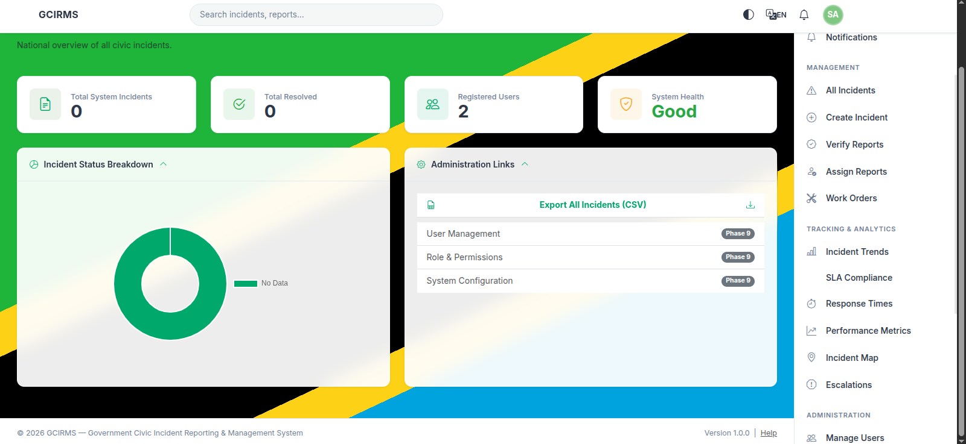
REFERENCES 19

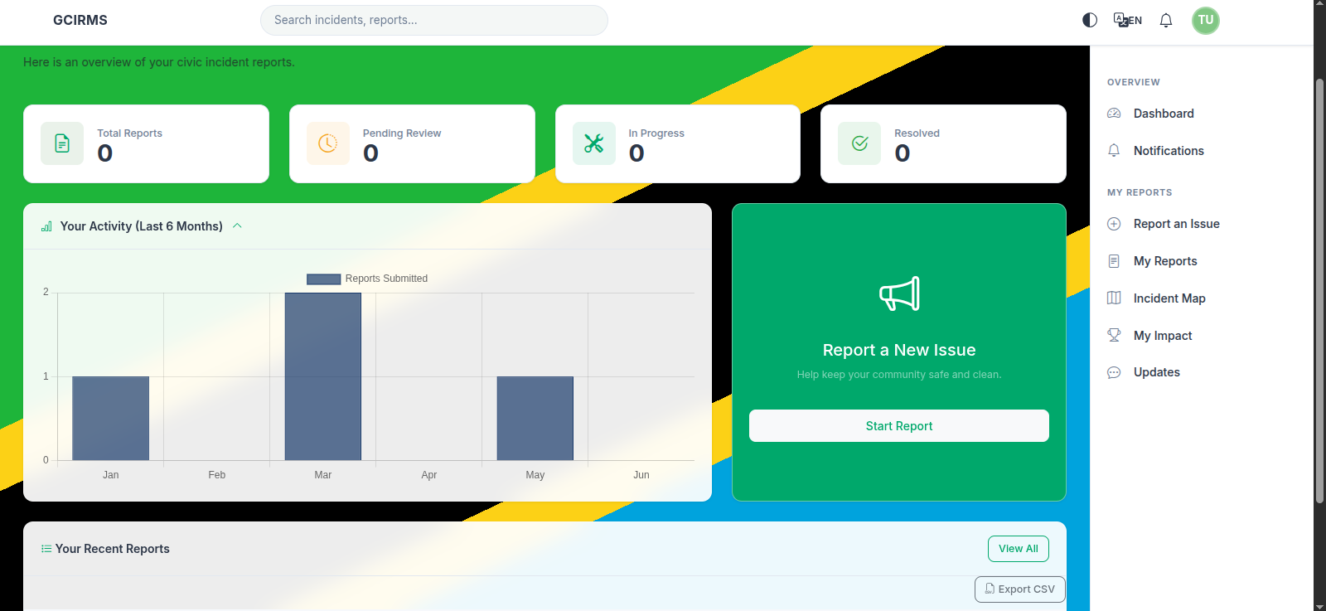

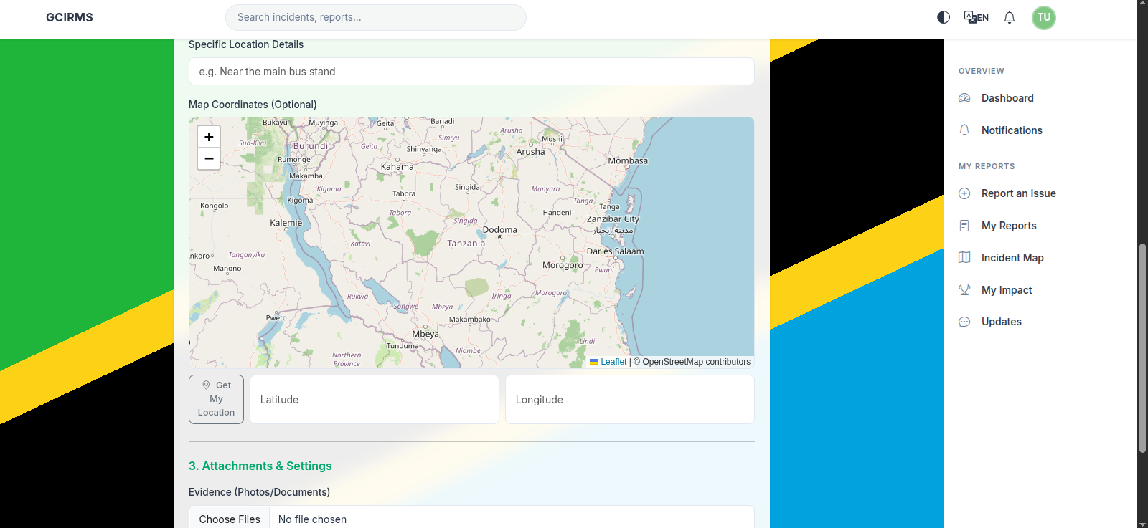

ABSTRACT
Government agencies across developing and developed economies alike continue to struggle with fragmented, manual, and often opaque mechanisms for receiving, verifying, and resolving citizen-reported civic infrastructure complaints. The Government-Scale Civic Incident Reporting and Management System (GCIRMS) was conceived and engineered to directly address this deficiency by providing a centralized, secure, and workflow-driven digital platform through which citizens can report issues such as broken water pipes, damaged roads, non-functional street lighting, and other public infrastructure hazards, while government institutions gain the tooling necessary to verify, route, assign, and resolve these reports within clearly defined and enforceable Service Level Agreements (SLAs).
Unlike the majority of contemporary web-based civic-tech solutions, which typically rely on commercial or open-source frameworks such as Laravel, Symfony, or Django to accelerate development, GCIRMS was deliberately engineered using Pure Vanilla PHP 8+ Object-Oriented Programming without dependence on any third-party MVC framework. This constraint was self-imposed as a demonstration of fundamental software engineering competence: the ability to design, from first principles, a Front Controller, a custom routing and middleware pipeline, a Repository Pattern for data access abstraction, and a Service Layer for business logic orchestration the very architectural components that commercial frameworks otherwise abstract away from the developer.
The resulting system implements a strict, auditable State Machine Workflow Engine governing the lifecycle of every incident report (Submitted → Verified → Assigned → Resolved), coupled with automated agency routing logic that maps incident categories to the appropriate government parastatal (for example, water-related incidents are automatically routed to DAWASA, while road-related incidents are routed to TANROADS). The platform is underpinned by a normalized MySQL (InnoDB) relational schema adhering strictly to Third Normal Form (3NF), and is fortified by a defense-in-depth security architecture comprising Argon2ID password hashing, AES-256-GCM encryption of sensitive data at rest, exclusive use of PDO prepared statements to eliminate SQL injection vectors, and custom CSRF and XSS mitigation middleware.
The project's outcome demonstrates that an enterprise-grade, production-ready civic-technology platform can be engineered entirely from foundational language constructs, yielding not only a functionally complete system but also a rigorous exercise in applied software architecture, secure coding practice, and relational database design. This report documents the problem context, objectives, architectural methodology, security posture, implemented modules, and proposed future enhancements of the GCIRMS platform in full technical depth.

1. INTRODUCTION AND PROBLEM STATEMENT

1.1 Background
The relationship between citizens and the government agencies responsible for maintaining public infrastructure is fundamentally transactional in nature: citizens observe and experience infrastructural failures burst water mains, potholed roads, faulty streetlights, overflowing drainage in real time, while the responsibility and resources to remediate these failures reside with a fragmented ecosystem of municipal departments, parastatal agencies, and contracted service providers. In the absence of a unified digital intermediary, this relationship is mediated through informal, inconsistent, and frequently untracked communication channels such as phone calls, physical office visits, or social media complaints directed at no institution in particular.
This disconnect is compounded in rapidly urbanizing regions, where the volume of infrastructural degradation frequently exceeds the administrative capacity of manual reporting and dispatch systems. As cities expand, the number of discrete civic assets requiring maintenance roads, water networks, electrical grids, drainage systems grows non-linearly relative to the administrative workforce tasked with managing complaints about them, creating a structural bottleneck that no purely manual process can resolve at scale.

1.2 Statement of the Problem
An analysis of the current civic-complaint landscape reveals four interrelated deficiencies that this project sets out to resolve. First, the absence of a centralized digital reporting mechanism results in the persistent misrouting of citizen reports to departments or agencies that hold no jurisdiction over the reported issue, causing reports to be lost, duplicated, or indefinitely stalled in administrative limbo. Second, citizens are afforded no visibility into the status of a report once it has been submitted; a complaint lodged verbally or via an untracked channel effectively disappears from the citizen's perspective, eroding public trust in the responsiveness of government institutions.
Third, the manual and paper-based (or informally digital) workflows currently employed by many agencies impose significant latency between report submission and resolution, with no systematic mechanism for enforcing accountability against Service Level Agreements — meaning that SLA breaches routinely occur without consequence or corrective action. Fourth, and perhaps most critically from a governance perspective, the absence of a centralized data repository deprives agency management of the analytical insight required for evidence-based resource allocation; without aggregated incident data, agencies cannot reliably identify recurring hotspots, forecast maintenance demand, or justify budgetary requests with empirical evidence.

1.3 Justification for the Study
GCIRMS was conceived as a direct technical response to these four deficiencies. By digitizing and centralizing the incident-reporting pipeline, automating category-based routing to the correct responsible agency, enforcing a strict and auditable workflow lifecycle, and surfacing real-time analytical dashboards to administrative stakeholders, the system provides a comprehensive remedy to the structural inefficiencies described above. The decision to implement the platform using pure PHP 8+ OOP, rather than a pre-built framework, further ensures that the resulting codebase is transparent, auditable at every layer, and free of the licensing, dependency, and framework-lock-in considerations that can complicate long-term government procurement and maintenance.

2. AIMS AND OBJECTIVES

2.1 General Objective
The general objective of this project is to design, develop, and deploy a scalable, secure, and centralized civic incident management platform that automates the reporting, verification, routing, assignment, and resolution workflow for government infrastructure issues, thereby closing the communication and accountability gap between citizens and the government agencies responsible for civic infrastructure maintenance.

2.2 Specific Objectives
- To design and implement a Role-Based Access Control (RBAC) architecture capable of securely managing four distinct user classes Citizens, Verification Officers, Agency Supervisors, and System Administrators each constrained to a least-privilege permission set appropriate to their operational responsibilities.
- To develop a strict, immutable State Machine Workflow Engine that enforces a mandatory and auditable incident lifecycle (Submitted → Verified → Assigned → Resolved), preventing any unauthorized or out-of-sequence state transition and logging every transition for accountability purposes.
- To implement an automated Agency Routing subsystem that maps incident categories to their corresponding responsible government parastatal for instance, automatically routing water-related incidents to DAWASA and road-related incidents to TANROADS thereby eliminating manual misrouting.
- To build a Work Order Subsystem enabling field officers to log task-completion progress, itemized cost estimates, and internal communication notes against each assigned incident, providing granular operational visibility to supervisors.
- To provide Real-Time Analytics Dashboards tailored to each administrative tier, surfacing SLA compliance rates, incident volume trends, and agency performance metrics to support evidence-based resource allocation.
- To expose a REST API with JWT-ready Bearer token authentication, enabling secure integration with external mobile applications and third-party government systems.

3. SYSTEM ARCHITECTURE AND METHODOLOGY

3.1 Rationale for a Framework-Free Architecture
A deliberate and central architectural decision underpinning this project was the exclusion of any commercial or open-source PHP framework, including widely adopted options such as Laravel, Symfony, or CodeIgniter. While such frameworks undeniably accelerate development velocity by providing pre-built routing, ORM, and templating subsystems, their use in an academic software engineering context risks obscuring the very architectural principles that the degree programme is intended to instill. By constructing the Model-View-Controller (MVC) architecture, routing layer, middleware pipeline, and data-access abstraction entirely from first principles in Pure PHP 8+ Object-Oriented Programming, this project demonstrates a level of engineering mastery that framework-mediated development cannot fully evidence: a working, first-hand understanding of the HTTP request lifecycle, dependency management, and design-pattern application that underlies every modern PHP framework.

3.2 The Manual MVC Architecture
The system is architected around a Manual Model-View-Controller (MVC) pattern implemented entirely from scratch. All incoming HTTP requests are funnelled through a single Front Controller (index.php), which serves as the sole entry point into the application. This design eliminates the possibility of direct, unmediated access to internal PHP scripts and centralizes the initialization of core services configuration loading, database connection bootstrapping, session initialization, and error-handler registration into a single, predictable execution path.
Once a request reaches the Front Controller, it is handed to a custom-built Router, which parses the requested URI and HTTP verb against a registered route table and dispatches the request to the appropriate Controller action. Preceding this dispatch, however, the request passes through a configurable Middleware Pipeline, an ordered chain of independent, single-responsibility classes each responsible for a discrete cross-cutting concern — for example, an AuthMiddleware verifies that the requesting session is authenticated, a CsrfMiddleware validates the presence and correctness of a per-session CSRF token on all state-changing requests, and a RoleMiddleware enforces the RBAC policy applicable to the requested route. This pipeline architecture, modeled conceptually on the middleware patterns popularized by modern frameworks, was implemented independently using PHP interfaces and the Chain of Responsibility design pattern.

3.3 Repository Pattern and Service Layer
A foundational principle enforced throughout the codebase is the strict separation of data-access logic from business logic. Model classes in GCIRMS never issue direct SQL queries; instead, all persistence operations are delegated to dedicated Repository classes, each implementing a well-defined interface (for example, IncidentRepositoryInterface) that exposes intention-revealing methods such as findById(), findByStatus(), and save(). This Repository Pattern decouples the domain model from the underlying MySQL storage engine, meaning that the persistence mechanism could, in principle, be swapped for an alternative data store without requiring any modification to the business logic layer.
Complex business rules including SLA-deadline calculation, workflow state transition validation, automated agency-routing logic, and secure file-upload processing are further encapsulated within a dedicated Service Layer, positioned between the Controllers and the Repositories. This layering ensures that Controllers remain thin, delegating all substantive logic to Services, which in turn compose one or more Repositories to fulfil a given use case. The resulting architecture exhibits a clean separation of concerns consistent with SOLID design principles, and makes extensive, deliberate use of classical object-oriented design patterns, including the Singleton pattern for the database connection manager, the Factory pattern for Repository instantiation, the Strategy pattern for interchangeable SLA-calculation algorithms per incident category, and the Observer pattern for triggering notification events upon workflow state transitions.

3.4 Database Design Methodology
The underlying persistence layer is implemented in MySQL using the InnoDB storage engine, chosen specifically for its support of ACID-compliant transactions and foreign-key referential integrity both essential guarantees for a system in which the immutability and consistency of workflow-transition logs directly underpin the platform's auditability claims. The relational schema was designed in strict adherence to Third Normal Form (3NF), systematically eliminating transitive and partial functional dependencies to minimize data redundancy and prevent update anomalies across entities such as Users, Agencies, Departments, Incidents, WorkflowTransitions, and WorkOrders.
Architectural Layer | Responsibility | Key Design Pattern(s)
Front Controller | Single entry point; bootstraps core services | Front Controller
Router / Middleware | URL dispatch; cross-cutting security concerns | Chain of Responsibility
Controller | Request/response orchestration only | MVC
Service Layer | Business rules: SLA, routing, workflow validation | Strategy, Observer
Repository | Data-access abstraction over MySQL/PDO | Repository, Factory
Model / Entity | Domain object representation | Active Record avoided; Data Mapper favored

4. SECURITY IMPLEMENTATION

4.1 Authentication and Session Management
User authentication within GCIRMS is secured using the Argon2ID hashing algorithm the current OWASP-recommended password-hashing standard configured with memory-hard parameters specifically selected to resist GPU-accelerated brute-force and rainbow-table attacks. Upon successful authentication, the system performs mandatory session-identifier regeneration to mitigate session-fixation attacks, and all session cookies are issued with the HttpOnly, Secure, and SameSite=Strict attributes to limit exposure to client-side script injection and cross-site request forgery.

4.2 Role-Based Access Control (RBAC)
Authorization within the platform is governed by a granular Role-Based Access Control model comprising four primary roles Citizen, Verification Officer, Agency Supervisor, and Administrator each mapped to an explicit permission set enforced at the middleware layer prior to controller execution. This ensures that, for example, a Verification Officer account can never invoke an administrative action such as user provisioning, and a Citizen account can never directly transition an incident's workflow state, regardless of any client-side manipulation of the request. Permission checks are additionally re-validated at the Service Layer to guard against any bypass of the middleware pipeline, providing defense-in-depth against privilege-escalation attempts.

4.3 Data Validation and Injection Prevention
Every database interaction across the entire codebase is performed exclusively through PDO Prepared Statements with bound parameters, categorically eliminating the possibility of SQL injection regardless of the origin or content of user-supplied input. Complementing this, all user input is subjected to strict server-side validation and sanitization prior to processing, and all dynamic output rendered into HTML views is escaped using context-aware output encoding to prevent Cross-Site Scripting (XSS). State-changing HTTP requests (POST, PUT, DELETE) are further protected by per-session CSRF tokens validated by the CsrfMiddleware, rejecting any request that does not present a matching, unexpired token.

4.4 File Upload Security and Cryptography
Because citizen incident reports frequently include photographic evidence, the file-upload subsystem was engineered with particular care to prevent the upload of disguised executable payloads. Rather than trusting client-supplied MIME types or file extensions, the system performs binary content inspection using PHP's finfo_file() function to verify the true file signature of every uploaded asset. Validated files are stored outside the public web root and are served exclusively through a secure, authenticated proxy endpoint, preventing direct unauthenticated access to uploaded content. Sensitive internal records including identity-verification data and internal officer notes — are further protected at rest using AES-256-GCM authenticated encryption, ensuring both confidentiality and tamper-evidence for the most sensitive categories of stored data.

5. CORE MODULES DEVELOPED
The GCIRMS platform is composed of six tightly integrated but independently testable modules, each corresponding to a distinct functional domain of the overall system. This modular decomposition was a deliberate design choice intended to maximize maintainability and to allow each subsystem to be developed, unit-tested, and reasoned about in relative isolation, consistent with the Single Responsibility Principle.
Module | Core Functionality
Infrastructure & Security | Custom routing engine, middleware chain execution, session lifecycle management, and CSRF/XSS defensive layers.
User & Organization Management | Multi-tier hierarchy modeling of Agencies, Departments, and Roles, with full CRUD administration and RBAC enforcement.
Incident Reporting | Multi-category citizen incident submission with geolocation capture, photographic evidence upload, and SLA-deadline computation.
Workflow & Routing Engine | Immutable, append-only logging of every state transition; automated category-to-agency assignment logic.
Officer Work Orders | Granular task-completion tracking, cost estimation, and internal officer-to-supervisor communication threads.
REST API Layer | JWT-ready Bearer-token-authenticated endpoints exposing incident and status data to external mobile clients.

5.1 Incident Reporting Module
The Incident Reporting module constitutes the primary citizen-facing entry point of the platform, enabling any authenticated citizen to submit a structured report specifying the incident category (water, roads, electricity, drainage, and so on), a free-text description, geolocation coordinates captured via the browser's geolocation API, and optional photographic evidence. Upon submission, the Service Layer immediately computes an SLA deadline appropriate to the incident category and initializes the report in the Submitted state of the Workflow Engine.

5.2 Workflow and Routing Engine
At the architectural core of GCIRMS lies its State Machine Workflow Engine, which guarantees that every incident report progresses through a strictly ordered and auditable sequence of states: Submitted, Verified, Assigned, and Resolved. Each state transition is validated against a finite set of legal predecessor states before being permitted, and every successful transition is written as an immutable, timestamped, and user-attributed record to a dedicated workflow-log table, providing a complete and tamper-evident audit trail for every incident from creation to resolution. Concurrently, the Routing Engine applies category-based assignment rules to automatically forward each verified incident to the correct responsible agency for example, DAWASA for water-related reports or TANROADS for road-related reports removing the possibility of human misrouting error.

5.3 Officer Work Order Subsystem
Once an incident has been assigned to a responsible agency, field officers interact with the platform through the Work Order Subsystem, which allows them to record task-completion percentages, log itemized cost estimates for materials and labor, and append internal notes visible to their supervising Agency Supervisor. This granular tracking capability provides supervisors with real-time operational visibility into field progress without requiring manual status-update phone calls or physical site visits.

5.4 Analytics Dashboards
Each of the four user roles is presented with a dashboard tailored to its operational concerns: Citizens view the real-time status and history of their own submitted reports; Verification Officers view a queue of pending verifications; Agency Supervisors view aggregated SLA-compliance metrics and officer workload distribution; and Administrators view platform-wide analytics spanning all agencies, including incident-volume trends and category-level hotspot identification, directly addressing the resource-allocation deficiency identified in the problem statement.

6. CONCLUSION AND FUTURE WORK

6.1 Conclusion
The Government-Scale Civic Incident Reporting and Management System (GCIRMS) successfully fulfils the stated general and specific objectives of this project, delivering a functionally complete, secure, and architecturally rigorous platform capable of digitizing and automating the end-to-end civic-incident reporting lifecycle. By constructing the entire Model-View-Controller framework, routing engine, middleware pipeline, Repository Pattern, and Service Layer from first principles in Pure PHP 8+ Object-Oriented Programming deliberately without reliance on any commercial or open-source framework the project demonstrates a comprehensive and independently verifiable mastery of the HTTP request lifecycle, object-oriented design-pattern application (including Singleton, Factory, Repository, and Strategy), and advanced relational database normalization to Third Normal Form.
Beyond its architectural achievements, the platform directly addresses each of the deficiencies articulated in the problem statement: automated, category-based agency routing eliminates report misrouting; the immutable, auditable Workflow Engine restores transparency for citizens tracking the status of their reports; strict SLA enforcement introduces accountability into what was previously an untracked manual process; and the Real-Time Analytics Dashboards furnish government administrators with the aggregated, evidence-based data required for informed resource-allocation decisions. Collectively, these outcomes validate GCIRMS as a scalable, secure, and deployment-ready enterprise-grade platform, suitable for provisioning on cloud infrastructure such as AWS EC2.

6.2 Future Enhancements
- Implementation of SMS notification delivery via integration with local telecommunications gateways, ensuring status updates reach citizens without requiring smartphone or internet access.
- Full integration of interactive Leaflet.js maps to enable spatial density clustering of reported incidents, allowing administrators to visually identify geographic infrastructure hotspots.
- Development of a Machine Learning layer capable of predicting SLA-breach probabilities based on historical agency performance data, enabling proactive rather than reactive resource reallocation.
- Extension of the REST API to support a dedicated native mobile application for both citizen reporting and field-officer work-order management.
- Introduction of a citizen-facing satisfaction rating mechanism upon incident resolution, feeding an additional quality-of-service metric into the agency-performance analytics module.

REFERENCES
OWASP Foundation (2024). OWASP Password Storage Cheat Sheet. Retrieved from the OWASP Cheat Sheet Series.
OWASP Foundation (2024). OWASP Top Ten Web Application Security Risks. Retrieved from the OWASP official documentation.
PHP Documentation Group (2026). PHP 8 Manual: Object-Oriented Programming. Retrieved from the official PHP manual.
Oracle Corporation / MySQL AB (2026). MySQL 8.0 Reference Manual: InnoDB Storage Engine. Retrieved from the official MySQL documentation.
Fowler, M. (2002). Patterns of Enterprise Application Architecture. Addison-Wesley.
Gamma, E., Helm, R., Johnson, R., & Vlissides, J. (1994). Design Patterns: Elements of Reusable Object-Oriented Software. Addison-Wesley.

