User Manual

Boggle is an extremely fun board game, traditionally played with family members and friends but in this version, it is played against a computer player. The rules of the game are simple. There is a 4 x 4 grid with16 cubes

The objective is to find most # of words in 1 minute with at least three letters. No repeating cubes in a word. There are singular and plural forms are counted as 2 words.

Program Graphics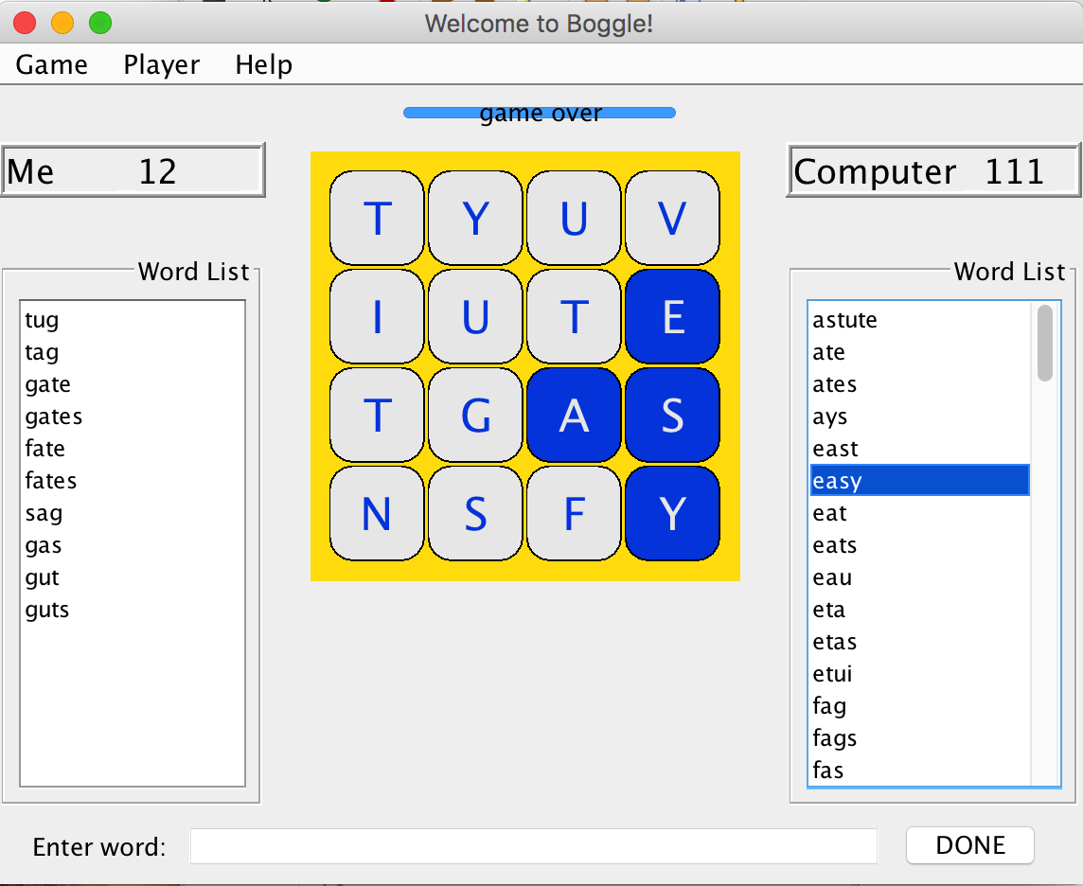

**Visual of Boggle’s Graphical User Interface**

Above is what the general Boggle game looks like. The design is simple, user-friendly, and intuitive to use. “Enter word:” at the bottom signifies that the right text field is where the user should enter their list of words. The “Done” button automatically ends the game and shows the list of words that the computer player found.