
PRODUCT RELE ASE

UPC: 099071008602

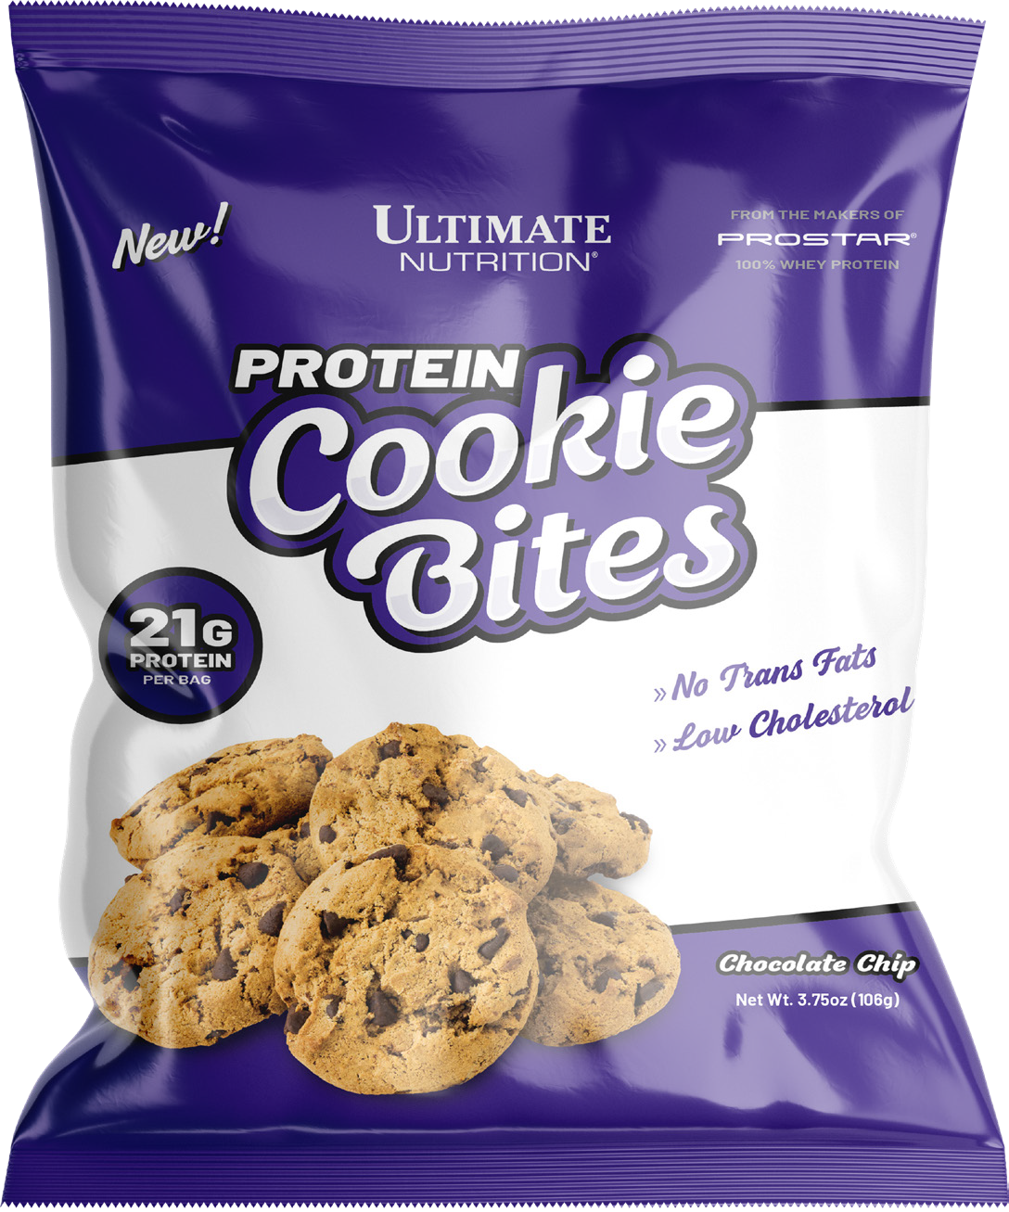
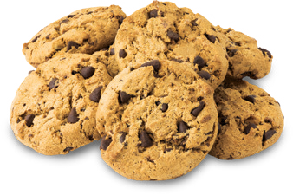
Why feel guilty when your sweet tooth starts aching?
PROTEIN COOKIE BITES
21G
PROTEIN
PER BAG
TRANS FATS
NO
LOW
CHOLESTEROL
AVAILABLE FLAVORS
CHOCOLATE CHIP
ultimatenutrition.com
Call Your Sales Rep for Details!
With Ultimate Nutrition Protein Cookie Bites, you can feel good about snacking while getting more protein in your diet! Each decadent chocolate chip cookie bite is packed with delicious chocolate chips! And you can easily take them wherever you go, giving you a delicious, protein-packed snack-on-the-go whenever you need it!

Why our Protein Cookie Bites over the others?
Ultimate Nutrition Protein Cookie Bites are Naturally Flavored, contain no trans fats and are low cholesterol!

Grab a bag, grab a bite, and start snacking better with

Ultimate Nutrition Protein Cookie Bites!

*
Nutrition Facts
About 5 servings per bag
Serving Size 4-5 Cookies (about 21g)
Amount per serving
Calories 90
% Daily Value*
Total Fat 4g |  | 5%
 | Saturated Fat 2g | 9%
 | Trans Fat 0g
 | Monounsaturated Fat 1g
Cholesterol <5mg |  | 1%
Sodium 90mg |  | 4%
Total Carbohydrate 11g |  | 4%
 | Dietary Fiber 1g | 4%
 | Total Sugars 5g
 | Includes 4g Added Sugars | 8%
Protein 4g |  | 8%
Calcium 15mg |  | <2%
Iron 1mg |  | 4%
Vitamin A 23mcg RAE |  | 2%
Thiamine 44mcg |  | 4%
Riboflavin 27mcg |  | 2%
Niacin 365mcg NE |  | 2%
Folate 20mcg DFE |  | 6%
Not a significant source of Vitamn D or Potassium
 | The % Daily Value (DV) tells you how much a nutrient in a serving of food contributes to a daily diet. 2,000 caloriesa day is used for general nutrition advice.

INGREDIENTS:
Enriched Flour (Wheat flour, niacin, reduced iron, thiamine mononitrate, riboflavin, folic acid), Margarine (Palm Oil, Water, Vegetable mono-and diglycerides, natural butter flavor, citric acid, beta carotene, Vitamin A palmitate), Chocolate Chips (Sugar, chocolate liquor, cocoa butter, soy lecithin, vanilla), Protein Blend (whey protein concentrate, casein, whey protein isolate), Sugar, Pea Protein, Inulin, Brown Rice Syrup, Molasses, Glycerine, Natural Flavors, Salt, Sunflower Lecithin, Sodium Bicarbonate
Contains Milk, Wheat, Soy

