
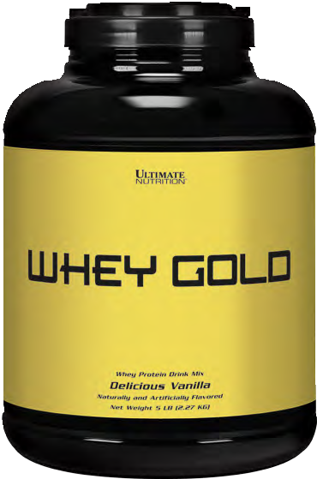
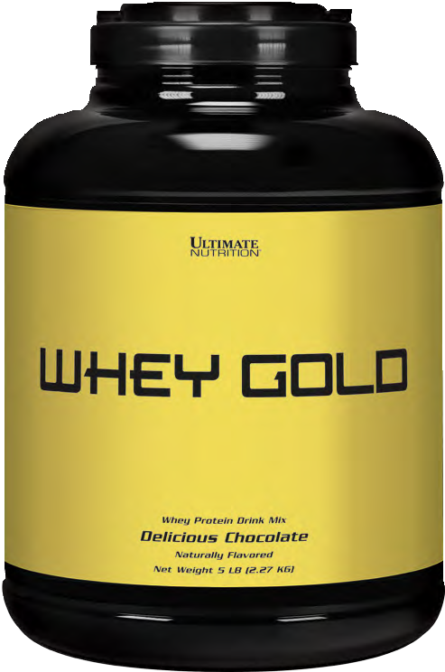

New Product release
Call Your Sales
Rep Today!

Introducing Ultimate Nutrition® Whey Gold

 Fast & Super-Fast Absorption
 20g Fast-acting Protein
 Hydrolyzed Whey Protein Isolate Whey Protein Isolate
Whey Protein Concentrate
 100% Naturally-occurring BCAA’s and EAA’s
 Mixes Instantly
 Amazing Taste
 5lb. (2.27kg) Value Size
 Chocolate & Vanilla Flavors

Gold Series
Biological Value of Important Protein Sources
159
104
88
80
77 74
Best Quality • Best Price
Whey Protein
Isolate
Whey Protein
Concentrate
Egg Protein
Beef
Casein
Soy

Contact Your Sales Rep for Details – (860) 409-7100

