Go lang

Some rules:
- Any variable that begins with a capital letter means it will be exported, private otherwise.
- The same rule applies for functions and constants, no public and private keyword exists in Go.

Flow of programs initialization in Go
Programs initialize and begin execution from the main package. If the main package imports other packages, they will be imported in the compile time. If one package is imported many times, it will be only compiled once. After importing packages, programs will initialize the constants and variables within the imported packages, then execute the init function if it exist, and so on. After all the other packages are initialized, programs will initialize constant and variables in the main package, then execute the init function inside the package if it exits. The following figure shows the process.

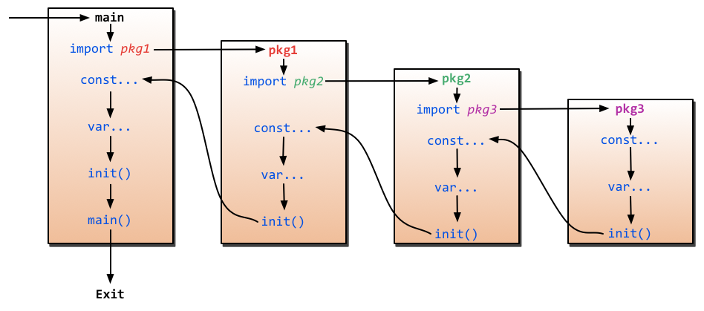

Import
- Dot operator
import .”fmt”
fmt.Print... → Print

- Alias operator
import f”fmt”
fmt.Print... → f.Print

