Using Txtzyme's SPI command

The quick start guide:

To send 3 16bit words (0x2000 0x6666 0x4199) to a AD9834 DDS

0b1o – set slave select pin high
0x9002S – init SPI hardware
0b0o 0x20S 0x00S 0b1o – drop SS, send 0x2000, latch in with SS
0b0o 0x66S 0x66S 0b1o – drop SS, send 0x6666, latch in with SS
0b0o 0x41S 0x99S 0b1o – drop SS, send 0x4199, latch in with SS

The plot below shows the last word being clocked in.

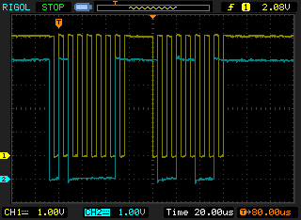

Initialisation
The SPI is initialised using either 9000S or 0x9000S. A number between 0 and 7 is added to this depending on how the hardware should be configured.

Initialisation number | AVR bit DORD | AVR bit CPOL | AVR bit CPHA | SPI Mode
9000 or 0x9000 | 0 | 0 | 0 | 0
9001 or 0x9001 | 0 | 0 | 1 | 1
9002 or 0x9002 | 0 | 1 | 0 | 2
9003 or 0x9003 | 0 | 1 | 1 | 3
9004 or 0x9004 | 1 | 0 | 0 | 0
9005 or 0x9005 | 1 | 0 | 1 | 1
9006 or 0x9006 | 1 | 1 | 0 | 2
9007 or 0x9007 | 1 | 1 | 1 | 3

DORD (Data Order) - When the DORD bit is written to zero, the MSB of the data word is transmitted first. When the DORD bit is written to one, the LSB of the data word is transmitted first.
CPOL (Clock Polarity) - When this bit is written to one, SCK is high when idle. When CPOL is written to zero, SCK is low when idle.
CPHA (Clock Phase) - The settings of the Clock Phase bit (CPHA) determine if data is sampled on the leading (first) or trailing (last) edge of SCK.

See the ATmega32U4 datasheet for more information.
The different SPI Modes are shown below (Clock on Ch1, Data on Ch2)
SPI Mode 0 | SPI Mode 1
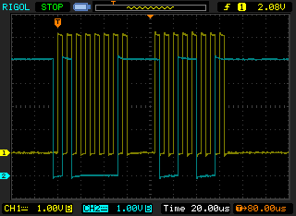 | 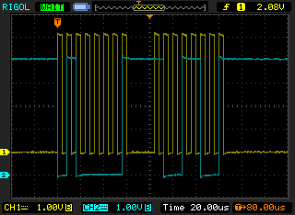
SPI Mode 2 | SPI Mode 3
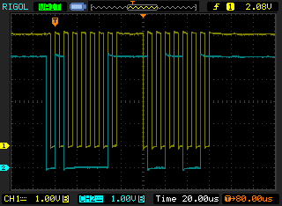 | 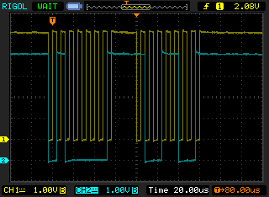

When the SPI is initalised the software will set port pin B0 as an output. This is because the SPI hardware module will be disabled if this is configured as an input and is set high. The easiest way to get round this is setting the pin as an output. This pin can be used as a gerneral purpose output.

The SPI clock is hard coded in software as Fosc/128, because the cystal on the Teensy is 16MHz the SPI clock frequency is set at 125kHz. This is the lowest rate it can be set to.

Sending and receiving data
8bit data can be sent by sending the required data to the Teensy. For example to send 85 out the SPI port either '85S' or '0x55S' can be sent to the Teensy
To receive data a dummy byte needs to be sent out the SPI so the clock pin can clock data in. So, for example, sending '0xFFS' could be used to get 8bit data. The 'p' command can then be used print the data.

