Appendix

Table 1

Table of x-y coordinates used to plot the nozzle geometry in graph 1. These are the origin of the characteristic lines (0,1) followed by the cancellation coordinates. Extracted from spreadsheet 1.

|  |  |
| --- | --- |
| X | Y |
| 0 | 1 |
| 1,64846501 | 2,00117542 |
| 5,02331897 | 3,7314592 |
| 10,0341101 | 5,37441903 |
| 19,7714364 | 7,37908801 |
| 39,3886905 | 8,70880065 |

Spreadsheet 1

On the right hand side of this paper is the spreadsheet used to answer the questions in section 2 and table 1

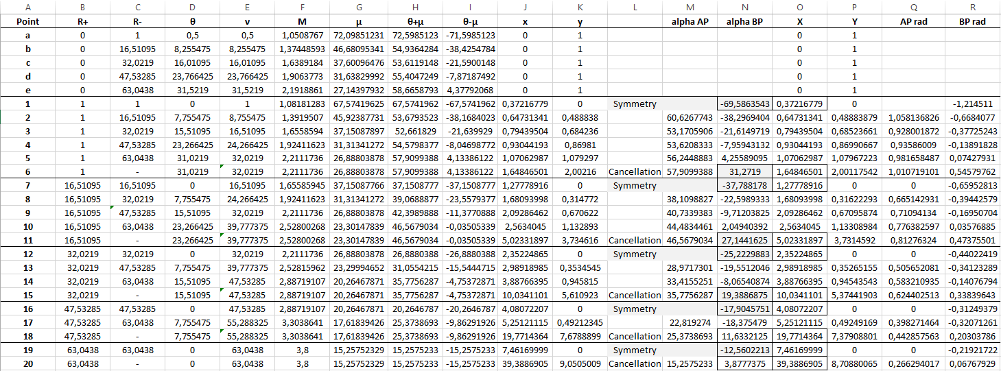

Graph 1: Nozzle design geometry

Graph 1: values obtained from spreadsheet, using the cancellation coordinates of each characteristic. 5 characteristics used.

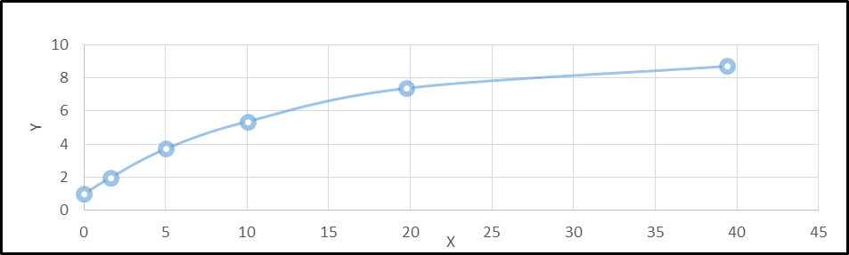

Graph 2.1

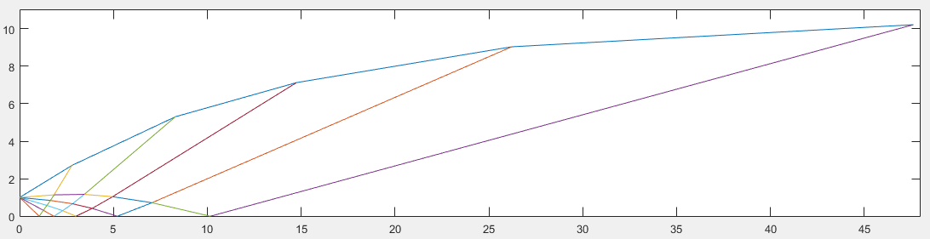

Graph 2.1: same case as above but obtained on a Matlab script. Spacing of characteristic lines is logarithmic, as opposed to constant angle spacing, plotted in graph 1. Same assumptions were used on this simulation: Me=3.8, Gamma =1.4, n=5, where n is the number of characteristics.

Graph 2

Graph 2.2

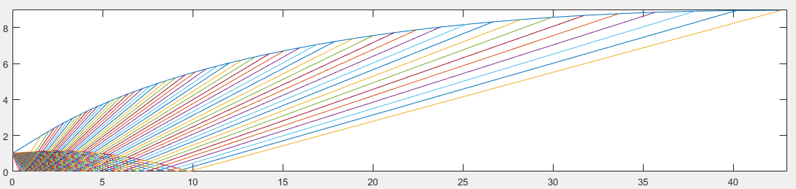

Graph 2.2: Same script as graph 2.1 but ran at 50 iterations. Me=3.8, Gamma =1.4, n=50.

Graph 2.3

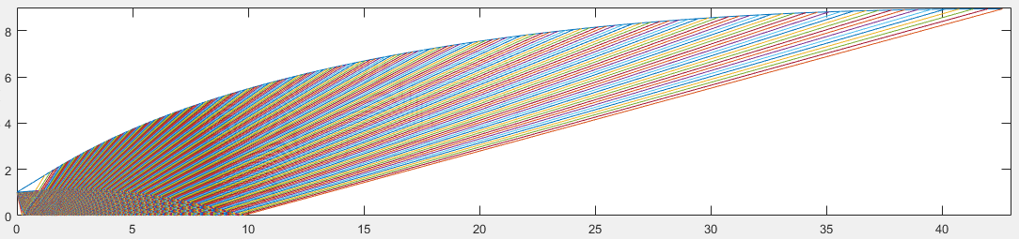

Graph 2.3: Same script as graph 2.1 but ran at 200 iterations. Me=3.8, Gamma =1.4, n=200.