Cryptocurrency Technical Analysis Tutorial
Video Summary & Illustrative Guide
Source: https://www.youtube.com/watch?v=BQdWgfYGqsI

1. Introduction to Technical Analysis
Technical analysis (TA) is a methodology used to evaluate and predict the future price movements of cryptocurrencies by analyzing historical price data and chart patterns. Unlike fundamental analysis, which looks at a project's team, technology, and market potential, technical analysis focuses exclusively on price action and trading volume.
The video introduces the core premise of TA: that all known information is already reflected in the price, and that price movements tend to follow identifiable trends and patterns. This makes TA a powerful tool for timing entries and exits in cryptocurrency markets, which are known for their high volatility.
Key takeaways from this section include:
- TA is based on three principles: the market discounts everything, price moves in trends, and history tends to repeat itself.
- TA is especially useful in crypto due to 24/7 market availability and high volatility.
- Combining TA with fundamental analysis provides the most robust trading approach.

2. Reading Candlestick Charts
Candlestick charts are the most commonly used chart type in cryptocurrency trading. Each candlestick represents a specific time period (e.g., 1 hour, 4 hours, 1 day) and displays four key data points: Open, High, Low, and Close (OHLC).
The body of the candle shows the range between the open and close prices. A green (or hollow) candle indicates the close was higher than the open (bullish), while a red (or filled) candle indicates the close was lower than the open (bearish). The thin lines above and below the body are called wicks or shadows, representing the high and low prices for that period.
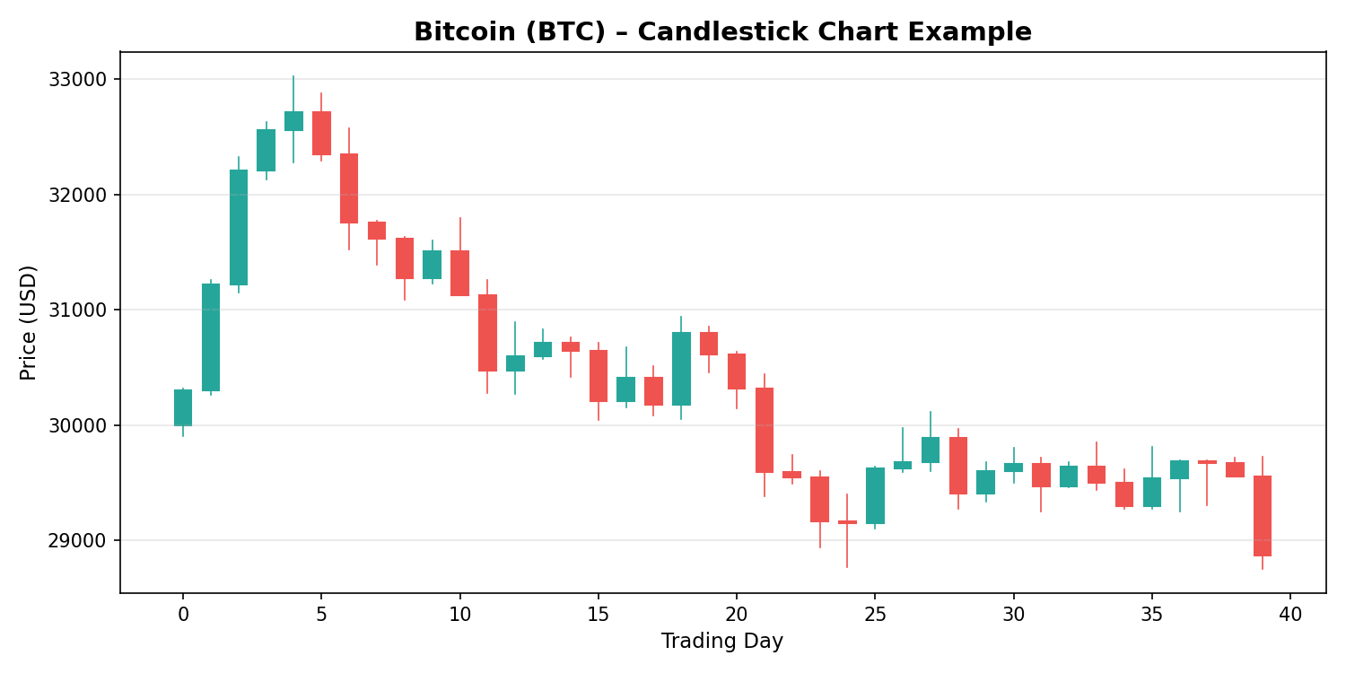
Figure 1: Example candlestick chart showing Bitcoin price action with bullish (green) and bearish (red) candles.
Common candlestick patterns discussed in the tutorial include:
- Doji: Indicates indecision in the market; the open and close are nearly equal.
- Hammer / Inverted Hammer: Signals a potential reversal after a downtrend.
- Engulfing Patterns: A large candle fully engulfs the previous one, signaling a trend reversal.
- Shooting Star: Appears at the top of an uptrend, indicating potential bearish reversal.
- Morning/Evening Star: Three-candle patterns indicating bullish or bearish reversals.

3. Moving Averages (SMA & EMA)
Moving averages smooth out price data to help identify the direction of a trend. The video covers two main types:
Simple Moving Average (SMA): Calculates the arithmetic mean of a set number of past closing prices. For example, a 20-day SMA adds up the last 20 closing prices and divides by 20. It gives equal weight to all prices in the period.
Exponential Moving Average (EMA): Gives more weight to recent prices, making it more responsive to new information. The EMA reacts faster to price changes than the SMA, which can be advantageous in fast-moving crypto markets.
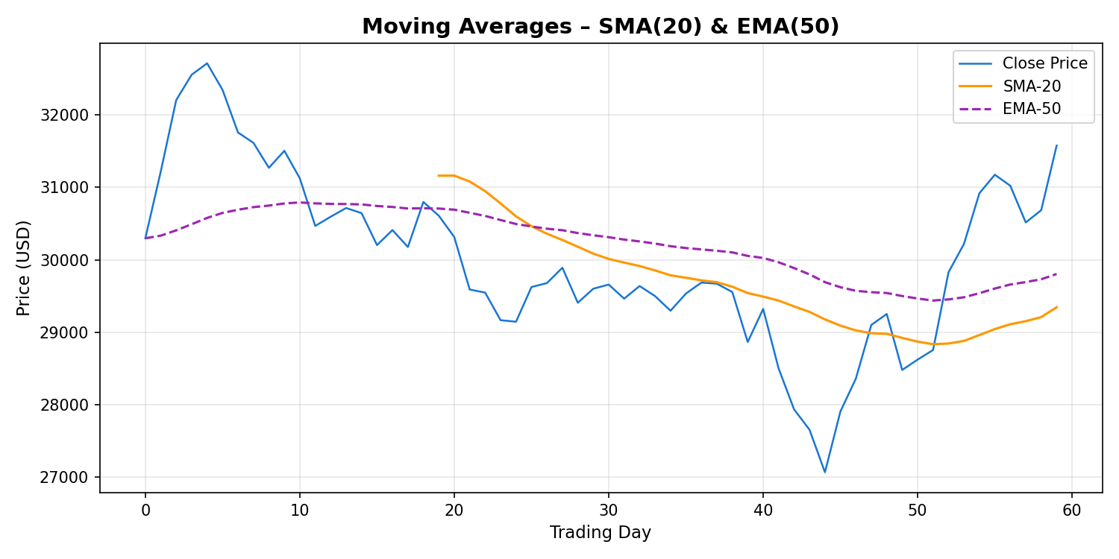
Figure 2: Price chart overlaid with SMA-20 (orange) and EMA-50 (purple dashed) moving averages.
Key moving average strategies discussed:
- Golden Cross: When a short-term MA crosses above a long-term MA – a bullish signal.
- Death Cross: When a short-term MA crosses below a long-term MA – a bearish signal.
- Dynamic Support/Resistance: MAs can act as support in an uptrend or resistance in a downtrend.

4. Relative Strength Index (RSI)
The Relative Strength Index (RSI) is a momentum oscillator that measures the speed and magnitude of recent price changes. It ranges from 0 to 100 and is typically calculated over a 14-period window.
An RSI reading above 70 generally indicates that an asset is overbought and may be due for a pullback. Conversely, an RSI below 30 suggests the asset is oversold and could be poised for a bounce. The video emphasizes that RSI divergences – when price makes a new high/low but RSI does not – are among the most reliable signals for predicting reversals.
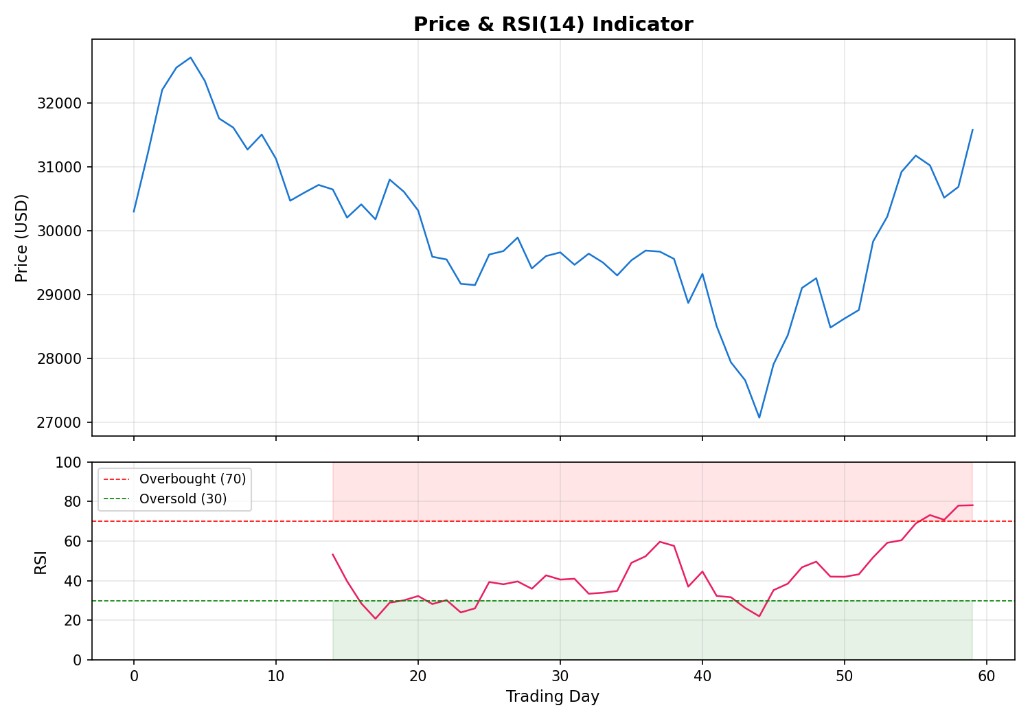
Figure 3: Price chart with RSI(14) indicator. Red zone (>70) = overbought; green zone (<30) = oversold.

5. Bollinger Bands
Bollinger Bands consist of three lines: a middle band (typically a 20-period SMA), an upper band (SMA + 2 standard deviations), and a lower band (SMA − 2 standard deviations). They dynamically expand and contract based on market volatility.
When the bands are narrow (a "squeeze"), it signals low volatility and often precedes a significant price move. When the price touches or breaks through the upper band, the asset may be overbought; touching the lower band may indicate oversold conditions. The video demonstrates how traders use Bollinger Band squeezes to anticipate breakout trades.
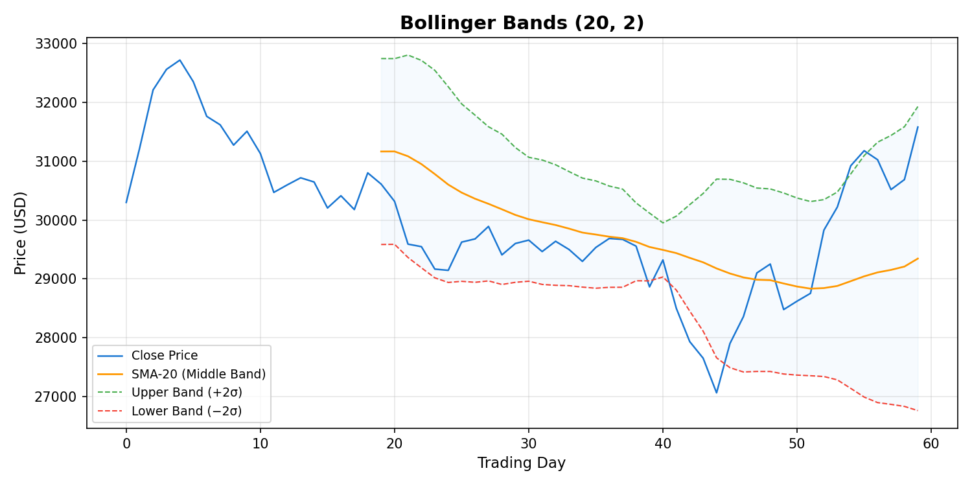
Figure 4: Bollinger Bands with upper/lower bands and the 20-period SMA as the middle band.

6. Support and Resistance Levels
Support and resistance are among the most fundamental concepts in technical analysis. A support level is a price point where buying interest is strong enough to prevent further decline, while a resistance level is where selling pressure prevents further price increases.
The tutorial explains how to identify these levels using historical price data, round numbers, and previous swing highs/lows. When a support level is broken, it often becomes a new resistance level (and vice versa) – a concept known as "polarity."
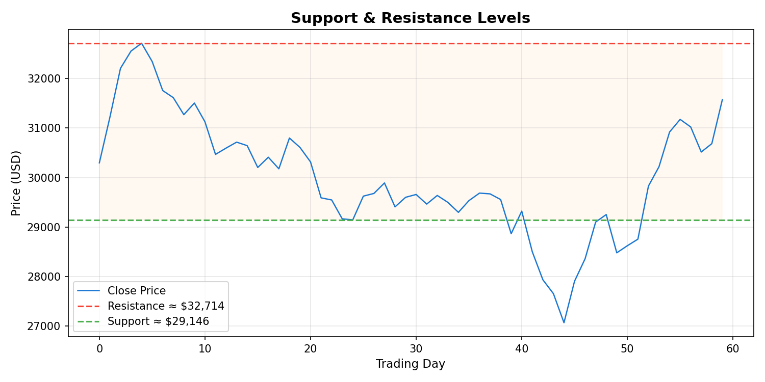
Figure 5: Price chart with identified horizontal support (green) and resistance (red) levels.

7. Volume Analysis
Trading volume is the total number of units traded during a given period. The video emphasizes that volume is a confirmation tool: a price move accompanied by high volume is more significant and sustainable than one with low volume.
For example, a breakout above resistance on high volume strongly confirms the breakout's validity. Conversely, a breakout on low volume may be a "false breakout" that quickly reverses. Volume spikes can also indicate capitulation events – where the last remaining sellers or buyers exit their positions.
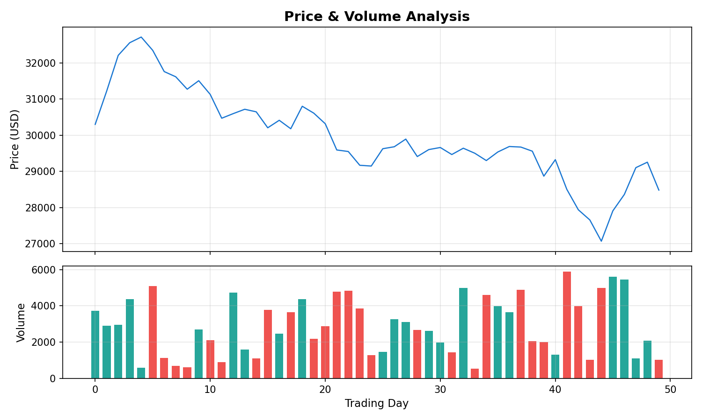
Figure 6: Price chart with volume bars. Green bars indicate buying volume; red bars indicate selling volume.

8. Common Chart Patterns
Chart patterns are shapes formed by price action on a chart that can signal potential future price movements. The video covers both continuation and reversal patterns.

Reversal Patterns
- Head and Shoulders: A three-peak pattern where the middle peak (head) is the highest. A neckline break confirms the reversal.
- Double Top / Double Bottom: Price tests a level twice and fails to break through, signaling a reversal.
- Triple Top / Triple Bottom: Similar to double top/bottom but with three tests of the level.

Continuation Patterns
- Flags and Pennants: Short consolidation patterns after a strong move, indicating the trend will likely continue.
- Ascending / Descending Triangles: Triangular consolidation patterns where one boundary is flat and the other is converging.
- Symmetrical Triangles: Both boundaries converge equally, with the breakout direction confirming the next trend.

9. Fibonacci Retracement
Fibonacci retracement levels are horizontal lines that indicate potential support and resistance levels based on the Fibonacci sequence. The key levels discussed in the video are 23.6%, 38.2%, 50%, 61.8%, and 78.6%.
To apply Fibonacci retracement, a trader draws the tool from a significant swing low to a swing high (for an uptrend) or from a swing high to a swing low (for a downtrend). These levels often serve as areas where price may pause or reverse during a pullback. The 61.8% level, known as the "golden ratio," is considered the most significant retracement level.

10. Risk Management and Trading Psychology
The final segment of the tutorial covers essential risk management practices and the psychological aspects of trading:
- Always use stop-loss orders to limit potential losses on each trade.
- Never risk more than 1–2% of your total trading capital on a single trade.
- Maintain a favorable risk-to-reward ratio (at least 1:2 or higher).
- Avoid emotional trading – stick to your analysis and trading plan.
- Understand that no indicator or pattern is 100% reliable; losses are part of trading.
- Keep a trading journal to track performance and identify areas for improvement.

11. Limitations of Technical Analysis
The video concludes by discussing the limitations of technical analysis in cryptocurrency markets:
- Crypto markets can be influenced by unexpected news, regulations, or events that TA cannot predict.
- Low-liquidity altcoins may not follow typical TA patterns due to market manipulation.
- Over-reliance on a single indicator can lead to false signals; it is best to use a combination of tools.
- Past performance does not guarantee future results – TA is probabilistic, not deterministic.

12. Conclusion
The "Cryptocurrency Technical Analysis Tutorial" provides a comprehensive introduction to the essential tools and concepts needed to analyze cryptocurrency price charts effectively. By mastering candlestick patterns, moving averages, RSI, Bollinger Bands, support/resistance levels, and volume analysis, traders can develop a structured approach to navigating the volatile cryptocurrency market.
The key message of the tutorial is that technical analysis should be used as part of a broader trading strategy that includes proper risk management, emotional discipline, and continuous learning. No single tool or indicator is sufficient on its own, but when combined thoughtfully, they provide a powerful framework for making informed trading decisions.

This document was generated as a summary of the YouTube video "Cryptocurrency Technical Analysis Tutorial" (https://www.youtube.com/watch?v=BQdWgfYGqsI). All charts are illustrative examples created for educational purposes.

