Video Summary
Top Altcoins to Make You RICH! | How to Find Moon Coins
YouTube Video by Crypto Content Creator
Source: https://www.youtube.com/watch?v=KBkc0-Syf8U



This document provides a comprehensive summary of the YouTube video discussing top altcoin investment strategies and methods for identifying potential high-growth cryptocurrencies ("moon coins").

Table of Contents
1. Video Overview
2. What Are Altcoins?
3. Key Strategies for Finding Moon Coins
4. Popular Altcoin Categories
5. Research Checklist – Due Diligence
6. Risk Warnings & Disclaimer
7. Conclusion

1. Video Overview
The video "Top Altcoins to Make You RICH! | How to Find Moon Coins" is a cryptocurrency education video that aims to teach viewers how to identify promising altcoins with high growth potential. The presenter walks through proven strategies for researching and selecting cryptocurrencies that could deliver significant returns — often referred to as "moon coins" in the crypto community.
Key Topics Covered:
- Moon Coin Criteria: Understanding what makes an altcoin a potential "moon coin"
- Research Methods: Methods for evaluating altcoin projects before investing
- Market Analysis: Analysis of market cap tiers and growth potential
- Risk Assessment: Red flags to watch out for when evaluating new coins
- Useful Tools: Tools and platforms for tracking altcoin performance
The video emphasises the importance of doing your own research (DYOR) rather than blindly following any influencer recommendations. It highlights that while altcoins can offer extraordinary returns, they also come with substantially higher risks compared to established cryptocurrencies like Bitcoin and Ethereum.

2. What Are Altcoins?
Altcoins (alternative coins) refer to all cryptocurrencies other than Bitcoin. The term encompasses thousands of digital assets, each with different use cases, technologies, and market positions. As discussed in the video, altcoins range from large-cap established projects like Ethereum to micro-cap speculative tokens.
Market Cap Tiers Explained:
- Large-Cap: Over $10 billion — Established projects (e.g., Ethereum, Solana, Cardano)
- Mid-Cap: $1 billion to $10 billion — Growing projects with solid track records
- Small-Cap: $100 million to $1 billion — Higher risk but higher potential reward
- Micro-Cap: Under $100 million — Highest risk, highest potential "moon" opportunity
The video highlights that "moon coins" are typically found in the small-cap and micro-cap categories, where market capitalisation is low enough that significant price increases are mathematically possible. A coin with a $10 million market cap has far more room to multiply in value compared to a $100 billion coin.

3. Key Strategies for Finding Moon Coins
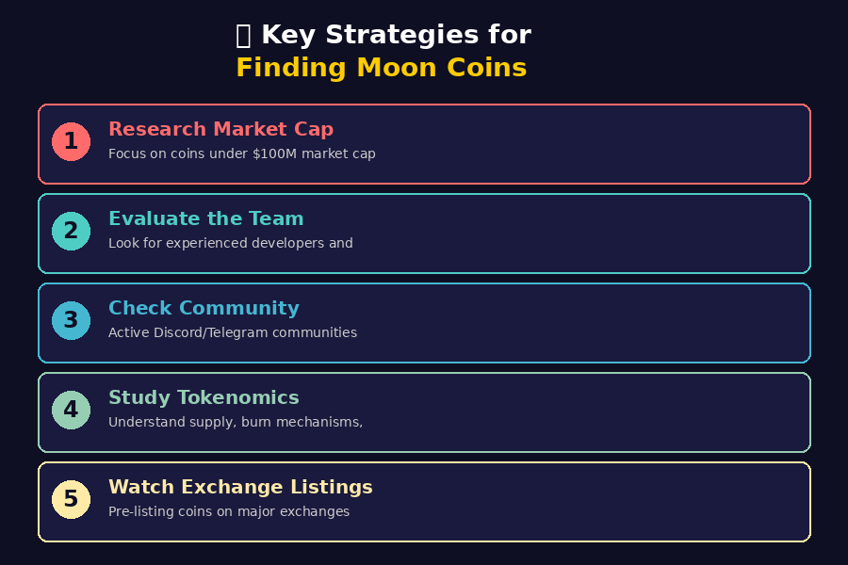
Figure 1: Key Strategies for Identifying Potential Moon Coins

Strategy 1: Research Market Capitalisation
The video emphasises that market cap is one of the most important metrics when searching for potential moon coins. Projects with lower market caps (under $100 million) have significantly more room for growth. However, extremely low market caps can also indicate lack of interest or potential scams. The sweet spot, according to the video, is finding quality projects in the $10M–$100M range that have strong fundamentals but haven't yet attracted mainstream attention.
Strategy 2: Evaluate the Development Team
A strong, transparent, and experienced team is crucial. The video recommends checking LinkedIn profiles, previous project experience, and whether team members are publicly identifiable (doxxed). Anonymous teams, while common in crypto, carry additional risk. Look for teams with backgrounds in software engineering, blockchain development, or relevant industries.
Strategy 3: Analyse Community Engagement
Vibrant, organic communities on Discord, Telegram, Twitter/X, and Reddit are strong indicators of a project's health. The video warns against projects that rely heavily on paid marketing and bot-driven followers. Genuine community engagement — including discussions, feedback, and developer interaction — is a much more reliable signal than raw follower counts.
Strategy 4: Study the Tokenomics
Understanding a coin's tokenomics is essential. This includes the total supply, circulating supply, token distribution, vesting schedules, and any burn or deflationary mechanisms. The video notes that coins with excessive tokens allocated to insiders or venture capital firms may face significant sell pressure when those tokens unlock.
Strategy 5: Monitor Exchange Listings
Coins that are about to be listed on major exchanges (Binance, Coinbase, etc.) often see significant price increases. The video suggests identifying promising projects before they reach these milestones. Early discovery on decentralised exchanges (DEXs) can offer the best entry points, though with additional risks around liquidity and smart contract security.

4. Popular Altcoin Categories
The video discusses several categories of altcoins that are currently showing strong growth potential. Each category represents a different sector within the crypto ecosystem:
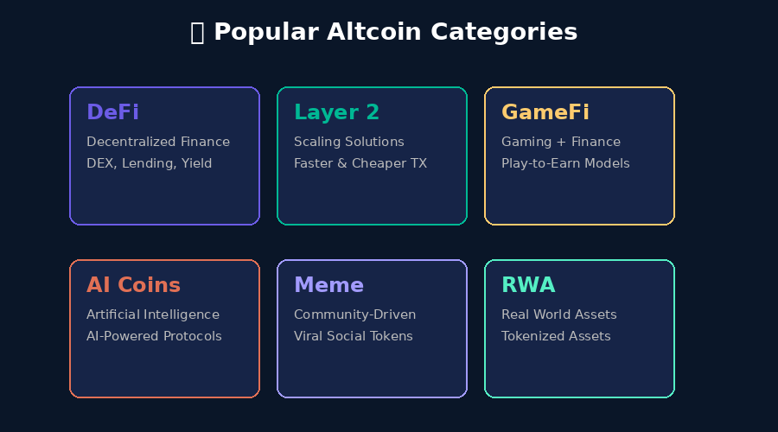
Figure 2: Major Altcoin Categories Discussed in the Video

DeFi (Decentralised Finance)
Protocols that replicate traditional financial services (lending, borrowing, trading) on blockchain. Examples include decentralised exchanges (DEXs), lending platforms, and yield farming protocols. The video notes that DeFi continues to be a major growth area as more users seek alternatives to centralised finance.
Layer 2 Scaling Solutions
Projects built on top of existing blockchains to improve speed and reduce transaction costs. These solutions are critical for mass adoption, as they address the scalability limitations of networks like Ethereum. The video suggests that successful Layer 2 projects could see significant appreciation as usage grows.
GameFi & Play-to-Earn
Combining gaming with blockchain-based finance, these projects allow users to earn cryptocurrency through gameplay. The video highlights this as an emerging sector with potential for mainstream adoption, especially as game quality improves.
AI-Integrated Crypto Projects
Artificial intelligence combined with blockchain technology is a rapidly growing niche. These projects leverage AI for trading, data analysis, or decentralised computing. The video identifies AI coins as one of the hottest trends in the current market cycle.
Meme Coins
Community-driven tokens that often start as jokes but can achieve massive market caps through viral marketing and social media hype. While extremely risky, the video acknowledges that meme coins have produced some of the largest returns in crypto history.
Real World Assets (RWA)
Projects that tokenise real-world assets like real estate, commodities, or financial instruments on the blockchain. The video suggests this sector has enormous potential as it bridges traditional finance with cryptocurrency.

5. Research Checklist – Due Diligence
The video provides a comprehensive checklist that viewers should follow before investing in any altcoin. This due diligence process is essential for separating legitimate projects from scams:
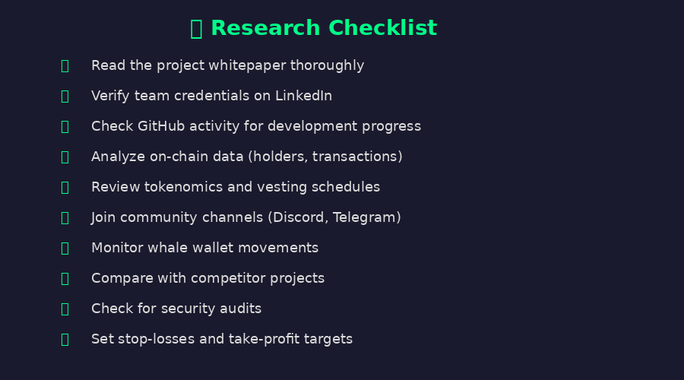
Figure 3: Essential Research Checklist for Altcoin Due Diligence

Read the Whitepaper
Every legitimate project should have a detailed whitepaper explaining their technology, use case, and roadmap. The video stresses that if you cannot understand or find a whitepaper, it is a major red flag.
Verify Team Credentials
Research team members on LinkedIn and other professional platforms. Experienced, publicly known team members add credibility and accountability.
Check Development Activity
Active GitHub repositories with regular commits indicate ongoing development. Dormant projects with no code updates are concerning.
Analyse On-Chain Data
Use blockchain explorers to check token distribution, holder counts, and transaction activity. Highly concentrated holdings (whale wallets) can indicate manipulation risk.
Review Tokenomics
Understand the supply schedule, vesting periods, and any inflationary or deflationary mechanisms. Poor tokenomics can undermine even the best technology.
Join Community Channels
Engage with the project's Discord and Telegram to gauge genuine community interest and developer responsiveness.
Monitor Smart Money
Track whale wallet movements using tools like Etherscan or dedicated whale-tracking platforms. Smart money flows can indicate informed investment decisions.
Compare with Competitors
Evaluate how the project compares with similar offerings in its category. Unique value propositions are essential for long-term success.
Check Security Audits
Reputable projects undergo third-party security audits. Unaudited smart contracts carry significant risk of exploits and hacks.
Set Risk Management Rules
Always define stop-losses and take-profit levels. The video strongly recommends never investing more than you can afford to lose entirely.

6. Risk Warnings & Disclaimer
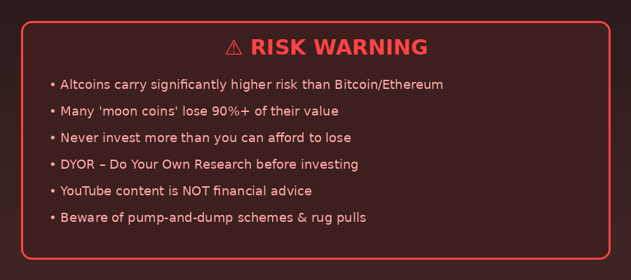
Figure 4: Important Risk Warnings for Altcoin Investors

The video includes several important disclaimers and risk warnings that all viewers should take seriously:
- Altcoins are extremely volatile and can lose 90% or more of their value in a short period.
- Many 'moon coin' picks do not materialise — survivorship bias makes successful picks appear more common than they are.
- Pump-and-dump schemes are common in the altcoin space, especially with micro-cap tokens.
- Rug pulls (where developers abandon a project and steal investor funds) are a significant risk.
- YouTube crypto content should never be treated as professional financial advice.
- Past performance does not guarantee future results — even previously successful coins can fail.
- Regulatory changes can significantly impact the value and legality of crypto assets.
- Only invest money that you can afford to lose entirely without impacting your financial stability.

DISCLAIMER: This document is a summary of publicly available YouTube content for educational purposes only. It does not constitute financial advice, investment recommendations, or an endorsement of any cryptocurrency or investment strategy. Always conduct your own thorough research and consider consulting a qualified financial advisor before making any investment decisions.

7. Conclusion
The video "Top Altcoins to Make You RICH! | How to Find Moon Coins" provides a comprehensive overview of strategies for identifying promising altcoins in the cryptocurrency market. The key takeaways include:
- Focus on low-cap altcoins with strong fundamentals for maximum growth potential.
- Always perform thorough due diligence using the research checklist provided.
- Diversify across multiple altcoin categories (DeFi, Layer 2, AI, GameFi, RWA).
- Pay close attention to tokenomics, team credibility, and community engagement.
- Set strict risk management rules and never invest more than you can afford to lose.
- Stay updated on market trends and be ready to adapt your strategy.
- Remember that DYOR (Do Your Own Research) is the single most important principle in crypto investing.

While the potential for significant returns exists in the altcoin market, it is crucial to approach investments with caution, discipline, and proper risk management. The strategies outlined in the video serve as a starting framework, but each investor must develop their own approach based on their risk tolerance, financial situation, and investment goals.

────────────────────────────────────────────────────────────
Video Source: https://www.youtube.com/watch?v=KBkc0-Syf8U
Document prepared for educational purposes only. Not financial advice.

