How to Day Trade Crypto
Video Summary & Key Takeaways
Source: https://www.youtube.com/watch?v=z4vYaD6xLT8

Overview
This document summarizes the YouTube video "How to Day Trade Crypto," which provides a comprehensive beginner's guide to day trading in the cryptocurrency market. The video covers essential concepts including what crypto day trading is, how to choose the right platform, core trading strategies, technical analysis tools, and critical risk management practices.

1. What Is Crypto Day Trading?
Day trading involves buying and selling cryptocurrencies within the same day (or even within minutes or hours) to profit from short-term price movements. Unlike traditional stock markets that operate during fixed hours, crypto markets are open 24 hours a day, 7 days a week.
- Positions are opened and closed within the same trading day
- Profits come from short-term price volatility, not long-term holding
- The 24/7 nature of crypto markets means opportunities are always available
- High volatility creates both significant opportunity and risk
- Requires active monitoring and quick decision-making

2. Choosing a Reliable Trading Platform
Selecting the right exchange is one of the most important first steps. A good platform can make the difference between a smooth trading experience and costly mistakes.
- High Liquidity: Ensures quick entry/exit without significant price slippage.
- Low Trading Fees: Frequent trading means fees add up — look for volume discounts.
- Strong Security: 2FA, cold storage, and regulatory compliance are essential.
- Advanced Charting Tools: Built-in indicators and real-time charts are crucial.
- User-Friendly Interface: Reduces costly errors during fast-moving markets.

3. The Importance of a Trading Plan
Successful day trading starts with a well-defined trading plan. Trading without a plan is essentially gambling.
- Entry Criteria: Specific conditions before opening a trade.
- Exit Criteria: Predetermined conditions for closing — profits and losses.
- Risk Parameters: Max loss per trade (typically 1-2% of portfolio) and per day.
- Position Sizing Rules: Capital allocation based on confidence and risk tolerance.
- Trading Schedule: Defined hours and rules for stepping away.
- Record Keeping: A journal logging every trade, rationale, and outcome.

4. Mastering Technical Analysis
Technical analysis is the backbone of crypto day trading — studying historical price data, chart patterns, and statistical indicators to forecast future price movements.

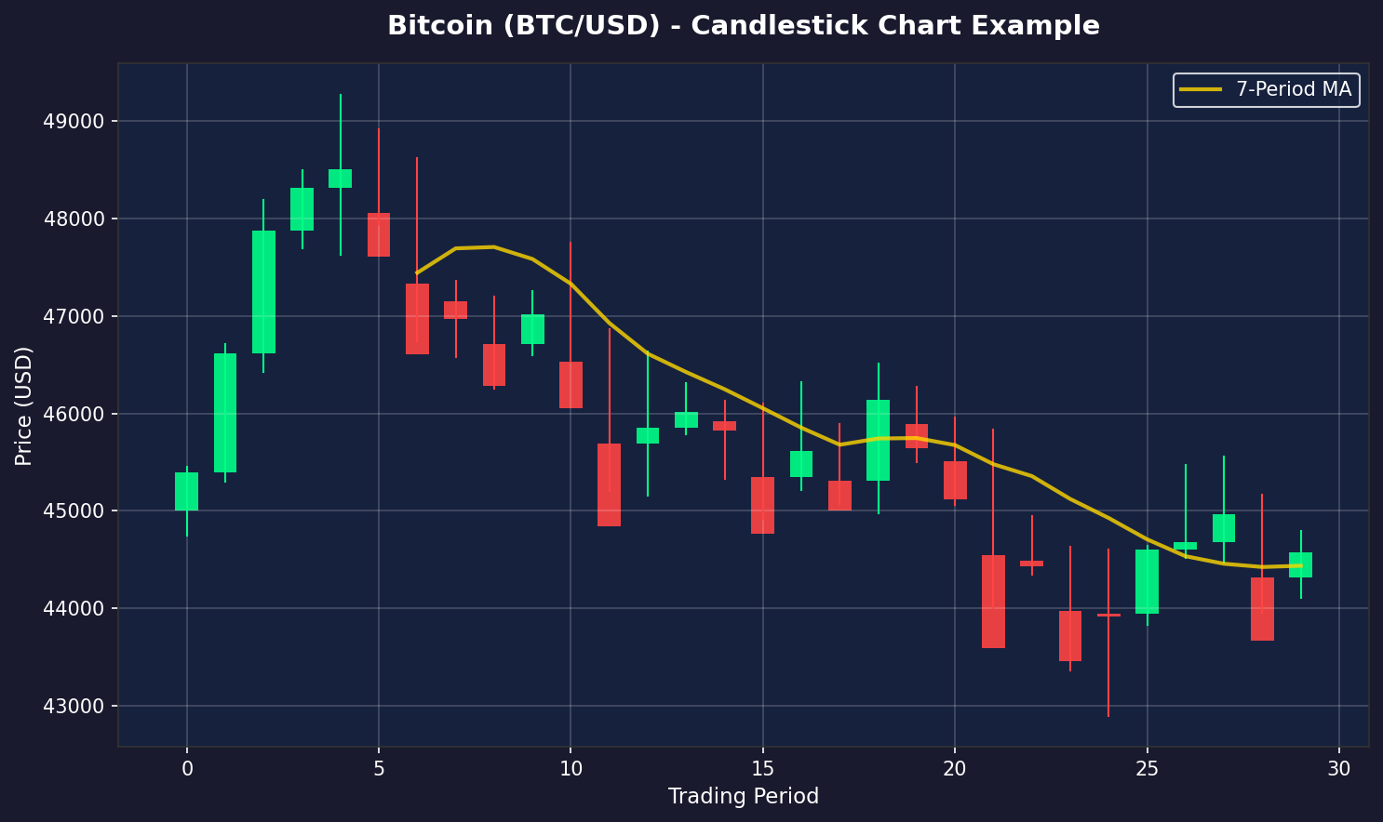
Figure 1: Example Bitcoin candlestick chart with 7-period moving average

Candlestick charts display Open, Close, High, and Low prices. Green candles are bullish (price up); red candles are bearish (price down).

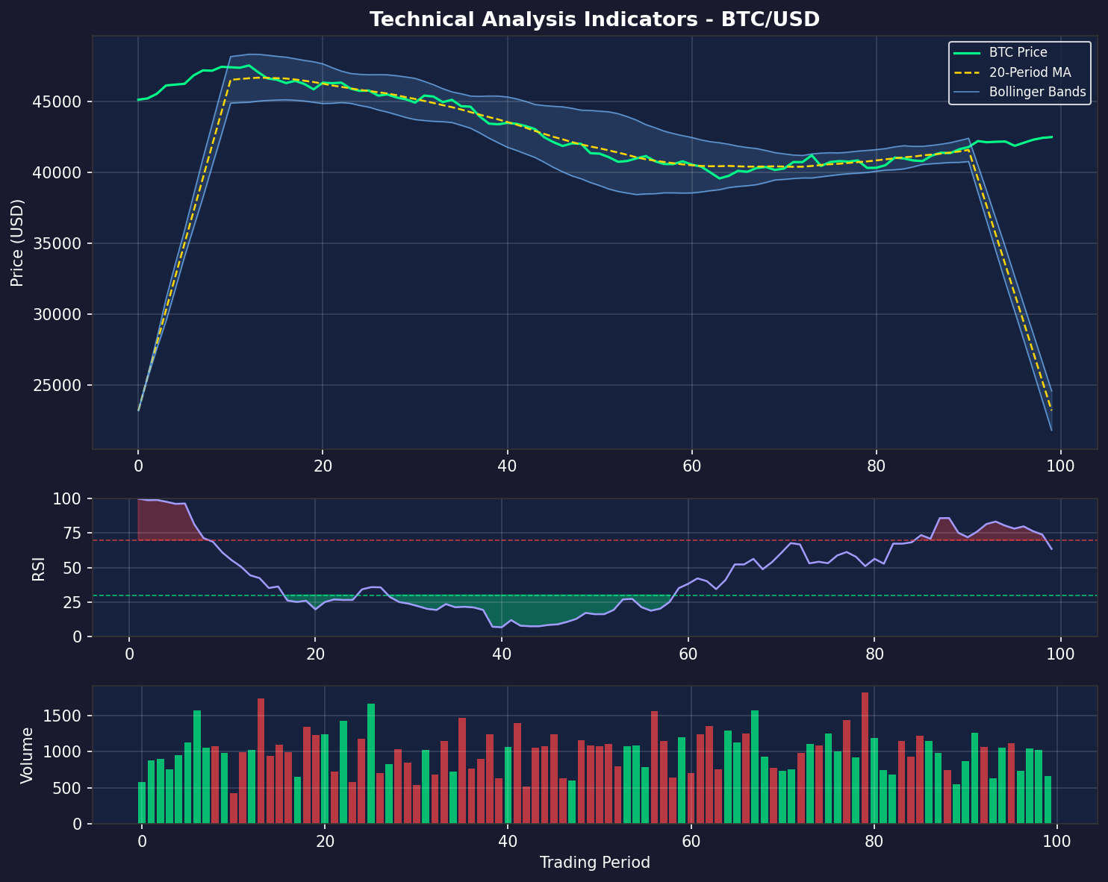
Figure 2: Technical indicators — Bollinger Bands, RSI, and Volume

- Moving Averages (MA): Smooth price data to show trend direction.
- RSI: Momentum oscillator (0-100); >70 overbought, <30 oversold.
- MACD: Tracks relationship between two MAs to signal trend changes.
- Bollinger Bands: Show volatility; squeezes often precede big moves.
- Volume Analysis: High volume confirms the strength of a price move.

5. Core Day Trading Strategies
Several proven strategies are outlined; successful traders often combine multiple approaches depending on market conditions.

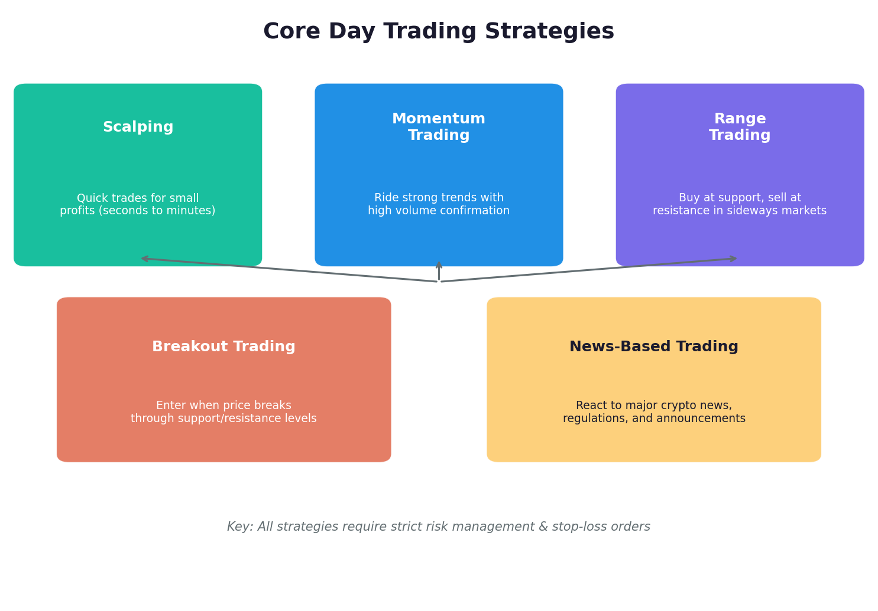
Figure 3: Overview of core crypto day trading strategies

- Scalping: Rapid trades lasting seconds to minutes for small, repeated gains.
- Momentum Trading: Ride strong trends confirmed by volume surges or news.
- Range Trading: Buy at support, sell at resistance in sideways markets.
- Breakout Trading: Enter when price moves decisively past support/resistance.
- News-Based Trading: React to major announcements — regulations, listings, etc.

6. Risk Management
Protecting your capital is more important than making profits. Many beginners fail not from bad strategies but from poor risk management.

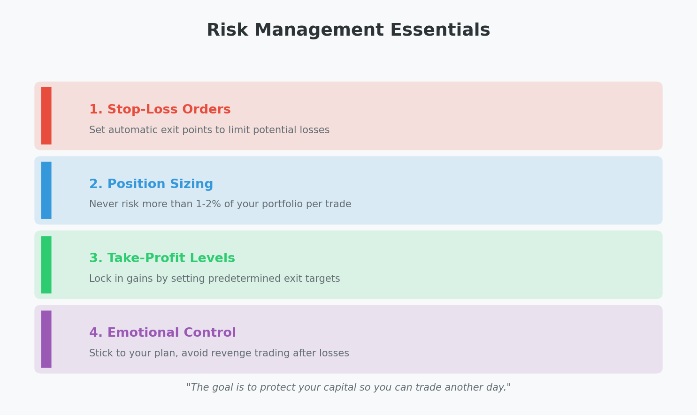
Figure 4: The four pillars of risk management for crypto day trading

- Stop-Loss Orders: Automatically close positions that move against you.
- Position Sizing: Never risk more than 1-2% of capital on one trade.
- Take-Profit Levels: Lock in gains with predetermined exit targets.
- Daily Loss Limits: Stop trading for the day if you hit your max loss.
- Leverage Caution: Beginners should avoid high leverage (start at 2-3x max).

7. Emotional Discipline & Psychology
Day trading is as much a psychological challenge as a technical one.
- FOMO: Jumping in impulsively without analysis.
- Revenge Trading: Taking bigger risks to recover losses — usually backfires.
- Overconfidence: Abandoning the plan after a winning streak.
- Analysis Paralysis: Over-analyzing to the point of inaction.

8. Getting Started — Practical Steps
- Educate yourself before risking real money.
- Practice with a demo / paper trading account.
- Choose a reputable exchange with low fees and strong security.
- Start with a small amount you can afford to lose.
- Focus on one or two trading pairs (e.g., BTC/USDT).
- Follow a written trading plan with clear rules.
- Keep a detailed trading journal.
- Start with simple strategies before advancing.
- Continuously review and refine your approach.
- Never stop learning — crypto markets evolve rapidly.

Conclusion
Success in crypto day trading requires education, discipline, a solid plan, mastery of technical analysis, and rigorous risk management. Start small, practice with paper trading, and never risk more than you can afford to lose.

References
- "How to Day Trade Crypto" — https://www.youtube.com/watch?v=z4vYaD6xLT8
- Mitrade — "How to Day Trade Crypto? Simplest Day Trading Strategy Ever"
- Margex — "Best Crypto Day Trading Strategies: A Trader's Guide"
- Finder — "How to Day Trade Crypto | Day Trading Strategies"
- BeInCrypto — "How To Trade Cryptocurrency: A Step-by-Step Beginners Guide"
- Coin Bureau — "The Ultimate Beginner's Guide to Successful Crypto Day Trading"

