How to Trade Using Binance Futures
Video Summary & Guide
Source: https://www.youtube.com/watch?v=SvXEAj7Mb48

Introduction
This document summarises the key points from the YouTube video
"How to Trade Using Binance Futures". Binance Futures is a
cryptocurrency derivatives platform that allows traders to speculate
on the future price of digital assets using leverage. The platform
supports both long (buy) and short (sell) positions, enabling
traders to profit in both rising and falling markets.

1. Account Setup & Funding
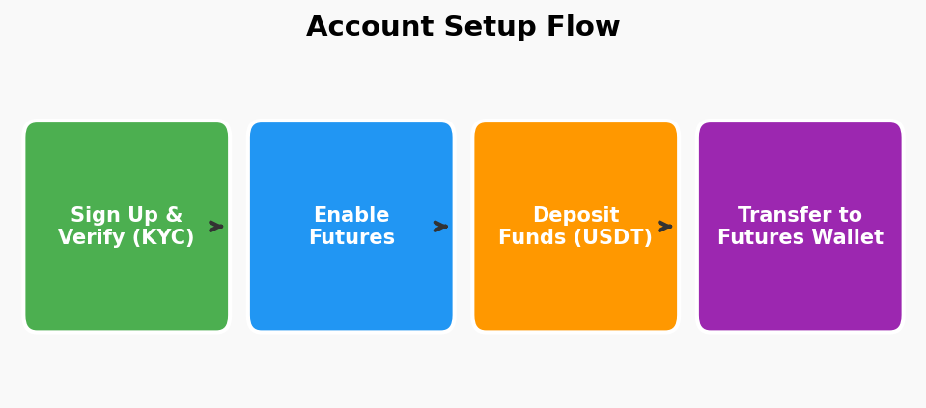
Step 1 – Sign Up & Verify: Create a Binance account at binance.com
and complete identity verification (KYC) as required by your
jurisdiction.
Step 2 – Enable Futures Trading: Navigate to the "Derivatives" menu
and activate your Binance Futures account. You may need to pass a
short quiz about futures trading risks.
Step 3 – Deposit Funds: Add funds (e.g., USDT, BUSD) to your Spot
wallet via bank transfer, credit card, or peer-to-peer trading.
Step 4 – Transfer to Futures Wallet: Use the in-platform "Transfer"
button to move assets from your Spot wallet into your Futures wallet
so they are available as margin for your trades.

2. Understanding Futures Contracts
Futures contracts let you speculate on an asset's future price
without owning the underlying cryptocurrency. Binance offers two
main types:
• USDT-Margined (USDT-M): Settled in USDT. The most popular choice
for beginners because profit and loss are denominated in a stable
asset.
• Coin-Margined (COIN-M): Settled in the cryptocurrency itself
(e.g., BTC). Useful for holders who want to hedge or increase
their crypto exposure.
Each contract has an expiry date (quarterly) or can be "perpetual"
(no expiry). Perpetual contracts use a funding-rate mechanism to
keep prices close to the spot market.

3. Using the Trading Interface

Order Types
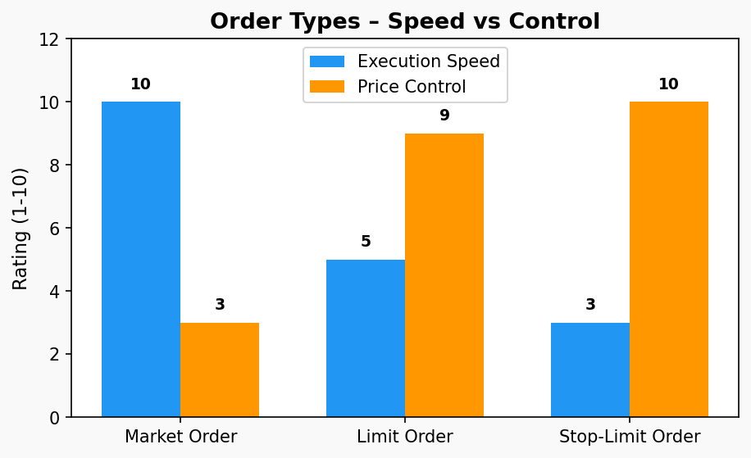
Market Order – Executes immediately at the best available price.
Ideal when speed matters more than the exact entry price.
Limit Order – You set the price at which you want to buy or sell.
The order only fills when the market reaches your specified price,
giving you full control over entry/exit.
Stop-Limit / Stop-Market Order – Combines a trigger price (stop)
with a limit or market order. Commonly used for setting stop-losses
or automated entries at key price levels.

4. Leverage
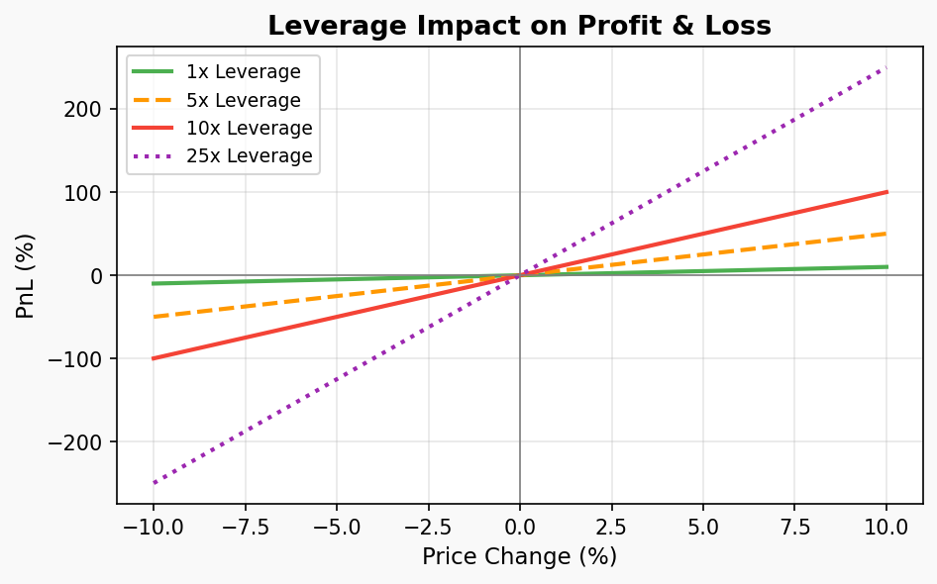
Leverage allows you to control a larger position with a smaller
amount of capital. Binance Futures offers leverage from 1× up to
125× depending on the trading pair.
Example: With 10× leverage and $100 margin, you control a $1,000
position. A 5 % price move in your favour yields a 50 % gain,
but the same move against you results in a 50 % loss.
Key tip from the video: beginners should start with low leverage
(2–5×) to limit risk while learning how the platform works.

5. Margin Modes: Cross vs Isolated
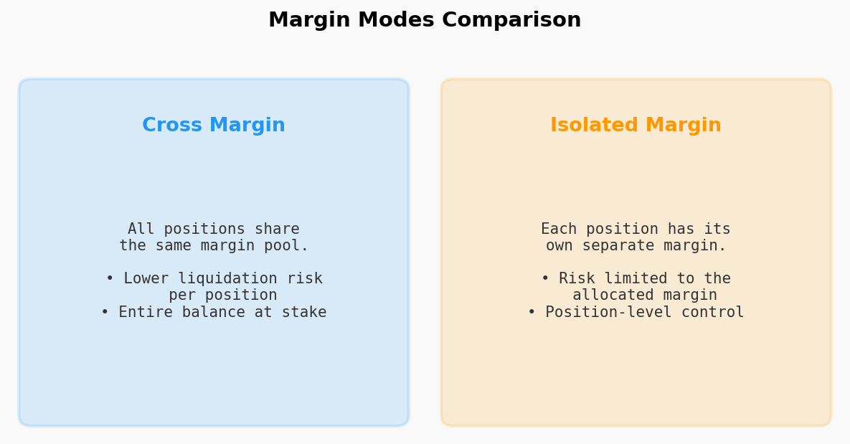
Cross Margin: Your entire Futures wallet balance serves as margin
for all open positions. This lowers the chance of liquidation on
any single position but puts your full balance at risk.
Isolated Margin: Each position has its own dedicated margin. If
the position is liquidated you only lose the margin allocated to
that specific trade, protecting the rest of your balance.
The video recommends Isolated Margin for beginners as it provides
clearer risk boundaries.

6. Opening & Managing Trades
1. Select a trading pair (e.g., BTCUSDT Perpetual).
2. Choose your margin mode (Cross or Isolated) and leverage level.
3. Decide on your direction:
• Long (Buy) – you expect the price to rise.
• Short (Sell) – you expect the price to fall.
4. Enter the order size and choose an order type.
5. Click "Buy/Long" or "Sell/Short" to open the position.
Once the position is open, monitor it in the "Positions" tab at
the bottom of the trading interface. Key metrics include:
• Entry Price – the price at which you entered.
• Mark Price – the current fair-value price used for PnL.
• Liquidation Price – the price at which your margin is exhausted.
• Unrealised PnL – your current floating profit or loss.

7. Risk Management
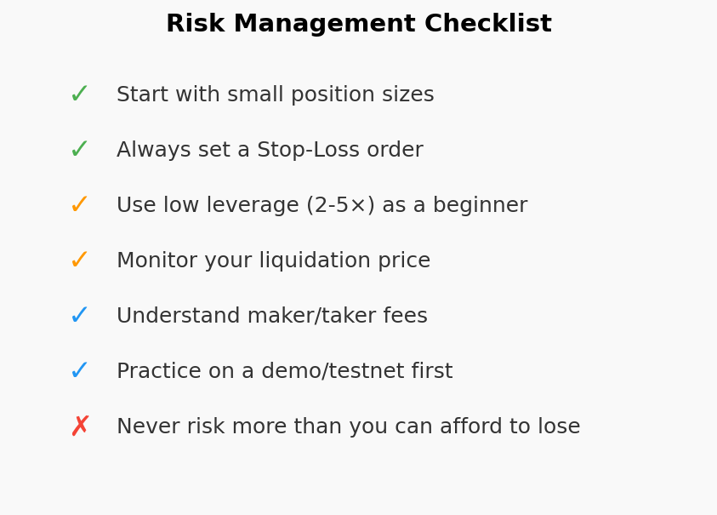
The video stresses that risk management is the most important
aspect of futures trading:
• Always use Stop-Loss orders to cap potential losses.
• Set Take-Profit orders to lock in gains at target levels.
• Start with very small position sizes until you are comfortable.
• Use the Binance Futures testnet / demo account for practice
before risking real funds.
• Understand the fee structure: Binance uses a maker/taker model
where limit orders (maker) typically pay lower fees than market
orders (taker).
• Never risk capital you cannot afford to lose – futures trading
with leverage is inherently high-risk.

8. Key Takeaways
1. Binance Futures lets you trade crypto derivatives with leverage,
profiting from both rising and falling markets.
2. Set up your account, verify your identity, and transfer funds
to your Futures wallet before trading.
3. Understand the differences between Market, Limit, and Stop
orders to pick the right tool for each situation.
4. Start with low leverage and Isolated Margin mode to limit risk.
5. Always set Stop-Loss and Take-Profit orders for every trade.
6. Practice on the testnet before using real money.
7. Continuously educate yourself – the crypto market moves fast.

Disclaimer: This document is for educational purposes only and does not constitute financial advice. Cryptocurrency futures trading involves substantial risk of loss. Always do your own research.

