TEAM PROPOSAL
Emerging Technologies for Nanyang Polytechnic
Competency Unit: Emerging Technologies Synthesis

Organization: Nanyang Polytechnic (NYP)
Sector: Education

Name | Role | Technology Focus
Clifton Chen Yi -231220B | Team Lead | Artificial Intelligence (AI)
Collin Koh Soon Ming -253991P | Member | Immersive Media (VR/AR)
Shin Thant Aung, Alex -243816M | Member | 5G and Edge Computing / Edge
Declan Chua Yuan Lok -240598B | Member | Blockchain-Based Certificate Verification Systems
Date: 19 February 2026

Table of Contents
- List of Illustrations
- Executive Summary
- Introduction
- Body
  - 4.1 Organization Overview
  - 4.2 Current Problems and Challenges
  - 4.3 Market Size and Potential Revenue
  - 4.4 Emerging Technology Solutions
    - 4.4.1 Artificial Intelligence (AI) — Clifton (Team Lead)
    - 4.4.2 Immersive Media (VR/AR) — Collin
    - 4.4.3 5G and Edge Computing / Edge — Alex
    - 4.4.4 Blockchain-Based Certificate Verification — Declan
- Conclusion
- References

1. List of Illustrations
Figures
Figure No. | Title | Section
Figure 1 | NYP's Educational Value Chain | 4.1
Figure 2 | Challenges Mapped to Value Chain Activities | 4.2
Figure 3 | Technology-to-Value-Chain Alignment Matrix | 4.4
Figure 4 | AI-Driven Adaptive Learning Workflow | 4.4.1
Figure 5 | VR/AR Integration Across the Learning Lifecycle | 4.4.2
Figure 6 | 5G and Edge Computing / Edge Campus Architecture | 4.4.3
Figure 7 | Blockchain Certificate Verification Flow | 4.4.4
Figure 8 | Three-Phase Implementation Roadmap | 5
Figure 9 | Technology Synergy Ecosystem | 5
Figure 10 | System Architecture Diagram for NYP Integrated Smart Campus | 5

Tables
Table No. | Title | Section
Table 1 | Team Members and Technology Assignments | Title Page
Table 2 | Potential Revenue Streams for NYP | 4.3
Table 3 | Cost Savings Through Technology Adoption | 4.3
Table 4 | AI Cost-Benefit Analysis | 4.4.1
Table 5 | AI Five-Year ROI Projection | 4.4.1
Table 6 | VR/AR Cost-Benefit Analysis | 4.4.2
Table 7 | VR/AR Five-Year ROI Projection | 4.4.2
Table 8 | 5G and Edge Computing / Edge Cost-Benefit Analysis | 4.4.3
Table 9 | 5G Five-Year ROI Projection | 4.4.3
Table 10 | Blockchain Cost-Benefit Analysis | 4.4.4
Table 11 | Blockchain Five-Year ROI Projection | 4.4.4
Table 12 | Consolidated Technology Investment Summary | 5

2. Executive Summary
Nanyang Polytechnic (NYP) is one of Singapore's five government-funded polytechnics, serving approximately 15,000 full-time students and thousands of continuing-education learners each year. As the digital economy transforms every sector, NYP faces mounting pressure to innovate its teaching methods, streamline operations, and prepare graduates for a technology-driven workforce.
This proposal evaluates how four emerging technologies — Artificial Intelligence (AI), Immersive Media (VR/AR), 5G and Edge Computing, and Blockchain-Based Certificate Verification — can be strategically adopted to address NYP's most pressing challenges. Our analysis maps each technology directly to NYP's educational value chain (student recruitment, curriculum design, teaching and learning delivery, assessment and certification, and campus operations) to ensure that every recommendation is operationally grounded and measurable.
Key findings:
- AI can reduce administrative costs by SGD 2–4 million per year and improve student retention by 10–15% through adaptive learning and predictive analytics.
- VR/AR can expand practical training capacity beyond physical lab constraints, with the potential to generate SGD 2–5 million per year in B2B licensing revenue from industry training simulations.
- 5G and Edge Computing can serve as the foundational infrastructure for a smart campus, lowering energy costs by 10–15% and enabling real-time, high-bandwidth applications for VR and AI.
- Blockchain can reduce credential verification processing time from days to seconds, cut manual verification labour by 50–70%, and position NYP as a leader in tamper-proof digital credentialing through Singapore's OpenCerts ecosystem.
The total estimated Year 1 investment across all four technologies ranges from SGD 8.8–17.1 million, with projected annual returns of SGD 10.5–23 million in combined revenue and cost savings, yielding a breakeven within 1–2 years for most initiatives. A phased three-year implementation roadmap is proposed to manage risk, and a technology synergy analysis demonstrates how the four solutions reinforce one another to form a cohesive smart-campus ecosystem.

3. Introduction
In today's rapidly evolving digital economy, emerging technologies hold the potential to revolutionize business operations, creating new opportunities for growth and innovation. The education sector in Singapore is at the forefront of this digital transformation, with institutions like Nanyang Polytechnic (NYP) actively seeking ways to enhance teaching, learning, and administrative efficiency through technology adoption.
Singapore's Smart Nation initiative and the Infocomm Media Development Authority (IMDA) Technology Roadmap have identified several frontier technologies — including Artificial Intelligence (AI), Immersive Media, 5G, and Blockchain — as key enablers of digital transformation across all sectors (IMDA, 2024). The education industry stands to benefit significantly from these technologies, as they can address longstanding challenges such as scalability of personalized learning, credential verification, campus connectivity, and experiential training.
This proposal examines how four emerging technologies can be strategically adopted by Nanyang Polytechnic to enhance its educational offerings, improve operational efficiency, and maintain its competitive position in Singapore's polytechnic education landscape. Each team member has researched one technology in depth, analyzing its potential impact on NYP's value chain, the disruption it brings to the digital economy, and the costs and benefits of adoption.
The structure of this proposal follows a systematic approach: Section 4.1 profiles the organization and its value chain; Section 4.2 diagnoses current challenges; Section 4.3 sizes the market opportunity; Sections 4.4.1–4.4.4 detail each technology solution; and Section 5 consolidates the findings into an implementation roadmap with a combined cost-benefit analysis.

4. Body
4.1 Organization Overview
About Nanyang Polytechnic (NYP)
Nanyang Polytechnic (NYP) is one of Singapore's five government-funded polytechnics, established in 1992. Located in Ang Mo Kio, NYP offers a wide range of full-time and part-time diploma courses, as well as Continuing Education and Training (CET) programs for adult learners (NYP, 2024).
Key Facts:
- Student Population: Approximately 15,000 full-time students and thousands of part-time/CET learners annually
- Schools: School of Information Technology, School of Engineering, School of Business Management, School of Design & Media, School of Health & Social Sciences, and School of Applied Science
- Mission: To nurture industry-ready professionals through practice-oriented education
- Annual Operating Budget: Estimated at SGD 200–300 million (funded by the Ministry of Education, Singapore)
- Website: https://www.nyp.edu.sg
NYP's Educational Value Chain
NYP's educational value chain (Figure 1) encompasses the end-to-end activities that deliver value to its primary customers — students — and its secondary stakeholders — employers, industry partners, and the government.
Figure 1: NYP's Educational Value Chain
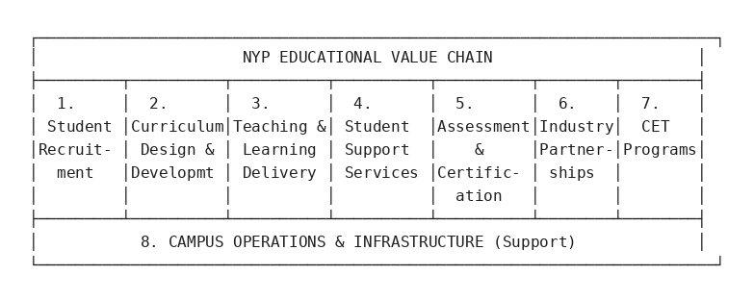
Each activity in the value chain represents an area where emerging technologies can create measurable improvements:
- Student Recruitment & Admissions — Marketing, outreach, application processing
- Curriculum Design & Development — Course creation, industry alignment, pedagogy innovation
- Teaching & Learning Delivery — Lectures, tutorials, lab sessions, online learning
- Student Support Services — Counseling, career guidance, financial aid
- Assessment & Certification — Examinations, grading, diploma issuance, certificate verification
- Industry Partnerships & Internships — Collaboration with companies for practical training
- Continuing Education & Training (CET) — Lifelong learning programs for working adults
- Campus Operations & Infrastructure — Facilities management, IT systems, security

4.2 Current Problems and Challenges
Nanyang Polytechnic faces several pressing challenges that directly affect specific stages of its value chain. Figure 2 maps each challenge to the value chain activity it most impacts.
Figure 2: Challenges Mapped to Value Chain Activities
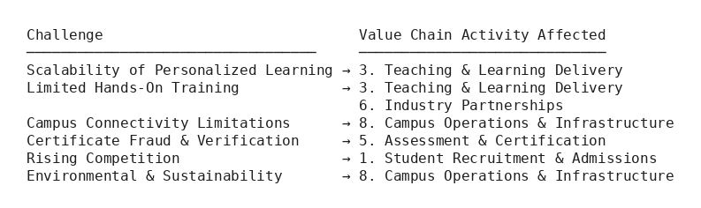
4.2.1 Scalability of Personalized Learning
Value chain link: Teaching & Learning Delivery
With approximately 15,000 full-time students across diverse disciplines, providing personalized learning experiences is a significant challenge. Lecturers have large class sizes, making it difficult to tailor instruction to individual learning paces and styles. Students who struggle may fall behind, while advanced students may not be adequately challenged.
4.2.2 Limited Hands-On Training Opportunities
Value chain link: Teaching & Learning Delivery; Industry Partnerships
Many courses, particularly in engineering, healthcare, and applied sciences, require hands-on practical training. However, physical lab spaces are limited and expensive to maintain. Equipment may be outdated, and scheduling constraints mean students get limited access to specialized facilities. The COVID-19 pandemic also highlighted the vulnerability of in-person practical training.
4.2.3 Campus Connectivity and Infrastructure Limitations
Value chain link: Campus Operations & Infrastructure
As NYP pushes toward smart campus initiatives and digital learning, the existing network infrastructure faces bandwidth limitations. With thousands of devices connecting simultaneously — laptops, tablets, IoT sensors, and smart building systems — the current Wi-Fi infrastructure can experience congestion, latency, and reliability issues, particularly during peak hours.
4.2.4 Certificate Fraud and Verification Delays
Value chain link: Assessment & Certification
The verification of academic credentials is a time-consuming, manual process. Employers and overseas institutions often request verification of diplomas and transcripts, requiring NYP's administrative staff to process each request individually. Additionally, certificate fraud remains a concern globally, with fake credentials undermining the credibility of legitimate qualifications.
4.2.5 Rising Competition in the Education Sector
Value chain link: Student Recruitment & Admissions
NYP competes with other polytechnics (Singapore Polytechnic, Temasek Polytechnic, Republic Polytechnic, Ngee Ann Polytechnic), universities, and private education institutions for student enrollment. To remain competitive, NYP must continuously innovate its teaching methods and student experience.
4.2.6 Environmental and Sustainability Concerns
Value chain link: Campus Operations & Infrastructure
Singapore faces environmental challenges including climate change, energy consumption, and resource efficiency. As a large institution, NYP has a responsibility to reduce its carbon footprint and adopt sustainable practices across its campus operations, in alignment with the Singapore Green Plan 2030 (Smart Nation, 2024).

4.3 Market Size and Potential Revenue
4.3.1 Singapore Education Market
Singapore's education industry is a significant contributor to the national economy (MOE, 2024):
- Total education expenditure: The Singapore government allocates approximately SGD 13 billion annually to education (approximately 15–20% of the national budget), making it the second-largest area of government spending.
- Polytechnic sector: The five polytechnics collectively enroll approximately 70,000 full-time students.
- NYP's share: With approximately 15,000 students, NYP captures approximately 21% of the polytechnic market.
4.3.2 EdTech Market Growth
The global Education Technology (EdTech) market is experiencing rapid growth (HolonIQ, 2024):
- Global EdTech market size: Estimated at USD 340 billion in 2024, projected to reach USD 605 billion by 2027 (CAGR of approximately 16%).
- Asia-Pacific EdTech market: Estimated at USD 115 billion in 2024, growing at approximately 18% CAGR.
- Singapore EdTech market: Estimated at SGD 1.5–2 billion, driven by government support through SkillsFuture and IMDA initiatives.
4.3.3 Potential Revenue Streams for NYP
By adopting emerging technologies, NYP can unlock new revenue opportunities that directly strengthen multiple value chain activities:
Table 2: Potential Revenue Streams for NYP
Revenue Stream | Value Chain Link | Estimated Annual Value (SGD)
AI-powered CET programs | CET Programs | 5–10 million
VR/AR training services (B2B licensing) | Industry Partnerships; CET | 2–5 million
Blockchain credential verification fees | Assessment & Certification | 0.5–1 million
5G-enabled smart campus services | Campus Operations | 1–3 million
Technology consulting/advisory | Industry Partnerships | 1–2 million
Total Potential Additional Revenue |  | 9.5–21 million
4.3.4 Cost Savings Through Technology
Beyond revenue generation, technology adoption can yield significant cost savings across the value chain:
Table 3: Cost Savings Through Technology Adoption
Technology | Saving Mechanism | Value Chain Link | Estimated Saving
AI | Administrative automation | Student Support; Recruitment | 10–20% reduction (SGD 2–4 M/year)
VR/AR | Replacing physical lab equipment | Teaching & Learning | 15–25% reduction in lab maintenance
Blockchain | Reducing manual verification | Assessment & Certification | 50–70% reduction in processing time
5G / Edge | Campus energy management | Campus Operations | 10–15% reduction in energy costs

4.4 Emerging Technology Solutions
The following subsections detail each of the four proposed technologies. Figure 3 shows how the technologies align to NYP's value chain, demonstrating that every part of the chain benefits from at least one initiative.
Figure 3: Technology-to-Value-Chain Alignment Matrix
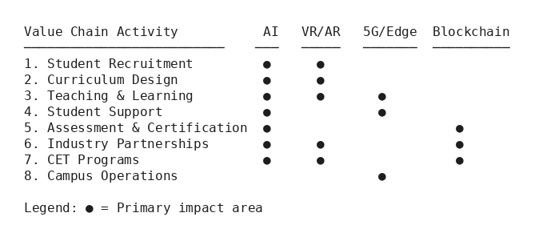

4.4.1 Artificial Intelligence (AI) — Clifton Chen Yi (Team Lead)
Technology Overview
Artificial Intelligence (AI) refers to the simulation of human intelligence by machines, enabling them to perform tasks such as learning, reasoning, problem-solving, and decision-making (Gartner, 2024). Key AI technologies relevant to education include:
- Machine Learning (ML): Algorithms that improve automatically through experience.
- Natural Language Processing (NLP): Enabling computers to understand and generate human language.
- Computer Vision: Enabling computers to interpret and analyze visual information.
- Generative AI: AI models (such as large language models) that can create content, answer questions, and assist in creative tasks.
According to the IMDA Technology Roadmap, AI is identified as a critical enabler for Singapore's digital economy, with applications spanning all industry sectors (IMDA, 2024). Gartner has consistently ranked AI as a top strategic technology trend, projecting that by 2026, more than 80% of enterprises will have used generative AI APIs or deployed generative AI-enabled applications (Gartner, 2024).
How AI Can Improve NYP's Business Processes
Figure 4 illustrates how AI-driven adaptive learning integrates with NYP's existing Learning Management System to personalize the student experience.
Figure 4: AI-Driven Adaptive Learning Workflow
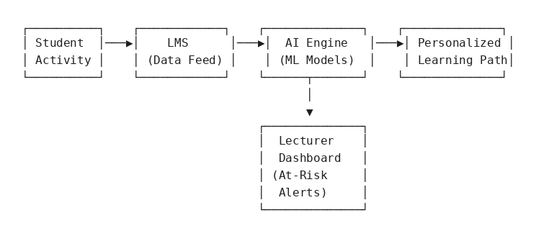
a) Adaptive Learning Platforms (Value chain: Teaching & Learning Delivery)
AI-powered adaptive learning systems can personalize the educational experience for each student. By analyzing individual learning patterns, performance data, and engagement metrics, AI can:
- Recommend customized learning paths and supplementary materials.
- Adjust the difficulty level of exercises in real time.
- Identify at-risk students early and alert lecturers for intervention.
Example: Platforms like DreamBox and Knewton use AI to adapt to each learner's level. NYP could implement similar systems within its Learning Management System (LMS) to provide individualized support across all courses.
b) AI-Powered Chatbots and Virtual Assistants (Value chain: Student Support Services; Recruitment)
NYP can deploy AI chatbots to handle routine student inquiries regarding:
- Course registration and timetabling.
- Financial aid and scholarship information.
- Campus facilities and event schedules.
- IT support and troubleshooting.
This would reduce the workload on administrative staff and provide 24/7 support to students. Example: Georgia State University in the United States deployed an AI chatbot called "Pounce," which reduced summer enrolment melt by 21% by proactively engaging with admitted students (Georgia State University, 2021).
c) Automated Assessment and Feedback (Value chain: Assessment & Certification)
AI can assist lecturers in grading assignments and providing feedback:
- NLP-based tools can grade essays and written assignments, providing detailed feedback on grammar, structure, and content.
- AI can auto-grade coding assignments by running test cases and analyzing code quality.
- This frees up lecturers to focus on higher-value activities such as mentoring and curriculum development.
d) Predictive Analytics for Student Success (Value chain: Student Support Services)
By analyzing historical data (attendance, grades, engagement), AI models can predict which students are at risk of failing or dropping out. NYP can then implement targeted interventions, such as additional tutoring or counselling.
Disruption to the Digital Economy and Future Markets
AI is fundamentally reshaping the education sector and the broader digital economy:
- Democratization of education: AI enables high-quality, personalized education at scale, potentially reducing the cost of education and making it accessible to broader populations.
- Shift in educator roles: As AI takes over routine tasks (grading, content delivery), educators evolve into facilitators, mentors, and designers of learning experiences.
- New business models: AI enables subscription-based, outcome-based, and micro-credentialing models in education.
- Workforce transformation: AI-driven automation is changing skill requirements across industries, increasing demand for CET programs that NYP can provide.
Impacts and Benefits
Benefits to NYP:
- Improved student outcomes and retention rates (estimated 10–15% improvement).
- Reduced administrative costs through automation (SGD 2–4 million/year).
- Enhanced competitive positioning as an AI-forward institution.
- New revenue from AI-powered CET courses (SGD 5–10 million/year).
Benefits to Students (Customers):
- Personalized learning experiences tailored to individual needs.
- Faster feedback on assignments and assessments.
- 24/7 access to support through AI chatbots.
- Better career guidance through AI-powered job matching.
Cost-Benefit Analysis
Table 4: AI Cost-Benefit Analysis
Item | Estimated Cost (SGD)
AI adaptive learning platform (licensing/development) | 1–2 million (initial) + 200K–500K/year
AI chatbot development and deployment | 200K–500K (initial) + 50K–100K/year
Predictive analytics infrastructure | 300K–600K (initial) + 100K–200K/year
Staff training and change management | 200K–400K
Data infrastructure and cloud computing | 300K–500K/year
Total (Year 1) | 2–4 million
Annual recurring costs | 650K–1.3 million
Table 5: AI Five-Year ROI Projection (SGD, midpoint estimates)
Year | Cumulative Investment | Cumulative Savings & Revenue | Net Position
1 | 3,000,000 | 2,500,000 | −500,000
2 | 3,975,000 | 7,500,000 | +3,525,000
3 | 4,950,000 | 12,500,000 | +7,550,000
4 | 5,925,000 | 17,500,000 | +11,575,000
5 | 6,900,000 | 22,500,000 | +15,600,000
Breakeven is achieved within Year 2. The five-year net return is approximately SGD 15.6 million, representing a 226% return on total investment.
Key Challenges for Adoption
- Data Privacy and Ethics: AI systems require large amounts of student data. NYP must ensure compliance with Singapore's Personal Data Protection Act (PDPA) and establish clear ethical guidelines for AI use (PDPC, 2024).
- Resistance to Change: Lecturers and staff may be resistant to AI tools that they perceive as replacing their roles. Comprehensive change management and training programs are essential.
- Data Quality: AI models are only as good as the data they are trained on. NYP must ensure data integrity and invest in data governance.
- Integration with Existing Systems: AI solutions must integrate seamlessly with NYP's existing LMS, student information systems, and IT infrastructure.

4.4.2 Immersive Media (VR/AR) — Collin Koh Soon Ming
Technology Overview
Immersive Media encompasses Virtual Reality (VR) and Augmented Reality (AR) technologies that create simulated or enhanced environments for users:
- Virtual Reality (VR): Fully immerses users in a computer-generated 3D environment using headsets (e.g., Meta Quest, HTC Vive).
- Augmented Reality (AR): Overlays digital information onto the real world through devices such as smartphones, tablets, or AR glasses (e.g., Microsoft HoloLens, Apple Vision Pro).
- Mixed Reality (MR): Blends real and virtual worlds, allowing digital and physical objects to interact in real time.
The IMDA Technology Roadmap identifies Immersive Media as a key technology for Singapore's digital transformation (IMDA, 2024). The global VR/AR market is projected to reach USD 300 billion by 2027, with education being one of the fastest-growing application areas.
How VR/AR Can Improve NYP's Business Processes
Figure 5 maps how VR/AR integrates across the learning lifecycle, from recruitment to industry training.
Figure 5: VR/AR Integration Across the Learning Lifecycle
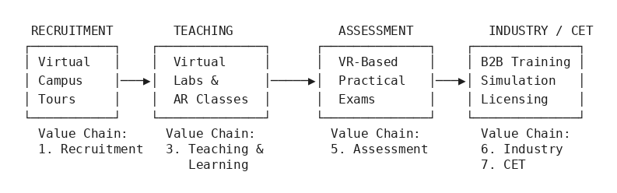
a) Virtual Laboratories and Practical Training (Value chain: Teaching & Learning Delivery)
VR can create highly realistic virtual laboratories where students can:
- Practice engineering experiments (e.g., circuit design, mechanical assembly) without physical equipment.
- Conduct chemistry and biology experiments safely in a virtual environment.
- Simulate healthcare scenarios (e.g., patient care, surgical procedures) for nursing and health science students.
Example: Labster, a VR laboratory simulation platform, is used by over 3,000 institutions worldwide, providing access to 200+ virtual lab experiments (Labster, 2024). NYP could adopt or develop similar VR labs tailored to its curriculum.
b) Immersive Learning Experiences (Value chain: Teaching & Learning Delivery; Curriculum Design)
AR can enhance classroom learning by:
- Overlaying 3D models of complex structures (e.g., human anatomy, building architecture, machine components) onto physical spaces.
- Allowing students to interact with and manipulate virtual objects in real time.
- Providing contextual information during field trips or on-campus exploration.
Example: The Microsoft HoloLens has been used in medical schools worldwide to allow students to explore 3D holographic models of the human body, improving spatial understanding compared to traditional 2D textbook diagrams (Microsoft, 2024).
c) Virtual Campus Tours and Student Recruitment (Value chain: Student Recruitment & Admissions)
NYP can create VR-based virtual campus tours for prospective students and their parents, allowing them to:
- Explore campus facilities from anywhere in the world.
- Experience student life through immersive 360-degree videos.
- Attend virtual open houses and information sessions.
This is particularly valuable for attracting international students and students who may not be able to visit the campus in person.
d) Industry Training Simulations (Value chain: CET Programs; Industry Partnerships)
NYP can develop VR training simulations for its CET programs, targeting industries such as:
- Aviation maintenance and safety training.
- Construction site safety and operations.
- Hospitality and customer service scenarios.
These simulations can be licensed to industry partners, creating a new revenue stream.
Disruption to the Digital Economy and Future Markets
Immersive Media is disrupting education and training markets in several ways:
- Remote learning evolution: VR/AR goes beyond video conferencing by enabling truly immersive remote learning experiences, making location irrelevant for hands-on training.
- Reduction in physical infrastructure needs: Virtual labs can reduce the need for expensive physical equipment and facilities.
- New content creation industry: The demand for VR/AR educational content is creating new markets for content developers, 3D artists, and immersive experience designers.
- Skills gap bridging: VR/AR training is proven to improve knowledge retention by 75% compared to traditional methods (PwC, 2022), making it a powerful tool for rapid upskilling.
Impacts and Benefits
Benefits to NYP:
- Expanded capacity for practical training without physical lab constraints.
- Reduced equipment maintenance and replacement costs (15–25% reduction).
- Differentiation from competing polytechnics.
- New B2B revenue from licensing VR training content to industry partners (SGD 2–5 million/year).
- Enhanced student recruitment through virtual campus experiences.
Benefits to Students (Customers):
- Safe, repeatable practice environments for high-risk scenarios.
- Access to experiments and equipment that may not be available physically.
- Improved learning outcomes through interactive, engaging experiences.
- Flexible access to virtual labs anytime, anywhere.
Cost-Benefit Analysis
Table 6: VR/AR Cost-Benefit Analysis
Item | Estimated Cost (SGD)
VR headsets (500 units × SGD 700/unit) | 350,000
VR lab development (10 virtual labs) | 1–2 million
AR application development | 300K–600K
VR content creation tools and licenses | 200K–400K
Dedicated VR/AR studio space setup | 500K–1 million
Staff training (lecturers and technicians) | 150K–300K
Annual maintenance and content updates | 300K–500K/year
Total (Year 1) | 2.5–4.7 million
Annual recurring costs | 300K–500K
Table 7: VR/AR Five-Year ROI Projection (SGD, midpoint estimates)
Year | Cumulative Investment | Cumulative Savings & Revenue | Net Position
1 | 3,600,000 | 1,500,000 | −2,100,000
2 | 4,000,000 | 5,000,000 | +1,000,000
3 | 4,400,000 | 8,500,000 | +4,100,000
4 | 4,800,000 | 12,000,000 | +7,200,000
5 | 5,200,000 | 15,500,000 | +10,300,000
Breakeven is achieved within Year 2. The five-year net return is approximately SGD 10.3 million, representing a 198% return on total investment.
Key Challenges for Adoption
- High Initial Investment: VR/AR hardware and content development require significant upfront investment, which must be justified through demonstrable learning outcomes.
- Content Development: Creating high-quality, curriculum-aligned VR/AR content is time-consuming and requires specialized skills (3D modeling, UX design, instructional design).
- Motion Sickness and Accessibility: Some users experience VR-induced motion sickness. NYP must ensure alternative access methods for students who cannot use VR.
- Technology Obsolescence: VR/AR hardware evolves rapidly, and NYP must plan for regular hardware refresh cycles (every 2–3 years).
- Pedagogical Integration: Lecturers need training not only on how to use VR/AR tools but also on how to effectively integrate them into their teaching methodology.

4.4.3 5G and Edge Computing — Shin Thant Aung, Alex
Technology Overview
5G (Fifth Generation Mobile Networks) is the latest generation of cellular technology, offering (IMDA, 2024):
- Ultra-high speeds: Up to 20 Gbps (20× faster than 4G).
- Ultra-low latency: As low as 1 millisecond (compared to 30–50 ms for 4G).
- Massive device connectivity: Support for up to 1 million devices per square kilometre.
- Network slicing: The ability to create multiple virtual networks on a single physical infrastructure.
Edge Computing brings computation and data storage closer to the sources of data (i.e., at the "edge" of the network), rather than relying on centralised cloud data centres. This reduces latency, improves response times, and reduces bandwidth consumption.
The IMDA Technology Roadmap highlights 5G as a foundational infrastructure for Singapore's digital economy. Singapore achieved nationwide standalone 5G coverage in 2025 through operators Singtel and StarHub (Singtel, 2025; StarHub, 2025). The combination of 5G and edge computing is identified as a key enabler for IoT, immersive media, and smart campus applications.
How 5G and Edge Computing Can Improve NYP's Business Processes
Figure 6 illustrates the proposed smart campus architecture, with 5G as the connectivity backbone and edge computing providing local processing power.
Figure 6: 5G and Edge Computing Campus Architecture
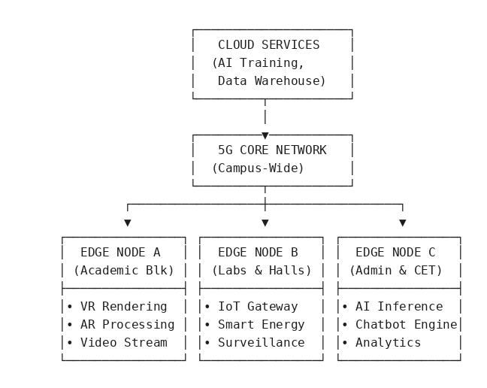
a) Smart Campus Infrastructure (Value chain: Campus Operations & Infrastructure)
5G and edge computing can transform NYP into a truly smart campus:
- IoT sensor networks: Deploy thousands of IoT sensors across the campus for real-time monitoring of air quality, temperature, lighting, and occupancy. Edge computing processes this data locally, enabling instant adjustments to building management systems.
- Smart energy management: AI-powered energy optimization systems running on edge servers can reduce campus energy consumption by 10–15%, contributing to Singapore's sustainability goals.
- Smart parking and navigation: Real-time campus navigation and parking availability through 5G-connected systems.
Example: The National University of Singapore (NUS) has implemented smart building systems that use IoT sensors and edge computing to optimize energy usage, achieving 15% energy savings across its campus (NUS, 2024).
b) Enhanced Online and Hybrid Learning (Value chain: Teaching & Learning Delivery)
5G's high bandwidth and low latency enable:
- High-quality video streaming: Seamless 4K/8K lecture streaming without buffering, improving the online learning experience.
- Real-time collaboration: Students and lecturers can collaborate on shared virtual workspaces with zero lag.
- Live remote lab access: Students can remotely control physical lab equipment in real time through 5G connections, with edge computing ensuring minimal latency.
c) Support for VR/AR and AI Applications (Value chain: Teaching & Learning Delivery; Student Support)
5G and edge computing are essential enablers for other technologies in this proposal:
- VR/AR applications require high bandwidth and low latency, which 5G provides natively.
- AI applications that require real-time processing (e.g., computer vision, speech recognition) can run on edge servers, reducing dependence on cloud computing and improving response times.
- This creates a synergistic technology ecosystem where 5G/edge computing serves as the foundational layer.
d) Campus Security and Safety (Value chain: Campus Operations & Infrastructure)
5G-connected security systems can include:
- AI-powered video surveillance with real-time threat detection (running on edge servers).
- Automated access control systems with facial recognition.
- Emergency alert systems with location-based notifications to all campus devices.
- Environmental monitoring (e.g., haze levels, flooding risk) with instant alerts.
Disruption to the Digital Economy and Future Markets
5G and edge computing are transforming the digital economy by:
- Enabling the IoT ecosystem: 5G's massive device connectivity enables the deployment of billions of IoT devices, creating new data-driven business models.
- Decentralising computing: Edge computing shifts processing from centralised clouds to distributed edge nodes, enabling real-time applications and reducing data transfer costs.
- Creating new service models: Network slicing allows operators to offer customized network services (e.g., a dedicated low-latency slice for VR applications, a high-bandwidth slice for video streaming).
- Accelerating Industry 4.0: 5G-connected smart factories, autonomous vehicles, and remote surgery are becoming reality, fundamentally changing industries and creating demand for new skills — skills that NYP must prepare its students for.
Impacts and Benefits
Benefits to NYP:
- Modernized campus infrastructure supporting next-generation applications.
- Reduced energy costs through smart building management (10–15% savings).
- Enhanced competitiveness as a technology-forward institution.
- Foundational infrastructure for VR/AR, AI, and IoT initiatives.
- Improved campus safety and security.
Benefits to Students (Customers):
- Seamless, high-quality online and hybrid learning experiences.
- Access to cutting-edge 5G-enabled applications and tools.
- Practical experience with 5G and edge computing technologies (enhancing employability).
- Improved campus experience through smart services.
Cost-Benefit Analysis
Table 8: 5G and Edge Computing Cost-Benefit Analysis
Item | Estimated Cost (SGD)
5G infrastructure (private network or enhanced coverage) | 1.5–3 million
Edge computing servers and infrastructure | 500K–1 million
IoT sensors and smart building systems | 800K–1.5 million
Network management and monitoring systems | 200K–400K
Integration with existing IT infrastructure | 300K–500K
Staff training (IT team and lecturers) | 100K–200K
Annual maintenance and operations | 400K–700K/year
Total (Year 1) | 3.4–6.6 million
Annual recurring costs | 400K–700K
Table 9: 5G Five-Year ROI Projection (SGD, midpoint estimates)
Year | Cumulative Investment | Cumulative Savings & Revenue | Net Position
1 | 5,000,000 | 1,000,000 | −4,000,000
2 | 5,550,000 | 3,000,000 | −2,550,000
3 | 6,100,000 | 5,500,000 | −600,000
4 | 6,650,000 | 8,500,000 | +1,850,000
5 | 7,200,000 | 12,000,000 | +4,800,000
Breakeven is achieved in Year 3–4. The five-year net return is approximately SGD 4.8 million, representing a 67% return on total investment. The longer payback reflects the infrastructure nature of this investment, which enables and accelerates the ROI of the other three technologies.
Key Challenges for Adoption
- High Infrastructure Costs: Deploying 5G and edge computing infrastructure requires significant capital investment. NYP may need to partner with telcos (e.g., Singtel, StarHub) to share costs.
- Spectrum and Regulatory Issues: Private 5G networks require spectrum allocation from IMDA, which involves regulatory approvals and compliance.
- Cybersecurity Risks: 5G's massive device connectivity increases the attack surface. Comprehensive cybersecurity measures are essential to protect the campus network and student data.
- Technical Expertise: Managing 5G and edge computing infrastructure requires specialized skills. NYP must invest in upskilling its IT team or partner with managed service providers.
- Interoperability: Ensuring that 5G/edge computing infrastructure integrates seamlessly with existing campus systems (LMS, student information systems, building management) is critical.

4.4.4 Blockchain-Based Certificate Verification — Declan Chua Yuan Lok
Technology Overview
Blockchain is a decentralised digital ledger that are most commonly used in cryptocurrencies such as Bitcoin but has other uses such as supply chain management, healthcare and of course, certificate verification.
Blockchain operates on a decentralized network of computers (Also known as nodes). These nodes each have an entire copy of the ledger, ensuring that no single entity or authority has control over the entire system. Much like Hadoop Distributed File System, this decentralization ensures resilience, as if one (or even 10% of nodes) node fails, the entire system does not go down.
The ledger is made up of data grouped into blocks. Each block typically contains a set of transactions (Or certificates in this case), and it also includes a cryptographic hash of the previous block in the chain. This means that the bottommost block can be linked to every other block, making it a “blockchain”.
Adding a block requires network consensus. The rules depend on the configuration of the consensus protocol, private blockchains often require two-thirds of nodes to agree, while public blockchains rely on mechanisms such as Proof of Work or Proof of Stake. This design prevents malicious actors from altering the ledger without controlling the majority of the nodes which is highly impractical. Once a block is added, it cannot be removed or modified.
How Blockchain Can Improve NYP's Business Processes
Figure 7 contrasts the current manual verification process with the proposed blockchain-based flow.
Figure 7: Blockchain Certificate Verification Flow
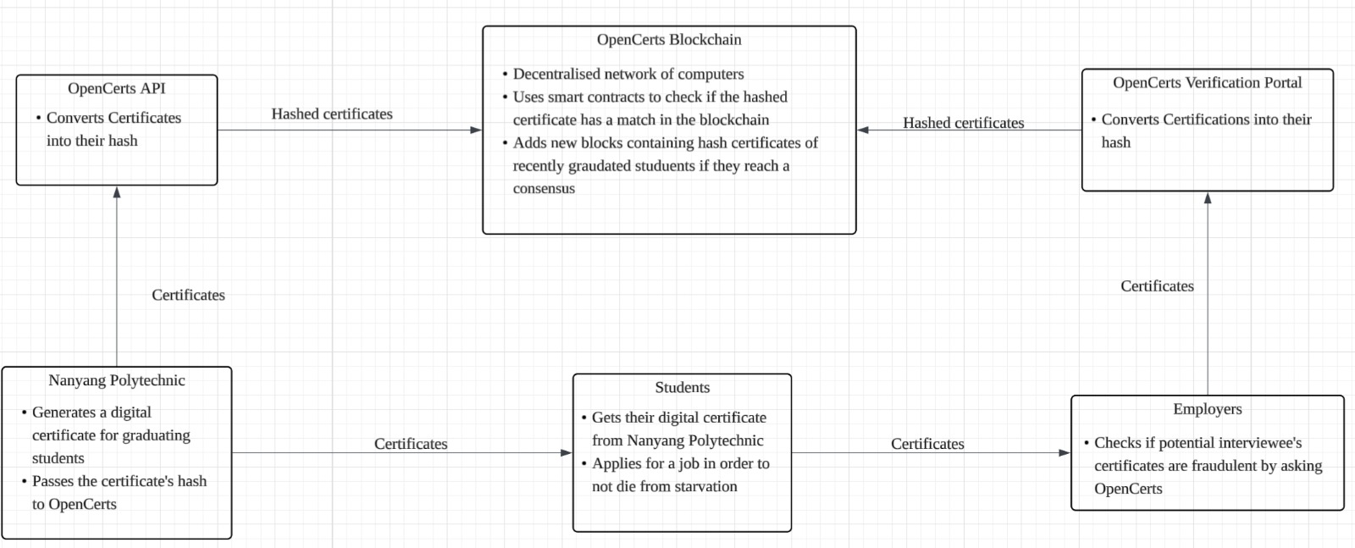
a) Digital Diploma and Certificate Issuance (Value chain: Assessment & Certification)
NYP can issue all diplomas, certificates of achievement, and competition awards as blockchain-verifiable digital certificates:
- Each certificate is cryptographically signed and stored on a blockchain network.
- Graduates receive the digital certificate.
- Employers and institutions can instantly verify the certificate's authenticity without contacting NYP via a verification portal.
Example: Singapore's OpenCerts platform (https://www.opencerts.io) already enables institutions to issue blockchain-verifiable certificates (OpenCerts, 2024). NYP is part of this ecosystem but can expand its use to include:
- Graduation diplomas.
- Competition and hackathon awards.
- CET course completion certificates.
- Internship completion certificates.
- Skill-based micro-credentials.
b) Micro-Credentialing and Skill Badges (Value chain: CET Programs; Industry Partnerships)
Blockchain enables the issuance of granular, verifiable micro-credentials for specific skills or competencies:
- Students can accumulate skill badges throughout their education (e.g., "Python Programming," "Data Analysis," "Project Management").
- These micro-credentials are stackable and can be shared on LinkedIn and other professional platforms.
- Employers can verify not just a student's diploma but their specific skill portfolio.
Example: MIT has used blockchain to issue digital diplomas through its Blockcerts platform since 2017, allowing graduates to share verified credentials with employers directly from their smartphones (MIT Media Lab, 2017).
c) Streamlined Verification Process (Value chain: Assessment & Certification)
Current verification process at NYP:
- Employer/institution requests verification (via email or form).
- NYP admin staff receives and processes the request.
- Staff checks records against student database.
- Verification letter is prepared and sent back.
- Typical processing time: 3–10 working days.
Blockchain-based verification:
- Employer inputs the certificate into the verification portal.
- Blockchain network instantly confirms authenticity.
- Processing time: Seconds.
This eliminates the need for manual verification, saving significant staff time and improving the experience for graduates and employers.
d) Transcript and Academic Record Management (Value chain: Assessment & Certification; Student Support)
A blockchain-based academic record system can:
- Store complete student transcripts on a blockchain network.
- Enable students to selectively share specific grades or courses with potential employers.
- Facilitate credit transfer between institutions with verified, tamper-proof records.
- Support the SkillsFuture movement by providing a unified, verifiable record of all learning achievements (SkillsFuture, 2024).
Disruption to the Digital Economy and Future Markets
Blockchain-based credential verification is disrupting the education sector and beyond:
- Elimination of credential fraud: The global cost of credential fraud is estimated at billions of dollars annually. Blockchain makes fake certificates immediately detectable.
- Decentralised education ecosystem: Blockchain enables recognition of learning from multiple sources (formal education, online courses, industry certifications) in a unified, verifiable format.
- Cross-border credential recognition: Blockchain credentials can be verified across countries, facilitating global mobility for graduates.
- New market for credential verification services: The global blockchain in education market was valued at approximately 0.35 billion USD in 2024 and is projected to reach 9.39 billion USD by 2033.
Impacts and Benefits
Benefits to NYP:
- Elimination of manual verification workload.
- Enhanced institutional reputation through tamper-proof credentials.
- First-mover advantage in comprehensive blockchain credentialing.
- Support for Singapore's OpenCerts and Smart Nation initiatives.
Benefits to Students (Customers):
- Ability to send credentials directly with employers.
- Protection against credential fraud (their qualifications cannot be forged).
- Portable credentials that work across borders.
- Granular skill-level credentials that showcase specific competencies.
Benefits to Employers:
- Instant verification of candidate qualifications (seconds instead of days).
- Elimination of the risk of hiring based on fake credentials.
- Reduced due diligence costs in the hiring process.
Cost-Benefit Analysis
Table 10: Blockchain Cost-Benefit Analysis
Item | Estimated Cost (SGD)
Blockchain platform development/integration (building on OpenCerts) | 300K–600K
Smart contract development and auditing | 100K–200K
Digital credential management system | 200K–400K
User interface development (student/employer portal) | 150K–300K
Integration with student information system (SIS) | 100K–200K
Staff training and change management | 50K–100K
Annual hosting, maintenance, and blockchain fees | 80K–150K/year
Total (Year 1) | 900K–1.8 million
Annual recurring costs | 80K–150K
Table 11: Blockchain Five-Year ROI Projection (SGD, midpoint estimates)
Year | Cumulative Investment | Cumulative Savings & Revenue | Net Position
1 | 1,350,000 | 400,000 | −950,000
2 | 1,465,000 | 1,150,000 | −315,000
3 | 1,580,000 | 1,900,000 | +320,000
4 | 1,695,000 | 2,650,000 | +955,000
5 | 1,810,000 | 3,400,000 | +1,590,000
Breakeven is achieved within Year 3. The five-year net return is approximately SGD 1.59 million, representing an 88% return on total investment. The relatively modest absolute figures reflect the low cost of blockchain implementation; however, the strategic value — institutional credibility, fraud elimination, and alignment with national initiatives — significantly exceeds the financial return.
Key Challenges for Adoption
- Stakeholder Adoption: Success depends on employers and other institutions accepting and using blockchain-verified credentials. NYP must engage with industry partners to drive adoption.
- Interoperability: Multiple blockchain platforms exist (Ethereum, Hyperledger, etc.). NYP must ensure its system is compatible with Singapore's OpenCerts framework and international standards.
- User Education: Students, staff, and employers need to understand how to use blockchain credentials effectively. Training and clear documentation are essential.
- Adoption Timing: Students who graduate before adoption may not have their credentials immediately verifiable on the blockchain, requiring manual verification for employers.

- Cryptographic Hash: The Hash must be secure enough to ensure that the hash cannot be reversed and have information extracted from it.

5. Conclusion
This proposal has examined how four emerging technologies — Artificial Intelligence, Immersive Media (VR/AR), 5G and Edge Computing, and Blockchain-Based Certificate Verification — can be strategically adopted by Nanyang Polytechnic to address current challenges, enhance its educational value chain, and position itself as a leader in Singapore's digital education landscape.

Consolidated Technology Investment Summary
Table 12: Consolidated Technology Investment Summary
Technology | Primary Impact Area | Year 1 Investment (SGD) | Annual Savings/Revenue (SGD) | Breakeven
AI | Teaching & Learning, Administration | 2–4 million | 7–14 million | Year 2
VR/AR | Practical Training, Recruitment | 2.5–4.7 million | 2–5 million | Year 2
5G & Edge Computing | Campus Infrastructure | 3.4–6.6 million | 1–3 million | Year 3–4
Blockchain Certificates | Certification & Verification | 0.9–1.8 million | 0.5–1 million | Year 3
Total |  | 8.8–17.1 million | 10.5–23 million | Range from Year 2-4
Implementation Roadmap
Figure 8 outlines a phased three-year plan that manages risk by prioritizing quick-win, lower-cost technologies in Phase 1 while laying the groundwork for infrastructure-heavy initiatives.
Figure 8: Three-Phase Implementation Roadmap
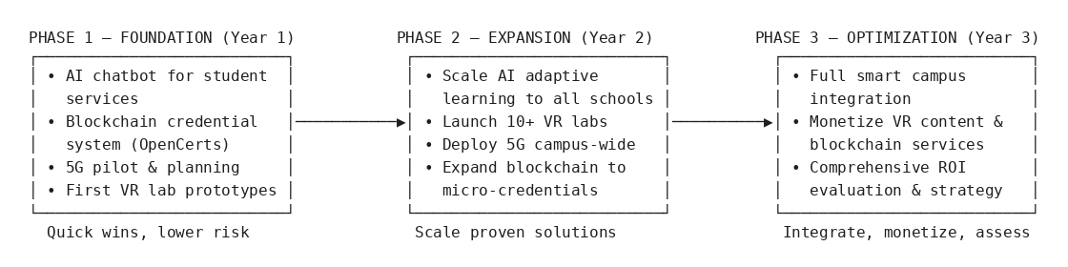
Phase 1 (Year 1): Foundation
- Deploy AI chatbot for student services.
- Implement blockchain credential system (building on OpenCerts).
- Begin 5G infrastructure planning and pilot.
- Develop first VR lab prototypes.
Phase 2 (Year 2): Expansion
- Scale AI adaptive learning across all schools.
- Launch 10+ VR virtual labs.
- Deploy 5G infrastructure campus wide.
- Expand blockchain to include micro-credentials.
Phase 3 (Year 3): Optimization
- Integrate all technologies into a cohesive smart campus ecosystem.
- Monetize VR content and blockchain verification services.
- Conduct comprehensive ROI evaluation and adjust strategy.

Technology Synergy Ecosystem
The four technologies are not independent — they create a synergistic ecosystem (Figure 9).
Figure 9: Technology Synergy Ecosystem
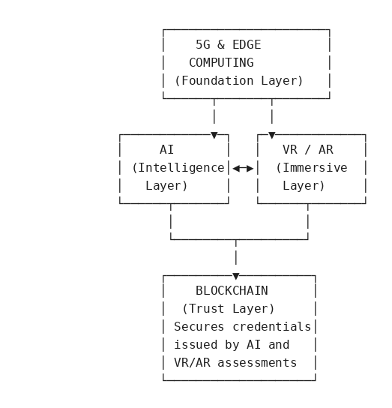
- 5G enables VR/AR: High-bandwidth, low-latency 5G is essential for seamless VR/AR experiences.
- AI enhances VR/AR: AI can personalize VR/AR learning scenarios based on individual student performance.
- Blockchain secures AI-issued credentials: As AI-driven assessment becomes more prevalent, blockchain ensures the integrity and verifiability of AI-generated evaluations.
- Edge computing supports all: Edge servers provide the low-latency processing required by AI inference, VR rendering, and IoT data processing.
By adopting these technologies in a coordinated manner, Nanyang Polytechnic can transform its operations, enhance the student experience, and secure its position as Singapore's leading polytechnic in the digital age.

System Architecture Diagram (please see the uploaded png in Brightspace for bigger view)
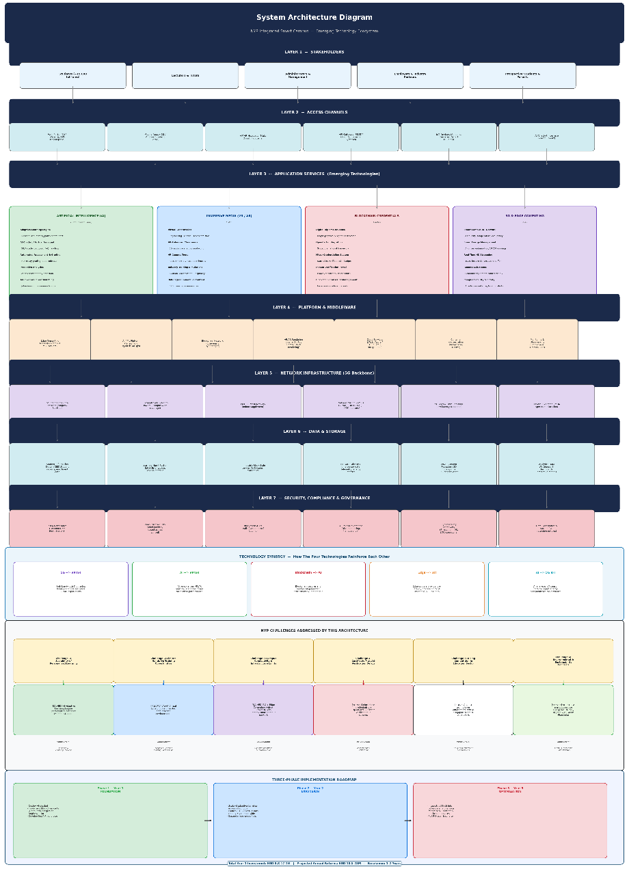
System Architecture Diagram — NYP Integrated Smart Campus
This diagram shows the complete, end-to-end technology architecture that integrates four emerging technologies (AI, VR/AR, 5G & Edge Computing, Blockchain) into a unified smart campus ecosystem for Nanyang Polytechnic. It is organized into 7 layers, plus supporting sections for synergy, challenge mapping, and implementation.

Layer 1 — Stakeholders
The top layer identifies the five stakeholder groups the system serves:
- Students (~15,000 full-time)
- Lecturers & Tutors
- Administrators & Management
- Employers & Industry Partners
- Prospective Students & Parents
Layer 2 — Access Channels
The interfaces through which stakeholders interact with the system:
- Web Portal (NYP Website, LMS Brightspace)
- Mobile Apps (iOS/Android Student Portal)
- VR/AR Headsets (Meta Quest, HoloLens)
- API Gateway (REST/GraphQL for external systems)
- IoT Devices (Sensors, Cameras, Smart Building)
- AI Chatbot Interface (24/7 Support)
Layer 3 — Application Services (Emerging Technologies)
The core of the architecture — four color-coded technology pillars, one per team member:
Technology | Owner | Key Capabilities
Artificial Intelligence (AI) (green) | Clifton (Team Lead) | Adaptive Learning Engine, AI Chatbot/Virtual Assistant, Automated Assessment & Grading, NLP essay grading, Predictive Analytics, AI-Powered Career Matching
Immersive Media (VR/AR) (blue) | Collin | Virtual Laboratories (Engineering, Science, Healthcare), AR-Enhanced Classrooms, VR Campus Tours, Industry Training Simulations, 360° Immersive Content
Blockchain Credentials (red/pink) | Declan | Digital Diploma Issuance (cryptographically signed), OpenCerts Integration, Micro-Credentialing System (stackable skill badges), Instant Verification Portal, Blockchain Transcript Management
5G & Edge Computing (purple) | Alex | Smart Campus IoT Network, Smart Energy Management (10–15% savings), Real-Time HD Streaming (4K/8K), Remote Lab Access (real-time equipment control via 5G), Campus Security & Safety
Layer 4 — Platform & Middleware
The computational backbone supporting all applications:
- Edge Computing Nodes (on-campus MEC servers)
- AI/ML Platform (TensorFlow, PyTorch, MLOps)
- Blockchain Network (Ethereum/Hyperledger)
- VR/AR Rendering Engine (Unity/Unreal, Cloud Rendering)
- Cloud Services (AWS/Azure/GCP, SaaS integrations)
- Container Orchestration (Kubernetes, Docker)
- Monitoring & Observability (Prometheus, Grafana, ELK)
Layer 5 — Network Infrastructure (5G Backbone)
The connectivity foundation:
- 5G Standalone Core Network (Singtel/StarHub)
- 5G Small Cells & Macro Towers (campus-wide)
- Wi-Fi 6E Mesh Network (indoor supplement)
- Network Slicing (eMBB for VR/AR, URLLC for IoT, mMTC for sensors)
- SD-WAN & Fibre Backhaul (low-latency backbone)
- Private 5G Option (IMDA spectrum allocation)
Layer 6 — Data & Storage
Where all data resides:
- Student Information System (SIS)
- Learning Management System (LMS/Brightspace)
- Immutable Blockchain Ledger (certificates, transcripts)
- IoT Data Lake (real-time sensor data, energy metrics)
- VR/AR Content Repository (3D models, simulations)
- Analytics Data Warehouse (BI dashboards, predictive models)
Layer 7 — Security, Compliance & Governance
Cross-cutting security and compliance:
- PDPA Compliance (Singapore's Personal Data Protection Act)
- Zero-Trust Security Model (identity-based access control)
- Blockchain Audit Trails (tamper-proof logging)
- AI Ethics Governance (bias monitoring, transparency)
- Cybersecurity Framework (encryption, IDS, SOC operations)
- Data Governance & Backup (DR, retention policies)

Technology Synergy Section
Shows how the four technologies reinforce each other (not siloed):
- 5G → VR/AR: High bandwidth & ultra-low latency enables seamless VR/AR
- AI → VR/AR: AI personalises VR/AR learning scenarios based on student performance
- Blockchain → AI: Blockchain secures and verifies AI-generated assessments & credentials
- Edge → All: Edge servers provide low-latency processing for AI inference, VR rendering, IoT
- AI → 5G IoT: AI analyses IoT sensor data for smart energy and predictive maintenance
NYP Challenges Addressed
Maps all 6 NYP challenges to their resolving technology:
- Scalability of Personalised Learning → AI Adaptive Learning Engine
- Limited Hands-On Training → VR/AR Virtual Labs
- Campus Connectivity & Infrastructure Limits → 5G + Edge Computing
- Certificate Fraud & Verification Delays → Blockchain via OpenCerts
- Rising Competition in Education → All 4 technologies differentiate NYP
- Environmental & Sustainability Concerns → 5G IoT + AI analytics (10–15% energy reduction)
Each challenge is linked to its corresponding value chain area (e.g., Teaching & Learning, Assessment & Certification, Campus Operations).
Three-Phase Implementation Roadmap
- Phase 1 (Year 1) — Foundation: Deploy AI chatbot, implement blockchain certs (OpenCerts), begin 5G pilot, develop first VR lab prototypes
- Phase 2 (Year 2) — Expansion: Scale AI adaptive learning across all schools, launch 10+ VR virtual labs, deploy 5G campus-wide, expand micro-credentials
- Phase 3 (Year 3) — Optimization: Integrate all tech into cohesive smart campus, monetize VR content & blockchain services, full ROI evaluation
Investment: SGD 8.8–17.1M Year 1 | Returns: SGD 10.5–23M annually | Breakeven: 1–2 years

6. References
- Infocomm Media Development Authority (IMDA). (2024). Singapore Digital Economy Technology Roadmap. Retrieved from https://www.imda.gov.sg/about-imda/research-and-statistics/sgdigital/services-and-digital-economy-technology-roadmap
- Nanyang Polytechnic (NYP). (2024). About NYP. Retrieved from https://www.nyp.edu.sg/about-nyp.html
- Gartner. (2024). Top Strategic Technology Trends for 2025. Retrieved from https://www.gartner.com/en/articles/gartner-top-10-strategic-technology-trends-for-2025
- Ministry of Education (MOE), Singapore. (2024). Education Statistics Digest. Retrieved from https://www.moe.gov.sg/about/publications/education-statistics
- OpenCerts. (2024). An Easy Way to Check and Verify Your Certificates. Retrieved from https://www.opencerts.io
- PwC. (2022). The Effectiveness of Virtual Reality Soft Skills Training in the Enterprise. Retrieved from https://www.pwc.com/us/en/tech-effect/emerging-tech/virtual-reality-study.html
- SkillsFuture Singapore. (2024). SkillsFuture Initiatives. Retrieved from https://www.skillsfuture.gov.sg
- Government Technology Agency (GovTech), Singapore. (2024). Blockchain for Government. Retrieved from https://www.tech.gov.sg
- IMDA. (2024). 5G Innovation. Retrieved from https://www.imda.gov.sg/how-we-can-help/5g-innovation
- Labster. (2024). Virtual Lab Simulations for Science Education. Retrieved from https://www.labster.com
- MIT Media Lab. (2017). Digital Certificates Project. Retrieved from https://www.blockcerts.org
- Georgia State University. (2021). Pounce AI Chatbot Case Study. Retrieved from https://success.gsu.edu
- HolonIQ. (2024). Global EdTech Market Size and Forecast. Retrieved from https://www.holoniq.com/edtech
- Singtel. (2025). 5G Coverage in Singapore. Retrieved from https://www.singtel.com/personal/products-services/mobile/5g
- Microsoft. (2024). HoloLens in Education. Retrieved from https://www.microsoft.com/en-us/hololens/industry-education
- Personal Data Protection Commission (PDPC), Singapore. (2024). Personal Data Protection Act Overview. Retrieved from https://www.pdpc.gov.sg/overview-of-pdpa/the-legislation/personal-data-protection-act
- Smart Nation Singapore. (2024). Transforming Singapore Through Technology. Retrieved from https://www.smartnation.gov.sg
- National University of Singapore (NUS). (2024). Smart Campus Initiatives. Retrieved from https://www.nus.edu.sg
- Gartner. (2024). Hype Cycle for Education. Retrieved from https://www.gartner.com/en/documents/hype-cycle-for-education
- StarHub. (2025). 5G Network Singapore. Retrieved from https://www.starhub.com/personal/mobile-plans/5g.html
- Veremark. (26 April). Rise in diploma fraud in Singapore and its impact on employers. https://www.veremark.com/blog/rise-in-diploma-fraud-in-singapore-and-its-impact-on-employers
- Hashtag Web3 Playbook. (n.d.). Blockchain based certificate verification systems. https://hashtagweb3.com/blockchain-based-certificate-verification-systems
- MySkillsFuture. (n.d.). Digital certificates (FAQs). https://www.myskillsfuture.gov.sg/content/portal/en/header/faqs/DigitalCertificates.html
- DiplomaSafe. (2023, 22 November). Blockchain certification process. https://diplomasafe.com/blockchain-certification-process/
- OpenCerts. (n.d.). OpenCerts – An easy way to check and verify your certificates. https://www.opencerts.io/
- Investopedia. (2023). Blockchain facts: What it is, how it works, and how it can be used. https://www.investopedia.com/terms/b/blockchain.asp#toc-pros-and-cons-of-blockchain
- GovTech Singapore. (2021, March 3). Losing your educational certificates is now a thing of the past. https://www.tech.gov.sg/technews/losing-your-educational-certs-a-thing-of-the-past/
- NADCAB. (2025, 3 Jun). The future of education certificate verification. https://www.nadcab.com/blog/future-of-blockchain-education-certificate-verification

