Digitization of Olfaction
Alan Pham
Neuroscience
Bates College
Advisor: Jason Castro
Preamble
One objective of sensory neuroscience is to understand how physical stimuli can be translated into perceptual representations in the brain. The stimulus-percept mapping is predictable and well-defined for most of the sensory systems. In vision, for example, the wavelength of light maps monotonically onto the human perception of color. In auditory processing, the frequency of a sound wave is directly correlated with the perception of pitch. However, olfaction long seemed to be the exception.. Even though we understand a great deal about the underlying stimuli ( chemistry, reactions, etc) the neural events mediating chemical detection (e.g. the neurobiology the putative “rules” of how a molecule's physiochemical properties translate into the perception of smell is still a mystery (Sell, 2006; Keller et al., 2017). [Perhaps the limiting factor hasn’t been a lack of understanding about the underlying chem or bio, but rather the lack of tools for reasoning about what is fundamentally a problem in high dimensional inference] The limiting factor of this translation has not been a lack of understanding the underlying chemical or biological systems, but rather the lack of tools for reasoning about the fundamental problem with high dimensional inference.
Understanding the olfactory code is not only a theoretical question; it is very important ecologically and economically. From an evolutionary perspective, the olfactory system is vital for survival, guiding behaviors like getting food, staying safe, and socializing. In humans, the neuroanatomical connections between the olfactory bulb and limbic system (amygdala and hippocampus) make scent a very strong driver of emotion and episodic memory. Economically, predictable digitization of scent would be the “hold grail” for the billion-dollar flavor and fragrance industry. A good computational model that is able to predict how a molecule will smell would change how the industry will synthesize digital scents, artificial flavorings, and chemical alternatives for sustainability. However, the long-term goals of the field move from more than just consumer goods to clinical healthcare to detect chemical signatures for disease. This looks like identifying specific cancers or bacterial infections from a patient’s breath (WSJ, 2024). In pharmacology, the generative deep learning model allowed the de novo design of new antibiotics from scratch (Krishnan et al,. 2025), a good olfactory model would allow us to move from pure predictions to active creation. Decoding these chemical rules would allow researchers to computationally engineer molecules to have specific properties.
One of the biggest obstacles to digitization of olfaction is how nonlinear and unpredictable the mapping is between the space of chemical compounds and the more abstract space of olfactory percepts. In vision and audio, any small change in physical stimulus outputs a correlated predictable shift in perception. Olfaction does not function like this; two molecules with the same structural topologies (like two enantiomers that are exact mirror images of each other) can give different perceptual qualities. For example, Carvone is the smell of spearmint in L-form but smells like caraway (seedy, warm, spicy) in D-form. Comparably, molecules that have basically no structural similarities can trigger the exact same perceptual response. An example of this is in musks (not the animal, originally derived from the musk deer); structurally diverse classes of chemicals (macrocyclic, polycyclic, and nitro musks) all can virtually make identical “musky” odors even though they have completely different two and three-dimensional geometries.
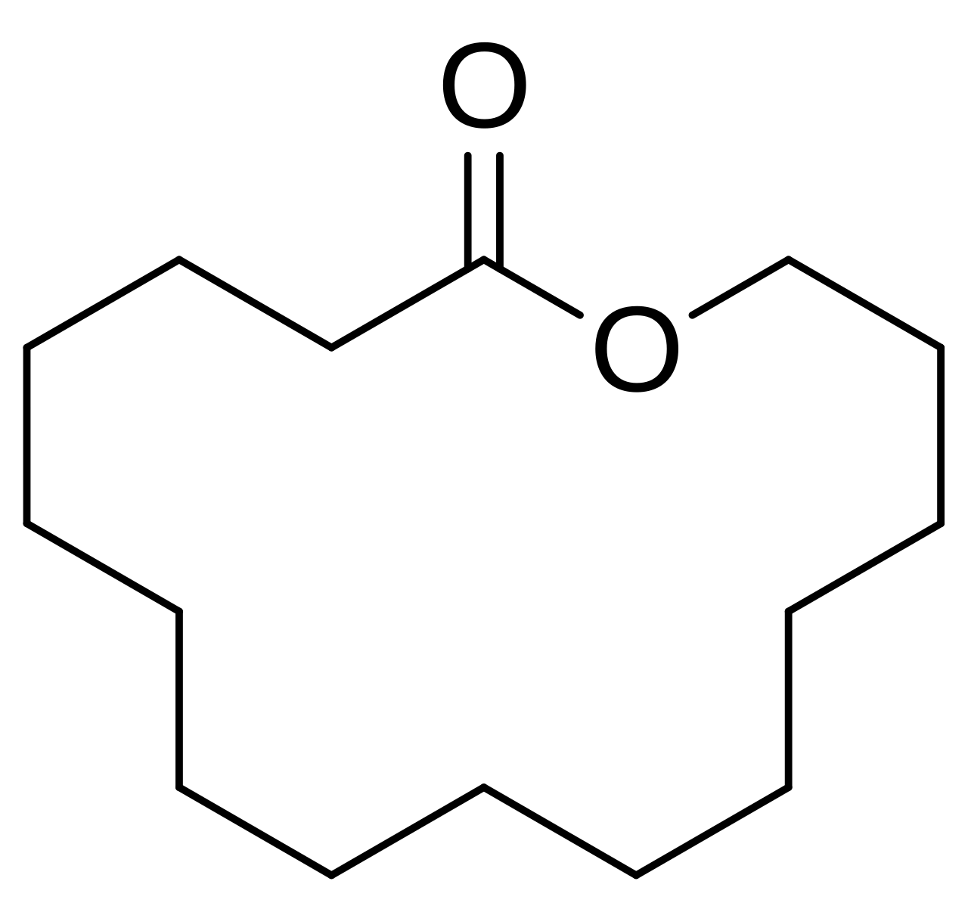 | 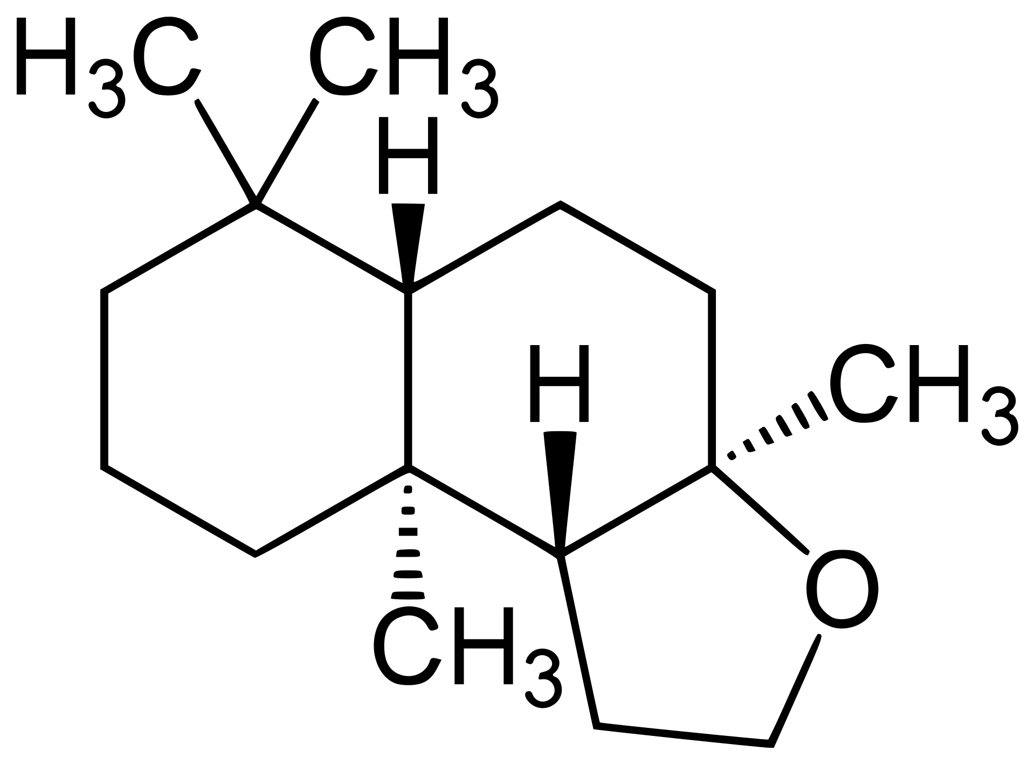 | 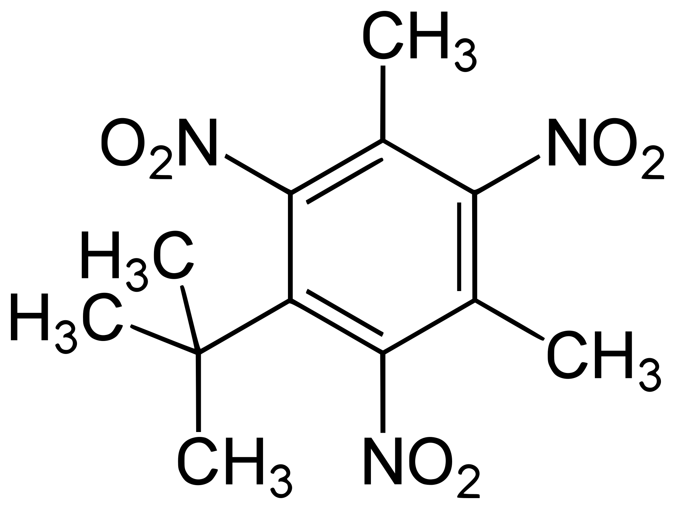
Figure 1.: Macrocyclic Musk (Cyclopentadecanolide) | Figure 2.: Polycyclic Musk (Ambroxide) | Figure 3.: Nitro Musk (Musk xylene)
To understand this gap, researchers used data science and machine learning. By framing the olfactory problem as a high-dimensional predictive task, researchers have tried to train algorithms to predict the rules that connect chemical inputs to human perceptual targets (Keller et al., 2017; Lee et al., 2023). Any machine learning model’s success has to inherently stay within the scope of quality and relevance of the input features. If the features given to the model do not fully capture the physical mechanisms that the human nose uses, the model will plateau.
The computational framework is based on structural topology, which uses two and three-dimensional molecular geometries (“Shape” theory) as the primary feature space. But we have to consider: Is structural topology the only physical dimension that odorant receptors detect, or does the classical model ignore a different orthogonal feature space? The answer is to look at another dimension of chemical data: molecular vibration. An unexplored and unexpected place to look for this missing information is in another dimension of chemical data: molecular vibration.
Background 1: Shape Theory and cheminformatics baseline
foundation of shape theory
The consensus for olfactory perception has been rooted in the steric theory of olfaction. The theory says that the olfactory system uses a “lock-and-key” mechanism. When volatile molecules are in the nose and reach the olfactory epithelium, they find millions of olfactory sensory neurons. These neurons have specific odorant receptors (ORs), which are a large family of G-protein-coupled receptors (GPCRs) (Mainland et al., 2014; Saito et al., 2009).
The three-dimensional geometry, molecular weight, and functional group distribution of an odorant molecule fits into the right binding pocket of the ORs. The physical binding causes a change in the receptor, which triggers a second-messenger chain reaction that fires an action potential to the olfactory bulb. Because the human genome encodes hundreds of different OR subtypes the brain decodes an odor by analyzing the pattern of which specific “locks” were activated by the molecule’s “shape.”
cheminformatics
To test the shape theory computationally, researchers had to translate physical molecules into machine-readable data, where physical properties are the features that are used for inference tasks. This process is the foundation of cheminformatics. The generic approach starts by using a one-dimensional text string to represent a molecule’s structure, done with Simplified Molecular-Input Line-Entry System (SMILES). Although SMILES strings can capture the basic atoms and bonds of a molecule, it is hard for machine learning algorithms to process.
Because of this, researchers use software libraries that extract “molecular descriptors” — numerical representations of a molecule’s physiochemical and topological properties. Modern computational pipelines use expansive descriptor libraries, like Mordred, which compute thousands of features from one molecular structure. The structural features range from simple one-dimensional metrics (molecular weight, atom counts) to complex two-dimensional and three-dimensional spatial parameters (Van der Waals volume, polar surface area). By mapping a molecule across all of these structural dimensions, machine learning algorithms will be able to compute and compare the “shapes” of different molecules.
structural predictive models
With being able to quantify molecular shape, the computational olfaction field has progressed in being able to predict human odor perception. A catalyst for this progress was the DREAM Olfaction Prediction challenge (Keller et al., 2017). They used a large psychophysical dataset collected by Keller and Vosshall (2016), where dozens of subjects rated hundreds of molecules across 20 distinct semantic descriptors (sweet, burnt, chemical, etc), the DREAM challenge crowdsourced machine learning models to map cheminformatic features to perceptual ratings. The winning models used Random Forest algorithms trained on thousands of structural descriptors (like Mordred and Dragon features), which showed that pure structural models can get significant predictive accuracy for more than half of the perceptual categories.
Deep learning has explored the scope of the shape framework even further. Lee et al. (2023) developed a Principal Odor Map (POM) using Graph Neural Networks (GNNs). Instead of relying on pre-calculated descriptors like Mordred, the GNNs were trained directly on the topologies for predicting odor. The POM showed a higher accuracy in predicting semantic labels, which increases the validity of the steric shape theory being the primary mechanism of smell.
ceiling of structural baseline
Despite all the computational power and advanced deep learning models, structural models have a consistent performance ceiling. In baseline testing, models trained strictly on physiochemical descriptors (Like Random Forest trained on Mordred features) gave a high accuracy, which correctly classified over 60% of the molecules into their dominant perceptual categories. This still leaves a big part of the variance to be unexplained.
Structural models still struggle to account for the core olfactory paradoxes — enantiomers with identical Mordred descriptors that smell different, or structurally unrelated molecules like musks smelling the same. Structural models still cannot explain behavioral phenomena where organisms can tell the difference between isotopomers (molecules that are structurally identical but are different in their atomic isotopes) (Franco et al., 2011). If the “shape” theory and cheminformatic models cannot solve these edge cases, it implies that structural topology is necessary but might not be enough to explain the olfactory code that builds human perception. To understand the missing variance, we have to look past the static geometry of molecules and consider other dynamic molecular behaviors.
Background 2: "Shake" and Spectral Feature Spaces
To address the edge cases and unexplained variance left by the shape model, researchers have proposed an alternative, a dynamic model of odor detection: the vibrational theory of olfaction (”shake” theory). First coined by Luca Turin (1996), this theory suggests that the olfactory receptors do not just act as spatial binding pockets but also function as biological spectroscopes.
According to Turin’s model, olfactory receptors use a quantum mechanical effect called inelastic electron tunneling (IET). When an odorant molecule binds to a receptor, an electron transfers from an electron donor site on the receptor to an electron acceptor site. This transfer can only happen if the odorant molecule has a specific vibrational frequency that matches the energy gap between the two sites. This means that the brain recognizes an odorant by the static geometric shape and also with specific resonant frequencies of chemical bonds bending and stretching. This theory would help address some of the shortcomings of the shape model. For example, it would explain why structurally diverse musks would smell the same, because their structures could still vibrate at the same resonant frequencies.
Biological controversy
The vibrational theory is a controversial debated topic in sensory neuroscience. Empirical support for the theory was from behavioral studies with isotopes. Isotopes (deuterated molecules where hydrogen atoms are replaced with heavier deuterium atoms [heavier hydrogens]) have the same three-dimensional shape and chemical volume as their counterparts. But they vibrate at lower frequencies because they have more mass. Franco et al. (2011) showed that fruit flies (Drosophila melanogaster) could learn to tell the difference between normal and deuterated versions of the same odorant molecule. Because the molecules have the same structural topologies, the ability to discriminate could mean that there is a vibration-sensing component in their olfactory system.
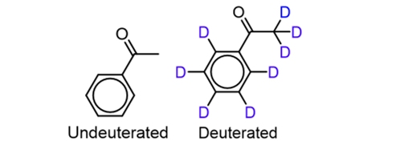
Figure 4. Acetophenone (Undeuterated and Deuterated)
Structural biologists have given the vibrational theory a lot of pushback. An important study by Block et al. (2015) tested human olfactory receptors, in vitro, by exposing them to both normal and deuterated odorants. They found no difference in receptor activation between the isotopes and that human ORs are structural sensors that do not use electron tunneling. Currently, the neurobiological community is divided, and the physiological reality of the human nose acting as a quantum spectroscope is viewed with considerable skepticism by people who support the steric model.
machine learning pivot: IR spectra as feature space
Solving the physiological debate is secondary to a more practical data science question: Does vibrational physiological data have any complementary orthogonal predictive information about human smell that structural data misses?
To translate the shake theory into machine data, researchers use Infrared (IR) Spectroscopy. IR spectroscopy measures how molecules interact with infrared light. When a molecule is exposed to a spectrum of infrared frequencies, its chemical bonds will absorb specific wavelengths of light that perfectly match their natural vibrational frequencies. By measuring the transmittance of light across a standardized range of wavenumbers (typically from 600 cm^-1 to 4000 cm^-1), researchers can generate a highly detailed, continuous “vibrational fingerprint” of the molecule.
Unlike Mordred descriptors, which have static and discrete summaries of molecules’ geometry (counting the number of carbon rings), an IR spectrum provides a high-dimensional, continuous dynamic representation of the molecule’s physical energy.
The application of vibrational spectra to machine learning is a relatively recent development in computational olfaction. Nozaski and Hasegawa (2018) successfully trained a machine learning model on only molecular vibrational spectra to predict specific odor characteristics like “fruity” or “minty”, with significant accuracy. Their work is the technological precedent, which helps us understand how Turin’s biological theory works alongside modern data science. It shows that vibrational spectra have enough inherent mathematical signal to predict odor perception, regardless if the biological nose actually uses inelastic electron tunneling.
This is the foundation of the current project(?)(investigation?)(thesis?). While deep neural networks and random forests have thoroughly exhausted the cheminformatic “shape” space. IR spectra represents an entirely different, high dimensional feature space. By treating IR spectra as purely computational input, we can test the “shake” theory mathematically. If the vibrational frequencies of the molecule capture perceptual information that structural topologies do not, then adding spectral data along with structural descriptors should give a combined machine learning model that significantly outperforms the shape-based baseline.
methods background: machine learning in chemosensory data
biological noise
Using machine learning to chemosensory data creates another computational challenge. Unlike predicting molecular weight or boiling point, predicting odor uses human psychophysical ratings. Datasets like Keller (2016) collection are inherently noisy because human olfaction is very subjective, influenced by genetics, experience, and culture. Because of this, human subjects often do not agree on how specific molecules smell.
It is important to use machine learning algorithms that are highly robust to noise and resistant to overfitting because of this variance. The Random Forest classifier (Breiman, 2001) is the perfect model for this task because by making a map of decision trees and taking the mode of the classes for classification, Random Forests smooth out the subjective noise in behavioral datasets. Random Forests do not need input features to be linearly correlated with the target. This lets the model see the non-linear relationship in olfactory mapping.
High dimensionality
Another big obstacle is the “curse of dimensionality.” When testing combined shape and shake theories, the feature space is very big. One molecule being represented by over 1000 Mordred features and 800 IR transmittance wavenumbers. The intersection of molecules that have both human perceptual data and IR spectra is relatively small. Feeding thousands of features in a machine learning model will cause overfitting — in which the model essentially “memorizes” training data instead of learning generalizable chemical rules.
Dimensionality reduction and feature selection is important to account for this. The feature space has to be filtered before a model can be trained. Variance Threshold is used to remove static features that do not give any information. Algorithms like SelectKBest are used to check the relationship between every feature and perceptual target. When the algorithm learns from a part of the best structural and spectral features, the models are much better.
Gap
thesis statement
This thesis computationally investigates whether vibrational spectral data (IR) is significantly important enough to complement models that use structural descriptors (Mordred) when mapping the physiochemical space of odorants to human perceptual categories. We will determine if molecular vibration has orthogonal information that improves the probabilistic mapping of the olfactory code by solving for these feature space independently and together.
specific aims
aim 1:
establish structural baseline (shape model). using keller (2016) psychophysical dataset, train machine learning classifier just on two-dimensional Mordred topological descriptors. This will establish baseline AUROC and classification accuracy for predicting dominant perceptual descriptor of odorants based on how well we can predict the dominant perceptual descriptor of an odorant based on static geometry.
aim 2:
calculate a spectral baseline (shake model). Use raw infrared spectra into machine data that is standardized into a feature matrix. Train the same classifier just on the vibrational values to find the predictive capacity of molecular energy and vibration
aim 3:
test combined feature space. concatenate most important structural descriptors with most important spectral features into a combined matrix. Calculate combined classifier to figure out if shape and shake features give out a significantly higher AUROC score or accuracy than either model independently.

