STUDENT REPORT COM4402
Student Name | ALAN ROGERIO CERATTI
Student Number | 2514597
Module Name | Programming
Module Code | COM4402
Assignment | A2: Implementation
Date of Submission

GITHUB URL: https://github.com/alanrceratti/assigment-COM4402

INTRODUCTION

This project is a console-based multiple-choice quiz application. It displays one question at time with four possible answers and asks the user to choose an option using simple keyboard input.
The main goals were to let the user select how many questions they want to answer, answer each question, choose to see correct/incorrect feedback after each question, and receive a final score and percentage at the end of the quiz.
The key requirements I focused on were storing quiz data using appropriate Python data structures (questions, options, and correct answers), designing the program using multiple functions for different tasks, and keeping the interaction clear, user-friendly, and easy to test.

GITHUB REPOSITORY LINK

Public GitHub Repository URL: https://github.com/alanrceratti/assigment-COM4402

DEVELOPMENT PROCESS & KEY DECISIONS

Overall Development Approach
I started the project by revising my pseudocode. The pseudocode and the actual code are similar but differ in a few things. I started to code the project last Thursday on 15/01. I did some initial coding on Thursday, starting by trying to define the functions that I could use to try to break the program in small tasks so each function would do only one thing.
I could not work on the code Friday and Saturday due to my job (uber driver, so Friday and Saturday I stay working around 15, 16 hours each day. I was able to continue the project on Sunday. I already program in other language so I am used to stay quite a few hours in the computer coding. Commits have been made after every few minutes while changing the code.

Choice of Data Structures
Data structure in Pseudocode and the actual code are different. In pseudocode I used a list of tuples and in the code a list of dictionaries. The list of dictionaries was used due to the main differences that I decided to implement in the code to make it more complete.

Code Structure and Functions
I tried to break the code into multiple functions to exercise the logic and make the code cleaner. Multiple functions were created as function to take user name, how many questions user want to answer, a randomize function to make the options of questions order different each time, function to select how many questions user chose to answer and more.

Problems Encountered and How You Solved Them
Multiple errors occur during tests. I was trying to create a function and test it separate, which make easier to debug, but once a lot functions were build and working (in theory), when I run the program somethings was breaking. One example was that the quiz was running two times. If user choose the number of questions, let’s say 5, then quiz start, user answer and after last question the quiz restart again in the first question. There was a loop somewhere. After debugging manually, I found that quiz was starting correctly and then another function was being called inside another one that call the start of the quiz (only questions) again.
Many other small errors happen like user input wrong type (if user put a letter instead of a number), but all these were easier corrected.

Comparison with Original Design (Flowchart / Pseudocode)

Changes were made from the original pseudocode, for example, in the actual code, the user is able to choose how many questions he wants to answer and also the random factor was implemented, the questions are randomly selected and the options are also randomized to make it more dynamic. So, the quiz is never the same for no one. The selected questions are in different order every time it runs and also the options for each question. None of these were in the pseudocode. Also the user can choose to run the quiz again, which would restart and ask how many questions he wish to answer.
Many more functions were added to the implement code comparing to the Pseudocode. The final code is more dynamic and singular for each time it runs. For instance, instead of a quiz, it could be used for an Exam, where each candidate would receive the same questions, but in different orders.
To be able to make this quiz more dynamic, it was necessary to find a way to make the questions and answers random, but still keep track of the correct answer. Doing it with numbers (as in the Pseudocode for example, “Correct answer for question 1, is number 3, correct answer for question 2, is number 4, etc etc) would make it harder to keep track of the correct answer so to not have any problems, I changed the answer from a number, to the actually text, so the order of the options would not matter and the correct answer could be found, independently of the position.

TESTING STRATEGY

4.1 Overall Testing Approach

There were only manual testing made. Multiple tests with a variation of inputs, valid and invalid to check results. The program was tested in a whole, not by each function.

4.2 Detailed Test Cases

Case No. | TC01
Description | Verify default player name when no name is entered
Input Data | 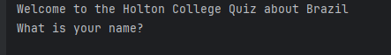
Expected Outcome | The quiz should proceed even with blank name and in the end program refers to the user as “Player”
Actual Outcome | 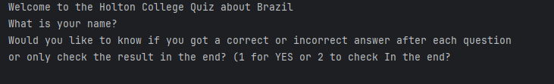  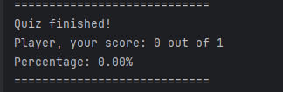
Pass/Fail | Pass

Case No. | TC02
Description | Validate input for showing correct/incorrect answers (valid input)
Input Data | 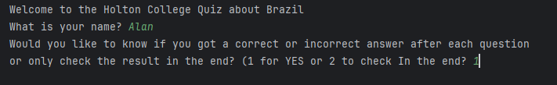
Expected Outcome | Program should show feedback after every question
Actual Outcome | 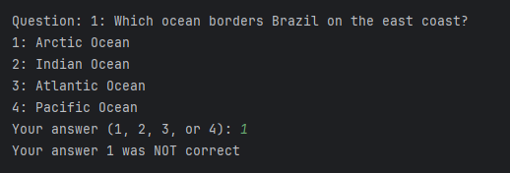
Pass/Fail | Pass

Case No. | TC03
Description | Validate input for showing correct/incorrect answers (invalid input)
Input Data | 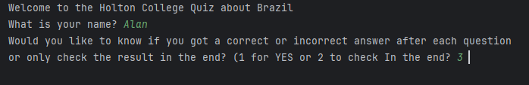
Expected Outcome | Program rejects 3 and print a message requesting user to try again.
Actual Outcome | 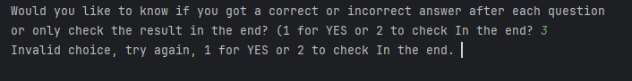
Pass/Fail | Pass

Case No. | TC04
Description | Validate number of questions input within valid range
Input Data | 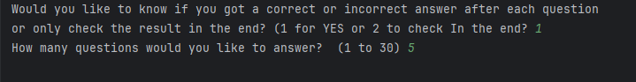
Expected Outcome | Quiz should include exactly 5 questions (or another number chosen)
Actual Outcome | 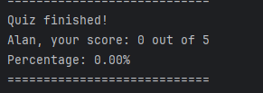
Pass/Fail | Pass

Case No. | TC05
Description | Validate randomization of answer options
Input Data | 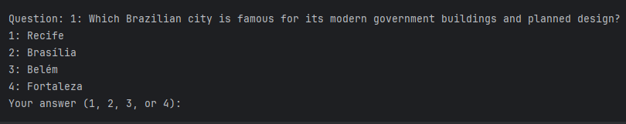
Expected Outcome | Order of options should vary between runs
Actual Outcome | 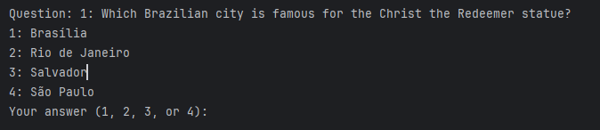
Pass/Fail | Pass

Case No. | TC06
Description | Validate randomization of questions
Input Data | 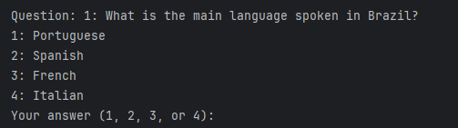
Expected Outcome | Order of questions should vary between runs
Actual Outcome | 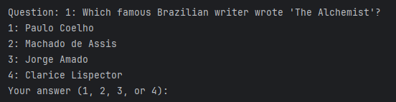
Pass/Fail | Pass

Case No. | TC07
Description | Validate user answer input validation
Input Data | 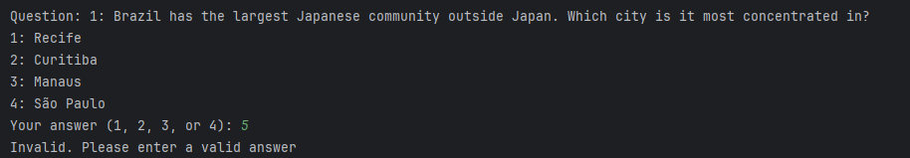
Expected Outcome | Program rejects 5 and accepts 2
Actual Outcome | 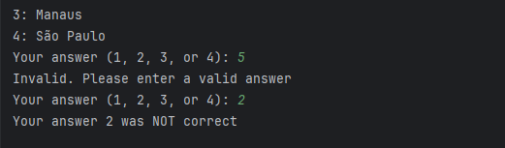
Pass/Fail | Pass

Case No. | TC08
Description | Validate score calculation by answering 3 questions correct and 2 incorrect.
Input Data | 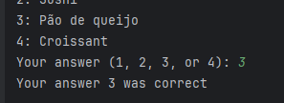  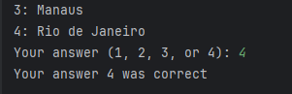  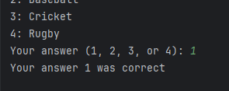  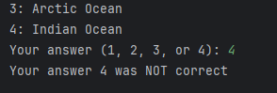  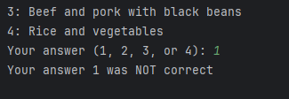
Expected Outcome | Score should display 3 out of 5 and 60.00%
Actual Outcome | 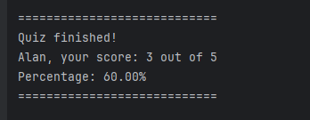
Pass/Fail | Pass

Case No. | TC09
Description | Validate quiz replay functionality
Input Data | 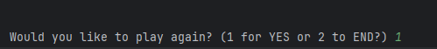
Expected Outcome | Quiz restarts from the beginning
Actual Outcome | 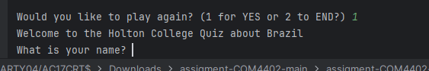
Pass/Fail | Pass

Case No. | TC10
Description | Validate program exit option
Input Data
Expected Outcome | Program should exit
Actual Outcome | 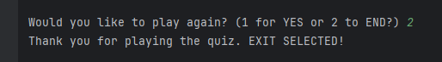
Pass/Fail | Pass

REFLECTION (OPTIONAL BUT RECOMMENDED)

Something I have never done before in Python, was to randomize things. I am glad I was able to randomize the questions and the answers in this quiz. After reading the test cases, I would like to implement an option for the user to Exit the program at any time and once user choose to exit, another questions should come warning the user and requesting confirmation.
While developing the quiz, definitely I remembered and learn a few methods built in Python to make coding easier, which was nice after so long without coding in Python.

SUBMISSION CHECKLIST (DO NOT DELETE)

Submission Checklist:
☒ The report is saved as a Word document (.docx).

☒ The file name follows the required convention: STUDENTNUMBER_COM4402_Report.docx
Example: 2532851_COM4402_Report.docx

☒ My student number, name, module name, and module code (COM4402) are included on the first page.

☒ I have included a correct, clickable URL to my public GitHub repository.

☒ My GitHub repository is public, contains all source code, and shows a sensible commit history.

☒ My GitHub repository includes a README.md with my student number, module code, and simple instructions for running the program.

☒ The report includes all required sections: Introduction, GitHub Link, Development Process & Decisions, Testing Strategy (with at least 10 test cases).

☒ All test cases include Test ID, Test Description, Input Data, Expected Outcome, Actual Outcome, Pass/Fail, and screenshots of input and output.

☒ I have removed ALL red guidance text before submitting.

☒ I have checked spelling and grammar.

