October 20, 2017

Task – History screen

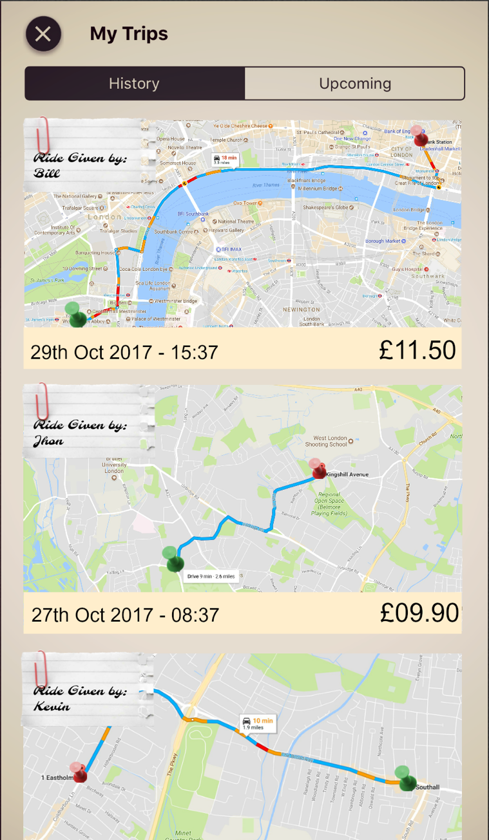 | CS2001 – Group PRoject|

The session screen of the app that will track location of people to set up the journey on google maps and will show meeting points setup by the group and destination point. The Driver will set up where riders can meet up if they live close or riders that live feather away can ping their location as a pick-up point. The screen will have the map displaying all user’s location and will show the best route for the driver to take.

* The red point on the map signifies the pickup location.
* The green point on the map signifies the drop off location(destination).
* The screen shows journey history and also any upcoming trips that the rider may have.
* Date and time of the trips are also recorded.
* After every trip, the rider will see the total cost of the trip as well as the name of the driver for that trip.

How the screen would look on a phone screen

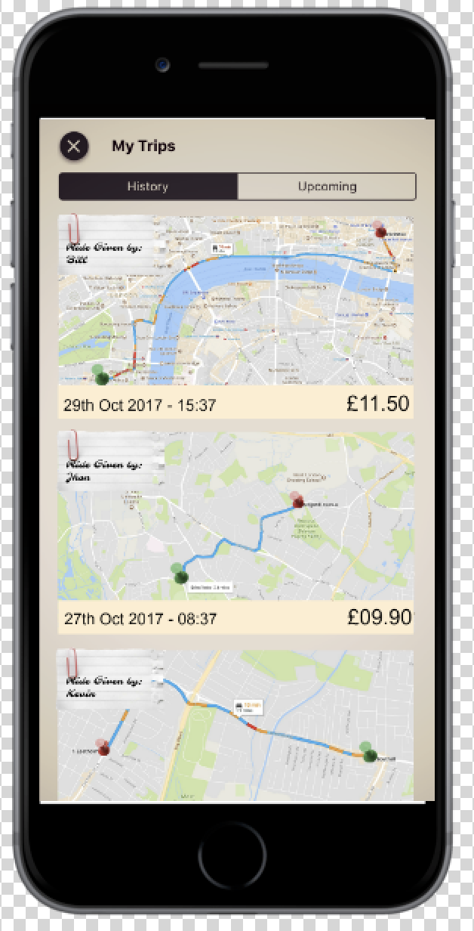

|  |  |
| --- | --- |
| STUDENT NAME: | **Don Kaluarachchi** |
| STUDENT NAME: | **Abdullahi Saleh Shehu** |

| Task | Due Date | Done | Group Member |
| --- | --- | --- | --- |
|  | [Date] |  |  |
|  | [Date] |  |  |
|  | [Date] |  |  |
|  | [Date] |  |  |