Lobo’s Cottage, Goddar,
Aldona, Bardez,
Goa. 403508
Ph. No. 0832-2289150
Mob. 9822161049
E-mail: alan.lobo@yahoo.co.in
Alan Savio Lobo

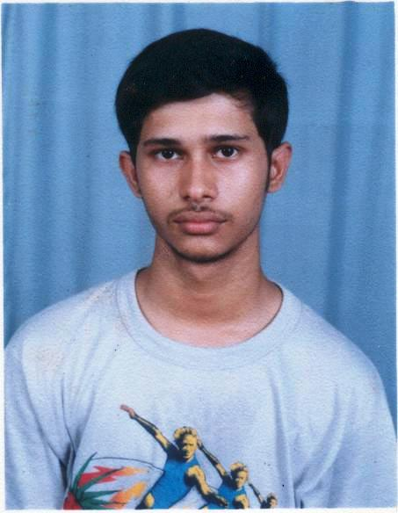
QUALIFICATION: B.E. (Computer Engineering)

OBJECTIVE: To be a part of a progressive and cohesive work environment and contribute therein to the best of my abilities. To achieve team goals effectively, and in doing so, make a difference.

ACADEMIC RECORD

PRE-ENGINEERING (GOA BOARD)
Exam | Institution | Month/Year | %
X | St. Britto’s High School, Mapusa Goa. | March 2000 | 83.6%
XII | St. Xaviers Higher Secondary School, Mapusa, Goa. | March 2002 | 81.6%

ENGINEERING (GOA UNIVERSITY)
Year | Institution | Month/Year | %
I | Padre Conceicao College of Engg, Verna, Goa. | June 2003 | 65.9%
II | Padre Conceicao College of Engg, Verna, Goa. | June 2004 | 63.2%
III | Padre Conceicao College of Engg, Verna, Goa. | Nov 2005 | 55.2%
IV | Padre Conceicao College of Engg, Verna, Goa. | May 2006 | 64.5%

B.E. PROJECT DETAILS
- Project done for Himachal Futuristic Communications Ltd. Goa Cabling Division
- Involving Systems Analysis of the Coloring, Secondary Coating, Stranding & Armoring Production Lines.
- System designed from the ground up, to meet the client’s specifications, using Apache 2.x, PHP 5.x, JavaScript, CSS and SMARTY.
- System developed and implemented, to manage, report on, and administer all data generated by the factory’s four production processes, stores department, and quality assurance department.

TECHNICAL ABILITY
- Ability to Program in PHP, C/C++, Pascal and JavaScript.
- Well versed in MySQL and SQL.
- Comfortable on Windows and various flavours of Linux.
- Working knowledge of Java, VB.Net.

EXTRA CURRICULAR ACTIVITIES (TECHNICAL):
- Member of College Organization “Amateur Programmers Club”.
- Participated in Pro Quest ’04 (inter-college).
- Participated in Kalp ’05 (inter-state).
- Secured 3rd Place in Softwired in Aavishkar ’05 (intra-college)
- Secured 2nd Place in Debugging in Manthan ’06 (inter-state)
- Secured 1st Place in Softwired in Aavishkar ’06 (intra-college)
- Participated in Microsoft Student Project Program for the years 2004-05
- Actively Contribute to several forums on Devshed.com, one of the largest online developer communities with a membership of over 160,000.

EXTRA CURRICLUAR ACTIVITIES (GENERAL):
- Member of the organizing team for Blitzkrieg ’04 (inter-college),
- Chief Organizer for Manthan ’05 (inter-state).
- Was awarded the Science Talent Search Scholarship for the years 1997-98, 1998-99, 1999-2000.
- Participated in the MBD Talent Search Exam for the years 1998-99 and secured the 2nd Place for the same in the year 1999-2000.

HOBBIES: Collecting Currency Notes & Coins, Listening to Music.

LANGUAGES KNOWN: Fluent in English and Konkani and working knowledge of Hindi.

I DECLARE THAT THE INFORMATION GIVEN ABOVE IS TRUE TO THE BEST OF MY KNOWLEDGE.

Alan Lobo
19 / 9 / 2006

