Climate Change Projections for Australia

Introduction
Evidence of global heating has been accumulating over the past three decades and it is now widely accepted that the climate is undergoing a rapid change. In Australia the major impacts of global heating include increased occurrences of heat waves, changes to the rainfall patterns, and increased occurrences of days where the weather enhances bush fires.

Group 7 team members: Milinda Liyanage, Alan Seed, Anjali Khare, Litesh Samji

Data source:
The data were downloaded from Climate Change in Australia which is a collaboration between the CSIRO and the Australian Government Bureau of Meteorology.

https://www.climatechangeinaustralia.gov.au/en/obtain-data/download-datasets/

Objectives:
Predicting Min, Max and Mean temperatures and Fire Danger Index for the years 2030 to 2090, comparisons to data from 1995

Visualizations:
- Fire danger index of Australian cities
- Mean temperature
- Minimum temperature
- Maximum temperature

Technical Tools:
- Python
- Flask Powered API - using Python
- HTML / CSS
- Java Script
- SQL Database - postgresql with SQLscripting to create database tables and populate with data.

Github link : https://github.com/alanseed/climate-change-dashboard.git

Predictions
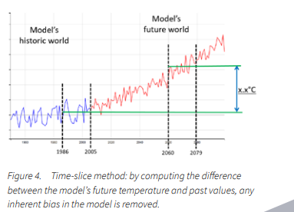

Examples

Maximum Temperature Year 2020
Future Climate Dashboard | LongPaddock | Queensland Government

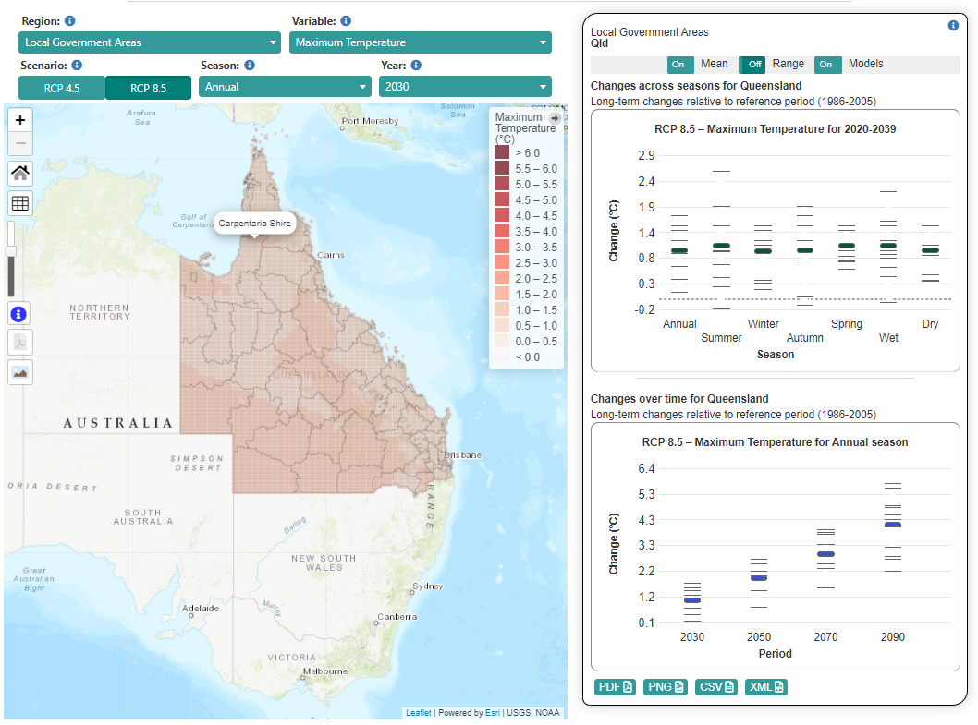

Minimum Temperature Year 2090
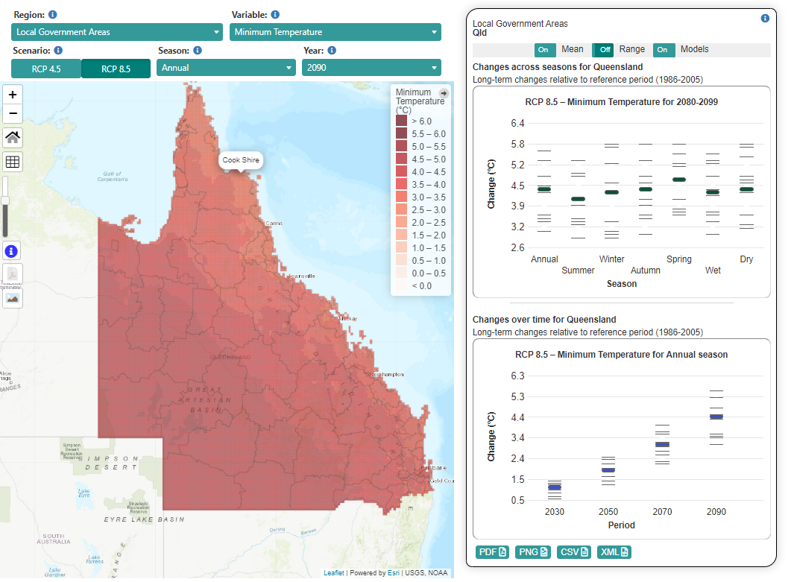

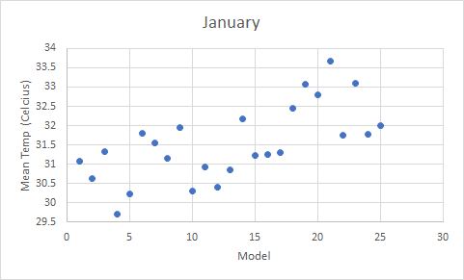
25 models were used to forecast the climate over the next 100 years, this is an example of the spread in the results for the mean temperature for January in Adelaide, 2080-2090, for the 25 models.

