’echo’ command in Linux

The syntax for the echo command is:
echo [option(s)] [string(s)]

1. Using option ‘\t‘ – horizontal tab with backspace interpretor ‘-e‘ to have horizontal tab spaces.
2.Using option ‘\v‘ – vertical tab with backspace interpretor ‘-e‘ to have vertical tab spaces.

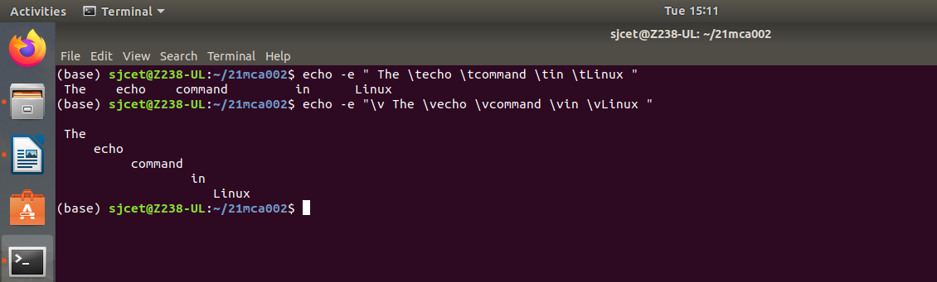

3. Declare a variable and echo its value. For example, Declare a variable of x and assign its value=10.
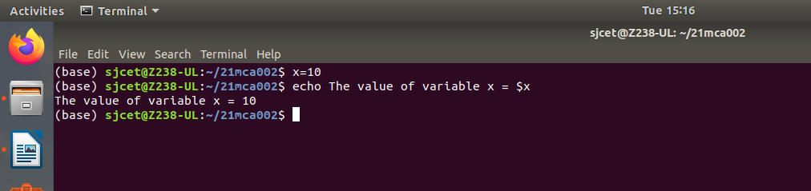

4. Using option ‘\b‘ – backspace with backslash interpretor ‘-e‘ which removes all the spaces in between.
5. Using option ‘\n‘ – New line with backspace interpretor ‘-e‘ treats new line from where it is used.
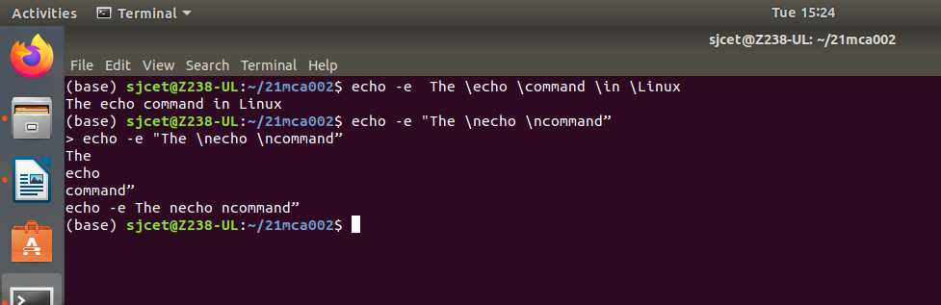
6.Using option ‘\r‘ – carriage return with backspace interpretor ‘-e‘ to have specified carriage return in output.

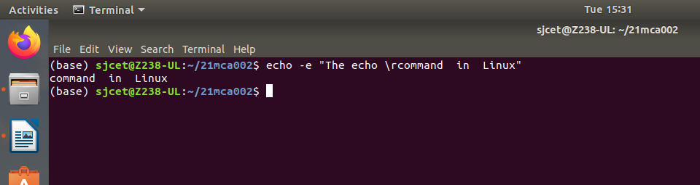

Read
The syntax for the read command is:
read <options> <arguments>

1.Save the user input into a specified variable by providing an argument:
read input
Retrieve the message with:
echo $input

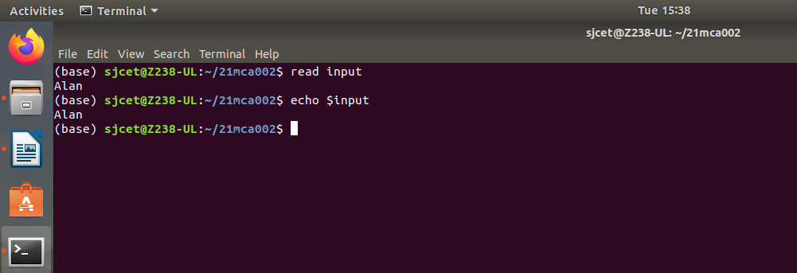

Piping:

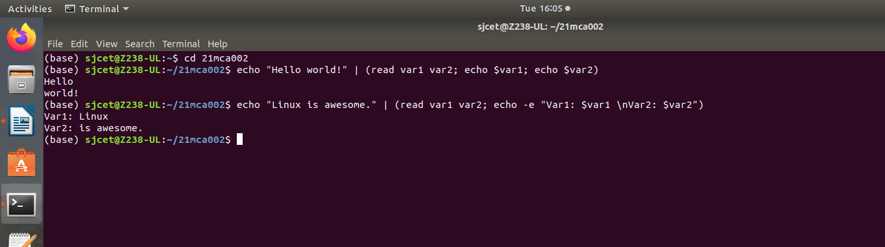

Changing the Delimiter:

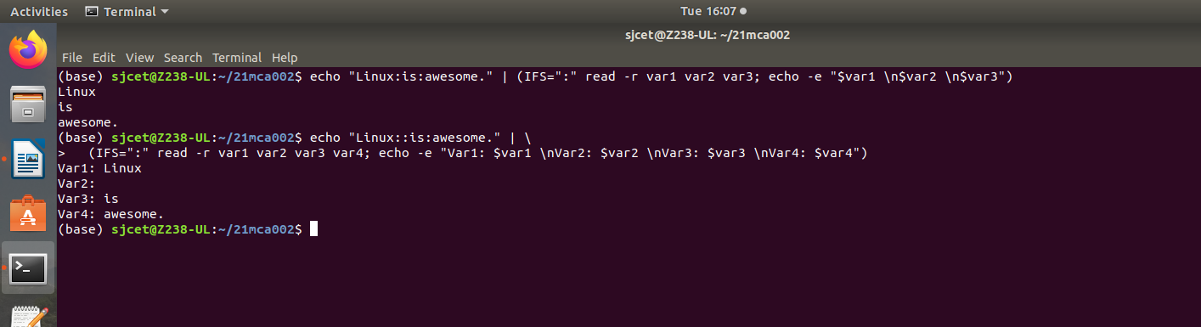

Prompt String:

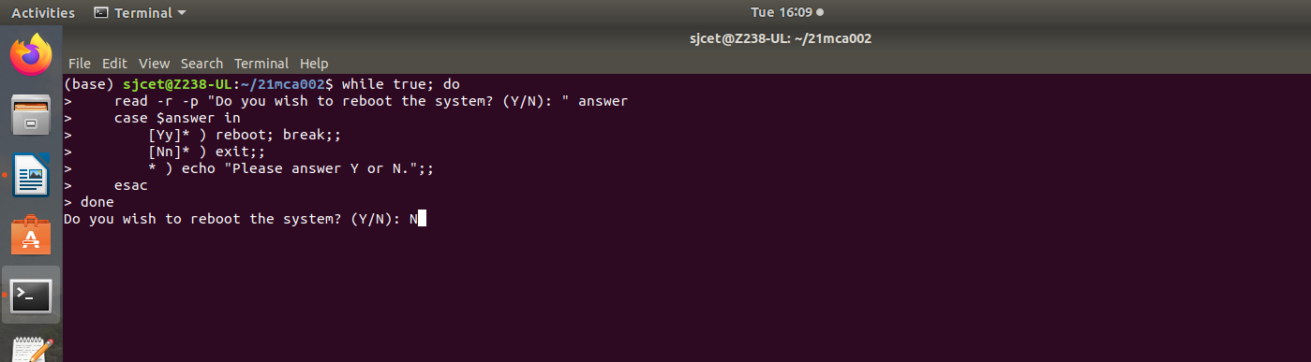

Assign the Words to Array:

