
Final Year Project Summary
The Project summary limited to One (1) page. Please submit in PDF format.
Name: Alan Syahmi bin Sanih @ Sani
Matric Number: BI23110344
Program: UH6481005 Data Science
Project Title: A Multi-Modal Framework for Quantifying Narrator Reliability in 'Ilm ar-Rijal using Semantic Sentiment Analysis and Graph Neural Networks
Supervisor: Dr. Khalifa Chekima
Project Type: Research
Problem Statement:
Traditional 'Ilm ar-Rijal (narrator evaluation) is a manual, labour-intensive process requiring scholars to cross-reference thousands of qualitative biographical entries to assess the authenticity of a Hadith isnad (chain of transmission). While recent advancements in Natural Language Processing (NLP) have improved narrator name extraction and entity disambiguation, there is a critical lack of computational frameworks that can quantify narrator reliability. Specifically, current models fail to integrate the semantic sentiment of Jarh wa Ta’dil (scholarly praise or criticism), a field in hadith sciences, found in classical texts with the structural features of the transmission network.
Objective:
- To design and implement an Arabic Named Entity Recognition (NER) model to isolate narrator names, lineages, and biographical labels, followed by an Entity Linking mechanism to resolve name variants and disambiguate narrators with similar names.
- To develop a Natural Language Processing (NLP) classification model that maps qualitative scholarly judgments found in Jarh wa Ta’dil texts to a standardized, quantitative reliability index (0.0 - 1.0).
- To construct a Knowledge Graph representing teacher-student relationships and utilise Graph Neural Networks or centrality measures to evaluate the structural integrity and temporal consistency of transmission chains.
- To evaluate the framework’s accuracy by comparing its automated reliability scores against established scholarly Hadith gradings for a selected benchmark of Hadith isnads.
Scope:
- Data:
  - Digital text corpus of Taqrib al-Tahdhib and Tahdhib al-Kamal via OpenITI/Shamela.
  - Scale: ~1,500 biographical entries (narrator records) and ~1,000 validated Hadith isnads (chains) for testing.
- Experiment Input and Output:
  - Independent Variables: Textual features, structural features, and temporal data.
  - Dependent Variables: Predicted narrator reliability score (continuous 0.0–1.0) and final chain authenticity classification (categorical: Sahih, Hasan, Dha'if).
  - Control Variables: Benchmark dataset of pre-graded Hadith from Al-Kutub al-Sittah.
- Experiment Input and Output:
  - Input: Raw Arabic text strings of a hadith isnad and corresponding biographical entries.
  - Output: At narrator level, individual reliability scores and resolved identities; at chain level, a composite probability score and a predicted authenticity grade for the entire hadith.
Supervisor Stamp of approval
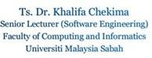
Date: 18/3/2026
Remarks (for Review Committee use)

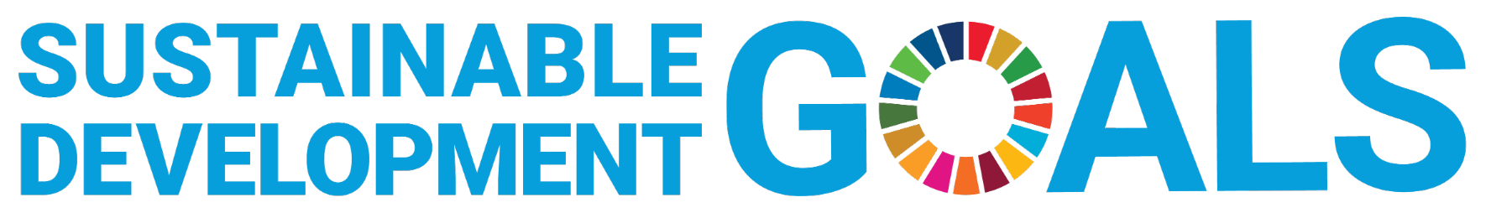
https://sdgs.un.org/goals
Your project should aim to fulfil one of the 17 Sustainable Development Goals (SDG). Please map your project to one of the relevant SDG by ticking the relevant box.
SDG | Description | / | SDG | Description | /
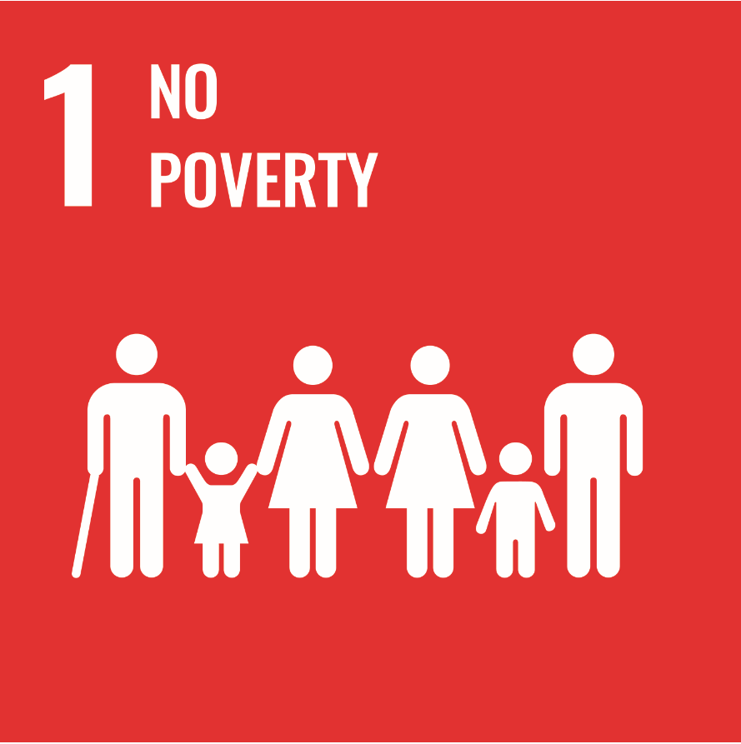 | End poverty in all its forms everywhere |  | 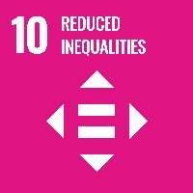 | Reduce inequality within and among countries
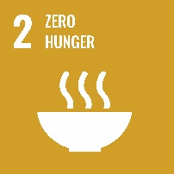 | End hunger, achieve food security and improved nutrition and promote sustainable agriculture |  | 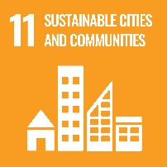 | Make cities and human settlements inclusive, safe, resilient and sustainable
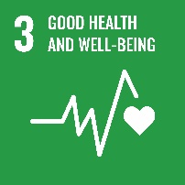 | Ensure healthy lives and promote well-being for all at all ages |  | 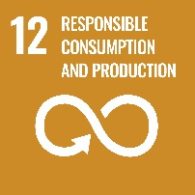 | Ensure sustainable consumption and production patterns
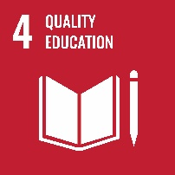 | Ensure inclusive and equitable quality education and promote lifelong learning opportunities for all |  | 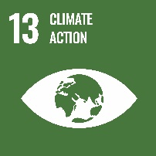 | Take urgent action to combat climate change and its impacts
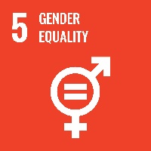 | Achieve gender equality and empower all women and girls |  | 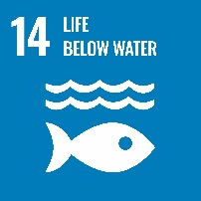 | Conserve and sustainably use the oceans, seas and marine resources for sustainable development
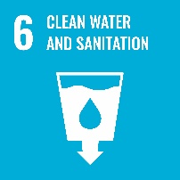 | Ensure availability and sustainable management of water and sanitation for all |  | 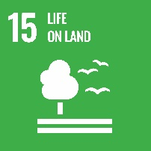 | Protect, restore and promote sustainable use of terrestrial ecosystems, sustainably manage forests, combat desertification, and halt and reverse land degradation and halt biodiversity loss
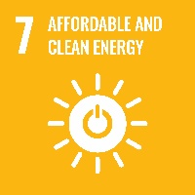 | Ensure access to affordable, reliable, sustainable and modern energy for all |  |  | Promote peaceful and inclusive societies for sustainable development, provide access to justice for all and build effective, accountable and inclusive institutions at all levels
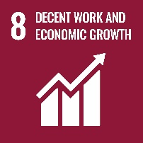 | Promote sustained, inclusive and sustainable economic growth, full and productive employment and decent work for all |  | 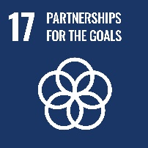 | Strengthen the means of implementation and revitalize the Global Partnership for Sustainable Development
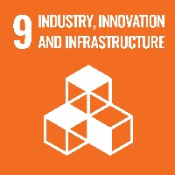 | Build resilient infrastructure, promote inclusive and sustainable industrialization and foster innovation | /

