Booking.com is one of the largest online travel agencies and under the top 100 most visited websites of the world. Customers booked in more than a billion (10^9) nights on booking. Thus, improving aiding the booking and hotel choice procedure has the potential to improve a huge number of customers. This, or something similar, is what you see when you try to book a hotel on booking.com. The most important information people use when booking a hotel is the room price, followed by the customer ratings and reviews.

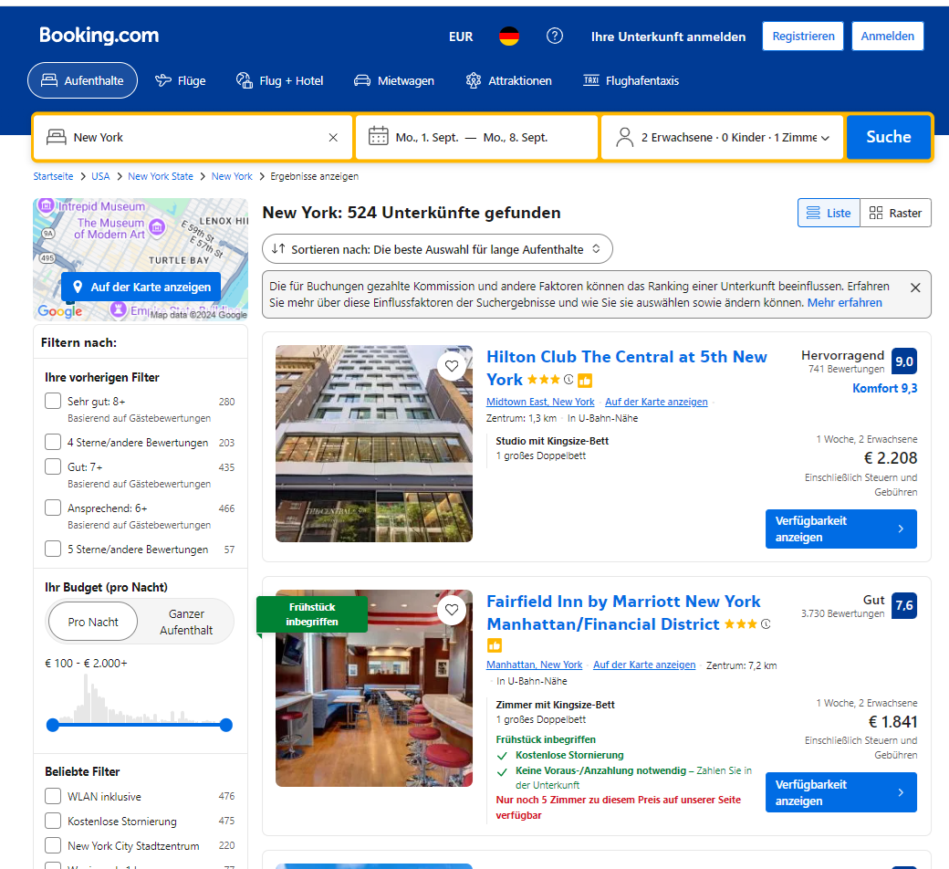

Here we want to better inform consumers by developing a Google Chrome (a Streamlit app as a first prototype) extension that improves customer experience by providing valuable additional information about the hotels and reviews:

1. Trend Detector: which identifies hotels that have deteriorating review scores. The scores of these hotels are too high and should be used with caution (time series analysis).
2. A Rag-system allowing the customer to ask questions about a specific hotel (e.g., How is the internet connection?) or generally Hotels in an area (Which hotels have good beds?).
3. Bonus: Extract meaningful reviews. An NLP model that identifies reviews with predictive power (i.e., predict future scoring of the hotel) and as such have by nature valuable information.
4. Bonus: A Recommendation system allowing to find similar Hotels.

Status:

* I have implemented a scraping pipeline allowing to scrape the top 500 Berlin hotels (could be scaled up to other cities) and build a review database.
* Implemented a first version Trend Detector.