# Git Kata: Basic Commits

This kata will introduce you to the `git add` and `git commit` commands.

This is a very introductory kata. if you have used `git status`, `git log --oneline --graph`, `git add` and `git commit` extensively you should probably skip it.

You can look at the bottom of this file, if you have not yet done basic git configuration.

## Setup:

1. Run `. setup.sh` (or `.\setup.ps1` in PowerShell)

## The task

1. Use `git status` to see which branch you are on.

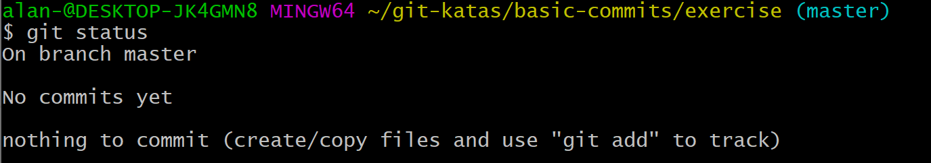

1. What does `git log` look like?



1. Create a file



1. What does the output from `git status` look like now?

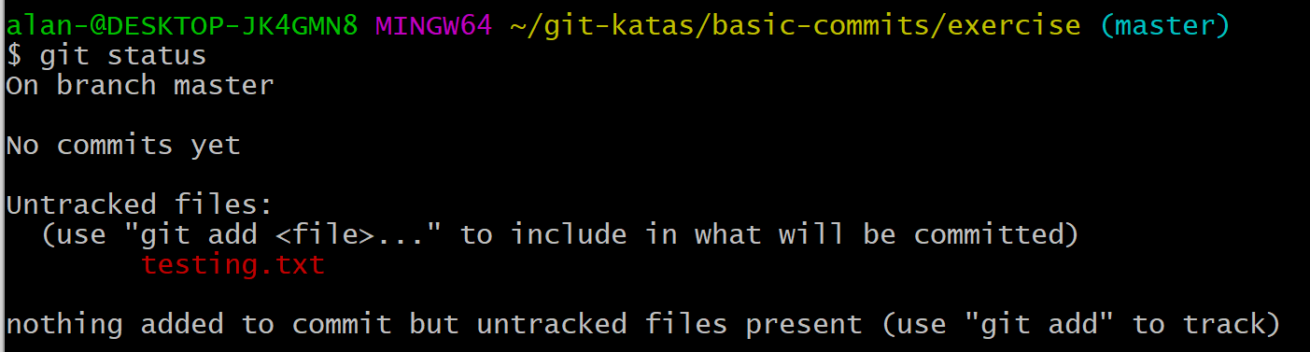

1. `add` the file to the staging area



1. How does `git status` look now?

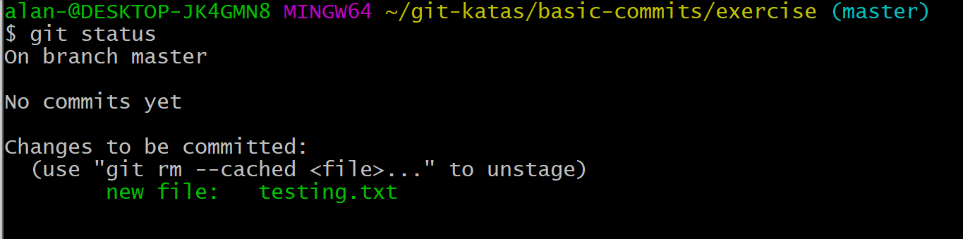

1. `commit` the file to the repository

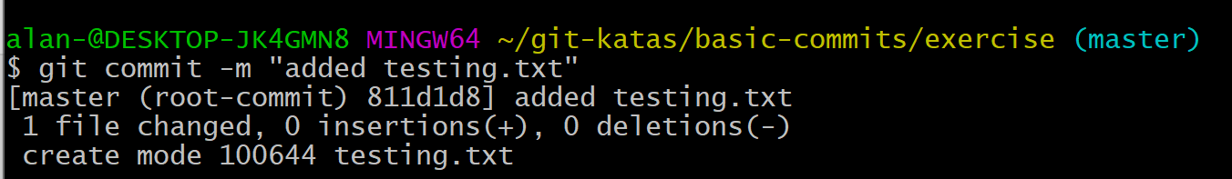

1. How does `git status` look now?

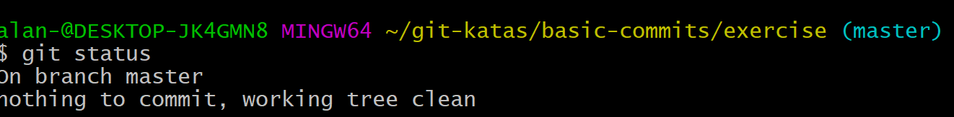

1. Change the content of the file you created earlier



1. What does `git status` look like now?

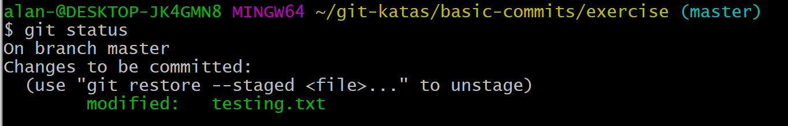

1. `add` the file change

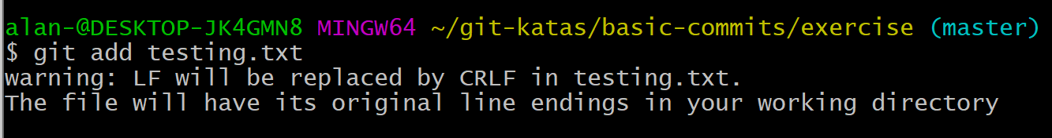

1. What does `git status` look like now?

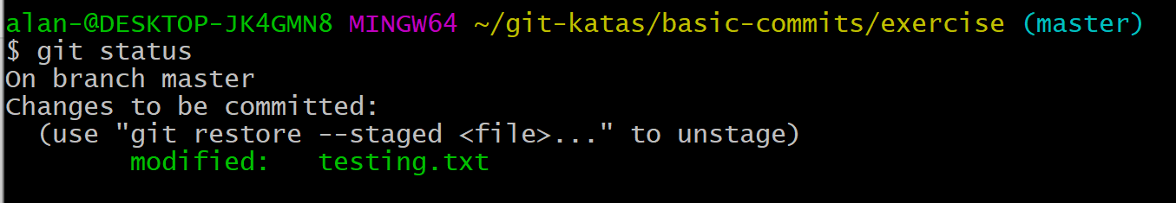

1. Change the file again



1. Make a `commit`

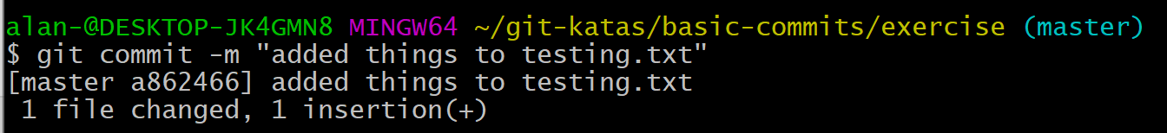

1. What does the `status` look like now? The `log`?

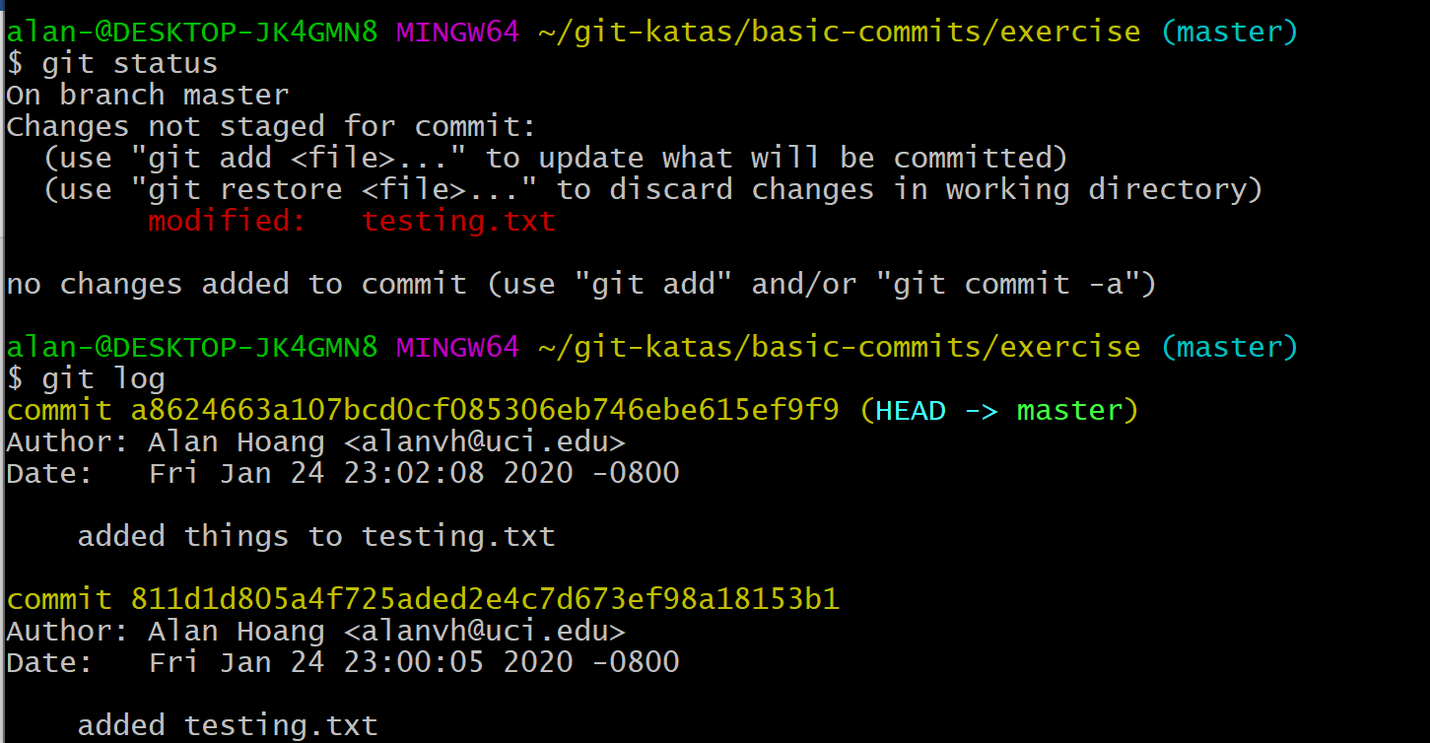

1. Commit the newest change

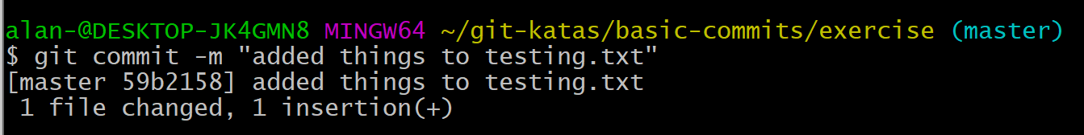

## Useful commands

- `git add`

- `git commit`

- `git commit -m "My commit message"`

- `git log`

- `git log -n 5`

- `git log --oneline`

- `git log --oneline --graph`

- `touch filename` to create a file (or `sc filename ''` in PowerShell)

- `echo content > file` to overwrite file with content (or `sc filename 'content'` in PowerShell)

- `echo content >> file` to append file with content (or `ac filename 'content'` in PowerShell)

## Git Initial Configuration

1. `git config --global user.name "John Doe"`

1. `git config --global user.email "johndoe@example.com`

For the vim scared:

- `git config --global core.editor nano`

For the windows peeps:

- `git config --global core.editor notepad`

Other editor options:

- `git config --global core.editor "atom --wait"`

- `git config --global core.editor "'C:/Program Files/Notepad++/notepad++.exe' -multiInst"`