**Tecnologies**

* SQL DB
* .NET CORE 3.1

**Tools**

* Postman

**Solution Layers**

* Model
* Services
* Controller

**Design Pattern**

* Singleton
* MVC

**Data Model**

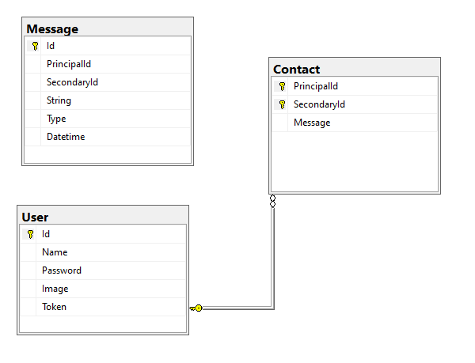

**Note**: The model was made using code first with Entity Freamwork.

**Sequency Diagram**

**Access**

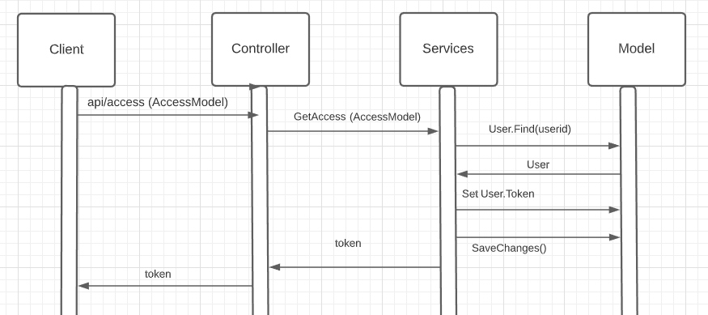

**Initialize**

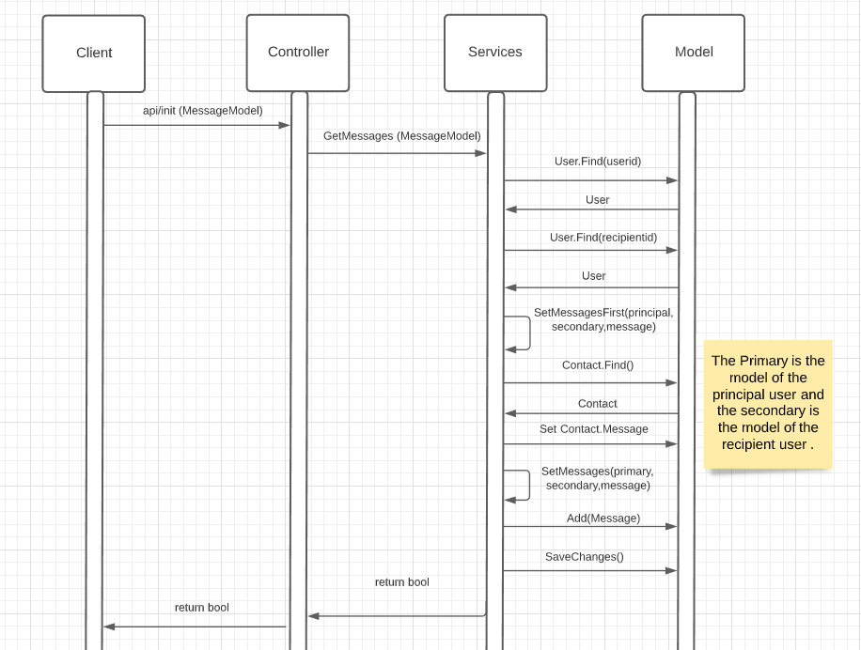

**Messages**

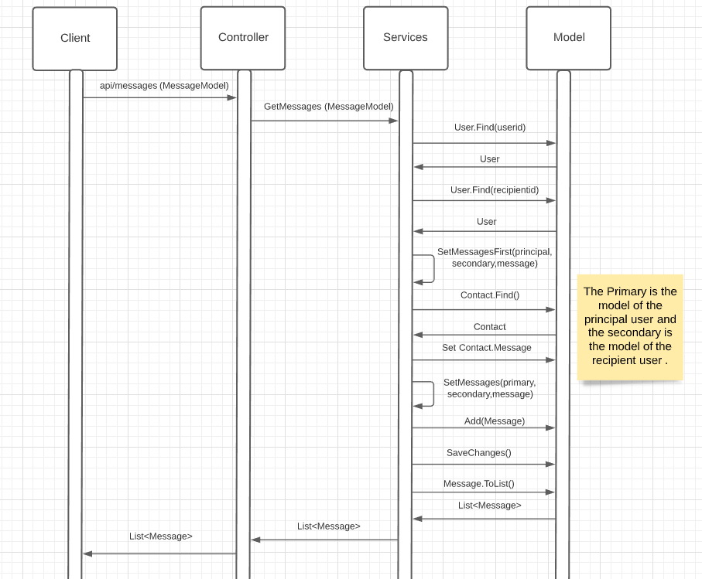

**Contacts**

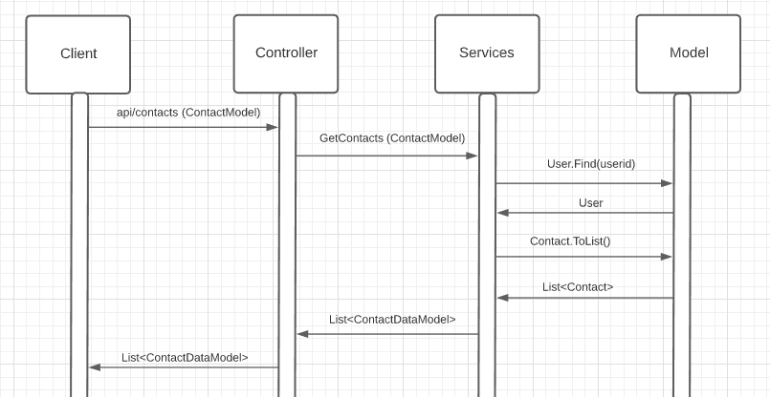

**Close**

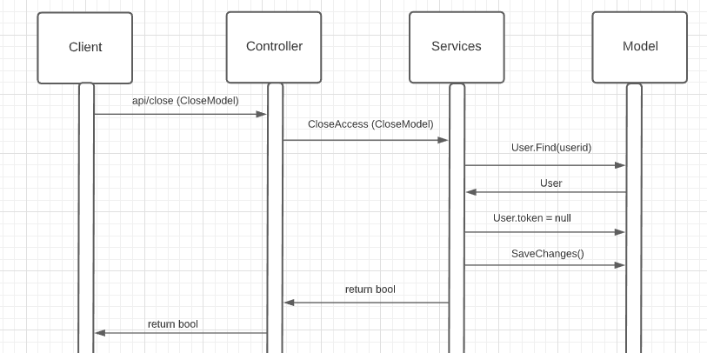

**Flow**

1. The Client ask for the token with the userid and password to initialize connection. The system generates a token for the user and return the same.
2. The client sends the message, user id, recipient id and security code (token). Return a boolean.
3. The client asks for the messages with the user id, a message and the security code. Return a list of the messages in json format.
4. The asks for the contacts of the user sending the user id and the security code. Return a list of the contact in json format.
5. The client sends the user id to finish the connection. The system cleans the users token and responds with a Boolean.