CRISPR screening pipeline

Table of contents:

Pipeline short description 3

Standard plate layouts for NGS, InCellWestern and IncuCyte 4

NGS library preparation 5

Primer design 5

Example with a STAT3 guide cutting at chr17: 42346678 5

Primer validation: 6

Primer validation by PCR: 6

Set-up: 7

Crude gDNA extraction from non-fixed cells: 7

First round of amplification (linker PCR): 8

PCR dilution: 8

Second round of amplification (indexing PCR): 8

Library consolidation and QC: 9

Example: 9

Sample submission to the Genomics Core: 9

Data submission to the Genome Editing app: 10

Clone validation: 10

Clone validation with TIDE (optional): 10

Clone validation by resequencing (optional): 10

APPENDIX --------------------------------------------------------------------------------------- 11

Additional methods: 11

Extraction of gDNA from formalin-fixed cells: 11

Linker PCR normalisation: 11

AmpPureXP protocol: 12

Alternative master mix with SYBR-GREEN I 13

Case examples 14

Case 1: several projects in the same sequencing run 14

Case 2: Primer design for knock-ins 14

Case 3: Rationale behind the scoring system for clone selection 15

Future to do’s 17

Bead-based normalisation of PCR input. 17

Nested PCR for cleaner amplification. 17

Automatise primer design. 18

Others. 18

List of reagents and Preparation of Stock solutions: 19

GEfileformats_annotations 20

IncellWestern file format 20

Incucyte file format 20

Plot examples and descriptions 21

Protein plot: 21

Growth plot: 22

Slopes plot 22

Global heatmap 22

Global protein + slopes + NGS plot 22

NGS plots: 22

Type of mutation 23

INDEL structure 24

Consequence of mutation 24

Zygosity 24

Indel lengths 24

Allele sequences 24

96-well plate plot 25

Pipeline short description
After CRISPR editing, a population of clones with discrete mutations is single-cell diluted and clones expanded. These clones are analysed on an IncuCyte (cell growth and growth rates), Odisey scanner (InCellWestern for protein abundance) and genotyped by NGS on a Miseq sequencer.
The pipeline outputs plots to explore growth rates, protein abundance and the range of genotypes at a clonal level, and if more than two of these sources of data are available also outputs plots combining these results.
The general workflow is shown below. You will have Plate.1 to Plate.n of clones, and each PCR and dilution is performed in individual plates (e.g. Plate_linkerPCR, Plate_dilution) that will be labelled (according to guidelines) and stored in the freezer until the Project is finished.

Standard plate layouts for NGS, InCellWestern and IncuCyte
The plate layout in the pipeline loading form describes all the contents of all wells, i.e. which cell line, clone and sgRNA have been used in that well, and whether the well is a control or a sample (for a detailed description see Experiment Layout [page Error: Reference source not found] in the GEsubmissionForms_annotations section). Its fixed structure allows more robust, efficient comparison within and between projects.
There is a single layout per plate, which is used in all plate types (IncellWestern, Incucyte, NGS), so the same well must always have the same contents across plate types. The exceptions are:
- A1 and H12, which can be seeded with cells for phenotypic analysis, and with gDNA for NGS.
- Wt and KO controls, which are required for Western blotting, but can be skipped for NGS (i.e. not make a library with them, but since the wells are reserved you cannot replace them with other samples in NGS).

See a diagram depicting the layouts below:

In grey, reserved wells.
Nr: cell normalisation control. It can be used to normalise between plates in growth and protein experiments. These wells are reserved for the IncuCyte, and must always contain cells.
wt: cell wild-type control, used in InCellWestern
KO: cell KO control (or no primary antibody control), used in InCellWestern and which shows only background levels of target fluorescence.
Water: in the NGS plate, these can be PCR negative controls.

NGS library preparation
NGS libraries are prepared in 96-well format following an amplicon sequencing protocol with a Fluidigm workflow.

Primer design
Use NCBI primerBLAST (https://www.ncbi.nlm.nih.gov/tools/primer-blast/). This web software allows for design of primer pairs specific to the template, and will throw warnings if they are not specific to the target region. As shown above, and assuming that the Cas9 cut site is in position ‘0’, the forward primer can be designed in the window (-125, -35) and the reverse primer in the window (+35, +125).
Note: indels will be shifted to the 5’ end, so to detect longer indels we can allow more sequencing space to the 5’ end of the amplicon, as forward (-150, -60) and reverse (+15, + 100).

After designing the primers, append the Fluidigm linker ‘common sequences’ to the 5’-end of the primers:
L1: 5’- acactgacgacatggttctaca -3’ + 5’-primerF-3’ > acactgacgacatggttctacaprimerF
L2: 5’- tacggtagcagagacttggtct -3’ + 5’-primerR-3’ > tacggtagcagagacttggtctprimerR

Example:

Example with a STAT3 guide cutting at chr17: 42346678
1. Get the accession number from NCBI gene (https://www.ncbi.nlm.nih.gov/gene/6774): NC_000017.11, and paste it in the ‘PCR template’ field in primerBLAST
2. Enter the primer design ranges forward (-125, -35) and reverse (+35, + 125): forward from 42346528 (i.e. 42346678 -125) to 42346618, reverse from 42346693 to 42346778
3. Set primer design parameters:
- PCR product size Min 75, Max 250
- primer melting temperatures: Min 59, Opt 60, Max 61
- Primer Pair Specificity Checking Parameters -database: Genome
- Primer Pair Specificity Checking Parameters -organism: Homo sapiens
- Primer Pair Specificity Checking Parameters -max target size: 800 (so we do not consider primers that give unintended amplicons bigger than 800 bp)
- Advanced Parameters -Primer GC content (%): Min 40, Max 60
- Advanced Parameters -Concentration of divalent cations: 4.5 (because we are using 4.5 mM MgCl₂)
- Advanced Parameters -Concentration of dNTPs 0.2 (we are using 0.2 mM)
- Click on Get Primers.
4. Select the best primer pair: if there are unintended templates, look for those with more mismatches at the 3’ end because they will less likely to amplify, and bear in mind that amplicons <50 bp (+103 bp of NGS tails) will be discarded during the bead purification, since the bead cutoff we use is ~200 bp.
5. Example (5’ Fluidigm linker + primer):
in_sgSTAT3.1-F: acactgacgacatggttctacaTGTGTGTATGCGTCGGCTT
in_sgSTAT3.1-R: tacggtagcagagacttggtctTTGTGCTGATAGAGAACATTCGAC

Note: if using the parameters above does not result in primers, try allowing for larger differences in melting temperatures and GC content.
Note: if primer validation does not work, consider designing nested primer pairs.

Primer validation:
Amplification should give unique PCR products at a similar yield (max ~20% difference, comparing brightness of bands on an agarose gel). When possible, PCR reactions should be multiplexed (all primers for targets and off-targets in the same reaction) to use the minimum number of PCR plates.
Notes:
- Unintended amplifications will be filtered out after NGS during the bioinformatics step, at the cost of having less good reads to call the variants. The Miseq yields about 2 million reads, and you can be confident with about 100 reads for accurate variant calling, so read losses will not be too bad.
- Differences in PCR yield will cause unbalancing between barcodes. Again, at 2 million reads this is not too bad if the unbalancing is not bigger than one order of magnitude (i.e. a PCR yielding 10 times the yield of others) and you don’t run a high number of samples (e.g. less than 300 samples in a run). Amplicons that are overrepresented will take most of the NGS reads (run waste), and amplicons underrepresented might be called as noise (loss of clone data, run waste). If unbalancing becomes a problem, try an normalise template amount (number of cells) in the linker PCR, or normalise the amount of template (diluted linker PCR) that is used in the indexing PCR (see the section Future to do’s for more info).
- Differences in amplification efficiency between amplicons in multiplexed reactions. Same effect as above.

Primer validation by PCR:

PCR components | uL in a 20ul reaction
10xHF buffer without MgCl₂ | 2
10mM dNTPs | 0.4 (0.2 mM final concentration)
10uM primers | 0.4 (0.2 uM final concentration)
25mM MgCl₂ | 3.6 (4.5 mM final concentration)
5U/ul FastStart | 0.2
5 ng/ul DNA | 2
water | 11.4
TOTAL | 20

PCR protocol: 95°C 2 min, 36x (95°C 20s, X°C 20s, 72°C 15s), 72°C 3min.
X is a gradient from 57-65°C in 3-5 steps.

Set-up:
controls:
- positive: gDNA that ‘works’ with a primer pair that has been tested before.
- positive: cells with the same primer pair as above.
- negative: one non-template (water) reaction per primer pair.
- negative: one non-template (water) reaction per multiplexed (all primers in a single tube) group.
primer tests:
- one gradient reaction per primer pair (this will show that the primer pairs work independently) with cells.
- one gradient multiplex reaction with cells.

Crude gDNA extraction from non-fixed cells:
Protocol:
1. 5ul of cells in trypsin or media + 45 ul Extracta buffer in PCR tubes.
2. PCR run: 95°C 10 min (keep frozen for a few days if needed. Don’t add the Extracta storage buffer, because this will dilute further the DNA in the extract).
3. Use 2 ul of extract per 20 ul PCR reaction.

Note: crude gDNA extraction was attempted using TE, Extracta and Viagen buffers. Extracta had the best performance (fewer unintended amplifications and higher sensitivity), followed by Viagen and TE. The comparison is online on OneNote.
Note: for preparation of gDNA from formalin-fixed cells, see Additional Methods (page 11).
Agarose gel: 2% in LAB buffer works best, but TAE can be used too. See LAB recipe in List of reagents and Preparation of Stock solutions (page 19).

Example: 4 primers (which I had tested and knew they best amplified at 60°C with the linker PCR protocol), and then multiplexed reactions at 0.2 and 0.1uM (per primer) over a temperature gradient (controls not shown). 3% agarose gel in LAB buffer, because the 169 and 174 bp bands were hard to resolve. I chose 0.2uM and 60°C for the multiplexed reactions, because they resulted in higher yield than 0.1uM and showed no significant unintended products under 150 bp.

First round of amplification (linker PCR):
The regions of interest are amplified with primers 5’-tagged with Fluidigm ‘common sequences’. Ideally done in a multiplexed format (all primers in one well) to reduce costs and preparation time.
Plate design:
gDNA: gDNA control. These contain cells in the IncuCyte plates.
Water: non-template (water) control.
Grey wells are reserved for IncuCyte and InCellWestern and can contain the Western controls or be empty, but cannot be used for samples. Clear wells are samples (cell extracts or gDNA), ordered by columns from top to bottom and left to right to keep consistency with the way the Fluidigm indexing primers are arranged in their 96-well plates.

1. If primer validation for multiplexing was OK, prepare a primer stock with all primers in the same tube at 10uM each.
Example: in a multiplexed primer stock with 4 primer pairs (one target, 3 off-targets), add 20ul of each 100uM primer stock to a tube (total 20*8 = 160 ul) and 40 ul of water to get a stock of 10uM each primer.
2. Extract gDNA from the clones.
3. Take 2ul of extraction and transfer to 18ul of PCR master mix.
4. PCR amplification using validated parameters.
5. Check that amplification worked and was specific running a 2% agarose gel with a few samples (see Additional Methods, Alternative master mix in page 13 for other options).

PCR dilution:
Dilute the PCR reactions 2:300 in water in a fresh PCR plate.

Second round of amplification (indexing PCR):
In this PCR the amplicons are indexed with Fluidigm barcoded primers, which are compatible with Illumina sequencing. Only forward primers are barcoded, and stocks are aliquoted in 96-well plates: each well contains a primer pair at 2uM each, and they are ordered in columns (A1-pair1, B1-pair2, C1, pair3, etc). Avoiding cross-contamination of primers in the stock plates is critical: if the seal looks clean, take it off from the frozen plate (this way spills are avoided). If not clean, defrost and spin down, then take the seal. When finished, replace with fresh seal.
PCR components | uL in a 20ul reaction
10xHF buffer without MgCl₂ | 2
10mM dNTPs | 0.4 (0.2 mM final concentration)
2uM primers | 0.4 (0.04 uM final concentration)
25mM MgCl₂ | 3.6 (4.5 mM final concentration)
5U/ul FastStart | 0.2
5 ng/ul DNA | 2
water | 11.4
TOTAL | 20
Note that 0.04 uM final concentration per primer in the PCR is very low (normal range is 0.1-1uM), but this works really well to minimise presence of Illumina primer dimers.

PCR protocol: 95°C 2 min, 16x (95°C 20s, 60°C 20s, 72°C 25s), 72°C 3min.

Test: run a few PCR reactions on a 2% agarose gel to check that it worked.

Library consolidation and QC:
Barcoded PCR products are combined in a single 1.5ml tube, purified and quantified. Product cleanliness (nanodrop readings) and accurate quantification (Qbit) are essential for downstream sequencing.
1. For <100 PCR reactions, take 2ul of each and combine into a single 1.5ml tube. For >100 reactions, take 1ul of each and combine into a single 1.5ml tube. Transfer 5ul to a separate tube to use as pre-purification control on a gel at the end of the protocol.
2. Purify with AmpureXP beads 1:1 and elute in 25ul of water (see Ampure protocol in Additional Methods).
3. Get a rough estimation of concentrations with a nanodrop (a nanodrop is not accurate enough for library quantification), and repeat purification if OD₂₆₀/₂₈₀ < 1.8 or OD₂₆₀/₂₃₀ < 1.7.
4. Run a 2% agarose gel to confirm there are no odd amplifications or dimers and the library is clean compared to the pre-purification control, and confirm the average size.
5. Quantify the library on a Qbit (reserve one in Research & Instrumentation via PPMS, see note below).
6. Dilute the library to 20ul of 20nM.
7. This is to be sorted out with Genomics: if you run a Kappa qPCR to estimate clustering-able library concentration, you could use the Miseq Express format and get the library sequencing results earlier. The drawback is that if something fails they don’t take responsibility. If they do the qPCR themselves the results take longer to come, but if something fails they may repeat the run.

Example:
average size: | 260 nt
nanodrop: | 58 ng/ul, OD260/280 = 2, OD260/230 = 1.7
qBit: | 46.2 ng/ul
solexaID: | SLX-13774
estimation of molarity (nM): | (46.2 *1000000)/(660*260) = 269.23 nM
dilution to 20 ul of 20 nM: | 1.49 ul + 18.51ul water = 20ul diluted library

Qbit note: use the dsDNA HS (high sensitivity, 0.2-100ng range) assay. The Qbit measurements are very sensitive to temperature: always prepare standards along the samples, and read tubes immediately after they are in the machine (do not leave them in the Qbit and measure them later, they will warm up and the reading will be lower than the real one, even by a few ng!).

Sample submission to the Genomics Core:
See the submission guidelines here: http://genomics.cruk.cam.ac.uk/sample-submission/sample-submission-guidelines. You will need SLX-labelled tubes supplied by Genomics, and to have a user created by the Bioinformatics Core to access Lablink.

Data submission to the Genome Editing app:
For examples of correct file formats, see the Appendix. Data files are uploaded manually to the app:
- incucyte data.
- incell western data.
- experiment design: use the GEPXXXXX.xlsx template (there is a template file with documentation that can be downloaded from the app).

Clone validation:

Clone validation with TIDE (optional):
After running the pipeline we get geno- and phenotypes for the clones, so a KO genotype with matching KO protein gives good confidence. To confirm the genotyping, primers can be designed spanning the cut site and with an amplicon size of 500-900 bp for Sanger sequencing. Since the amplicon size is bigger, this can allow you to detect false homozygotes that are actually double mutants (e.g. if the deletion is so big in one of the alleles that it spans the binding sites of the NGS primers).

1. PCR the clone(s) and one wt per target cut site and send for Sanger sequencing.
2. Submit the sample and wt Sanger traces (.abi) to TIDE (https://tide-calculator.nki.nl/) (TIDE compares the sample with the wt, and determines the sites at which the phase out; it will give you the sizes of the indels, but not their sequence -which you must determine by hand on the wt trace).
3. Compare NGS results (number and size of indels) with TIDE output.

Below, example of TIDE result. It shows two deletions of -7 and -8 bp, which can be compared to the NGS results.

Clone validation by resequencing (optional):
To QC genotyping, you can make libraries again with the selected clones and submit them as an independent project alongside samples from another project, in the same sequencing run. Everything goes together for Genomics, but each project must have its own excel project_submission file for the pipeline.

APPENDIX ---------------------------------------------------------------------------------------

Additional methods:

Extraction of gDNA from formalin-fixed cells:
This method is used to do PCR directly from cells that have been used in an in-cell Western.

1. Discard PBS (throw in basin and blot on paper).
2. Add 25ul of Extracta* buffer, cover with PCR film, incubate at 50°C O/N.
3. Add 1ul proteinase K (20mg/ml) + 5ul Extracta buffer**, incubate at 50°C for 1h.
4. Transfer to a PCR plate, incubate at 90°C for 10min.
5. Use 2ul of extract per 20ul PCR reaction.

* I tried this with TE instead, but Extracta should work equally or better.
** 1ul of enzyme is cumbersome to pipet, and diluting in buffer makes it easier.

Proteinase K is an essential step. See example below, with different primer pairs (RA-), different extraction reaction volumes (50, 25 and 15ul), and presence/absence of proteinase K (PK) alongside negative (water, -) and positive (gDNA, +) controls. Ladder is a 100-bp one.

Linker PCR normalisation:
Each PCR well comes from a clone, and cell concentrations in the gDNA extraction are not quantified. This will lead to different PCR yields. Each reaction is later barcoded in the linker PCR for NGS, which will result in clones represented by different number of reads in the NGS library. Some barcodes can have lots of reads (which are not needed) and others too few (so they won’t be usable). This is called unbalancing.
In our case, unbalancing is not too bad because each barcode corresponds to only a few amplicons (target and off-targets) and we have high sequencing depth (millions of reads in the Miseq machine). Therefore even with few reads each amplicon can be well represented. However, the more the barcodes sequenced simultaneously, the more likely we will have samples lost due to under-representation. Currently, by sequencing ~150 barcodes in a run we have plenty of reads for base calling. If we try to increase that to 600 barcodes per run we may run into under-representation problems.
An option to minimise this problem is to overrun the linker PCR by doing 40-45 cycles. This will finish all reactions at a similar concentration. The drawback is that the more cycles, the more the propagation of PCR errors, which can affect accurate variant calling in the end. They do this in the Sanger and don’t seem to worry too much, so this option can be explored.
The other option is to normalise the amount of PCR product that is transferred to the indexing PCR. Currently we do a 1:150 dilution step. A possibility is to use very diluted AmpPureXP beads, which would carry a small amount of gDNA that can be amplified (i.e. add the beads to the first PCR, transfer supernatant to a backup plate, wash and add the indexing PCR mastermix to the beads).

AmpPureXP protocol:
You can get well-described versions of this protocol in Illumina library preparation documents. There is a great description of how the beads work from our Genomics Core’s blog: http://core-genomics.blogspot.co.uk/2012/04/how-do-spri-beads-work.html. The overall idea is that the beads capture DNA in a high-salt/PEG buffer, they are retained with a magnet, washed, and the DNA is eluted from the beads in water.

This is just a quick guide:
1. Prepare fresh 70% Ethanol (always use from the day).
2. Resuspend well the bead stock well by vortexing for at least 10 s.
3. Add 1:1 (V/V, critical step, see note below) beads to the pooled library, vortex 10 s, let stand for 10 min at RT.
4. Place on magnet (borrow from Gilbertson group) for ~1 min.
5. Discard supernatant, add 500 ul 70% Ethanol, vortex 10 s and let stand for ~1 min on the magnet.
6. Repeat wash step 5 twice more.
7. Discard supernatant, pipette-dry and air dry for 10 min at RT.
8. Resuspend in 30 ul water, vortex 10 s and let stand for ~1 min on the magnet.
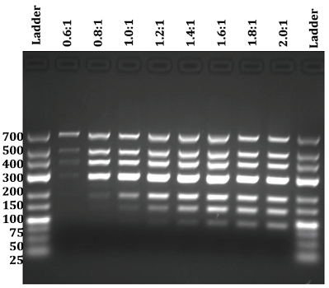
9. Transfer supernatant to fresh tube (0.2 or 1.5 ml, depending on how you want to store it).

In step 3, accurate ratio of beads to sample is critical. Note that the bead suspension is viscous (because of 20% PEG in it) and pipette with care. See the example gel on the right, where different ratios beads:sample have been used, and how small changes in the ratio affect the exclusion of smaller nucleic acid sizes. Careful wash steps are important, because any salt and PEG carryover will affect downstream sequencing. The final amplicon size after the indexing PCR is > 213 bp (70 bp from the 2*35 bases around the target site, plus 40 bp of an average primer pair, plus 103 bp of linker and indexing primer tails), so a 1:1 ratio beads:sample allows to clean undesired products (e.g. dimers and small unintended products) and high recovery of the desired amplicons in the range of 213-353 bp.

Alternative master mix with SYBR-GREEN I
This master mix can be used to validate primers and multiplexed reactions using a qPCR approach.
PCR components | uL in a 20ul reaction
10xHF buffer without MgCl₂ | 2
10mM dNTPs | 0.4
10uM primers | 0.4
25mM MgCl2 | 3.6
5U/ul FastStart | 0.2
5 ng/ul DNA | 2
100x SYBR GreenI | 0.04
water | 11.36
TOTAL | 20

Important note: this mix works OK with individual primer pairs, but some experiments suggest it does not work when it is added before the amplification when multiplexing primers. We have not tried adding SYBR just after the PCR, just before using the qPCR machine. Test before using in a large-scale experiment.

If you added SYBR-GREENI to the mastermix, run this protocol on a qPCR machine in a qPCR plate (you cannot use normal PCR plates in the qPCR machine because they are too tall!):
72°C 1min, scan (SYBR-FAM), melting run (65-95°C in 0.2°C step).
With this you will know if every sample amplified (comparing the positive control and the samples with the negative control), and the melting peaks will show the specificity.

Case examples

Case 1: several projects in the same sequencing run

Case 2: Primer design for knock-ins
This pipeline assumes that sufficient time has passed between the beginning of the experiment (addition of CRISPR reagents) and the NGS library preparation for all initial reagents to be degraded in the cell. I.e. if you add a DNA donor, by the time you make the library the cells will have divided and there will be no donor left.
However, if you add a donor to a pool of cells (e.g. if you want to test different donor designs) and you prepare a library soon after, that donor can remain the cell and act as template for the PCR. Therefore, make sure you design at least one of primers outside the donor range.

Case 3: Rationale behind the scoring system for clone selection
Suggested best clones:
The idea clone is a dmut with frameshifts and no off-targets. We prefer dmut to homo because it’s more accurate to accept correct genotyping in dmut than in homo. As you can see in the example below, some homo’s can be disguised dmuts.
(paper https://www.nature.com/articles/ncomms15464).
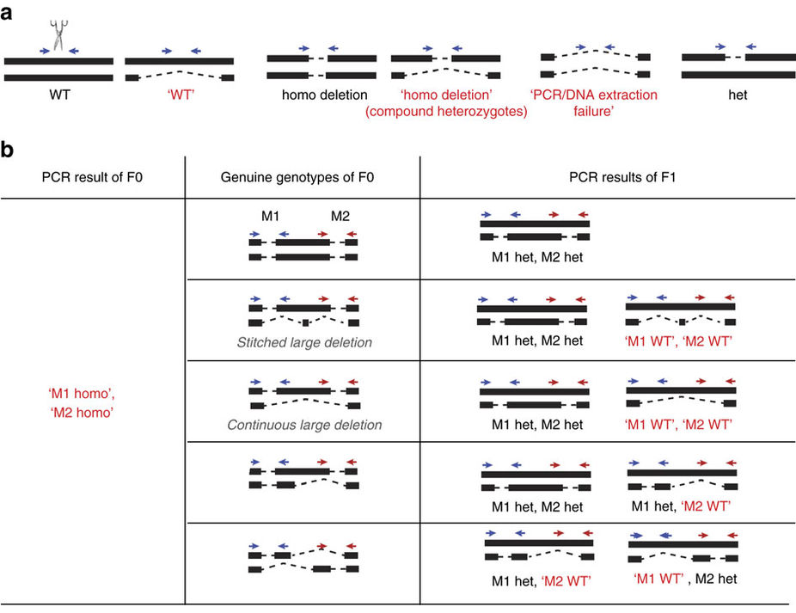
Assumptions and definitions:
The scoring system assumes (currently) a bialelic situation, so it will not yield meaningful scoring for >2 alleles. It uses zygosity, mutation consequence (e.g. frameshift) and presence of off-targets to suggest the best clone in a KO situation. It does not currently use protein abundance, but it’s on the todo list (note that this would depend on what you expect, either no protein or overexpression, so the score should be relative to the experiment goal). It gives a null result for knock-ins.
Calculation of zygosity: it uses the allele frequencies (which range from 0 to 1) and the number of variants found in a clone to decide between wild-type (wt), homozygous (homo), double-mutant (dmut), single-mutant (smut), iffy (iffy) and warning (warn).
- Wt: no variants found.
- Homo: single variant with allele fraction > 0.85.
- Smut: single variant with allele fraction between 0.35-0.85.
- Dmut: two variants with allele fractions between 0.35-0.85.
- Iffy: cases not contemplated above (e.g. single variant with allele fraction < 0.35, two variants with allele fraction >0.85, more than two variants, etc.). These are cases that may be valid mutants but require manual examination. If you work in a tri-allelic situation, your desired clones will fall in this range because you will have three variants.
- Warn: e.g. if the coordinate of the variant falls outside the range of the amplicon where it should be (e.g. you have cross-contamination between wells that contained different sgRNA guides).

Calculation of score:
If zygosity is a warn, the score is set to 0.
The absence of off-targets weighs 70*100, a frameshift weighs 10*100, a dmut weighs 10*80, a homo 10*15 and an smut 10*5.

Future to do’s

Bead-based normalisation of PCR input.
As commented on the primer validation section, Differences in PCR yield will cause unbalancing between barcodes. […]. If unbalancing becomes a problem, try an normalise template amount (number of cells) in the linker PCR, or normalise the amount of template (diluted linker PCR) that is used in the indexing PCR.
This normalisation could be done with AmpureXP beads at a very low concentration.
The AmpureXP mix contains beads (with very high nucleic acid binding capacity) and a buffer of PEG and NaCl. The beads capture the nucleic acid, and the buffer concentration determines the size of nucleic acid captured: the higher the concentration, the smaller the molecules that can be captured. In a normal protocol to retain amplicons >200 bp, a ratio 1:1 sample:bead solution is used.
What we want here is to keep the concentration of buffer but dilute the amount of beads, so we just need to make up buffer (20% PEG-8000 and 2.5M NaCl in TE, see http://www.openwetware.org/wiki/SPRI_bead_mix for more details).
The bead concentration is to be determined, but I suggest starting with a dilution curve of beads:buffer like: 1:10, 1:50, 1:100, 1:150, 1:200, 1:250, 1:500, and then use the standard 1:1 diluted beads:sample to be purified.
At the Sanger they do a large number of cycles during the linker PCR, so all reactions reach plateau and naturally even out differences in starting template. However, that approach should be tested with a good proof-reading polymerase. Unintended mutations that will look like SNV’s can be introduced in the sequencing reads due to PCR errors.

Nested PCR for cleaner amplification.
Sometimes it is very hard to design amplicons on some targets, especially when they are in pseudogenes or repeated regions, and we are using very strict design parameters (maximum amplicon size is 250 bp, but we reserve 70 bp in the middle of the amplicon where we cannot design primers. For 20 nt primers, there are not many design options in such a small sequence!). If the amount of unintended templates is too high, it may be more effective to do a nested PCR approach to skip time-consuming PCR optimisation steps (gradient PCR, touchdown, primer concentration, etc).
The experimental design would look like this: You first design primers with less constrains (amplicon size between 300-1000 bp, instead of max 250 bp). These primers can be reused after clone selection for QC with Sanger sequencing. Then dilute the PCR and do a nested PCR with the primers with linkers, and follow the standard protocol.
Pros: higher specificity of reactions, less time invested on optimising amplifications. The primers can be reused for Sanger.
Cons: double amount of primers (target + off-targets) to design, one extra PCR to do.

Automatise primer design.
Currently we use primerBLAST to get specific primers. Very useful but very time-consuming: 5 min or more per primer pair, assuming everything goes fine and there are not unintended targets to check, plus manually copy primer details (name, sequence, coordinates) onto the pipeline submission form.
This NCBI tool is web-only and cannot be downloaded. However, a form can be created to submit automatically and receive a html file with the primer results. The primerBLAST maintainer said that the server would accept up to two simultaneous submissions.
The html file could be parsed, so if primers can be selected from it and automatically passed to the pipeline app, it would save a very, very big amount of time.

Others.
- Growth data should be more robust, following on work with reservoir plates. This robustness should be checked bioinformatically as well, to decide which samples/projects use growth data in the score.
- The layout forms accept marking replicates in the samples. In the next revision, these replicates can be used to compute statistics.
- The database model has a Donor class. This donor (DNA sequence that is introduced in the cell to recombine, in a knock-in approach) can be matched after the variant calling, allowing to call knock-ins directly.
- The scoring system works for a biallelic KO situation only, when low protein is expected. It can be updated to accept user input (e.g. expect high protein level instead), for situations with one or more than two alleles, for knock-ins, etc. Growth slopes are not currently considered in the score, because at the time of finishing the project the growth data was low quality. The scoring system should be user-driven, so the user can decide which datasets to score on (growth, protein data), and whether high or low values impact positively or negatively in the score (e.g. now it’s assumed that KO results in low protein, but there could be upregulation; also, the user could decide to give a higher score to slow or fast growing clones, etc). This scoring system currently marks as iffy those clones that cannot be assigned to standard categories (homozygous, double mutant, etc); it is likely that those iffy clones indicate cross-contamination between clones, so further refinement of the score could give more information in this respect.
- The selected clones will normally require a QC by Sanger sequencing to confirm genotyping. This could be included in the database model and the processing, so the web app gives results directly.
- It may be interesting to accept libraries from external sources, so Genome Editing uses only the app to process the data. In this case, the bioinformatics pipeline should be able to accept different barcoding systems to allow for greater flexibility.

List of reagents and Preparation of Stock solutions:
Name | Supplier | Ordering code | Full name
Extracta buffer (25 ml) | VWR | 95091-025 | Extracta DNA prep for PCR-Tissue
FastStart HF | Sigma | 000000003553361001 | FastStart High Fidelity PCR System (Roche 03553361001, sold through Sigma)
PCR Seals | Thermo | AB0558 | Note: they are OK for qPCR
SYBR Green I | Fisher | 10710004 | Invitrogen™ SYBR™ Green I Nucleic Acid Gel Stain - 10,000X concentrate in DMSO (Invitrogen™ S7563 )

SYBR Green I (100x stock):
SYBR Green 10000X comes in DMSO, store frozen and protected from light. Make a 100X working stock in water, that can be stored at 4ºC protected from light.

LAB buffer:
Better resolution than TAE and TBE at <500 bp, but it compresses bands at >1000 bp, so not recommended for e.g. plasmid restriction digestions.
See http://www.openwetware.org/wiki/LAB_Media for the detailed recipe. Briefly, a 1L of 25X stock solution contains:
25.5g Lithium acetate dihydrate
15.5g Boric acid
make up 1L with dH2O

You can run the gel at 15-20 V/cm, i.e. 200V for a minigel, and 200-350V for bigger gels, or at the same voltage as a TAE gel if you wish.

GEfileformats_annotations
Documentation of the Genome Editing submission forms, in markdown in GEfileformats_annotations.Rmd
This document establishes the file formats (IncellWestern and Incucyte) that are accepted by the webapp. Both are tab-delimited and .txt files.

IncellWestern file format
This file must contain a line called "Total Channel 700", with the data from the 96-well plate below, and a line called "Total Channel 800" also with the correspondent 96-well data, as in the example below and file IncellWestern_fileformat.txt. Any other lines in the file are ignored.
Total Channel 700
458.46 | 393.17 | 1138.75 | 427.52 | 577.21 | 1158.68 | 843.28 | 918.89 | 733.88 | 799.29 | 975.93 | 292.81
188.38 | 810.96 | 204.89 | 421.68 | 587.29 | 697.48 | 906.43 | 153.23 | 809.24 | 892.18 | 450.47 | 148.43
896.52 | 85.92 | 491.9 | 1130.73 | 764.09 | 571.85 | 603.87 | 816.89 | 485.83 | 1115.93 | 451.67 | 41.28
80.89 | 313.43 | 900.51 | 415.72 | 474.17 | 65.2 | 1154.76 | 176.96 | 434.48 | 31.38 | 893.64 | 829.24
477.92 | 471.44 | 383.92 | 284.21 | 108.92 | 109.02 | 193.87 | 176.18 | 496.93 | 1092.23 | 1107.24 | 50.88
16.22 | 1004.73 | 621.3 | 804.81 | 843.27 | 680.63 | 709.32 | 25.61 | 315.45 | 80.31 | 898.83 | 1166.72
674.37 | 155.62 | 293.62 | 1061.21 | 553.23 | 1106.07 | 617.51 | 339.42 | 517.69 | 394.6 | 346.37 | 68.57
603.8 | 63.87 | 1175.23 | 37.54 | 928.39 | 642.82 | 140.6 | 254.83 | 957.23 | 813.5 | 328.68 | 669.7
Total Channel 800
408.76 | 830.23 | 568.93 | 86.59 | 235.03 | 825.31 | 390.89 | 408.96 | 121.72 | 844.39 | 981.91 | 405.2
237.07 | 949.09 | 818.33 | 568.13 | 681.13 | 70.25 | 201.15 | 260.68 | 370.52 | 357.28 | 692.21 | 732.58
930.81 | 140.73 | 983.7 | 179.29 | 86.57 | 382.68 | 780.21 | 275.05 | 992.34 | 636.07 | 764.7 | 159.36
987.55 | 681.93 | 685.6 | 885.71 | 610.31 | 244.86 | 41.02 | 270.25 | 862.14 | 911.94 | 224.42 | 483.22
89.99 | 323.89 | 622.45 | 825.01 | 882.68 | 835.88 | 502.15 | 595.63 | 232.17 | 589.13 | 718.89 | 408.93
811.66 | 403.7 | 209.65 | 477.52 | 740.33 | 844.32 | 452.04 | 878.81 | 702.83 | 840 | 828.37 | 57.41
457.68 | 667.09 | 279.19 | 104.58 | 134.99 | 222.44 | 200.69 | 929.5 | 529.65 | 522.99 | 389.25 | 975.89
907.72 | 621.77 | 269.51 | 248.83 | 541.57 | 315.01 | 657.52 | 451.2 | 843.74 | 844.8 | 304.82 | 376.35

Incucyte file format
This file must contain a line that starts with "Date Time" (this column contains the time stamp), followed by the time elapsed (this column contains the elapsed hours), and followed by the well locations (these columns contain the %confluence), as in the example below and file IncuCyte_fileformat.txt. Any other lines in the file are ignored.
Date.Time | Elapsed | A1 | B2 | C2 | ... | H12
13/01/2017 11:00:00 | 0 | 22.30 | 21.67 | 24.37 | ... | 19.79
13/01/2017 14:00:00 | 3 | 22.44 | 23.47 | 25.60 | ... | 20.32
... | ... | ... | ... | ... | ... | ...
17/01/2017 08:00:00 | 93 | 85.97 | 93.87 | 95.45 | ... | 89.19

Plot examples and descriptions

GEplot_descriptions

Ruben Alvarez

17 July 2017

Documentation of the Genome Editing plot outputs

Protein plot:
This plot shows the IncellWestern 800nm/700nm ratios, with guides and controls one column each in the x-axis. Each dot corresponds to a single well. 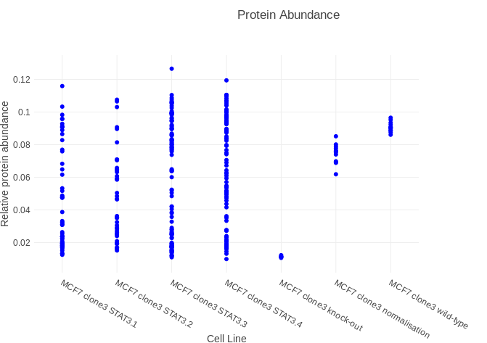

Growth plot:
This plot shows IncuCyte data as growth curves, mapping colours to guides and controls. Each line corresponds to a single well.
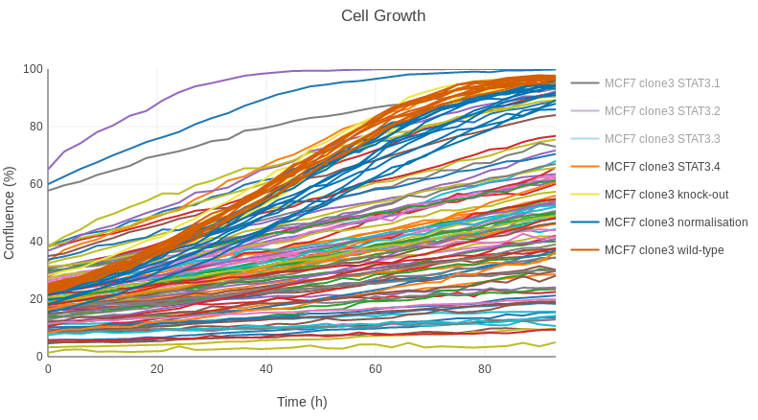

Slopes plot
When the growth slopes can be calculated, this plot shows the values with guides and controls one column each in the x-axis. Each dot corresponds to a single well.

Combined data plots:

Global heatmap
This heatmap shows an overview of the whole experiment, depicting (in columns and one clone per row) protein amounts (800/700 ratios), NGS genotyping (frameshift to frame 2-3 and no frameshift | presence of off-targets | zygosity of the mutation) and Growth slope.

Global protein + slopes + NGS plot
A combination of protein ratios (xaxis), growth slopes (yaxis) and NGS genotyping (zygosity and frameshifts) on a per-guide basis.

NGS plots:
These (except the INDEL structre plot) are experiment-wide exploratory plots, that will provide information about zygosity frequencies, alleles, indel sizes, etc., and show if different guides result preferences for certain types of mutations. The sgRNA guides are represented independently (in this case, STAT3.1 to 3.4).
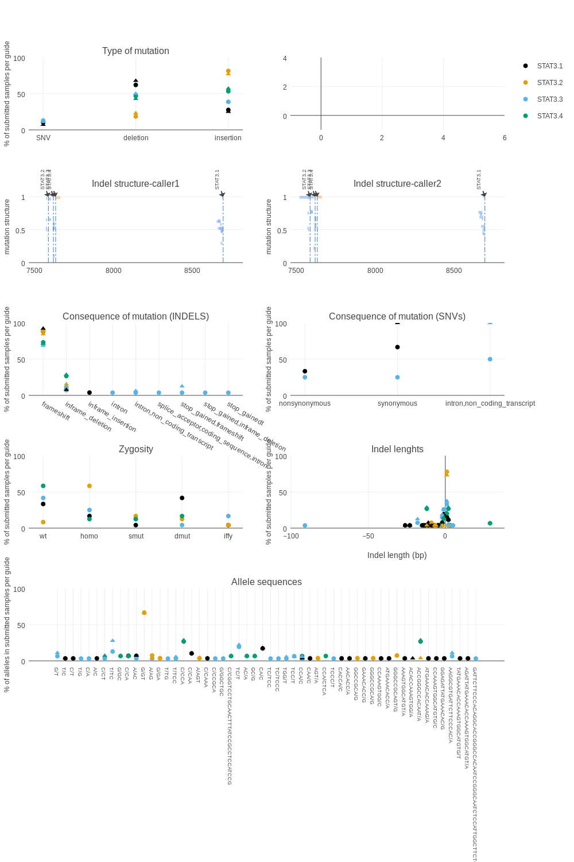

Type of mutation
This plot shows the % of alleles that have a mutation of a certain type. It shows allele data from all samples that have a mutation (so wt are excluded, and double and single mutants contribute with two and one alleles respectively). The types of mutation considered are insertion, deletion and SNV (single-nucleotide variant).

INDEL structure
These plots show an overview of position, size, allele frequency and type of mutation (INDEL/SNV) of all the clones in the experiment. Currently, Vardict and HaplotypeCaller are used.

Consequence of mutation
These are two plots, one for INDELs and the other one for SNVs, that show the % of submitted samples on a per-guide and per-allele basis that have the same variant (frameshift, inframe-deletion, synonymous mutation…). The results are the % of alleles in the samples that show mutations (i.e. the wild-types are not included).

Zygosity
This plot shows the % of samples submitted for NGS on a per-guide basis. I.e. if you submit 100 samples for NGS and only 80 of them are edited, this plot will show a 20% of wild-types and the corresponding percentages of INDELS (not considering SNVs for this plot). These mutations can be:
wt. Wild-type, no mutation.
homo. Homozigous (biallelic) mutation. Called when allele_fraction > 0.85 and there is only one mutation in the variants output.
dmut. Double-mutant, i.e. both alleles have at least a mutation and they are different. Called when allele fraction is between 0.35 and 0.85.
smut. Single-mutant, i.e. only one allele is mutated with allele fraction between 0.35 and 0.85.
iffy. Uncertain mutation, which can be e.g. a case with allele fraction >0.85 but two mutations (note that this could happen e.g. if the same allele is mutated in two positions, because allele fractions are computed per position, not per allele), or a case where allele_fraction is < 0.35.
warn. A warning when the number of mutations (mutated positions) is not the same as the number of variants.

Indel lengths
This plot shows the % of samples submitted for NGS on a per-guide and per-allele basis. It represents the percent of alleles that have an indel of the same length.

Allele sequences
This plot shows the % of samples submitted for NGS on a per-guide and per-allele basis. It represents the percent of alleles with a certain sequence of indel or SNV.

96-well plate plot
This plot shows the plates in the experiment, colour-coding the wells accordingly to the scoring system, to suggest the highest-scored clones for selection.
