

Technical Safety Concept Lane Assistance

**Document Version: [Version]**

**Template Version 1.0, Released on 2017-06-21**



# Document history

**[Instructions: Fill in the date, version and description fields. You can fill out the Editor field with your name if you want to do so. Keep track of your editing as if this were a real world project.**

**For example, if this were your first draft or first submission, you might say version 1.0. If this is a second submission attempt, then you'd add a second line with a new date and version 2.0]**

|  |  |  |  |
| --- | --- | --- | --- |
| Date | Version | Editor | Description |
|  |  |  |  |
|  |  |  |  |
|  |  |  |  |
|  |  |  |  |
|  |  |  |  |

# 

# Table of Contents

**[Instructions: We have provided a table of contents. If the table of contents is not showing up correctly in your word processor of choice, please update it. The table of contents should show each section of the document and page numbers or links. Most word processors can do this for you. In** [**Google Docs**](https://support.google.com/docs/answer/116338?co=GENIE.Platform%3DDesktop&hl=en)**, you can use headings for each section and then go to Insert > Table of Contents.** [**Microsoft Word**](https://support.microsoft.com/en-us/help/285059/how-to-create-a-table-of-contents-by-marking-text-in-word) **has similar capabilities]**

Document history

Table of Contents

Purpose of the Technical Safety Concept

Inputs to the Technical Safety Concept

Functional Safety Requirements

Refined System Architecture from Functional Safety Concept

Functional overview of architecture elements

Technical Safety Concept

Technical Safety Requirements

Refinement of the System Architecture

Allocation of Technical Safety Requirements to Architecture Elements

Warning and Degradation Concept

# Purpose of the Technical Safety Concept

**[Instructions: Answer what is the purpose of a technical safety concept?]**

**The purpose of the Technical Safety Concept is to translates high-level functional safety requirements into functional safety requirements based on the system architecture.**

# Inputs to the Technical Safety Concept

## Functional Safety Requirements

**[Instructions: Provide the functional safety requirements derived in the functional safety concept ]**

|  |  |  |  |  |
| --- | --- | --- | --- | --- |
| **ID** | **Functional Safety Requirement** | **ASIL** | **Fault Tolerant Time Interval** | **Safe State** |
| Functional  Safety  Requirement  01-01 | The Electronic Power Steering ECU shall  ensure that the oscillating torque amplitude  requested by the LDW function is below  Max_Torque_Amplitude. | C | 50 ms | The Lane  Assistance  functionality is  switched off. |
| Functional  Safety  Requirement  01-02 | The lane keeping item shall ensure that the  lane departure oscillating torque frequency  is below Max_Torque_Frequency. | C | 50 ms | The Lane  Assistance  functionality is  switched off. |
| Functional  Safety  Requirement  02-01 | The lane keeping item shall ensure that the  lane departure oscillating torque frequency  is above Min_Torque_Frequency. | B | 50 ms | The Lane  Assistance  functionality is  switched off. |

## Refined System Architecture from Functional Safety Concept

**[Instructions: Provide the refined system architecture from the functional safety concept]**

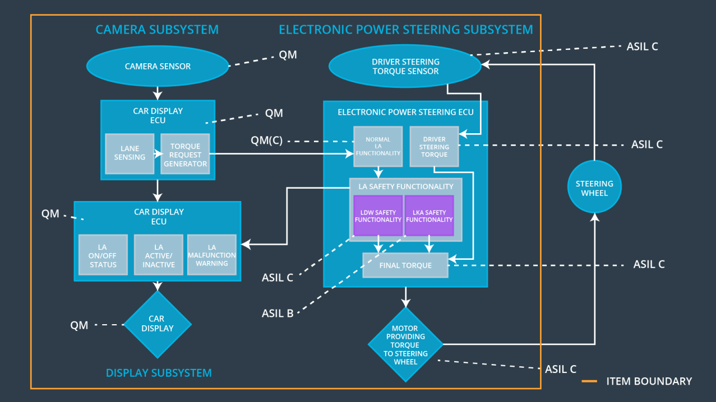

### Functional overview of architecture elements

**[Instructions: Provide a description for each functional safety element; what is each element's purpose in the lane assistance item? ]**

|  |  |
| --- | --- |
| **Element** | **Description** |
| Camera Sensor | The Camera Sensor reads in images from the road. |
| Camera Sensor ECU - Lane Sensing | Lane Sensing element process the images from Cmaera Sensor to  identifies when the vehicle is leaving the lane. |
| Camera Sensor ECU - Torque request generator | The Camera Sensor ECU Torque Request  Generator determine  necessary torque for lane keeping and sends signals to Electronic Power  Steering ECU and Car Display ECU. |
| Car Display | The Car Display shows the current status  of LDW and LK functions by turning on/off status lights. |
| Car Display ECU - Lane Assistance On/Off Status | Lane Assistance On/Off  Status element sends a signal to the Car Display to  notify whether each LA function has been  turned on or off. |
| Car Display ECU - Lane Assistant Active/Inactive | Lane Assistant  Active/Inactive element sends a signal to the Car  Display to turn on the Lane Assistance Active  status light.  The Car Display ECU LA Active/Inactive element  determines whether the lane assist is active or  inactive for display on the dashboard. |
| Car Display ECU - Lane Assistance malfunction warning | The Car Display ECU LA Malfunction Warning  element receives LDW_Error_Status messages  and provides appropriate warnings on the  display. |
| Driver Steering Torque Sensor | The Driver Steering Torque Sensor detects the  amount of torque from the  steering wheel. |
| Electronic Power Steering (EPS) ECU - Driver Steering Torque | Driver Steering Torque element sends a signal from the Driver Steering Torque Sensor to the Final Torque element with the amount of torque applied by the driver. |
| EPS ECU - Normal Lane Assistance Functionality | Normal Lane Assistance  Functionality element sends messages from  Torque Request Generator to Lane Assistance  Safety module. |
| EPS ECU - Lane Departure Warning Safety Functionality | Lane Departure Warning Safety  Functionality element ensures that the LDW  functionality does not malfunction. |
| EPS ECU - Lane Keeping Assistant Safety Functionality | Lane Keeping Assistant Safety  Functionality element is responsible for safety-  related functions. |
| EPS ECU - Final Torque | Final Torque element combines  signals from Lane Assistance Safety module and  Driver Steering Torque module |
| Motor | The Motor provides torque for the steering wheel. |

# Technical Safety Concept

## Technical Safety Requirements

**[Instructions: Fill in the technical safety requirements for the lane departure warning first functional safety requirement. We have provided the associated functional safety requirement in the first table below. Hint: The technical safety requirements were discussed in the lesson videos. The architecture allocation column should contain element names such as LDW Safety block, Data Transmission Integrity Check, etc. Allocating the technical safety requirements to the "EPS ECU" does not provide enough detail for a technical safety concept.]**

**Lane Departure Warning (LDW) Requirements:**

Functional Safety Requirement 01-01 with its associated system elements

(derived in the functional safety concept)

|  |  |  |  |  |
| --- | --- | --- | --- | --- |
| **ID** | **Functional Safety Requirement** | **Electronic Power Steering ECU** | **Camera ECU** | **Car Display ECU** |
| Functional  Safety  Requirement  01-01 | The lane keeping item shall ensure that the lane departure oscillating torque amplitude is below Max_Torque_Amplitude | X |  |  |

Technical Safety Requirements related to Functional Safety Requirement 01-01 are:

|  |  |  |  |  |  |
| --- | --- | --- | --- | --- | --- |
| **ID** | **Technical Safety Requirement** | **ASIL** | **Fault Tolerant Time Interval** | **Architecture Allocation** | **Safe State** |
| Technical  Safety  Requirement  01 | The LDW safety component  shall ensure that the amplitude  of the LDW_Torque_Request  sent to the final electronic  power steering torque  component is below  Max_Torque_Amplitude. | C | 50 ms | LDW safety | The  LDW torque  amplitude  is set to 0 |
| Technical  Safety  Requirement  02 | As soon as the LDW function  deactivates the LDW feature,  the 'LDW Safety' software  block shall send a signal to  the car display ECU to turn on  a warning light. | C | 50 ms | LDW safety | The  LDW torque  amplitude  is set to 0 |
| Technical  Safety  Requirement  03 | As soon as a failure is  detected by the LDW function,  it shall deactivate the LDW feature and the  'LDW_Torque_Request' shall  be set to zero. | C | 50 ms | LDW safety | The  LDW torque  amplitude  is set to 0 |
| Technical  Safety  Requirement  04 | The validity and integrity of  the data transmission for  'LDW_Torque_Request' signal  shall be ensured. | C | 50 ms | Data  transmission  integrity  check | The  LDW torque  amplitude  is set to 0 |
| Technical  Safety  Requirement  05 | Memory test shall be  conducted at start up of the  EPS ECU to check for any  faults in memory. | A | Ignition  cycle | Safety startup | The  LDW torque  amplitude  is set to 0 |

**[Instructions: Fill in the technical safety requirements for the lane departure warning second functional safety requirement. We have provided the associated functional safety requirement in the table below. Hint:. Most of the technical safety requirements will be the same. At least one technical safety requirement will have to be slightly modified because we are talking about frequency instead of amplitude. These requirements were not given in the lessons]**

Functional Safety Requirement 01-2 with its associated system elements

(derived in the functional safety concept)

|  |  |  |  |  |
| --- | --- | --- | --- | --- |
| **ID** | **Functional Safety Requirement** | **Electronic Power Steering ECU** | **Camera ECU** | **Car Display ECU** |
| Functional  Safety  Requirement  01-02 | The lane keeping item shall ensure that the lane departure oscillating torque frequency is below Max_Torque_Frequency | X |  |  |

Technical Safety Requirements related to Functional Safety Requirement 01-02 are:

|  |  |  |  |  |  |
| --- | --- | --- | --- | --- | --- |
| **ID** | **Technical Safety Requirement** | **ASIL** | **Fault Tolerant Time Interval** | **Architecture Allocation** | **Safe State** |
| Technical  Safety  Requirement  01 | The LDW safety component  shall ensure that the frequency  of the LDW_Torque_Request  sent to the final electronic power  steering torque component is  below Max_Torque_Frequency. | C | 50 ms | LDW Safety | The  LDW torque  frequency  is set to 0 |
| Technical  Safety  Requirement  02 | As soon as the LDW function  deactivates the LDW feature,  the 'LDW Safety' software  block shall send a signal to the  car display ECU to turn on a  warning light. | C | 50 ms | LDW Safety | The  LDW torque  frequency  is set to 0 |
| Technical  Safety  Requirement  03 | As soon as a failure is  detected by the LDW function,  it shall deactivate the LDW  feature and the  'LDW_Torque_Request' shall  be set to zero. | C | 50 ms | LDW Safety | The  LDW torque  frequency  is set to 0 |
| Technical  Safety  Requirement  04 | The validity and integrity of the  data transmission for  'LDW_Torque_Request' signal  shall be ensured. | C | 50 ms | Data  Transmission  Integrity  Check | N/A |
| Technical  Safety  Requirement  05 | Memory test shall be  conducted at start up of the  EPS ECU to check for any  faults in memory. | A | Ignition  cycle | Safety  Startup | The  LDW torque  frequency  is set to 0 |

**Lane Departure Warning (LDW) Verification and Validation Acceptance Criteria:**

**[OPTIONAL: For each technical safety requirement, identify both the verification and validation acceptance criteria. “Validation” asks whether or not you chose the appropriate parameters. “Verification” involves testing to make sure the vehicle behaves as expected when the parameter value is crossed. There is not necessarily one right answer. Look at your verification and validation acceptance criteria from the functional safety concept for inspiration.]**

**Lane Keeping Assistance (LKA) Requirements:**

**[Instructions: Fill in the technical safety requirements for the lane keeping assistance functional safety requirement 02-01. We have provided the associated functional safety requirement in the table below. Hint:. You can reuse the technical safety requirements from functional safety requirement 01-01. But you need to change the language because we are now looking at a different system. The ASIL and Fault Tolerant Time Interval are different as well.]**

Functional Safety Requirement 02-1 with its associated system elements

(derived in the functional safety concept)

|  |  |  |  |  |
| --- | --- | --- | --- | --- |
| **ID** | **Functional Safety Requirement** | **Electronic Power Steering ECU** | **Camera ECU** | **Car Display ECU** |
| Functional  Safety  Requirement  02-01 | The lane keeping item shall ensure that the lane keeping assistance torque is applied for only Max_Duration | X |  |  |

Technical Safety Requirements related to Functional Safety Requirement 02-01 are:

|  |  |  |  |  |  |
| --- | --- | --- | --- | --- | --- |
| **ID** | **Technical Safety Requirement** | **ASIL** | **Fault Tolerant Time Interval** | **Allocation to Architecture** | **Safe State** |
| Technical  Safety  Requirement  01 | The LKA safety component shall  make sure that the duration of LK  usage is less than Max_Duration. | B | 500 ms | LKA Safety | The LKA  system will  completely  turn off |
| Technical  Safety  Requirement  02 | As soon as the LKA function  deactivates the LKA feature, the  'LKA Safety' software block shall notify the car display  ECU to turn on a warning light. | B | 500 ms | LKA Safety | The LKA  system will  completely  turn off |
| Technical  Safety  Requirement  03 | As soon as a failure is detected  by the LKA function, it shall  turn off the LKA feature and  the 'LKA_Torque_Request' shall  be set to 0. | B | 500 ms | LKA Safety | The LKA  system will  completely  turn off |
| Technical  Safety  Requirement  04 | The validity and integrity of the  data transmission for  'LKA_Torque_Request' signal  shall be ensured. | B | 500 ms | Data  Transmission  Integrity Check | The LKA  system will  completely  turn off |
| Technical  Safety  Requirement  05 | Memory test shall be conducted  to check for any faults in memory during the start up of the EPS ECU. | A | Ignition  Cycle | Safety Startup | The LKA  system will  completely  turn off |

**Lane Keeping Assistance (LKA) Verification and Validation Acceptance Criteria:**

**[OPTIONAL: For each technical safety requirement, identify both the verification and validation acceptance criteria. “Validation” asks whether or not you chose the appropriate parameters. “Verification” involves testing to make sure the vehicle behaves as expected when the parameter value is crossed. There is not necessarily one right answer. Look at your verification and validation acceptance criteria from the functional safety concept for inspiration.]**

## Refinement of the System Architecture

**[Instructions: Include the refined system architecture. Hint: The refined system architecture should include the system architecture from the end of the technical safety lesson, including all of the ASIL labels.]**

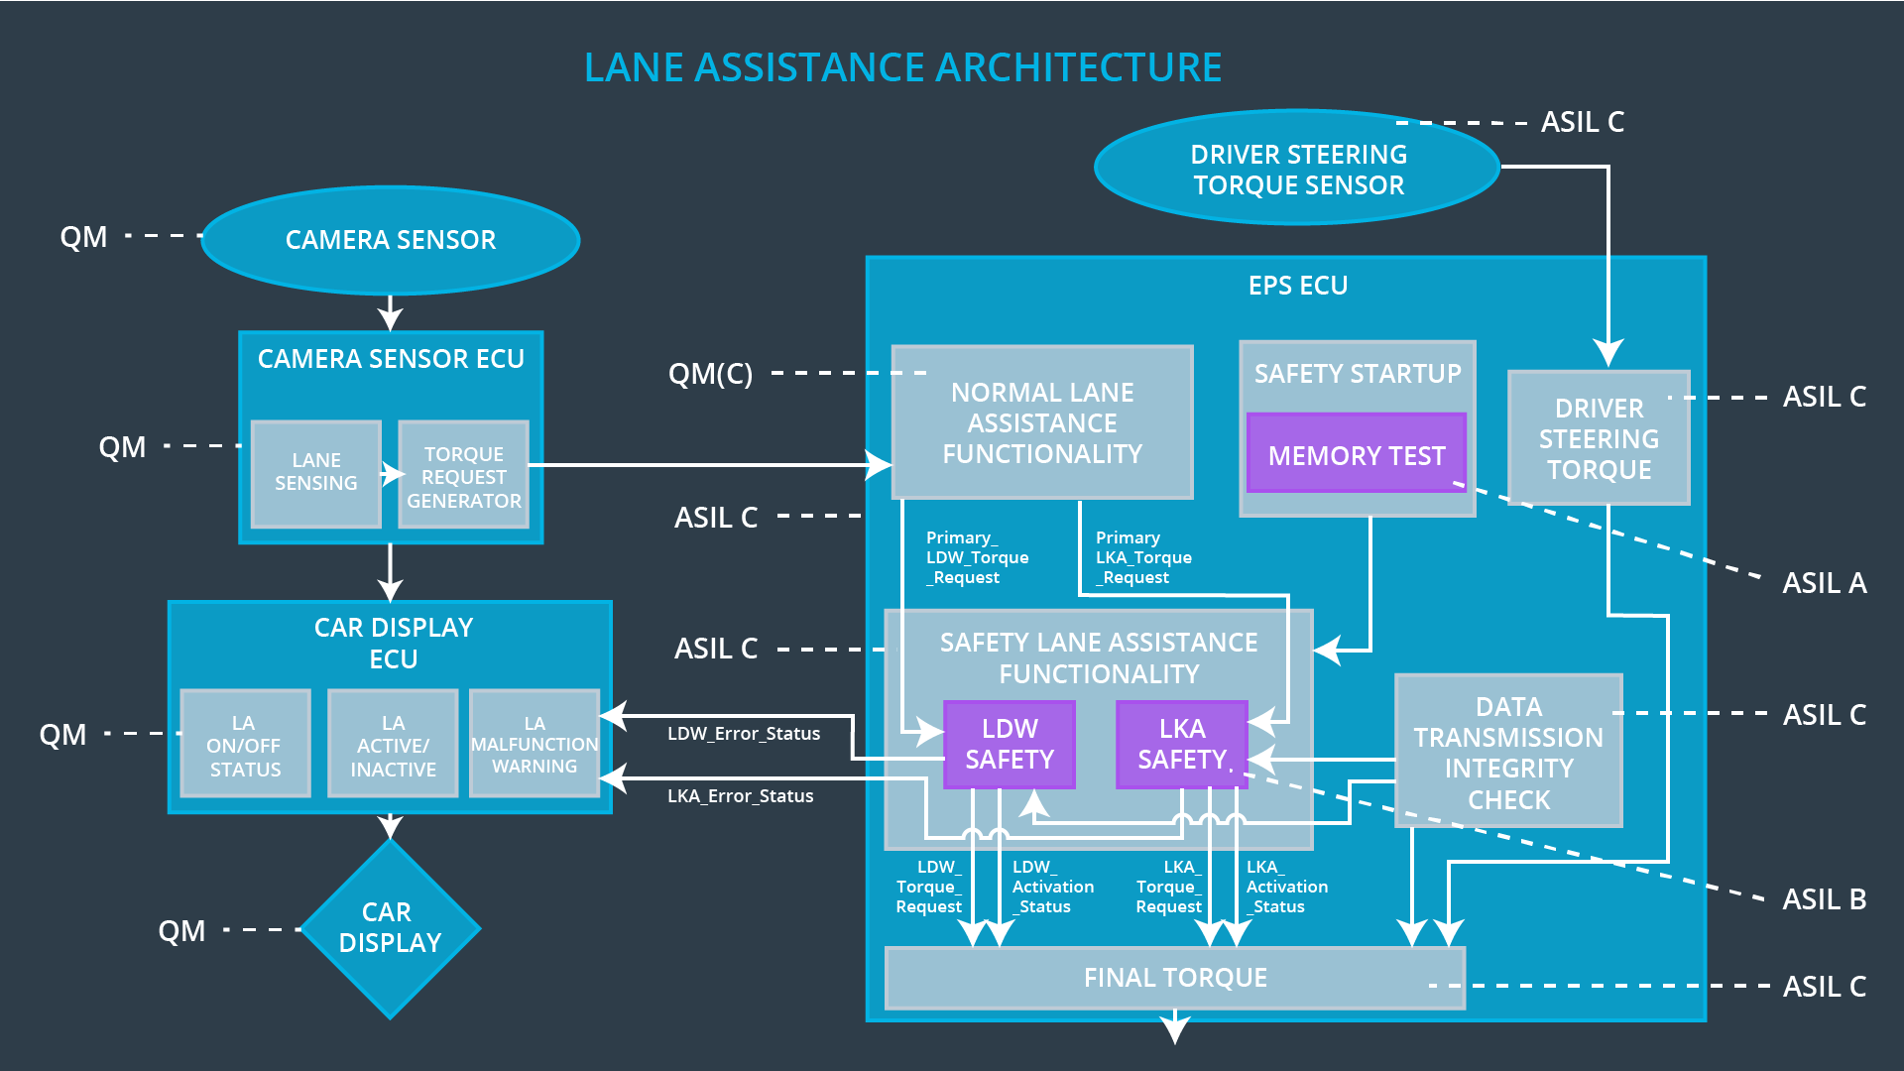

## Allocation of Technical Safety Requirements to Architecture Elements

**[Instructions: We already included the allocation as part of the technical requirement tables. Here you can state that for this particular item, all technical safety requirements are allocated to the Electronic Power Steering ECU]**

**All technical safety requirements are allocated to the electronic power steering ECU.**

## Warning and Degradation Concept

**[Instructions: We've already identified that for any system malfunction, the lane assistance functions will be turned off and the driver will receive a warning light indication. The technical safety requirements have not changed how functionality will be degraded or what the warning will be.**

**So in this case, the warning and degradation concept is the same for the technical safety requirements as for the functional safety requirements. You can copy the functional safety warning and degradation concept here.**

**Oftentimes, a technical safety analysis will lead to a more detailed warning and degradation concept. ]**

|  |  |  |  |  |
| --- | --- | --- | --- | --- |
| ID | Mode | Degradation  Mode | invoked? | Driver Warning |
| WDC-01 | Turn off the  functionality | The amplitude of oscillating torque  from LDW is greater than  Max_Torque_Amplitude | Yes | Display warning  light |
| WDC-02 | Turn off the  functionality | The frequency of oscillating torque  from LDW is greater than  Max_Torque_Frequency | Yes | Display warning  light |
| WDC-03 | Turn off the  functionality | The frequency of oscillating torque  from LDW is less than  Min_Torque_Frequency | Yes | Display warning  light |