**ROP and Safety stock Issue & Suggested Solution:**

**Points to consider:**

1. My opinion I see nothing wrong with formulas and we need to stick with rop calculation principles.

We need to see how much sku are like this and what is impact on inventory as total. I fit is small amount then do not spend too much effort on this.

Also sis there to mitigate stock out risk. What if customer place and order of 600 ? That effectively reduce 50% stock in one hit, you also do not want to lost customers as they will go away from you as we fail to deliver.

Are this sku part of awning we can not afford to not supply ?

I believe calculation is correct, why ask to order more - they are certainly Moq and pack size cause this.

If inventory sounds too high, then business decision need to made. I also think , even if we go by system and I am 100% behind this in principle- do not make me wrong, but there is no one size fits all solution and we will have exception. And To deal with exception, we need somehow/ sometimes to work outside system, I am not encouraging work outside system, there is fundamental differences between purely rely on working outside system and use system as guide however modify our approach sometime to meet our goals.

I have no problems doing that , in my previous job we often do that and we need to be bit flexible.

So the high inventory is to protect unforseen variations in supply or/and demand ,also its purpose is to prevent disruption in manufacturing and delivery issues, to compensate forecast inaccuracies.

By, we put 200 sku into rop, even if 20 are like this we still achieved our goal.

So how much impact in terms of dollars we are talking about ? How much percentage we are talking about?

This is purchasing decision, I just express my opinion.

----

If we remove ss,

We only consider consumption within lead time, say 80 which is 20x4 as trigger point, so even if we are holding 90 stock we think we are ok what about we get a hit of 500 unit of customer orders ... we are going running out of stock before we get stock back in.

So are we rely on instinct to purchase?

I believe ROP calculation is correct. Any different opinion? Everyone agrees?if not, telllme you have better way to calculate ROP?

Now order qty is different to your re order point quantities that two different thing.

How much to order after we hit point and have inventory below ROP is business decision.

<https://www.lokad.com/economic-order-quantity-eoq-definition-and-formula>

**ECONOMIC ORDER QUANTITY (EOQ), DEFINITION AND FORMULA**

[Home](https://www.lokad.com/home) » [Knowledgebase](https://www.lokad.com/support) » Here  
*By Joannes Vermorel, January 2012*  
  
EOQ is the purchase order quantity for [replenishment](https://www.lokad.com/stock-replenishment-definition) that minimizes total inventory costs. The purchase order is triggered when the inventory level hits the [reorder point](https://www.lokad.com/reorder-point-definition). The EOQ is calculated in order to **minimize a combination of costs** such as the purchase cost (which may include volume discounts), the inventory holding cost, the ordering cost, etc. The order quantity optimization is complementary to the [safety stock](https://www.lokad.com/calculate-safety-stocks-with-sales-forecasting) optimization that focuses on finding the optimal *threshold* to trigger the reorder.

Model and formula

The *classical* EOQ formula (see the [Wilson Formula](https://www.lokad.com/economic-order-quantity-eoq-definition-and-formula#wilson) section below) is essentially a trade-off between the ordering cost, assumed to be a flat fee per order, and inventory holding cost. Although this formula dating for 1913 is extremely well-known, **we advise *against* using such a formula in any modern supply chain environment**. The underlying mathematical assumptions behind this formula are simply incorrect nowadays.  
  
The historical formula assumes that the cost of the *act of ordering* is the one key business driver. It certainly was an important factor back in 1913 when an army of clerks was required to manually keep track of the books, but with inventory management software and possibly [EDI](http://en.wikipedia.org/wiki/Electronic_data_interchange), this factor is usually insignificant. As a result, the "optimization" performed by the formula makes little sense, and completely ignores any price break that can be available when larger quantities are ordered.  
  
**Download Excel sheet:** [eoq-calculator.xlsm](https://www.lokad.com/GetFile.aspx?File=%2fSupport%2fGlossary%2feoq-formula.xlsm) (illustrated calculation)  
  
Thus, we propose here an EOQ formula variant that **optimizes the trade-off of carrying costs vs volume discounts**. Let's introduce the variables:

* ZZ be the lead demand.
* HH be the *carrying cost* per unit for the duration of the [lead time](https://www.lokad.com/lead-time-definition-and-formula) (1).
* δδ be the delta inventory quantity needed to reach the reorder point (2).
* PP be the per unit purchase price, a function that depends on the order quantity q

<http://web.mit.edu/2.810/www/files/readings/King_SafetyStock.pdf>

You got to be careful about ...using system ...

Yes, we should use system, but he cannot hold you ransoms about this... otherwise you will be kidnaped... there will be always exceptions and we will have to work from system from time to time... but we need firstly base on system use other tools to manage exceptions , no system is perfect and will deal with all your problems, we got to be realistic about this.

And there will be no one size fit all solution.

About education part, yes happy to help and provide training, but it becomes difficult when you teach,people did not listen , let alone argue with you. Then there is frustration and I feel like I am waste my precious time.

Also, to sit here in office and as an procurement professional, I do expect them to understand ASICS concepts and if for demand planning, basic of statistics and database management.

pass onto my knowledge,

--

Anyone disagree about how to calculate re order point?

If you do, I suggest and recommend you study the API S textbook and understand the concept before we continue.

To use gutter feeling and hunch’s to set ss level or on porpotion of cycle stock, it is easy to execute but often yield poor performance.

I am sorry to say that but I think we will have more meaningful conversations after you understand the concept and why and how ROP is calculated.

A sound , proven, mathematical approach to ss and ROP not only justify the required inventory level to business, but also balancing conflicting goals maximise customer service and minimising inventory cost.

Ss determination are not intended to eliminate all stock outs, but the majority of them...

<http://web.mit.edu/2.810/www/files/readings/King_SafetyStock.pdf>

--

**26/7/2018**

**Market Intelligence – Commercial Project**

Why we need to raise/enter & see WO for commercial orders in JDE ?

1. Currently there is a disconnect
2. There is no harm to do so – it only bring benefits & visibility
3. We should adopt & working toward system based not human being based – using system because that is where everybody see the information, and human being is prone to making error since it is manual
4. It does not mean we do not need forecast and new process of collaboration to communication is excellent initiates
5. Planner can still use Mismatch report to plan in case that time is tight & system capability is not ready yet – we need more resources
6. If it is too hard for AWF team to raise the order, Can we automate the process so WO is automatically raised – using BOM to spit out requirement for all individual items
7. Why would they ( AWF ) hold stock in its first place ? Is it because that they have stock for items they sourced by themselves - not buying from HD ?
8. By having customer order in system under HD branch ( like our normal daily orders from AWF ) planning team can have visibility of them and we can run report to check whether there is abnormal customer demand either in immediate month ( this month or this week ) or distant month ( 2 or 3 months down in the track ).

You can actual validate the spike of demand by see both customer order and forecast and understand reason why – in comparsion with neighbouring ( adjacent ) months.

Need to learn walk before run

Do you want to learn how to change forecast in JDE/FC Pro ? I can train you .

Show people how to change forecast one by one SKU by month, validate /confirm and enter into code again. Time consuming.

How to synchronize data/system in terms of forecast is challenge.

Nic, even if we use Red gate SQL , we still end up dealing with separate Sqlite db resides with FC Pro, Red gate, JDE ( like how transfer fc to ERP and pull out sales history, purchase order etc )

Note there are a lot things which will have nothing to do with having or not having efficient fc system, there are still manual works you need to do to make effective planning , you cannot automate everything right ?

How to do planning properly, will forecasting only one answer to efficient/effective supply chain ?

Reading this:

<https://www.relexsolutions.com/measuring-forecast-accuracy/>

## Conclusion: Measuring Forecast Accuracy is a Good Servant But a Poor Master

At this point, we have produced more than 7,000 words of text and still not answered the original question of how high your forecast accuracy should be. You probably see now why we are sometimes tempted just to say an arbitrary number, like 95%, and move on. However, especially these days when there is so much hype around machine learning, we fear that the focus in improving retail and supply chain planning is shifting too much towards increasing forecast accuracy at the expense of improving the effectiveness of the full planning process. All the while our customers are enjoying the benefits of increased forecast accuracy with our machine learning algorithms, we still strongly feel that there is a need to discuss the role of forecasting in the bigger picture.

For some products, it is easy to attain a very high forecast accuracy. For others, it is more cost-effective to work on mitigating the consequences of forecast errors. For the ones that fall somewhere in-between, you need to continuously evaluate the quality of your forecast and how it works together with the rest of your planning process.

Good forecast accuracy alone does not equate a successful business. Therefore, measuring forecast accuracy is a good servant, but a poor master.

To summarize, here are a few key principles to bear in mind when measuring forecast accuracy:

**1. Primarily measure what you need to achieve, such as efficiency or profitability.** Use this information to focus on situations where good forecasting matters. Ignore areas where it will make little or no difference. Keep in mind that forecasting is a means to an end. It is a tool to help you get the best results; high sales volumes, low waste, great availability, good profits, and happy customers.

**2. Understand the role of forecasts in attaining business results and improve forecasting as well as the other parts of the planning processes in parallel.** Optimize safety stocks, lead times, planning cycles and demand forecasting in a coordinated fashion, focusing on the parts of the process that matter the most. Critically review assortments, batch sizes and promotional activities that do not drive business performance. Great forecast accuracy is no consolation if you are not getting the most important things right.

Ultimately will let sales to take care of forecasting

Currently it is hold by me but in future I would like to pass on the sales and product team ( for NP).

Current concerns are :

1. Not confident to let sales person to update FC database, worry that they might wipe out forecast inadventaltly ( there is risk ) and it will take more time to restore them, data security is concern. You give people previllage and access to database will the trust be abused? Stakes sometimes is too high because ultimately I am responsible for maintenance of db, if there is problem, I do not want it to cause disruption to business process that is last thing you want to see.
2. Before we dive into this change/update FC/MI, I just want to/would like to spend 5 minutes to elabourate / explain how FC Pro works/handle market intelligence currently. When forecast was generated in system, we will have statistical

Change notice consume me a lot of time because information is not clear ( sometime conflicting ), format is not consistent, incompleted ( forecast is missing in All tab ). Forecast was supposed to be demand instead of stock on hand number, if product is discontinued – should be combined / consolidated ? If superssion involved then need to prepare superssion file.

Try to clarify and get clear information cost time – sometimes communication need to happy in email sometimes need to have quick conversation.

Checking cost time.

Also in order to avoid missing or prevent missing log book have been created to track the change progress, so there are extra step to create and maintain log book for any change notice raised, sometimes a change notice get sent couple of times ( initial stage, general pending stages, final circulation stages etc ) you do not want to input same change notice twice in spreadsheet –if one particular change notice has been taken care of.

27/7/2018

**Demand planning / Forecasting database design**

1. Need full admin control of server – that is what we had in Caroma when implementing DSX. We had dedicated SQL server and you can create database to house all your data. You need to full admin rights to manage your databases.
2. delete table, create table, update table, Delete records, add records, update records, create view, delete view, create function, delete function, create store procedure, modify store procedure, delete procdure,create temp table, create index ( clustered and non-clustered index ), delete, add index, create trigger, delete trigger ( alert )

Send email from server – using Powershell command

Using SQL Server Agent – schedule job, create job, delete job, modify job as per business requirement, One time, at a specific date and time. On a recurring schedule. Whenever CPU utilization of the computer is at a level you have defined as idle.

Run SSIS package

Run an Analysis Services command.

1. Backup database ( performance issue if your tables resides in a db with other tables ) – at any given time – say if I do not want to wait pre-determined daily time to back up or if I want to do testing – if I do not have access and rights/previlliges my ability to handle or manupilate db is limited , shrink database (log ), restore database
2. Delete database – if by accident important table was deleted inadvertently or for whatever reason and you want your data back – just for argument sake. You have backup db you can retrieve your data but you do not want to lose your work ( including newly created table or store procedures created today ) , you can/need to restore last saved version of db ( which is your backup db ) and import back you deleted tables ( objects ) then detach/delete old backup, then backup your one. It is much like mergered two different db together. Which I did before for hunter douglas. As matter of fact, you can compare two database and identify the difference, after the diagnose, you can provide solutions.
3. Be careful of different version of database – current db is 2008R2 or 2016 ? you can downgrade but cannot upgrade db, but if you downgrade to lower version of server, you will lost some futures which only supported in higher version.
4. Production environment/ client
5. Now albeit you are using FC Pro and use client as server, the benefits is I have full control of server and db, I can do whatever I want, there is no restriction or block as to what I want to achieve – on the flip side, if I switch to company based server environment there is restrictions and I need to consider impact if I want to do what is impact on other side of business. And also could face there is possibility of time lag, you will not get you need or want because people might not be available or they are busy and I have to wait.
6. You cannot manage such huge amount data in Excel, Excel is not database product , you also have problems using Excel and have security risk of someone delete data, change the data or even delete Excel file with /without letting you know. Excel will struggle if not impossible to manage big data, it will crash ( you downtime will be big ) all the time. Performance issue. Excel is a analysis tool.

---

1. Currently because of FC Pro is client based, my work time and efforts is doubled at least in terms of data management. Image I need to push data in SQL server from JDE then pull out , then loaded in FC Pro, then push data out ( in Excel as database like numeric output ) , then push back in SQL server , do works like pareto calculation ( pareto creation ), safety stock calculation which will involved standard deviation, forecast accuracy measurement using leadtime offset ( MAPE ), Market intelligence manupilation, New product data management, phase in / phase out, portfolio analysis, schedule the job, Mismatch reporting, S& OP reporting ( high level ), inventory projection in conjunction with future forecast, exception report ( abnormal forecast, forecast accuracy etc ), stock turn analysis, Pareto analysis.

Store procedure to push forecast in and out of Server to Enterprises Resourcing planning system in specially required format ( using SQ code - like manage date time , -1 day + 1 day month end date etc )

FC Pro ( Sqlite database or Excel ) < -- > SQL Server < -- > Red Gate < -- > JDE ( ERP )

You data management effort is in porporation of how data flows ( is it one way, two ways, three ways or even four ways ? )

Even with Red gate and in future have DSX in operation, you need have spend time on looking after at least two ways of data flow ( ETL process ) – this requirement will not go away. It will not be like OK , we have Red Gate, now your problem will go away and now you are free . It still require more work from you.

Design. EVEN with red gate db comes into play in future, it will still require a fair decent amount of time, efforts from someone ( Me ) which has skills and expertise to implement/ manage/ maintain the data base. I am also learning .

This is a full time job.

I come to business as working as demand analysist and expect some role of database developer since my work is rely heavily on data and insight draw from it.

Now I also got heavily involved in inventory management for the business. Inventory projection and stock turns, making sure and support Nick to meet inventory target for the business , have balance stock position which provide best customer service level

Now I do not mind doing some work for database admin job/task, I will need some resources ( like addition people in dp area to help out ). You only have 24 hours a day and you can only do so much, you do not want to get over burned right ?

1. ddd

Challenge of manage market Intelligence for demand planning system – how to incorporate MI data into SQL database

1. We will have zigzag data format when time progress and when we have more data, each project will have different time frame
2. Usually front end user prefer data structure laid out in human readable way ie with data spread out horizontally and that is what most people used in office. However we need to change data in a machine readable format for any give 24 months
3. Duplicated rows does exist – we might have same product required in different project , so one product we might loaded in July and got override forecast to statistical forecast in July, then in Aug we might have requirement for same product then you need to work out overrides over / on top of overrides, you need to pull out Adjusted forecast ( which is your override forecast ) again and go from there otherwise you will lost 1st MI input if you choose statistical fc as base ( because of time lag, you already have override ( MI ) in JULY and loaded that fc into system, so in Aug you need to override overrides ! This is FC Pro deficiency.
4. 0 value
5. Item has no sales history but active, if does not have FC but you need to add MI in. So you need to create a placed holder first – this will be extra work and it is mandatory otherwise when you load data you will encounter error and cannot proceed and everything will fall over with MI data not uploaded
6. You need to first down statistical forecast and combine and recalculate final number as overrides – be careful you cannot load your MI number directly straight away , if you do so, you will have wrong forecast for all products related to projects could be 20,10 or 50 SKUs. They are all, in most circumstance, under cut, and you will have false action message to push out, delay or cancel order in pipeline.
7. 0 value – how to get rid of 0 value at back end ( as we loaded 24 months data – we have interwoven data structure ) . if loaded then you will end up with risking override stat forecast with 0 but actually should be 500 say for example
8. 0 value – how to get rid of 0 value at front end – same reason as above, because it is common to have MI only for 1 or 2 months – I do not need to have 0 forecast for July, Aug, but Sep , Oct ( promotion start from 2 months time in Sep )
9. 0 value – how to keep 0 value within 12 months buckets – this seems conflict with point 7 and 8 if you filter out by using ‘ >0 ’ condition
10. Need to add hierarchy data to raw data to make data compatible with FC Pro
11. Need to input data in spread sheet like Change notice details, Project details, who is author/owner for future reference and check

--

31/7/2018

**Market intelligence incorporation challenge**

1. Some MI like siganature post launch review – 178 skus, 50% skus oversold original NP forecast, so it will switch to stat FC.
2. 50% stick to original fc
3. Among SKUs which overselling forecast, because all of them have very short history ( 4-5 months ) and if immediate last month has high actual ( say 500 ) then Stat FC will be 500 per month which is not true. Then you might use last 4 month average say 111 to replace stat fc. So in this instance you directly change/override FC Pro forecast
4. Now, some MI will be provided as top up or additional commercial project orders like ( Commonwealth bank Proj or Ramler – shades in Hawthorn ) or promotions quantities, so in this case you top up or apply say 25% of your original ( stat ) fc. This MI is different from MI in point 3.
5. You cannot add MI in point 3 and point 4 together – one is direct override and the other is top up or add on.
6. If you separate two MI which is right way to manager two MI of different nature – you also face double up the forecast when you load MI because you 2nd load ( if there is more than 1 project resulting in MI ) then you inevitably will look at doubling up. So how to reset forecast to original status of only Stat FC + direct override = adjust FC and go from there ?
7. Does that mean every single time you add another project you need to re run whole process of forecasting process ?
8. We could have 1 product which related to multiple commercial project or multiple MI, how to combine them together ? MI input Excel file to FC pro are not allowed duplicated entry !
9. Challenge to manage MI if you have both direct MI override ( like Signature post launch review ) and MI as top up ( + ) or revise down ( - ). You cannot combine these two category together - see below screen shot.

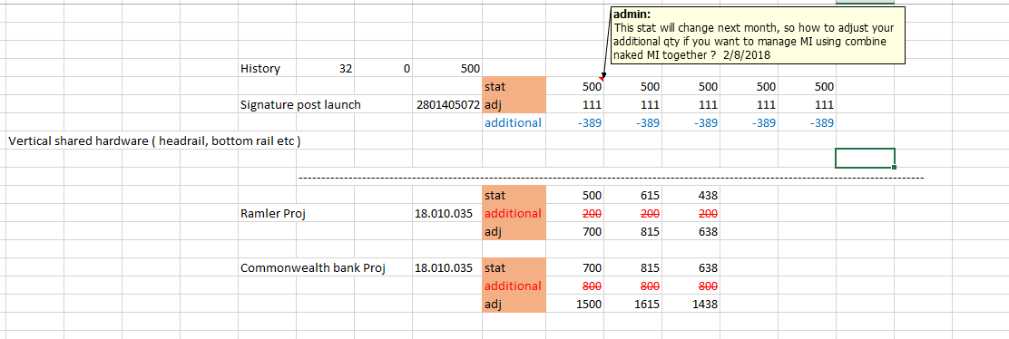

1. You cannot say, I do not care what you did but I want to get result only, I think to have good understanding of challenge of data collection and transformation and how it works gives you better appreciation of data and hope provide inputs to how to improve system and process and operation efficiency
2. To get meaningful market intelligence is very good, but it is half job done ( it is easy to say I am anticipating say 30% sales up or here is commercial order for common wealth bank project ) but how to manage this dataset and incorporate with current dataset include FC, PO , Inventory to provide visibility ofr whole picture is another story. Everything is easy said, I wish I can just push a button and magic will happen. I mean to manage and how to maintain data ( in your MI database ) cost time and efforts – different version ( like what happened in simplification project etc ).
3. Mangae MI database is part of S & OP process – you are actually manage outcome of S&OP process ( like from your meetings with sales or customer service team )
4. Everything should be managed in system – not using excel , to avoid problems of different version , delete/change etc . Excel is not data tool, it is not efficient and not secure – what if files get deleted ? or someone changed it inadventently ? how to handle 1 million rows of data ? how to update if data is refreshed – downloaded again ? Not value added. How about file crashed ?

This mindset of using Excel need to be long gone and change.

We need to manage forecast and its data including history, meta data & its hierarchy , master data in system not in Excel. And spend time to maintain it to get best result for business.

Unless you want to go back way.

This is finalized and we talked so this is agreed – we should not spend more time to debate this . Full stop , rather we need to spend more time to discuss to how to better current process and system.

We probably need more resources if we do not have adequeat.

And we already see great/good improvement in demand planning function and s & OP process ( I am supporting you but do not own it ).

And one thing at a time – need to learn to work before run. Now we are just learn how to crawl from not knowing how to move.

It is in a envolving process and infant /baby stages – in my experience it takes at least 3-5 years to establish a good demand planning and S&op process and see good result – and it also depends how much support you got from business and your stake holders ( assume not more people change and system is good ), it is not one man job.

I am proud of what had achieved so far, we have made great improvement . How much/far or what experience you can expect/have to travel/riding with Nissan , you cannot say I want posh performance using driving with Nissan – that is not real . we need to be honest about ourselves.

1. We do not have aggregation capability ( both vertically or horizontally – on year total ) in Apex pro

--

17/9/2018

To chop off history or just allow 36 month history is not ideal solution as spike might happened in between.

You should not change actual sales

The purpose is to create accurate forecast not to change the history, we can use history as a guide

7491700182 – in 2015/Feb there is abnormal demand of 5494 – good system are smart enough to filter out noise 1 or 2 ( spikes ) and normalize your sales history then generated more accurate forecast – but it does not mean you need or going to change the **actual sales** history itself but rather you know you past history is dirty and you want to remove those noise to arrive more ‘reasonable’ – I mean reasonable, since forecast is always not 100% and we are trying to minimize the errors .

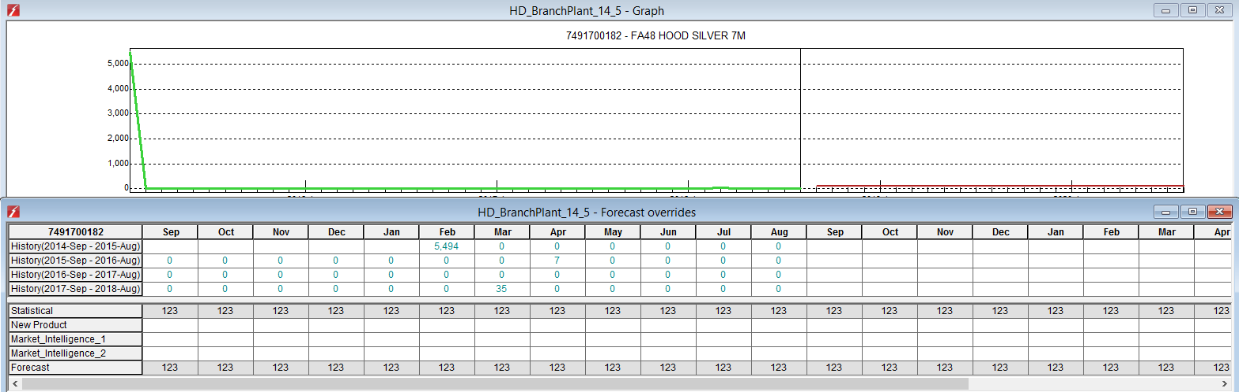

085552500D064 – there is a huge once off sales in Sep 2018 – Nathan advise there is customer demand of 1500 ( splitted into 2 lots delivery – depends on our stock on hand – we currently has 794 SM on hand which will be 1st delivery to customer).

So we need to filter out this Sep history going forward as it is a noise but our underlying demand ( base line ) is around 28 SM per month.

The point is yes it is true we made 309 + 1500 SM on year 2018 which is

309 * $33.19 + 1500 * $33.19 = $10255.71 + $497850.00 = $60040.71

If we reduce history to 309 SM and report we only has $10255.71 revenue we are reporting wrong number it is misleading business , it becomes data integrity issue because we tainted the history. And using distorted history will ( lead to a result ) which yield wrong business decision.

When we forecast on high level using aggregated values if we deliberately reduce or increase actual sales, we are actually creating a wrong base to start hence forecast on which based on these history will be distorted as well.

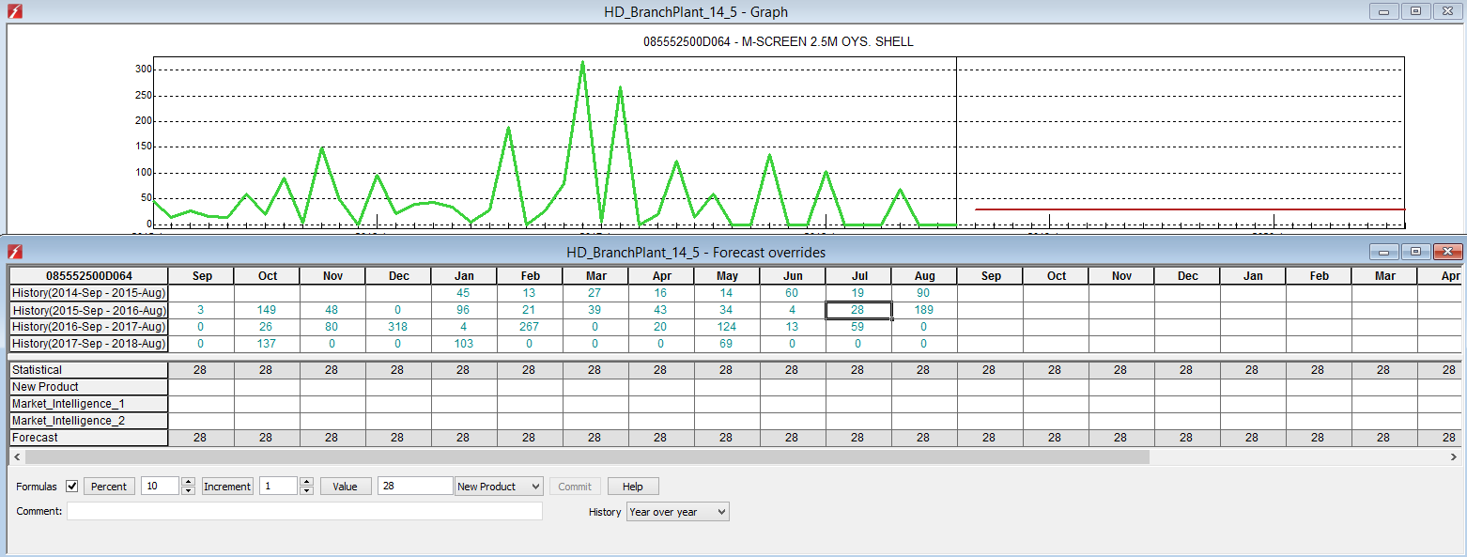

**Ten Ways to Reduce Inventory, While Maintaining or**

**Improving Service**

Number 4: Improve your forecasting

Many people don’t like the “F” word. But let’s face facts – every make-to-stock or purchase-to-stock company forecasts, admittedly with differing degrees of formality. Even if your production rules are “make what we sold yesterday” or “replenish up to x,” a forward-looking view of demand is implicit in determining how much to buy and keep on hand. While everyone knows the forecast will always be wrong, it is possible to become less wrong. Often, improvement efforts start with the mathematical forecasting method, e.g., – exponential smoothing vs. regression vs. Winters. That should actually be the last step. As the saying goes, “I’d rather be approximately correct

than precisely incorrect.” Think of forecast improvement in three segments:

1. Are the input data the relevant drivers of demand? If marketing or sales are influencing demand through pricing and promotion activity and you don’t take this into account, the forecasting formula doesn’t matter. You must understand and collect the inputs that drive demand.
2. The data must be accurate. If you forecast from shipments, but shipments don’t reflect true customer order quantity and dates (based on unavailability and backorders), the shipment data are tainted – garbage in, garbage out. Get as close as possible to true demand.
3. Review the forecasting method. If you have the right inputs and the data is clean, basic forecasting methods will produce good results. If you have limited resources, spend the effort on the first two steps to achieve the best result.

2: Forecast on Demand — Not Sales

In some cases, how much you actually manage to produce and sell to a customer is different than how much and

when your customer actually requested it. An extreme example occurs if you go out of stock of a product and make

no sales for several periods. The sales history data stream would suggest that the customer has no demand for the

product for those months. Another example is where manufacturing struggles to produce what your customer

wanted, when they wanted – but because of capacity, scheduling or raw material availability they made it available

in one large batch. In both cases forecasting using the historical customer order demand stream by request date

rather than the actual sales will generate more accurate statistical forecasts.

**How to Spot Exceptional Demand Behavior**

Demand is erratic or irregular if:

•

Its history includes irregularly occurring spikes, zeros, and/or negative values

•

It is a poor statistical fit to any forecasting formula

•

The records have a high forecast error . After you identify exceptional behavior in demand streams, adjust the history of that stream to eliminate the exception

3: Identify and Separate Different Demand Streams

Different demand streams can behave in differing ways. A good example of this is a pharmaceutical company we

worked with. The client’s total demand history by product appeared erratic and unpredictable. However, when we

delved a little deeper and analyzed the business, we found that it broke down into two separate demand streams

— tender business, which was about one-third of the revenue and exceptionally lumpy and unpredictable; and

pharmacy and distributor business, which was regular, seasonal and statistically forecastable. The combined demand

history was unpredictable, but by separating the history into the two streams, we identified an opportunity to use

forecasting algorithms to calculate the forecast in one of the streams. For the other, we used collaborative tools to

allow the sales team to provide the best and latest “market intelligence” about the tenders. Increasingly, companies

utilize different channels to market, such as, online sales channels and retail sales channels. These channels can have

very different demand profiles and should be managed separately.

**Below is good point -**

4: Understand and Modify History to Remove the Effect of Exceptions

Any good forecasting package will have the capability to highlight and filter out exceptional circumstances so that history can be “cleansed”. This allows forecasting professionals to remove those one-time variables that can skew a forecast. Typical factors that distort history include:

•

Promotions — particularly where the promotional activity cannot be flagged and

those that occur irregularly

•

Stock outs

•

Unusual competitor activity that increases or decreases sales

•

“Fire sales” to move inventory

•

New market entrant buying market share by undercutting prices

--

10/10/2018

To complete and create monthly forecast is a challenge not only in a sense there is a lot of data transformation, but also you want to capture most up to date and complete information related to future demand, wether it is a large commercial order or mi, you want to capture but do not want to go through a whole process again after complete forecast process and re start because it was missed. Sometime team member is not available or busy with other project, like one for NP – Qmotion tube + foam, after we had a meeting together with Anna, after one week there is still no SKU set up when I talk to Balan he mentioned his team is under heavy workload and he does not have adequate info like cost , work centre – router etc to set up product in Master ( burden ? ). So I guess what I am trying to say is that it is not one man job and my work is depend on others as well. You need to work as team and everyone is different some might take longer time some are not, they are not all as good as you are your meeting your /business expectation. You just need to be aware or be conscious of that ( be mindful ). Because you need to work together within a team.

Talking about large commercial order , you know how hard it is to get all information together and more difficult though, sometime you need to spend more time to cleanse and communicate and confirm the info you get , like Wynstan project, new customer – the spreadsheet is like terrible. And not clear, has obsolete item – we had at least 2 meeting / 2 week to get final data set. Because during the process you have to talk and communicate with other team ( product – kevin, customer service – etc ) and this all takes time.