21/2/2019

**Fish-Yates algorithm**

1.

<https://www.quora.com/What-is-a-simple-implementation-of-the-Fisher%E2%80%93Yates-shuffle-in-C>

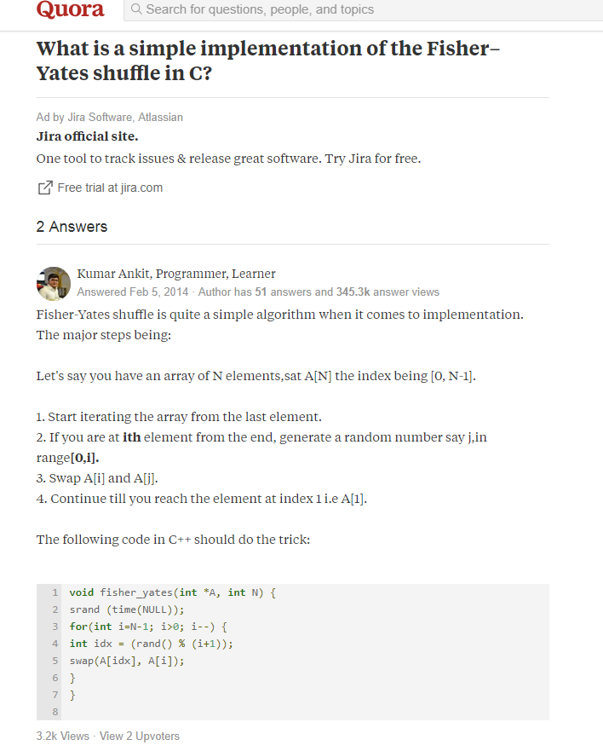

2. <http://eforexcel.com/wp/article-37-vba-generating-unique-non-repeating-random-numbers-efficiently/>

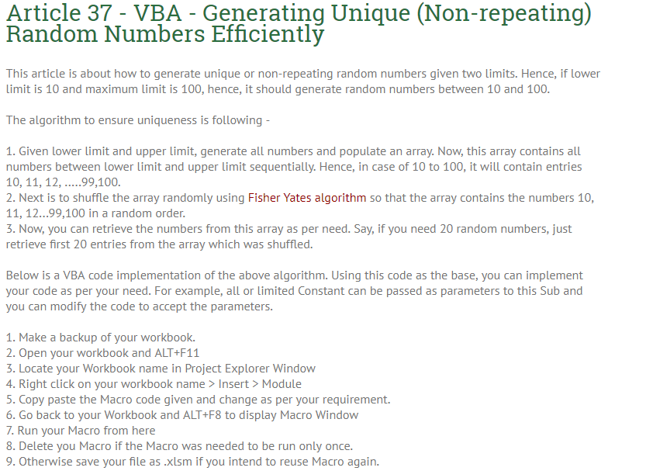

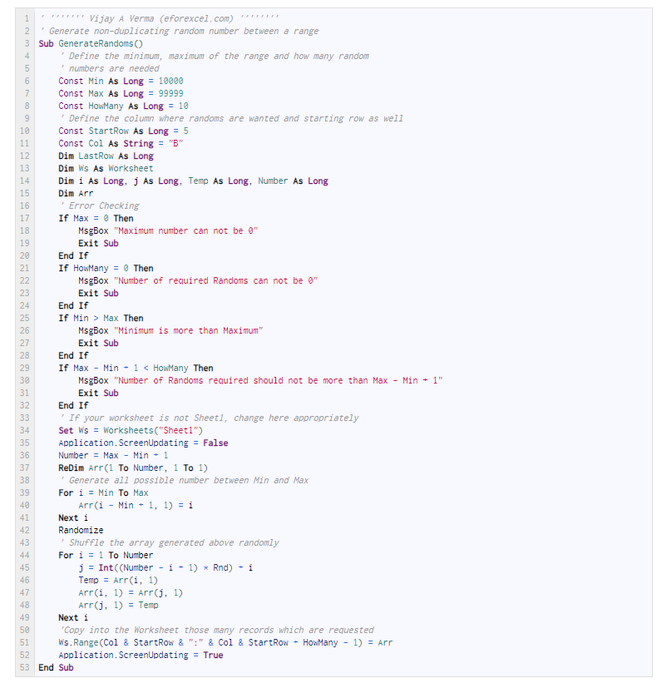

3. <https://www.geeksforgeeks.org/shuffle-a-given-array-using-fisher-yates-shuffle-algorithm/>

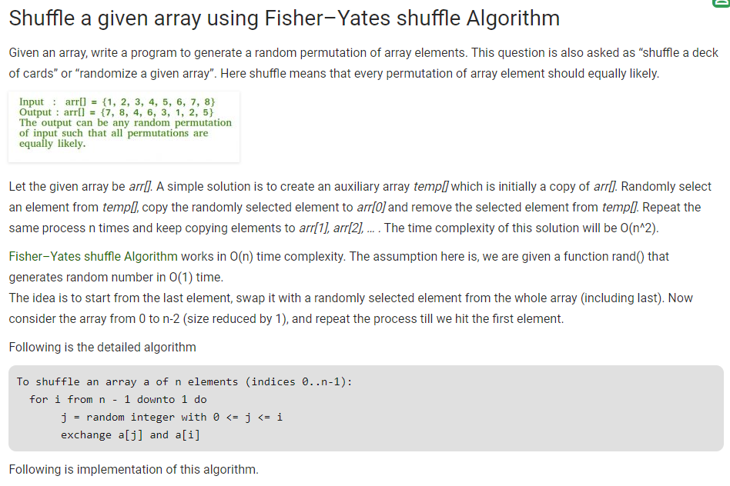

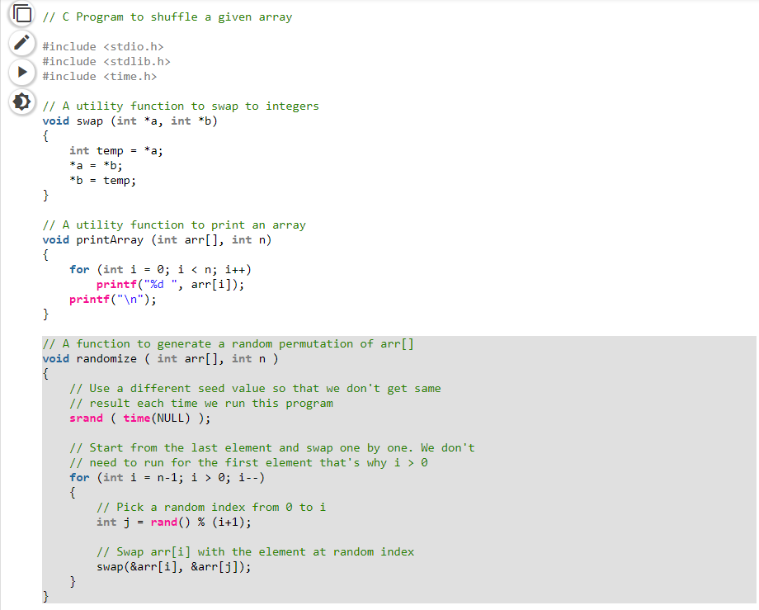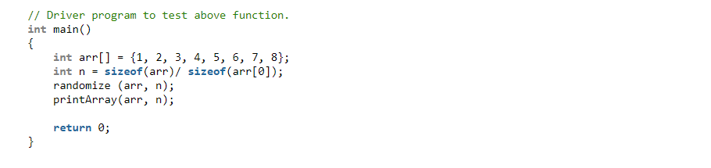

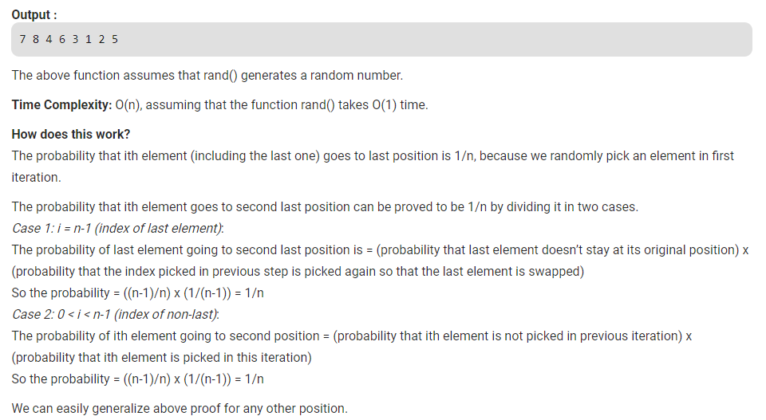

4.

<http://www.programming-algorithms.net/article/43676/Fisher-Yates-shuffle>

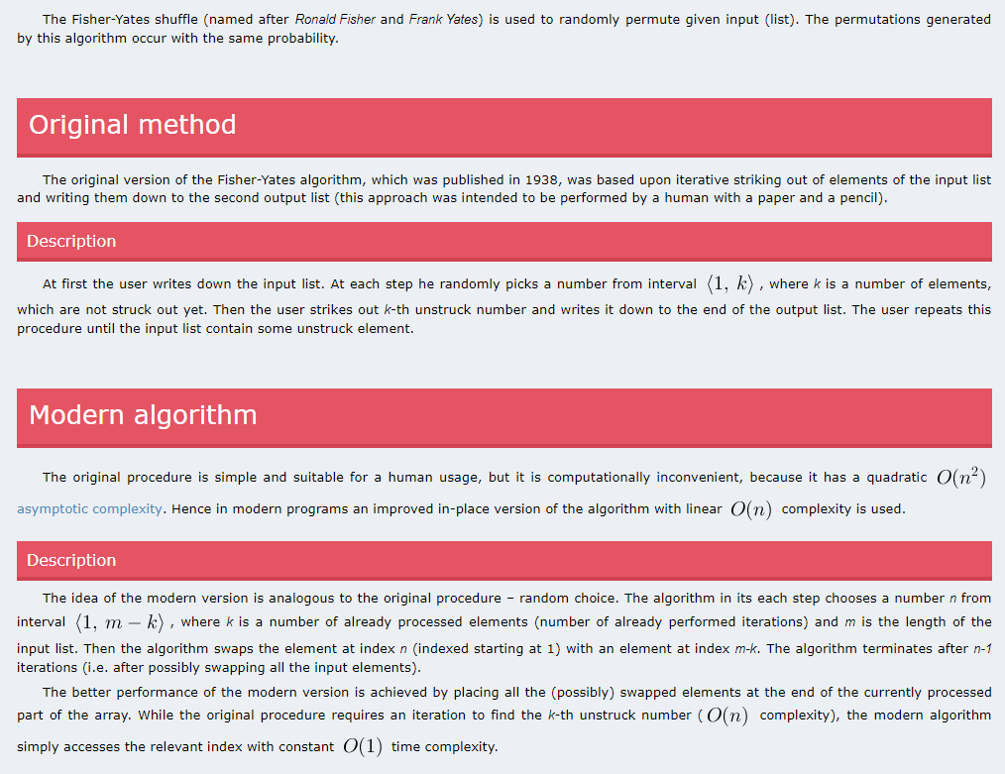

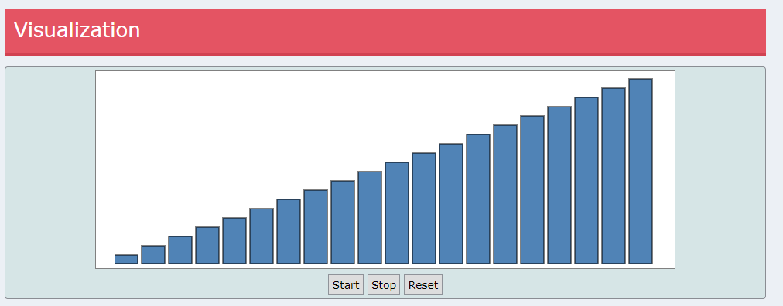



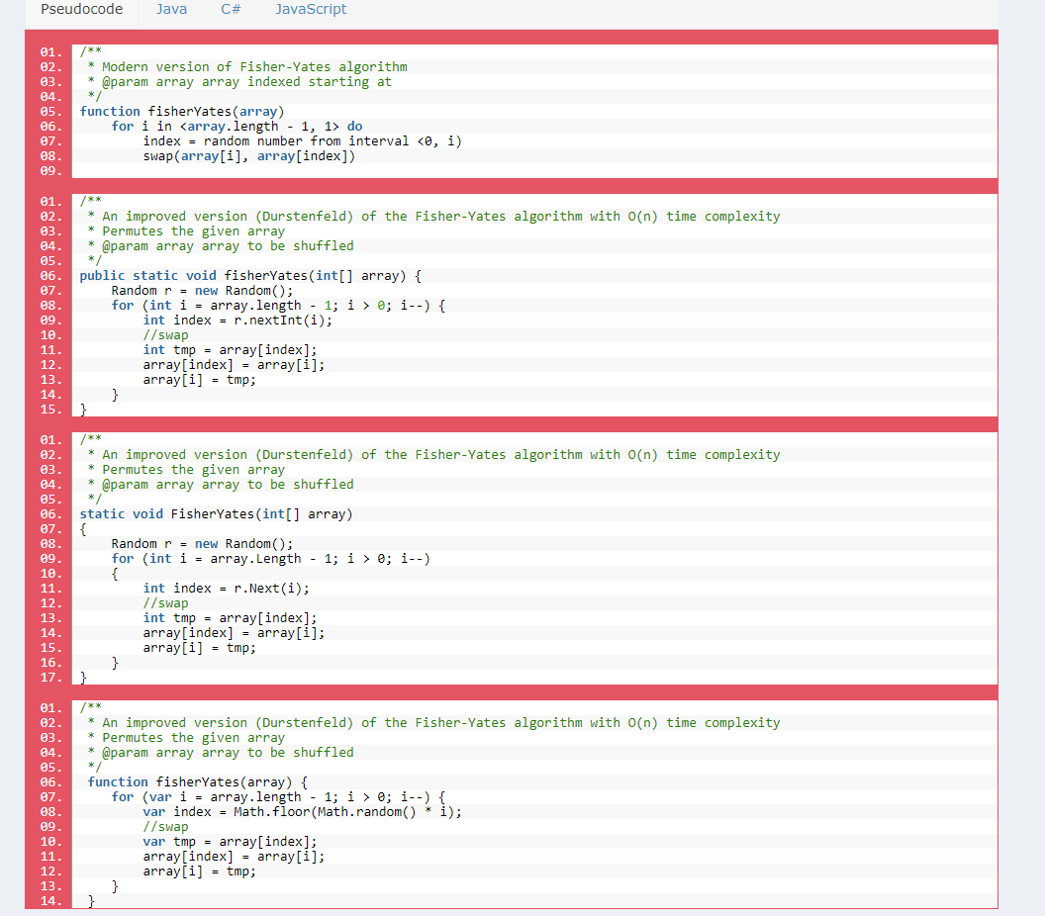

5.

<https://en.wikipedia.org/wiki/Fisher%E2%80%93Yates_shuffle>

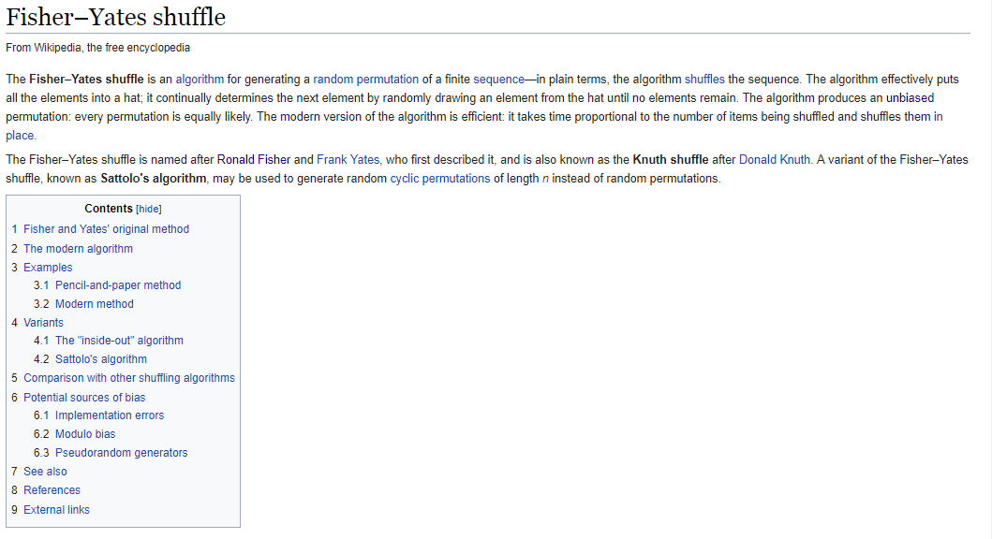

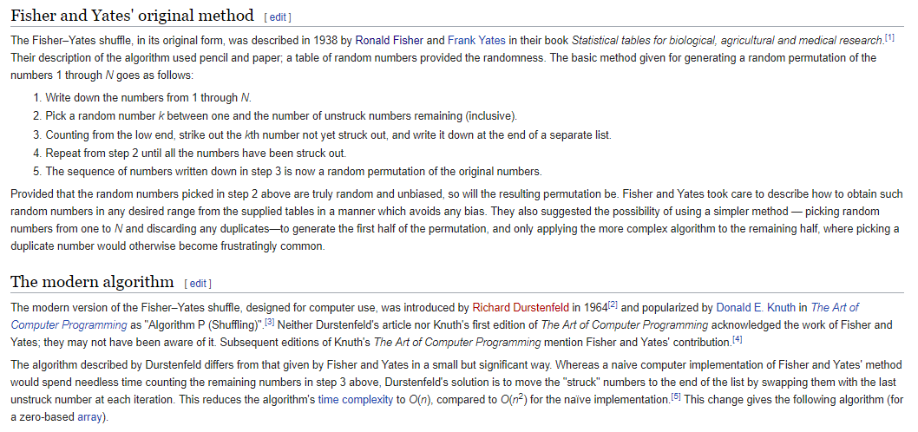

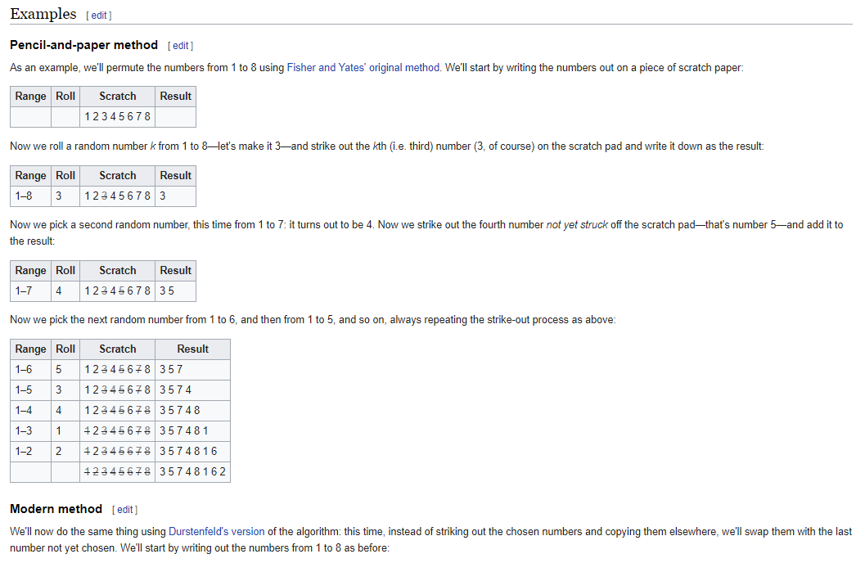

<https://en.wikipedia.org/wiki/Ronald_Fisher>

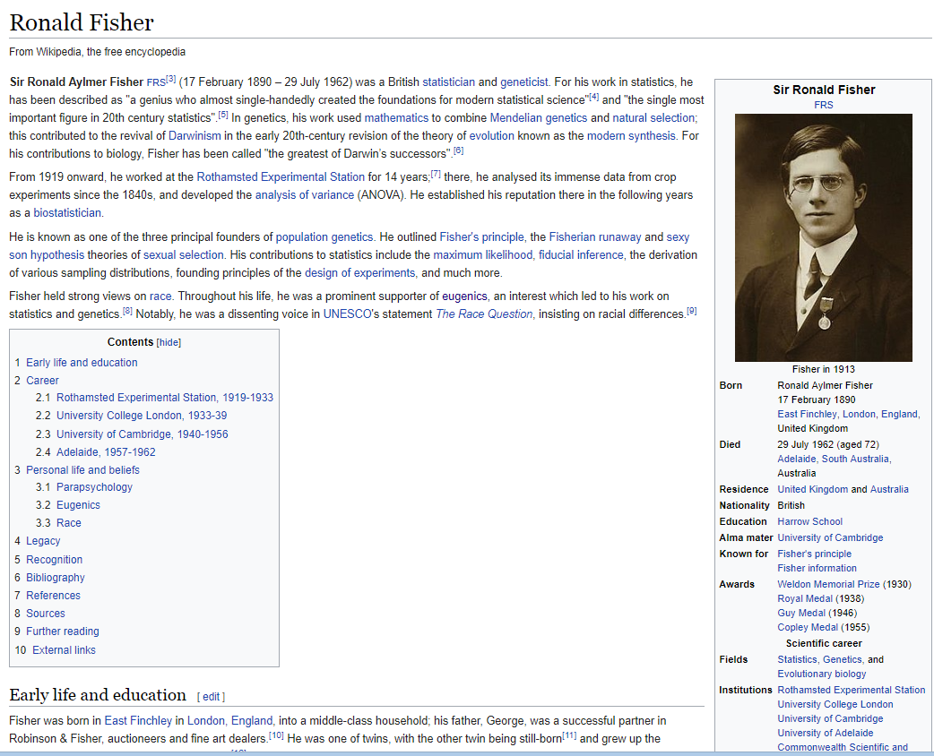

6.

<https://www.kidscodecs.com/fisher-yates-shuffle/>



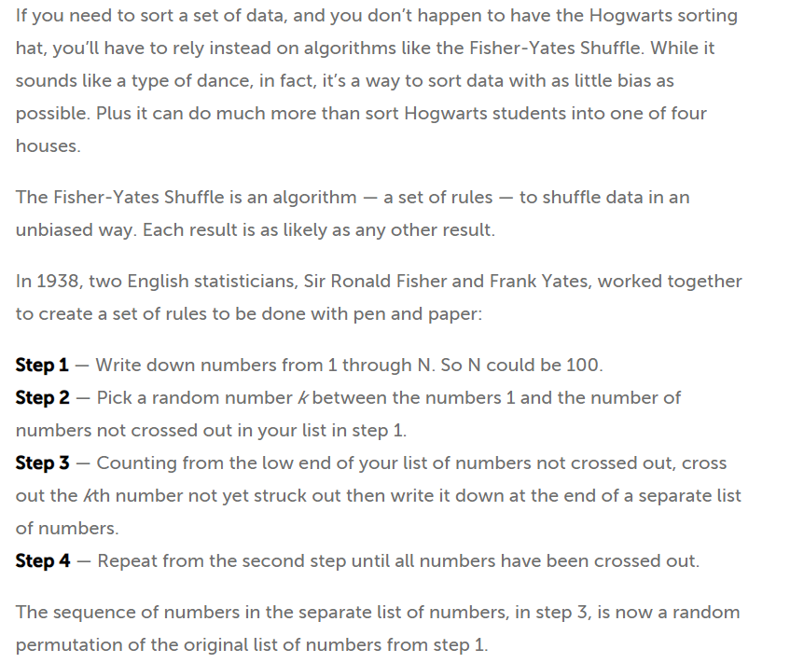

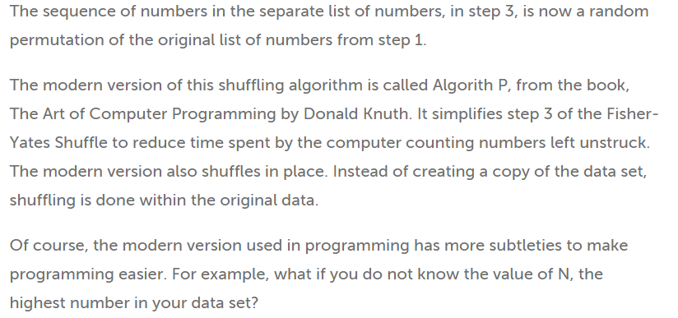

7.

<http://datagenetics.com/blog/november42014/index.html>

good

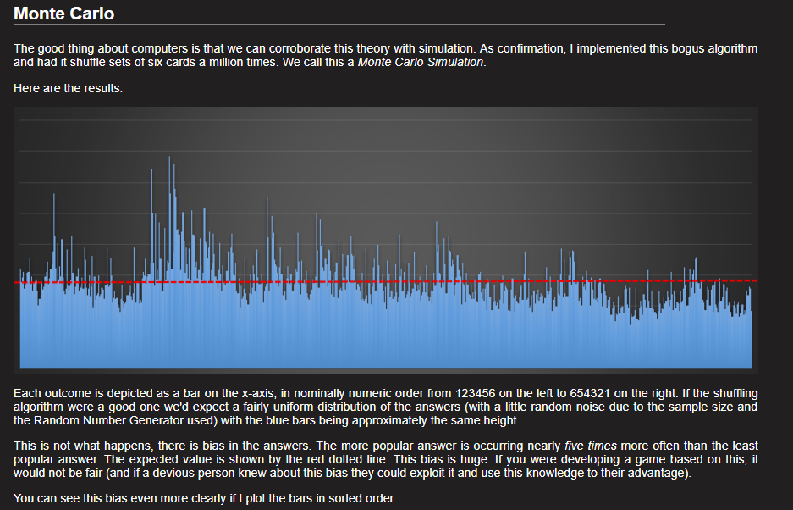

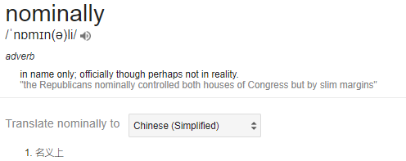

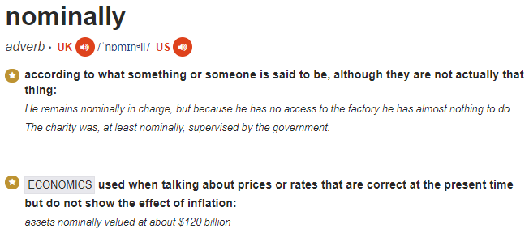

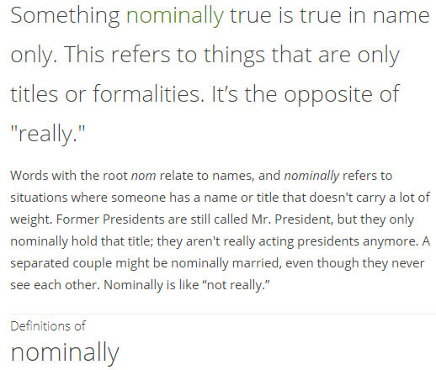

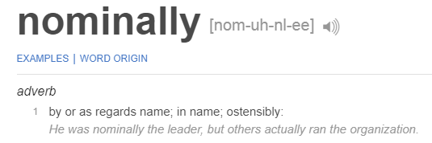

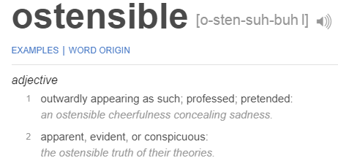

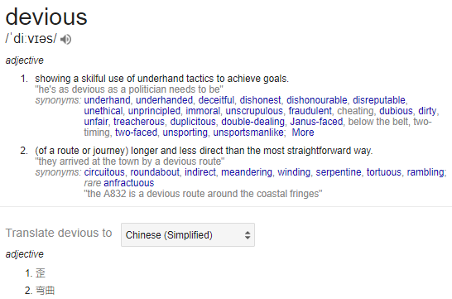

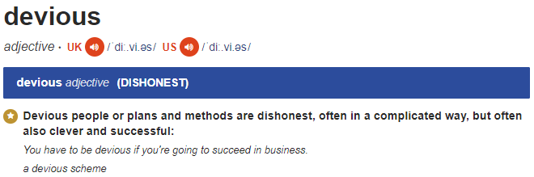

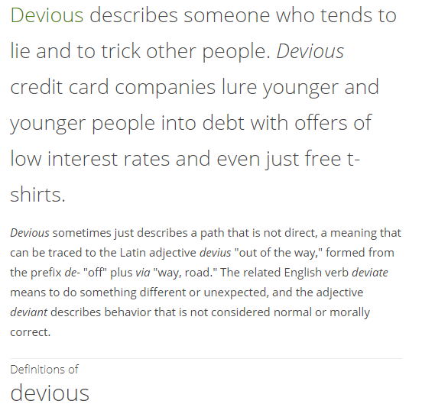

8.

<http://www.blackwasp.co.uk/FisherYatesShuffle.aspx>

Good

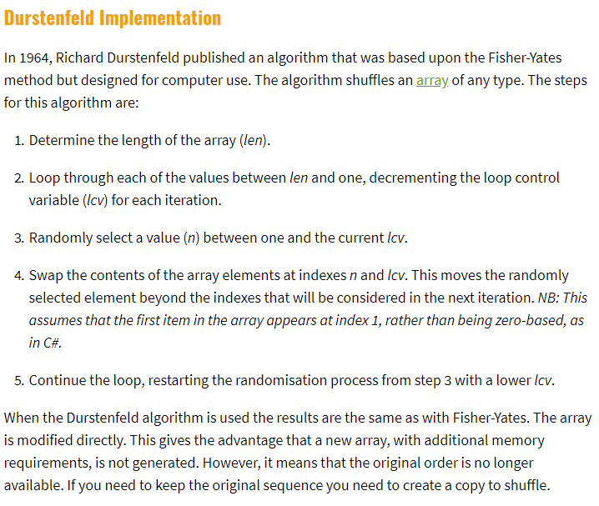

9.

<https://www.techiedelight.com/shuffle-given-array-elements-fisher-yates-shuffle/>

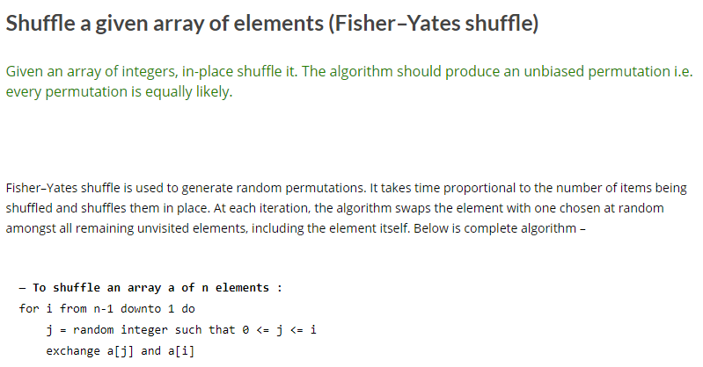

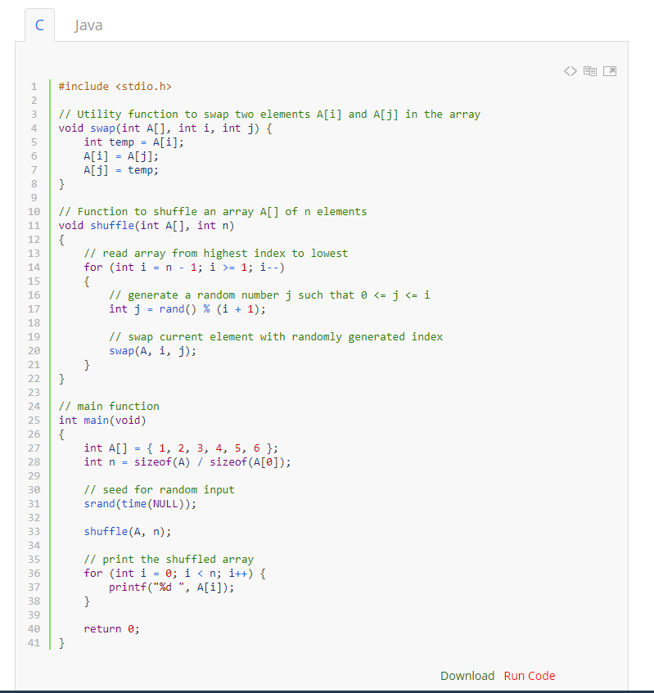

10.

<https://www.semanticscholar.org/paper/File-encryption-using-Fisher-Yates-Shuffle-Hazra-Ghosh/8a8fc0ad136c2bced4c29e18818c8d654c29b4a5>

